Software Requirements Specification
for
Missile Launch
Version 1.0 approved
Prepared by:
Claudia Alvarado
Jason Herzog
8/6/2012
Contents
1. Introduction 1
1.1 Purpose 1
1.2 Problem Statement 1
2. Overall Description 1
2.1 Product Perspective 1
3. Functional Requirements – System Features 1
3.1 Create a new mission 1
3.1.1 Description and Priority 1
3.1.2 Stimulus/ Response Sequences 2
3.1.3 Functional Requirements 3
3.2 Launch Mission 4
3.2.1 Description and Priority 4
3.2.2 Stimulus/ Response Sequences 4
3.2.3 Functional Requirements 4
3.3 Abort Mission 5
3.3.1 Description and Priority 5
3.3.2 Stimulus/ Response Sequences 5
3.3.3 Functional Requirements 6
4. Non-Functional Requirements 7
4.1 Usability Requirements 7
4.1.1 Standard Installation Process 7
4.1.2 In-Program Help 7
4.1.3 User Control 7
4.2 Learnability Requirements 7
4.2.1 User Performance/ Operability 7
4.3 Appearance Requirements 7
4.3.1 Layout 7
5. Design/Implementation Constraints 8
5.1 Development Constraints 8
6. References 8
7. Appendix I 8
7.1 Sequence Diagram 8
7.2 Class Diagram 1- Overall System 9
7.3 Class Diagram 2- Entity Associations 9
7.4 Class Diagram 3- View 10
10

- Appendix A – Glossary...…………………………………………………………………….19
- Appendix B - Analysis Models……..……………………………………………………….20

Revision History
Name | Date | Reason For Changes | Version

Introduction

Purpose
This purpose of the Software Requirements Specification (SRS) is to give a clear and precise description of the functionality and features of the Missile Launch missile guidance simulation tool. For the customer, this SRS serves as an outline and checklist of all of the functions that the final product is capable of performing. For developers, this document serves as a reference for product design, implementation, and future product releases. The SRS is divided into two sections that correspond to functional and non-functional requirements. The functional requirements describe the features that the software has as well as how the software interacts with a user and it’s environment. The non-functional requirements focus on the attributes of the software.

Problem Statement
Missile Launch models three different navigational guidance systems used to give a launched missile a level of intelligence when seeking a target. Missile Launch is a stand-alone application that offers an intuitive graphical user interface (GUI), real-time feedback of current mission status, and the ability to see a graphical representation of trajectories and their comparisons.

Overall Description

Product Perspective
Missile Launch aims to correctly model the physics involved when launching a guided missile. The user can select one of three missile guidance options: pursuit, proportional, and parallel. Once the guidance is selected, a user can either manually launch the missile, or it can be automatically fired from a default location. Once the missile has been deployed, there is an update window that displays the current mission details and status.

Functional Requirements – System Features
This section provides a detailed description of the key features that Missile Launch is equipped with. These requirements are organized by use case scenarios and are ordered in a manner to reflect functional hierarchy and promote a clear understanding of the design intent.

Create a new mission

Description and Priority
Creating a mission consists of supplying Missile Launch with a desired location and a navigation guidance choice. This is imperative to the main feature of Missile Launch and is considered to have the highest priority. Correctly preparing the missile for flight is crucial to the success of the mission

Stimulus/ Response Sequences

Pre-condition
- Product is installed

Normal Data Flow
- User opens Missile Launch
- System displays a splash screen while the program runs an initialization process
- User selects ‘New Mission’
- System displays the New Mission window and prompts user to select a target selection option and guidance preference
- User selects ‘Automatic Target Selection’
- User selects ‘Pursuit’/ ‘Proportional’/ ’Parallel’
- User selects ‘Launch’

Alternative Data Flows

Alternative Data Flow 1
- User opens Missile Launch
- System displays a splash screen while the program runs an initialization process
- User selects ‘New Mission’
- System displays the New Mission window and prompts the user to pick a target selection option and guidance preference.
- User selects ‘Manual’ or target selection option
- System temporarily closes ‘New Mission’ window to allow user to pick target coordinates
- User clicks anywhere on the screen
- ‘New Mission’ window re-opens and the target coordinates are automatically updated according to where the user clicked
- User selects ‘Pursuit’/ ‘Proportional’/ ‘Parallel’
- User selects ‘Launch’

Alternative Data Flow 2

- User opens Missile Launch
- System displays a splash screen while the program runs an initialization process
- User selects ‘New Mission”
- System displays the New Mission window and prompts the user to pick a target selection option and guidance preference
- User selects ‘Start Mission!’ before entering required options
- System begins a default mission where target selection is automatic and all information regarding position is random.

Alternative Data Flow 3
- User opens Missile Launch
- System displays a splash screen while the program runs an initialization process
- User selects ‘New Mission’
- System displays the New Mission window and prompts the user to pick a target selection option and guidance preference.
- User selects ‘Abort’ or closes out window
- System returns to main view ready for a new mission.

Post-condition
- New mission is created

Functional Requirements
REQ-1: Mission must have a target selection method picked or automatic will be the default
REQ-2: Pursuit is the default navigational method if one is not selected

Figure 3.1a shows the display when a new mission is being created

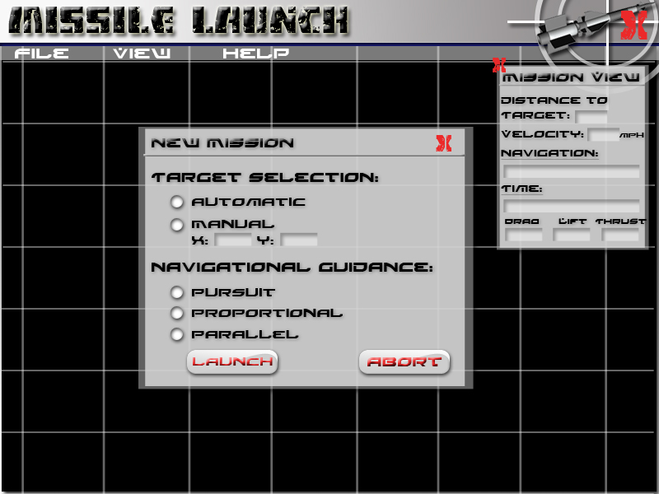
Fig 3.1a

Launch Mission

Description and Priority
Launching a missile allows the user to see, in real time, the trajectory of the chosen navigational method. There is a graphical representation of a missile and a target (an aircraft) that continuously updates and draws the trajectory curve. A user could then launch a number of different missions in order to compare different guidance methods.

Stimulus/ Response Sequences

Pre-condition
- A new mission has been created

Normal Data Flow
- System displays a launch view where the missile is visible
- System does a continuous animation update where the flight of the target and the missile is made visible
- The system draws a trajectory line that reflects the path of the missile
- The system continuously updates the ‘Mission View’ window where the following are displayed: distance to target, missile velocity, navigation guidance being used, time, drag, lift and thrust.
- The system displays an explosion when the missile hits the target
- The system notifies the user of a successful mission

Alternative Data Flows

Alternative Data Flow 1
- System displays a launch view where the missile is visible
- System does a continuous animation update where the flight of the target and the missile is made visible
- The system draws a trajectory line that reflects the path of the missile
- The system continuously updates the ‘Mission View’ window where the following are displayed: distance to target, missile velocity, navigation guidance being used, time, drag, lift and thrust.
- The missile misses the target and self destructs off of the screen
- The system notifies the user of a failed mission

Post-condition
- Mission completed, system is ready for new mission

Functional Requirements
REQ-1: A current mission must be ready to be executed
Figure 3.2a shows the main view when a mission is currently in progress. The red line following the missile reflects the resultant trajectory of the selected navigational guidance method.

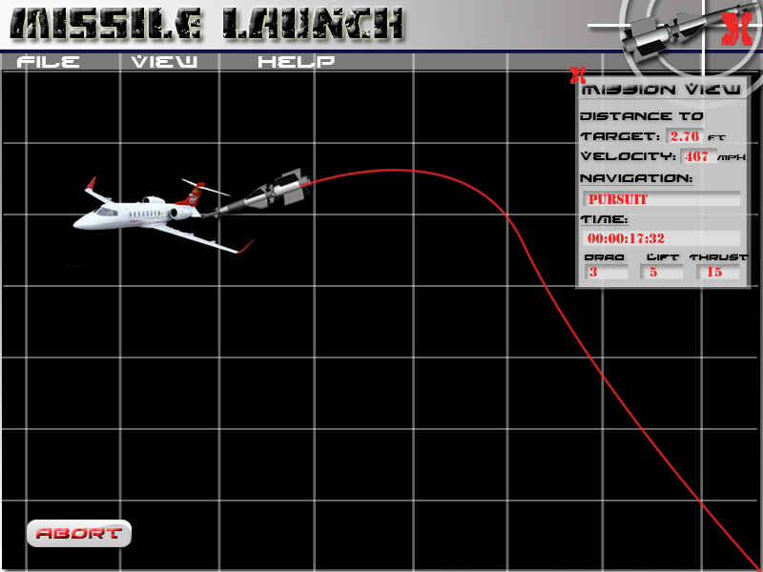
Fig 3.2a

Abort Mission

Description and Priority
The user is capable of aborting a mission at any point in time. This feature enables a user to restart a mission in the case that a different navigational method is desired or a different target position.

Stimulus/ Response Sequences

Pre-condition
- A mission is currently in process

Normal Data Flow
- User selects ‘Abort’ in the middle of a mission
- System pauses the current mission and displays a window asking for confirmation to abort the mission
- User selects ‘Abort’
- System resumes to it’s initial state and awaits the creation of a new mission

Alternative Data Flows

Alternative Data Flow 1
- User selects ‘Abort’ in the middle of a mission
- System pauses the current mission and displays a window asking for confirmation to abort the mission
- User selects ‘Cancel’
- System returns to the previously interrupted mission

Post-condition
- Mission is aborted, system is ready for new mission
- Mission is resumed and executed as planned

Functional Requirements
REQ-1: A current mission must be active and in progress

Figure 3.3a shows the confirmation required to abort a mission in progress.

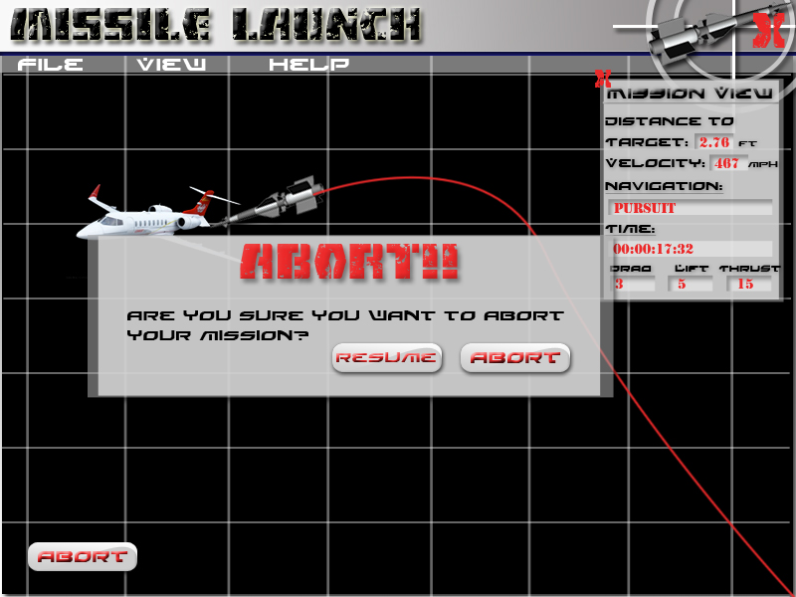
Fig 3.3a

Non-Functional Requirements

Usability Requirements

Standard Installation Process
Missile Launch is designed to run on any Windows or Mac OS. Missile Launch is easily installed with the aid of the system’s Installation Wizard.

In-Program Help
Missile Launch features a Help file which is easily accessible at any stage of execution. The Help menu option contains a PDF that focuses on normal workflow, frequently asked questions, trouble-shooting tips, and a detailed explanation of the physics that are modeled.

User Control
The user is able to freely create and abort missions at will.

Learnability Requirements

User Performance/ Operability
A first-time user will be able to successfully create and execute a mission within 15 minutes. A complete understanding of the creation process and options available is a result of reading the Help documentation thoroughly. A deeper examination of the navigational methods is required for full understanding. An intermediate user with additional knowledge in guidance and kinematic physics understands the underlying forces that affect the missile’s trajectory as well as the equations used to determine the path of flight.

Appearance Requirements

Layout
Missile Launch consists of a main view window which has a menu bar along the top containing three menus: File, View, and Help. Custom graphics are located at the top right near an Exit button and the Mission Launch brand is located at the top left.
An optional mission view window displays the following details of the current mission: Distance to Target, Velocity, Navigation Method, Time, Drag, Lift and Thrust. This window is automatically displayed by default and can be changed via the View menu under Options.

Design/Implementation Constraints

Development Constraints
Missile Launch is implemented in Java for ease of evolution.

References
Rafael Yanushevsky (2008) Modern Missile Guidance. Boca Raton, FL: CRC Press.

Appendix I

Sequence Diagram

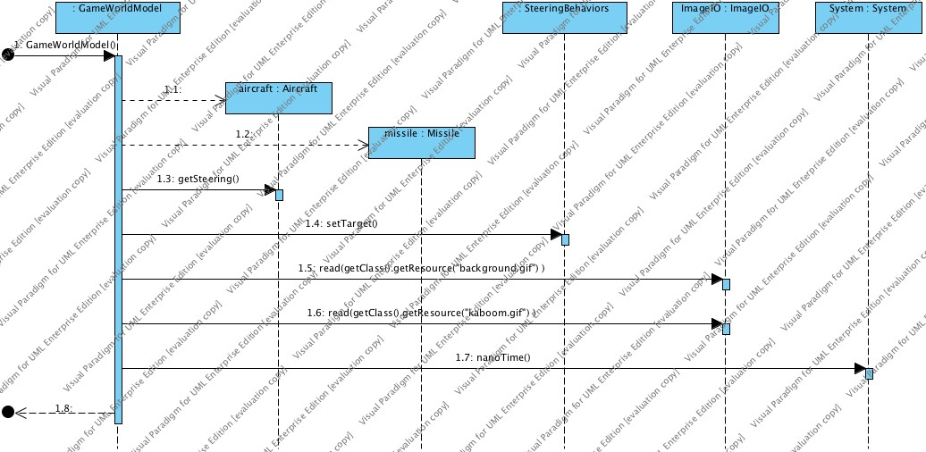

Class Diagram 1- Overall System
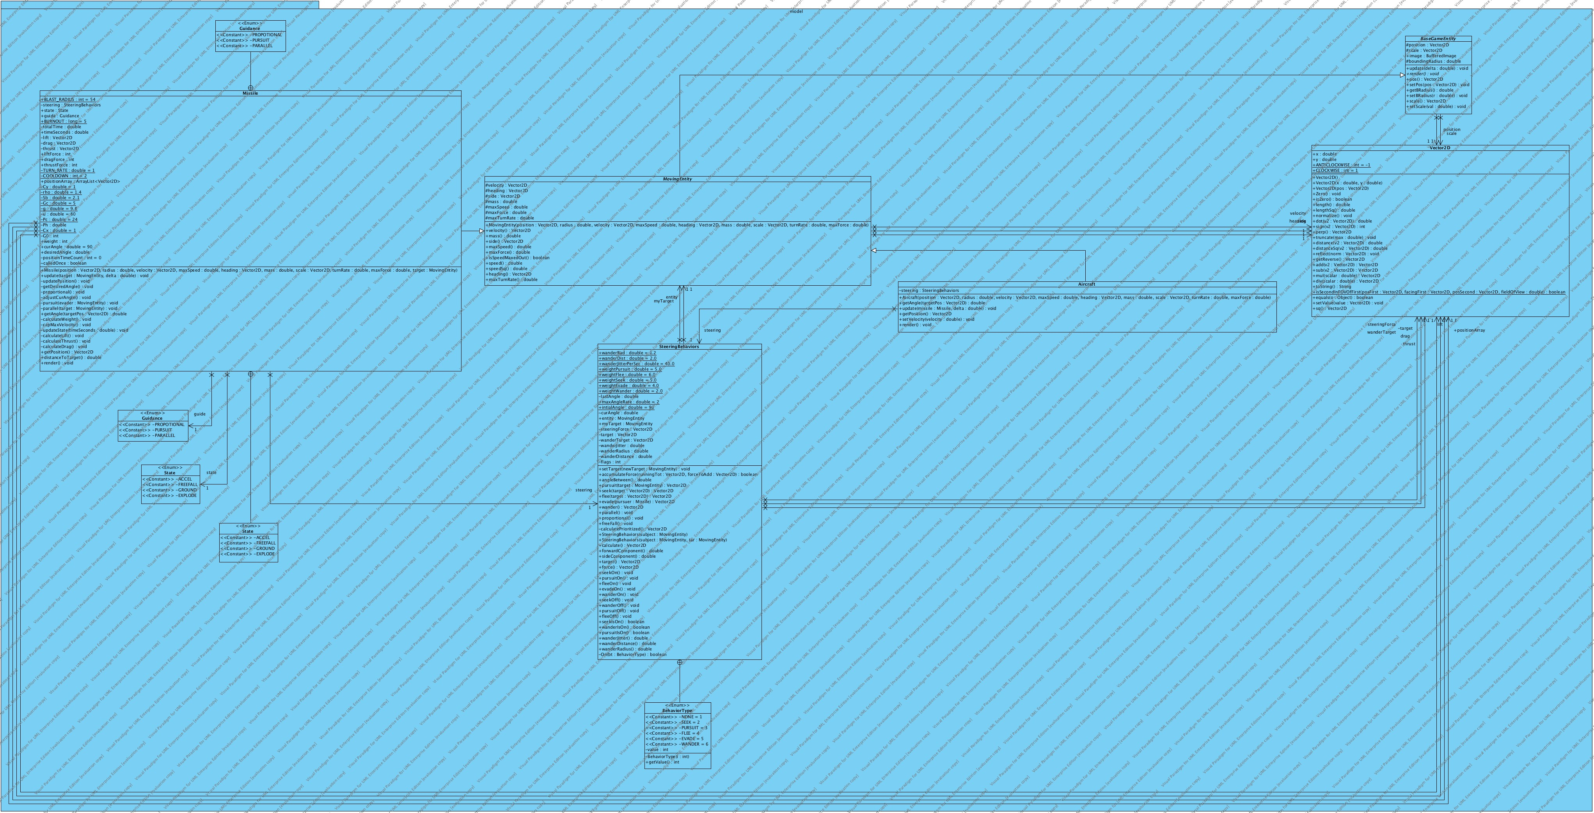

Class Diagram 2- Entity Associations
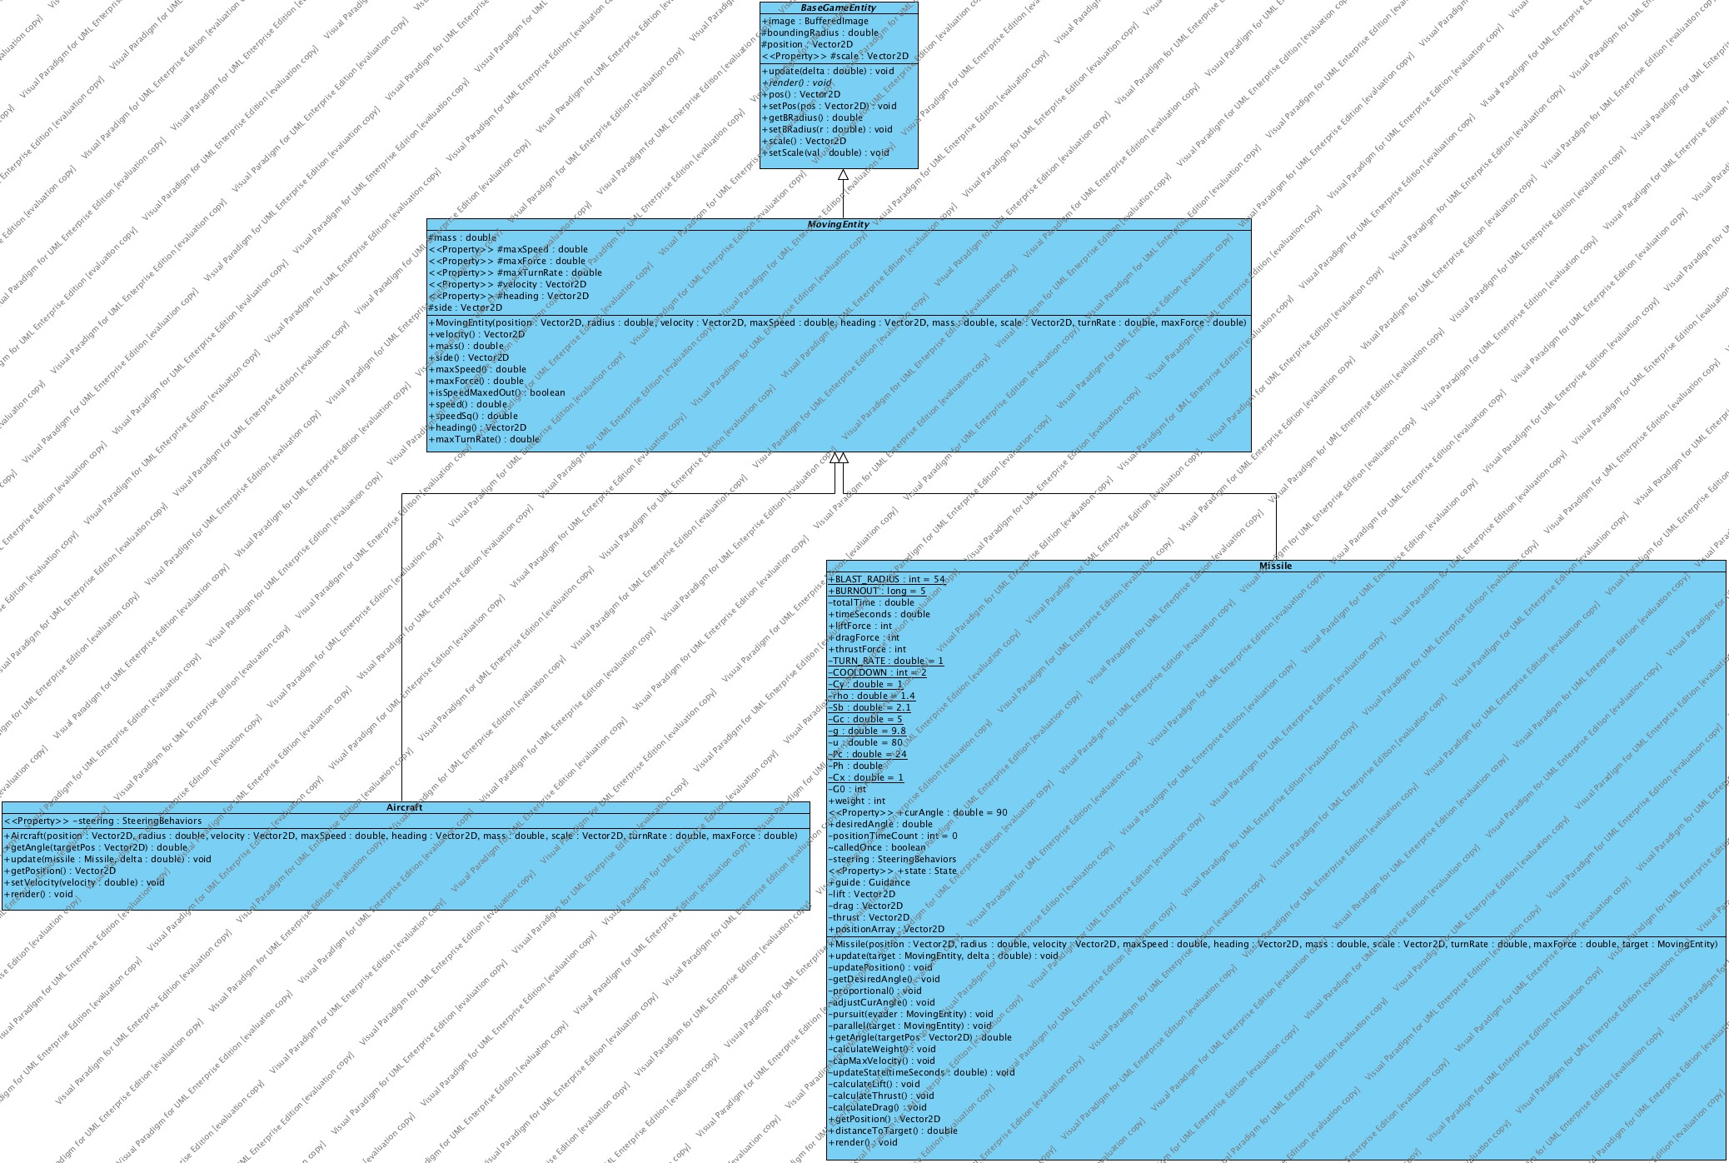

Class Diagram 3- View

