ARC · Initiative A
Exploitation-Request Sandbox — Design & Requirements
Design & requirements for a network-contained agent that pulls source from S3, analyses it, and runs code it writes — with no other access

1 · Purpose & scope
Goal. Stand up a proof-of-concept sandbox in our AWS account where an AI agent (a model-driven harness — pluggable: the ARC agent-core / ADK or a custom runner calling Bedrock; NOT tied to Claude Code) can: (1) pull a source-code bundle from S3, (2) read/scan it, (3) write code, and (4) run that code to analyse the source — while having no network or AWS access beyond exactly what those four steps require.
Infrastructure. The chosen runtime is listed as an infrastructure requirement (§4.1): the sandbox runs as an ECS Fargate task — one ephemeral task per request, each isolated by AWS in its own Firecracker microVM. (An EC2 single-run variant was explored but not chosen.) Fargate has no fixed maximum task runtime, so hours-long analysis runs are fine on-demand. The containment design itself is runtime-agnostic — the requirements below hold regardless of compute.
Out of scope (later initiatives): per-action governance service, RoE engine, HITL, and attacking a live running target. This POC is only about containing the agent's network.

2 · Architecture
A launcher (ECS RunTask / Step Functions) starts one ephemeral Fargate task per request, passing the source bucket+prefix. The task runs the agent harness, pulls source via the S3 gateway endpoint, calls the model via the in-account Bedrock interface endpoint, pulls its image via ECR endpoints, and writes logs/results — and can reach nothing else. The task is wiped on exit.
Containment principle. Deny-by-default by absence, not filtering: the task runs in private subnets with NO internet gateway and NO NAT, so there is no route to the internet. The only way out is a small set of scoped VPC endpoints. Three independent walls must all agree before any byte leaves: (a) routing — no internet path exists; (b) security group — egress only to the endpoints; (c) IAM + endpoint policy — only the specific bucket and model.
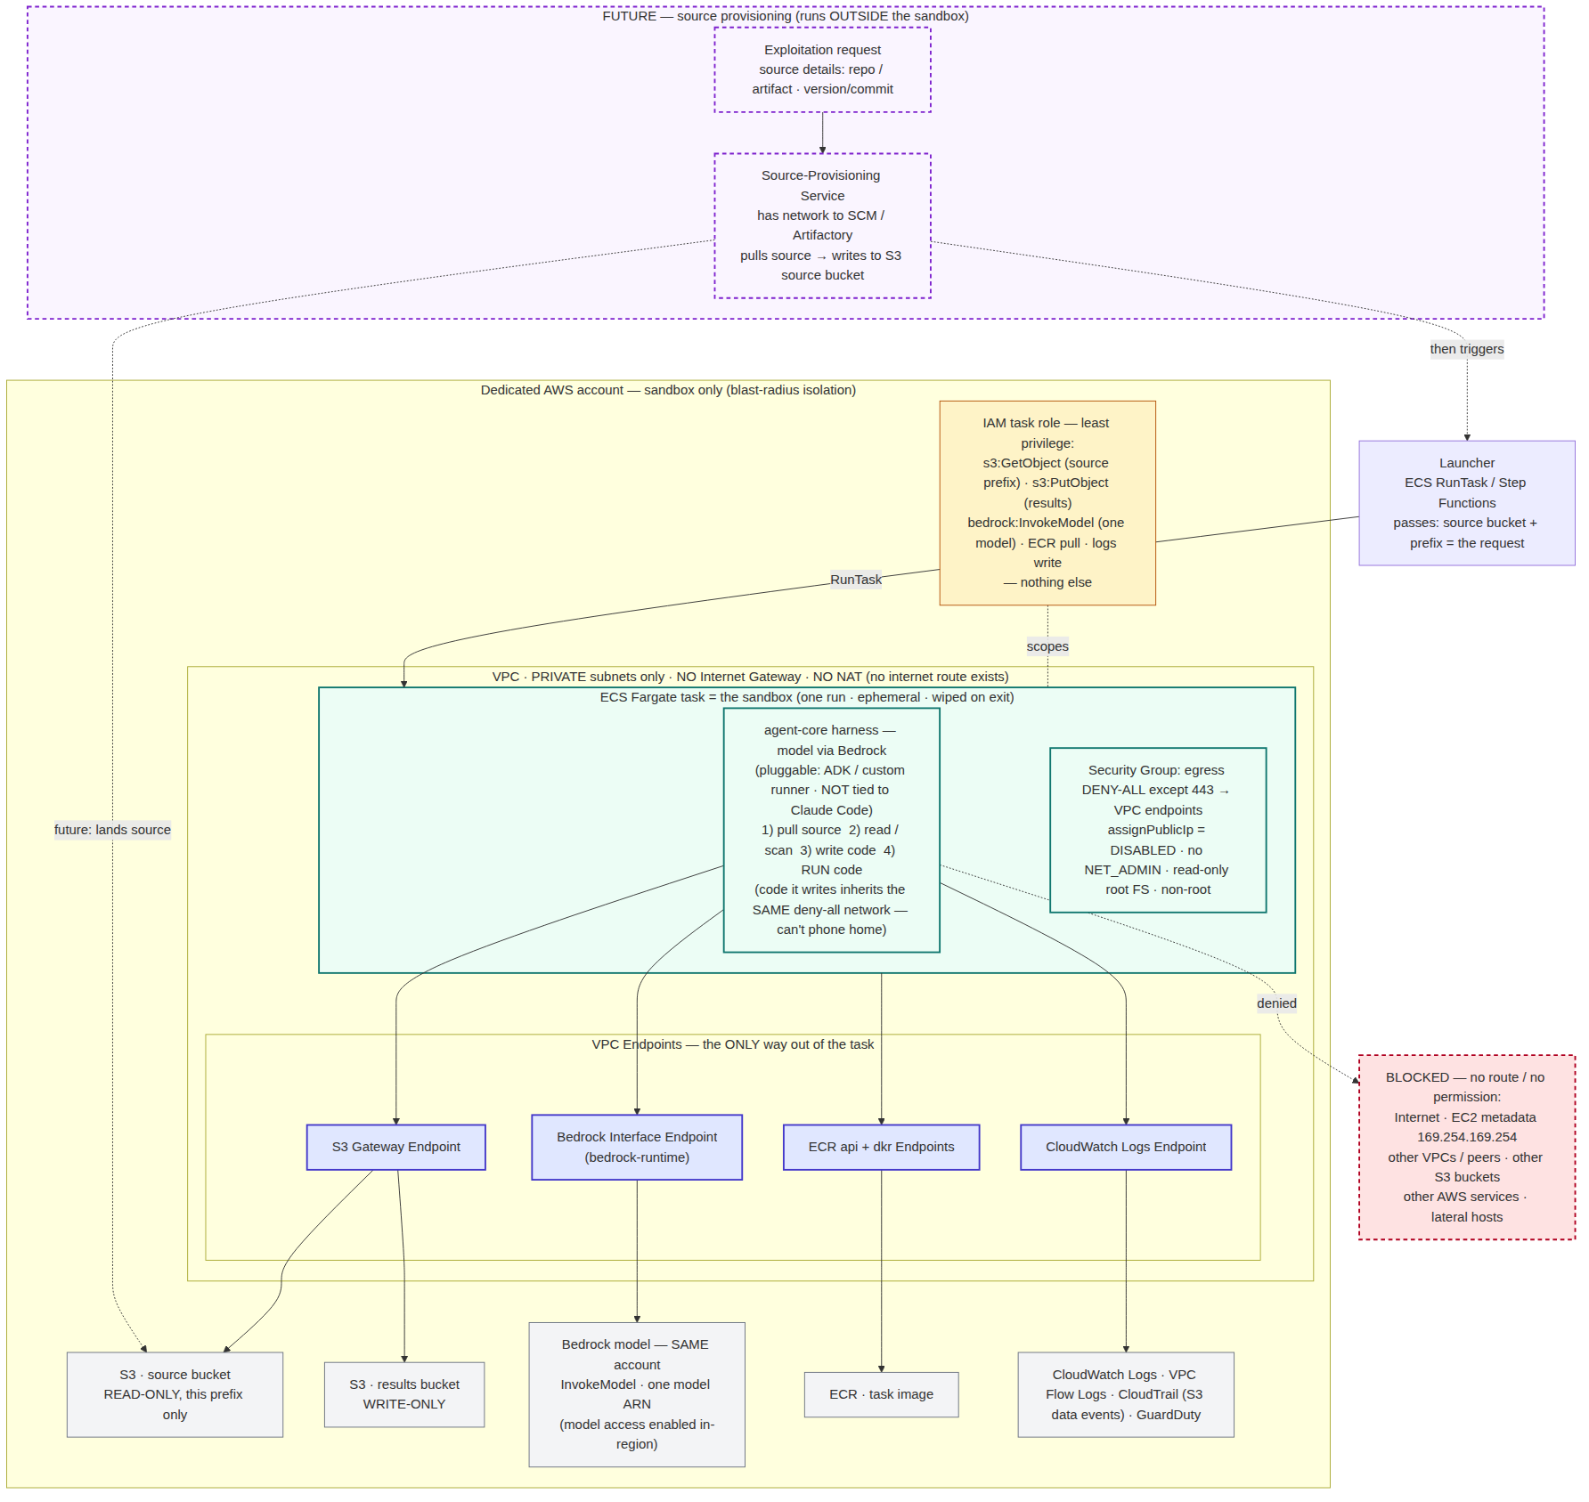
Figure 1 — ECS Fargate sandbox: the task reaches only S3, Bedrock, ECR and Logs via VPC endpoints; everything else has no route. Dashed purple = future source-provisioning (F1).

3 · Assumptions & open questions
- Source location: source code is in an S3 bucket for now (one bucket/prefix per run). Later it may be provisioned from an exploitation request (see §6).
- Agent harness: not Claude Code-specific — pluggable (ARC agent-core / ADK or a custom runner). The containment design is harness-agnostic.
- Model access: RESOLVED — Bedrock is in the SAME account, reached only via the in-account Bedrock interface endpoint (bedrock-runtime) over PrivateLink. No internet hole needed. Note: in-account does NOT make Bedrock private by itself — the interface endpoint is still required.
- Results destination: assumed a separate write-only S3 results bucket. Confirm.
- Account: assumed a dedicated sandbox account (or at least a dedicated VPC) for blast-radius isolation. Confirm.

4 · Requirements

4.1 Infrastructure, account & VPC isolation
ID | Requirement | AWS service / mechanism | Priority
INF1 | Compute: run each sandbox as one ephemeral task per request (AWS-managed Firecracker microVM isolation) | Amazon ECS on Fargate | MUST
INF2 | Orchestration/launcher: start one task per request with run parameters | ECS RunTask / Step Functions | MUST
INF3 | Private registry for the agent container image | Amazon ECR (private) | MUST
N1 | Dedicated sandbox account (or dedicated VPC) separate from any production workload | AWS account / Organizations OU | MUST
N2 | Private subnets only — NO Internet Gateway, NO NAT (no internet route exists) | VPC route tables | MUST
N3 | Task gets NO public IP | awsvpc · assignPublicIp=DISABLED | MUST

4.2 Network egress — the funnel
ID | Requirement | AWS mechanism | Priority
N4 | Security group: egress DENY-ALL except 443 to the VPC endpoints / S3 prefix list | Task SG egress rules | MUST
N5 | Subnet NACL deny-all except endpoint ENIs (static backstop under the SG) | Network ACLs | SHOULD
N6 | No VPC peering / Transit Gateway routes to any other network | Route tables (absence) | MUST
N7 | Code the agent writes and runs inherits the same deny-all network | Single task network namespace | MUST

4.3 VPC endpoints (only way out) + endpoint policies
ID | Requirement | AWS mechanism | Priority
E1 | S3 gateway endpoint; policy limited to the source bucket (read) + results bucket (write) | S3 Gateway endpoint + policy | MUST
E2 | In-account Bedrock interface endpoint; policy = InvokeModel on the one model | Interface endpoint (bedrock-runtime) | MUST
E3 | Image pull via ECR api + dkr endpoints (+ S3 gateway for layers) | ecr.api, ecr.dkr endpoints | MUST
E4 | Logs via CloudWatch Logs interface endpoint | logs endpoint | MUST
E5 | No other interface endpoints present | Endpoint inventory review | MUST
E6 | Bedrock model access enabled for the model in this account + region (one-time grant) | Bedrock console · model access | MUST

4.4 IAM least privilege
ID | Requirement | AWS mechanism | Priority
I1 | Task role: s3:GetObject (source prefix) + s3:PutObject (results prefix), ARN-scoped, no wildcards | IAM task role | MUST
I2 | Task role: bedrock:InvokeModel on one in-account model ARN (no bedrock:*) | IAM task role | MUST
I3 | Execution role: only ECR pull + logs write | IAM execution role | MUST
I4 | No s3:* , no account-wide perms, no iam:* / ec2:* | Policy review / Access Analyzer | MUST
I5 | Buckets enforce TLS + only the task role (bucket policy) | S3 bucket policy · aws:SecureTransport | SHOULD

4.5 Metadata & credential protection
ID | Requirement | AWS mechanism | Priority
M1 | Block EC2 metadata 169.254.169.254 from the workload (SSRF cred-theft path) | egress deny / app-level block | MUST
M2 | Task-role creds only via the ECS task credential path 169.254.170.2 | Fargate platform default | MUST
M3 | No long-lived AWS keys in the image or env; task role only | Image + task-def review | MUST

4.6 Task / container hardening
ID | Requirement | AWS mechanism | Priority
C1 | Ephemeral: one run per task; task stops after; ephemeral storage discarded | ECS RunTask lifecycle | MUST
C2 | Read-only root filesystem + a scratch volume only where code is written/run | task def readonlyRootFilesystem | SHOULD
C3 | Non-root user; no privileged mode; drop Linux capabilities incl. NET_ADMIN | task def linuxParameters | MUST
C4 | CPU / memory / ephemeral-storage limits + task-level timeout | task def sizing + launcher timeout | MUST
C5 | Agent image from private ECR (scanned), pinned by digest | ECR + digest pin | SHOULD

4.7 Observability & audit
ID | Requirement | AWS mechanism | Priority
O1 | VPC Flow Logs capturing every allowed + denied flow | VPC Flow Logs | MUST
O2 | CloudTrail S3 data events on the source + results buckets | CloudTrail data events | MUST
O3 | Agent stdout/stderr + run transcript to CloudWatch Logs | awslogs driver | MUST
O4 | Alarm on any denied/blocked egress attempt | Flow Log metric filter → alarm; GuardDuty | SHOULD

4.8 Lifecycle & orchestration
ID | Requirement | AWS mechanism | Priority
L1 | Launcher starts the task with run parameters (source bucket+prefix, run id) | ECS RunTask / Step Functions | MUST
L2 | Hard wall-clock timeout per run; force-stop past it. (No fixed Fargate max — hours OK; use on-demand, not Spot) | launcher / Step Functions timeout | MUST
L3 | On-demand kill path to stop an in-flight task | StopTask API + runbook | SHOULD

4.9 Data handling
ID | Requirement | AWS mechanism | Priority
D1 | Source bucket read-only; results bucket write-only; separate buckets | S3 + bucket policy | MUST
D2 | Encrypt source, results, and logs with KMS; task role scoped to the key | SSE-KMS + key policy | SHOULD
D3 | Results are the only thing that leaves the task; nothing written back to source | bucket policy | MUST

4.10 Forward-compatibility (build these into the POC now so the future design drops in without rework)
These are requirements on the current POC whose only purpose is to make the future exploitation-request provisioning (§6) slot in with no change inside the sandbox. They cost almost nothing now and save a redesign later.
ID | Requirement | How enforced | Priority
FC1 | Source location is a RUNTIME PARAMETER to the task (bucket + prefix) — never hardcoded, so a service can supply it later | task def env/overrides via launcher | MUST
FC2 | Source laid out under a per-run prefix now: s3://<source-bucket>/<run-id>/… — the sandbox reads only its own prefix | S3 key convention + IAM prefix scope (I1) | MUST
FC3 | Results keyed by run_id: s3://<results-bucket>/<run-id>/… — so a future request can be tied back to its output | S3 key convention | MUST
FC4 | run_id is THE correlation key, carried through source prefix, results prefix, and logs | run_id minted by launcher; stamped everywhere | MUST
FC5 | Launcher is invocable programmatically / event-driven (not only manual) so a future 'source ready' event can trigger it | RunTask API / Step Functions / EventBridge target | SHOULD
FC6 | Nothing in the sandbox assumes WHO placed the source — human today, a service tomorrow; the task only reads S3 | design rule (the S3 seam) | MUST

5 · The three controls not to compromise
- No internet route exists (N2) — containment by absence beats containment by filter.
- Metadata 169.254.169.254 blocked (M1) — the #1 pivot to steal AWS credentials.
- IAM + endpoint policy scoped to the one bucket and one model (E1/E2/I1/I2) — so even the allowed path can't reach anything else.

6 · Future design: exploitation-request-driven source provisioning
Direction. Today the source bundle is assumed pre-placed in S3. In future, an exploitation request (carrying source details — repo/artifact coordinates, version/commit) arrives, and a dedicated Source-Provisioning Service pulls the source, lands it in the S3 source bucket at the per-run prefix, and triggers the run. The sandbox is unchanged — S3 stays the seam.
Boundary. The provisioning service runs OUTSIDE the sandbox — it needs network to SCM/Artifactory, with its own scoped permissions — deliberately NOT inside the locked-down task, so the agent never inherits that reach.

6.1 Future requirements (define the contract now; build later)
ID | Future requirement | Component / mechanism | Priority
FR1 | Define the exploitation-request contract: {request_id, source:{type:scm|artifact, coords, version|commit}, target_metadata, roe_ref?} | contract-first schema (JSON Schema) | MUST
FR2 | Source-Provisioning Service resolves the request and WRITES source to s3://<source-bucket>/<run-id>/ | new service, OUTSIDE the sandbox | MUST
FR3 | Provisioning service has network to SCM/Artifactory + write-only to the source bucket prefix; NO read of results; NOT inside the task | its own IAM role + SG; separate from task role | MUST
FR4 | 'Source ready' signal triggers the launcher (which starts the Fargate run) | S3 event / EventBridge / explicit API → launcher (FC5) | MUST
FR5 | Idempotency: one request_id → one source bundle → one run; re-delivery does not duplicate | dedup on request_id (outbox / conditional write) | SHOULD
FR6 | Provenance: record which request_id + source version produced which run_id (audit linkage) | run metadata + CloudTrail | SHOULD
FR7 | If the source producer later shifts from S3 to Artifactory/SCM directly, the service normalises it into the same S3 seam — sandbox contract unchanged | provisioning-service adapter | SHOULD
The link back to the POC: FR1–FR7 land cleanly only because the POC already satisfies the forward-compatibility set (§4.10). Build FC1–FC6 now and this future service is additive, not a rewrite.

7 · Containment exit-test (POC pass criteria)
- From inside the task, attempts to reach the internet, a second S3 bucket, another AWS service, and 169.254.169.254 all FAIL.
- Pulling the authorized source prefix and calling the one model SUCCEED.
- Flow Logs show the denied attempts; the alarm fires.
- Task stops and storage is gone after the run; results land only in the results bucket.
This POC proves the sandbox is network-contained on ECS Fargate. The source-provisioning service (§6), governance service, RoE engine, HITL, and live-target exploitation are separate initiatives that build on top of this contained task through the stable S3 (source) and results seams.

