using System.Collections;

using System.Collections.Generic;

using UnityEngine;

public class Laporan2a : MonoBehaviour

{ public int[] Numbers;

public string[] Texts;

[System.Serializable]

public class Collection

{ public int ID;

public string AnyValue;

}

string myText1, myText2, myText3;

public Collection[] Collections;

// Start is called before the first frame update

void Start()

{

myText1 = "";

for (int c = 0; c < Numbers.Length; c++)

{ myText1 = myText1 + Numbers[c].ToString() + ' ';}

myText2 = "";

for (int c = 0; c < Texts.Length; c++)

{myText2 = myText2 + Texts[c]+ ' ';}

myText3 = "";

for (int c = 0; c < Collections.Length; c++)

{

myText3 = myText3 + Collections[c].ID.ToString() + ":" +

Collections[c].AnyValue + " ";

}

}

// Update is called once per frame

void Update() { }

void OnGUI()

{

GUILayout.BeginArea(new Rect(10,10, 400, 2000));

GUILayout.Label("Array Integer: " + myText1);

GUILayout.Label("Array String: " + myText2);

GUILayout.Label("Array Object: " + myText3);

GUILayout.EndArea();

}

}

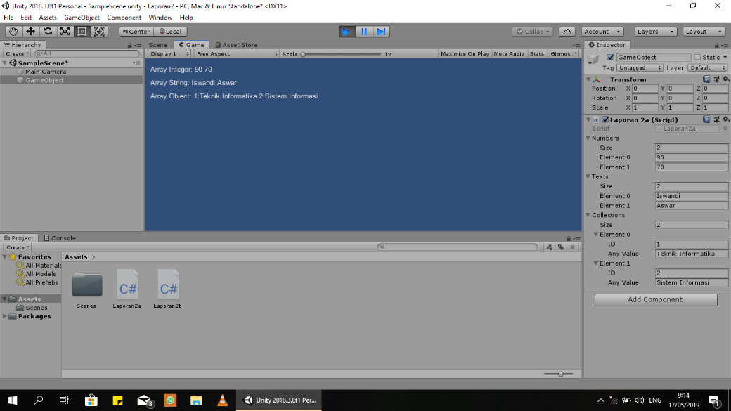

using System.Collections;

using System.Collections.Generic;

using UnityEngine;

public class Laporan2b : MonoBehaviour

{

int number1, number2, number3, number4, number5, countdown;

// Start is called before the first frame update

void Start()

{

number1 = 0;

number2 = 0;

number3 = 0;

number4 = 0;

number5 = 0;

countdown = 3;

InvokeRepeating("CountDown", 1, 1);

}

// Update is called once per frame

void Update()

{

if (countdown ==0)

{ number1++;}

}

void FixedUpdate()

{

if (countdown == 0)

{number2++;}

}

void CountDown()

{

countdown--;

if (countdown ==0)

{

InvokeRepeating("Looping1", 1, 1);

InvokeRepeating("Looping2", 5, 0.5f);

Invoke("NoLooping", 10);

CancelInvoke("CountDown");

}

}

void Looping1()

{

number3++;

}

void Looping2()

{

number4++;

}

void NoLooping()

{

number5++;

}

void OnGUI()

{

GUILayout.BeginArea(new Rect (10, 10, 400, 200));

if (countdown == 0)

{

GUILayout.Label("Update Increment:" + number1.ToString());

GUILayout.Label("Fixed Update Increment:" +  
 number2.ToString());

GUILayout.Label("Start At: 1 sec (Interval 1):" +  
 number3.ToString());

GUILayout.Label("Start At: 5 sec (Interval 0.5):" +  
 number4.ToString());

GUILayout.Label("Start At: 10 sec (No Looping):" +  
 number5.ToString());

}

else

{

GUILayout.Label("Count Down: " + countdown.ToString());

}

GUILayout.EndArea();

}

}

