OBSTACLE AVOIDING ROBOT
A PROJECT REPORT
Submitted by
ASHIRBAD BISWAL (240301120168)
SUMIT KUMAR PRUSTY (240301120140)
SHUBHANKAR TRIPATHY (240301120165)
ISWAR BEHERA (240301120142)
CHINMAYA MOHAPATRA (240301120151)
in partial fulfilment for the award of the degree of
BACHELOR OF TECHNOLOGY
in
COMPUTER SCIENCE AND ENGINEERING

SCHOOL OF ENGINEERING AND TECHNOLOGY BHUBANESWAR CAMPUS
CENTURION UNIVERSITY OF TECHNOLOGY AND MANAGEMENT
ODISHA

MARCH 2026
CERTIFICATE

DEPARTMENT OF COMPUTER SCIENCE AND ENGINEERING
SCHOOL OF ENGINEERING AND TECHNOLOGY
BHUBANESWAR CAMPUS

BONAFIDE CERTIFICATE
Certified that this project report “OBSTACLE AVOIDING ROBOT” is the Bonafide work of the team consisting of SHUBHANKAR TRIPATHY carried out the project work under my supervision. This is to further certify to the best of my knowledge, that this project has not been carried out earlier in this institute and the university.

SIGNATURE
(Prof. Chinmayee Dora)
Head of the Department of ECE

Certified that the above-mentioned project has been duly carried out as per the norms of the college and statutes of the university.

SIGNATURE
(Prof. Rajkumar Mohanto)
HEAD OF THE DEPARTMENT / DEAN OF THE SCHOOL
Professor of Computer Science and Engineering

DEPARTMENT SEAL
DECLARATION
I hereby declare that the project entitled “OBSTACLE AVOIDING ROBOT” submitted for the “Minor Project” of 4th semester B. Tech in Computer Science and Engineering is my original work and the project has not formed the basis for the award of any Degree / Diploma or any other similar titles in any other University / Institute.

Name of the Students: Registration No:
ASHIRBAD BISWAL 240301120168
SUMIT KUMAR PRUSTY 240301120140
SHUBHANKAR TRIPATHY 240301120165
ISWAR BEHERA 240301120142
CHINMAYA MOHAPATRA 240301120151

Place: BHUBANESWAR
Date:
NAME:
ACKNOWLEGDEMENTS
I wish to express my profound and sincere gratitude to Prof. Chinmayee Dora, Department of Computer Science and Engineering, SoET, Bhubaneswar Campus, who guided me into the intricacies of this project nonchalantly with matchless magnanimity.
I thank Raj Kumar Mohanta, Head of the Dept. of Department of Computer Science and Engineering, SoET, Bhubaneswar Campus and Prof. Sujata Chakrabarty, Dean, School of Engineering and Technology, Bhubaneswar Campus for extending their support during Course of this investigation.
I would be failing in my duty if I don’t acknowledge the cooperation rendered during various stages of image interpretation by Prof. Raj Kumar Mohanta
I am highly grateful to Prof. Chinmayee Dora who evinced keen interest and invaluable support in the progress and successful completion of my project work.
I am indebted to for their constant encouragement, co-operation and help. Words of gratitude are not enough to describe the accommodation and fortitude which they have shown throughout my endeavour.

Name of the Students: Registration No:
ASHIRBAD BISWAL 240301120168
SUMIT KUMAR PRUSTY 240301120140
SHUBHANKAR TRIPATHY 240301120165
ISWAR BEHERA 240301120142
CHINMAYA MOHAPATRA 240301120151
Place: BHUBANESWAR
Date:
ABSTRACT

The project titled “OBSTACLE AVOIDING ROBOT” focuses on designing and developing an autonomous robotic system capable of detecting and avoiding obstacles using sensor-based technology. The main objective of the project is to create an intelligent robot that can navigate its path without human intervention by using an ESP32 microcontroller and ultrasonic sensors.
The robot is built using hardware components such as ESP32, ultrasonic sensors, motor drivers, and DC motors. The ultrasonic sensor detects obstacles by measuring the distance between the robot and surrounding objects. The ESP32 processes the sensor data and controls the movement of the robot accordingly. The programming is carried out using the Arduino IDE, which provides an easy and efficient platform for coding and uploading instructions to the microcontroller.
The system works by continuously monitoring the environment. When an obstacle is detected within a specific range, the robot automatically stops and changes its direction to avoid collision. This ensures smooth and safe navigation in different environments. The use of ESP32 enhances the performance of the system by providing faster processing, low power consumption, and wireless communication capabilities.
This project demonstrates the practical implementation of robotics, embedded systems, and automation technologies. It provides hands-on experience in hardware integration, programming, and real-time decision-making. The obstacle avoiding robot can be applied in various fields such as autonomous vehicles, industrial automation, surveillance systems, and smart robotics applications. The system successfully showcases efficiency, reliability, and the importance of intelligent robotic systems in modern technology.
This streamlined setup enhances efficiency for developers and small businesses seeking quick web presence.

TABLE OF CONTENTS

- INTRODUCTION
- PROBLEM STATEMENT
- OBJECTIVES
- PROPOSED SYSTEM
- FEASIBILITY STUDY
- METHODOLOGY
- IMPLEMENTATION
- Components Used
- Working Principle
- Code Implementation
- Final Output
- RESULT ANALYSIS
- PROJECT IMAGES / SAMPLE OUTPUTS
- CONCLUSION
- REFERENCES

INTRODUCTION
In today’s modern era, ROBOTICS has become an essential technology in automation and intelligent systems. It enables machines to perform tasks efficiently with minimal human intervention. One of the key features of autonomous systems is the ability to detect and avoid obstacles, ensuring safe and reliable operation in real-world environments.

The project titled “OBSTACLE AVOIDING ROBOT” aims to design and develop an autonomous robotic system that can navigate its surroundings without human control. The robot is built using an ESP32 MICROCONTROLLER, ULTRASONIC SENSOR, motor driver, and DC motors. The programming is done using the ARDUINO IDE, which provides an easy platform for coding and controlling the robot’s operations.
The system works by continuously monitoring the environment using the ultrasonic sensor, which measures the distance between the robot and nearby objects. Based on this data, the ESP32 processes the input and controls the movement of the robot. When an obstacle is detected, the robot automatically STOPS AND CHANGES DIRECTION, ensuring safe navigation.
This project helps in understanding the core concepts of EMBEDDED SYSTEMS, AUTOMATION, and real-time decision-making. It also provides practical knowledge of hardware integration and programming. The obstacle avoiding robot can be applied in areas such as AUTONOMOUS VEHICLES, industrial automation, and smart surveillance systems.
Thus, this project demonstrates how intelligent robotic systems can improve efficiency, safety, and performance in modern technological applications.

PROBLEM STATEMENT
In today’s rapidly advancing technological world, ROBOTICS and AUTOMATION are becoming essential in various fields such as industry, healthcare, transportation, and surveillance. The need for AUTONOMOUS SYSTEMS that can operate without human intervention has increased significantly. One of the most important requirements of such systems is the ability to navigate safely in an environment filled with obstacles.
Traditional robotic systems often rely on MANUAL CONTROL, which limits their efficiency and increases the chances of human error. These systems require continuous monitoring and are not suitable for applications where real-time response is critical. In dynamic environments, where obstacles may appear unexpectedly, manual control becomes ineffective and may lead to COLLISIONS and system damage.
The existing robotic systems without proper sensing mechanisms suffer from several limitations such as LACK OF INTELLIGENCE, poor adaptability, and inability to respond to changing surroundings. These systems cannot make decisions independently, which restricts their use in advanced applications like AUTONOMOUS VEHICLES, robotic navigation, and industrial automation. Therefore, there is a need to develop intelligent robots that can sense their environment and take decisions accordingly.
The core problem addressed in this project is the development of a robot capable of OBSTACLE DETECTION AND AVOIDANCE in real-time. For a robot to move safely, it must continuously monitor its surroundings, calculate distances, and respond immediately when an obstacle is detected. This requires the integration of SENSORS, MICROCONTROLLERS, and efficient programming techniques. To overcome these challenges, the proposed system uses an ESP32 MICROCONTROLLER along with an ULTRASONIC SENSOR to detect obstacles. The ultrasonic sensor works on the principle of sound wave reflection, measuring the distance between the robot and nearby objects. The ESP32 processes this data and controls the robot’s movement through motor drivers. The programming is implemented using the ARDUINO IDE, which allows easy development and real-time control.
The project focuses on solving the following key challenges:
- LACK OF AUTOMATION
Most traditional robots require human control, which reduces efficiency and limits real-world applications.
- COLLISION AND SAFETY ISSUES
Without proper sensing, robots may collide with obstacles, leading to hardware damage and system failure.
- REAL-TIME PROCESSING
The robot must process sensor data instantly and take quick decisions to avoid obstacles.
- ADAPTABILITY TO ENVIRONMENT
The system should work effectively in different environments with varying obstacle positions.
- COST-EFFECTIVE IMPLEMENTATION
The solution should be affordable and easy to build using commonly available components like ESP32 and sensors.
- RELIABILITY AND PERFORMANCE
The robot should provide consistent and accurate performance during continuous operation.

Thus, the problem statement of this project is to design and develop an INTELLIGENT OBSTACLE AVOIDING ROBOT that can perform REAL-TIME OBSTACLE DETECTION, make decisions autonomously, and ensure SAFE AND EFFICIENT NAVIGATION using embedded system technology.
This project aims to bridge the gap between basic robotic systems and advanced intelligent automation by creating a system that is reliable, efficient, and capable of operating independently in real-world environments.

OBJECTIVES
The main objective of this project is to design and develop an OBSTACLE AVOIDING ROBOT using an ESP32 MICROCONTROLLER and ULTRASONIC SENSOR, capable of detecting and avoiding obstacles automatically. The project aims to demonstrate how ROBOTICS, EMBEDDED SYSTEMS, and AUTOMATION TECHNOLOGIES can be integrated to create an intelligent and efficient robotic system.
This project not only focuses on hardware implementation but also emphasizes learning the core principles of SENSOR INTEGRATION, REAL-TIME PROCESSING, and ROBOT CONTROL SYSTEMS. The objectives are categorized into technical, functional, and educational goals, as outlined below:

A. Technical Objectives
- To design and develop an obstacle avoiding robotic system:
Create a fully functional robot that can detect obstacles and navigate safely without human intervention.
- To implement ESP32-based control system:
Utilize the ESP32 MICROCONTROLLER for processing sensor data and controlling motor operations efficiently.
- To integrate ultrasonic sensor for distance measurement:
Use the ULTRASONIC SENSOR to measure distance and detect obstacles based on sound wave reflection.
- To develop motor control mechanism:
Interface motor drivers and DC motors to control the movement of the robot in different directions.
- To program the system using Arduino IDE:
Write and upload code using the ARDUINO IDE for real-time control and decision-making.
B. Functional Objectives
- To enable automatic obstacle detection and avoidance:
Ensure the robot can DETECT OBSTACLES and CHANGE DIRECTION AUTOMATICALLY without manual control.
- To ensure smooth and efficient navigation:
Design the system to move continuously while avoiding collisions in different environments.
- To achieve real-time response:
Process sensor data instantly to provide quick and accurate movement decisions.
- To ensure reliability and performance:
Develop a system that performs consistently under different working conditions.
- To implement a cost-effective robotic solution:
Use easily available and affordable components for building the system.

C. Educational and Learning Objectives
- To gain practical knowledge in robotics:
Understand the working principles of ROBOTICS SYSTEMS and autonomous navigation.
- To apply embedded system concepts:
Implement concepts like SENSOR INTERFACING, MICROCONTROLLER PROGRAMMING, and control logic.
- To develop hardware and software integration skills:
Learn how to connect and synchronize hardware components with software instructions.
- To enhance problem-solving abilities:
Identify challenges in robot movement and develop efficient solutions for obstacle avoidance.

The successful completion of this project helps in understanding the complete process of designing and developing an AUTONOMOUS ROBOTIC SYSTEM. It bridges the gap between theoretical knowledge and practical implementation by applying concepts of EMBEDDED SYSTEMS, AUTOMATION, and REAL-TIME CONTROL.The project’s objectives not only enhance technical skills but also provide a strong foundation for advanced applications in SMART ROBOTICS, AUTONOMOUS VEHICLES, and INDUSTRIAL AUTOMATION.

PROPOSED SYSTEM
The proposed system aims to design and implement an AUTONOMOUS OBSTACLE AVOIDING ROBOT that can navigate its environment safely without human intervention. The robot is developed using an ESP32 MICROCONTROLLER for processing, an ULTRASONIC SENSOR for obstacle detection, and motor drivers with DC motors for movement control. The entire system is programmed using the ARDUINO IDE, ensuring efficient and real-time operation.
The system overcomes the limitations of traditional manually controlled robots by providing AUTOMATIC NAVIGATION, REAL-TIME DECISION MAKING, and improved safety. The integration of sensors and microcontroller enables the robot to detect obstacles and respond instantly, making it suitable for dynamic environments.
The obstacle avoiding robot focuses on three key modules — SENSING MODULE, CONTROL MODULE, and ACTUATION MODULE. These modules work together to achieve smooth and intelligent movement.

1. Sensing Module
The sensing module is responsible for detecting obstacles in the robot’s path. It uses an ULTRASONIC SENSOR which works on the principle of sound wave reflection.
• The sensor sends ultrasonic waves and receives the reflected signals.
• It calculates the DISTANCE between the robot and nearby objects.
• Provides real-time data to the microcontroller for processing.
This module ensures accurate and continuous monitoring of the environment.

2. Control Module
The control module is the brain of the system, implemented using the ESP32 MICROCONTROLLER.
• It processes the data received from the ultrasonic sensor.
• Executes programmed instructions written in the ARDUINO IDE.
• Makes decisions based on distance values (e.g., stop, turn, or move forward).
• Ensures REAL-TIME RESPONSE and efficient system control.
The ESP32 enhances system performance with faster processing and reliability.

3. Actuation Module
The actuation module is responsible for the movement of the robot.
• Uses MOTOR DRIVER (L298N) to control DC motors.
• Converts control signals into physical movement.
• Enables the robot to move forward, backward, left, and right.
This module ensures smooth and controlled navigation of the robot.

4. Working Principle
The robot continuously monitors its surroundings using the ultrasonic sensor. When an obstacle is detected within a predefined distance:
- The sensor sends distance data to the ESP32.
- The ESP32 processes the data in real-time.
- The robot automatically STOPS AND CHANGES DIRECTION.
- It selects an alternate path and continues movement. This ensures SAFE AND COLLISION-FREE NAVIGATION.
5. Implementation and Programming
The system is programmed using the ARDUINO IDE, where the logic for obstacle detection and movement control is written.
• Sensor interfacing and data processing are handled in code.
• Motor control instructions are executed based on conditions.
• The system runs continuously in a loop for real-time operation.
6. Advantages of the Proposed System
• AUTOMATIC OPERATION: No need for manual control
• REAL-TIME RESPONSE: Immediate action on obstacle detection
• HIGH EFFICIENCY: Smooth and continuous movement
• COST-EFFECTIVE: Uses affordable and easily available components
• RELIABILITY: Performs consistently in different environments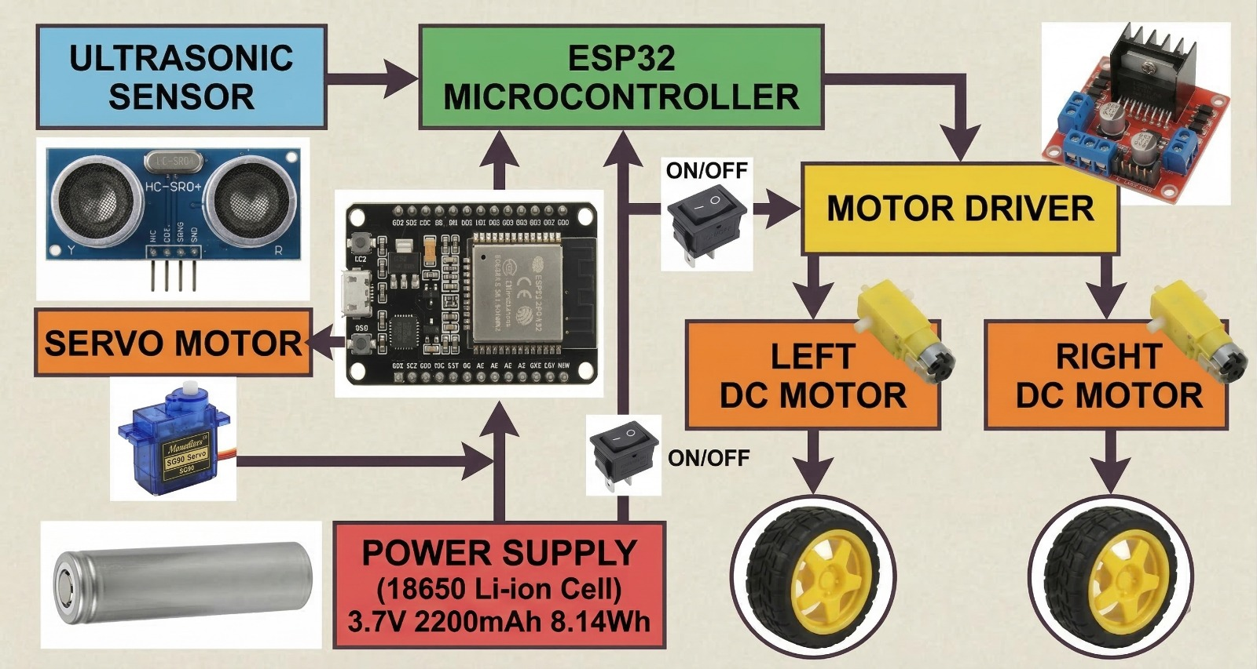

FEASIBILITY
Operational Feasibility
Operational feasibility focuses on how well the proposed system will function in a real-world environment and whether it will effectively meet the required needs. The proposed system — OBSTACLE AVOIDING ROBOT — is designed to operate autonomously and navigate safely by detecting and avoiding obstacles in its path.
The system provides a simple and efficient robotic solution that can function without continuous human intervention. It uses an ULTRASONIC SENSOR to detect obstacles and an ESP32 MICROCONTROLLER to process the data and control movement. The robot responds instantly to environmental changes, ensuring SAFE AND SMOOTH NAVIGATION.

This system replaces traditional manually controlled robots with an AUTOMATED SOLUTION that improves efficiency and reduces human effort. It can be used in various real-world applications such as AUTONOMOUS VEHICLES, industrial automation, and surveillance systems.
Moreover, the robot is designed using simple and easily available components, making it easy to operate and maintain. The system performs continuously once powered, requiring minimal supervision.
Thus, the system is operationally feasible because it:
• Meets the functional requirement of OBSTACLE DETECTION AND
AVOIDANCE.
• Provides AUTOMATIC NAVIGATION without human control
• Operates efficiently in real-time environments
• Reduces human effort and improves safety
• Ensures reliable and consistent performance

Technical Feasibility:
Technical feasibility evaluates whether the required technology for developing and implementing the system is available and suitable.
The system is built using an ESP32 MICROCONTROLLER, which is powerful, cost-effective, and suitable for real-time applications. The ULTRASONIC SENSOR is used for accurate distance measurement based on sound wave reflection. The robot also uses a MOTOR DRIVER (L298N) and DC motors to control movement. The SG90 Servo Motor in an obstacle-avoiding robot rotates the ultrasonic sensor to scan surroundings for obstacles.
The programming is done using the ARDUINO IDE, which is widely used for embedded system development due to its simplicity and flexibility. It allows easy coding, testing, and uploading of programs to the microcontroller.
All the hardware components used in this project are easily available, affordable, and compatible with each other. The system does not require complex infrastructure or advanced tools, making it suitable for student-level implementation.
Thus, the project is technically feasible because:
• Uses EASILY AVAILABLE AND LOW-COST COMPONENTS
• Supports REAL-TIME PROCESSING using ESP32
• Simple programming using ARDUINO IDE
• Easy to design, implement, and maintain
• Provides reliable performance with minimal complexity

METHODOLOGY
In this project, we have adopted a systematic and iterative approach for the development of the OBSTACLE AVOIDING ROBOT. The methodology focuses on step-by-step design, testing, and improvement of the system to ensure efficient performance. The development process includes DESIGN, IMPLEMENTATION, TESTING, AND OPTIMIZATION, allowing continuous verification at each stage.
The reason behind selecting this approach is its flexibility and simplicity, which allows modifications and improvements during development. The system is built, tested, corrected, and re-tested multiple times to ensure accuracy and reliability. This approach helps in identifying errors early and improving the overall performance of the robot.
The methodology involves both HARDWARE IMPLEMENTATION and SOFTWARE DEVELOPMENT, which are integrated to achieve the desired output.
1. Hardware Design Module
This module focuses on assembling all the physical components required for the robot.
• Selection of components such as ESP32 MICROCONTROLLER, ULTRASONIC SENSOR, MOTOR DRIVER (L298N), SG90 Servo Motor, BO Motor & DC MOTORS
• Designing the robot chassis and mounting all components properly
• Establishing connections between sensor, microcontroller, and motors
• Ensuring proper POWER SUPPLY using batteries
This module forms the physical structure of the robot.

2. Sensor and Detection Module
This module is responsible for OBSTACLE DETECTION.
• The ULTRASONIC SENSOR emits sound waves and receives reflected signals
• Calculates the DISTANCE between the robot and obstacles
• Sends real-time data to the ESP32 for processing
This ensures continuous monitoring of the environment.
3. Control and Processing Module
This module acts as the brain of the system.
• The ESP32 MICROCONTROLLER processes the sensor data
• Executes decision-making logic based on programmed conditions
• Determines actions such as MOVE FORWARD, STOP, or TURN
This module ensures REAL-TIME DECISION MAKING and control.
4. Programming Module
The system is programmed using the ARDUINO IDE.
• Writing code for sensor interfacing and motor control
• Implementing conditions for obstacle detection
• Uploading and testing the program on ESP32
• Debugging and optimizing the code for better performance

5. Testing and Validation Module
This module ensures the proper functioning of the system.
• Testing the robot in different environments
• Checking accuracy of DISTANCE MEASUREMENT
• Verifying obstacle avoidance behaviour.
• Making necessary corrections and improvements
6. Working Process
The working of the system follows a continuous cycle:
- The ultrasonic sensor detects obstacles
- Distance data is sent to the ESP32
- The microcontroller processes the data
- The robot automatically STOPS AND CHANGES DIRECTION
- The robot continues moving in a safe path
This methodology ensures that the OBSTACLE AVOIDING ROBOT is developed in a structured and efficient manner. It combines HARDWARE INTEGRATION, SOFTWARE PROGRAMMING, and REAL-TIME TESTING to achieve reliable and accurate performance.

IMPLEMENTATION
The implementation phase is one of the most crucial stages in the development life cycle of a project. It is the phase where the system design is transformed into a working model that can be executed, tested, and used in real-world applications. The implementation of the OBSTACLE AVOIDING ROBOT involves both HARDWARE ASSEMBLY and SOFTWARE PROGRAMMING, ensuring proper integration of all components.
This project integrates multiple technologies such as the ESP32 MICROCONTROLLER, ULTRASONIC SENSOR, MOTOR DRIVER (L298N), and DC MOTORS. The system is programmed using the ARDUINO IDE, which provides a simple and efficient platform for writing and uploading code to the microcontroller.
The implementation process includes assembling the hardware components, establishing proper connections, programming the control logic, and testing the robot in different environments to ensure smooth and efficient operation. The robot is designed to detect obstacles and automatically change its direction, ensuring SAFE AND COLLISION-FREE MOVEMENT.

1. Components Used
The following components are used in the development of the project:
- ESP32 Microcontroller
- Ultrasonic Sensor (HC-SR04)
- Motor Driver (L298N)
- DC Motors
- Robot Chassis
- Battery
- Jumper Wires
- SG90 Servo Motor

Components Used in Obstacle Avoiding Robot
2. Working Principle
The working of the robot is based on ULTRASONIC SENSING and REAL-TIME PROCESSING. The ultrasonic sensor continuously emits sound waves and receives the reflected signals from nearby objects. Based on the time taken for the signal to return, the DISTANCE between the robot and the obstacle is calculated.
The ESP32 processes this data and decides the movement of the robot. When an obstacle is detected within a predefined range, the robot automatically STOPS AND CHANGES DIRECTION to avoid collision. Otherwise, it continues to move forward.

3. Code Implementation
The system is programmed using the ARDUINO IDE, where the logic for obstacle detection and motor control is implemented.
- Sensor data is read and processed continuously
- Conditional statements are used for decision-making
- Motor control signals are generated based on distance

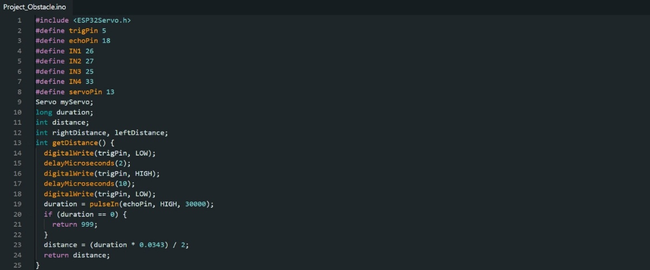
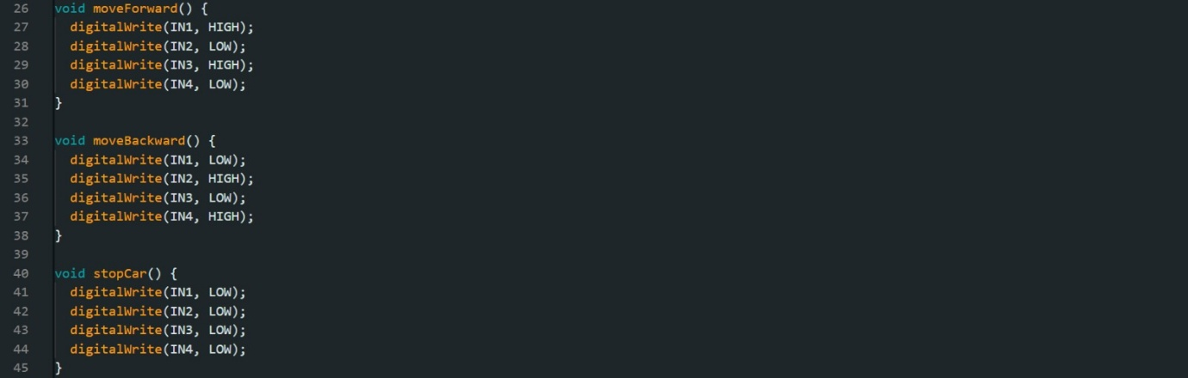
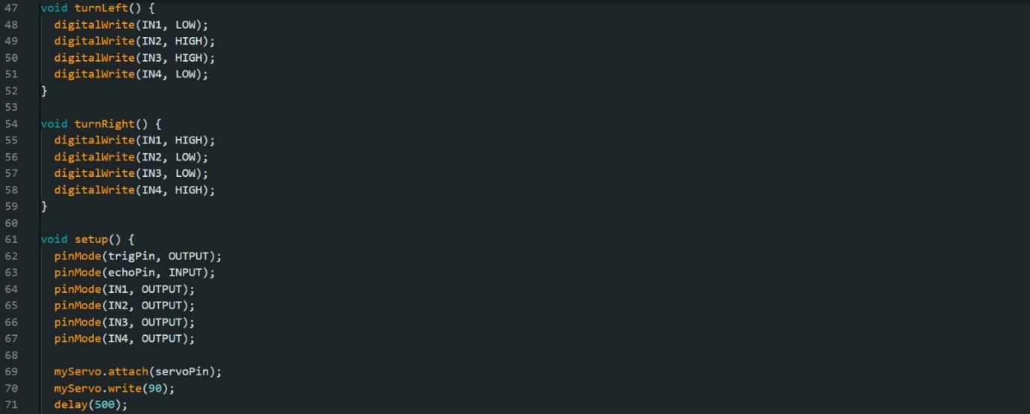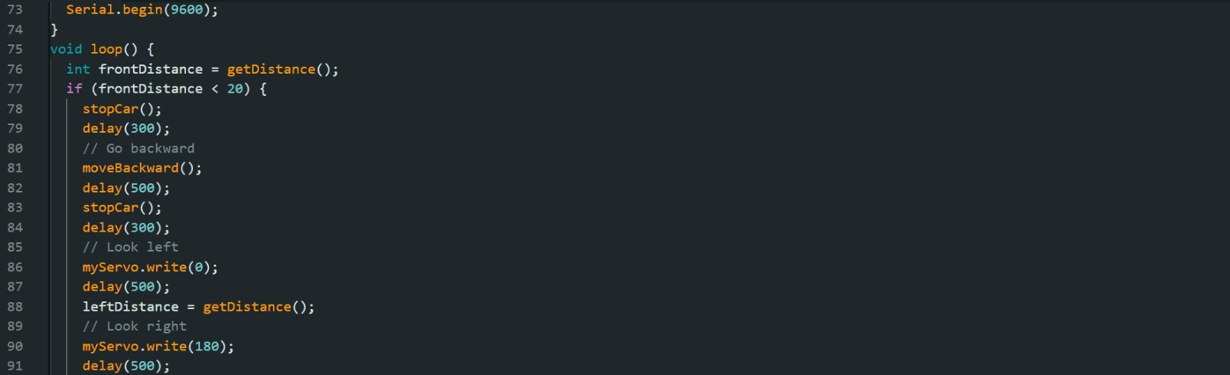
RESULT ANALYSIS
The Result Analysis section evaluates the overall performance, functionality, and efficiency of the developed system after successful implementation. It focuses on how well the OBSTACLE AVOIDING ROBOT meets its objectives and performs under real-world conditions.
The robot, developed using an ESP32 MICROCONTROLLER and ULTRASONIC SENSOR, was tested under different conditions to analyze its performance. The evaluation was based on parameters such as OBSTACLE DETECTION ACCURACY, RESPONSE TIME, MOVEMENT EFFICIENCY, and RELIABILITY. The results show that the system operates effectively as an autonomous robotic system capable of safe navigation.
During testing, the robot was able to detect obstacles within a specific range and respond accordingly. When an obstacle was detected, the robot successfully STOPPED AND CHANGED DIRECTION, avoiding collisions in most cases. The ULTRASONIC SENSOR provided accurate distance measurements, and the ESP32 processed the data efficiently to control the robot’s movement.
The system demonstrated good REAL-TIME RESPONSE, as the robot reacted quickly to obstacles without noticeable delay. The movement of the robot was smooth, and it was able to navigate through different paths without manual intervention. The overall PERFORMANCE AND STABILITY of the system were satisfactory.
Various test conditions were applied, such as placing obstacles at different distances and angles. The robot performed consistently in most scenarios, although minor variations in detection accuracy were observed due to environmental factors like surface type and object shape.
The analysis also highlights that the system is COST-EFFECTIVE, ENERGY-EFFICIENT, and easy to implement using basic components. The integration of hardware and software was successful, and the robot operated continuously without major issues.
Thus, the result analysis confirms that the OBSTACLE AVOIDING ROBOT meets the desired objectives and provides an efficient solution for AUTONOMOUS NAVIGATION. The system can be further enhanced by adding advanced sensors or improving the control algorithm for better accuracy and performance.
PROJECT IMAGES / SAMPLE OUTPUTS
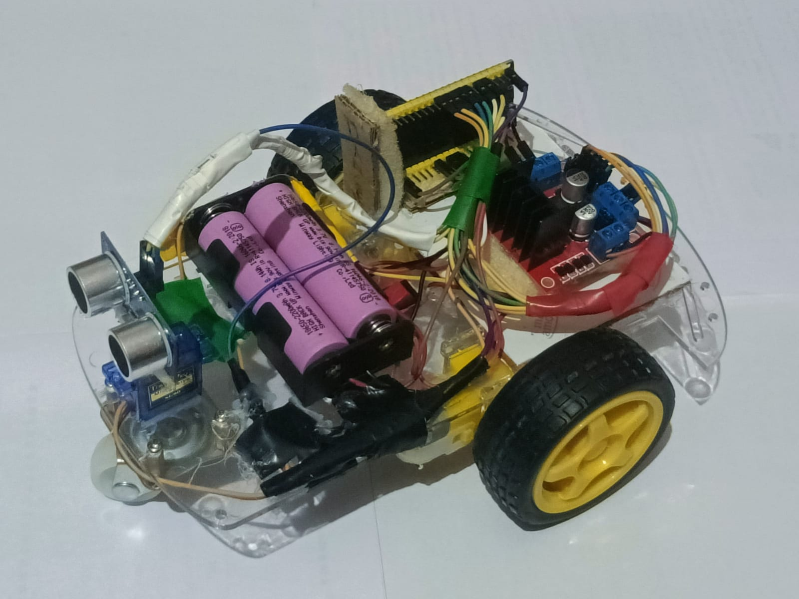
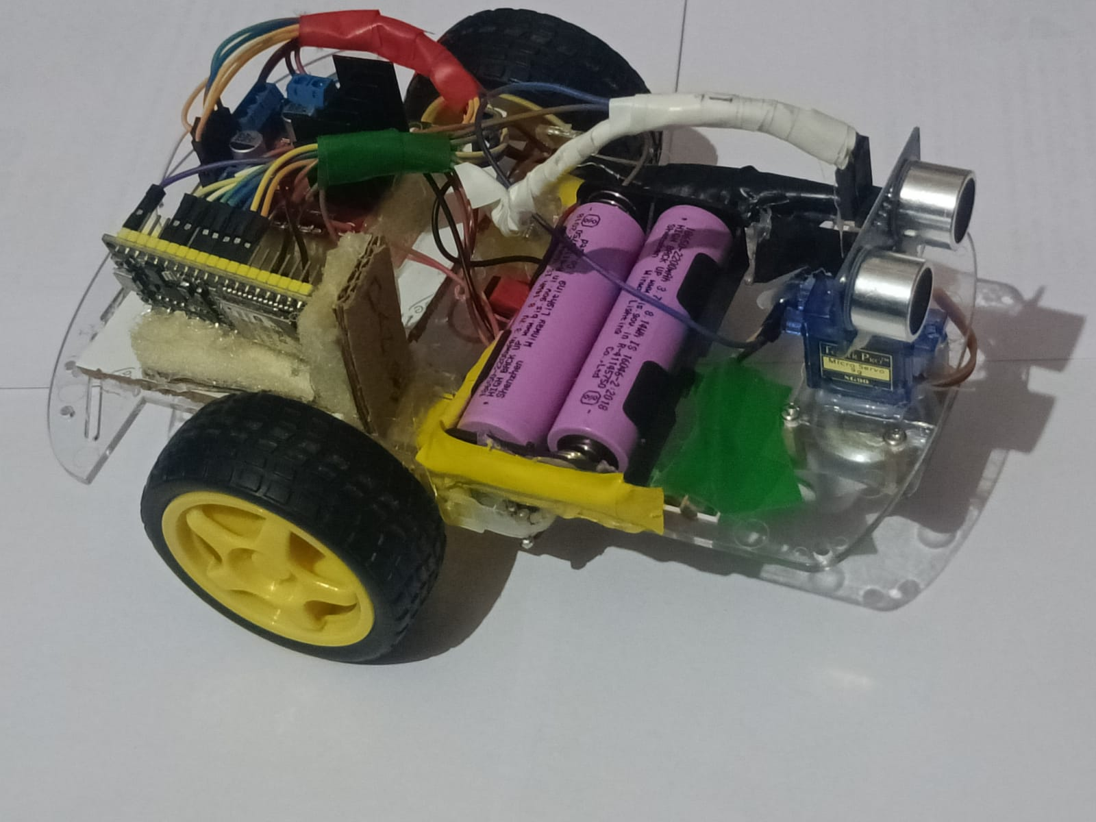
CONCLUSION
The project titled “OBSTACLE AVOIDING ROBOT” was developed with the primary objective of designing and implementing an autonomous robotic system capable of detecting and avoiding obstacles using sensor-based technology. The system successfully demonstrates the integration of ROBOTICS, EMBEDDED SYSTEMS, and AUTOMATION TECHNOLOGIES to create an efficient and intelligent robot.
The project shows how components like the ESP32 MICROCONTROLLER, ULTRASONIC SENSOR, motor driver, and DC motors can work together to build a reliable and cost-effective robotic system. The use of the ARDUINO IDE made it easier to program and control the robot, ensuring smooth operation and real-time responsiveness.
During the implementation and testing phase, the robot achieved its key objectives — including AUTOMATIC OBSTACLE DETECTION, REAL-TIME DECISION MAKING, and SAFE NAVIGATION. The system was able to detect obstacles accurately and respond by stopping and changing direction, thereby avoiding collisions effectively. The overall performance of the robot was stable and reliable under different test conditions.
Through this project, practical knowledge was gained in HARDWARE INTEGRATION, MICROCONTROLLER PROGRAMMING, and SENSOR INTERFACING. It also provided hands-on experience in designing and developing a complete robotic system from scratch. This enhances understanding of real-world applications of robotics and automation.
Additionally, this project highlights how simple and affordable components can be used to develop intelligent systems capable of performing complex tasks. The OBSTACLE AVOIDING ROBOT can be further improved by incorporating advanced technologies such as ARTIFICIAL INTELLIGENCE, VISION SYSTEMS, or additional sensors for enhanced performance and functionality.
Overall, the project successfully achieves its objectives and demonstrates the potential of AUTONOMOUS ROBOTIC SYSTEMS in improving efficiency, safety, and performance in modern technological applications.

REFERENCES
- Arduino Official Documentation — Arduino IDE & Programming Guide
https://www.arduino.cc/en/Guide
- ESP32 Documentation — ESP32 Microcontroller Reference
https://docs.espressif.com/projects/esp-idf/en/latest/
- Ultrasonic Sensor (HC-SR04) Datasheet — Working and Specifications
https://components101.com/sensors/ultrasonic-sensor-working-pinout-datasheet
- L298N Motor Driver Module — Technical Guide
https://components101.com/modules/l298n-motor-driver-module
- GeeksforGeeks — Arduino and Sensor Interfacing Tutorials
https://www.geeksforgeeks.org/
- Tutorials Point — Robotics and Embedded Systems Basics
https://www.tutorialspoint.com/robotics/index.htm
- Electronics Hub — Obstacle Avoiding Robot using Arduino/ESP32
https://www.electronicshub.org/
- Circuit Digest — Obstacle Avoiding Robot Projects and Guides
https://circuitdigest.com/
- All About Circuits — Electronics and Embedded System Learning
https://www.allaboutcircuits.com/
- Stack Overflow — Arduino and ESP32 Programming Discussions
https://stackoverflow.com/
- YouTube — Practical Tutorials on Obstacle Avoiding Robot
https://www.youtube.com/
- Research Papers on Robotics and Automation — IEEE Xplore
https://ieeexplore.ieee.org/
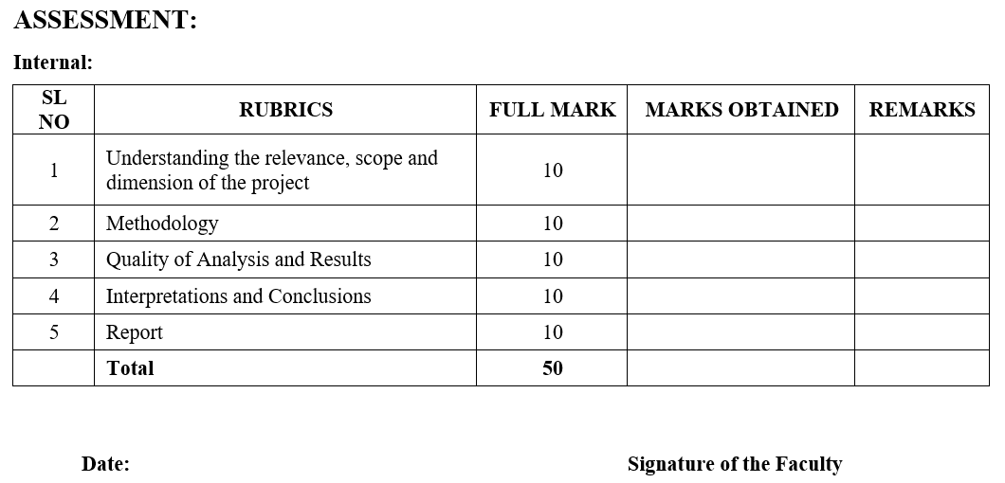

COURSE OUTCOME (COs) ATTAINMENT
- Expected Course Outcomes (COs):
(Refer to COs Statement in the Syllabus)

- Course Outcome Attained:
How would you rate your learning of the subject based on the specified COs?










1 2 3 4 5 6 7 8 9 10

LOW HIGH
- Learning Gap (if any):

- Books / Manuals Referred:

Date: Signature of the Student
- Suggestions / Recommendations:
(By the Course Faculty)

Date: Signature of the Faculty

