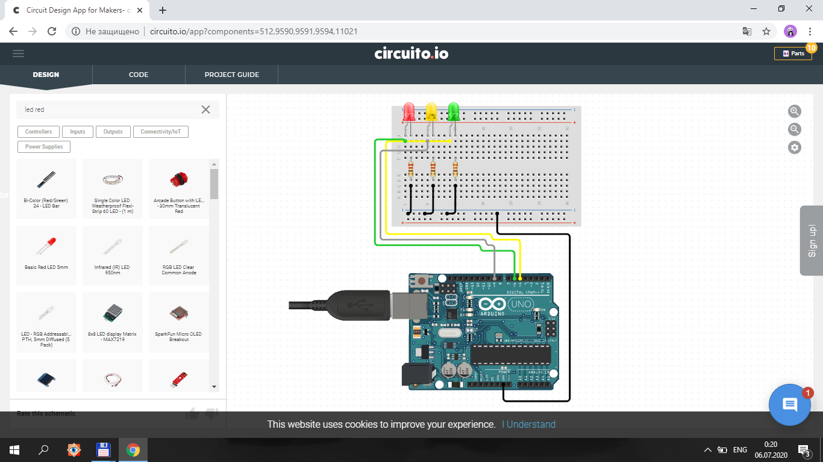

**Dastur.**

int qizil=6;

int sariq=9;

int yashil=5;

void setup() {

pinMode(yashil,OUTPUT);

pinMode(qizil,OUTPUT);

pinMode(sariq,OUTPUT);

}

void loop() {

digitalWrite(qizil,HIGH);

delay(5000);

digitalWrite(qizil,LOW);

digitalWrite(sariq,HIGH);

delay(1500);

digitalWrite(sariq,LOW);

digitalWrite(yashil,HIGH);

delay(5000);

digitalWrite(yashil,LOW);

digitalWrite(sariq,HIGH);

delay(1500);

digitalWrite(sariq,LOW);

}