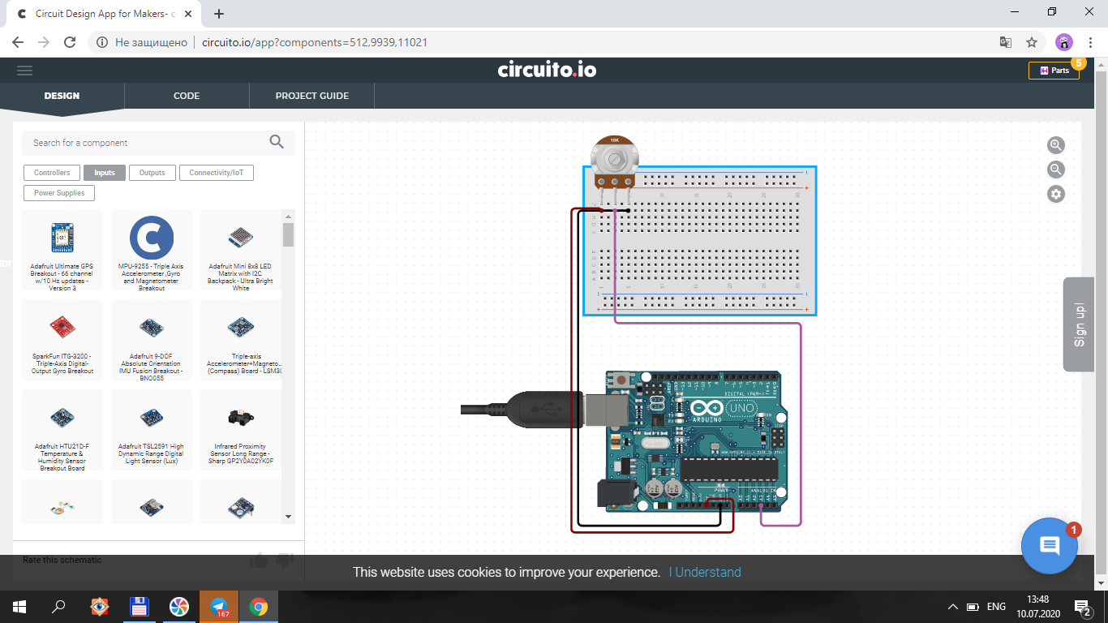

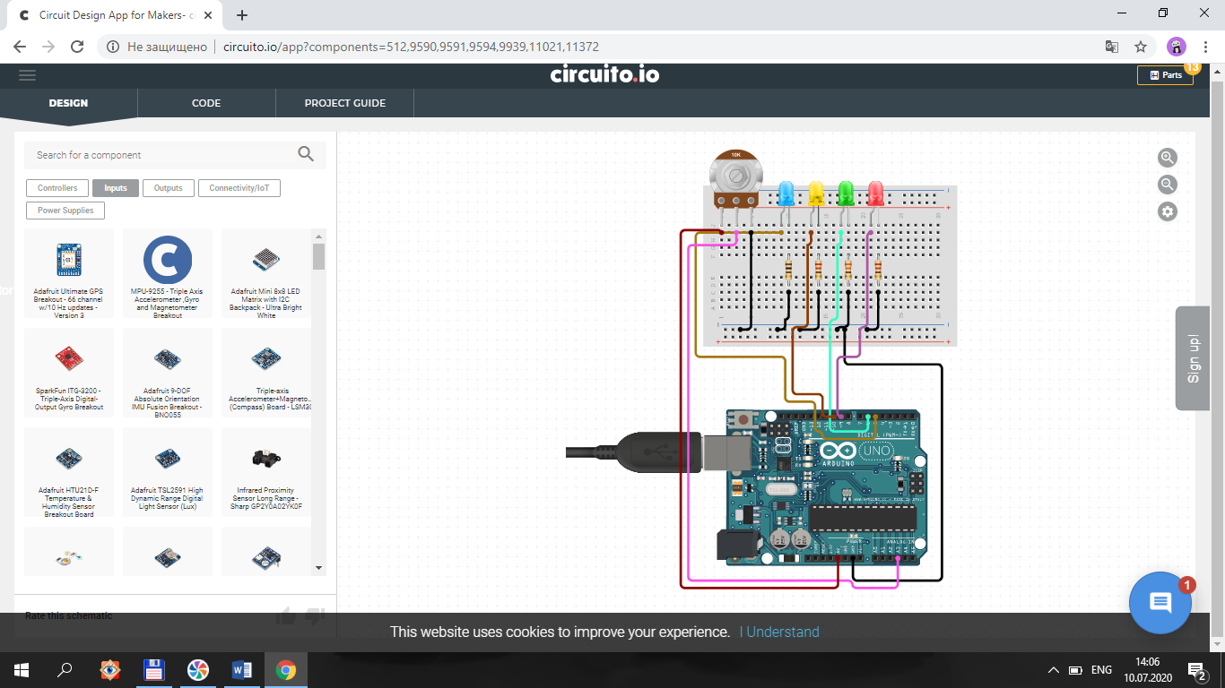

**1-Dastur.**

int kok=5;

int yashil=6;

int qizil=9;

int sariq=10;

int a;

void setup() {

pinMode(kok,OUTPUT);

pinMode(yashil,OUTPUT);

pinMode(qizil,OUTPUT);

pinMode(sariq,OUTPUT);

pinMode(A3,INPUT);

}

void loop() {

a=analogRead(A3);

if(a>=800){

digitalWrite(qizil,HIGH);

digitalWrite(kok,LOW);

digitalWrite(yashil,LOW);

digitalWrite(sariq,LOW);

}

else if(a>=600){

digitalWrite(yashil,HIGH);

digitalWrite(qizil,LOW);

digitalWrite(sariq,LOW);

digitalWrite(kok,LOW);

}

else if(a>=400){

digitalWrite(sariq,HIGH);

digitalWrite(kok,LOW);

digitalWrite(yashil,LOW);

digitalWrite(qizil,LOW);

}

else if(a>=200){

digitalWrite(kok,HIGH);

digitalWrite(yashil,LOW);

digitalWrite(qizil,LOW);

digitalWrite(sariq,LOW);

}

}

**2-Dastur.**

int kok=5;

int yashil=6;

int qizil=9;

int sariq=10;

int a;

void setup() {

pinMode(kok,OUTPUT);

pinMode(yashil,OUTPUT);

pinMode(qizil,OUTPUT);

pinMode(sariq,OUTPUT);

pinMode(A3,INPUT);

}

void loop() {

a=analogRead(A3);

if(a>=800){

digitalWrite(qizil,HIGH);

digitalWrite(kok,LOW);

digitalWrite(yashil,LOW);

digitalWrite(sariq,LOW);

}

else if(a>=600){

digitalWrite(yashil,HIGH);

digitalWrite(qizil,LOW);

digitalWrite(sariq,LOW);

digitalWrite(kok,LOW);

}

else if(a>=400){

digitalWrite(sariq,HIGH);

digitalWrite(kok,LOW);

digitalWrite(yashil,LOW);

digitalWrite(qizil,LOW);

}

else if(a>=200){

digitalWrite(kok,HIGH);

digitalWrite(yashil,LOW);

digitalWrite(qizil,LOW);

digitalWrite(sariq,LOW);

}

else {

digitalWrite(kok,LOW);

digitalWrite(yashil,LOW);

digitalWrite(qizil,LOW);

digitalWrite(sariq,LOW);

}

}