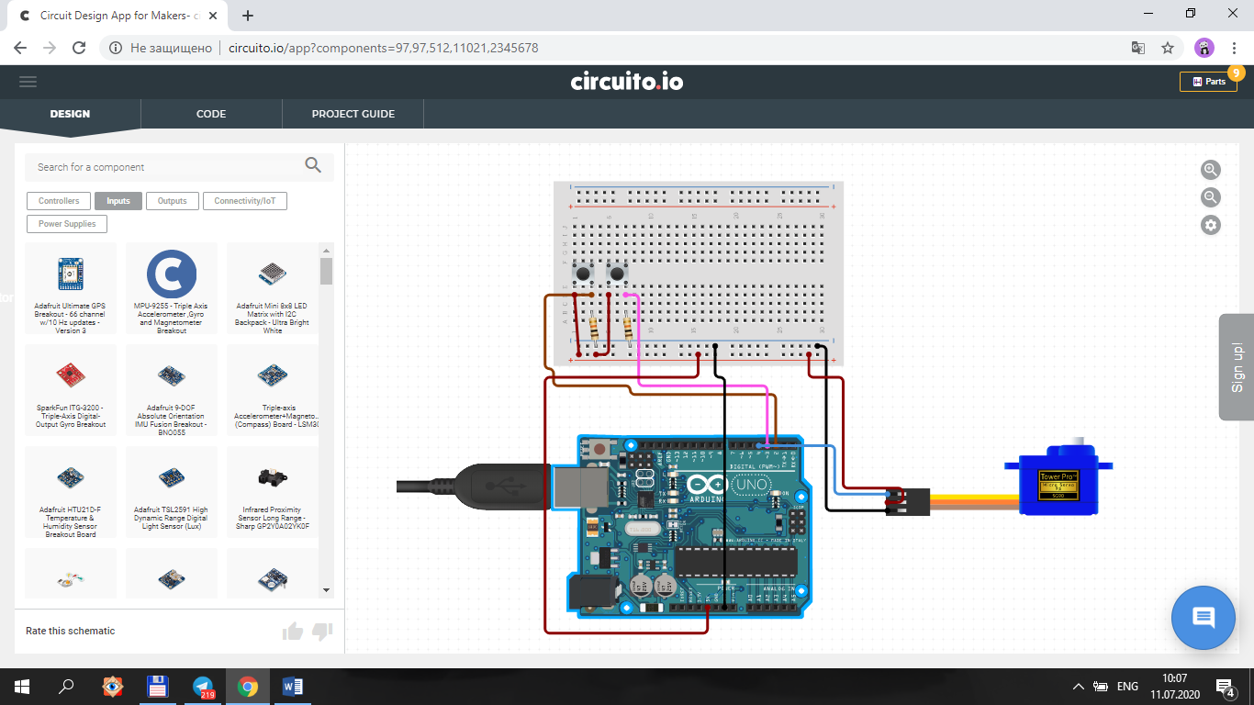

**Dastur.**

#include <Servo.h>

Servo mator;

int k1=0;

int k2=0;

int g;

void setup() {

// put your setup code here, to run once:

pinMode(2,INPUT);

pinMode(3,INPUT);

mator.attach(4);

mator.write(90);

}

void loop() {

// put your main code here, to run repeatedly:

k1=digitalRead(2);

k2=digitalRead(3);

if(k1==1){

g=mator.read();

if(g<180){

mator.write(g+30);

delay(500);

}

}

if(k2==1){

g=mator.read();

if(g>0){

mator.write(g-30);

delay(500);

}

}

}