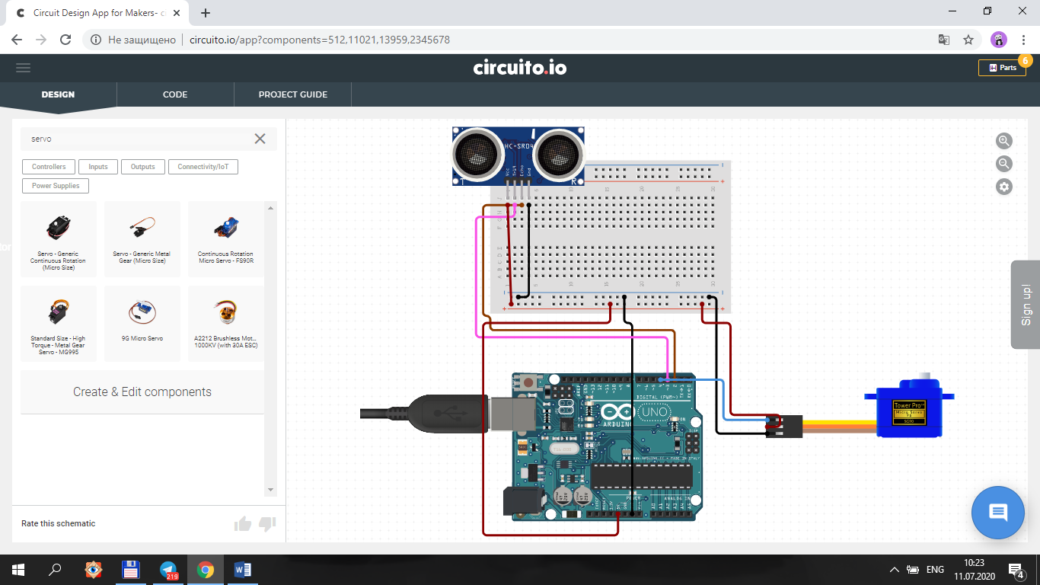

**Dastur.**

#include <Servo.h>

Servo mator;

int echoPin = 2;

int trigPin = 3;

void setup() {

Serial.begin(9600);

pinMode(trigPin,OUTPUT);

pinMode(echoPin,INPUT);

mator.attach(4);

mator.write(90); }

void loop() {

int duration, sm;

digitalWrite(trigPin, LOW);

delayMicroseconds(2);

digitalWrite(trigPin, HIGH);

delayMicroseconds(10);

digitalWrite(trigPin, LOW);

duration = pulseIn(echoPin, HIGH);

sm = duration / 58;

Serial.print(sm);

Serial.println(" sm");

if(sm<=5){

mator.write(0);

delay(5000);

}

else{

mator.write(90);

}

delay(500);

}