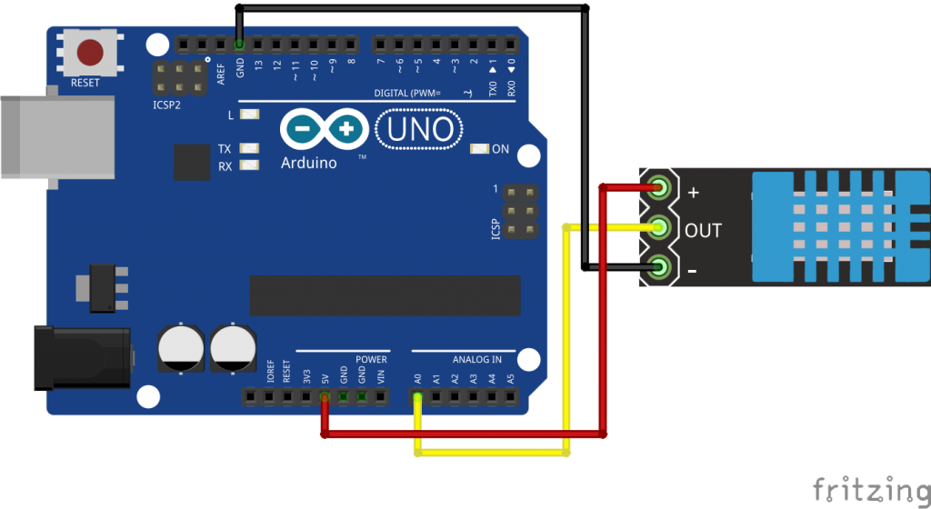

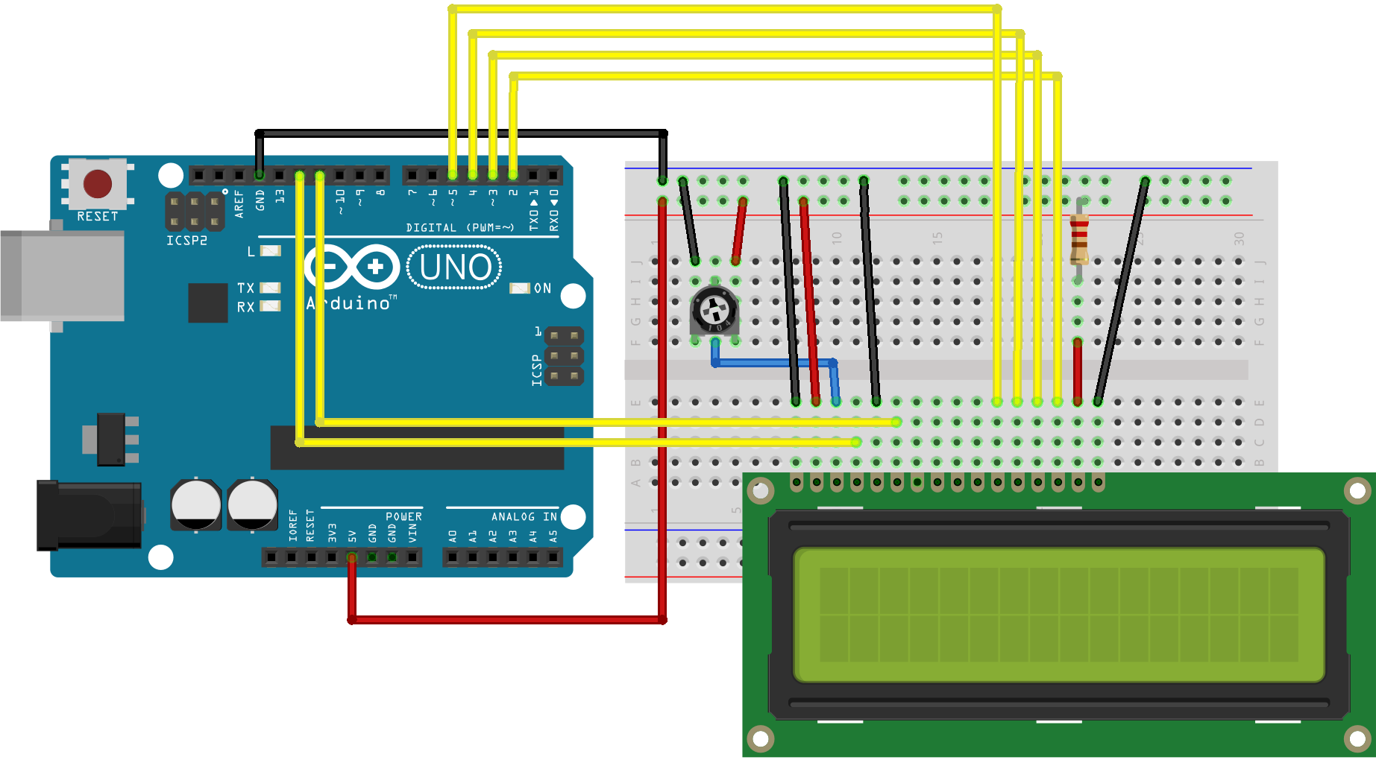

**Dastur.**

#include <LiquidCrystal.h>

LiquidCrystal lcd(12,11,5,4,3,2);

#include<dht.h>

dht DHT;

#define DHT11_PIN A0

void setup()

{ lcd.begin(16,2); }

void loop() {

delay(500);

int chk = DHT.read11(DHT11_PIN);

int a = DHT.humidity;

int b = DHT.temperature;

lcd.setCursor(0,0);

lcd.print("Xarorat ");

lcd.setCursor(8,0);

lcd.print(b);

lcd.setCursor(11,0);

lcd.print("C");

lcd.setCursor(0,1);

lcd.print("Namlik ");

lcd.setCursor(8,1);

lcd.print(a);

lcd.setCursor(11,1);

lcd.print("%");

delay(2000);

}