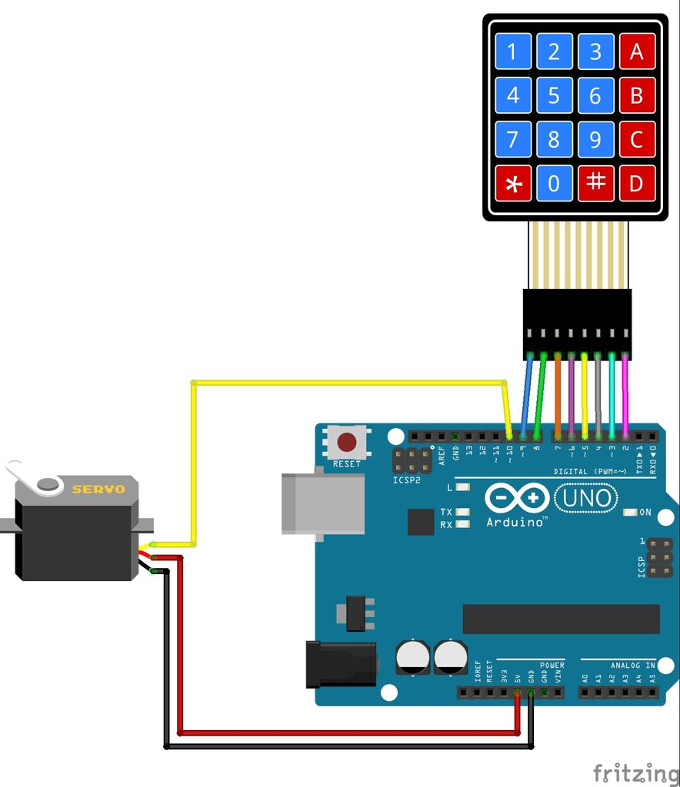

**Dastur.**

#include <Keypad.h>

#include <Servo.h>

Servo mator;

const byte numRows=4;

const byte numCols=4;

char keymap[numRows][numCols]={

{'1','2','3','A'},

{'4','5','6','B'},

{'7','8','9','C'},

{'*','0','#','D'}

};

byte rowPins[numRows]={9,8,7,6};

byte colPins[numCols]={5,4,3,2};

Keypad myKeypad=Keypad(makeKeymap(keymap),rowPins,colPins,numRows,numCols);

int K=0;

long K1=0;

void setup() {

Serial.begin(9600);

mator.attach(10);

mator.write(90);

}

void loop() {

char keypressed=myKeypad.getKey();

if (keypressed !=NO_KEY)

{

Serial.print(keypressed);

if(keypressed==42){keypressed=48; K1=0;}

K=keypressed-48;

K1=K1*10+K;

}

if(K1==12345678){mator.write(0);}

else{mator.write(90);}

}