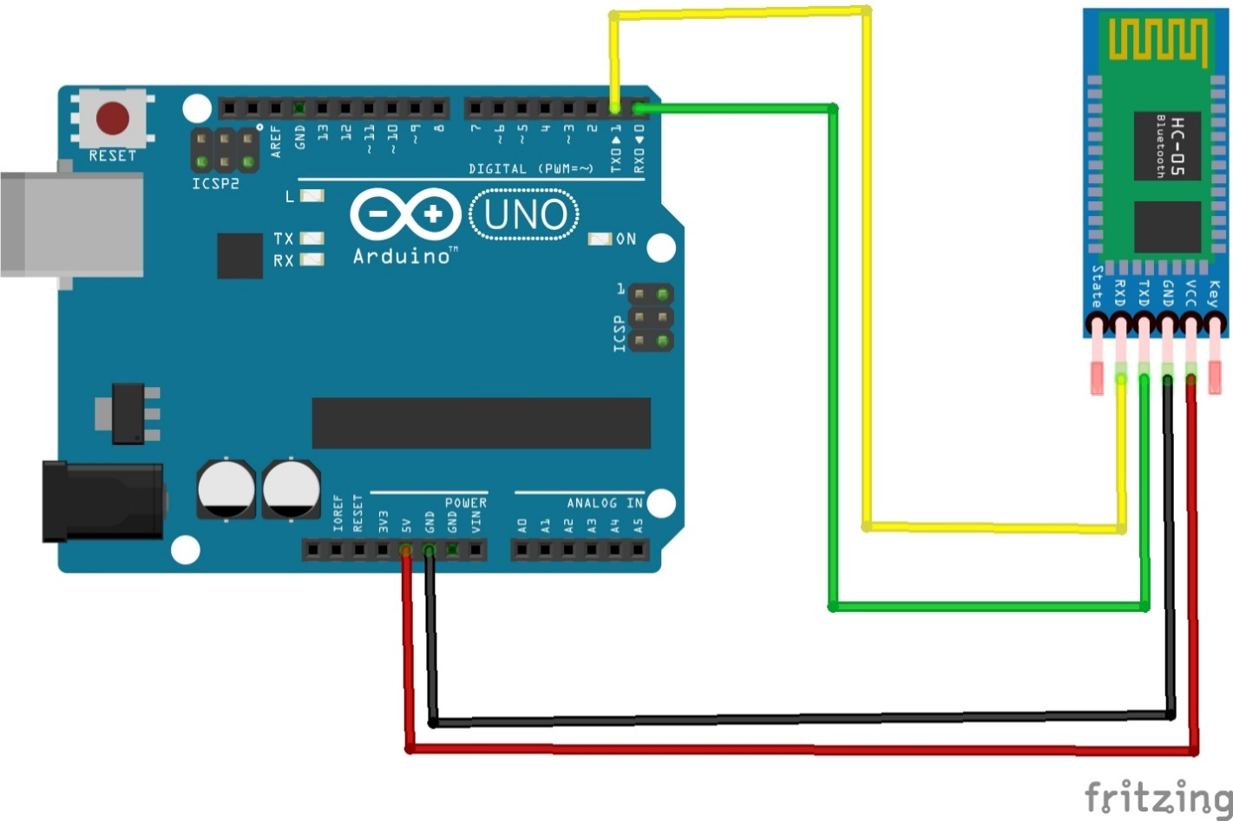

**Dastur.**

int a1=0;

int a2=0;

int a3=0;

int a4=0;

void setup() {

// put your setup code here, to run once:

Serial.begin(9600);

pinMode(2,OUTPUT);

pinMode(3,OUTPUT);

pinMode(4,OUTPUT);

pinMode(5,OUTPUT);

}

void loop() {

// put your main code here, to run repeatedly:

if(Serial.available()>0){

char a = Serial.read();

if(a=='1'){if(a1==0){digitalWrite(2,1); a1=1;} else{digitalWrite(2,0); a1=0;} delay(100); }

else if(a=='2'){if(a2==0){digitalWrite(4,1); a2=1;} else{digitalWrite(4,0); a2=0;} delay(100); }

else if(a=='3'){if(a3==0){digitalWrite(3,1); a3=1;} else{digitalWrite(3,0); a3=0;} delay(100); }

else if(a=='4'){if(a4==0){digitalWrite(5,1); a4=1;} else{digitalWrite(5,0); a4=0;} delay(100); }

}}