

**ISYS 630 Project Management**

**Pie Pub Restaurant**

**Project Cost Analysis**

Group 3

**Team members**

Abeer Katiyal | Aditya Purandare | Sneha Chandrashekaraiah

**Project Cost Analysis**

Budgeting is part of managing a business and is included in the plan. It is also a valuable tool to help the consultant and restaurant owners to have a realistic sense of the budget. A budget is really just a financial plan.  A budget document is created to track the monetary expense and also to forecast the financial reserve required for the project. They serve as a dependable basis for business planning and budget reviews, facilitate any re-adjustment of funds when necessary, create transparency and a clear audit trail, and aid in external reporting and regulatory reporting to the investment community along with the SEC.

The budget document explains the financial distribution in two different periods. We provide a long term budget plan which covers the major business functions and key activities extended over the entire project. The short term budget represents the in-depth expense per month over the staff, resource and other expenses.

The budget was formulated by the Agventures and sign-off will be provided Pie Pub regarding the over-all financial distribution across the period of 6 months.

**Cost Analysis**

* Labor Cost: Our project incurs heavy labor cost for both hardware installation and software development sectors. Our total resources expenditure for both department inclusive is $207,000. This also includes the consultants, analysts and the training staff.
* Hardware and Software cost: Our project requires purchase of hardware equipment and software development takes care of the integration, mobile app and other aspects. Apart from the actual Point of Sale systems, routers and as such that needs to be purchased, we also need external connectors that needs to be purchased. The total budget for all sectors is combined to $116,500.
* Training: Exclusive of staff salary, the training imparted to the restaurant staff on how to use the system and its integration with the mobile devices has a budget of $5000 for space renting and other utilities.
* Miscellaneous: Other costs which might not always be anticipated or deemed irrelevant costs will be charged to miscellaneous account which has a budget of $14000.
* Management Reserve: We have allocated 2% of our total budget as management reserve, and as a buffer resource.

**Long Term Budget**

Long term budget provides an overview of how our finances are distributed over the entire project duration. It covers the money spent on the key areas and our major spending sectors. It gives us an overview of which sectors may need extra buffer and provides a high-level view of the money spread across in a matrix. We have the breakdown given in a matrix and its graphical representation below:

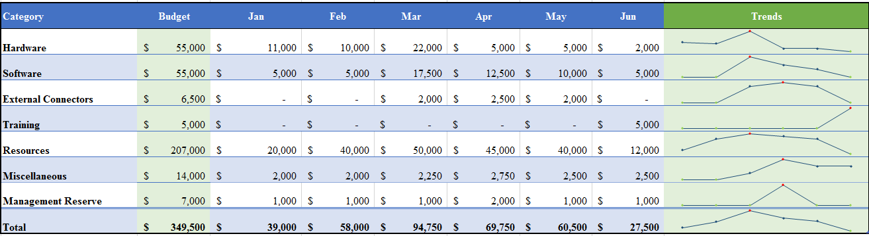

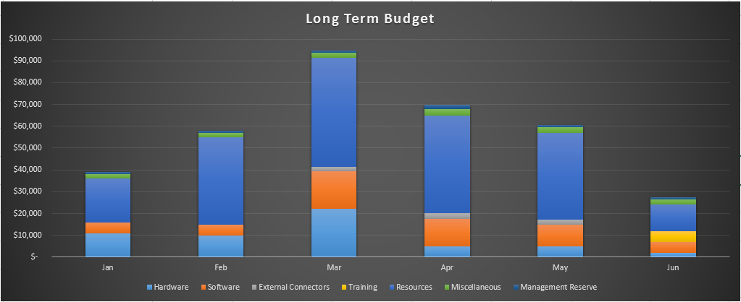

**Short-Term Budget**

Short term budget is a detailed breakdown of each key area given in the long term budget and how that applies in that month. It also takes into account any additional expense incurred and provides an in-depth analysis of each month expenditure. We have chosen to give a break-up of the month of March as it provides a good representation of the mid-project budget allocation to various departments.

***Budget for the month of March***

|  |  |  |  |  |
| --- | --- | --- | --- | --- |
| **Hardware Procurement** | | **Rate** | **Quantity** | **Hardware Cost** |
|  | PoS Terminal | 180 | 50 | 9000 |
|  | Routers | 25 | 20 | 500 |
|  | Cloud server | 750 | 4 | 3000 |
|  | Workstations | 200 | 20 | 4000 |
|  | Scanners | 125 | 10 | 1250 |
|  | Printers | 50 | 10 | 500 |
|  | Disk Storage | 25 | 10 | 250 |
|  | UPS | 75 | 20 | 1500 |
|  | Tablets | 200 | 10 | 2000 |
|  | **Hardware total** |  |  | **22000** |
| **Software Procurement** | | **Rate** | **Quantity** | **Cost** |
|  | Cloud Hosting space | 4500 | 100 GB | 4500 |
|  | Virtual Private Network license | 5 | 100 | 500 |
|  | Operating System | 40 | 50 | 2000 |
|  | Application software user license | 100 | 40 | 4000 |
|  | Google Apps for work | 5 | 400 | 2000 |
|  | Inventory Management subscription | 450 | 1 | 450 |
|  | Security Software | 12 | 250 | 3000 |
|  | Mobile App license | 100 | 3 | 300 |
|  | Integration software license | 750 | 1 | 750 |
|  | **Software total** |  |  | **17500** |
| **External Connectors** | | Rate | Quantity | Cost |
|  | Switches | 60 | 15 | 900 |
|  | Ethernet Cables | 4 | 200 | 800 |
|  | Coaxial cable | 10 | 30 | 300 |
|  | **External connector total** |  |  | **2000** |
| **Resources** |  | **Hourly Rate** | **Man-hours** | **Cost** |
|  | Mobile application development team | 40 | 100 | 4000 |
|  | Integration software development team | 50 | 250 | 12500 |
|  | Web Development team | 45 | 100 | 4500 |
|  | Project Managers | 70 | 150 | 10500 |
|  | Testing team | 40 | 160 | 6400 |
|  | Business Analyst | 40 | 55 | 2200 |
|  | Network analyst | 35 | 60 | 2100 |
|  | Quality Analyst | 45 | 100 | 4500 |
|  | Security Analyst | 50 | 66 | 3300 |
|  | **Resources** |  |  | **50000** |
| **Miscellaneous** | | 2250 |  |  |
|  | Contingency resource | 2250 | - | 2250 |
|  | **Miscellaneous total** |  |  | **2250** |
| **Management Reserve** | | 1000 |  |  |
|  | Management Reserve | 1000 | - | 1000 |
|  | **Reserve Total** |  |  | **1000** |