

**ISYS 630 Project Management**

**Pie Pub Restaurant**

**Organization Chart and**

**Responsibility Assignment Matrix**

Group 3

**Team members**

Aditya Purandare | Abeer Katiyal | Sneha Chandrashekaraiah

1. **Brief Description**

Organization chart is a visual representation of how an organization or an institution its authority, responsibility and information flows in its organizational structure. In our organization, we have our project director and project manager jointly leading the project, who breakdown the work into their respective departments and hand over the responsibility to the department heads as shown.

The department heads further delegate the work down the chain and each individual element in the work breakdown structure will have an individual responsible for it. A responsibility matrix is used to define who in the organization chart is responsible for individual work elements and deliverables. By forming a matrix around the work breakdown structure, its elements and the organizational structure, responsibilities can be assigned to lower level tasks and individuals. The responsibility is also divided into the four different categories – Responsible, Accountable, Consult, Inform. These categories define how much information is passed on to who and also identifies the people who are to be consulted with regard to which work.

1. **Organization Chart**

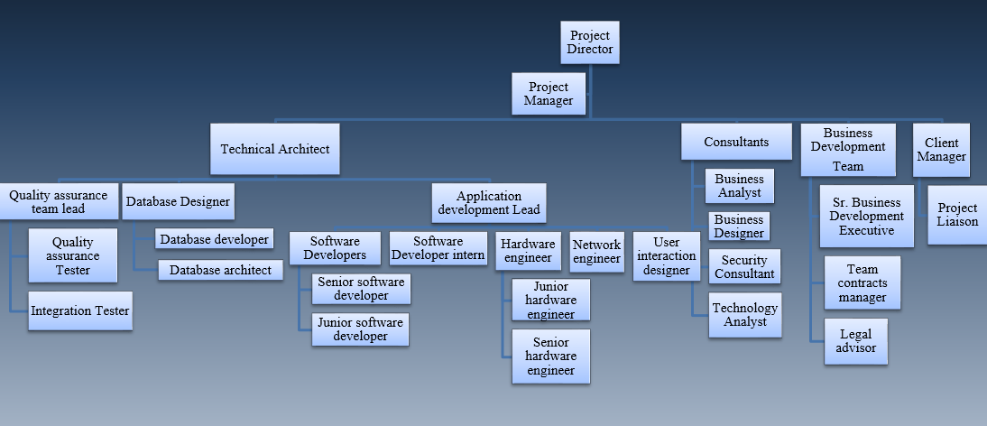

1. **Responsibility Matrix**

