

**ISYS 630 Project Management**

**Pie Pub Restaurant**

**Stakeholder Analysis**

Group 3

**Team members**

Abeer Katiyal

Aditya Purandare

Sneha Chandrashekaraiah

Project Stakeholder Analysis

# Purpose

The reason for a stakeholder analysis is to keep the Project Board and Project Manager informed as they need to contribute to the project, regarding the blockades that might be and the necessary solutions that need to be taken before in-depth project planning.

Identification of stakeholders will also aid in determining who would become key members of the Advisory Board and Business Community in the Project Organization.

Though for small projects, identifying key stakeholders is obvious, for complex projects a formal analysis will be very beneficial, as the addition of stakeholders at a later stage might prove troublesome to the project progress.

# Stakeholder Analysis

Both internal and external key stakeholders in the project need to be identified and their interests and requirements from the project be taken into account. We need to document what the project need from them, any risks or perceived attitudes the stakeholders may have and the measures that has to be to achieve it.

This means a series of meetings and workshops to gather requirements. Documentation of the process using interview sheets.

From the list of people that are interviewed, we form the Advisory Board and Business Community in the Project Organization.

# Influence / Interest Grid

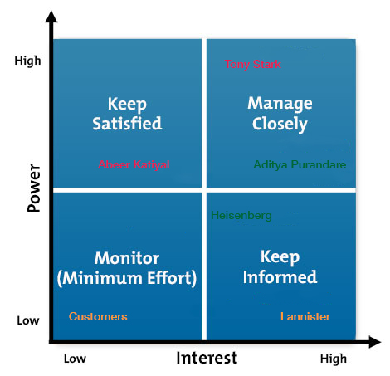

Figure 1: Influence/Interest Grid

We plot their positions on the grid once the key stakeholders are identified. Refer ‘Guidance Notes’ for more detailed explanation.

# Guidance notes

The intention of stakeholder analysis is to utilize the most powerful stakeholders to shape the project in the early on, once they are identified. This will help in their extended support throughout the project lifetime and their input can assist the quality of the project. These influential stakeholders can help with gaining the correct level of resources for your project. Using the above interest grid, communications strategy can be driven, ensuring that stakeholders receive the correct level of information at the right time. The sooner communications begins with the stakeholders the better their understanding and contributions to the project and its benefits.

Stakeholder’s position on the grid above using the following guidelines:

* **High influence, interested people:** This class of people needs to be constantly engaged and taken care of e.g. A head of the business unit, who represents the users/customers
* **High influence, less interested people:** They are also important decision makers who need to be kept up-to-date, but not overwhelmed with data e.g. Management Board
* **Low influence, interested people:** This class of people needs to be kept informed so that no major crisis arises, they can assist in detailing of the project e.g. End Users, external project managers, other business development teams
* **Low influence, less interested people:** This class of people needs minimal communication as they are not the key decision makers e.g. other departmental members, teams unaffected by the change.

When plotting on the grid distinguish between the supporters and the critics of the projects in order easily identify to-go people in times of need. We use color coding to identify which of these two types the stakeholder belongs – e.g. green for supporters, red for unsupportive and orange for non-key members.

Projects become more important and relevant the nearer they get to implementation and will at that point will affect more people. Stakeholder analysis and communications need to be kept updated and constantly monitored so that the right people are always informed about the key developments and changes that occur.