

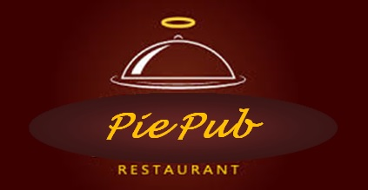

**ISYS 630 Project Management**

**Pie Pub Restaurant**

**Work Breakdown Structure**

Group 3

**Team members**

Abeer Katiyal

Aditya Purandare

Sneha Chandrashekaraiah

## Project Description

Pie Pub restaurant currently has its branches in Dallas, TX and Miami, FL. Owing to flourishing business, the owners have decided to expand Pie Pub restaurants to 25 branches, under the franchise regime. AgVentures proposes to expand and technologically arm the current two branch restaurant business to a 25 branch franchise-owned distributed business to gain a competitive edge in the restaurant business.

## Work Breakdown Structure

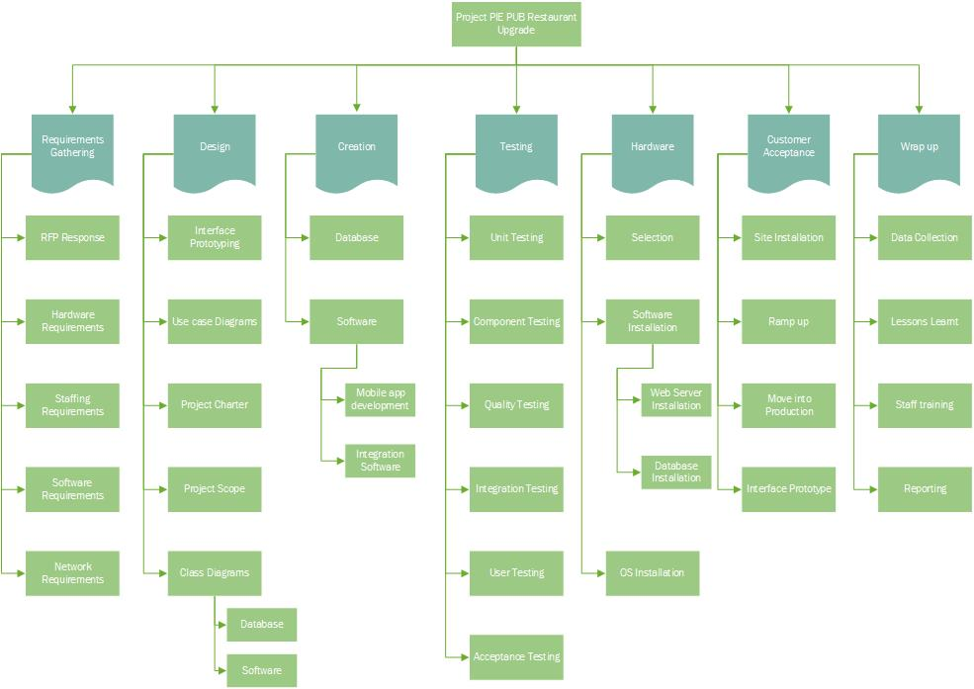

## Key Terms

1. Requirement gathering
   1. RFP Response
   2. Hardware requirements
   3. Staffing requirements
   4. Software requirements
   5. Network requirements
2. Design
   1. Interface prototyping
   2. Use case diagram
   3. Project charter
   4. Project scope
   5. Class diagrams
      1. Database
      2. Software
3. Creation
   1. Database
   2. Software
      1. Mobile app development
      2. Integration software
4. Testing
   1. Unit Testing
   2. Component Testing
   3. Quality Testing
   4. Integration Testing
   5. User Testing
   6. Acceptance Testing
5. Hardware
   1. Selection
   2. Software Installation
      1. Web Server Installation
      2. Database Installation
   3. Operating System Installation
6. Customer Acceptance
   1. Site Installation
   2. Ramp Up
   3. Move into production
   4. Interface Prototype
7. Wrap Up
   1. Data Collection
   2. Lessons learnt
   3. Staff training
   4. Reporting

## Authorization

The project is being sponsored by the Pie Pub restaurant owners. The requirements have

Approved by the Project Sponsor:

*Pie Pub Restaurants*

Date: 02/28/2016