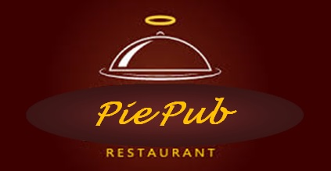

**ISYS 630 Project Management**

**Pie Pub Restaurant**

**Project Summary**

Group 3

**Team members**

Abeer Katiyal

Aditya Purandare

Sneha Chandrashekaraiah

**Project Summary - The Pie Pub**

ISYS 630, Section-602, Group 3

Pie Pub is a modern and trendy two branch restaurant chain which is looking to expand its business to atleast 25 locations with state of the art technologically infrastructure. The current PoS and IMS systems at the locations are antiquated. Expansion requires upgrade to  better system and softwares. Larger establishments prefer integrated suites, and integration requirements will be regulated in accordance with the establishment size. We propose to install a COTS solution for PoS from industry leading vendor to meet customer expectations. Implement the best in class cloud based technology solutions to reduce hardware and software at each PoS. Provide free wireless access to customers in addition to utilizing mobile devices to facilitate order taking and processing.

Functional aspects: The proposed COTS PoS system will be capable of self-updating and releasing exciting offers on a regular basis. It will be optimized for taking orders and will be easy to use for staff and customers of all ages. We propose an intuitive user-interface, buffer capability for high speed and volume of sales during festive seasons. The system will be accustomed to adjust and accommodate changes on the fly.

1. *Work-flow integration*: The system will seamlessly integrate with Pie Pub specific operations over the cloud. Credit card transaction system will be integrated in the PoS Commercial off the Shelf (COTS) that will be purchased. Inventory Management System will be bought from COTS and will be integrated with the PoS. Wifi routers will bought and set up at all 25 locations with software installed to access the PoS for taking orders.
2. *Target stakeholders*: Internal stakeholders will be Pie Pub Owners, employees and managers. External stakeholders will be customers, franchisees, shareholders and investors.

With changing industry trends, adaption to these trends is essential like integration of tablets into restaurant operations. Being technologically advanced can give the business an edge over the competition. We aspire to give them that edge.