**CHAPTER III**

**TECHNICAL SPECIFICATIONS**

This section discusses and presents the software and hardware proponents decided to use in developing the proposed system as well as the different diagrams pertaining to the software project being developed.

**Software**

The web application was developed using the following development environment.

Table 3.1: Software Development Requirements

|  |  |  |
| --- | --- | --- |
| Software | Specification | Descriptions |
| Operating System | Windows 7, 8.1 and 10 | A system software used to control and manage the [hardware](https://www.lifewire.com/computer-hardware-2625895) and other software on a computer. |
| Programming Language | Hypertext Preprocessor 7.2 (PHP) | A fast and feature-rich open source scripting language used to develop Web Applications or Internet / Intranet Applications. |
| Client Side Script | Asynchronous Javascript and XML (AJAX) | A set of development techniques used for developing web applications which update web content asynchronously. |
| Framework | CodeIgniter MVC 3.1.9 | An application development framework used in developing a website. |
| Database Software | MySQL | A powerful open source database server built based on a relational database management system (RDBMS) and is capable of handling a large concurrent database connection. |
| Server Software | Cross platform, Apache Server, MariaDB, PHP, and Perl (XAMPP) 7.2.10 | A cross-platform web server used as local development environment. |
| Web Browser | Chrome v.69 | A [software](https://www.computerhope.com/jargon/s/software.htm) program locate, retrieve, and display content on the World Wide Web. |
| Application Software | Sublime Text 3 | A proprietary, cross-platform text editor used for coding, markup and prose. |
| Graphics Editor | Adobe Photoshop CS6 | A software extensively used for raster image editing, graphic design and digital art. |

The proponents used Windows as the operating system to develop the proposed system as it is more convenient to use compared to other operating system. For the programming language, the proponents used PHP for it results in faster site loading speeds and it is flexible for database connectivity. AJAX is used as Client Side Script for it allows web pages to be updated asynchronously without reloading the whole page. The CodeIgniter framework is used by the proponents because it is based on Model-View-Controller; it helps to divide the entire application into three linked sections which enables the developers perform customization and enhancement without any hindrance. In database software, the proponents decided to utilize MySQL because of its ubiquity and scalability characteristics.

In terms of the server software, XAMPP is used by the proponents as a tool for managing MySQL databases as it is easy to understand and use. Also, the developers apply Sublime as the code editor because it is stable, familiar and it provides easy customization. For the web browser, Google Chrome is used for its simplicity and speed which allows the web application to load faster. The logo and icons used for the system are created in Adobe Photoshop CS6 for the reason that it has simple and neat environment that enables easy way of importing and editing of photos and icons.

Table 3.2: Software Implementation Requirements

|  |  |  |
| --- | --- | --- |
| Software | Specification | Descriptions |
| Server OS | Linux - Ubuntu Server 18.04 | An open-source operating system (OS) incorporating all the features of a Unix OS with an added customizable GUI. |
| Server Hosting | Apache 7.2.10 | An open-source web server creation, deployment and management software. |
| Server Database | MySQL 5.0 | An open source relational database management system that relies on SQL for processing the data in the database. |
| Client Browser | Google Chrome v65 and later, Microsoft Edge | An [open source](https://whatis.techtarget.com/definition/open-source) program for accessing the World Wide Web and running Web-based applications. |

Table 3.2 shows the software applications that will be used by the user when the system is implemented. For the server operating system (OS), Linux Ubuntu will be used as it is open source software and more reliable in terms of security. Apache will be used as a server hosting for it has high level of compatibility with any OS particularly Windows and Linux. The server database is MySQL because it is capable of handling huge amount of data and it provides fast and easy maintenance and upgrading. The proponents decided to make use of Google Chrome and Microsoft Edge as a client browser for the reason of its overall usability, performance, and support for web technologies and standards.

**Hardware**

The web application is developed using the following hardware requirements. The proponents used minimum requirements of hardware as it is the available resources and it is capable of developing the system.

Table 3.3 Hardware Development Requirements

|  |  |  |
| --- | --- | --- |
| Software | Specification | Descriptions |
| Processor | Intel Core i3 3rd Generation | A dual-core computer processor, available for use in both desktop and laptop computers. |
| Random Access Memory (RAM) | 2 gigabyte (GB) RAM or higher | The hardware in a computing device where the operating system ([OS](https://whatis.techtarget.com/definition/operating-system-OS)), application programs and data in current use are kept. |
| Storage | 250 GB available Hard Disk space or higher | Type of storage medium that permanently stores data on personal computers (PCs) and other electronic devices. |

Table 3.3 displays the hardware needed for the development of the web application. Intel Core i3 processor is used because it is the optimal requirement and it performs well in form of overall processing speed and graphic performance. 2 GB RAM is at least needed to develop the system but a higher RAM is recommended especially to graphic designer in order to work at ease and perform better. In terms of storage, 250 GB is required to create the system.

**Technologies**

Web application is an [application program](https://searchsoftwarequality.techtarget.com/definition/application-program) that is stored on a remote server and delivered over the Internet through a browser interface. It utilizes web browsers and web technology to perform tasks over the Internet and allows fast and secure transactions. The proponents decided to employ web application for the reason that it is what QC PESO requires and is needed by the department.

The system will provide job matching feature which matches the applicant’s skills to the specific vacant job qualifications. It will speed up the process as well as eases the workload of the client assistant officer. Incorporating job matching technology to the proposed system is a way to improve the current system and benefit the entities involved.

Dashboard is a user interface that organizes and presents information in a way that is easy to read. It allows the administrator to monitor the current status or performance of the management. The proponents integrate the use of dashboard as it is valuable for the decision-making of the high-level management. It also allows flexibility for the organization’s growth and can increase efficiency.

**Diagrams**

The different diagrams below pertain to the software project being developed. It was used by the proponents to effectively explain the context of the proposed system. These diagrams are Context Diagram, Use Case Diagram, and Flowcharts. The Context Diagram was used to define the boundary between the proposed system and its environment, thus showing the entities that interact with it. Use Case Diagram shows the interactions between the proposed system and the users. And the Flowchart was used to gain an understanding of how a process is done.

**Context Diagram**

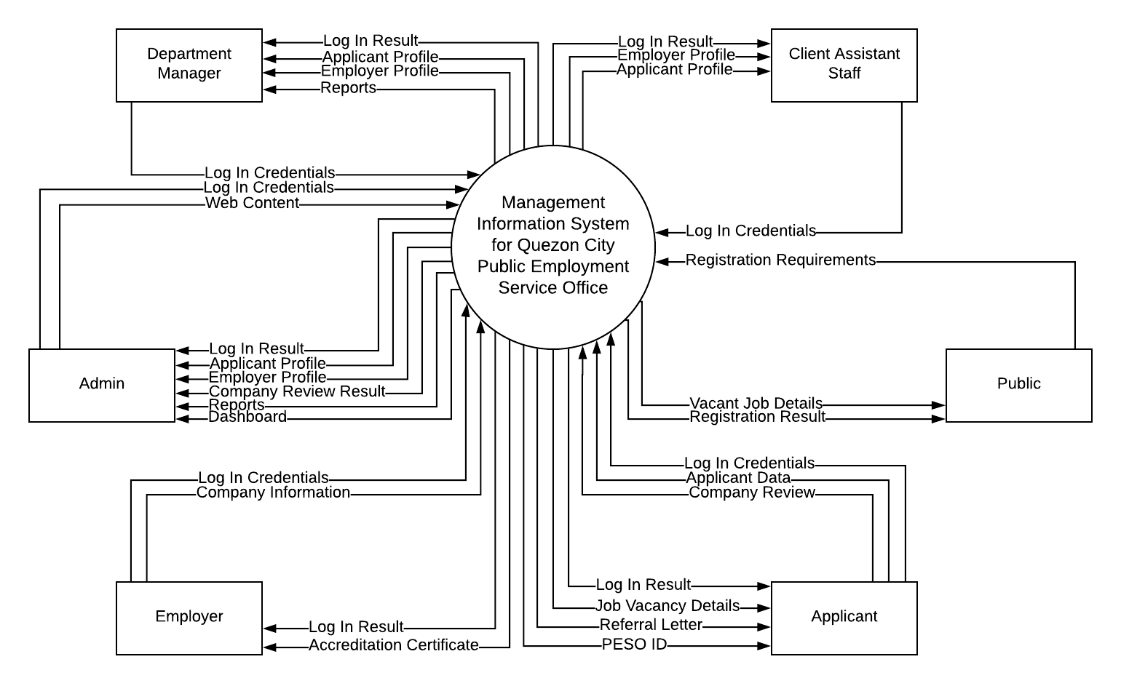

**Figure 3.1 Context Diagram of Management Information System for Quezon City Public Employment Service Office**

Fig. 3.1 describes the overview functionalities required by the external entities. It is used to show a broad overview of the proposed system and to understand the context of an entity being examined.

**Use Case Diagram**

Admin Side

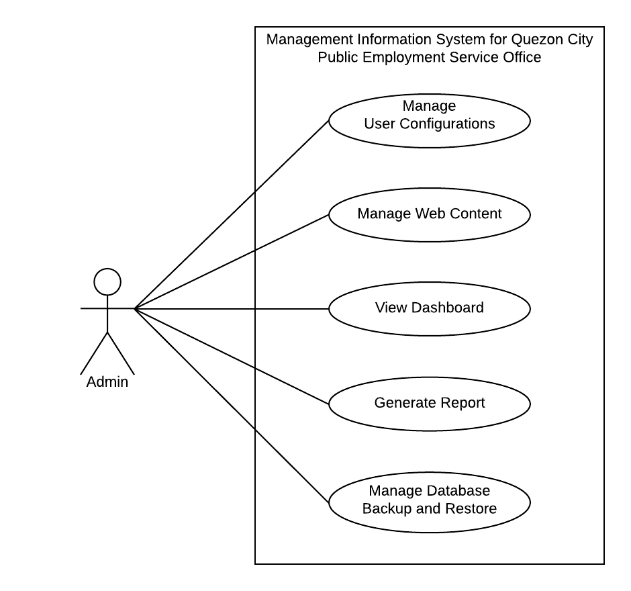

**Fig. 3.2 Use Case Diagram Management Information System for Quezon City Public Employment Service Office (Admin Side)**

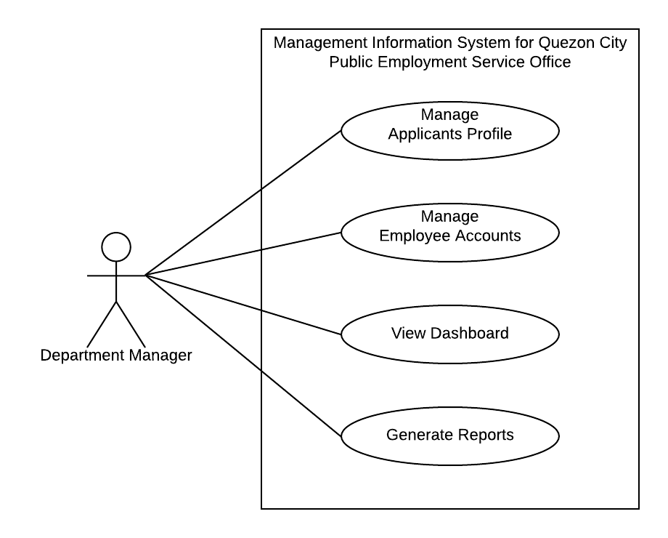

**Fig. 3.3 Use Case Diagram Management Information System for Quezon City Public Employment Service Office (Department Manager Side)**

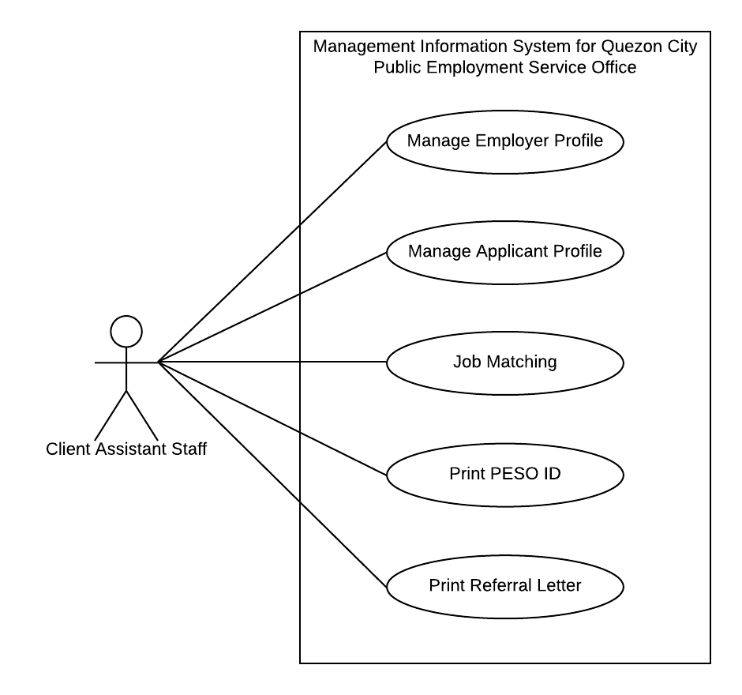

**Fig. 3.4 Use Case Diagram Management Information System for Quezon City Public Employment Service Office (Client Assistant Staff Side)**

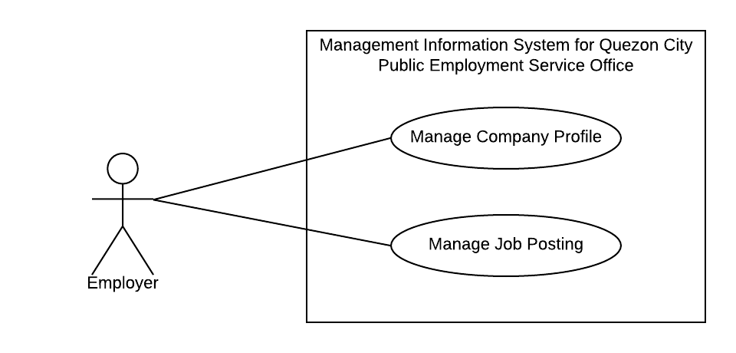

**Fig. 3.4 Use Case Diagram Management Information System for Quezon City Public Employment Service Office (Employer Staff Side)**

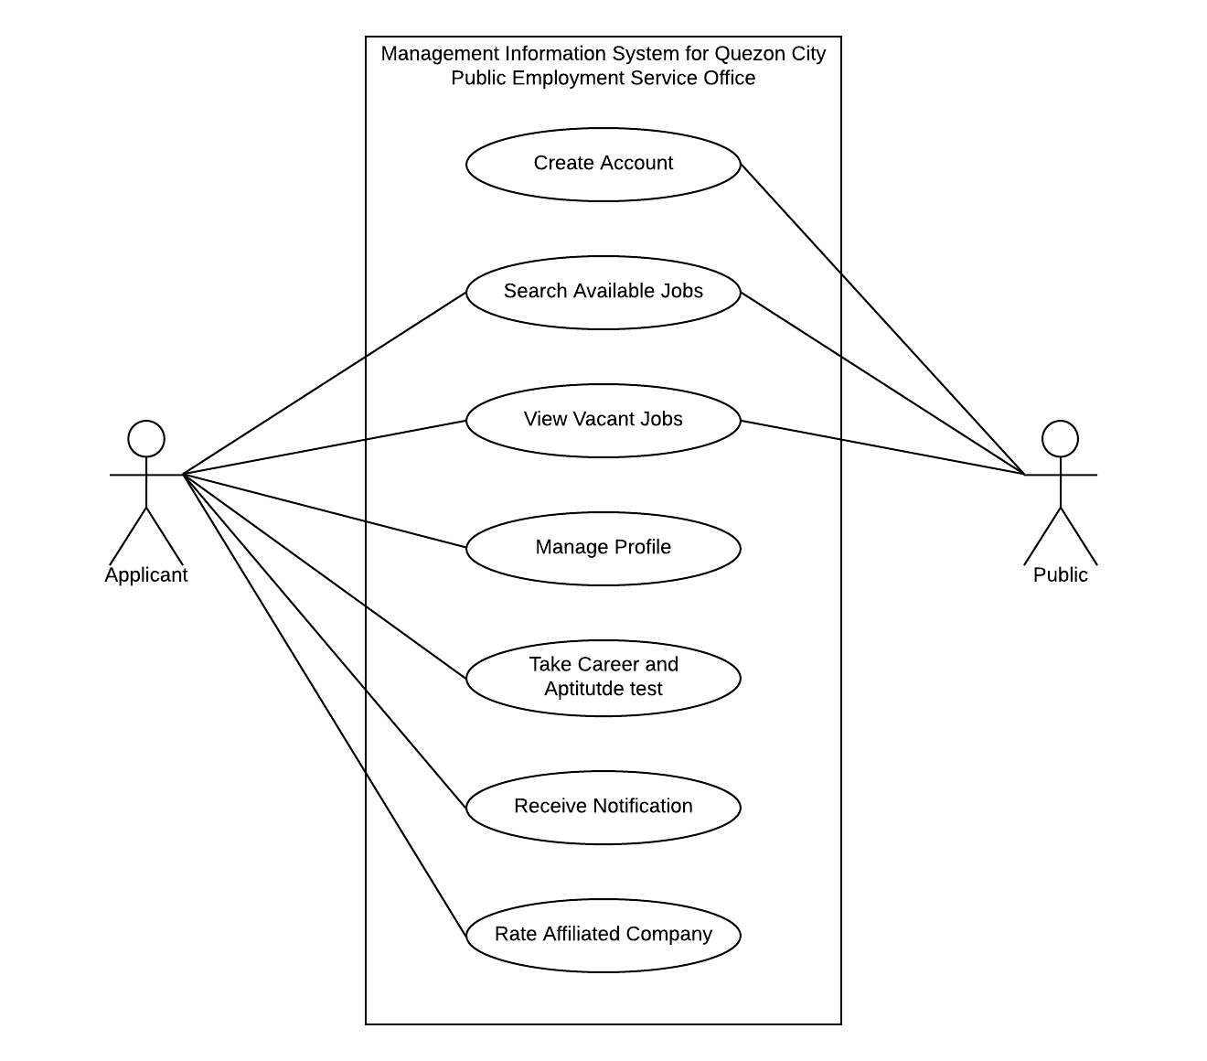

**Fig. 3.6 Use Case Diagram Management Information System for Quezon City Public Employment Service Office (Applicant and Public Side)**