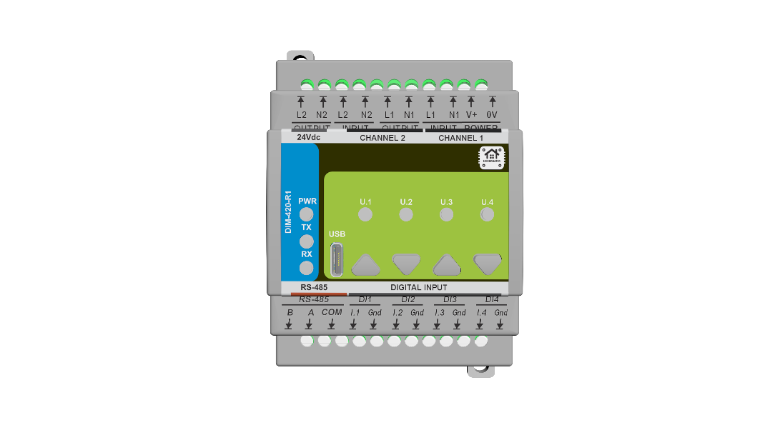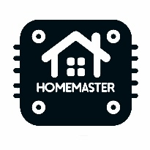

**Datasheet**

**DIM-420-R1 Module**

**Part No. 0000009**

**About the product**

**The DIM-420-R1 is a smart lighting control module designed for modular integration with HomeMaster MiniPLC and MicroPLC systems. It offers smooth, silent dimming for 110/230 V lighting circuits and supports both trailing-edge and leading-edge dimming modes. Ideal for smart homes, commercial automation, and industrial lighting control.**

**Designed for seamless integration with ESPHome and Home Assistant, the gateway allows OTA updates, local LED indicators, and configuration via USB Type-C.**

**Electrical Data**

|  |  |
| --- | --- |
| Power supply | 24VDC,  USB-C female (5V DC via USB-C) for programming |
| Power consumption | typ. 1.85W, max. 3W |
| ESP32 | ESP32-WROOM-32U |
| Digital Inputs | 4 isolated, surge protected digital sourcing inputs |
| Dimming channels | 2 independent dimming channels with support for trailing-edge and leading-edge dimming |
| RS-485 | Half-duplex,  data rate 115,2 kbps,  short-circuit current limited and protected against excessive power dissipation,  fail-safe for open circuit,  surge protected |
| USB | USB type-C USB Specification 2.0 compliant,  ESD protected,  Silicon Labs CP2102N USB-to-UART bridge controller,  Virtual COM Port Device Drivers, Works with existing COM port Applications, Supported on Windows, Mac, and Linux |
| Real-time clock | PCF8563 |
| Ambient temperature | 0 ... 40°C / 32 ... 104°F |
| Humidity | max. 95% r.H. (non condensing) |

**Information: \***

High loads at the digital outputs result in heat development, which can influence the lifetime in the long run. We recommend using coupling relays with loads greater than 5A.

**Connections**

|  |  |
| --- | --- |
| Terminals | 300V 20A 26-12 AWG 2.5mm2,  Torque of terminal blocks 0.5 ... 0.6Nm /0.37 ... 0.44 lbf ft,  Pitch: 5.08mm(.200") |
| WiFi antena | SMA male |
| USB | USB type-C |

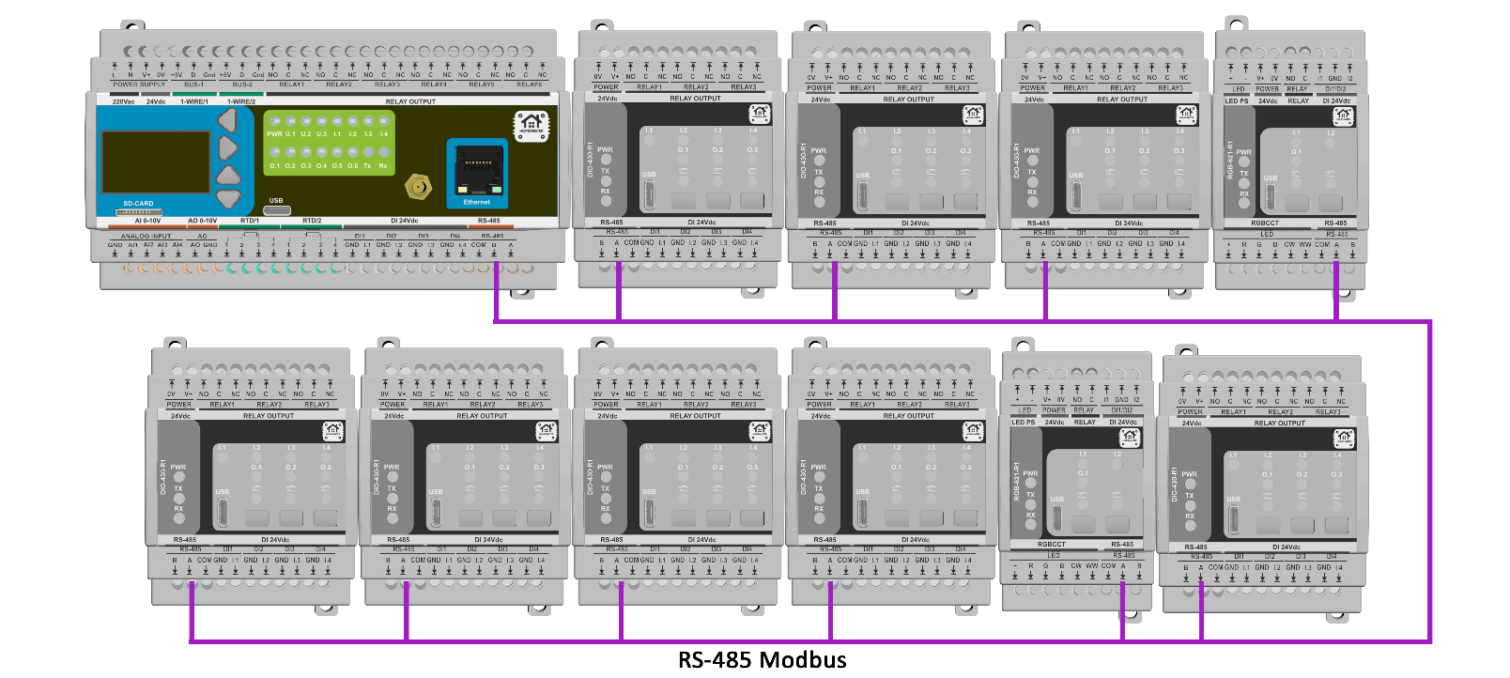

**Product Characteristics**

|  |  |
| --- | --- |
| Mounting type | DIN rail according to EN50022, 35mm |
| Colors | Light Gray/Black, Smoke Panel |
| Material | PC/ABS/V0 |
| Finish | Matte |

**Weight & Dimensions**

|  |  |
| --- | --- |
| Net weight | 420g |
| Total weight | 580g |
| Product dimensions | 157.4 x 91 x 58.4 mm (6.2 x 3.58 x 2.3 in) (LxWxH), 9 division units |
| Pack size | 230x140x87mm (9 x 5.5 x 3.4 in) (LxWxH), |

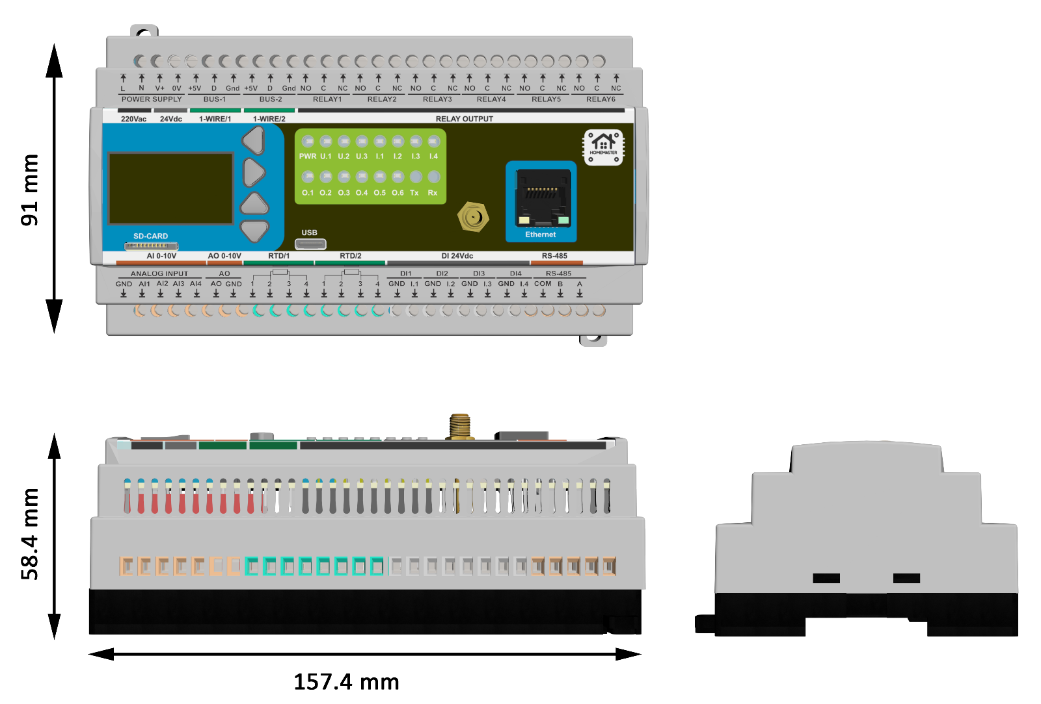

**Certifications & Standards**

|  |  |
| --- | --- |
| Safety rating | IP20 |
| Operation | Type 1 (UL60730-1, CSA E60730-1) |
| Rated impulse voltage for digital output | 2.5kV (UL60730-1, max. Altitude 2000m) |
| Degree of pollution | 2 |
| Certifications | CE, UL60730-1, CSA E60730-1 |

The ESP32 MiniPLC enables a variety of connected devices to work with HOMEMASTER technology.

See https://www.home-master.eu for more details.

Communication between iPhone, iPad, Apple Watch, HomePod, or Mac and the HomeKit- enabled

ESP32 MiniPLC is secured by ESPHome and Home Assistant technology.

Installation must be carried out by a qualified electrician in accordance with the relevant regulations.

**Published by**

**ISYSTEMS AUTOMATION S.R.L.**

Deligintei 18

Ploiesti

Romania

Tel: +40721389963

http://www.home-master.eu