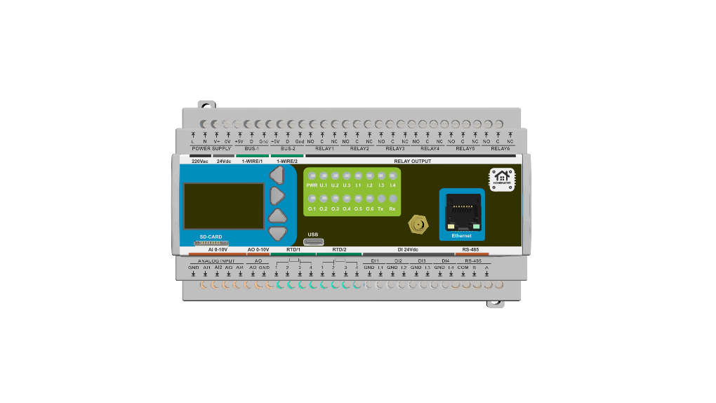

Datasheet
ESP32 MiniPLC
Part No. 0000001

Product Description
The HomeMaster MiniPLC is a professional, open-source DIN rail controller built around the ESP32 platform, designed for robust and scalable smart automation in residential, commercial, and light industrial environments. It combines extensive onboard I/O—including relays, digital and analog inputs, temperature sensors, and a user interface—with native Home Assistant integration via pre-installed ESPHome.
Engineered for reliability and flexibility, the MiniPLC supports multiple power input options (24V DC or wide-range AC/DC) and features an isolated RS-485 Modbus interface for expansion with a wide range of compatible I/O modules. Its local processing capability ensures continued operation even when network or cloud connectivity is lost, making it suitable for mission-critical applications.
This controller operates as a complete standalone automation system using its comprehensive onboard I/O, while also offering seamless expansion via the RS-485 bus to connect HomeMaster smart modules for energy metering, lighting control, security, and more. It provides a versatile, ready-to-integrate platform for HVAC control, energy management, security systems, lighting automation, and custom industrial applications.

Technical Specifications
Specification | Details
Microcontroller | ESP32-WROOM-32U (dual-core)
Power Input | 24 V DC nominal (V+ / 0V) OR 85–265 V AC (L / N) OR 120–370 V DC (L / N + / −)
Digital Inputs | 4 × isolated, 24 V DC compatible
Relay Outputs | 6 × SPDT — 3 A MAX continuous per output (board/system limit).  Relay component contacts rated up to 12 A @ 250 V AC (resistive).
Analog Inputs | 4 × 0–10 V, 16-bit (ADS1115)
Analog Output | 1 × 0–10 V, 12-bit (MCP4725)
Temperature Inputs | 2 × RTD (PT100/PT1000 via MAX31865), 2 × 1-Wire (DS18B20 compatible)
Display | 128 × 64 OLED (SH1106)
User Interface | 4 buttons, 3 user LEDs, 1 status LED, onboard buzzer (GPIO2, PWM)
Wi-Fi | Wi-Fi (ESP32)
Ethernet | Optional Ethernet (LAN8720 PHY)
RS-485 | RS-485 Modbus RTU (MAX485, half-duplex) with TVS surge protection, PTC fuses, EMI choke, and fail-safe biasing
Storage | MicroSD card (SPI interface, power-switched 3.3 V rail)
USB | USB-C (ESD protected, CC detection, data to ESP32)
RTC | PCF8563 with battery backup
Note: Relay outputs are not internally fused. Use external overcurrent protection per local code and use an external contactor/relay for loads above 3 A or with high inrush/inductive characteristics.

Installation, Environmental & Mechanical
Category | Specification | Details
Terminal Specifications | Terminal type | Pluggable screw terminal blocks, 5.08 mm pitch
Terminal Specifications | Terminal pitch | 5.08 mm
Terminal Specifications | Wire cross-section | 0.2–2.5 mm² (AWG 24–12)
Terminal Specifications | Conductor type | Solid or stranded copper
Terminal Specifications | Stranded wire | Ferrules recommended
Terminal Specifications | Tightening torque | 0.4 Nm (max)
Environmental Ratings | Operating temperature | 0 °C to +40 °C
Environmental Ratings | Storage temperature | -10 °C to 55 °C
Environmental Ratings | Relative humidity | 0–90 % RH, non-condensing
Environmental Ratings | Ingress protection | IP20 (inside cabinet)
Environmental Ratings | Installation | Indoor control cabinet only; not for outdoor or exposed installation
Environmental Ratings | Terminal protection | All wiring terminals must be protected against accidental contact
Mechanical & Packaging | Product dimensions | 157.4 × 91 × 58.4 mm (6.2 × 3.58 × 2.3 in) (L × W × H)
Mechanical & Packaging | DIN units | 9 division units (≈ 90 mm DIN rail mounting width)
Mechanical & Packaging | Mounting | 35 mm DIN rail
Mechanical & Packaging | Net weight | 300 g
Mechanical & Packaging | Gross weight | 450 g
Mechanical & Packaging | Pack size | 230 × 140 × 87 mm (9 × 5.5 × 3.4 in) (L × W × H)
Mechanical & Packaging | Mechanical drawing | Front + side views with DIN-clip depth (see below)
Mechanical & Packaging | Notes | All dimensions shown in millimeters unless stated otherwise
Install only inside a control cabinet with ventilation; the cabinet must include a protective front plate covering all module connection terminals and a closing protective door; not for outdoor or exposed installation.
All wiring terminals must be protected against accidental contact by an insulating front plate, wiring duct, or terminal cover. Exposed live terminals are not permitted.
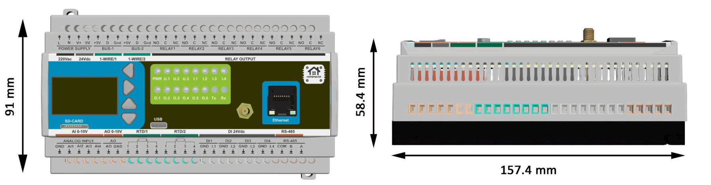

Compliance & Certifications
The HomeMaster MiniPLC is CE marked and designed to comply with the applicable European Union directives. The manufacturer, ISYSTEMS AUTOMATION (HomeMaster brand), maintains the technical documentation and a signed EU Declaration of Conformity (DoC).

EU Directives
EMC 2014/30/EU · LVD 2014/35/EU · RED 2014/53/EU · RoHS 2011/65/EU

Harmonised Standards
Area | Standards
EMC | EN 61000-6-1 (Immunity) · EN 61000-6-3 (Emissions)
Electrical Safety | EN 62368-1
Radio | EN 300 328 · EN 301 489-1 · EN 301 489-17
RoHS | EN IEC 63000

Radio
The product integrates a pre-certified ESP32 Wi-Fi radio module (2.4 GHz). Final product conformity with the Radio Equipment Directive is demonstrated by the maintained technical documentation and conformity assessment of the complete device.

Safety notice
L / N: hazardous voltage · 24 V DC: SELV · Qualified personnel only

Published by
ISYSTEMS AUTOMATION S.R.L.
Deligintei 18
Ploiesti
Romania
Tel: +40721389963
http://www.home-master.eu

