Authorization Letter
Date: September 22, 2024

To: Google Play Team
Subject: Authorization for Use of Name and Logo by Developer iSystems Ltd

Dear Sir/Madam,

We, the undersigned, represent Koshish School and Kindergarten and are writing to confirm that we have authorized the software developer iSystems Ltd (Account ID: 4877899662794969745) to develop a mobile application for our institution. We hereby grant them full permission to use:our name and logo for the purposes of this application, as described below:

Developer Details:
- Developer Name: iSystems Ltd
- Account ID: 4877899662794969745
- Email: isystems.developer@gmail.com
- Legal Name: Besaran Aziz

We acknowledge that the mobile application developed by iSystems Ltd is intended for our institution, and we have given them explicit permission to use our official name, "Koshish School and Kindergarten," and our logo for the purposes of creating, branding, and publishing the app orn Google Play.

This authorization is being provided in response to a policy violation that occurred during the attempt to publish the application. We confirm that iSystems Ltd is fully authorized by Koshish School and Kindergarten to represent us by using our name and logo in connection with the development and publication of this mobile application.

Please consider this letter as formal confirmation of the authorization and we kindly request you to allow the publication of the mobile application on the Google Play·Store.

Should you require any further information or verification, please do not hesitate to contact us at the details provided below.
Thank you for your understanding and support. Sincerely,

Mr. Amanj Younis
Head of School Board

Koshish School and Kindergarten
New Hawler City, 120m. Road, Erbil, Iraq info@koshish.edu.krd
(+964} o7so588 1000 / (+964) 01so 588 sooo
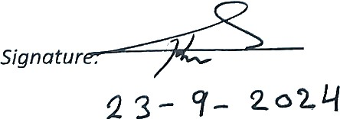
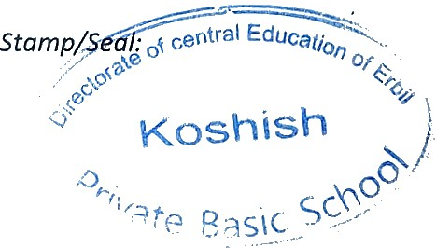

Date:

