# Create Reddit app

* Login to reddit account
* Go to <https://www.reddit.com/prefs/apps/>
* Click on create an app

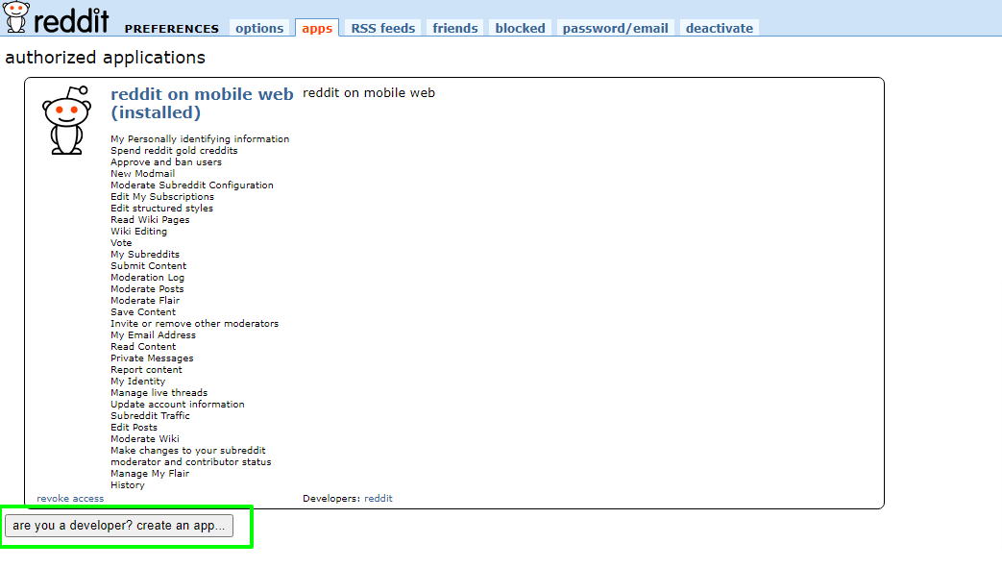

* Enter app name
* Enter <http://localhost:8080> in the shown fields

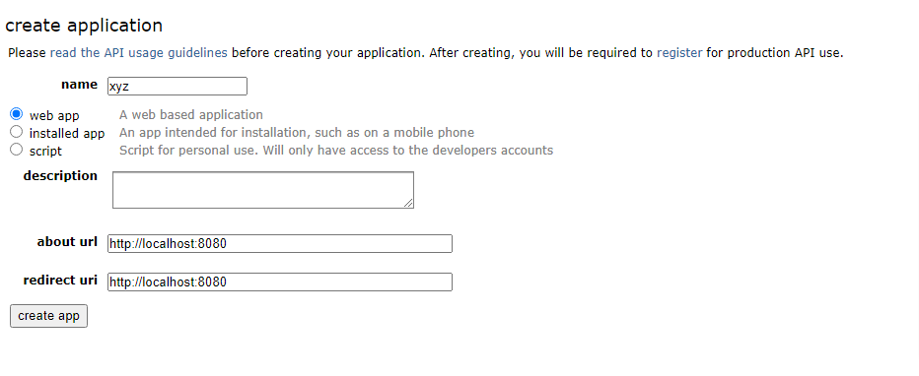

* Click create app
* Copy the id and secret

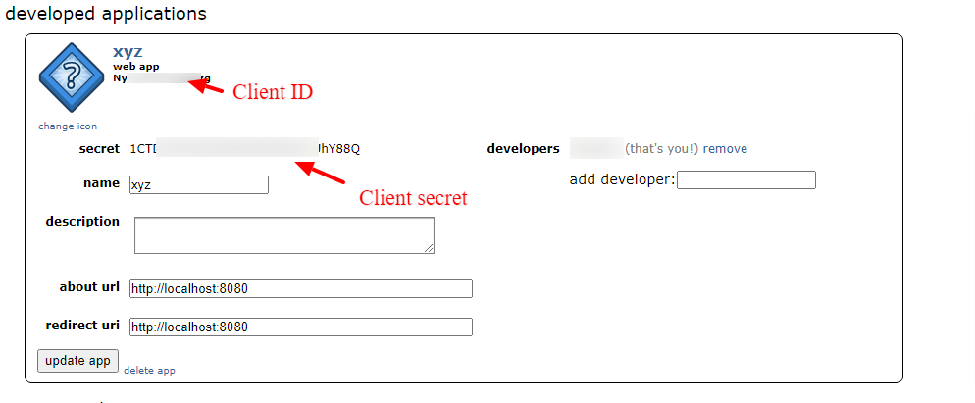

* Open the redditapp.json (in the ‘Playlist’ folder) in notepad and replace the id and secret (keep the quotes)

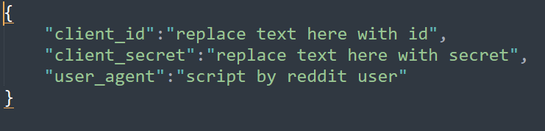

* Save the file

# Google cloud project

* Go to <https://console.cloud.google.com/home/dashboard> and click on ‘Select a project’

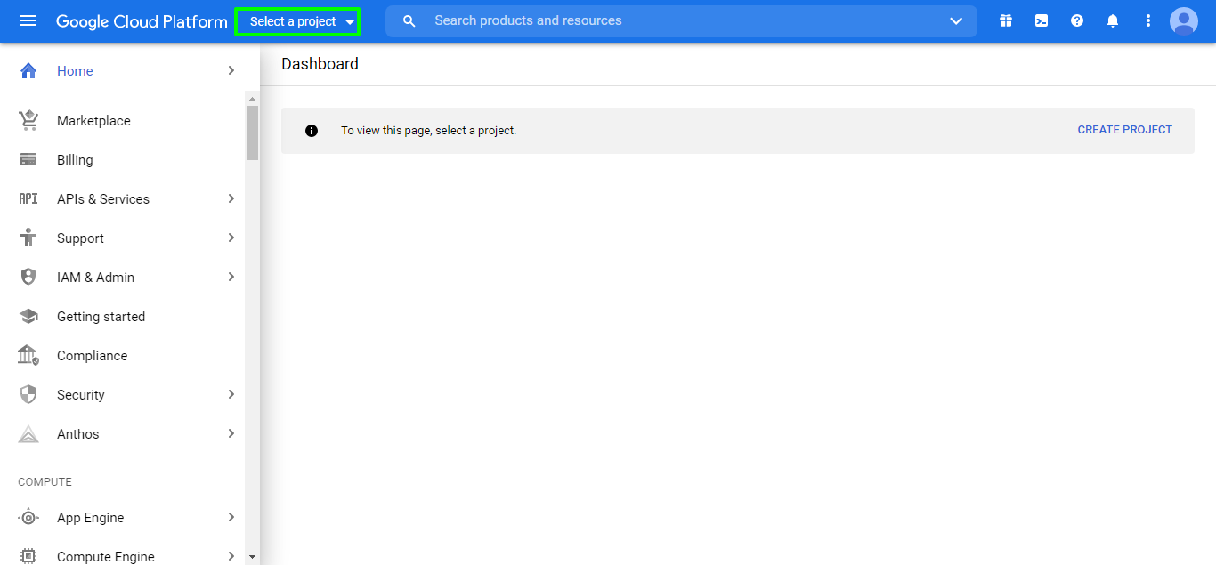

* Click on New project

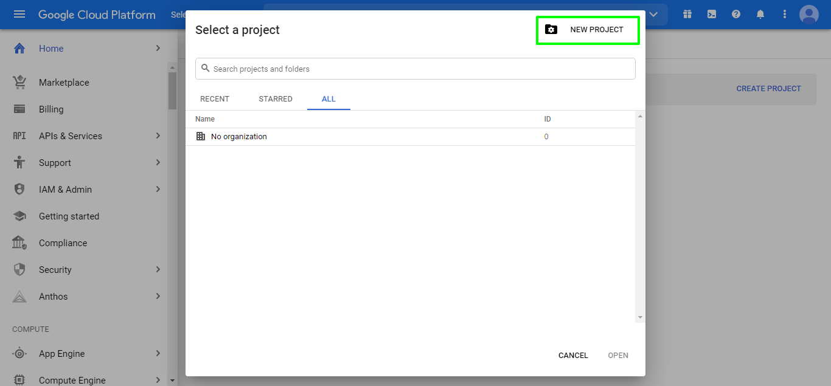

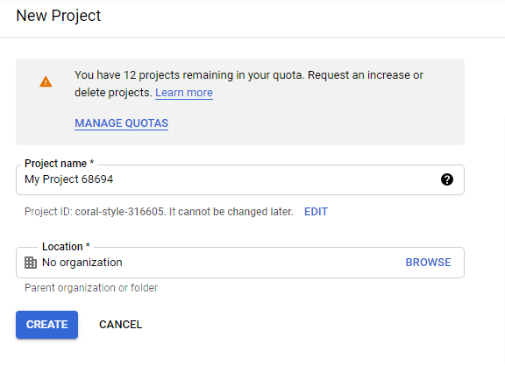

* Click CREATE
* Go to <https://console.cloud.google.com/apis/credentials/consent/>
* Choose internal or external and click create

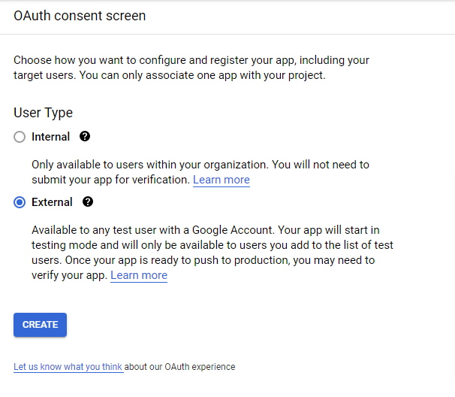

* Enter app name and choose user support email

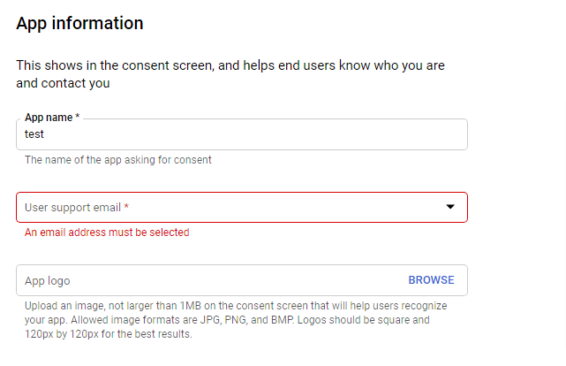

* Scroll down and enter email and click ‘save and continue’

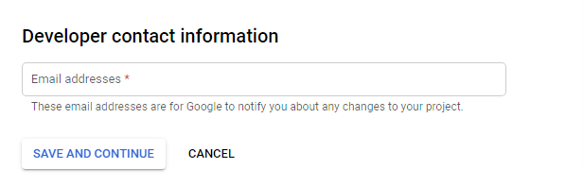

* Go to <https://console.cloud.google.com/apis/credentials>
* Click on create credentials and choose OAuth client ID

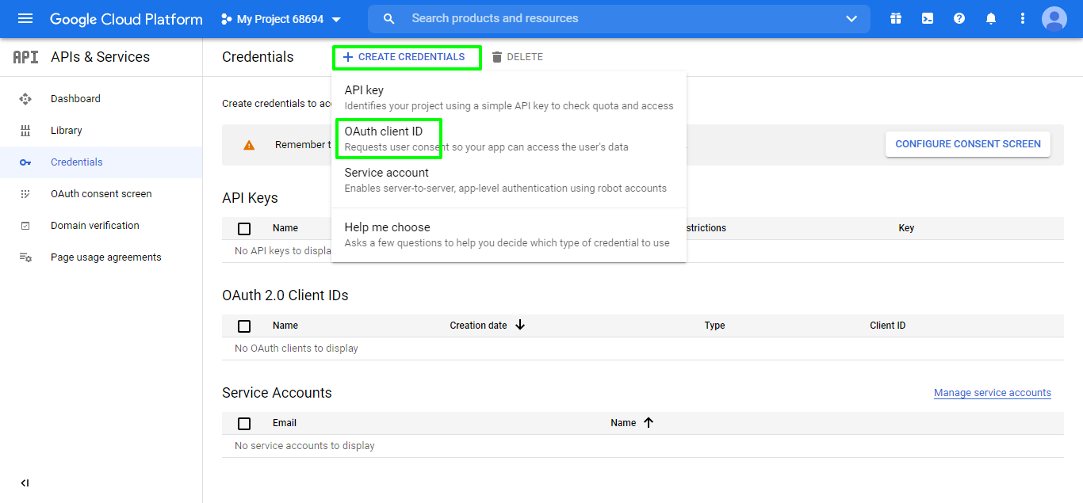

* Choose application type

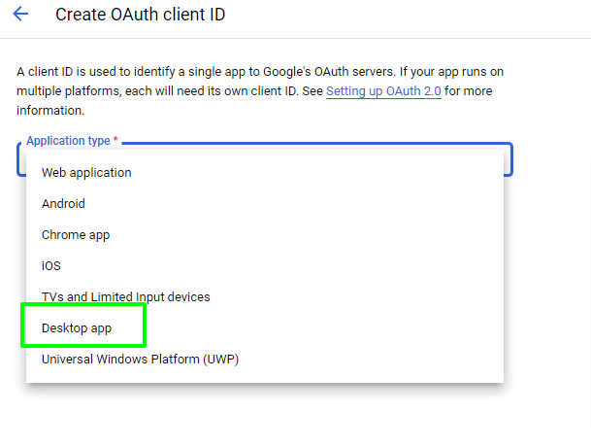

* Click create

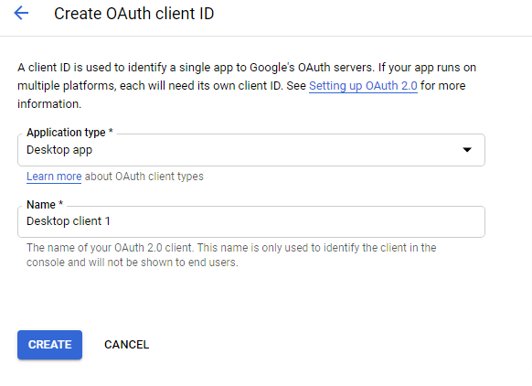

* Click Ok on the popup
* Download the client_secret.json file by clicking the download icon and rename it to **client_secrets.json** and place it in the ‘Playlist’ folder

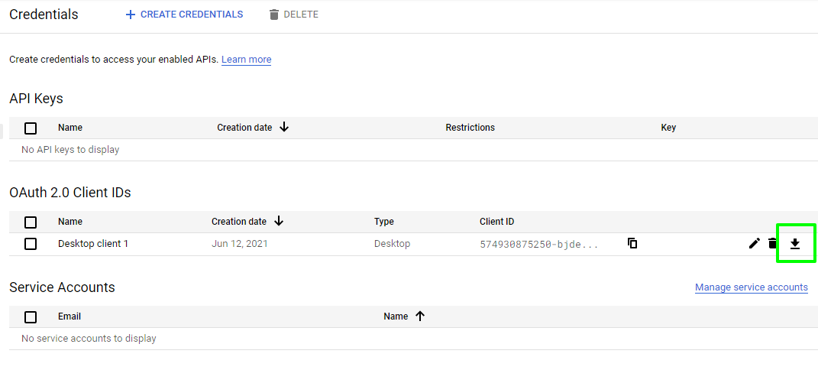

# Playlist folder

Your playlist folder should have all these files

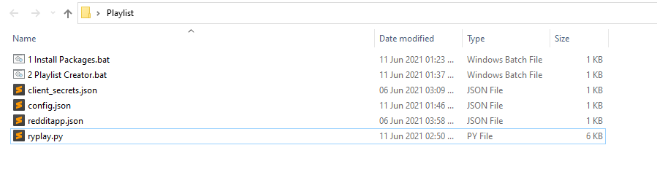

1. ‘1 Install Packages’ batch file will install these packages

* praw (Python Reddit API Wrapper)
* google-auth-oauthlib (Google authentication library for Python)

1. Before running the ‘2 Playlist Creator’ batch file

* Open the config.json file

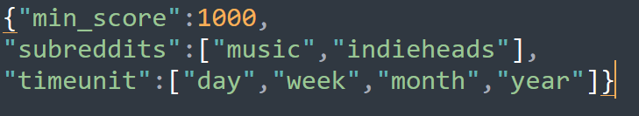

***Change these values to your requirement***

***min_score***

It is the minimum upvotes on a reddit post. The posts that have lower than this score will not be retrieved.

*Here, I took only posts with a minimum of 1000 upvotes.*

***subreddits***

I took only music and indieheads subreddits. You can add more subreddits.

If you want to add the subreddit EDM. It should look like this ["music","indieheads", "EDM"]

***timeunit***

Top posts from day, week, month and year.

# First run

* Click on ‘2 Playlist Creator’ batch file

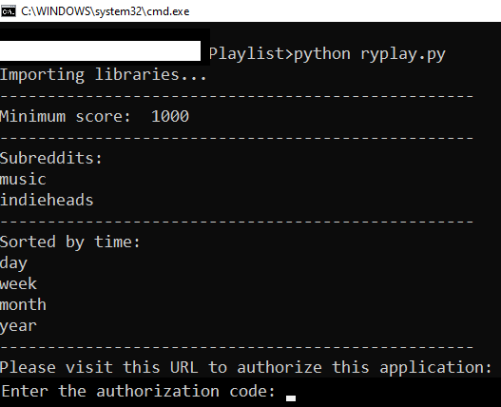

* Copy the URL and open it in the browser
* Click continue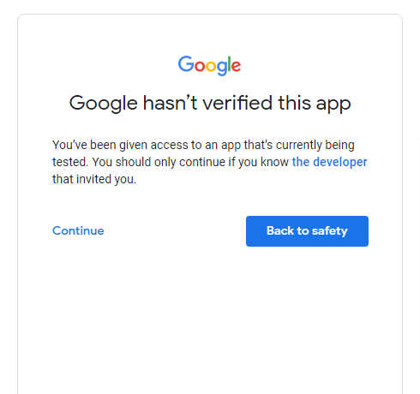
* Click allow on both permissions and the confirm your choices again by clicking allow

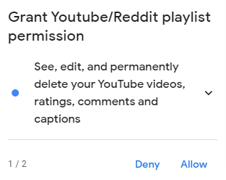

Copy the code and paste it in the command prompt

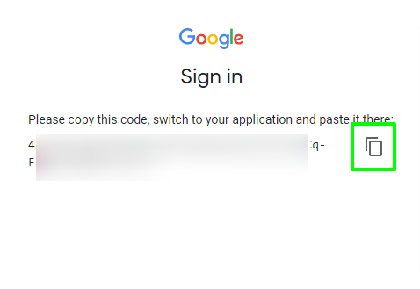

*Note: This will create a “refresh_token.json” file in the ‘Playlist’ folder so you don’t have to authorize every time you run the script*

The app will start running.

