

**IT3010**

**Network Design & Management**

**3rd Year, 2nd Semester**

<Assignment>

**<Individual Assignment>**

Submitted to

Sri Lanka Institute of Information Technology

In partial fulfillment of the requirements for the

Bachelor of Science Special Honors Degree in Information Technology

2024-04-26

**Declaration**

I certify that this report does not incorporate without acknowledgement, any material previously submitted for a degree or diploma in any university, and to the best of my knowledge and belief it does not contain any material previously published or written by another person, except where due reference is made in text.

Registration Number: IT21360978

Name: Serasinghe G.P.G.Y

## DNS Server Configuration

* Step 01

### Login to the server using root Credentials.

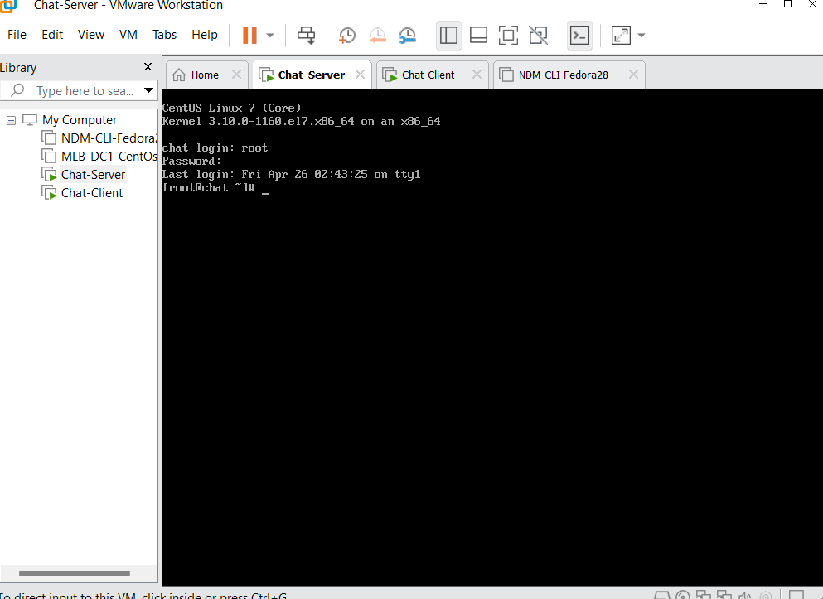

Figure 1.root login.

### Go to Network Manager TUI and edit the connections.

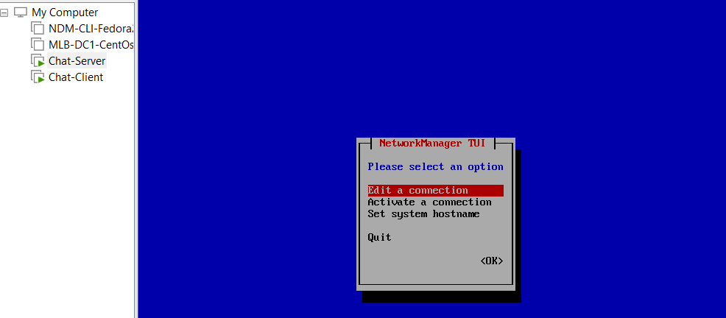

Figure 2. edit connection.

### Edit the VMNet2 adapter settings.

Figure 3. edit the VMNET2.

Figure 4. edit the VMNet2.

### Not need to edit Other Adapters (NAT).

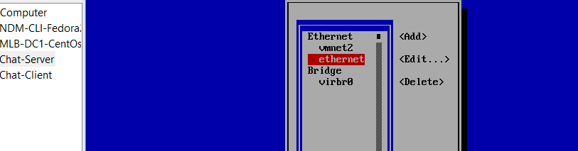

Figure 5. Nat Adapter

* Step 02

### After the edit Connections then navigate to the activate a connection and activate the NAT adapter.

Figure 1.activate Nat.

### After the connect NAT Adapter, go back to root mode, and install the DNS packages.

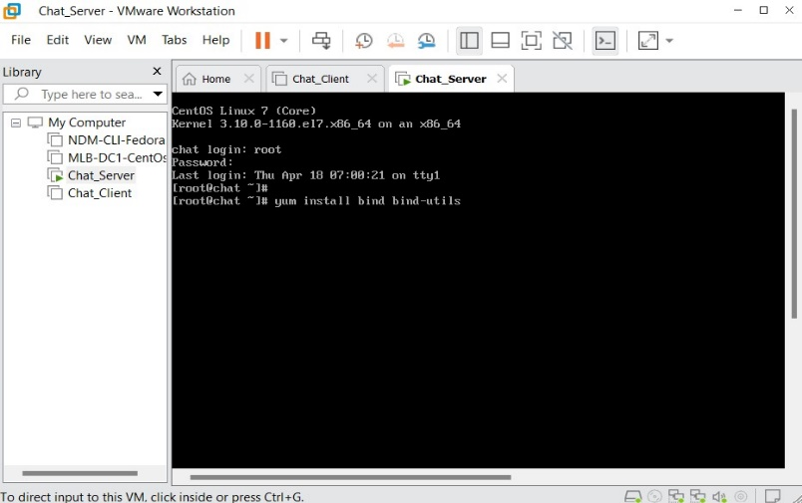

Figure 2. Util package install

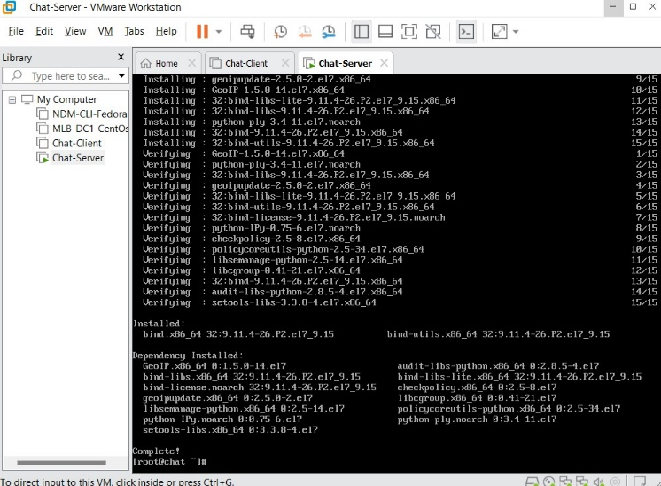

Figure 2.1. Util package install

### When packages are installed. Then navigate to Network Manager TUI and Deactivate the NAT adapter and Activate the VMNet2 Adapter.

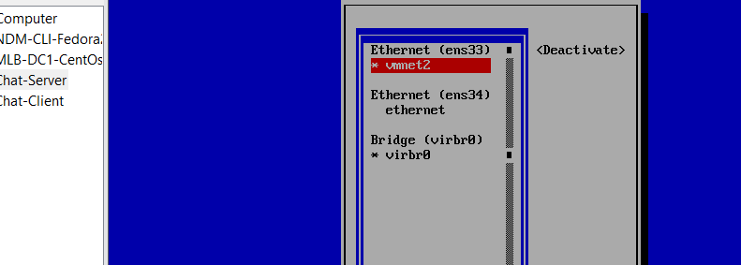

Figure 3. activate vmnet2 and deactivate Nat.

* Step 03

### After that, add a hostname as chat.ndm.lk.

Hostname = chat.ndm.lk

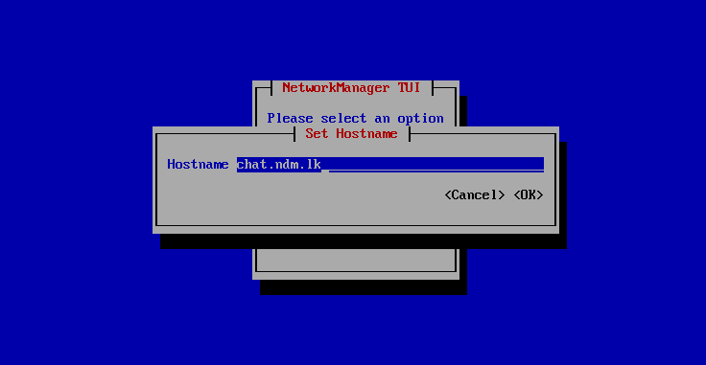

Figure 3.set hostname.

### When added the hostname, then enter hostname command to display hostname.

Command -> hostname

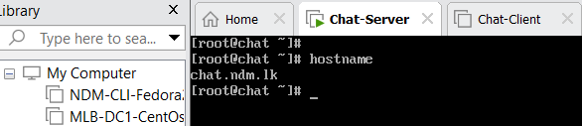

Figure 4. check hostname

* Step 04

### Open the DNS Config file in VI editor.

Command -> vi /etc/named.conf

Figure 1. Open the named file.

### Then navigate to the Insert mode and change the Options.

Options -> listen-on port 53 {127.0.0.1; 10.0.1.2; };

allow-query { localhost; 10.0.1.0/24 };

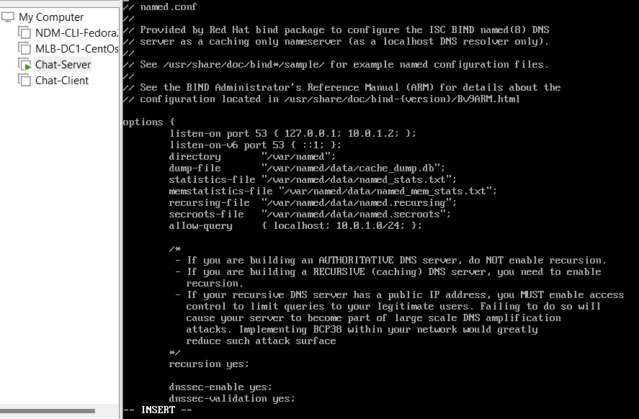

Figure 2. edit the named file.

### After the change options, then add forward and reverse lookup files.

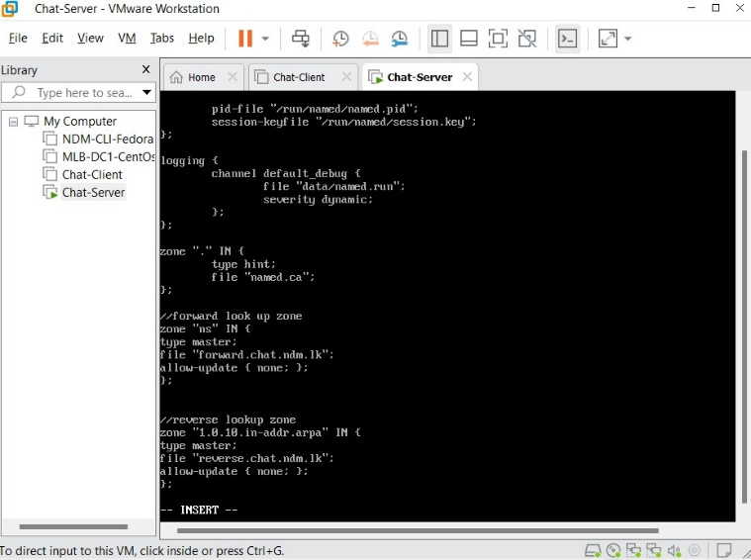

Figure 2.1. add lookup files.

//forward look up zone . zone"ns" IN { . type master; . file "forward.chat.ndm.lk"; . allow-update { none; }; . };

### After the changes, save and exit.

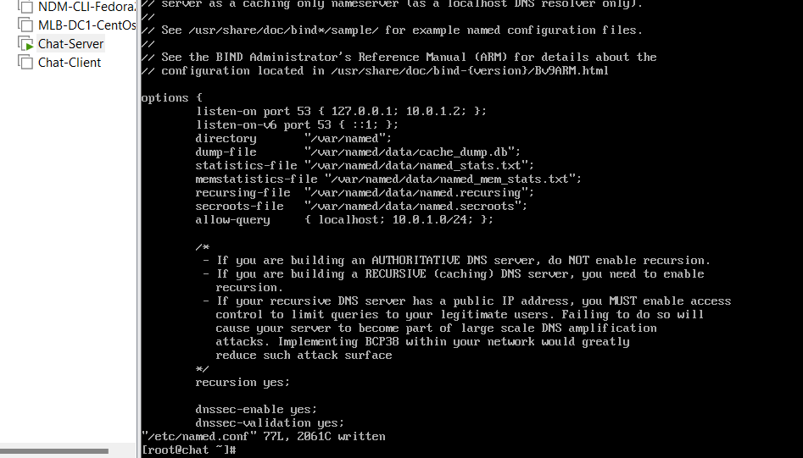

Figure 2.2. exit the named file.

* Step 05

### Change the directory to named directory.

Command -> cd /var/named

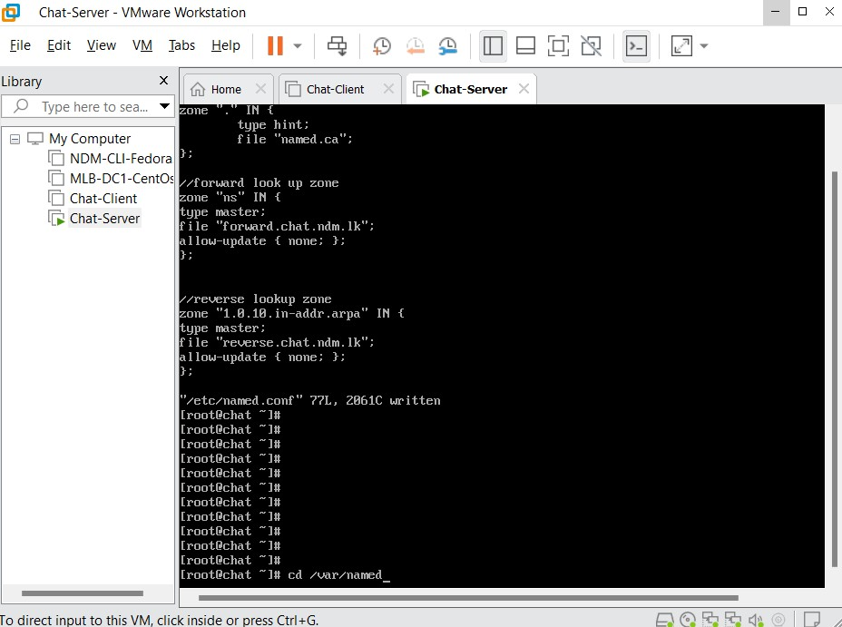

Figure 1. change the directory.

### Open the forward lookup file and insert the given lines into the file.

Command -> vi forward.chat.ndm.lk

Figure 2. open the forward file.

Figure 2.1. edit the forward file.

### After successfully added, save and exit and view the forward lookup file inserted correctly using Cat command.

Command -> cat forward.chat.ndm.lk.

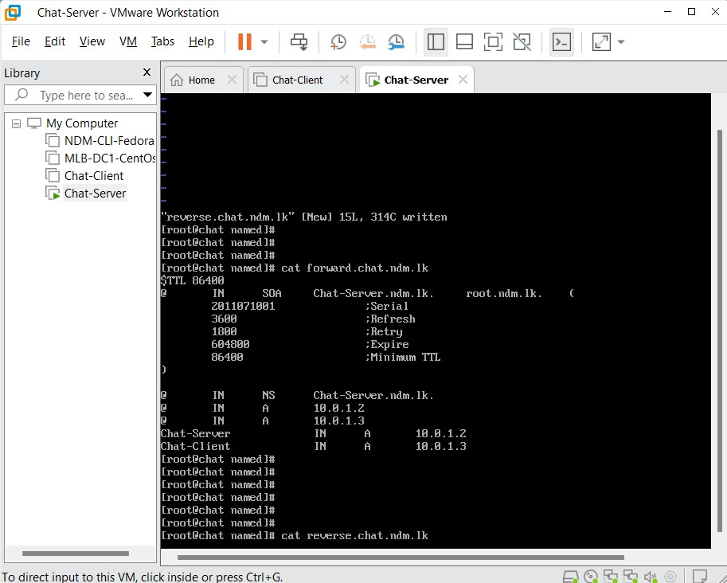

Figure 3. view the forward file.

* Step 06

### Open the reverse lookup file in VI editor and insert the given lines into the file.

Command -> vi reverse.chat.ndm.lk

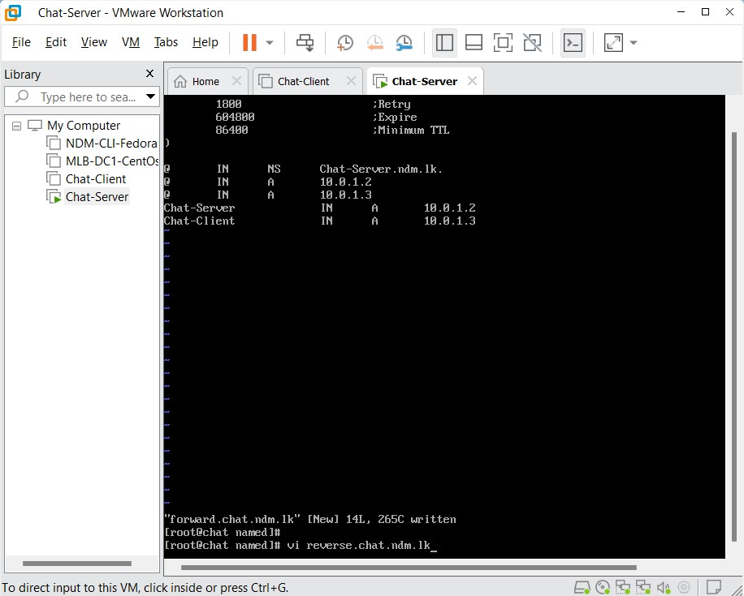

Figure 1. open the reverse file.

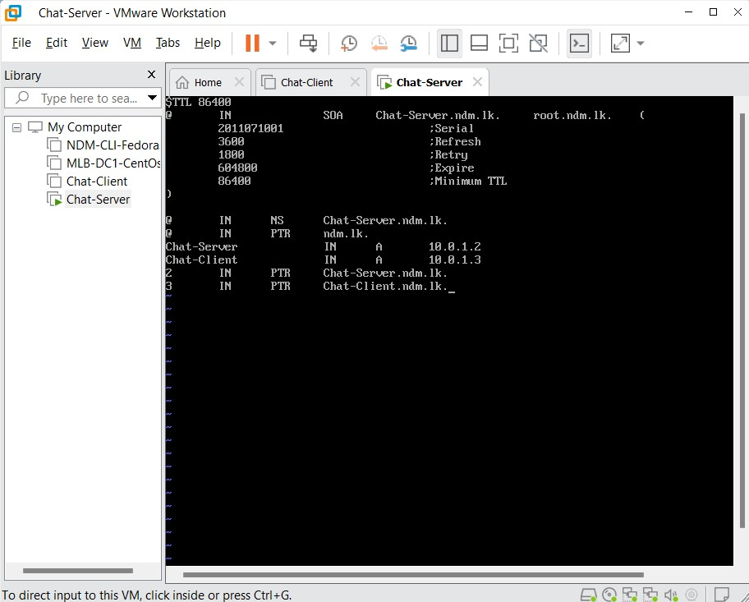

Figure 2. edit the reverse file.

### After successfully added, save and exit and view the reverse lookup file inserted correctly using Cat command.

Command -> cat reverse.chat.ndm.lk.

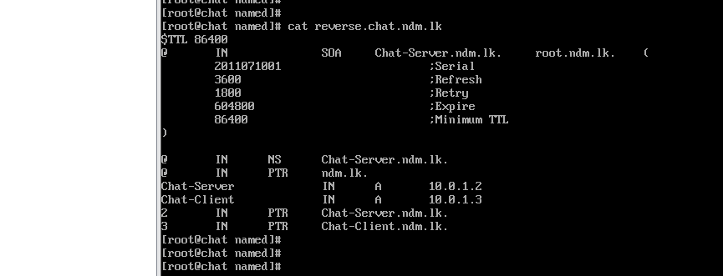

Figure 3. view the reverse file.

* Step 07

### Open the DHCP file in VI editor and add domain name and domain-name-server.

Command -> vi /etc/dhcp/dhcpd.conf

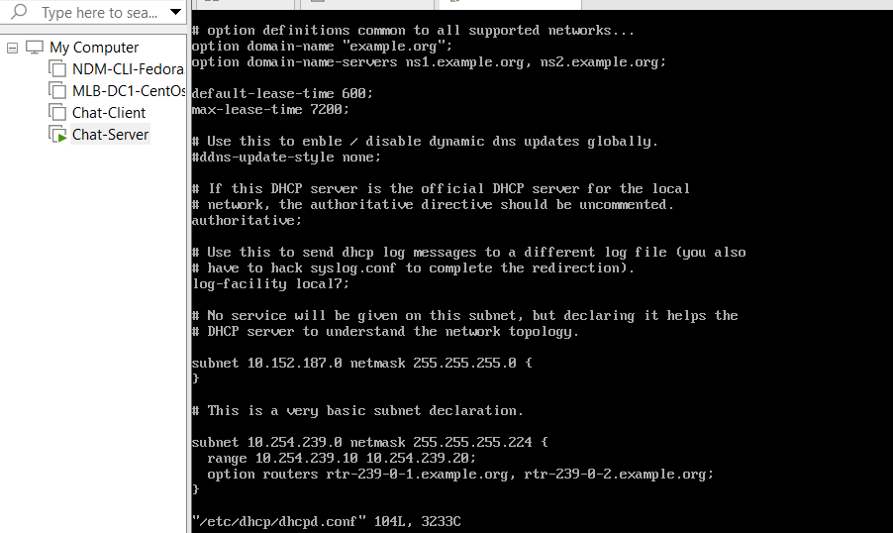

Figure 1. uncomment the authoritative

### Define the subnet and Range of IP addresses, domain name Servers. After that, save and exit the file

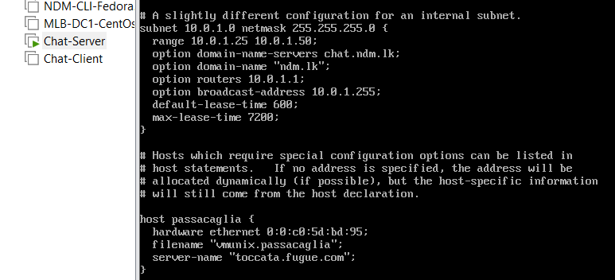

Figure 2. add the Ip ranges and domain name.

* Step 08

### Allow DNS communication via the firewall of Cent OS. Add the firewall in 53 port.

Command -> firewall-cmd –permanent –add-port=53/udp

Figure 1. add the firewall

### Load the firewall rules to the server firewall.

Command -> firewall-cmd --reload

Figure 2. reload the firewall.

* Step 09

### Testing the DNS Configuration file has errors or not, if file has no errors, then display the prompt again.

Command -> named-checkconf /etc/named.conf

Figure 1. checked the named file.

### Testing the Zone files has errors or not, if file has no errors, then display the serial number and OK status.

Command -> named-checkzone ndm.lk /var/named/forward.chat.ndm.lk

Command -> named-checkzone ndm.lk /var/named/reverse.chat.ndm.lk

Figure 2. checked the lookup files.

* Step 10

### After that, Open the resolve.conf file in VI editor and add these commands.

Command -> vi /etc/resolve.conf

Figure 1. open the resolve.conf file.

# Generated by NetworkManager

Search ndm.lk

nameserver 10.0.1.2

Figure 2. add the Ip and the name.

* Step 11

### Restart the DNS service ,DHCP service and run the dig commands.

Command -> service named start

Command -> service dhcpd start

Figure 1. restart the DHCP and Named files.

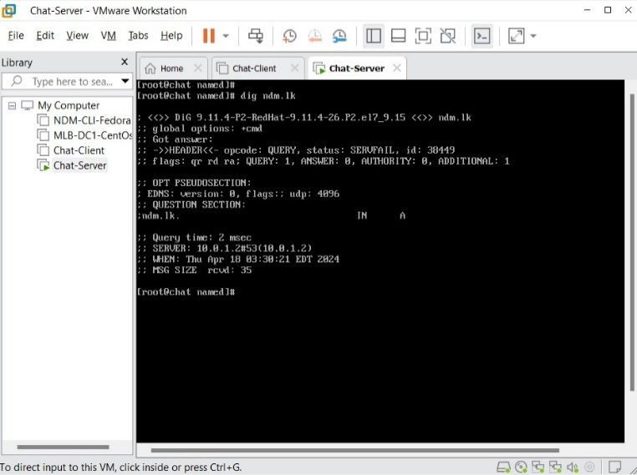

Figure 2. dig the ndm.lk.

Command -> dig ndm.lk

Command -> dig chat-server.ndm.lk.

Figure 2. dig the server.

## Socket Programming

* Step 01

### Install the GUI interface to the Server Machine

Command -> yum groups install “GNOME Desktop”

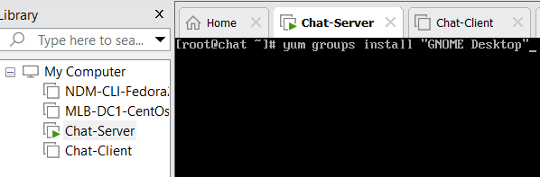

Figure 1. install the GNOME.

### After the installation, run the GNOME Desktop using startx command.

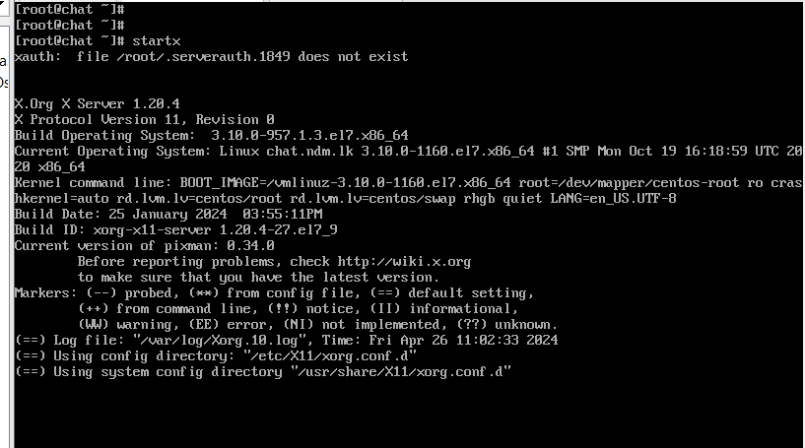

Command -> startx

Figure 2. running the GUI

### Create the server.c file in documents path and implement the server code.

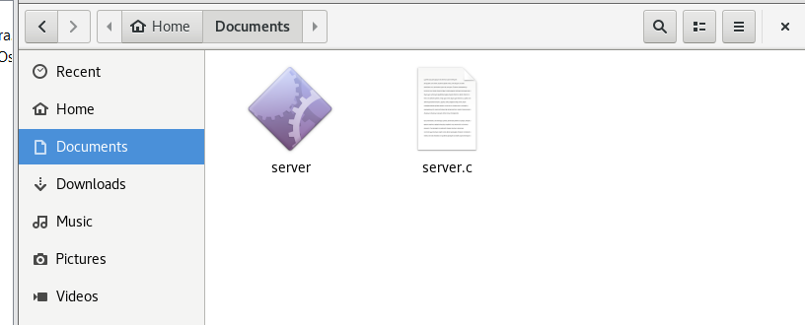

Figure 3. server code implementation

### After that, compile the server file and run it.

Command -> cc -o server server.c-lpthread -std=c99

Command ->. /server

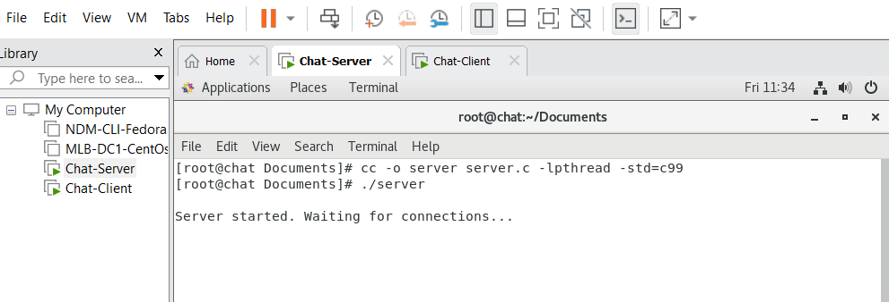

Figure 4. compile and run the server.

* Step 02

### Login to the Client Machine

Figure 1. login to the client

### Create a file called client.c in document folder and implement the client code.

Figure 2. create a client.c file.

### Compile the client code and run it.

Command -> cc -o client client.c-lpthread

Command ->. /client

Figure 3. compile the client file

* Outcome

### Server side



Figure 1. Server running

### Client side

Figure 2. Client running