**5. GENERATE PAYROLL PAGE**

GENERATE NEW

*EXTRA PAYRUN*

*REGULAR PAY RUN*

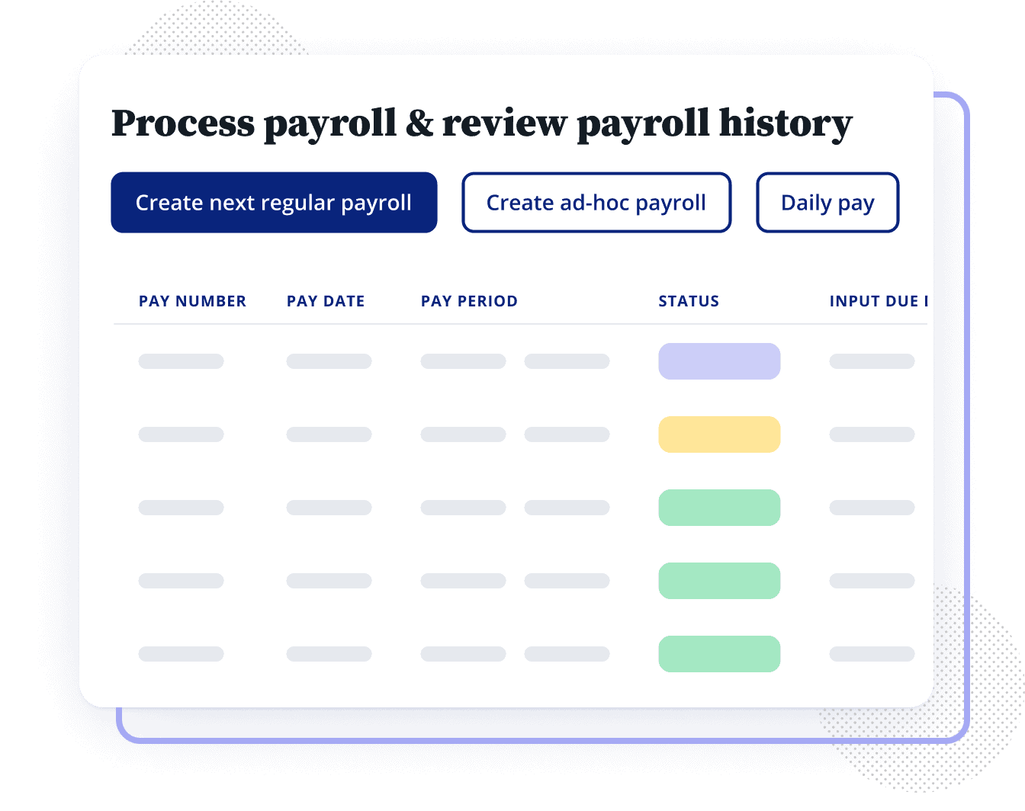

*PAY NOW*

**Action** 

*VIEW*

*VIEW*

*VIEW*

GENERATE SCREEN

*SCHEDULE TO PAY*

*PAY NOW*

PAGE SHOWS:

PAYRUN SCHEDULED FOR PAYMENT! (IT GETS ADDED INTO THE STATUS PAGE ON THE MAIN PAGE)

*SCHEDULED FOR PAYMENT*

Edit

Edit

Edit

Extra

E2

PAGE SHOWS:

PAYRUN SCHEDULED FOR PAYMENT! (IT GETS ADDED INTO THE STATUS PAGE ON THE MAIN PAGE)

*PAY NOW*

Automatically populated for regular payments from time sheets but can be overridden here.

Will need to have a plus sign to add employees for extra payrun.

Go to time sheets Icon next to each employee maybe.. which will automatically populate that persons timesheets and allow edits to keep things as clean as possible with overrides used only when necessary.

WHEN YOU CLCIK PAY NOW:

*Preview Submission Report*

* Banking data missing for Dave Smith
* Vacation payout exceeds accrued amount for Jenny Turner

*Process (or Submit) Payroll*

Payroll register will show OPEN. When closed the button will show for Submit Payroll

Additional note: for schedules they should be automatically generated then approved.

