**Free Captions Generator: Setup & Usage Guide**

This guide provides step-by-step instructions to **extract captions from a video, overlay captions, and record the final video using OBS Studio**. Follow the steps below to set up your environment and run the provided script files.

**1. Environment Setup**

**Extract/place the code files on your computer**

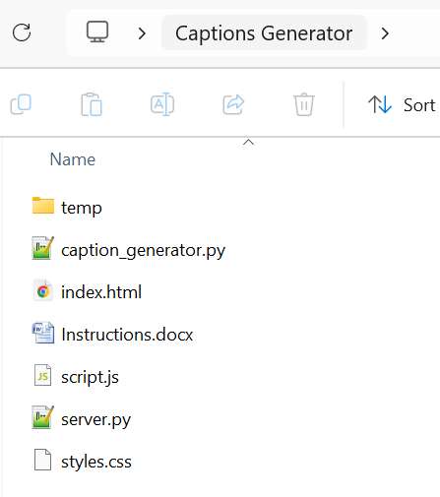

Before running the scripts, install the necessary dependencies.

**Install Python and Dependencies**

1. Download and install **Python 3.8+** from [python.org](https://www.python.org/downloads/).
2. Install required Python packages using below commands:

python -m venv venv

venv\Scripts\activate

pip install moviepy==2.0.0.dev2 openai-whisper flask flask_cors

1. Install FFmpeg (required for video processing):
   * Windows: Download from FFmpeg official site and add it to system PATH.
   * macOS: Install via Homebrew:
     + brew install ffmpeg
   * Linux:
     + sudo apt install ffmpegInstall OBS Studio (for recording)

**Install OBS Studio (for recording)**

* Download and install OBS Studio from [obsproject.com](https://obsproject.com/).

**2. Extract Captions from Video**

Use the caption_generator.py script to **extract captions** from a video file.

**Step 1: Run the Caption Extraction Script**

1. Place your **video file** (name input_video.mp4) in the same folder as caption_generator.py.
2. Open a terminal or command prompt and run:
3. python caption_generator.py
4. This script will:
   * Extract audio from the video.
   * Transcribe the speech using **Whisper AI**.
   * Save the captions in temp folder.

**Step 2: Verify the Captions**

* After the script runs, check the generated captions.

**3. Overlay Captions on Video**

Use the provided **HTML, CSS, and JavaScript** files to apply and customize captions on the video.

**Step 1: Start the server**

1. Open a terminal or command prompt and run:
   * python server.py
2. Open index.html

**Step 2: Load the Video with Captions**

* Play the video and see the captions overlayed in different styles.
* Use the dropdown menu to **change caption styles**.

**4. Record the Video with OBS Studio**

**Step 1: Open OBS Studio**

1. Launch **OBS Studio**.
2. Click **+** in the *Sources* panel and select **Window Capture**.
3. Choose your browser window displaying index.html.
4. Resize and position the capture area as needed.

**Step 2: Configure Recording Settings**

* **Output Format:** MP4 or MKV
* **Resolution:** Match your video’s resolution
* **Frame Rate:** 30-60 FPS for smooth playback
* **Audio:** Ensure your system audio is included

**Step 3: Start Recording**

* Click **Start Recording** and play the video.
* Once done, click **Stop Recording**, and your captioned video will be saved.

**5. Script Files Included for Users**

Users can download and modify the following script files:

* caption_generator.py – Extracts captions from the video.
* index.html – Displays video with captions.
* styles.css – Controls caption styling.
* script.js – Syncs captions with video playback.
* server.py – server to allow html/JavaScript code to access the captions files.

For additional customization, users can modify the CSS file to adjust fonts, colors, and animations.

**Final Notes**

* This guide ensures **free, high-quality captions** for videos.
* If you need assistance, feel free to ask questions in the comments!
* Enjoy creating captioned videos without paying for expensive services!