LAB MANUAL

Regulation : 2013

Branch : B.E. – CSE

Year & Semester : III Year / VI Semester
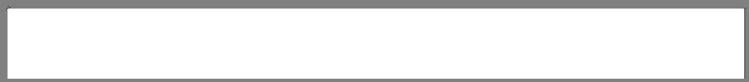

CS6611-MOBILE APPLICATION DEVELOPMENT LAB


ICAL ENG

BIT/CSE Department of Computer Science and Engineering

CS6611 MOBILE APPLICATION DEVELOPMENT LAB


ANNA UNIVERSITY: CHENNAI

REGULATION – 2013

SYLLABUS

CS6611 MOBILE APPLICATION DEVELOPMENT LABORATORY

OBJECTIVES:

The student should be made to:

Know the components and structure of mobile application development frameworks for Android and windows OS based mobiles.

Understand how to work with various mobile application development frameworks. Learn the basic and important design concepts and issues of development of mobile applications. Understand the capabilities and limitations of mobile devices.

LIST OF EXPERIMENTS:

1 .Develop an application that uses GUI components, Font and Colours

- Develop an application that uses Layout Managers and event listeners.

- Develop a native calculator application.

- Write an application that draws basic graphical primitives on the screen.

- Develop an application that makes use of database.

- Develop an application that makes use of RSS Feed.

- Implement an application that implements Multi threading

- Develop a native application that uses GPS location information.

- Implement an application that writes data to the SD card.

- Implement an application that creates an alert upon receiving a message.

- Write a mobile application that creates alarm clock

TOTAL: 45 PERIODS

BIT/CSE Department of Computer Science and Engineering

CS6611 MOBILE APPLICATION DEVELOPMENT LAB

INDEX

 |  |  | SIGNATURE
S.NO | DATE | EXPERIMENTS | OF THE | REMARKS
 |  |  | STAFF
1 |  | Develop an application that uses GUI components,
1 |  | Font and Colors
2 |  | Develop an application that uses Layout Managers
2 |  | and event listeners.
3 |  | Develop a native calculator application.
4 |  | Write an application that draws basic graphical
4 |  | primitives on the screen.
5 |  | Develop an application that makes use of database.
6 |  | Develop an application that makes use of RSS Feed.
7 |  | Implement an application that implements
7 |  | Multi-threading
8 |  | Develop a native application that uses GPS location
8 |  | information.
9 |  | Implement an application that writes data to the
9 |  | SD card.
10 |  | Implement an application that creates an alert upon
10 |  | receiving a message.
11 |  | Write a mobile application that creates alarm clock

BIT/CSE Department of Computer Science and Engineering

CS6611 MOBILE APPLICATION DEVELOPMENT LAB

Ex.No: 1

Date :

Develop an application that uses GUI components, Font and Colours

Simple application to change font size and color of text view

1) Open eclipse or android studio and select new android project
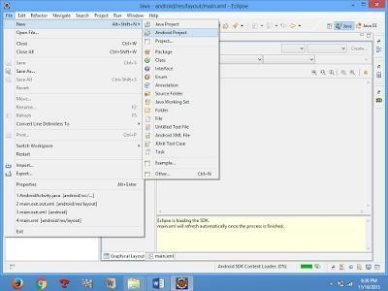

2)Give project name and select next

- Choose the android version. Choose the lowest android version (Android 2.2) and select next

- Enter the package name. Package name must be two word separated by comma and click finish

- Go to package explorer in the left hand side. Select our project.

- Go to res folder and select layout. Double click the main.xml file

- Now you can see the Graphics layout window.

BIT/CSE Department of Computer Science and Engineering

CS6611 MOBILE APPLICATION DEVELOPMENT LAB
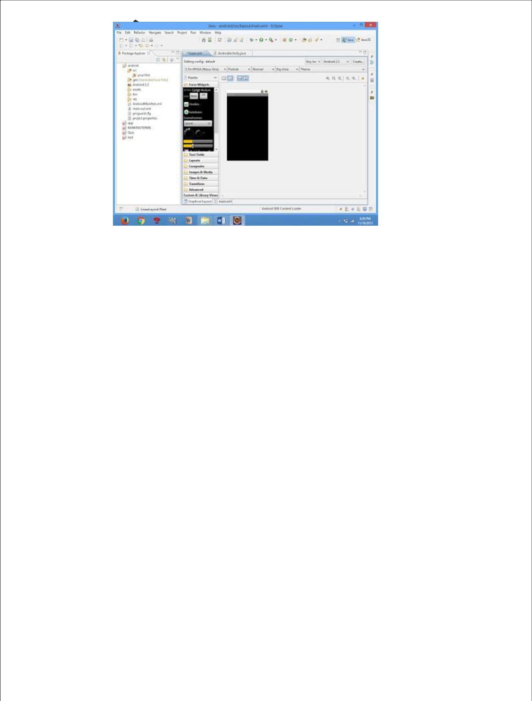

8) Click the main.xml file and type the code below

Code:

<?xml version="1.0" encoding="utf-8"?>

<LinearLayout

xmlns:android="http://schemas.android.com/apk/res/android"

android:layout_width="fill_parent" android:layout_height="fill_parent"

android:orientation="vertical" >

<TextView

android:id="@+id/textView1"

android:layout_width="match_parent"

android:layout_height="wrap_content"

android:layout_margin="20sp"

android:gravity="center"

android:text="HELLO WORLD"

android:textSize="20sp"

android:textStyle="bold" />

<Button

android:id="@+id/button1"

android:layout_width="match_parent"

android:layout_height="wrap_content"

BIT/CSE Department of Computer Science and Engineering

CS6611 MOBILE APPLICATION DEVELOPMENT LAB

android:gravity="center"

android:text="Change font size"

android:textSize="20sp" />

<Button

android:id="@+id/button2"

android:layout_width="match_parent"

android:layout_height="wrap_content"

android:gravity="center"

android:text="Change color"

android:textSize="20sp" />

<Button

android:id="@+id/button3"

android:layout_width="match_parent"

android:layout_height="wrap_content"

android:gravity="center"

android:text="Change font"

android:textSize="20sp" />

</LinearLayout>

9) Again click the graphics layout tab and screen layout is look like below
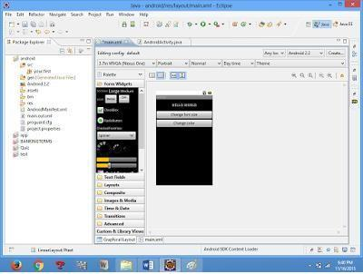

- Go to project explorer and select src folder.Now select mainactivity.java file and type the following code.

BIT/CSE Department of Computer Science and Engineering

CS6611 MOBILE APPLICATION DEVELOPMENT LAB

PROGRAM

import android.R; import

android.app.Activity; import

android.graphics.Color; import

android.graphics.Typeface; import

android.os.Bundle; import

android.view.View; import

android.widget.Button; import

android.widget.TextView;

public class AndroidActivity extends Activity

{ float font =24; int i=1;

@Override public void

onCreate(Bundle savedInstanceState) {

super.onCreate(savedInstanceState);

setContentView(R.layout.main);

final TextView t1=(TextView)

findViewById(R.id.textView1); Button

b1 = (Button) findViewById(R.id.button1);

b1.setOnClickListener(new

View.OnClickListener() {

public void onClick(View view) {

t1.setTextSize(font);

font=font+4; if(font==40)

font=20;

}

});

Button b2 = (Button)

findViewById(R.id.button2);

b2.setOnClickListener(new

View.OnClickListener()
{

BIT/CSE Department of Computer Science and Engineering

CS6611 MOBILE APPLICATION DEVELOPMENT LAB

public void onClick(View view) {

switch(i)

{
case 1:
t1.setTextColor(Color.parseColor("#0000FF"));
break;

case 2:
t1.setTextColor(Color.parseColor("#00FF00

"));
break;

case 3:

t1.setTextColor(Color.parseColor("#FF0000"));

break; case 4:

t1.setTextColor(Color.parseColor("#800000")); break;

}
i++;

if(i==5)

i=1;

}

});
} }

11) Now go to main.xml and right click .select run as option and select run configuration
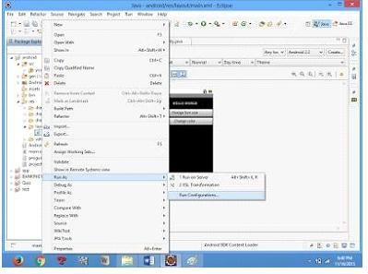

BIT/CSE Department of Computer Science and Engineering

CS6611 MOBILE APPLICATION DEVELOPMENT LAB

12) Android output is present in the android emulator as shown in below.

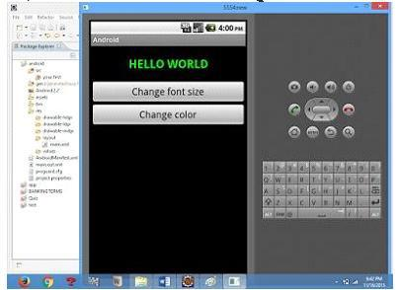

BIT/CSE Department of Computer Science and Engineering

CS6611 MOBILE APPLICATION DEVELOPMENT LAB

Ex.No : 2

Date :

DEVELOP AN APPLICATION THAT USES LAYOUT

MANAGERS AND EVENT LISTENERS

- Open eclipse or android studio and select new android project

- Give project name and select next

- Choose the android version. Choose the lowest android version (Android 2.2) and select next

- Enter the package name. Package name must be two word separated by comma and click finish

- Go to package explorer in the left hand side. select our project.

- Go to res folder and select layout. Double click the main.xml file. Add the code below

<RelativeLayout

xmlns:android="http://schemas.android.com/apk/res/android"

android:id="@+id/relativeLayout1" android:layout_width="fill_parent"

android:layout_height="fill_parent" >

<LinearLayout

android:id="@+id/linearLayout1"

android:layout_width="wrap_content"

android:layout_height="wrap_content"

android:layout_alignParentLeft="true"

android:layout_alignParentRight="true"

android:layout_alignParentTop="true" >

<TextView

android:layout_width="wrap_content"

android:layout_height="wrap_content"

android:layout_gravity="center"

android:text="ADDITION"

android:textSize="20dp" >

BIT/CSE Department of Computer Science and Engineering

CS6611 MOBILE APPLICATION DEVELOPMENT LAB

</TextView>

</LinearLayout><LinearLayout

android:id="@+id/linearLayout2"

android:layout_width="wrap_content"

android:layout_height="wrap_content"

android:layout_alignParentLeft="true"

android:layout_alignParentRight="true"

android:layout_below="@+id/linearLayout1" >

<TextView

android:layout_width="wrap_content"

android:layout_height="wrap_content"

android:text="ENTER NO 1" >

</TextView><EditText

android:layout_width="wrap_content"

android:layout_height="wrap_content"

android:layout_weight="0.20"

android:id="@+id/edittext1"

android:inputType="number">

</EditText>

</LinearLayout><LinearLayout

android:id="@+id/linearLayout3"

android:layout_width="wrap_content"

android:layout_height="wrap_content"

android:layout_alignParentLeft="true"

android:layout_alignParentRight="true"

android:layout_below="@+id/linearLayout2" >

<TextView

android:layout_width="wrap_content"

android:layout_height="wrap_content"

android:text="ENTER NO 2" >

</TextView><EditText

android:layout_width="wrap_content"

BIT/CSE Department of Computer Science and Engineering

CS6611 MOBILE APPLICATION DEVELOPMENT LAB

android:layout_height="wrap_content"

android:layout_weight="0.20"

android:id="@+id/edittext2"

android:inputType="number">

</EditText>

</LinearLayout><LinearLayout

android:id="@+id/linearLayout4"

android:layout_width="wrap_content"

android:layout_height="wrap_content"

android:layout_alignParentLeft="true"

android:layout_alignParentRight="true"

android:layout_below="@+id/linearLayout3" >

<Button

android:layout_width="wrap_content"

android:id="@+id/button1"

android:layout_height="wrap_content"

android:text="Addition"

android:layout_weight="0.50" />

<Button

android:layout_width="wrap_content"

android:id="@+id/button3"

android:layout_height="wrap_content"

android:text="subtraction"

android:layout_weight="0.50" />

<Button

android:layout_width="wrap_content"

android:id="@+id/button2"

android:layout_height="wrap_content"

android:text="CLEAR"

android:layout_weight="0.50" />

</LinearLayout>

BIT/CSE Department of Computer Science and Engineering

CS6611 MOBILE APPLICATION DEVELOPMENT LAB

<View

android:layout_height="2px"

android:layout_width="fill_parent"

android:layout_below="@+id/linearLayout4"

android:background="#DDFFDD"/>

</RelativeLayout>

7) Now select mainactivity.java file and type the following code.

package layout.ne;

import android.app.Activity;

import android.os.Bundle;

import android.view.View;

import

android.view.View.OnClickListener;

import android.widget.Button; import

android.widget.EditText; import

android.widget.Toast;

public class LAYOUTActivity

extends Activity {

/** Called when the activity is first created. */ EditText txtData1,txtData2; float num1,num2,result1,result2;

@Override

public void onCreate(Bundle

savedInstanceState) {

super.onCreate(savedInstanceSt

ate);

setContentView(R.layout.main);

Button add = (Button)

findViewById(R.id.button1);

add.setOnClickListener(new

BIT/CSE Department of Computer Science and Engineering

CS6611 MOBILE APPLICATION DEVELOPMENT LAB

OnClickListener() { public

void onClick(View v) {

try

{

txtData1 = (EditText)

findViewById(R.id.edittext1);

txtData2 = (EditText)

findViewById(R.id.edittext2);

num1 =

Float.parseFloat(txtData1.getTe

xt().toString()); num2

=

Float.parseFloat(txtData2.getTe

xt().toString());

result1=num1+num2;

Toast.makeText(getBaseContext(),"ANSWER:"+result1,Toast.LENGTH_SHORT).show();

}

catch(Exception e)

{

Toast.makeText(getBaseContext(), e.getMessage(),

Toast.LENGTH_SHORT).show();

}

}

});

Button sub = (Button) findViewById(R.id.button3); sub.setOnClickListener(new OnClickListener() {

public void onClick(View v) {

try

{

BIT/CSE Department of Computer Science and Engineering

CS6611 MOBILE APPLICATION DEVELOPMENT LAB

txtData1 = (EditText) findViewById(R.id.edittext1);

txtData2 = (EditText) findViewById(R.id.edittext2); num1 =

Float.parseFloat(txtData1.getText().toString()); num2 =

Float.parseFloat(txtData2.getText().toString());

result2=num1-num2;

Toast.makeText(getBaseContext(),"ANSWER:"+result2,Toast.LENGTH_SHORT).show();

}

catch(Exception e)

{

Toast.makeText(getBaseContext(), e.getMessage(),

Toast.LENGTH_SHORT).show();

}

}

});

Button clear = (Button) findViewById(R.id.button2); clear.setOnClickListener(new OnClickListener() {

public void onClick(View v) {

try

{

txtData1.setText("");

txtData2.setText("");

}

catch(Exception e)

{

Toast.makeText(getBaseContext(), e.getMessage(),

Toast.LENGTH_SHORT).show();

}

}

});

} }

BIT/CSE Department of Computer Science and Engineering

CS6611 MOBILE APPLICATION DEVELOPMENT LAB

- Now go to main.xml and right click .select run as option and select run configuration

- Android output is present in the android emulator as shown in below.
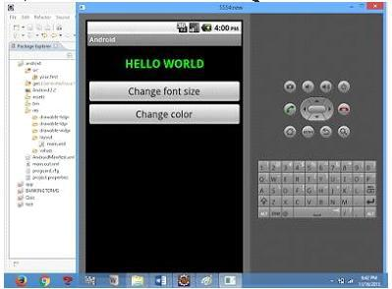

BIT/CSE Department of Computer Science and Engineering

CS6611 MOBILE APPLICATION DEVELOPMENT LAB

Ex.No : 3

Date :

DEVELOP A NATIVE CALCULATOR APPLICATION

- Open eclipse or android studio and select new android project

- Give project name and select next

- Choose the android version. Choose the lowest android version(Android 2.2) and select next

- Enter the package name. package name must be two word separated by comma and click finish

- Go to package explorer in the left hand side. select our project.

- Go to res folder and select layout. Double click the main.xml file. Add the code below

Main.xml coding

<?xml version="1.0" encoding="utf-8"?>

<LinearLayout

xmlns:android="http://schemas.android.com/apk/res/android"

android:orientation="vertical"

android:layout_width="fill_parent"

android:layout_height="fill_parent">

<LinearLayout android:layout_width="match_parent" android:layout_height="wrap_content" android:id="@+id/linearLayout1" android:layout_marginLeft="10pt" android:layout_marginRight="10pt" android:layout_marginTop="3pt">

<EditText android:layout_weight="1"

android:layout_height="wrap_content"

android:layout_marginRight="5pt"

android:id="@+id/etNum1"

android:layout_width="match_parent"

android:inputType="numberDecimal">

BIT/CSE Department of Computer Science and Engineering

CS6611 MOBILE APPLICATION DEVELOPMENT LAB

</EditText><EditText

android:layout_height="wrap_content"

android:layout_weight="1"

android:layout_marginLeft="5pt"

android:id="@+id/etNum2"

android:layout_width="match_parent"

android:inputType="numberDecimal">

</EditText>

</LinearLayout><LinearLayout

android:layout_width="match_parent"

android:layout_height="wrap_content"

android:id="@+id/linearLayout2"

android:layout_marginTop="3pt"

android:layout_marginLeft="5pt"

android:layout_marginRight="5pt">

<Button android:layout_height="wrap_content" android:layout_width="match_parent"

android:layout_weight="1" android:text="+"

android:textSize="15pt"

android:id="@+id/btnAdd">

</Button><Button

android:layout_height="wrap_content"

android:layout_width="match_parent"

android:layout_weight="1" android:text="-"

android:textSize="15pt" android:id="@+id/btnSub">

</Button><Button

android:layout_height="wrap_content"

android:layout_width="match_parent"

android:layout_weight="1" android:text="*"

android:textSize="15pt" android:id="@+id/btnMult">

</Button><Button

android:layout_height="wrap_content"

android:layout_width="match_parent"

BIT/CSE Department of Computer Science and Engineering

CS6611 MOBILE APPLICATION DEVELOPMENT LAB

android:layout_weight="1" android:text="/"

android:textSize="15pt"

android:id="@+id/btnDiv"></Button>

</LinearLayout><TextView

android:layout_height="wrap_content"

android:layout_width="match_parent"

android:layout_marginLeft="5pt"

android:layout_marginRight="5pt"

android:textSize="12pt"

android:layout_marginTop="3pt"

android:id="@+id/tvResult"

android:gravity="center_horizontal">

</TextView>

</LinearLayout>

7) Now select mainactivity.java file and type the following code. package

MainActivity.java coding package CALCU.CALU; import android.app.Activity; import android.os.Bundle;

import android.text.TextUtils;

import android.view.View;

import

android.view.View.OnClickListener;

import android.widget.Button; import

android.widget.EditText; import

android.widget.TextView;

public class CALCULATORActivity extends Activity implements OnClickListener { EditText input1;

EditText input2;

Button addition;

Button subtraction;

BIT/CSE Department of Computer Science and Engineering

CS6611 MOBILE APPLICATION DEVELOPMENT LAB

Button multiplication;

Button division;

TextView tvResult;

String oper = "";

@Override

public void onCreate(Bundle savedInstanceState) { super.onCreate(savedInstanceState);

setContentView(R.layout.main); input1 =

(EditText) findViewById(R.id.etNum1); input2

= (EditText) findViewById(R.id.etNum2);

addition = (Button) findViewById(R.id.btnAdd); subtraction = (Button) findViewById(R.id.btnSub); multiplication = (Button) findViewById(R.id.btnMult); division = (Button) findViewById(R.id.btnDiv); tvResult = (TextView) findViewById(R.id.tvResult);

- set a listener addition.setOnClickListener(this); subtraction.setOnClickListener(this); multiplication.setOnClickListener(this); division.setOnClickListener(this);

}

@Override

public void onClick(View v) { // TODO Auto-generated method stub

float num1 = 0; float num2 = 0;

float result = 0;

BIT/CSE Department of Computer Science and Engineering

CS6611 MOBILE APPLICATION DEVELOPMENT LAB

// check if the fields are empty if

(TextUtils.isEmpty(input1.getText().toString())

|| TextUtils.isEmpty(input2.getText().toString())) {

return; }

- read EditText and fill variables with numbers num1 = Float.parseFloat(input1.getText().toString()); num2 = Float.parseFloat(input2.getText().toString());

- defines the button that has been clicked and performs the corresponding operation

- write operation into oper, we will use it later for

output switch (v.getId()) { case R.id.btnAdd:

oper = "+"; result

- num1 + num2;

break; case R.id.btnSub:

oper = "-"; result

- num1 - num2;

break;case R.id.btnMult:

oper = "*"; result

- num1 * num2;

break;case R.id.btnDiv:

oper = "/"; result

- num1 / num2; break; default: break;

}

BIT/CSE Department of Computer Science and Engineering

CS6611 MOBILE APPLICATION DEVELOPMENT LAB

// form the output line

tvResult.setText(num1 + " " + oper + " " + num2 + " = " + result);

}

}

8) Android output is present in the android emulator as Shown in below

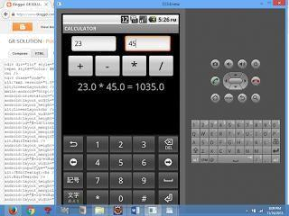

BIT/CSE Department of Computer Science and Engineering

CS6611 MOBILE APPLICATION DEVELOPMENT LAB

Ex. No : 4

Date :

WRITE AN APPLICATION THAT DRAWS BASIC GRAPHICAL

PRIMITIVES ON THE SCREEN IN ANDROID

- Open eclipse or android studio and select new android project

- Give project name and select next

- Choose the android version. Choose the lowest android version(Android 2.2) and select next

- Enter the package name. package name must be two word separated by comma and click finish

- Go to package explorer in the left hand side. select our project.

- Go to res folder and select layout. Double click the main.xml file. Don’t change anything in layout. Leave as default.
- Now select mainactivity.java file and type the following code.

package Basic.primitive;

import

android.app.Activity;

import

android.content.Context;

import

android.graphics.Canvas

- import android.graphics.Color; import android.graphics.Paint; import android.os.Bundle; import android.view.View;

BIT/CSE Department of Computer Science and Engineering

CS6611 MOBILE APPLICATION DEVELOPMENT LAB

public class BasicprimitiveActivity extends Activity { /** Called when the activity is first created. */ @Override

public void onCreate(Bundle savedInstanceState) { super.onCreate(savedInstanceState); setContentView(new myview(this)); }

private class myview extends View

{

public myview(Context context)

{

super(context);

}

@Override

protected void onDraw(Canvas canvas)

{
super.onDraw(canvas); | Paint
paint=new Paint();
paint.setTextSize(40);
paint.setColor(Color.GREEN);
canvas.drawText("Circle", 55, 30,
paint);
paint.setColor(Color.RED);
canvas.drawCircle(100, 150,100, paint);
paint.setColor(Color.GREEN);
canvas.drawText("Rectangle", 255, 30, paint);
paint.setColor(Color.YELLOW); |  | canvas.drawRect(250,
50,400,350, paint); | paint.setColor(Color.GREEN);
canvas.drawText("SQUARE", 55, 430, paint);
paint.setColor(Color.BLUE); |  | canvas.drawRect(50,
450,150,550, paint); | paint.setColor(Color.GREEN);

BIT/CSE Department of Computer Science and Engineering

CS6611 MOBILE APPLICATION DEVELOPMENT LAB

canvas.drawText("LINE", 255, 430, paint);

paint.setColor(Color.CYAN);

canvas.drawLine(250, 500, 350, 500, paint);

}

}

}

- Now go to main.xml and right click .select run as option and select run configuration

- Android output is present in the android emulator as shown in below.
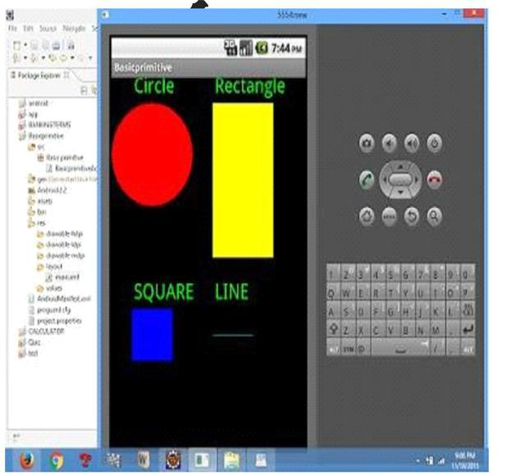

BIT/CSE Department of Computer Science and Engineering

CS6611 MOBILE APPLICATION DEVELOPMENT LAB

Ex.No : 5

Date :

DEVELOP AN APPLICATION THAT MAKES USE OF

DATABASE

- Open eclipse or android studio and select new android project

- Give project name and select next

- Choose the android version. Choose the lowest android version (Android 2.2) and select next

- Enter the package name. package name must be two word separated by comma and click finish

- Go to package explorer in the left hand side. select our project.

- Go to res folder and select layout. Double click the main.xml file. Add the code below

<?xml version="1.0" encoding="utf-8"?>

<AbsoluteLayout

xmlns:android="http://schemas.android.com/apk/res/android"

android:id="@+id/myLayout" android:stretchColumns="0" android:layout_width="fill_parent" android:layout_height="fill_parent"><TextView

android:text="@string/title" android:layout_x="110dp"

android:layout_y="10dp"

android:layout_width="wrap_content"

android:layout_height="wrap_content"/><TextView

android:text="@string/empid"

android:layout_x="30dp" android:layout_y="50dp" android:layout_width="wrap_content" android:layout_height="wrap_content"/><EditTe xt android:id="@+id/editEmpid" android:inputType="number" android:layout_x="150dp" android:layout_y="50dp"

BIT/CSE Department of Computer Science and Engineering

CS6611 MOBILE APPLICATION DEVELOPMENT LAB

android:layout_width="150dp" android:layout_height="40dp"/><TextView android:text="@string/name" android:layout_x="30dp" android:layout_y="100dp" android:layout_width="wrap_content" android:layout_height="wrap_content"/><EditTe xt android:id="@+id/editName" android:inputType="text" android:layout_x="150dp" android:layout_y="100dp" android:layout_width="150dp" android:layout_height="40dp"/><TextView android:text="@string/salary"

android:layout_x="30dp" android:layout_y="150dp" android:layout_width="wrap_content" android:layout_height="wrap_content"/><EditText android:id="@+id/editsalary" android:inputType="number" android:layout_x="150dp" android:layout_y="150dp" android:layout_width="150dp" android:layout_height="40dp"/><Button android:id="@+id/btnAdd" android:text="@string/add" android:layout_x="30dp" android:layout_y="200dp" android:layout_width="130dp" android:layout_height="40dp"/><Button android:id="@+id/btnDelete" android:text="@string/delete"

BIT/CSE Department of Computer Science and Engineering

CS6611 MOBILE APPLICATION DEVELOPMENT LAB

android:layout_x="160dp"

android:layout_y="200dp"

android:layout_width="130dp"

android:layout_height="40dp"/>n <Button

android:id="@+id/btnModify"

android:text="@string/modify"

android:layout_x="30dp"

android:layout_y="250dp"

android:layout_width="130dp"

android:layout_height="40dp"/><Button

android:id="@+id/btnView"

android:text="@string/view"

android:layout_x="160dp"

android:layout_y="250dp"

android:layout_width="130dp"

android:layout_height="40dp"/><Button

android:id="@+id/btnViewAll"

android:text="@string/view_all"

android:layout_x="85dp"

android:layout_y="300dp"

android:layout_width="150dp"

android:layout_height="40dp"/>

</AbsoluteLayout>

7)Go to values folder and select string.xml file. Replace the code below

<?xml version="1.0" encoding="utf-8"?>

<resources>

<string name="app_name">Employee detail1</string>

<string name="hello">Hello World, Employee detail Activity!</string><string name="title">Employee Details</string>

<string name="empid">Enter Employee ID: </string>

BIT/CSE Department of Computer Science and Engineering

CS6611 MOBILE APPLICATION DEVELOPMENT LAB

<string name="name">Enter Name: </string> <string name="salary">Enter salary: </string> <string name="add">Add Employee</string> <string name="delete">Delete Employee</string> <string name="modify">Modify Employee</string> <string name="view">View Employee</string> <string name="view_all">View All Employee</string> </resources>

- Now select mainactivity.java file and type the following code.In my coding maniactivity name is EmployeedetailActivity.

package employee.detail;

//import android.R; import android.app.Activity; import android.app.AlertDialog.Builder; import android.content.Context; import android.database.Cursor; import

android.database.sqlite.SQLiteDatabase;

import android.os.Bundle; import

android.view.View;

import

android.view.View.OnClickListener;

import android.widget.Button; import

android.widget.EditText;

public class EmployeedetailActivity extends Activity implements OnClickListener { EditText editEmpid,editName,editsalary;

Button btnAdd,btnDelete,btnModify,btnView,btnViewAll; SQLiteDatabase db;

/** Called when the activity is first created. */

@Override

public void onCreate(Bundle savedInstanceState)

{

BIT/CSE Department of Computer Science and Engineering

CS6611 MOBILE APPLICATION DEVELOPMENT LAB

super.onCreate(savedInstanceState);

setContentView(R.layout.main);

editEmpid=(EditText)findViewById(R.id.editEmpid);

editName=(EditText)findViewById(R.id.editName);

editsalary=(EditText)findViewById(R.id.editsalary);

btnAdd=(Button)findViewById(R.id.btnAdd);

btnDelete=(Button)findViewById(R.id.btnDelete);

btnModify=(Button)findViewById(R.id.btnModify);

btnView=(Button)findViewById(R.id.btnView);

btnViewAll=(Button)findViewById(R.id.btnViewAll);

btnAdd.setOnClickListener(this);

btnDelete.setOnClickListener(this);

btnModify.setOnClickListener(this);

btnView.setOnClickListener(this);

btnViewAll.setOnClickListener(this);

db=openOrCreateDatabase("EmployeeDB", Context.MODE_PRIVATE, null);

db.execSQL("CREATE TABLE IF NOT EXISTS employee(empid VARCHAR,name

VARCHAR,salary VARCHAR);");

}

public void onClick(View view)

{

if(view==btnAdd)

{

if(editEmpid.getText().toString().trim().length()==0|| editName.getText().toString().trim().length()==0|| editsalary.getText().toString().trim().length()==0)
{

showMessage("Error", "Please enter all values");

return;

}

db.execSQL("INSERT INTO employee VALUES('"+editEmpid.getText()+"','"+editName.getText()+

BIT/CSE Department of Computer Science and Engineering

CS6611 MOBILE APPLICATION DEVELOPMENT LAB

"','"+editsalary.getText()+"');");

showMessage("Success", "Record added");

clearText();

}

if(view==btnDelete)

{

if(editEmpid.getText().toString().trim().length()==0)

{

showMessage("Error", "Please enter Employee id");

return; }

Cursor c=db.rawQuery("SELECT * FROM employee WHERE

empid='"+editEmpid.getText()+"'", null);

if(c.moveToFirst())

{

db.execSQL("DELETE FROM employee WHERE empid='"+editEmpid.getText()+"'"); showMessage("Success", "Record Deleted");

}else

{

showMessage("Error", "Invalid Employee id");

}

clearText();

}

if(view==btnModify)

{

if(editEmpid.getText().toString().trim().length()==0)

{

showMessage("Error", "Please enter Employee id"); return;

}

Cursor c=db.rawQuery("SELECT * FROM employee WHERE

BIT/CSE Department of Computer Science and Engineering

CS6611 MOBILE APPLICATION DEVELOPMENT LAB

empid='"+editEmpid.getText()+"'", null);

if(c.moveToFirst())

{

db.execSQL("UPDATE employee SET name='"+editName.getText()+"',salary='"+editsalary.getTe
xt()+ "' WHERE

empid='"+editEmpid.getText()+"'");

showMessage("Success", "Record Modified");

}

else

{

showMessage("Error", "Invalid Rollno");

}

clearText();

}

if(view==btnView)

{

if(editEmpid.getText().toString().trim().length()==0)

{

showMessage("Error", "Please enter Employee id");

return;

}

Cursor c=db.rawQuery("SELECT * FROM employee WHERE

empid='"+editEmpid.getText()+"'", null);

if(c.moveToFirst())

{

editName.setText(c.getString(1));

editsalary.setText(c.getString(2));

}

else

{

BIT/CSE Department of Computer Science and Engineering

CS6611 MOBILE APPLICATION DEVELOPMENT LAB

showMessage("Error", "Invalid Employee id");

clearText();

}

}

if(view==btnViewAll)

{

Cursor c=db.rawQuery("SELECT * FROM employee", null); if(c.getCount()==0)

{
showMessage("Error", "No records found"); | return;
}
StringBuffer buffer=new StringBuffer(); | while(c.moveToNext())
{

buffer.append("Employee id: "+c.getString(0)+"\n");

buffer.append("Name: "+c.getString(1)+"\n");

buffer.append("salary: "+c.getString(2)+"\n\n");

}

showMessage("Employee details Details", buffer.toString());

}

}

public void showMessage(String title,String message)

{

Builder builder=new Builder(this);

builder.setCancelable(true); builder.setTitle(title); builder.setMessage(message);

builder.show();

}

public void clearText()

{

editEmpid.setText(""); editName.setText("");

editsalary.setText("");

editEmpid.requestFocus();

BIT/CSE Department of Computer Science and Engineering

CS6611 MOBILE APPLICATION DEVELOPMENT LAB

}

}

  - Now go to main.xml and right click .select run as option and select run configuration

- Android output is present in the android emulator as shown in below.
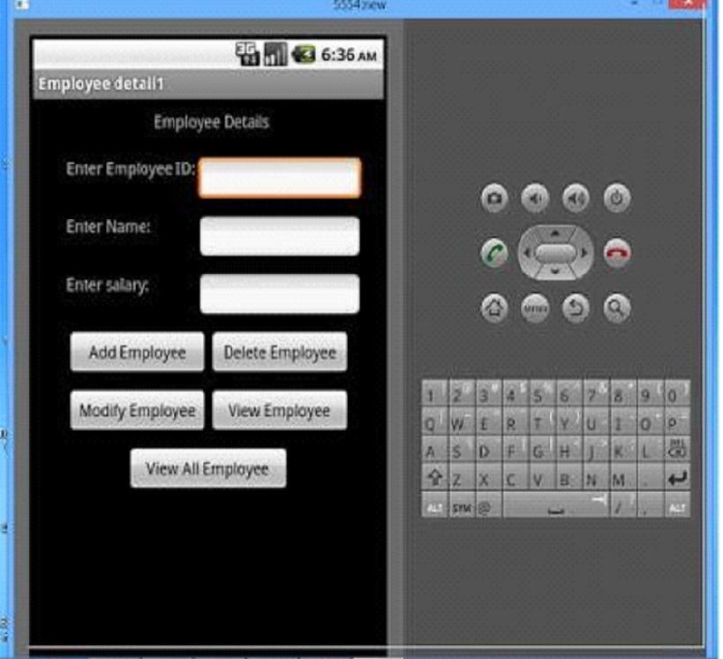

BIT/CSE Department of Computer Science and Engineering

CS6611 MOBILE APPLICATION DEVELOPMENT LAB

Ex. No : 6

Date :

DEVELOP AN APPLICATION THAT MAKES USE OF RSS FEED

- Open eclipse or android studio and select new android project

- Give project name and select next

- Choose the android version. Choose the lowest android version (Android 2.2) and select next

- Enter the package name. Package name must be two word separated by comma and click finish

- Go to package explorer in the left hand side. Select our project.

- Go to res folder and select layout. Double click the main.xml file

- Now you can see the Graphics layout window.
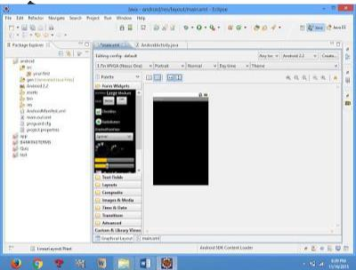

8) Click the main.xml file and type the code below

Code:

<?xml version="1.0" encoding="utf-8"?>

<LinearLayout

xmlns:android="http://schemas.android.com/apk/res/android"

BIT/CSE Department of Computer Science and Engineering

CS6611 MOBILE APPLICATION DEVELOPMENT LAB

android:layout_width="fill_parent" android:layout_height="fill_parent"

android:orientation="vertical" >

<TextView

android:id="@+id/textView1"

android:layout_width="match_parent"

android:layout_height="wrap_content"

android:layout_margin="20sp"

android:gravity="center"

android:text="HELLO WORLD"

android:textSize="20sp"

android:textStyle="bold" />

<Button

android:id="@+id/button1"

android:layout_width="match_parent"

android:layout_height="wrap_content"

android:gravity="center"

android:text="Change font size"

android:textSize="20sp" />

<Button

android:id="@+id/button2"

android:layout_width="match_parent"

android:layout_height="wrap_content"

android:gravity="center"

android:text="Change color"

android:textSize="20sp" />

<Button

android:id="@+id/button3"

android:layout_width="match_parent"

android:layout_height="wrap_content"

android:gravity="center"

android:text="Change font"

android:textSize="20sp" />

BIT/CSE Department of Computer Science and Engineering

CS6611 MOBILE APPLICATION DEVELOPMENT LAB

</LinearLayout>

9) Again click the graphics layout tab and screen layout is look like below
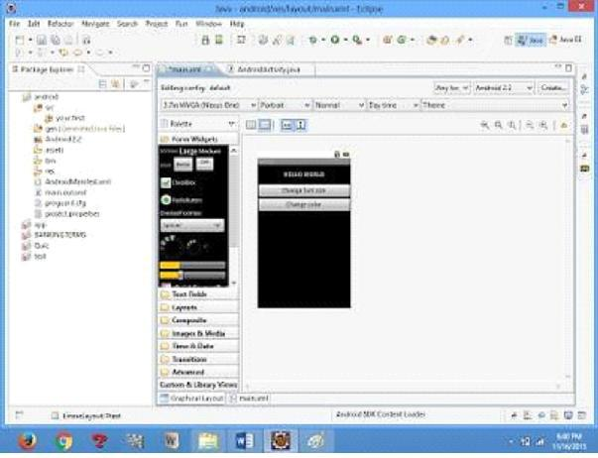

- Go to project explorer and select src folder.Now select mainactivity.java file and type the following code.

PROGRAM
import android.R; import
android.app.Activity; import
android.graphics.Color; import
android.graphics.Typeface; import
android.os.Bundle; import
android.view.View; import
android.widget.Button; import
android.widget.TextView;
public class AndroidActivity extends Activity { |  |  | float
font =24; | int i=1;
@Override public void onCreate(Bundle
savedInstanceState) {
super.onCreate(savedInstanceState); |  | setContentView(R.layout.main);

BIT/CSE Department of Computer Science and Engineering

CS6611 MOBILE APPLICATION DEVELOPMENT LAB

final TextView t1=(TextView) findViewById(R.id.textView1); Button b1

= (Button) findViewById(R.id.button1);

b1.setOnClickListener(new View.OnClickListener() {

public void onClick(View view) {

t1.setTextSize(font);

font=font+4; if(font==40)

font=20;

}

});

Button b2 = (Button) findViewById(R.id.button2);

b2.setOnClickListener(new View.OnClickListener() {

public void onClick(View view) {

switch(i)

{ case 1:

t1.setTextColor(Color.parseColor("#0000FF"));

break; case 2:

t1.setTextColor(Color.parseColor("#00FF00"));

break; case 3:

t1.setTextColor(Color.parseColor("#FF0000"));

break; case 4:

t1.setTextColor(Color.parseColor("#800000")); break;

} i++;

if(i==5)

i=1;

}

});

} }

BIT/CSE Department of Computer Science and Engineering

CS6611 MOBILE APPLICATION DEVELOPMENT LAB

8) Now go to main.xml and right click .select run as option and select run configuration

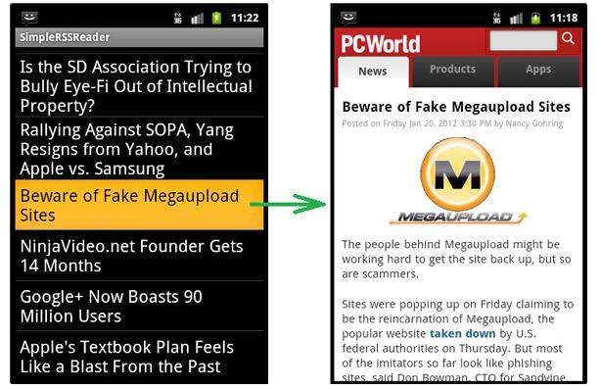

BIT/CSE Department of Computer Science and Engineering

CS6611 MOBILE APPLICATION DEVELOPMENT LAB

Ex. No: 7

Date :

IMPLEMENT AN APPLICATION THAT IMPLEMENTS

MULTI THREADING

- Open eclipse or android studio and select new android project

- Give project name and select next

- Choose the android version. Choose the lowest android version (Android 2.2) and select next

  - Enter the package name. Package name must be two word separated by comma and click finish

- Go to package explorer in the left hand side. Select our project.

- Go to res folder and select layout. Double click the main.xml file. Add the code below

<?xml version="1.0" encoding="utf-8"?>

<LinearLayout

xmlns:android="http://schemas.android.com/apk/res/android"

android:layout_width="match_parent"

android:layout_height="match_parent" android:orientation="vertical"

android:id="@+id/info" >

<Button

android:id="@+id/button1"

android:layout_width="match_parent"

android:layout_height="wrap_content"

android:onClick="fetchData"

android:text="Start MULTITHREAD" />

<TextView

android:id="@+id/textView1"

android:layout_width="wrap_content"

android:layout_height="wrap_content"

android:text="Main thread" />

</LinearLayout>

BIT/CSE Department of Computer Science and Engineering

CS6611 MOBILE APPLICATION DEVELOPMENT LAB

- Now select mainactivity.java file and type the following code. package multi.threading;

//import your.first.R; import android.app.Activity; import android.os.Bundle; import android.os.Handler; import android.view.View; import android.widget.TextView;

public class MultiThreadingActivity extends Activity { private TextView tvOutput; private static final int t1 = 1; private static final int t2 = 2; private static final int t3 = 3; @Override

public void onCreate(Bundle savedInstanceState) { super.onCreate(savedInstanceState); setContentView(R.layout.main);

tvOutput = (TextView) findViewById(R.id.textView1);

}

public void fetchData(View v) {

tvOutput.setText("Main thread");

thread1.start();

thread2.start();

thread3.start();

}

Thread thread1 = new Thread(new Runnable() {

@Override public void

run() { for (int i = 0; i

< 5; i++) { try {

BIT/CSE Department of Computer Science and Engineering

CS6611 MOBILE APPLICATION DEVELOPMENT LAB

Thread.sleep(1000); } catch

(InterruptedException e) {

e.printStackTrace();

}

handler.sendEmptyMessage(t1);

}

}

});

Thread thread2 = new Thread(new Runnable() {

@Override public void

run() { for (int i = 0; i

< 5; i++) { try {

Thread.sleep(1000); } catch

(InterruptedException e) {

e.printStackTrace();

}

handler.sendEmptyMessage(t2);

}

}

});

Thread thread3 = new Thread(new Runnable() {

@Override public void

run() { for (int i = 0; i

< 5; i++) { try {

Thread.sleep(1000);

} catch (InterruptedException e) { e.printStackTrace();

}

handler.sendEmptyMessage(t3);

BIT/CSE Department of Computer Science and Engineering

CS6611 MOBILE APPLICATION DEVELOPMENT LAB

}

}

});

Handler handler = new Handler() {

public void handleMessage(android.os.Message msg) {

if(msg.what == t1) {

tvOutput.append("\nIn thread 1");

}

if(msg.what == t2) {

tvOutput.append("\nIn thread 2");

}

if(msg.what == t3) {

tvOutput.append("\nIn thread 3");

}

}

};

- Now go to main.xml and right click .select run as option and select run configuration

- Android output is present in the android emulator as shown in below.
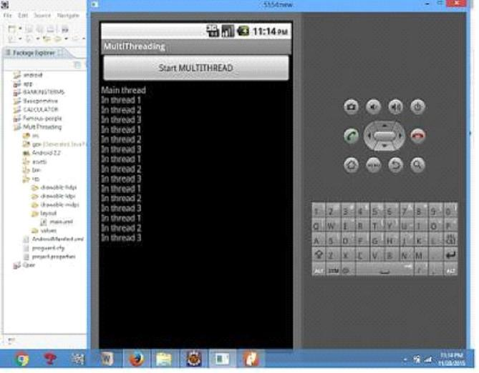

BIT/CSE Department of Computer Science and Engineering

CS6611 MOBILE APPLICATION DEVELOPMENT LAB

Ex.No : 8

Date :

DEVELOP A NATIVE APPLICATION THAT USES GPS LOCATION INFORMATION

- Open eclipse or android studio and select new android project

- Give project name and select next

- Choose the android version. Choose the lowest android version (Android 2.2) and select next

- Enter the package name. package name must be two word separated by comma and click finish

  - Go to package explorer in the left hand side. select our project.

6) Go to res folder and select layout. Double click the main.xml file. Add the code below

<?xml version="1.0" encoding="utf-8"?>

<RelativeLayout

xmlns:android="http://schemas.android.com/apk/res/android"

android:id="@+id/relativeLayout1"

android:layout_width="match_parent"

android:layout_height="match_parent" >

<Button

android:id="@+id/show_Location

"

android:layout_width="wrap_cont

ent"

android:layout_height="wrap_cont

ent

android:text="Show_Location"

android:layout_centerVertical="tr

ue"

BIT/CSE Department of Computer Science and Engineering

CS6611 MOBILE APPLICATION DEVELOPMENT LAB

android:layout_centerHorizontal="true"

/>

</RelativeLayout>

- Now select mainactivity.java file and type the following code. In my coding man activity name is GPSlocation Activity. Package gps.location;

//import android.R;

import

android.app.Activity;

import

android.os.Bundle;

import

android.view.View;

import

android.widget.Butto

n; import

android.widget.Toast

;

public class GPSlocationActivity extends Activity { /** Called when the activity is first created. */ Button btnShowLocation; GPStrace gps;

@Override

public void onCreate(Bundle savedInstanceState) {

super.onCreate(savedInstanceState);

setContentView(R.layout.main);

btnShowLocation=(Button)findViewById(R.id.show_Location);

btnShowLocation.setOnClickListener(new View.OnClickListener() {

@Override

public void onClick(View v) {

BIT/CSE Department of Computer Science and Engineering

CS6611 MOBILE APPLICATION DEVELOPMENT LAB

  - TODO Auto-generated method stub gps=new GPStrace(GPSlocationActivity.this); if(gps.canGetLocation()){

double latitude=gps.getLatitude(); double longitude=gps.getLongtiude(); Toast.makeText(getApplicationContext(),"Your Location is \nLat:"+latitude+"\nLong:"+longitude, Toast.LENGTH_LONG).show();

}

else

{

gps.showSettingAlert();

}

}

});

}

}

- Go to src folder and Right Click on your package folder and choose new class and give the class names as GPS trace
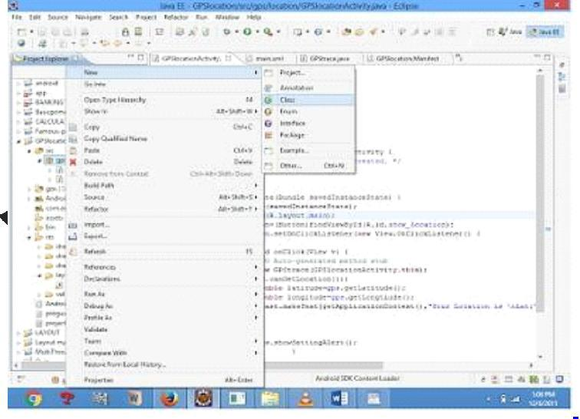

BIT/CSE Department of Computer Science and Engineering

CS6611 MOBILE APPLICATION DEVELOPMENT LAB

9) Select the GPStrace.java file and paste the following code.

Package gps.location;

import android.app.AlertDialog;

import android.app.Service;

import android.content.Context;

import

android.content.DialogInterface;

import android.content.Intent;

import android.location.Location;

import

android.location.LocationListener

- import android.location.LocationManage r; import android.os.Bundle; import android.os.IBinder; import android.provider.Settings;

public class GPStrace extends Service implements

LocationListener{ private final Context context; boolean

isGPSEnabled=false; boolean canGetLocation=false; boolean

isNetworkEnabled=false;

Location

location; double

latitude; double

longtitude;

private static final long MIN_DISTANCE_CHANGE_FOR_UPDATES=10; private static final long MIN_TIME_BW_UPDATES=1000*60*1; protected LocationManager locationManager; public GPStrace(Context context)

{

this.context=conte

xt;

getLocation();

BIT/CSE Department of Computer Science and Engineering

CS6611 MOBILE APPLICATION DEVELOPMENT LAB

}

public Location getLocation()

{

try{

locationManager=(LocationManager) context.getSystemService(LOCATION_SERVICE); isGPSEnabled=locationManager.isProviderEnabled(LocationManager.GPS_PROVIDER) ;

isNetworkEnabled=locationManager.isProviderEnabled(LocationManager.NETWORK_PR OVI DER);
if(!isGPSEnabled && !isNetworkEnabled){

}else{

this.canGetLocation=true;

if(isNetworkEnabled){

locationManager.requestLocationUpdates(

LocationManager.NETWORK_PROVIDER,

MIN_TIME_BW_UPDATES,

MIN_DISTANCE_CHANGE_FOR_UPDATES,this);

}

if(locationManager!=null){

location=locationManager.getLastKnownLocation(LocationManager.NETWORK_PROVI

DER)

;

if(location !=null){

latitude=location.getLatitude();

longtitude=location.getLongitude();

}

}

BIT/CSE Department of Computer Science and Engineering

CS6611 MOBILE APPLICATION DEVELOPMENT LAB

}

if(isGPSEnabled){

if(location==null){

locationManager.requestLocationUpdates(LocationManager.GPS_PROVIDER,MIN_TIM E_B

W_UPDATES, MIN_DISTANCE_CHANGE_FOR_UPDATES, this); if(locationManager!=null){

location=locationManager.getLastKnownLocation(LocationManager.GPS_PROV

IDER); if(location!=null){

latitude=location.getLatitude();

longtitude=location.getLongitude();

}

}

}

}

}

catch(Exception e)

{

e.printStackTrace();

}

return location;

}

public void stopUsingGPS(){ if(locationManager!=null){ locationManager.removeUpdates(GPStrace.this);

} } public double getLatitude(){ if(location!=null){ latitude=location.getLatitude();

BIT/CSE Department of Computer Science and Engineering

CS6611 MOBILE APPLICATION DEVELOPMENT LAB

}

return latitude;

}

public double getLongtiude(){

if(location!=null){

longtitude=location.getLatitude();

}

return longtitude;

}

public boolean canGetLocation(){

return this.canGetLocation;

}

public void showSettingAlert(){

AlertDialog.Builder alertDialog=new AlertDialog.Builder(context); alertDialog.setTitle("GPS is settings"); alertDialog.setMessage("GPS is not enabled.Do you want to go to setting menu?"); alertDialog.setPositiveButton("settings", new DialogInterface.OnClickListener() { @Override

public void onClick(DialogInterface dialog,int which){

Intent intent=new Intent(Settings.ACTION_LOCATION_SOURCE_SETTINGS); context.startActivity(intent);
}

});

alertDialog.setNegativeButton("cancel", new DialogInterface.OnClickListener() {

@Override

public void onClick(DialogInterface dialog, int which) {

- TODO Auto-generated method stub dialog.cancel();

}

});

BIT/CSE Department of Computer Science and Engineering

CS6611 MOBILE APPLICATION DEVELOPMENT LAB

alertDialog.show();

}

@Override

public void onLocationChanged(Location location) { // TODO Auto-generated method stub

}

@Override

public void onProviderDisabled(String provider) { // TODO Auto-generated method stub

}

@Override

public void onProviderEnabled(String provider) { // TODO Auto-generated method stub

}

@Override

public void onStatusChanged(String provider, int status, Bundle extras) { // TODO Auto-generated method stub

}

@Override

public IBinder onBind(Intent

intent) { // TODO Auto-generated

method stub return null;

}

}

10)Go to manifest.xml file and add the code below

<uses-permission

android:name="android.permission.ACCESS_FINE_LOCATION"/>

BIT/CSE Department of Computer Science and Engineering

CS6611 MOBILE APPLICATION DEVELOPMENT LAB

<uses-permission

android:name="android.permission.INTERNET"/>

- Now go to main.xml and right click .select run as option and select run configuration

- Android output is present in the android emulator as shown in below.
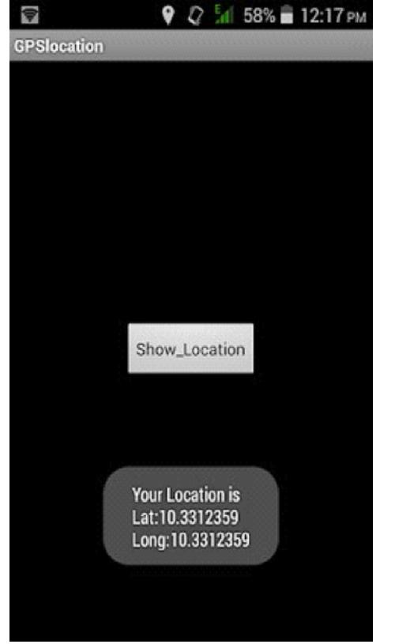

BIT/CSE Department of Computer Science and Engineering

CS6611 MOBILE APPLICATION DEVELOPMENT LAB

Ex.No : 9

Date :

IMPLEMENT AN APPLICATION THAT WRITES DATA TO THE

SD CARD

- Open eclipse or android studio and select new android project

- Give project name and select next

- Choose the android version. Choose the lowest android version (Android 2.2) and select next

- Enter the package name. Package name must be two word separated by comma and click finish

- Go to package explorer in the left hand side. Select our project.

- Go to res folder and select layout. Double click the main.xml file. Add the code below

<?xml version="1.0" encoding="utf-8"?> <LinearLayout xmlns:android="http://schemas.android.com/apk/res/android" android:layout_width="fill_parent" android:layout_height="fill_parent" android:background="#ff0000ff" android:orientation="vertical" > <EditText

android:id="@+id/editText1" android:layout_width="match_parent" android:layout_height="wrap_content" > <requestFocus />
</EditText>

<Button

android:id="@+id/button1" android:layout_width="match_parent" android:layout_height="wrap_content" android:text="SAVE DATA" /> <Button

BIT/CSE Department of Computer Science and Engineering

CS6611 MOBILE APPLICATION DEVELOPMENT LAB

android:id="@+id/button2"

android:layout_width="match_parent"

android:layout_height="wrap_content"

android:text="SHOW DATA" />

<TextView

android:id="@+id/textView1"

android:layout_width="wrap_content"

android:layout_height="wrap_content"

/>

</LinearLayout>

- Now select mainactivity.java file and type the following code. package save.sd;

import java.io.File; import java.io.FileInputStream; import java.io.FileNotFoundException; import java.io.FileOutputStream; import java.io.IOException; import java.io.InputStreamReader; import java.io.OutputStreamWriter; import android.app.Activity; import android.os.Bundle; import android.os.Environment; import android.view.View; import android.widget.Button; import android.widget.EditText; import android.widget.TextView; import android.widget.Toast;

public class SavedatasdcardActivity extends Activity { /** Called when the activity is first created. */ Button save,load;

EditText message; TextView t1;

BIT/CSE Department of Computer Science and Engineering

CS6611 MOBILE APPLICATION DEVELOPMENT LAB

String Message1;

@Override

public void onCreate(Bundle savedInstanceState) { super.onCreate(savedInstanceState);

setContentView(R.layout.main); save=(Button)

findViewById(R.id.button1); load=(Button)

findViewById(R.id.button2); message=(EditText)

findViewById(R.id.editText1); t1=(TextView) findViewById(R.id.textView1); save.setOnClickListener(new View.OnClickListener(){ public void onClick(View v){

//Get message from user store in message1 variable

Message1 =message.getText().toString(); try{

//Create a new folder called MyDirectory in SDCard

File sdcard=Environment.getExternalStorageDirectory();

File directory=new File(sdcard.getAbsolutePath()+"/MyDirectory"); directory.mkdirs();

//Create a new file name textfile.txt inside MyDirectory File file=new File(directory,"textfile.txt");

//Create File Outputstream to read the file FileOutputStream fou=new FileOutputStream(file); OutputStreamWriter osw=new OutputStreamWriter(fou); try{

//write a user data to file

osw.append(Message1);

osw.flush();

osw.close();

Toast.makeText(getBaseContext(),"Data

Saved",Toast.LENGTH_LONG).show();

}catch(IOException e){

e.printStackTrace();

BIT/CSE Department of Computer Science and Engineering

CS6611 MOBILE APPLICATION DEVELOPMENT LAB

}

}catch (FileNotFoundException e){

e.printStackTrace();

}

}

});

load.setOnClickListener(new View.OnClickListener(){ public void onClick(View v){ try{

File sdcard=Environment.getExternalStorageDirectory();

File directory=new File(sdcard.getAbsolutePath()+"/MyDirectory"); File file=new File(directory,"textfile.txt");

FileInputStream fis=new FileInputStream(file); InputStreamReader isr=new InputStreamReader(fis); char[] data=new char[100]; String final_data="";

int size;

try{

while((size=isr.read(data))>0)

{

//read a data from file

String read_data=String.copyValueOf(data,0,size);

final_data+=read_data;

data=new char[100];

}

//display the data in output

Toast.makeText(getBaseContext(),"Message:"+final_data,Toast.LENGTH_LONG).show()

;

}catch(IOException e){

e.printStackTrace();

}

BIT/CSE Department of Computer Science and Engineering

CS6611 MOBILE APPLICATION DEVELOPMENT LAB

}catch (FileNotFoundException e){

e.printStackTrace();

}

}

});

}

}

- Next step is to set permission to write data in sd card. So go to AndroidManifest.xml file. Copy and paste the following coding. The code should come before <application> tab.

<uses-permission

android:name="android.permission.WRITE_EXTERNAL_STORAGE"></uses-permission>

  - Now go to main.xml and right click .select run as option and select run configuration

  - Android output is present in the android emulator as shown in below.
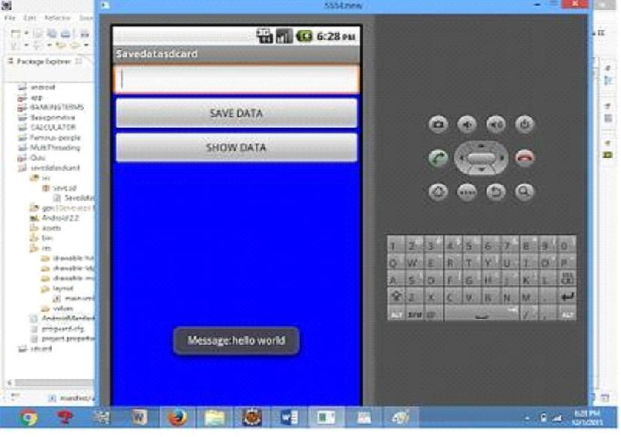

BIT/CSE Department of Computer Science and Engineering

CS6611 MOBILE APPLICATION DEVELOPMENT LAB

Ex.No: 10

Date :

IMPLEMENT AN APPLICATION THAT CREATES AN ALERT

UPON RECEIVING A MESSAGE IN ANDROID

- Open eclipse or android studio and select new android project

- Give project name and select next

- Choose the android version. Choose the lowest android version(Android 2.2) and select next

- Enter the package name. package name must be two word separated by comma and click finish

  - Go to package explorer in the left hand side. select our project.

6) Go to res folder and select layout. Double click the main.xml file. Add the code below

<ScrollView

xmlns:android="http://schemas.android.com/apk/res/android"

android:layout_width="fill_parent"

android:layout_height="wrap_content"

android:scrollbars="vertical" >

<TableLayout

android:layout_width="match_parent"

android:layout_height="wrap_content"

android:shrinkColumns="*"

android:stretchColumns="*"

android:background="#000000">

<TableRow

android:layout_height="wrap_content"

android:layout_width="match_parent"

android:gravity="center_horizontal">

<TextView

android:id="@+id/Title"

android:layout_width="fill_parent"

android:layout_height="wrap_content"

BIT/CSE Department of Computer Science and Engineering

CS6611 MOBILE APPLICATION DEVELOPMENT LAB

android:layout_margin="5px"

android:focusable="false"

android:focusableInTouchMode="false"

android:gravity="center_vertical|center_hori

zontal" android:text="QUIZ"

android:textSize="25sp"

android:textStyle="bold" />

<View

android:layout_height="2px"

android:layout_marginTop="5dip"

android:layout_marginBottom="5dip"

android:background="#DDFFDD"/>

</TableRow>

<TableRow

android:layout_height="wrap_content"

android:layout_width="match_parent"

android:gravity="center_horizontal">

<TextView

android:layout_width="match_parent"

android:layout_height="wrap_content"

android:textSize="18sp"

android:text="1.CAPTIAL OF INDIA"

android:layout_span="4"

android:padding="18dip"

android:textColor="#ffffff"/>

</TableRow><TableRow

android:id="@+id/tableRow1"

android:layout_height="wrap_content"

android:layout_width="match_parent">

<RadioGroup

android:id="@+id/answer1"

android:layout_width="match_parent"

BIT/CSE Department of Computer Science and Engineering

CS6611 MOBILE APPLICATION DEVELOPMENT LAB

android:layout_height="wrap_content"

android:layout_weight="0.4" >

<RadioButton

android:id="@+id/answer1A"

android:layout_width="match_parent"

android:layout_height="wrap_content"

android:textColor="#ffffff"

android:text="CHENNAI" />

<RadioButton

android:id="@+id/answer1B"

android:layout_width="match_parent"

android:layout_height="wrap_content"

android:textColor="#ffffff"

android:text="NEW DELHI" />

<RadioButton

android:id="@+id/answer1C"

android:layout_width="match_parent"

android:layout_height="wrap_content"

android:textColor="#ffffff"

android:text="MUMBAI" />

<RadioButton

android:id="@+id/answer1D"

android:layout_width="match_parent"

android:layout_height="wrap_content"

android:textColor="#ffffff"

android:text="HYDERBAD" />

</RadioGroup>

</TableRow><TableRow

android:layout_height="wrap_content"

android:layout_width="match_parent"

android:gravity="center_horizontal">

<TextView

BIT/CSE Department of Computer Science and Engineering

CS6611 MOBILE APPLICATION DEVELOPMENT LAB

android:layout_width="match_parent" android:layout_height="wrap_content"

android:textSize="18sp" android:text="2. CAPTIAL OF RUSSIA?" android:layout_span="4"

android:padding="18dip" android:textColor="#ffffff"/>

</TableRow>

<TableRow

android:id="@+id/tableRow2"

android:layout_height="wrap_content"

android:layout_width="match_parent">

<RadioGroup

android:id="@+id/answer2"

android:layout_width="match_parent"

android:layout_height="wrap_content"

android:layout_weight="0.4" >

<RadioButton

android:id="@+id/answer2A"

android:layout_width="match_parent"

android:layout_height="wrap_content"

android:textColor="#ffffff"

android:text="WARSAW " />

<RadioButton

android:id="@+id/answer2B"

android:layout_width="match_parent"

android:layout_height="wrap_content"

android:textColor="#ffffff"

android:text="BERLIN" />

<RadioButton

android:id="@+id/answer2C"

android:layout_width="match_parent"

android:layout_height="wrap_content"

android:textColor="#ffffff"

android:text="MASCOW " />

BIT/CSE Department of Computer Science and Engineering

CS6611 MOBILE APPLICATION DEVELOPMENT LAB

<RadioButton

android:id="@+id/answer2D"

android:layout_width="match_parent"

android:layout_height="wrap_content"

android:textColor="#ffffff"

android:text="CANEBRA " />

</RadioGroup>

</TableRow><TableRow

android:layout_height="wrap_content"

android:layout_width="match_parent"

android:gravity="center_horizontal">

<Button

android:id="@+id/submit"

android:layout_width="wrap_content"

android:layout_height="wrap_content"

android:gravity="center"

android:text="Submit" />

</TableRow>

</TableLayout></ScrollView>

- Now select mainactivity.java file and type the following code. In my coding man activity name is Alert1Activity.

- Now go to main.xml and right click .select run as option and select run configuration

- Android output is present in the android emulator as shown in below.
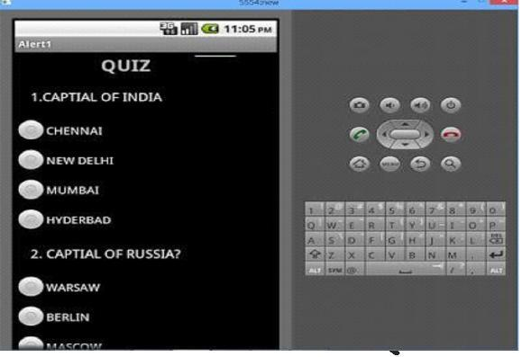

BIT/CSE Department of Computer Science and Engineering

CS6611 MOBILE APPLICATION DEVELOPMENT LAB
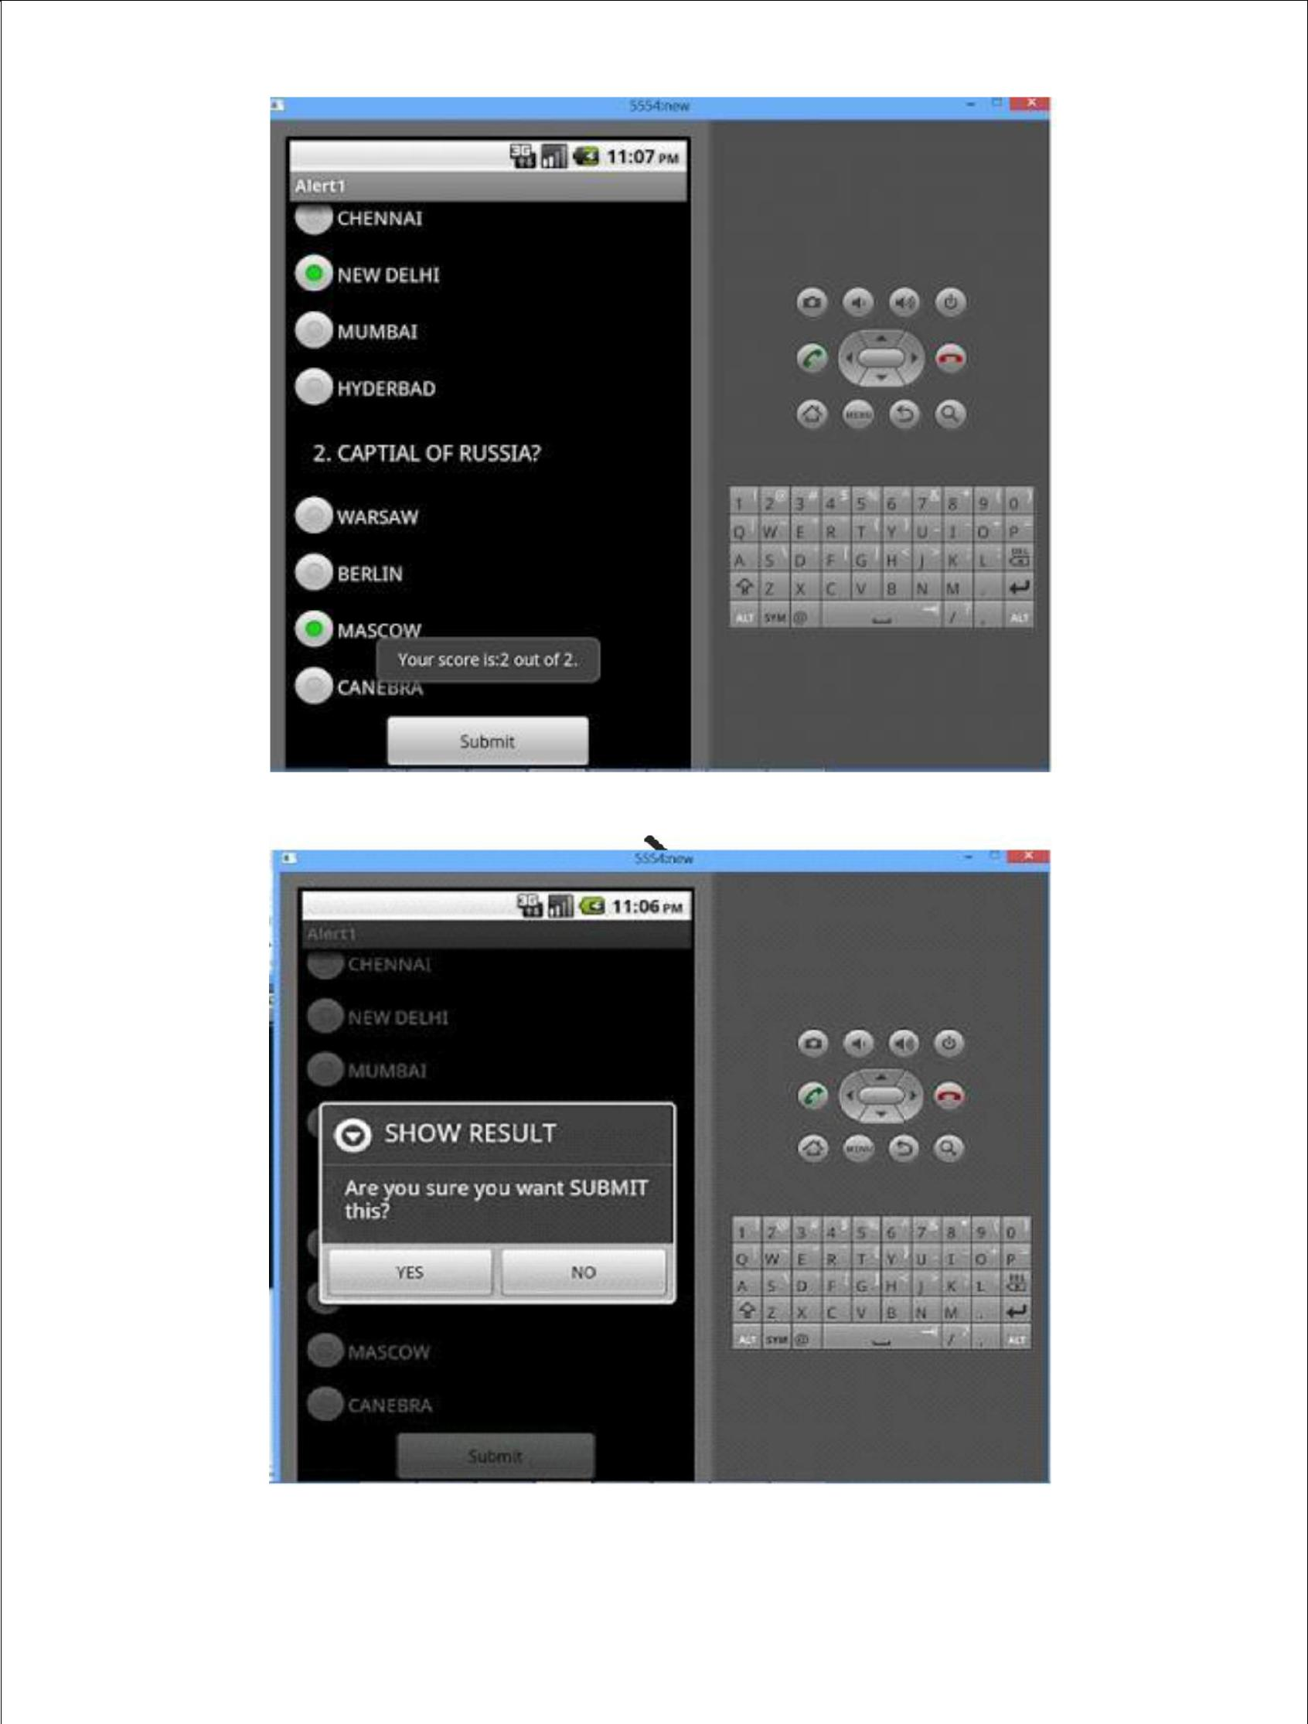

BIT/CSE Department of Computer Science and Engineering

CS6611 MOBILE APPLICATION DEVELOPMENT LAB

Ex.No : 11

Date :

WRITE A MOBILE APPLICATION THAT CREATES ALARM

CLOCK

- Android Manifest AndroidManifest.xml

We need to give uses-permission for _{WAKE_LOCK}, other than that the AndroidManifest.xml is pretty standard one. Just need to include the service and receiver.

<?xml version="1.0" encoding="utf-8"?>

<manifest xmlns:android="http://schemas.android.com/apk/res/android"

package="com.javapapers.androidalarmclock"> <uses-permission android:name="android.permission.WAKE_LOCK" /> <application

android:allowBackup="true" android:icon="@drawable/ic_launcher"

android:label="@string/app_name" android:theme="@style/AppTheme"> <activity

android:name=".AlarmActivity" android:label="@string/app_name"> <intent-filter>

<action android:name="android.intent.action.MAIN" />

<category android:name="android.intent.category.LAUNCHER" />

</intent-filter>

</activity><service

android:name=".AlarmService" android:enabled="true" /> <receiver android:name=".AlarmReceiver" /> </application>

</manifest>

BIT/CSE Department of Computer Science and Engineering

CS6611 MOBILE APPLICATION DEVELOPMENT LAB

2. Android Activity

activity_my.xml

The Android Activity is designed to be simple. We have a Time Picker component followed by a Toggle Button. That’s it. Choose the time to set the alarm and toggle the switch to on. The alarm
will work.

<RelativeLayout xmlns:android="http://schemas.android.com/apk/res/android"

xmlns:tools="http://schemas.android.com/tools" android:layout_width="match_parent"

android:layout_height="match_parent"

android:paddingLeft="@dimen/activity_horizontal_margin"

android:paddingRight="@dimen/activity_horizontal_margin"

android:paddingTop="@dimen/activity_vertical_margin"

android:paddingBottom="@dimen/activity_vertical_margin" tools:context=".MyActivity">

<TimePicker

android:layout_width="wrap_content" android:layout_height="wrap_content"

android:id="@+id/alarmTimePicker" android:layout_alignParentTop="true" android:layout_centerHorizontal="true" /> <ToggleButton

android:layout_width="wrap_content"

android:layout_height="wrap_content" android:text="Alarm

On/Off" android:id="@+id/alarmToggle" android:layout_centerHorizontal="true" android:layout_below="@+id/alarmTimePicker" android:onClick="onToggleClicked" /> <TextView
android:layout_width="wrap_content" android:layout_height="wrap_content"

android:textAppearance="?android:attr/textAppearanceLarge"

android:text="" android:id="@+id/alarmText" android:layout_alignParentBottom="true" android:layout_centerHorizontal="true" android:layout_marginTop="20dp" android:layout_below="@+id/alarmToggle" /> </RelativeLayout>

BIT/CSE Department of Computer Science and Engineering

CS6611 MOBILE APPLICATION DEVELOPMENT LAB

AlarmActivity.java

Alarm Activity uses the Alarm Manager to set the alarm and send notification on alarm trigger.

package com.javapapers.androidalarmclock;

import android.app.Activity; import

android.app.AlarmManager; import

android.app.PendingIntent; import

android.content.Intent; import

android.os.Bundle; import

android.util.Log; import

android.view.View; import

android.widget.TextView; import

android.widget.TimePicker; import

android.widget.ToggleButton;

import java.util.Calendar; public

class AlarmActivity extends Activity

{

AlarmManager alarmManager; private

PendingIntent pendingIntent; private

TimePicker alarmTimePicker; private

static AlarmActivity inst; private TextView

alarmTextView;

public static AlarmActivity instance() {

return inst; }

@Override

public void onStart() {

super.onStart(); inst =

this; }

@Override

protected void onCreate(Bundle savedInstanceState) {

super.onCreate(savedInstanceState); setContentView(R.layout.activity_my);

BIT/CSE Department of Computer Science and Engineering

CS6611 MOBILE APPLICATION DEVELOPMENT LAB

alarmTimePicker = (TimePicker) findViewById(R.id.alarmTimePicker); alarmTextView

= (TextView) findViewById(R.id.alarmText);

ToggleButton alarmToggle = (ToggleButton) findViewById(R.id.alarmToggle);

alarmManager = (AlarmManager) getSystemService(ALARM_SERVICE);

}

public void onToggleClicked(View view) { if

(((ToggleButton) view).isChecked()) {

Log.d("MyActivity", "Alarm On");

Calendar calendar = Calendar.getInstance();

calendar.set(Calendar.HOUR_OF_DAY,

alarmTimePicker.getCurrentHour());

calendar.set(Calendar.MINUTE, alarmTimePicker.getCurrentMinute());

Intent myIntent = new Intent(AlarmActivity.this, AlarmReceiver.class);

pendingIntent = PendingIntent.getBroadcast(AlarmActivity.this, 0, myIntent, 0);

alarmManager.set(AlarmManager.RTC, calendar.getTimeInMillis(), pendingIntent);

} else {

alarmManager.cancel(pendingIntent); setAlarmText("");

Log.d("MyActivity", "Alarm Off");

} }

public void setAlarmText(String alarmText) { alarmTextView.setText(alarmText);

}

}

3. Alarm Receiver

AlarmReceiver.java

this is the one that receives the alarm trigger on set time. From here we initiate different actions to notify the user as per our choice. I have given three type of notifications, first show a message to user in the activity UI, second play the alarm ringtone and third send an Android notification message. So this is the place to add enhancement for different types of user notifications.
package com.javapapers.androidalarmclock;

BIT/CSE Department of Computer Science and Engineering

CS6611 MOBILE APPLICATION DEVELOPMENT LAB

import android.app.Activity; import

android.content.ComponentName; import

android.content.Context; import

android.content.Intent; import

android.media.Ringtone; import

android.media.RingtoneManager; import

android.net.Uri;

import android.support.v4.content.WakefulBroadcastReceiver; public class AlarmReceiver extends WakefulBroadcastReceiver { @Override

public void onReceive(final Context context, Intent intent) {

//this will update the UI with message AlarmActivity inst =

AlarmActivity.instance(); inst.setAlarmText("Alarm! Wake up!

Wake up!");

//this will sound the alarm tone

//this will sound the alarm once, if you wish to

//raise alarm in loop continuously then use MediaPlayer and setLooping(true)

Uri alarmUri =

RingtoneManager.getDefaultUri(RingtoneManager.TYPE_ALARM

); if (alarmUri == null) { alarmUri = RingtoneManager.getDefaultUri(RingtoneManager.TYPE_NOTIFICATION); }

Ringtone ringtone = RingtoneManager.getRingtone(context, alarmUri); ringtone.play();

//this will send a notification message

ComponentName comp = new ComponentName(context.getPackageName(), AlarmService.class.getName());

startWakefulService(context, (intent.setComponent(comp))); setResultCode(Activity.RESULT_OK); }

}

BIT/CSE Department of Computer Science and Engineering

CS6611 MOBILE APPLICATION DEVELOPMENT LAB

4. Alarm Notification Message

AlarmService.java

The receiver will start the following Intent Service to send a standard notification to the user.

package com.javapapers.androidalarmclock;

import android.app.IntentService; import

android.app.NotificationManager; import

android.app.PendingIntent; import

android.content.Context; import

android.content.Intent;

import android.support.v4.app.NotificationCompat; import android.util.Log;

public class AlarmService extends IntentService { private NotificationManager alarmNotificationManager;

public AlarmService() {

super("AlarmService"); }

@Override

public void onHandleIntent(Intent intent) { sendNotification("Wake Up! Wake

Up!");

}

private void sendNotification(String msg) {

Log.d("AlarmService", "Preparing to send notification...: " + msg); alarmNotificationManager = (NotificationManager) this .getSystemService(Context.NOTIFICATION_SERVICE);

PendingIntent contentIntent = PendingIntent.getActivity(this, 0, new Intent(this,

AlarmActivity.class), 0);

NotificationCompat.Builder alamNotificationBuilder = new

NotificationCompat.Builder(

BIT/CSE Department of Computer Science and Engineering

CS6611 MOBILE APPLICATION DEVELOPMENT LAB

this).setContentTitle("Alarm").setSmallIcon(R.drawable.ic_launcher)

.setStyle(new NotificationCompat.BigTextStyle().bigText(msg))

.setContentText(msg);

alamNotificationBuilder.setContentIntent(contentIntent); alarmNotificationManager.notify(1, alamNotificationBuilder.build()); Log.d("AlarmService", "Notification sent."); } }
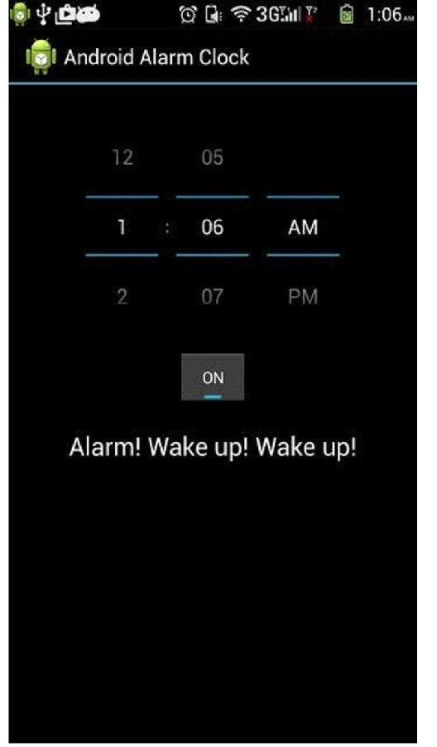

BIT/CSE Department of Computer Science and Engineering

