IT6612 | COMPILER LABORATORY | L T P C
 |  | 0 0 3 2
OBJECTIVES: The student should be made to:

- Be exposed to compiler writing tools.

- Learn to implement the different Phases of compiler

- Be familiar with control flow and data flow analysis

- Learn simple optimization techniques

LIST OF EXPERIMENTS:

- Implementation of Symbol Table

- Develop a lexical analyzer to recognize a few patterns in C. (Ex. identifiers, constants, comments, operators etc.)
- Implementation of Lexical Analyzer using Lex Tool

- Generate YACC specification for a few syntactic categories.

  - Program to recognize a valid arithmetic expression that usesoperator +, - , * and /.

- Program to recognize a valid variable which starts with a letterfollowed by any number of letters or digits.

c)Implementation of Calculator using LEX and YACC

5. Convert the BNF rules into Yacc form and write code to generate Abstract Syntax Tree.

6. Implement type checking

7. Implement control flow analysis and Data flow Analysis

8. Implement any one storage allocation strategies(Heap,Stack,Static)

9. Construction of DAG

10. Implement the back end of the compiler which takes the three address code and produces the 8086 assembly language instructions that can be assembled and run using a 8086 assembler. The target assembly instructions can be simple move, add, sub, jump. Also simple addressing modes are used.

11. Implementation of Simple Code Optimization Techniques (Constant Folding, etc.)

TOTAL: 45 PERIODS

OUTCOMES: At the end of the course, the student should be able to
- Implement the different Phases of compiler using tools

- Analyze the control flow and data flow of a typical program

- Optimize a given program

- Generate an assembly language program equivalent to a source language program

LIST OF EQUIPMENT FOR A BATCH OF 30 STUDENTS:

Standalone desktops with C / C++ compiler and Compiler writing tools 30 Nos. (or) Server with C / C++ compiler and Compiler writing tools supporting 30 terminals or more. LEX and YACC

INDEX

EX.NO | EXPERIMENT NAME

1 Implementation of Symbol Table

Develop a lexical analyzer to recognize a few patterns in C.
2
(Ex. identifiers, constants, comments, operators etc.)

- Implementation of Lexical Analyzer using Lex Tool

- Generate YACC specification for a few syntactic categories

4a | Program | to | recognize | a valid arithmetic expression that
4a | usesoperator +, - , *
4b | Program | to | recognize a | valid variable which | starts | with | a
4b | letterfollowed by any number of letters or digits
4c | Implementation of Calculator using LEX and YACC
5 | Convert | the | BNF rules | into Yacc form and | write | code | to
5 | generate Abstract Syntax Tree

- Implement type checking

- Implement control flow analysis and Data flow Analysis

8 | Implement | any | one | storage | allocation
8 | strategies(Heap,Stack,Static)
9 | Construction of DAG

Implement the back end of the compiler which takes the three address code and produces the 8086 assembly language

- instructions that can be assembled and run using a 8086 assembler. The target assembly instructions can be simple move, add, sub, jump. Also simple addressing modes are used

Implementation of Simple Code Optimization Techniques
11
(Constant Folding., etc.)

Beyond the syllabus

12 Implementation Of Shift-Reduced Parsing Algorithms

Construction Of LR -Parsing Table

13

Ex.no:1

Date:

Implementation of Symbol Table

AIM:

To write a program in C for implementing Symbol Table.

ALGORITHM

1.Start the program.
2. Declare the variables.Get the character and check it using while Loop.
3.If n value is less than or equal to I then print the symbol address and type.Again check the n value with j.

4.The C value is changed to ASCII and check it using if statement.Store the C value in P and print the identifier.

Else check the character is equal to +, -, *, /, (,) using if statement. Store the C value in P and print the operator.
- Enter any symbol to find in the Symbol Table.
- Stop the program.

PROGRAM:

#include<stdio.h>
#include<conio.h>

#include<alloc.h>
#include<ctype.h>

void main()

{
int j=0,i=0,x=0,n;

int flag=0;

int *p,*add[10];

char c,ch='y',srch,b[10],d[10];

clrscr();

printf("\ nEnter an expression and it is terminated by $");

while((c=getchar())!='$')

{

b[i]=c;
i++;

}

n=i-1;

i=0;

printf("Symbol Table \n");

printf(" \nSymbol\t\tAddress\t\ttype");

while(j<=n)
{

c=b[j];

if(isalpha(toascii(c)))
{

p=malloc(c);

add[x]=p;

d[x]=c;

printf(" \n\t%c\t\t%d\t\tidentifier",c,p);

}

if(c=='+'||c=='-'||c=='*'||c=='/'||c=='='||c==')')
{

p=malloc(c);

add[x]=p;

d[x]=c;

printf(" \n\t%c\t\t%d\t\tOperator",c,p);

}

x++;

j++;

}
while(ch=='y')

{

flag=0;
printf(" \nEnter the symbol to search");

fflush(stdin);

srch=getchar();

for(i=0;i<=n;i++)

{

if(srch==d[i])

{
printf(" \nSymbol found\t");

printf("%c \t%s%d\n",srch,"@address",add[i]);

flag=1;
}

}

if(flag==0)

{
printf("Symbol not found");

}

printf("Do you want to continue (y/n): ");
fflush(stdin);

ch=getchar();

}

}

OUTPUT
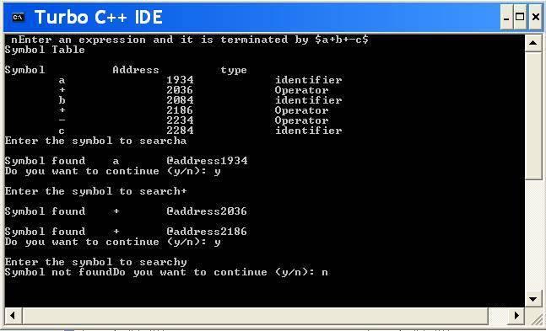

Viva voce

What are the various data structures used for implementing the symbol table? 1.Linear list 2.binary tree 3. hash table

Ex. No: 2 Develop a lexical analyzer to recognize a few patterns in C. (Ex. identifiers, constants, comments, operators etc

Date:

Aim:

To write a C program to develop a lexical analyzer to recognize a few patterns in C. (Ex.
identifiers, constants, comments, operators etc.

Algorithm:

1.Start the program.

2.Intialize the symbol table with keywords.

3.Read token by token from the input string.

4.Using finite automation check for keywords, identifiers, constants & thenOperators successively.

5.If nothing matches print an error message.

6.Until all tokens are over, repeat above three steps.
7.Print token information.

8.Stop.

Procedure to run the program:

- Start the program.
- Lex program consists of three parts. a. Declaration %% b. Translation rules %% c. Auxilary procedure.
- The declaration section includes declaration of variables, maintest, constants and regular definitions.
- Translation rule of lex program are statements of the form a. P1 {action} b. P2 {action} c. … d. … e. Pn {action}
- Write a program in the vi editor and save it with .l extension.

- Compile the lex program with lex compiler to produce output file aslex.yy.c.

eg $ lex filename.l

$ cc lex.yy.c -ll

7. Compile that file with C compiler and verify the output.

Program:

Lexical.C:

#include<stdio.h>

#include<conio.h>

#include<ctype.h>

#include<string.h>

void main()

{

FILE *fi,*fo,*fop,*fk;
int flag=0,i=1;

char c,t,a[15],ch[15],file[20];

clrscr();
printf("\n Enter the File Name:");

scanf("%s",&file);

fi=fopen(file,"r");

fo=fopen("inter.c","w");

fop=fopen("oper.c","r");

fk=fopen("key.c","r");

c=getc(fi);
while(!feof(fi))

{

if(isalpha(c)||isdigit(c)||(c=='['||c==']'||c=='.'==1))

fputc(c,fo);

else

{

if(c=='\n')

fprintf(fo,"\t$\t");

else
fprintf(fo,"\t%c\t",c);

}

c=getc(fi);
}

fclose(fi);

fclose(fo);

fi=fopen("inter.c","r");

printf("\n Lexical Analysis");

fscanf(fi,"%s",a);

printf("\n Line: %d\n",i++);
while(!feof(fi))

{

if(strcmp(a,"$")==0)
{

printf("\n Line: %d \n",i++);

fscanf(fi,"%s",a);

}
fscanf(fop,"%s",ch);

while(!feof(fop))

{
if(strcmp(ch,a)==0)

{

fscanf(fop,"%s",ch);

printf("\t\t%s\t:\t%s\n",a,ch);

flag=1;

}

fscanf(fop,"%s",ch);
}

rewind(fop);

fscanf(fk,"%s",ch);
while(!feof(fk))

{

if(strcmp(ch,a)==0)

{

fscanf(fk,"%k",ch);

printf("\t\t%s\t:\tKeyword\n",a);

flag=1;
}

fscanf(fk,"%s",ch);

}
rewind(fk);

if(flag==0)

{

if(isdigit(a[0]))

printf("\t\t%s\t:\tConstant\n",a);

else

printf("\t\t%s\t:\tIdentifier\n",a);
}

flag=0;

fscanf(fi,"%s",a);

}

getch();

}

Key.C:

int
void

main

char
if

for

while

else

printf

scanf

FILE
include

stdio.h

conio.h
iostream.h

Oper.C:

( open para
) closepara

{ openbrace } closebrace <lesser >greater

" doublequote ' singlequote : colon

; semicolon

# preprocessor = equal
== asign

% percentage ^ bitwise
& reference * star
+ add - sub

\ backslash / slash

Input.C:

#include "stdio.h"
#include "conio.h"

void main()

{

int a=10,b,c;

a=b*c;

getch();

}

OUTPUT

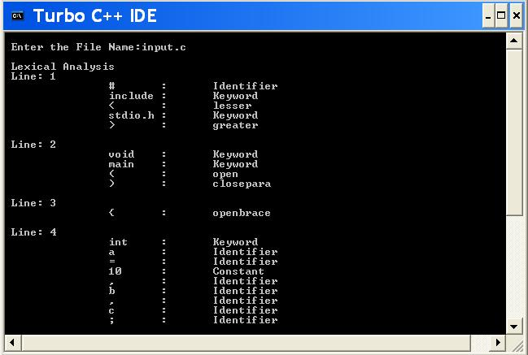

Result:

The above C program was successfully executed and verified

Ex. No:3

Date:

Implementation of Lexical Analyzer using Lex Tool

Aim:To implement Lexical Analyzer using Lex Tool.

Algorithm:

- Start the program

- Open a file file.c in read and include the yylex() tool for input scanning
- Define the alphabets and numbers.

- Print the preprocessor, function, keyword using yytext.lex tool.

5.Print the relational, assignment and all the operator using yytext() tool.

6.Also scan and print where the loop ends and begins.

- Use yywrap() to enter an error.

- Stop the program.

Program:

Lextool.l

%{

%}

identifier[a-zA-Z][a-zA-Z0-9]*

%%

#.* printf("\n%s is PREPROCESSOR DIRECTIVE\n", yytext); int |

float |

double |

char |

for |

if printf("%s is a keyword\n",yytext);

{identifier}\( printf("\n\n FUNCTION CALL\n %s",yytext); \{

printf("BLOCK BEGINS\n");

\}

printf("BLOCK ENDS\n");

{identifier}(\[[0-9]*\])? printf("%s is identifier\n",yytext);

- printf("%s is a ASSIGNMENT OPERATOR\n",yytext); [0-9]+ printf("%s is NUMBER\n",yytext);
\< | \> | \== | \>= |

\<= printf("%s is a RELATIONAL OPERATOR\n",yytext); \( printf("open para\n");
\) printf("close para\n"); \+ | \- |

\* printf("%s is a ARITHMETIC OPERATOR \n",yytext);
\++ printf("%s is a INCREMENTAL OPERATOR\n",yytext);

\; { ECHO; printf("\n");}

%%

main()

{

yylex();

}

int yywrap()

{

return 1;

}

Output
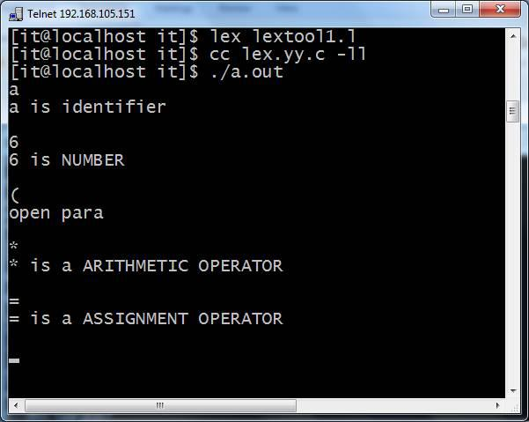

Ex.no 4a

Program to recognize a valid arithmetic expression that

Date:

Usesoperator +, - , * and /.

Aim :To write a yacc and lex program to recognize a valid arithmetic expression that uses operator+,-,* and /.

Algorithm:

Input: Programming language arithmetic expression
Output: A sequence of tokens.

Tokens have to be identified and its respective attributes have to be printed.

Lex:

- {Declaration and regular definition] Define header files to include first section

- [translation rule]

Tokens generated are used in yacc files
[a-z A-Z] alphabets are returned

0-9 one or more combinations of integers

Yacc:

- Accept token generated in lex part as input
- Specify the order of procedure

- Define rules with end points

- Parse input string from standard input by calling yyparse() main function.
- Print the result of any rules defined matches as arithmetic expression as valid

- If none of the rule defined matches print arithmetic expression is invalid.

Program:

Yacc4a.y(without lex only yacc program)

%{

#include<stdio.h>

#include<ctype.h>
#include<stdlib.h>

%}

%token num let
%left '+' '-'

%left '*' '/'

%%

stmt: stmt '\n' {printf("\n..valid Expression..\n"); exit(0);} | expr

|

| error '\n' {printf("\n..Invalid..\n"); exit(0);}
;

expr: num

| let

| expr '+' expr

| expr '-' expr

| expr '*' expr

| expr '/' expr
| '(' expr ')'

%%

main()
{

printf("Enter an exoression to validate :");

yyparse();

}

yylex()

{

int ch;
while((ch=getchar())==' ');

if(isdigit(ch))

return num;
if(isalpha(ch))

return let;

return ch;

}

yyerror(char *s)

{

printf("%s",s);
}

Output :
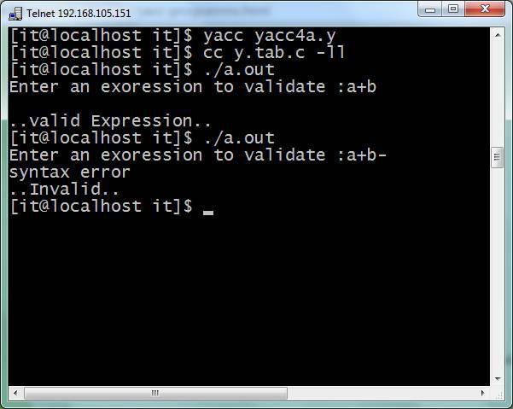

Lex program (with lex and yacc)

%{
#include"y.tab.h"

extern yylval;

%}

%%
[0-9]+ {yylval=atoi(yytext); return NUMBER;}

[a-zA-Z]+ {return ID;}

[\t]+ ;
\n {return 0;}

. {return yytext[0];}

%%

int yywrap()

{

return(1);

}

Yacc program

%{
#include<stdio.h>

%}

%token NUMBER ID

%left '+' '-'
%left '*' '/'

%%expr:

expr '+' expr
|expr '-' expr

|expr '*' expr

|expr '/' expr

|'-'NUMBER|'-'ID

|'('expr')'

|NUMBER

|ID
;

%%

main()
{

printf("Enter the expression\n");

yyparse();

printf("\nExpression is valid\n");

exit(0);

}

int yyerror(char *s)
{

printf("\nExpression is invalid");

exit(0);
}

Output
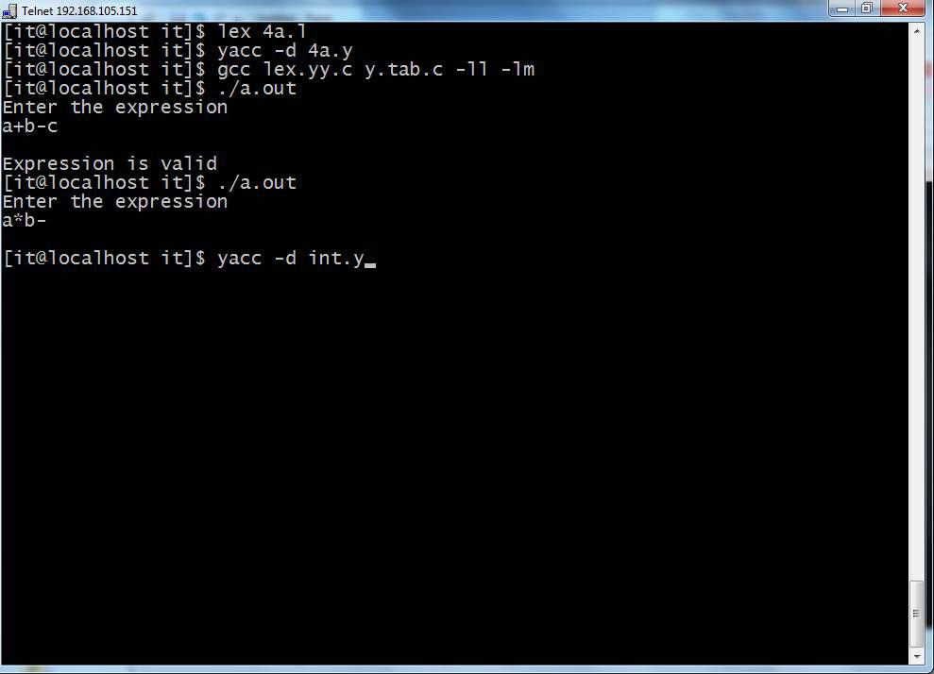

Ex.no :4b

Program to recognize a valid variable which starts with a letterfollowed by any number of letters or digits

Aim: To write a yacc & lex program to recognize a valid variable which starts with a letter followed by any number of letters or digits.

Algorithm:

Input: Programming language 'if' statement
Output: A sequence of tokens.
Tokens have to be identified and its respective attributes have to be printed

1.Include header file y.tab.h

- Define tokens

- Declare [a-z] as L [0-9] as D

- Declare variable L D P

- Call function yyerror()
- If error exists then print “invalid” and exit

- In main() call yyparse(), if yyparse() print “valid variable”

Program: (without lex)

%{
#include<stdio.h>
#include<ctype.h>

#include<stdlib.h>

%
}

%token let dig

%%

TERM: XTERM '\n'

{

printf("\nAccepted\n");

exit(0);
}

|error

{
yyerror ("Rejected\n"); exit(0);

};

XTERM: XTERM let

| XTERM dig

| let

;

%%
main()

{

printf("Enter a variable:");
yyparse();

}

yylex()

{

char ch;

while((ch=getchar())==' ');

if(isalpha(ch))
return let;

if(isdigit(ch))

return dig;

return ch;

}

yyerror(char *s)

{

printf("%s",s);

}

Output
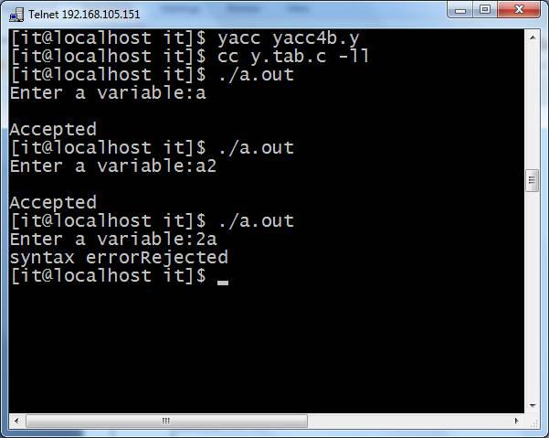

Program: with lex and yacc

Yacc 4b.l

%{

#include"y.tab.h"

extern yylval;

%}
%%

[0-9]+ {yylval=atoi(yytext); return DIGIT;}

[a-zA-Z]+ {return LETTER;}
[\t] ;

\n return 0;

. {return yytext[0];}

%%

Yacc 4b.y

%{
#include<stdio.h>
%}

%token LETTER DIGIT

%%
variable: LETTER|LETTER rest

;

rest: LETTER rest

|DIGIT rest
|LETTER|DIGIT;

%%

main()
{

yyparse();

printf("The string is a valid variable\n");

}

int yyerror(char *s)

{

printf("this is not a valid variable\n");
exit(0);

}

Output
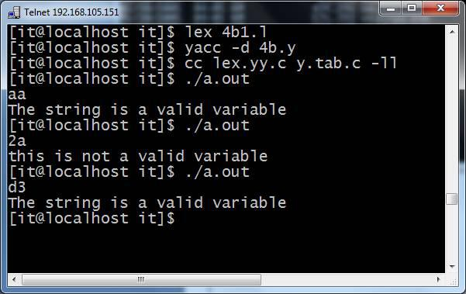

Ex.no :4c: Implementation of Calculator using LEX and YACC

Date :

Aim: To write a lex and yacc program to implement Calculator.

Algorithm:

1. Start the program.

2.Perform the calculation using both the lex and yacc.

3.In the lex tool, if the given expression contains numbers and letters then they are displayed.

4.In the same way, the digits, letters and uminus are identified and displayed using yacctool.

5.The calculation is performed and the result is displayed.

6.Stop the program

Program: Calci.l

%{

#include<stdio.h>

#include<math.h>

#include "y.tab.h"

%}

%%

[0-9]+ {

yylval.dval=atoi(yytext);
return NUMBER;

}

[t];
n return 0;

. {return yytext[0];}

%%

void yyerror(char *str)

{

printf("n Invalid Character...");

}
int main()

{

printf("Enter Expression => ");
yyparse();

return(0);

}

Program:calci.y

%{
#include<stdio.h>
int yylex(void);

%}

%union

{

float dval;

}

%token <dval> NUMBER
%left '+' '-'

%left '*' '/'

%nonassoc UMINUS
%type <dval> exp

%%

state : exp {printf("Answer = %fn",$1);}

;

exp : NUMBER

| exp '+' exp {$$=$1+$3;}

| exp '-' exp {$$=$1-$3;}
| exp '*' exp {$$=$1*$3;}

| exp '/' exp {$$=$1/$3;}

| '('exp')' {$$=$2;}
| '-' exp %prec UMINUS {$$=-$2;}

;

%%

Output
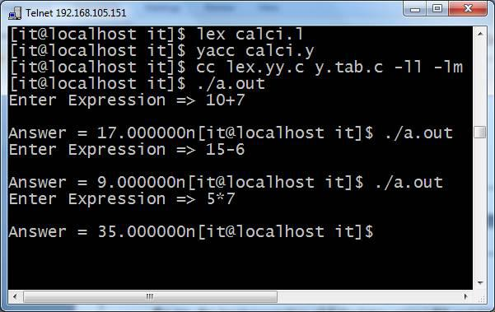

EX.NO:5

Convert the BNF rules into Yacc form and write code to DATE:Generate abstract syntax tree.

Aim:To convert The BNF rules into Yacc form and write code to generate abstract syntax tree

Algorithm:

Step1: Start the program.
Step2: Declare the declarations as a header file {include}

Step3: Declare the token digit.

Step4: Define the translations rules like line, expr, term, factor

Line: exp ‘\n’ {print(“\n %d \n”,$1)}

Expr: expr’+’ term ($$=$1=$3}

Term: term ‘+’ factor($$ =$1*$3}

Factor

Factor:’(‘enter’) ‘{$$ =$2) % %

Step5: define the supporting C routines

Step6: Stop

Program:

<int.l>
%{
#include"y.tab.h"

#include<stdio.h>

#include<string.h>

int LineNo=1;

%}

identifier [a-zA-Z][_a-zA-Z0-9]*

number [0-9]+|([0-9]*\.[0-9]+)

%%

main\(\) return MAIN;

if return IF;

else return ELSE;

while return WHILE;

int |

char |

float return TYPE;

{identifier} {strcpy(yylval.var,yytext);
return VAR;}

{number} {strcpy(yylval.var,yytext);

return NUM;}

\< |

\> |

\>= |

\<= |

- {strcpy(yylval.var,yytext); return RELOP;}

[ \t] ;

\n LineNo++;

. return yytext[0];

%%

<int.y>

%{

#include<string.h>

#include<stdio.h>

struct quad

{

char op[5];

char arg1[10];

char arg2[10];
char result[10];

}QUAD[30];

struct stack
{

int items[100];

int top;

}stk;

int Index=0,tIndex=0,StNo,Ind,tInd;

extern int LineNo;

%}
%union

{

char var[10];
}

%token <var> NUM VAR RELOP

%token MAIN IF ELSE WHILE TYPE

%type <var> EXPR ASSIGNMENT CONDITION IFST ELSEST WHILELOOP
%left '-' '+'

%left '*' '/'

%%
PROGRAM : MAIN BLOCK

;

BLOCK: '{' CODE '}'

;

CODE: BLOCK

| STATEMENT CODE

| STATEMENT
;

STATEMENT: DESCT ';'

| ASSIGNMENT ';'
| CONDST

| WHILEST

;

DESCT: TYPE VARLIST

;

VARLIST: VAR ',' VARLIST

| VAR
;

ASSIGNMENT: VAR '=' EXPR{

strcpy(QUAD[Index].op,"=");
strcpy(QUAD[Index].arg1,$3);

strcpy(QUAD[Index].arg2,"");

strcpy(QUAD[Index].result,$1);

strcpy($$,QUAD[Index++].result);

}

;

EXPR: EXPR '+' EXPR {AddQuadruple("+",$1,$3,$$);} | EXPR '-' EXPR {AddQuadruple("-",$1,$3,$$);} | EXPR '*' EXPR {AddQuadruple("*",$1,$3,$$);}

| EXPR '/' EXPR {AddQuadruple("/",$1,$3,$$);}

| '-' EXPR {AddQuadruple("UMIN",$2,"",$$);}

| '(' EXPR ')' {strcpy($$,$2);}

| VAR

| NUM

;

CONDST: IFST{
Ind=pop();

sprintf(QUAD[Ind].result,"%d",Index);

Ind=pop();
sprintf(QUAD[Ind].result,"%d",Index);

}

| IFST ELSEST

;

IFST: IF '(' CONDITION ')' {

strcpy(QUAD[Index].op,"==");

strcpy(QUAD[Index].arg1,$3);
strcpy(QUAD[Index].arg2,"FALSE");

strcpy(QUAD[Index].result,"-1");

push(Index);
Index++;

}

BLOCK {

strcpy(QUAD[Index].op,"GOTO");
strcpy(QUAD[Index].arg1,"");

strcpy(QUAD[Index].arg2,"");

strcpy(QUAD[Index].result,"-1");
push(Index);

Index++;

};

ELSEST: ELSE{

tInd=pop();

Ind=pop();

push(tInd);
sprintf(QUAD[Ind].result,"%d",Index);

}

BLOCK{
Ind=pop();

sprintf(QUAD[Ind].result,"%d",Index);

};

CONDITION: VAR RELOP VAR {AddQuadruple($2,$1,$3,$$); StNo=Index-1;

}

| VAR
| NUM

;

WHILEST: WHILELOOP{
Ind=pop();

sprintf(QUAD[Ind].result,"%d",StNo);

Ind=pop();

sprintf(QUAD[Ind].result,"%d",Index);

}

;

WHILELOOP: WHILE '(' CONDITION ')' {
strcpy(QUAD[Index].op,"==");

strcpy(QUAD[Index].arg1,$3);

strcpy(QUAD[Index].arg2,"FALSE");

strcpy(QUAD[Index].result,"-1");

push(Index);

Index++;

}

BLOCK {

strcpy(QUAD[Index].op,"GOTO");
strcpy(QUAD[Index].arg1,"");

strcpy(QUAD[Index].arg2,"");

strcpy(QUAD[Index].result,"-1");
push(Index);

Index++;

}

;

%%

extern FILE *yyin;

int main(int argc,char *argv[])
{

FILE *fp;

int i;
if(argc>1)

{

fp=fopen(argv[1],"r");

if(!fp)
{

printf("\n File not found");

exit(0);
}

yyin=fp;

}

yyparse();

printf("\n\n\t\t ---""\n\t\t Pos Operator Arg1 Arg2 Result" "\n\t\t--------"); for(i=0;i<Index;i++)
{
printf("\n\t\t %d\t %s\t %s\t %s\t %s",i,QUAD[i].op,QUAD[i].arg1,QUAD[i].arg2,QUAD[i].result);
}

printf("\n\t\t -----------------------");

printf("\n\n");

return 0;

}

void push(int data)

{

stk.top++;
if(stk.top==100)

{

printf("\n Stack overflow\n");
exit(0);

}

stk.items[stk.top]=data;

}

int pop()

{

int data;
if(stk.top==-1)

{

printf("\n Stack underflow\n");

exit(0);

}

data=stk.items[stk.top--];

return data;

}

void AddQuadruple(char op[5],char arg1[10],char arg2[10],char result[10])
{

strcpy(QUAD[Index].op,op);

strcpy(QUAD[Index].arg1,arg1);
strcpy(QUAD[Index].arg2,arg2);

sprintf(QUAD[Index].result,"t%d",tIndex++);

strcpy(result,QUAD[Index++].result);

}

yyerror()

{

printf("\n Error on line no:%d",LineNo);
}

Input:

$vi test.c
main()

{

int a,b,c;

if(a<b)
{

a=a+b;

}
while(a<b)

{

a=a+b;

}

if(a<=b)

{

c=a-b;
}

else

{
c=a+b;

}

}

Output:

$lex int.l

$yacc –d int.y

$gcc lex.yy.c y.tab.c –ll –lm
$./a.out test.c

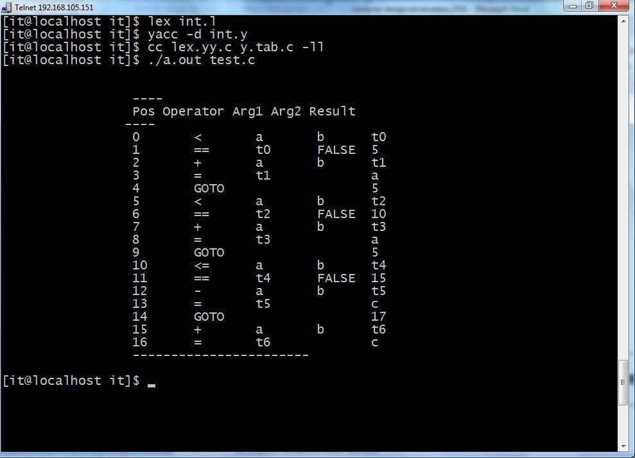

Ex.no :6 Implement type checking

Date:

Aim:To implement type checking.

Algorithm:

AIM:

To develop a C program to test whether a given identifier is valid or not.

ALGORITHM:

- Read the given input string.

- Check the initial character of the string is numerical or any special character except ‘_’ then print it is not a valid identifier.

- Otherwise print it as valid identifier if remaining characters of string doesn’t contains any special characters except ‘_’

PROCEDURE: Go to debug -> run or press CTRL + F9 to run the program.

PROGRAM

#include<stdio.h>

#include<conio.h>

#include<ctype.h>

void main()

{

char a[10];

int flag, i=1;

clrscr();

printf("

\

n Enter an identifier:");

gets(a);

if(isalpha(a[0]))

flag=1;

else

printf("

\

n Not a valid identifier");

while(a[i]!='

\

0')

{

if(!isdigit(a[i])&&!isalpha(a[i]))

{

flag=0;

break;

}

i++;

}

if(flag==1)

printf("

\

n Valid identifier");

getch();

}

OUTPUT:

Input

:

Enter an identifier: first

Output:

Valid

identifier

Enter an identifier:1aqw

Not a valid identifier

Ex.no:7 Implement control flow analysis and Data flow Analysis

Aim:To implement control flow analysis and Data flow Analysis

Algorithm:

Step1:

Program:

- include<stdio.h>

- include<conio.h>

#include<alloc.h>

#include<string.h> struct Listnode
{

char data[50];

int leader,block,u_goto,c_goto; struct Listnode *next;
char label[10],target[10]; }*temp,*cur,*first=NULL,*last=NULL,*cur1;

FILE *fpr;

void createnode(char code[50])

{

temp=(struct Listnode *)malloc(sizeof(struct Listnode));

strcpy(temp->data,code);

strcpy(temp->label,'\0');
strcpy(temp->target,'\0');

temp->leader=0;

temp->block=0;

temp->u_goto=0;

temp->c_goto=0;

temp->next=NULL;

if(first==NULL)

{
first=temp;

last=temp;

}
else

{

last->next=temp;

last=temp;

}}

void printlist()

{
cur=first;

printf("\nMIR code is \n\n");

while(cur!=NULL)

{

printf("\ncode:%s",cur->data);

printf("\nleader:%d\t",cur->leader);

printf("block:%d\t",cur->block);

printf("u_goto:%d\t",cur->u_goto);

printf("c_goto:%d\t",cur->c_goto);
printf("label:%s\t",cur->label);

printf("target:%s\n",cur->target);

cur=cur->next;

}}

void main()

{

char codeline[50];

char c,dup[50],target[10];
char *substring,*token;

int i=0,block,block1;

int j=0;
fpr= fopen("input.txt","r");

clrscr();

while((c=getc(fpr))!=EOF)

{
if(c!='\n')

{

codeline[i]=c;
i++;

}

else

{

codeline[i]='\0';

createnode(codeline);

i=0;
}}

//create last node

codeline[i]='\0';
createnode(codeline);

fclose(fpr);

  - printlist();

- find out leaders,conditional stmts cur=first; cur->leader=1; while(cur!=NULL)

{

substring=strstr((cur->data),"if"); if(substring==NULL)
{

if((strstr((cur->data),"goto"))!=NULL)

{

cur->u_goto=1; (cur->next)->leader=1;

}
}

else

{

cur->c_goto=1;

(cur->next)->leader=1;

}

substring=strstr((cur->data),":");

if(substring!=NULL)

{
cur->leader=1;

}

substring=strstr((cur->data),"call");
if(substring!=NULL)

{

cur->leader=1;

}

if(strstr(cur->data,"return")!=NULL)

{

cur->leader=1;
(cur->next)->leader=1;

}

cur=cur->next;
}

//to find labels and targets

cur=first;

while(cur!=NULL)
{

if((cur->u_goto==1)||(cur->c_goto==1))

{
substring=strstr(cur->data,":");

if(substring!=NULL)

{

token=strstr(substring,"L" );

if(token!=NULL)

strcpy(cur->target,token);

}
else

{

substring=strstr(cur->data,"L");
if(substring!=NULL)

strcpy(cur->target,substring);

}

}

if(strstr(cur->data,":")!=NULL)

{
strcpy(dup,cur->data);

token=strtok(dup,":");

  - printf("\ntoken:%s",token);
if(token!=NULL) strcpy(cur->label,token);

}

cur=cur->next;

}

- printlist();

//to identify blocks

cur=first;

while(cur!= NULL)

{

cur=cur->next;

if((cur->leader)==1)

{

j++;

cur->block=j;
}

else

cur->block=j;
}

- printlist();

- print basic blocks

printf("\n\n......Basic Blocks......\n");

cur=first;

j=0;
printf("\nBlock %d:",j);

while(cur!=NULL)

{

if ((cur->block)==j)

{

printf("%s",cur->data);

printf("\n\t");

cur=cur->next;
}

else

{

j++;

printf("\nBlock %d:",j);

}}

//to output the control flow from each block
printf ("\t\t.......Control Flow.......\n\n");

cur=first;

i=0;
while(cur!=NULL)

{

if((cur->block)!=(cur->next)->block)

{

block=cur->block;

if(cur->u_goto==1)

{
strcpy(target,cur->target);

cur1=first;

while(cur1!=NULL)
{

if(strcmp(cur1->label,target)==0)

{

block1=cur1->block;

printf("\t\tBlock%d---------->Block%d\n",block,block1);

}

cur1=cur1->next;
}

}

else if(cur->c_goto==1)

{

strcpy(target,cur->target);

cur1=first;

while(cur1!=NULL)

{

if(strcmp(cur1->label,target)==0)
{

block1=cur1->block;

printf("\t\tBlock%d---TRUE--->Block%d---FALSE--->Block%d\n",block,block1,(block+1));
}

cur1=cur1->next;

}

}

else if(strstr(cur->data,"return")==NULL)

{

printf("\t\tBlock%d---------->Block%d\n",block,(block+1));
}

else

printf("\t\tBlock%d---------->NULL\n",block);
}

cur=cur->next;

}
cur=last;

block= cur->block;

printf("\t\tBlock%d--------->NULL",block);
getch();

}

Input file: Input.txt

m <- 0

v <- 0
L1 : if v < n goto L5

- <- v

- <- 0 return
L2 : if r >= n goto L3

- <- v + 1 goto L1
L3 : x = a

- <- s + x

if s <= m goto L2 call P
L4 : r <- r + 1 goto L2
L5 : return m

- <- m+10

- <- s -10

Output:
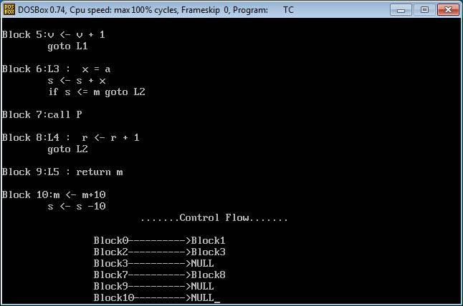

Ex.no :8 Implement any one storage allocation strategies(Heap,Stack,Static)

Date:

Aim:To implement storage allocation strategies using Static.

Algorithm:

Step1: Start the program

Step2: Define the pre-processor MAXNUM as 3

Step3: define the sum_up(void) function.

Step4: Inside main function declare count and initialize it to 0.

Step5: Iterate the loop till count <MAXNUM and invoke sum_up().

Step6: Inside sum_up() function declare sum as static variable and get the the number and sum it.

Step7: Print the sum value.

Step8: Stop the program.

Program:

#include <stdio.h>

#define MAXNUM 3

void sum_up(void);

int main()

{

int count;

printf("\n*****static storage*****\n");

printf("Key in 3 numbers to be summed ");

for(count = 0; count < MAXNUM; count++)

sum_up();

printf("\n*****COMPLETED*****\n");

return 0;

}

void sum_up(void)

{

/* at compile time, sum is initialized to 0 */

static int sum = 0;

int num;

printf("\nEnter a number: ");

scanf("%d", &num);

sum += num;

printf("\nThe current total is: %d\n", sum);

}

Output:
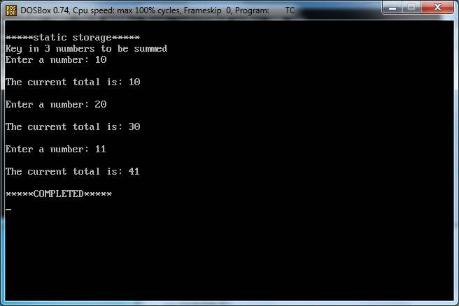

Ex.no: 9

Date:

Construction of DAG

Aim:To construct DAG for the given expression.

Algorithm for labeling the nodes of tree(DAG):

1. For Leaf Nodes

Assign label 1 to left child node and label 0 to right child node.

2. For Interior Nodes

Case 1: If Node's children's labels are different, then
Node's Label = Maximum among Children's Labels.
Case 2: If Node's children's labels are same, then

Node's Label = (Left Child's Label OR Right Child's Label) + 1

Algorithm for Generating Assembly Code:

(Say, R is a Stack consists of registers)
void gencode(Node)

{

if Node is intermediate node of tree(DAG)

{

Case 1: if Node's left child's label == 1 && Node's right child's label == 0 && Node's left child is leaf node && Node's right child is leaf node

{

print "MOV Node's left child's data,R[top]"
print "op Node's right child's data,R[top]"

}

Case 2: else if Node's left child's label >= 1 && Node's right child's label == 0

{
gencode(Node's left child);

print "op Node's right child's data,R[top]"
}

Case 3: else if Node's left child's label < Node's right child's label

{

int temp;

Swap Register Stack's top and second top element; gencode(Node's right child);

temp=pop();

gencode(Node's left child);

push(temp);
Swap Register Stack's top and second top element; print "op R[top-1],R[top]"

}

Case 4: else if Node's left child's label >= Node's right child's label

{
int temp;
gencode(Node's left child);

temp=pop();

gencode(Node's right child);
push(temp);

print "op R[top-1],R[top]"

}

}

else if Node is leaf node and it is left child of it's immediate parent

{

print "MOV Node's data,R[top]"

}

}

Program:

#include<stdlib.h>

#include<iostream>

using namespace std;

/* We will implement DAG as Strictly Binary Tree where each node has zero or two children */

struct bin_tree

{

char data;

int label;

struct bin_tree *right, *left;

};

typedef bin_tree node;

class dag

{

private:

/* R is stack for storing registers */

int R[10];

int top;

/* op will be used for opcode name w.r.t. arithmetic operator e.g. ADD for + */

char *op;

public:

void initializestack(node *root)

{

/* value of top = index of topmost element of stack R = label of Root of tree(DAG) minus one */ top=root->label - 1;

/* Allocating Stack Registers */

int temp=top;

for(int i=0;i<=top;i++)

{

R[i]=temp;

temp--;

}

}

/* insertnode() and insert() functions are for adding nodes to tree(DAG) */

void insertnode(node **tree,char val)

{

node *temp = NULL;

if(!(*tree))

{

temp = (node *)malloc(sizeof(node));

temp->left = temp->right = NULL;

temp->data = val;

temp->label=-1;

*tree = temp;

}

}

void insert(node **tree,char val)

{

char l,r;

int numofchildren;

insertnode(tree, val);

cout<< "\nEnter number of children of " << val <<" :";

cin>> numofchildren;

if(numofchildren==2)

{

cout<< "\nEnter Left Child of " << val <<" :";

cin>> l;

insertnode(&(*tree)->left,l);

cout<< "\nEnter Right Child of " << val <<" :";

cin>> r;

insertnode(&(*tree)->right,r);

insert(&(*tree)->left,l);

insert(&(*tree)->right,r);

}

}

/* findleafnodelabel() will find out the label of leaf nodes of tree(DAG) */

void findleafnodelabel(node *tree,int val)

{

if(tree->left != NULL && tree->right !=NULL)

{

findleafnodelabel(tree->left,1);

findleafnodelabel(tree->right,0);

}

else

{

tree->label=val;

}

}

/* findinteriornodelabel() will find out the label of interior nodes of tree(DAG) */

void findinteriornodelabel(node *tree)

{

if(tree->left->label==-1)

{

findinteriornodelabel(tree->left);

}

else if(tree->right->label==-1)

{

findinteriornodelabel(tree->right);

}

else

{

if(tree->left != NULL && tree->right !=NULL)

{

if(tree->left->label == tree->right->label)

{

tree->label=(tree->left->label)+1;

}

else

{

if(tree->left->label > tree->right->label)

{

tree->label=tree->left->label;

}

else

{

tree->label=tree->right->label;

}

}

}

}

}

/* function print_inorder() will print inorder of nodes. Here we are also printing label of each node of tree(DAG) */
void print_inorder(node * tree)

{

if (tree)

{

print_inorder(tree->left);

cout<< tree->data <<" with Label "<< tree->label << "\n"; print_inorder(tree->right);

}

}

/* function swap() will swap the top and second top elements of Register stack R */

void swap()

{

int temp;

temp=R[0];

R[0]=R[1];

R[1]=temp;

}

/* function pop() will remove and return topmost element of stack */

int pop()

{

int temp=R[top];

top--;

return temp;

}

/* function push() will increment top by one and will insert element at top position of

Register stack */

void push(int temp)

{

top++;

R[top]=temp;

}

/* nameofoperation() will return opcode w.r.t. arithmetic operator */

void nameofoperation(char temp)

{

switch(temp)

{

case '+': op =(char *)"ADD"; break;

case '-': op =(char *)"SUB"; break;

case '*': op =(char *)"MUL"; break;

case '/': op =(char *)"DIV"; break;

}

}

/* gencode() will generate Assembly code w.r.t. labels of tree(DAG) */

void gencode(node * tree)

{

if(tree->left != NULL && tree->right != NULL)

{

if(tree->left->label == 1 && tree->right->label == 0 && tree->left->left==NULL && tree->left-

>right==NULL && tree->right->left==NULL && tree->right->right==NULL)

{

cout << "MOV "<< tree->left->data << "," << "R[" << R[top] << "]\n"; nameofoperation(tree->data);

cout << op << " " << tree->right->data << ",R[" << R[top] << "]\n"; }

else if(tree->left->label >= 1 && tree->right->label == 0)

{

gencode(tree->left);

nameofoperation(tree->data);

cout << op << " " << tree->right->data << ",R[" << R[top] << "]\n"; }

else if(tree->left->label < tree->right->label)

{

int temp;

swap();

gencode(tree->right);

temp=pop();

gencode(tree->left);

push(temp);

swap();

nameofoperation(tree->data);

cout<< op << " " << "R[" << R[top-1] <<"],R[" << R[top] << "]\n"; }

else if(tree->left->label >= tree->right->label)

{

int temp;

gencode(tree->left);

temp=pop();

gencode(tree->right);

push(temp);

nameofoperation(tree->data);

cout<< op << " " << "R[" << R[top-1] << "],R[" << R[top] <<"]\n"; }

}

else if(tree->left == NULL && tree->right == NULL && tree->label == 1)

{

cout << "MOV "<< tree->data << ",R[" << R[top] << "]\n";

}

}

/* deltree() will free the memory allocated for tree(DAG) */

void deltree(node * tree)

{

if (tree)

{

deltree(tree->left);

deltree(tree->right);

free(tree);

}

}

};

/* Program execution will start from main() function */

int main()

{

node *root;

root = NULL;

node *tmp;

char val;

int i,temp;

dag d;

/* Inserting nodes into tree(DAG) */

cout<< "\nEnter root of tree:";

cin>> val;

d.insert(&root,val);

/* Finding Labels of Leaf nodes */

d.findleafnodelabel(root,1);

/* Finding Labels of Interior nodes */

while(root->label == -1)

d.findinteriornodelabel(root);

/* Initializing Stack contents and top variable */ d.initializestack(root);

/* Printing inorder of nodes of tree(DAG) */

cout<< "\nInorder Display:\n";

d.print_inorder(root);

/* Printing assembly code w.r.t. labels of tree(DAG) */ cout<< "\nAssembly Code:\n"; d.gencode(root);

/* Deleting all nodes of tree */

d.deltree(root);

return 0;

}

Output1:
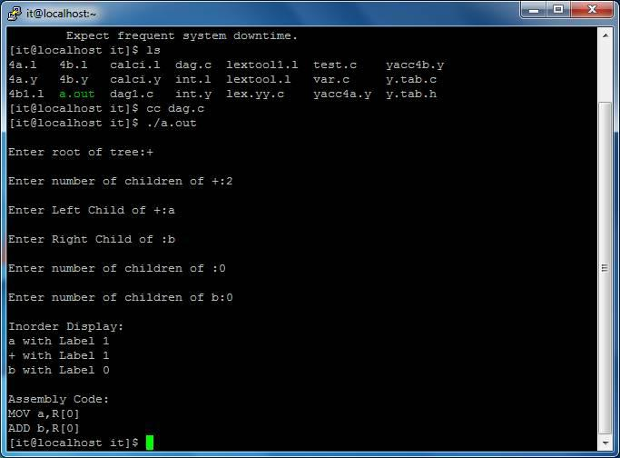

OUTPUT2:
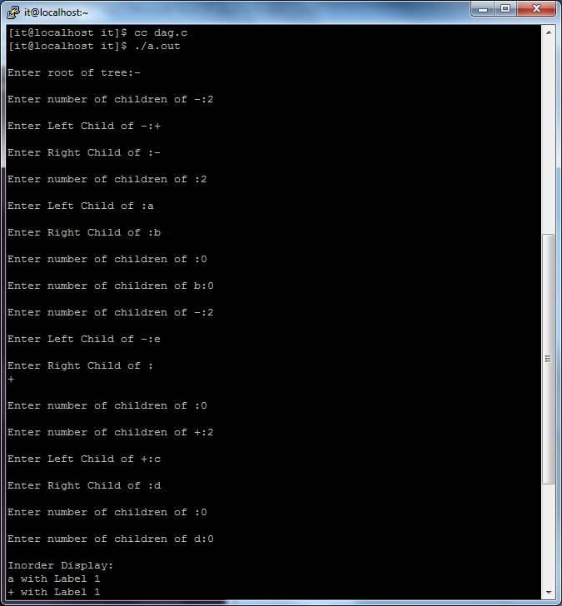

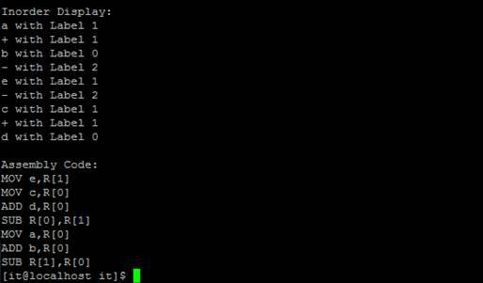

Ex.no: 10 Implement the back end of the compiler which takes the three address code and produces the 8086 assembly language instructions that can be assembled and run using a 8086 assembler. The target assembly instructions can be simple move, add, sub, jump. Also simple addressing modes are used.

Aim: To write a C program to implement the code generation algorithm.

Algorithm:

Input: Set of three address code sequence.

Output: Assembly code sequence for three address codes (opd1=opd2, op, opd3).

Method:

1- Start the program

2- Get address code sequence.

3- Determine current location of 3 using address (for 1st operand).

4- If current location not already exist generate move (B,O).

5- Update address of A(for 2nd operand).

6- If current value of B and () is null, exist.

7- If they generate operator () A,3 ADPR.

8- Store the move instruction in memory.

9- Stop.

Program:

#include<stdio.h>

#include<conio.h>

#include<string.h>

#include<ctype.h>

#include<graphics.h>

typedef struct

{

char var[10];

int alive;

}

regist;

regist preg[10];

void substring(char exp[],int st,int end)

{

int i,j=0;

char dup[10]="";

for(i=st;i<end;i++)

dup[j++]=exp[i];

dup[j]='0';

strcpy(exp,dup);

}

int getregister(char var[])

{

int i;

for(i=0;i<10;i++) {

if(preg[i].alive==0) {

strcpy(preg[i].var,var);

break;

}}

return(i);

}

void getvar(char exp[],char v[])

{

int i,j=0;

char var[10]="";

for(i=0;exp[i]!='\0';i++)

if(isalpha(exp[i]))

var[j++]=exp[i];

else

break;

strcpy(v,var);

}

void main()

{

char basic[10][10],var[10][10],fstr[10],op;

int i,j,k,reg,vc,flag=0;

clrscr();

printf("\nEnter the Three Address Code:\n");

for(i=0;;i++)

{

gets(basic[i]);

if(strcmp(basic[i],"exit")==0)

break;

}

printf("\nThe Equivalent Assembly Code is:\n");

for(j=0;j<i;j++)

{

getvar(basic[j],var[vc++]);

strcpy(fstr,var[vc-1]);

substring(basic[j],strlen(var[vc-1])+1,strlen(basic[j]));

getvar(basic[j],var[vc++]);

reg=getregister(var[vc-1]);

if(preg[reg].alive==0)

{

printf("\nMov R%d,%s",reg,var[vc-1]);

preg[reg].alive=1;

}

op=basic[j][strlen(var[vc-1])];

substring(basic[j],strlen(var[vc-1])+1,strlen(basic[j]));

getvar(basic[j],var[vc++]);

switch(op)

{

case '+': printf("\nAdd"); break;

case '-': printf("\nSub"); break;

case '*': printf("\nMul"); break;

case '/': printf("\nDiv"); break;

}

flag=1;

for(k=0;k<=reg;k++)

{

if(strcmp(preg[k].var,var[vc-1])==0)

{

printf("R%d, R%d",k,reg);

preg[k].alive=0;

flag=0;

break;

}

}

if(flag)

{

printf(" %s,R%d",var[vc-1],reg);

printf("\nMov %s,R%d",fstr,reg);

}

strcpy(preg[reg].var,var[vc-3]);

getch();

}

}

Output
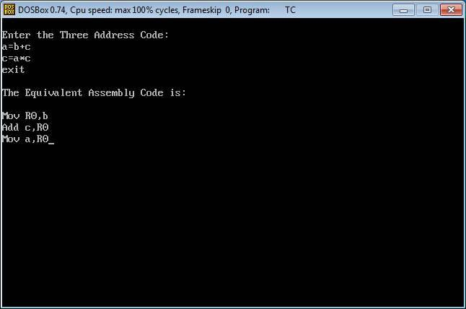

EX.NO:11 IMPLEMENTATION OF CODE OPTIMIZATION TECHNIQUES

AIM:

To write a C program to implement the code optimization algorithm.

ALGORITHM:

The code generation algorithm takes as input a sequence of three – address statements constituting a basic block. For each three – address statement of the form x := y op z we perform the following actions:

- Invoke a function getreg to determine the location L where the result of the computation y op z should be stored. L will usually be a register, but it could also be a memory location.

2.We shall describe getreg shortly, L to place a copy of y in L.′ if the value of y is currently both in memory and a register. If the value of y is not already in L, generate the instruction MOV y′, (one of) the current location(s) of y. prefer the register for y′.

- Consult the address descriptor for y to determine yis a current location of z. Again, prefer a register to a memory location if z is in both.

4.Update the address descriptor of x to indicate that x is in location L. If L is a register, update its descriptor to indicate that it contains the value of x, and remove x from all other register descriptors.′, L where z′.

- Generate the instruction OP z

- If the current values of y and/or z have no next users, are not live on exit from the block, and are in register descriptor to indicate that, after execution of x := y op z, those registers no longer will contain y and/or z, respectively.

Input: Set of ‘L’ values with corresponding ‘R’ values.

Output: Intermediate code & Optimized code after eliminating common expressions.

PROGRAM:

#include<stdio.h>

#include<conio.h>

#include<string.h>

struct op

{

char l;

char r[20];

}op[10],pr[10];

void main()

{

int a,i,k,j,n,z=0,m,q;

char *p,*l;

char temp,t;

char *tem;
clrscr();

printf("enter no of values");

scanf("%d",&n);

for(i=0;i<n;i++)

{

printf("left\t");

op[i].l=getche();

printf("right:\t");

scanf("%s",op[i].r);
}

printf("intermediate Code\n") ;

for(i=0;i<n;i++)
{

printf("%c=",op[i].l);

printf("%s\n",op[i].r);

}

for(i=0;i<n-1;i++)

{

temp=op[i].l;
for(j=0;j<n;j++)

{

p=strchr(op[j].r,temp);
if(p)

{

pr[z].l=op[i].l;

strcpy(pr[z].r,op[i].r);
z++ ;

}} }

pr[z].l=op[n-1].l;

strcpy(pr[z].r,op[n-1].r);

z++;

printf("\nafter dead code elimination\n");

for(k=0;k<z;k++)

{

printf("%c\t=",pr[k].l);

printf("%s\n",pr[k].r);

}

//sub expression elimination

for(m=0;m<z;m++)

{

tem=pr[m].r;

for(j=m+1;j<z;j++)

{
p=strstr(tem,pr[j].r);

if(p)

{
t=pr[j].l;

pr[j].l=pr[m].l ;

for(i=0;i<z;i++)

{

l=strchr(pr[i].r,t) ;

if(l)

{
a=l-pr[i].r;

//printf("pos: %d",a);

pr[i].r[a]=pr[m].l;

}}}}}

printf("eliminate common expression\n");

for(i=0;i<z;i++)

{

printf("%c\t=",pr[i].l);

printf("%s\n",pr[i].r);
}

// duplicate production elimination

for(i=0;i<z;i++)

{

for(j=i+1;j<z;j++)

{

q=strcmp(pr[i].r,pr[j].r);

if((pr[i].l==pr[j].l)&&!q)

{

pr[i].l='\0';

strcpy(pr[i].r,'\0');
}}

}

printf("optimized code");

for(i=0;i<z;i++)
{

if(pr[i].l!='\0')

{
printf("%c=",pr[i].l);

printf("%s\n",pr[i].r);

}

}

getch();

}

OUTPUT:
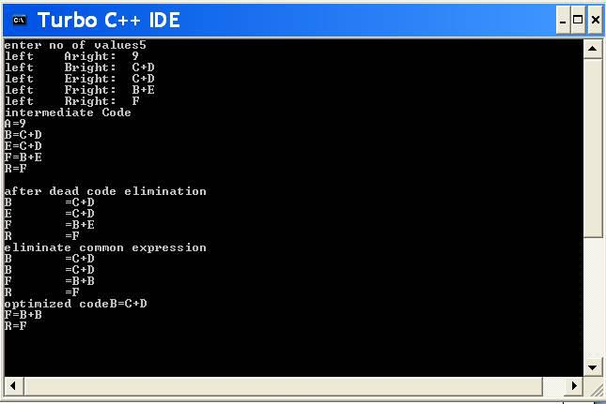

Beyond the syllabus

Ex.No: 12 IMPLEMENTATION OF SHIFT-REDUCED PARSING ALGORITHMS AIM:

To write a program for implementing Shift Reduce Parsing using C.

ALGORITHM:

- Get the input expression and store it in the input buffer.

- Read the data from the input buffer one at the time.

- Using stack and push & pop operation shift and reduce symbols with respect to production rules available.

- Continue the process till symbol shift and production rule reduce reaches the start symbol.

- Display the Stack Implementation table with corresponding Stack actions with input symbols.
PROGRAM:

#include<stdio.h>

#include<stdlib.h>

#include<conio.h>

#include<string.h>

char ip_sym[15],stack[15];

int ip_ptr=0,st_ptr=0,len,i;

char temp[2],temp2[2];

char act[15];

void check();

void main()

{

clrscr();

printf("\n\t\t SHIFT REDUCE PARSER\n");

printf("\n GRAMMER\n");

printf("\n E->E+E\n E->E/E");

printf("\n E->E*E\n E->a/b");

printf("\n enter the input symbol:\t");

gets(ip_sym);

printf("\n\t stack implementation table");

printf("\n stack \t\t input symbol\t\t action");

printf("\n________\t\t____________\t\t____________\n");

printf("\n $\t\t%s$\t\t\t--",ip_sym);

strcpy(act,"shift");

temp[0]=ip_sym[ip_ptr];

temp[1]='\0';

strcat(act,temp);

len=strlen(ip_sym);

for(i=0;i<=len-1;i++)

{

stack[st_ptr]=ip_sym[ip_ptr];

stack[st_ptr+1]='\0';

ip_sym[ip_ptr]=' ';

ip_ptr++;

printf("\n $%s\t\t%s$\t\t\t%s",stack,ip_sym,act);

strcpy(act,"shift");

temp[0]=ip_sym[ip_ptr];

temp[1]='\0';

strcat(act,temp);

check();

st_ptr++;

}

st_ptr++;

check(); }

void check()

{int flag=0;

temp2[0]=stack[st_ptr];

temp2[1]='\0';

if((!strcmpi(temp2,"a"))||(!strcmpi(temp2,"b")))

{

stack[st_ptr]='E';

if(!strcmpi(temp2,"a"))

printf("\n $%s\t\t%s$\t\t\tE->a",stack,ip_sym);

else

printf("\n $%s\t\t%s$\t\t\tE->b",stack,ip_sym);

flag=1;

}

if((!strcmpi(temp2,"+"))||(strcmpi(temp2,"*"))||(!strcmpi(temp2,"/")))

{flag=1;

}

if((!strcmpi(stack,"E+E"))||(!strcmpi(stack,"E\E"))||(!strcmpi(stack,"E*E")))

{strcpy(stack,"E"); st_ptr=0; if(!strcmpi(stack,"E+E"))

printf("\n $%s\t\t%s$\t\t\tE->E+E",stack,ip_sym);

else

if(!strcmpi(stack,"E\E"))

printf("\n $%s\t\t%s$\t\t\tE->E\E",stack,ip_sym);

else

if(!strcmpi(stack,"E*E"))

printf("\n $%s\t\t%s$\t\t\tE->E*E",stack,ip_sym);

else

printf("\n $%s\t\t%s$\t\t\tE->E+E",stack,ip_sym);

flag=1;

} if(!strcmpi(stack,"E")&&ip_ptr==len)

{

printf("\n $%s\t\t%s$\t\t\tACCEPT",stack,ip_sym); getch();
exit(0);

}

if(flag==0)

{

printf("\n%s\t\t\t%s\t\t reject",stack,ip_sym); exit(0); }
return;

}

OUTPUT: SHIFT REDUCE PARSER

GRAMMER

E->E+E

E->E/E

E->E*E

E->a/b

Enter the input symbol: a+b

Stack Implementation Table

Stack | Input Symbol | Action
------- | ----------------- | ---------
$ | a+b$ | --
$a | +b$ | shift a
$E | +b$ | E->a
$E+ | b$ | shift +
$E+b | $ | shift b

$E+E | $ | E->b
$E | $ | E->E+E
$E | $ | ACCEPT

RESULT:Thus the program for implementation of Shift Reduce parsing algorithm is executed and verified

Ex.No:13 CONSTRUCTION OF LR-PARSING TABLE

AIM:

To write a program for construction of LR Parsing table using C.

ALGORITHM:

- Get the input expression and store it in the input buffer.

- Read the data from the input buffer one at the time and convert in to corresponding Non Terminal using production rules available.

- Perform push & pop operation for LR parsing table construction.

- Display the result with conversion of corresponding input symbols to production and production reduction to start symbol. No operation performed on the operator.

PROGRAM:

#include<stdio.h>

#include<conio.h>

char stack[30];

int top=-1;

void push(char c)

{

top++;

stack[top]=c;

}

char pop()

{

char c;

if(top!=-1)

{

c=stack[top];

top--;

return c;

}

return'x';

}

void printstat()

{

int i;

printf("\n\t\t\t $");

for(i=0;i<=top;i++)

printf("%c",stack[i]);

}

void main()

{

int i,j,k,l;

char s1[20],s2[20],ch1,ch2,ch3;

clrscr();

printf("\n\n\t\t LR PARSING");

printf("\n\t\t ENTER THE EXPRESSION");

scanf("%s",s1);

l=strlen(s1);

j=0;

printf("\n\t\t $");

for(i=0;i<l;i++)

{

if(s1[i]=='i' && s1[i+1]=='d')

{

s1[i]=' ';

s1[i+1]='E';

printstat(); printf("id");

push('E');

printstat();

}

else if(s1[i]=='+'||s1[i]=='-'||s1[i]=='*' ||s1[i]=='/' ||s1[i]=='d')

{

push(s1[i]);

printstat();

}

}

printstat();

l=strlen(s2);

while(l)

{

ch1=pop();

if(ch1=='x')

{

printf("\n\t\t\t $");

break;

}

if(ch1=='+'||ch1=='/'||ch1=='*'||ch1=='-')

{

ch3=pop();

if(ch3!='E')

{

printf("errror");

exit();

}

else

{

push('E');

printstat();

}

}

ch2=ch1;

}

getch();

}

OUTPUT:

LR PARSING

ENTER THE EXPRESSION

id+id*id-id

$

$id

$E

$E+

$E+id

$E+E

$E+E*

$E+E*id

$E+E*E

$E+E*E-

$E+E*E-id

$E+E*E-E

$E+E*E-E

$E+E*E

$E

$

RESULT:

Thus the program for construction of LR Parsing table is executed and verified.

