Real Estate Agency Portal
Course: CIS 344
Semester: Spring 2026
Professor: Yanilda Peralta Ramos
Name: Radhika Joshi

1. Introduction
The purpose of this project is to develop a web-based Real Estate Agency Portal using PHP and MySQL. The platform simulates a real-world real estate management system where different types of users interact with property listings and agency services through a secure and organized online environment.
The system supports three types of users: agents, buyers, and renters. Agents are responsible for adding and managing property listings, while buyers and renters can browse available properties, save favorite listings, and submit inquiries regarding properties they are interested in. The project demonstrates the integration of database systems with server-side programming and user authentication mechanisms.
The portal was developed using several technologies and tools. PHP was used as the primary backend programming language to handle application logic, sessions, and database communication. MySQL was used to design and manage the relational database. HTML and CSS were used to create the user interface and improve the overall appearance of the website. PDO (PHP Data Objects) was implemented to establish secure database connections and execute prepared SQL statements safely.
This project combines database management, secure login systems, CRUD operations, and role-based access control into a single functional web application that resembles a realistic real estate agency platform.
2. System Features
The Real Estate Agency Portal contains multiple features that support realistic interactions between users and property listings.
Agents
Agents are responsible for managing properties within the system. After logging in, agents are redirected to their dashboard where they can add new property listings. Each listing contains detailed information including property title, property type, address, city, price, and availability status.
Buyers
Buyers can browse all available properties through the listings page. They can view property details, submit inquiries about specific properties, and save favorite properties for future reference. Buyers also have access to a personalized dashboard that displays their submitted inquiries.
Renters
Renters have functionality like buyers. They can search for available properties, send inquiries to agents, and save listings to their favorites page. The portal treats renters as a separate user role for better access control and system organization.
Property Listings
The properties page displays all available listings stored in the database. Users can filter properties by city using the search functionality. Each listing displays property details such as city, price, status, and agent information.
Favorites System
The portal includes a favorites system that allows buyers and renters to save properties they are interested in. Saved listings are stored in the Favorites table and displayed on the favorites page.
Inquiry System
The inquiry system allows buyers and renters to contact agents regarding specific properties. Inquiry messages are stored in the database and associated with both the user and the selected property.
3. Database Design
The project uses a relational database named:
real_estate_portal_db
The database was designed using multiple related tables connected through primary and foreign keys.
Users Table
The Users table stores all registered users in the system.
Fields:
- userId (Primary Key)
- userName
- contactInfo
- passwordHash
- userType
The userType field identifies whether the user is an agent, buyer, or renter.
Properties Table
The Properties table stores all property listings added by agents.
Fields:
- propertyId (Primary Key)
- title
- propertyType
- address
- city
- price
- status
- agentId (Foreign Key)
The agentId field connects each property to the agent who created the listing.
Inquiries Table
The Inquiries table stores messages submitted by buyers and renters regarding properties.
Fields:
- inquiryId (Primary Key)
- userId (Foreign Key)
- propertyId (Foreign Key)
- message
- inquiryDate
This table creates a relationship between users and properties through inquiries.
Transactions Table
The Transactions table stores completed property sales or rental transactions.
Fields:
- transactionId (Primary Key)
- propertyId (Foreign Key)
- userId (Foreign Key)
- transactionType
- transactionDate
- amount
The transactionType field determines whether the transaction was a sale or rental.
Favorites Table
The Favorites table stores saved properties for buyers and renters.
Fields:
- favoriteId (Primary Key)
- userId (Foreign Key)
- propertyId (Foreign Key)
- savedDate
This table allows users to maintain a list of preferred properties.
Database Relationships
The database relationships ensure proper data organization and integrity:
- One agent can manage many properties.
- One property can receive multiple inquiries.
- One user can save multiple favorite properties.
- One property can have associated transactions.
Screenshots from phpMyAdmin showing tables, keys, and relationships should be inserted in this section.
4. Advanced SQL Features
Several advanced SQL features were implemented in the project to improve automation and database functionality.
Stored Procedure: AddOrUpdateUser
The AddOrUpdateUser procedure was created to simplify user management within the database. This procedure allows the system to either insert a new user or update an existing user record depending on whether the user already exists.
Stored Procedure: ProcessTransaction
The ProcessTransaction procedure records a completed property sale or rental transaction. After inserting transaction data into the Transactions table, the procedure automatically updates the status of the related property.
For example:
- Sale transactions update property status to "sold"
- Rental transactions update property status to "rented"
View: PropertyListingView
The PropertyListingView view combines information from the Properties and Users tables into a single user-friendly listing view. The view displays:
- Property title
- Property type
- City
- Price
- Status
- Agent name
Using a view simplifies SQL queries and improves readability within the PHP application.
Trigger: AfterTransactionInsert
A database trigger named AfterTransactionInsert was implemented to automatically update property status whenever a new transaction is inserted into the Transactions table.
The trigger performs the following actions:
- If the transaction type is sale, the property status becomes "sold"
- If the transaction type is rental, the property status becomes "rented"
These advanced SQL features demonstrate the use of automation and relational database functionality within the project.
5. PHP Implementation
The portal was developed using PHP to handle server-side logic and database interaction.
Login System
The login system authenticates users using usernames and passwords stored in the database. Passwords are verified using PHP’s password_verify () function. After successful login, session variables are created to maintain authentication throughout the website.
Registration System
Users can register as agents, buyers, or renters using the registration page. During registration, passwords are securely hashed before being stored in the database.
Session Handling
PHP sessions are used to maintain user login states. Sessions ensure that users remain authenticated while navigating between pages. Logging out destroys the session securely.
CRUD Operations
The project implements CRUD operations for multiple system features:
- Create new users
- Add new properties
- Submit inquiries
- Save favorites
- Retrieve and display property data
These operations are performed using PHP methods and SQL queries through PDO prepared statements.
Role-Based Access Control
The system uses role-based access control to limit functionality depending on user type.
- Agents can add and manage properties
- Buyers and renters can browse properties, submit inquiries, and save favorites
Authorization checks are implemented using helper functions in auth.php.
6. Security Features
Several security techniques were implemented to improve the safety and reliability of the application.
Password Hashing
Passwords are securely hashed using PHP’s password_hash() function before being stored in the database. During login, password_verify() compares the entered password with the stored hash.
Prepared Statements
Prepared statements were implemented using PDO to protect the system from SQL injection attacks. User input is never directly inserted into SQL queries.
Session Security
The application uses PHP sessions to manage authentication securely. Session IDs are regenerated after login to help prevent session fixation attacks.
Role Authorization
Restricted pages use role verification functions to ensure that only authorized users can access certain features.
Examples:
- Only agents can add properties
- Only buyers and renters can submit inquiries or save favorites
7. Challenges and Solutions
Challenge 1: Foreign Key Constraints
During development, deleting table data caused foreign key constraint errors because related records existed across multiple tables.
Solution
The issue was resolved by deleting records in the correct relational order using DELETE statements instead of TRUNCATE commands.
Challenge 2: User Authentication
Initial login attempts failed because passwords were stored as plain text rather than hashed values.
Solution
Password hashing and verification were implemented using password_hash() and password_verify () functions.
Challenge 3: Role-Based Access Control
Ensuring that each user type only accessed authorized pages required additional logic.
Solution
Custom helper functions were created in auth.php to verify user roles before granting access to pages.
Challenge 4: Database Integration
Connecting PHP pages with MySQL while maintaining secure database communication required careful implementation.
Solution
PDO prepared statements and centralized database connection methods were used throughout the project.
8. Screenshots
The following screenshots should be included in this section of the report:
- Home Page
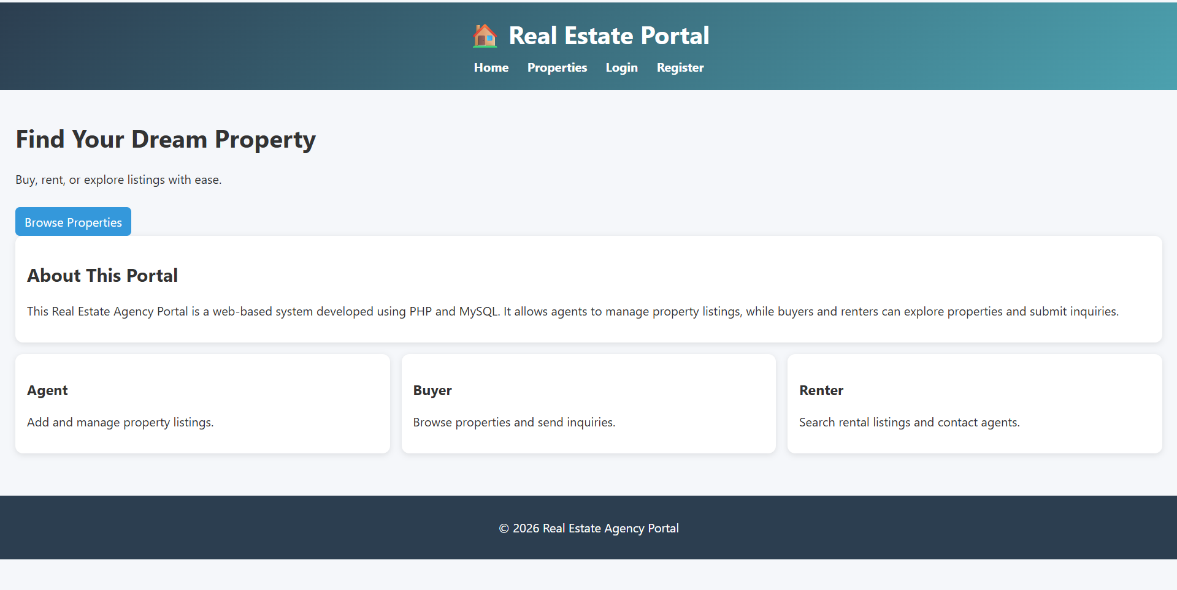
- Login Page
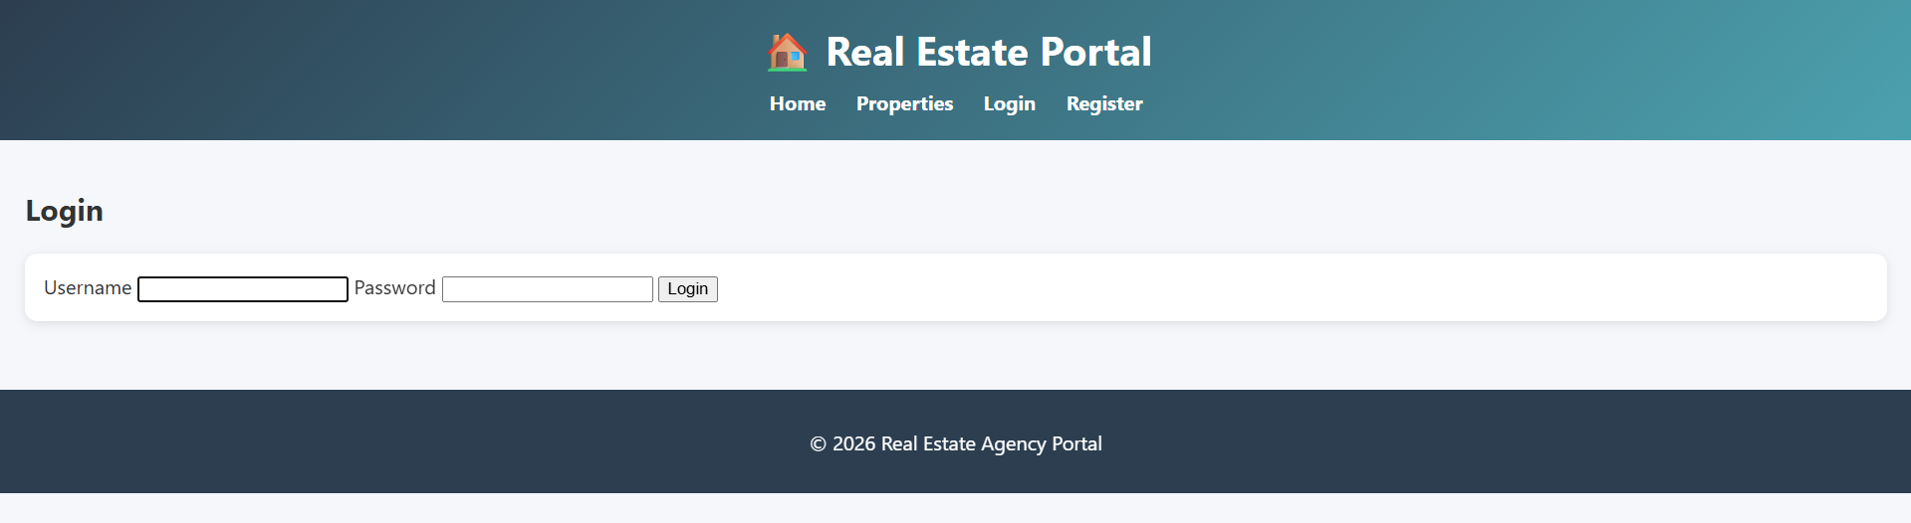
- Registration Page
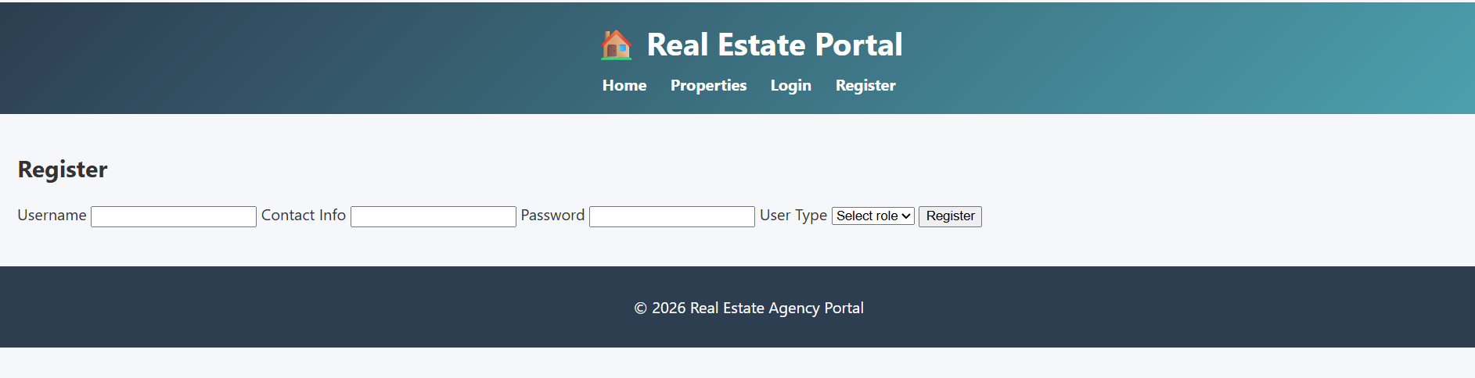
- Agent Dashboard
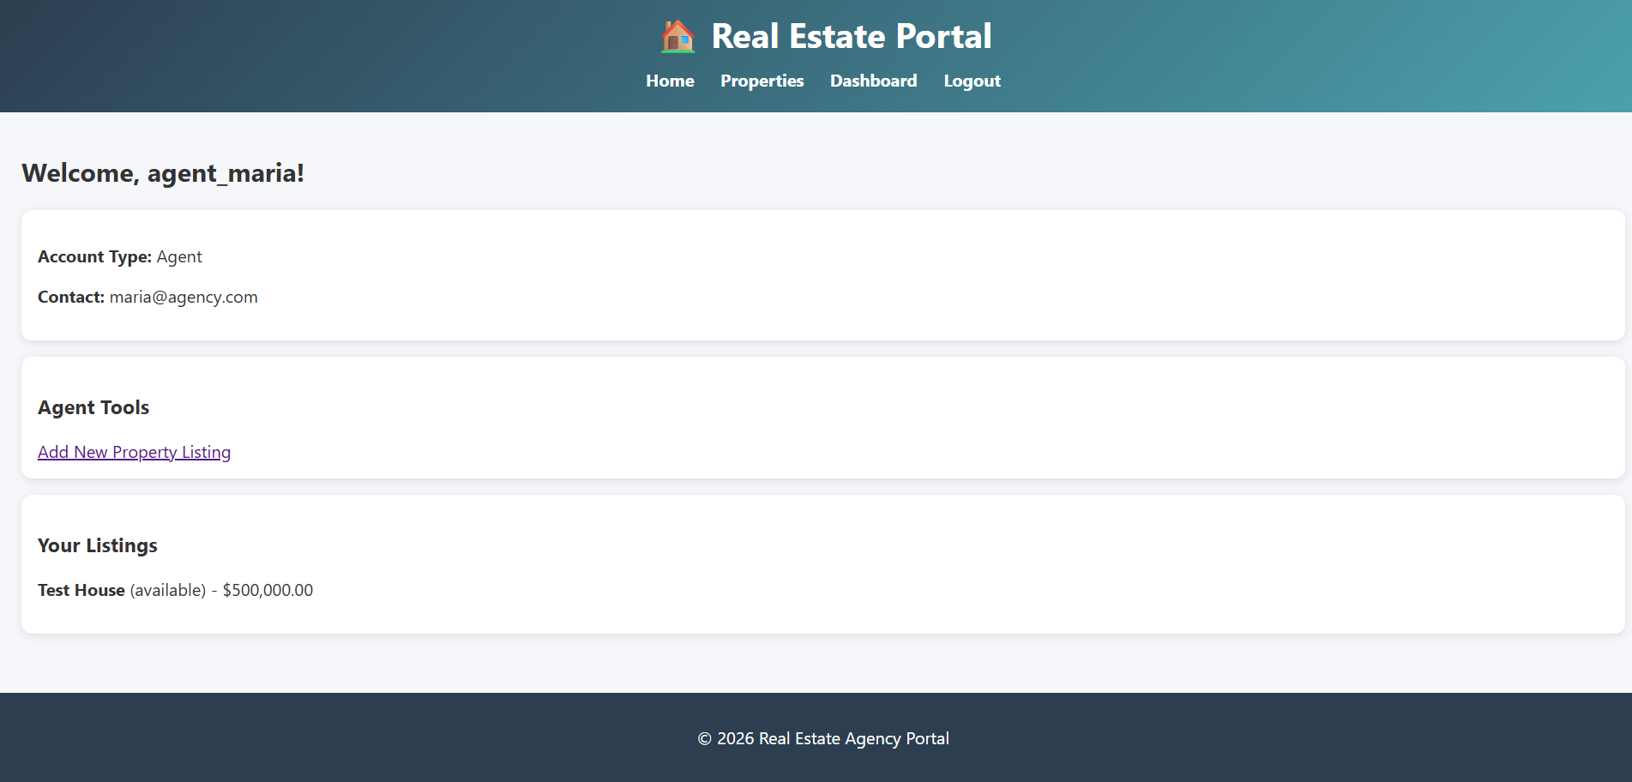
- Renter Dashboard
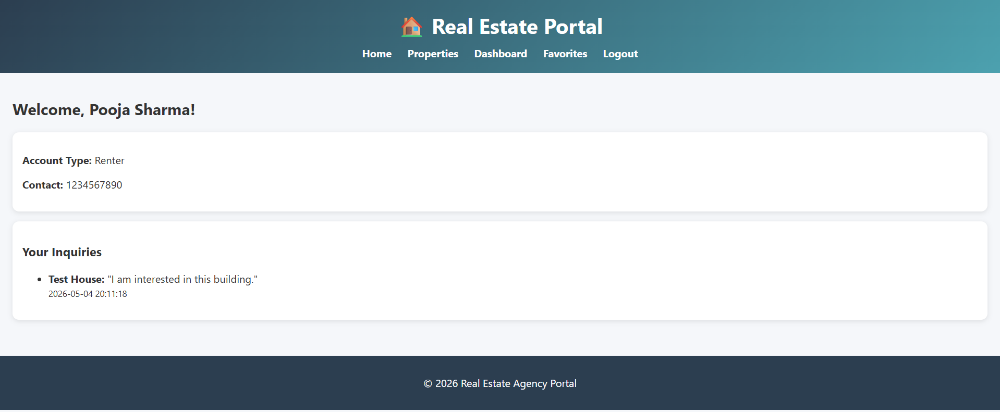
- Property Listings Page
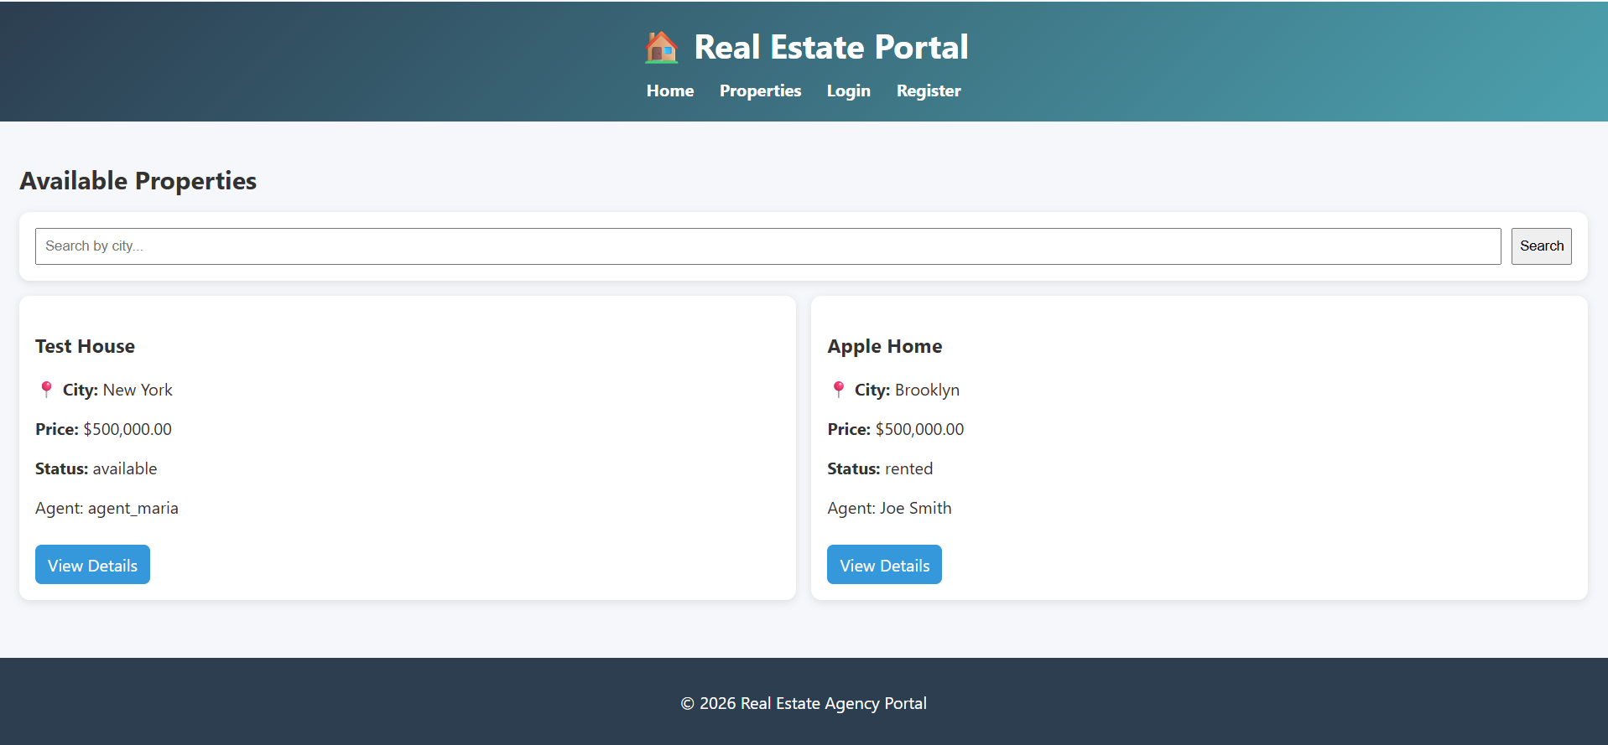
- Property Details Page
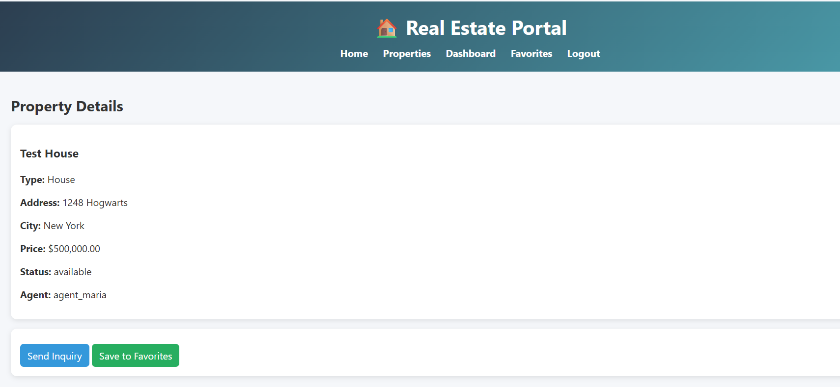
- Favorites Page
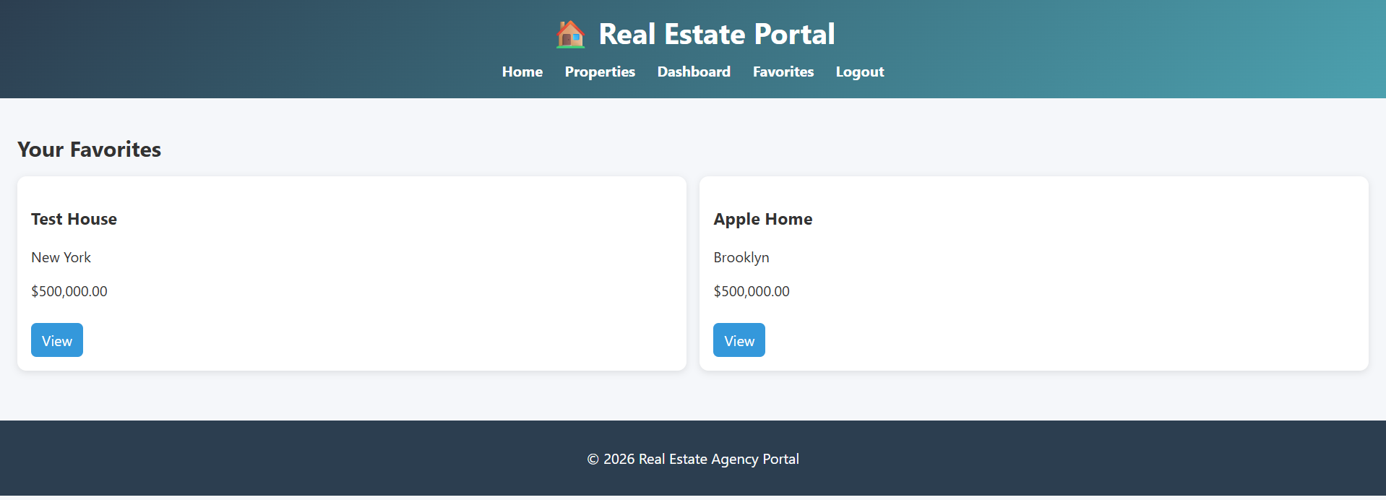
- Inquiry Submission Page
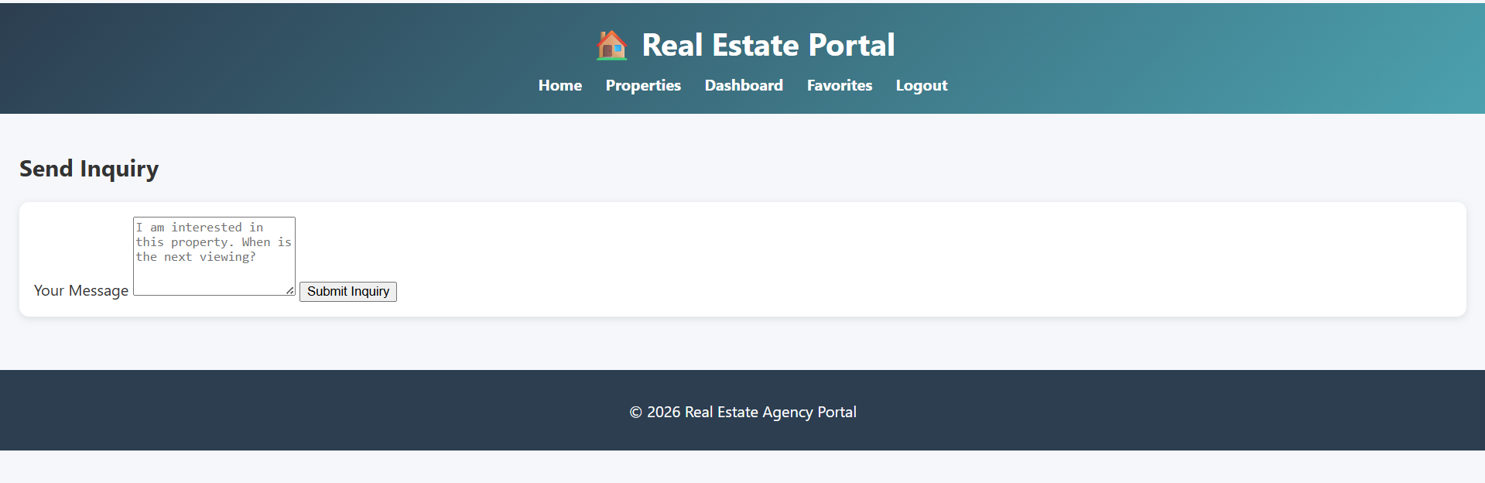
- phpMyAdmin Database Tables
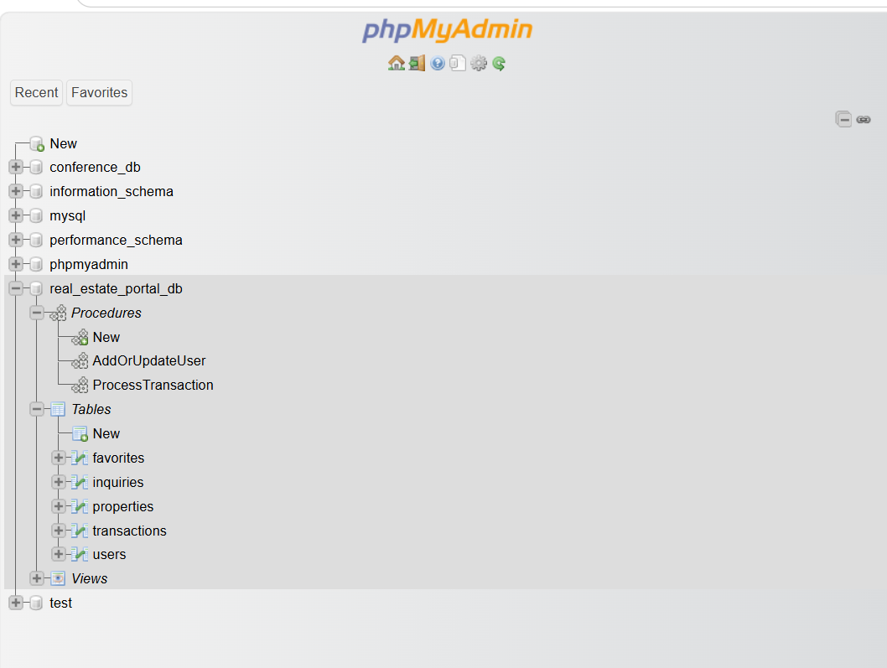

These screenshots demonstrate that the platform functions correctly and satisfies all project requirements.
9. Conclusion
The Real Estate Agency Portal successfully demonstrates the integration of PHP and MySQL within a realistic web application environment. The project includes secure authentication, relational database management, role-based access control, property management, inquiry handling, and advanced SQL functionality.
The platform allows agents to manage property listings while enabling buyers and renters to interact with listings through inquiries and favorites. Security features such as password hashing, prepared statements, and session handling were implemented to improve application safety.
Overall, this project provided me a practical experience in full-stack web development, relational database design, SQL programming, and PHP application development. It also demonstrated how multiple technologies can work together to create a functional and secure real-world portal.
10. Github Link

