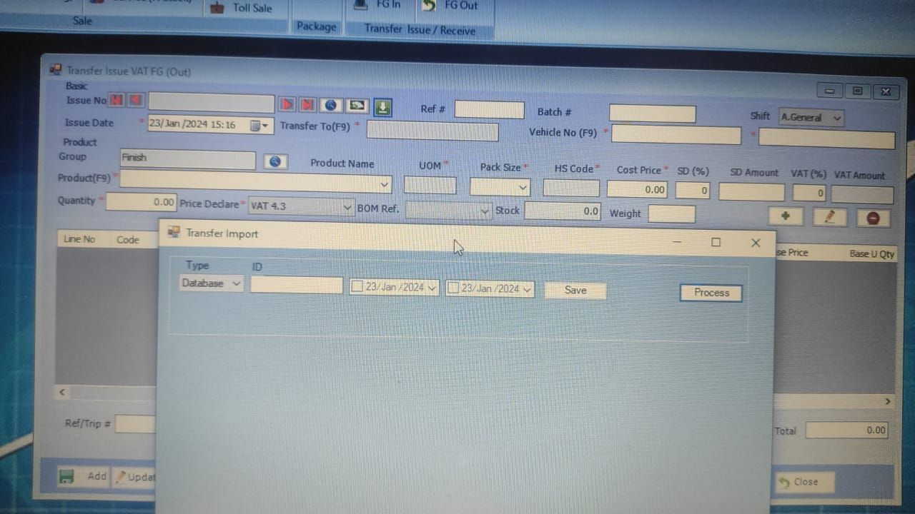
Bata: FG Out (no excel file upload menu)
Database: 2019

