Program:
public class add{
public static void main(String[] args){
int a=10;
int b=20;
int res=a+b;
System.out.println(res);
}
}
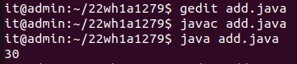
Output:

