IHI – A Mobile Application for ADHD Analysis and Detection

2022_309

Logbook

Dilshan K. G. T

IT19020822

IT4010

B.Sc. (Hons) in Information Technology Specializing in Software Engineering

Department of Computer Science and Software Engineering

Sri Lanka Institute of Information Technology

Sri Lanka

Table of Contents

Gantt Chart 3

Git Labs Commit History 3

MS Planner Tasks 4

Communication Channels 4

MS Teams 4

WhatsApp 5

Logbook 6

Test Data 8

# Gantt Chart

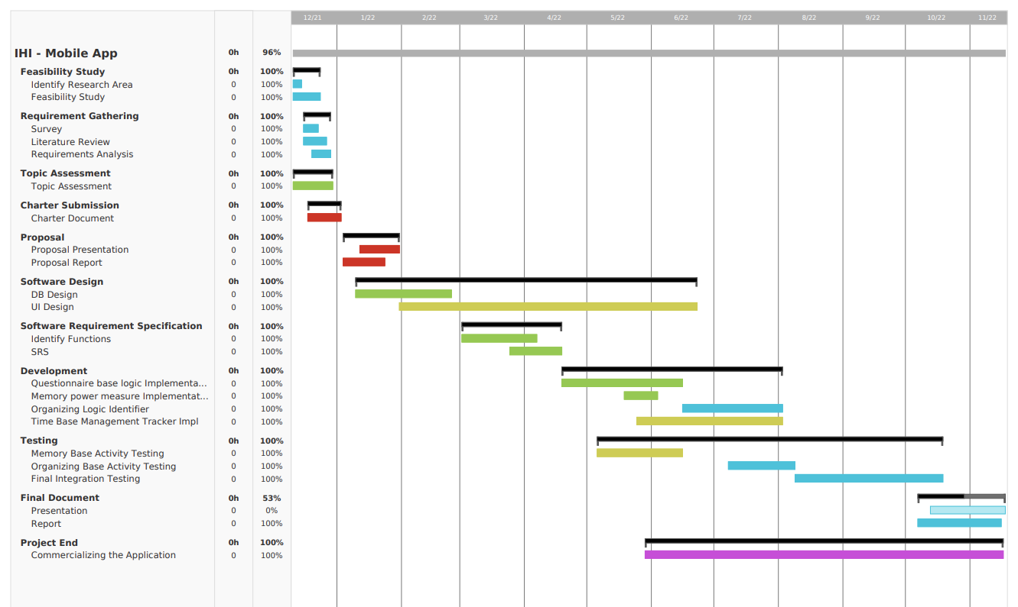

# Git Labs Commit History

IT19020822

# Graphical user interface, text, application Description automatically generatedMS Planner Tasks

# Communication Channels

## MS Teams

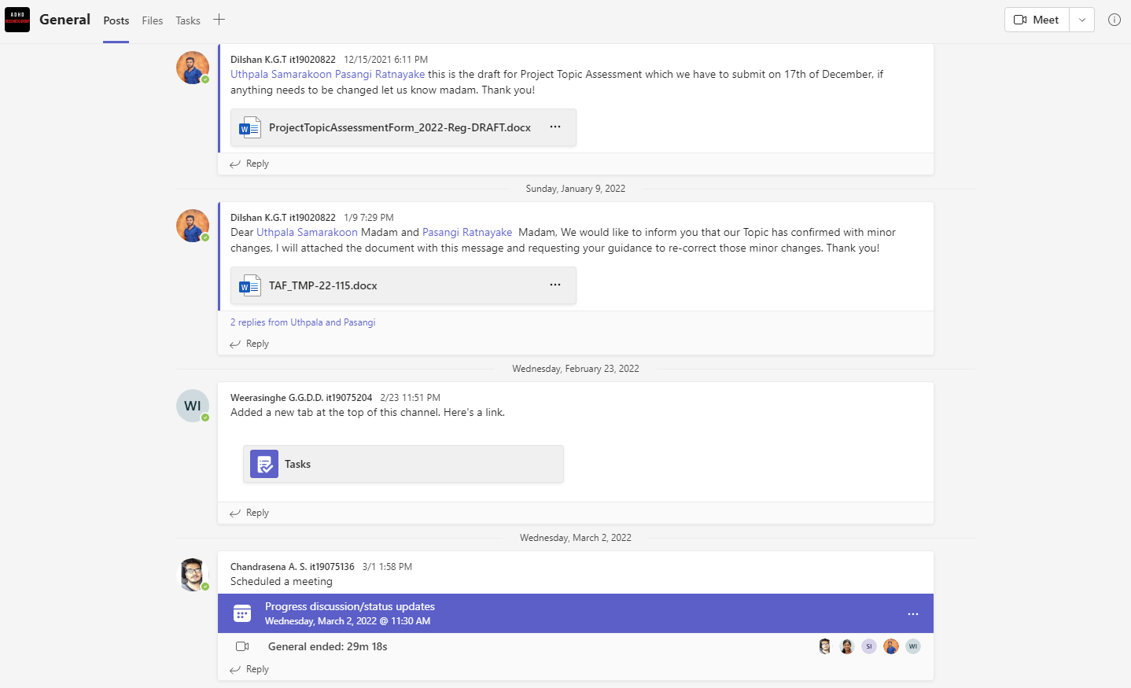

General: For all team members – Including supervisor and co-supervisor

## WhatsApp

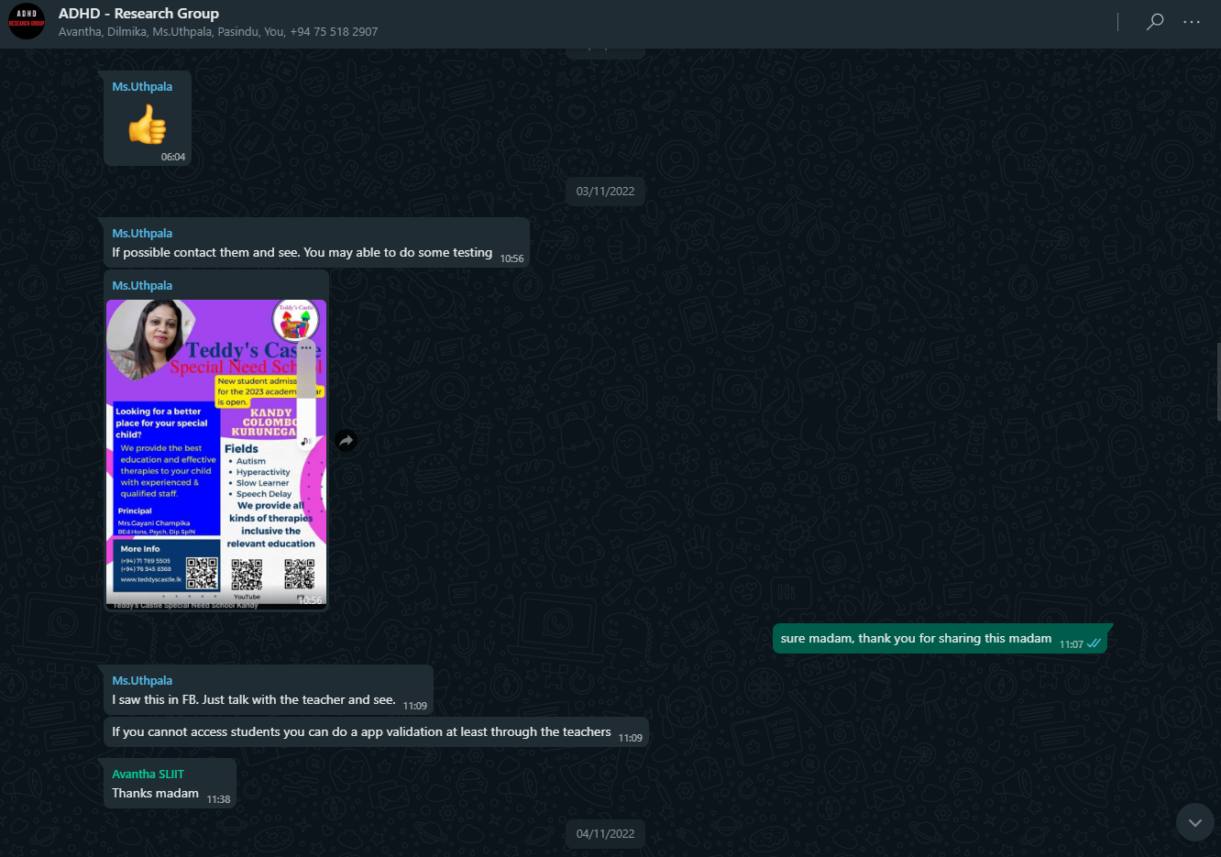

Git Lab for PR reviews and comments.

## Logbook

|  |  |
| --- | --- |
| Meeting Date | Content Discussed |
| 2021/12/11 | * Brief Discussion regarding the ADHD and the solution discussion using the IHI application    |
| 2022/03/15 | * Discuss about the technologies related to application development. * Suggested to localizable the application * Guide to collect information and contact industrial experts related to this specific area   + External Supervisor - Doctor or a counselor * Each component descriptive discussion regarding the improvement and methodologies.   **Graphical user interface, text, application, table  Description automatically generated**  **Graphical user interface, text, application  Description automatically generated** |
| 2022/04/12 | * Review and present the draft version of the application UI and basic components.   + How to improve the UX and UI. * Progress update on external supervisor meeting. * Pre-plan testing stages and discuss the importunacy of testing when considering each component. |
| 2022/04/27 | * Review progress of the research from individual members * Appearance of the application and how colors affect the children * Usage of graphs and charts in the application * Progress update for the past 2 weeks |
| 2022/05/06 | * Review progress of the research from individual members * How we should prepare for the progress presentation 1 * Information we got from our tests |
| 2022/06/07 | * Conference details discussion * Usability and UI improvement guidelines |
| 2022/09/20 | * Conference details discussion * Feedback regarding the flow and module integrations |
| 2022/10/28 | * Final Paper Discussion * Research paper/ Camera ready copy feedbacks * Final Demo |

# Test Data

