

IHI: (INATTENTIVE -HYPERACTIVITY/IMPULSIIVITY)

A MOBILE APPLICATION FOR ADHD ANALYSIS AND DETECTION

2022-309

Log Book

Supervisor – Ms. Uthpala Samarakoon

Co supervisor – Ms. Pasangi Rathnayake

## Chandrasena A.S – IT19075136

BSc (Hons) Degree in Information Technology (Specialization in Software Engineering)

Department of Information Technology

Sri Lankan Institute of Information Technology

May 2022

Table of Contents

[Gantt Chart 3](NULL#_Toc119275045)

[Git Labs Commit History 3](NULL#_Toc119275046)

[MS Planner Tasks 4](NULL#_Toc119275047)

[Communication Channels 4](NULL#_Toc119275048)

[MS Teams 4](NULL#_Toc119275049)

[WhatsApp 5](NULL#_Toc119275050)

[Logbook 6](NULL#_Toc119275051)

[Test Data 8](NULL#_Toc119275052)

**Gantt Chart**

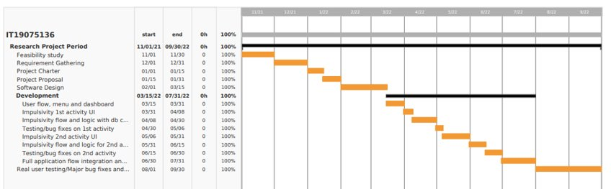

**Git Labs Commit History**

**Communication channels**

***MS Teams***

General: For all team members to have status update meetings etc.

Regular Team Meeting: For all the members except supervisors.

***Whatsapp***

***Git Lab for PR reviews and comments.***

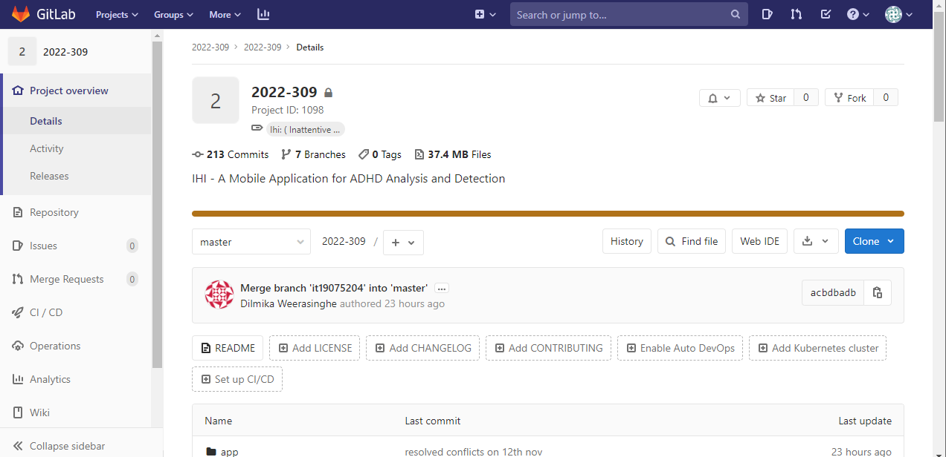

## Logbook

|  |  |
| --- | --- |
| Meeting Date | Content Discussed |
| 2021/12/11 | * Brief Discussion regarding the ADHD and the solution discussion using the IHI application    |
| 2022/03/15 | * Discuss about the technologies related to application development. * Suggested to localizable the application * Guide to collect information and contact industrial experts related to this specific area   + External Supervisor - Doctor or a counselor * Each component descriptive discussion regarding the improvement and methodologies.   Graphical user interface, text, application, table  Description automatically generated  Graphical user interface, text, application  Description automatically generated |
| 2022/04/12 | * Review and present the draft version of the application UI and basic components.   + How to improve the UX and UI. * Progress update on external supervisor meeting. * Pre-plan testing stages and discuss the importunacy of testing when considering each component. |
| 2022/04/27 | * Review progress of the research from individual members * Appearance of the application and how colors affect the children * Usage of graphs and charts in the application * Progress update for the past 2 weeks |
| 2022/05/06 | * Review progress of the research from individual members * How we should prepare for the progress presentation 1 * Information we got from our tests |
| 2022/06/07 | * Conference details discussion * Usability and UI improvement guidelines |
| 2022/09/20 | * Conference details discussion * Feedback regarding the flow and module integrations |
| 2022/10/28 | * Final Paper Discussion * Research paper/ Camera ready copy feedbacks * Final Demo |

# Test Data

