

**IHI: (INATTENTIVE-HYPERACTIVITY / IMPULSIVITY) - A MOBILE APPLICATION FOR ADHD ANALYSIS AND DETECTION**

2022-309

Log Book

Supervisor – Ms. Uthpala Samarakoon

Co supervisor – Ms. Pasangi Rathnayake

**BSc (Hons) Degree in Information Technology (specialization in Software Engineering)**

**November 2022**

|  |  |
| --- | --- |
| **ID No** | **Name** |
| IT19390260 | Sadun G.W.P. |

**Gantt Chart**

**Git Labs Commit History**

**MS Planner Tasks**

**Communication channels**

***MS Teams***

***WhatsApp***

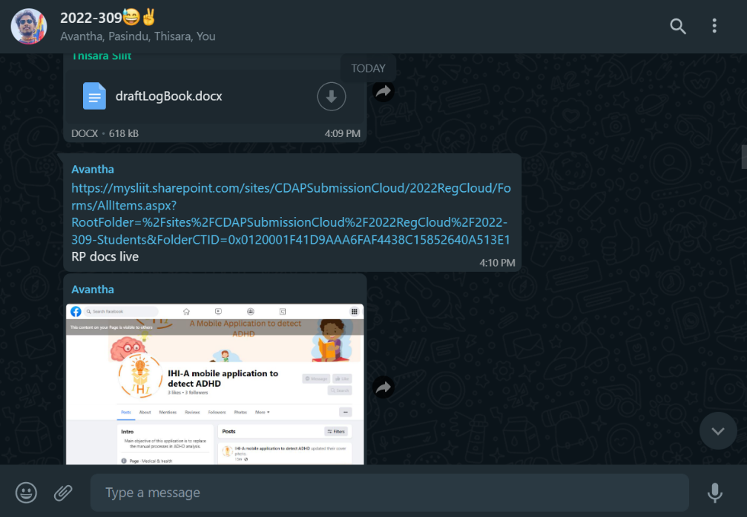

General: For all team members.

Regular Team Meeting: For just the members except supervisors.

***Git Lab for PR reviews and comments.***

***Team meeting topics and dates***