1. Convert the following ER diagram to a Relational model.

Student

Tutor

Course

Subject

ON

Tutors

Name

TCode

Name

Extn

Scode

Title

Date

Grade

ID

Code

Director

N

N

N

1

M

1

Results

2. Refer to the ER diagram given below of a Bank database, Map the ER to a relational schema indicating all the primary keys and foreign keys.

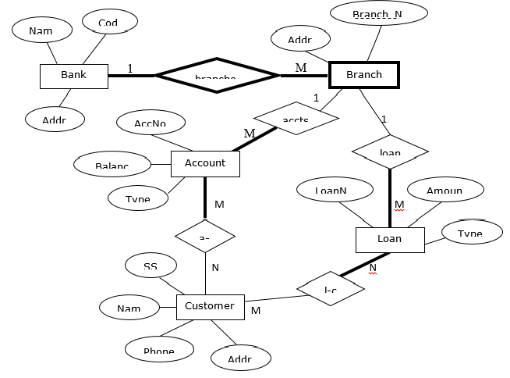

3. Map the company ER given below to a relational database schema.

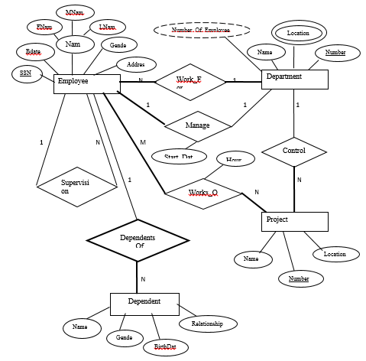

\*\*End of the Tutorial\*\*