**Q1)**

**Python features used in the code:**

**List**: The sales_data is a list of tuples.

**Tuple**: Each tuple in the sales_data list contains the name of an employee as a string (the first element of the tuple), and their sales data as an integer (the second element of the tuple).

**List comprehension**: The bonus_eligible list is created using a list comprehension, which is a compact way of creating a list based on another list or other iterable.

**Conditional statement**: The list comprehension includes a conditional statement that filters out employees who have not met the sales target. Only employees whose sales are greater than or equal to 100000 will be included in the bonus_eligible list.

**Print statement**: The final line of the code uses the print function to display the list of bonus-eligible employees.

**Explanation:**

The code creates a list of sales data for employees and then uses list comprehension to filter out employees who have met a certain sales target, and returns a list of bonus-eligible employees.

The sales data is stored in a list of tuples, where each tuple contains the name of an employee and their sales data.

The list comprehension iterates over each tuple in the sales_data list and checks if the employee's sales data is greater than or equal to 100,000. If the employee has met the target, their name is added to the bonus_eligible list using the employee[0] expression.

Finally, the bonus_eligible list is printed using the print statement.

Q2) a)

**Python features used in the code:**

**Dictionary**: The library_books is a dictionary that contains information about books. Each book is a key in the dictionary, and the corresponding value is a nested dictionary containing the author, publisher, and year of publication.

**Print statement**: The print function is used to display the entire library_books dictionary.

So, the output of the code will be a string representation of the library_books dictionary, which will display information about the books in the library.

**Explanation**

The code defines a dictionary named library_books that contains information about books.

In part a), the entire dictionary is printed using the print() function.

In part b), a value from the dictionary is accessed by specifying its key. The author of "The Great Gatsby" is retrieved by accessing the value of the 'author' key within the dictionary for that book.

In part c), the year of publication for "The Great Gatsby" is updated to 2022 using the same key-value syntax. The updated dictionary is then printed.

In part d), a new key-value pair for the book "Animal Farm" is added to the library_books dictionary using the same syntax as in part c). The updated dictionary is then printed.

In part e), the key-value pair for the book "To Kill a Mockingbird" is removed from the dictionary using the del statement, and the resulting dictionary is printed.

Overall, the code demonstrates the basic operations of dictionary manipulation in Python, including dictionary creation, access, modification, addition of new key-value pairs, and deletion of key-value pairs.

Q3)

**Python features used in the code:**

**Print statement**: The print function is used to display the outputs.

**Union**: Union of two set

**Intersection**: Intersection of two sets

**Explanation**

a) A set named "jersey_numbers" is created with five elements: 34, 10, 45, 53, and 22. The "print()" function is used to display the contents of the set to the console.

b) The "in" keyword is used to check if the value 22 is present in the set "jersey_numbers". The result is displayed using the "print()" function.

c) The "add()" method is used to add the value 67 to the set "jersey_numbers". The "print()" function is used to display the updated set.

d) The "remove()" method is used to remove the value 34 from the set "jersey_numbers". The "print()" function is used to display the updated set.

e) A new set named "other_jersey_numbers" is created with three elements: 23, 89, and 10. The "union()" method is used to create a new set named "all_jersey_numbers" that contains all elements from both "jersey_numbers" and "other_jersey_numbers". The "print()" function is used to display the resulting set.

f) The "intersection()" method is used to create a new set named "common_jersey_numbers" that contains elements common to both "jersey_numbers" and "other_jersey_numbers". The "print()" function is used to display the resulting set.

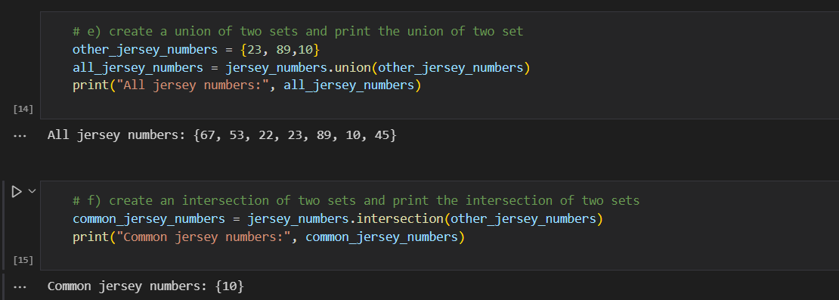

Q4)

**Python features used in the code:**

**Function:** A python function(def) is used

**Print statement**: The print function is used to display the employee bonus.

**Explanation**

Here, the calculate_bonus function takes in two parameters performance_rating and salary. If the performance_rating is "excellent", the function calculates and returns the bonus as 10% of the salary. If the performance_rating is "good", the function calculates and returns the bonus as 5% of the salary. If the performance_rating is anything else, the function returns 0.

In this case, we have set performance_rating as "excellent" and salary as 5000. We pass these values to the calculate_bonus function and store the returned bonus in a variable called bonus. Finally, we print the bonus value to the console.

