**Lab 4**

**7. In the below given cell, shape of the boxes.eval() is (1783,4). Why are there 1783 boxes? Explain the reason for it. What is the maximum number and minimum number you can get for that?**

The number of boxes (1783 in this case) is determined by how many predicted boxes pass the confidence threshold in the yolo_filter_boxes function. There are 19*19*5 = 1805 initial boxes and during the filtering process, a threshold of 0.5 is applied. Thus, only boxes with confidence scores above this threshold are kept. Hence, in this run, 1783 boxes pass the threshold value. The maximum and minimum values are 1805 (if all boxes pass the threshold) and 0 (if no boxes pass the threshold) respectively. However, due to the random normal distribution used (mean=1, stddev=4), it's statistically unlikely to get exactly 0 or 1805 boxes. The actual range will usually be somewhere in between, with the exact number varying each time when running the code.

Observations after changing values for mean, standard deviation and threshold.

1. Mean = 1.5, Standard deviation = 3, Threshold = 0.70

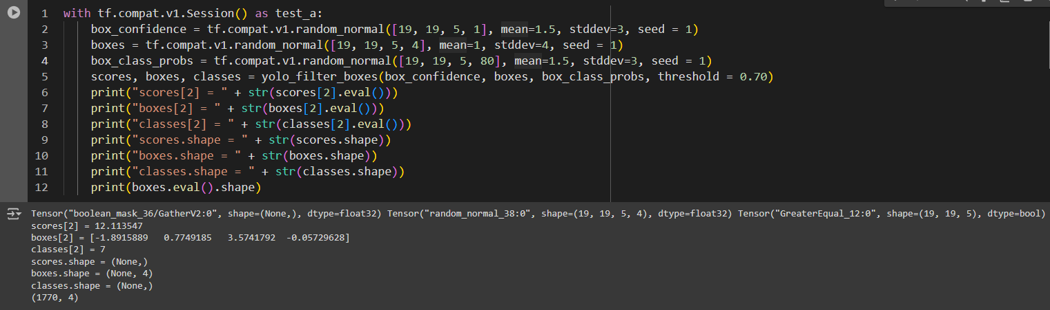

1. Mean = 2, Standard deviation = 4.5, Threshold = 0.85

**8. yolo_anchors.txt contains 10 values. They can be considered as height and width of 5 anchor boxes. What is the advantage of using such anchor boxes? What was the method used to determine the sizes of these anchor boxes?**

There are several advantages of using anchor boxes as follows:

* *Improved detection of objects with various aspect ratios*

Anchor boxes help the model detect objects of different shapes and sizes more effectively.

Each anchor box is specialized for certain object dimensions, allowing better coverage of various object geometries.

* *Faster convergence*

Predefined anchor boxes give the model a better starting point for learning, potentially leading to faster training.

* *Increased recall*

Multiple anchor boxes per grid cell increase the chance of having a box that closely matches the shape of the actual object, improving overall detection performance.

* *Handling of overlapping objects*

Anchor boxes allow the model to predict multiple objects in the same grid cell, which is crucial for detecting densely packed or overlapping objects.

The method typically used to determine the sizes of anchor boxes is k-means clustering which follows a series of steps as outlined below:

1. *Collect a dataset*

Gather a large set of ground truth bounding boxes from your training dataset.

1. *Apply k-means clustering*

Use the k-means algorithm on the dimensions (width and height) of these bounding boxes. The number of clusters (k) is set to the desired number of anchor boxes.

1. *Iterate and optimize*

The clustering process aims to minimize the difference between the anchor boxes and the actual object boxes in the dataset.

1. *Extract cluster centroids*

The centroids of the resulting clusters become the dimensions of the anchor boxes.

1. *Normalize*

The dimensions are typically normalized relative to the image size.

**9. Upload a new traffic image to images and edit the code as needed to detect vehicles in that image.**

**10. Write what you observe regarding correctly detected objects, incorrectly detected objects, undetected objects, and incorrect bounding boxes.**

***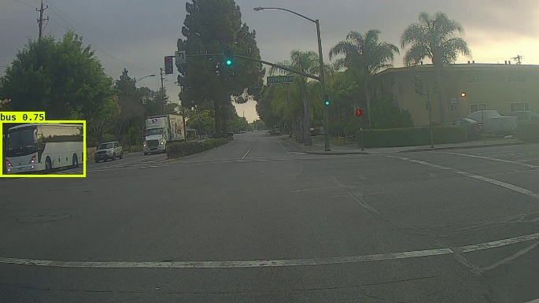****Image 1*

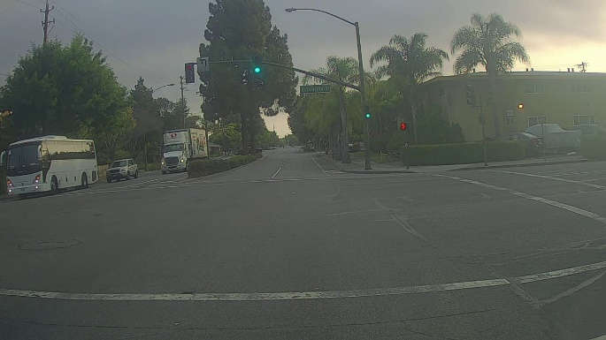

Here, though the bus is detected correctly with a decent bounding box, it has failed to identify the traffic light and there is no bounding box surrounding it.

*Image 2*

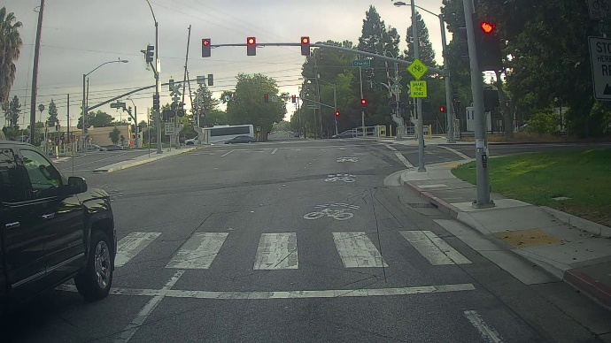 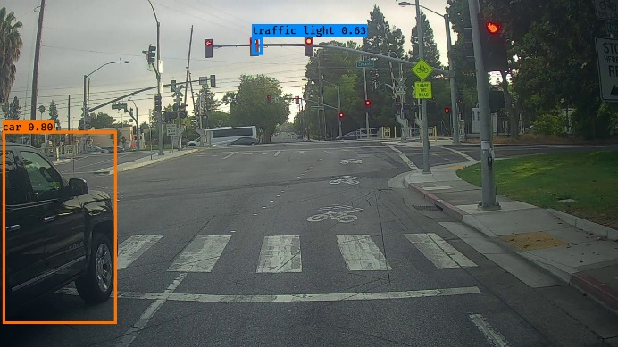

Here, although one traffic light has been identified, it is not surrounded by a bounding box fully, it is only surrounded partially. Furthermore, the rest of the traffic lights have not even been detected.

**11. Change the max_boxes [integer value] to a different value but use the original values for other 2 variables. Observe if this result in improvement compared to step 10 for the same two images**

*max_boxes = 30*

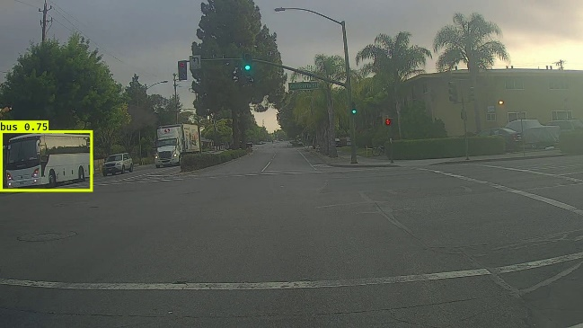 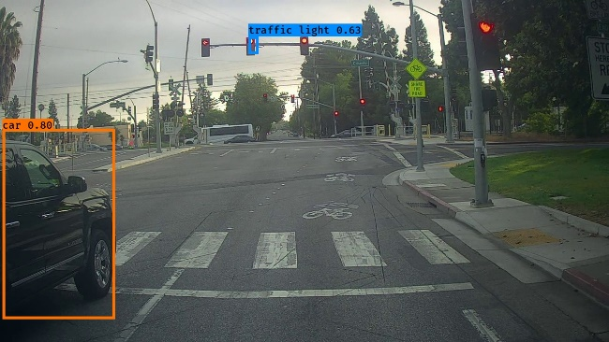

According to observations, even with this new value for max_boxes, there seems to be no improvement.

*score_threshold = 0.3*

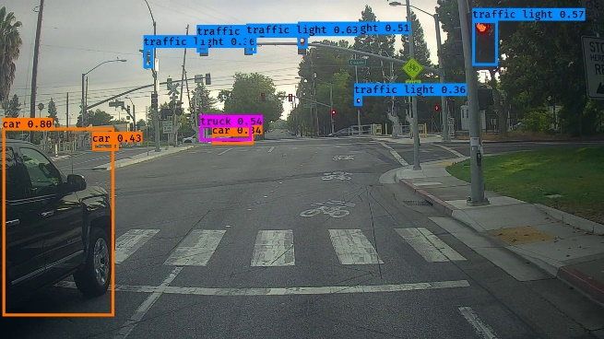

By lowering the score_threshold value from 0.6 to 0.3, it has detected multiple objects (both traffic lights and vehicles). However, in the first image, it has also incorrectly identified an object as a “bus”, whereas in fact, it should a “truck”.

*iou_threshold = 0.8 and iou_threshold = 0.2 on 2 separate runs*

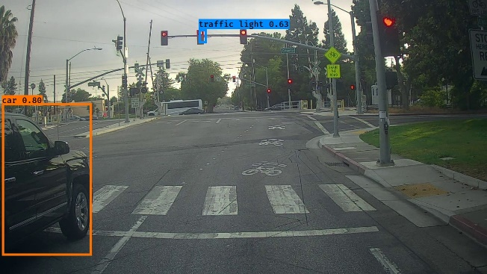

Changed the iou_threshold value from 0.5 to 0.8 and 0.2 and tested the behavior on two separate runs. However, there was no noticeable improvement.