IT2117804 – Kumari T.A.T.N

Relationship Between Linear Autoencoder and Principal Component Analysis (PCA)

An autoencoder (AE) is a type of neural network used to learn efficient representations (encodings) of data. When an autoencoder does not use any non-linear activation functions, it is referred to as a linear autoencoder (linear AE). This creates a strong connection between linear AEs and Principal Component Analysis (PCA), a well-known technique for dimensionality reduction.  
  
Linear AE and PCA:  
In essence, both linear autoencoders and PCA aim to project high-dimensional data onto a lower-dimensional subspace, capturing the most important features or variance within the data. PCA accomplishes this by finding a set of orthogonal directions (principal components) that maximize the variance in the data.  
  
Key Relationships:  
1. Dimensionality Reduction: Both linear AEs and PCA reduce the dimensionality of data. In PCA, the components are computed by solving an eigenvalue problem, whereas in linear AE, the network tries to learn a linear mapping through backpropagation without any activation functions.  
  
2. Linear Transformations: In the case of a linear autoencoder, the encoder and decoder are simple linear mappings, much like the linear transformations in PCA. Without non-linearity, the layers perform matrix multiplication similar to the transformation in PCA.  
  
3. Reconstruction of Data: Both PCA and linear autoencoders aim to reconstruct the original input data with minimal loss. PCA achieves this by projecting the data into a lower-dimensional space and then projecting it back to the original space. In a linear AE, the same process happens, where the bottleneck layer compresses the input data into a lower-dimensional space and then reconstructs it.  
  
Mathematical Equivalence:  
Under specific conditions (such as minimizing the Mean Squared Error and using linear encoders and decoders without non-linear activations), a linear autoencoder can be shown to perform similarly to PCA. In fact, the weights of the linear autoencoder's encoder can converge to the principal components of the data, making the AE and PCA mathematically equivalent in this case.  
  
Differences:  
1. Training: PCA is a deterministic algorithm that directly computes principal components, while a linear AE uses iterative optimization via backpropagation and gradient descent to find the optimal weights.  
  
2. Non-Linearity: While PCA is inherently a linear method, autoencoders can easily incorporate non-linearity (by using activation functions), allowing for more powerful representations of complex data.  
  
In summary, while a linear AE and PCA share many similarities in terms of dimensionality reduction and data reconstruction, PCA remains a linear, non-iterative approach, while autoencoders can generalize to more complex scenarios by incorporating non-linearities.

### Reasons for Observed Improvements (Vanilla CNN over AE_FFNN)

**Spatial Awareness**: CNNs preserve the spatial structure of images during the encoding and decoding process, leading to better reconstructions. In contrast, AE_FFNNs flatten the images, causing a loss of spatial relationships.

**Feature Extraction**: Convolutional layers in CNNs act as feature detectors that progressively capture local patterns such as edges, shapes, and textures, which are essential for image reconstruction. Fully connected networks lack this capacity and treat all input features equally.

**Efficient Learning**: CNNs, with fewer parameters and weight-sharing, are more efficient in terms of computational resources and training speed. AE_FFNNs, by contrast, require more parameters for the same amount of data, leading to increased complexity and slower training.

**Dimensionality Reduction**: CNNs are better at learning lower-dimensional representations because they can focus on important features by scanning local regions. AE_FFNNs often struggle to reduce the dimensionality effectively for high-dimensional data like images.

### ****Observe Performance Differences Between Image Denoising AE and Vanilla CNN AE****

compare the two autoencoders (Image Denoising AE and Vanilla CNN AE) by observing:

* Reconstruction accuracy (e.g., using MSE or other evaluation metrics).
* Visual comparison of the reconstructed images.

**Image Denoising AE (Mean squared Error)**

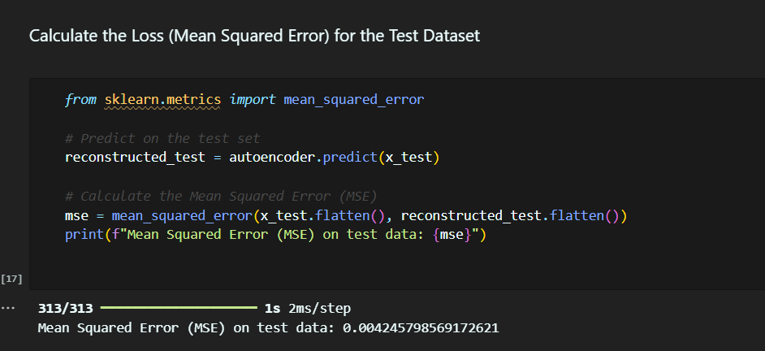

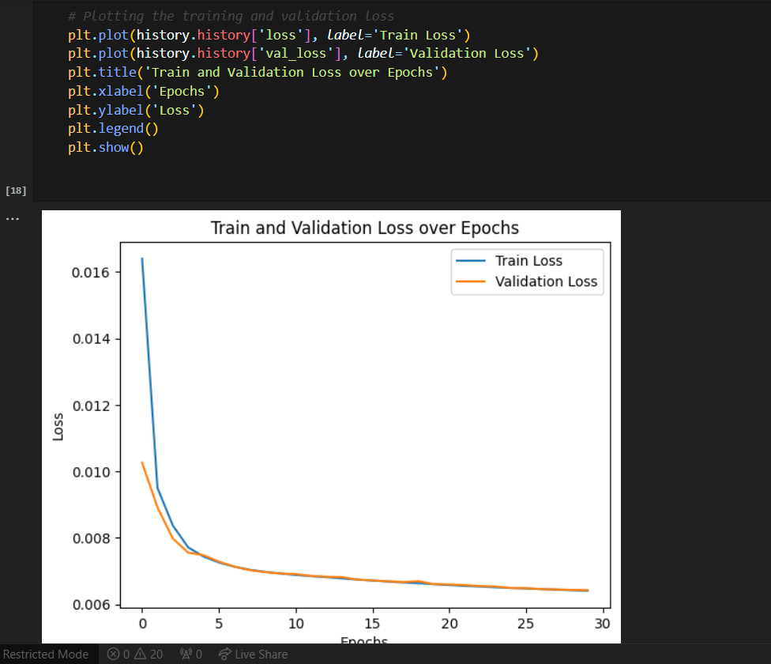

**Vanila CNN AE(Mean squared Error)**

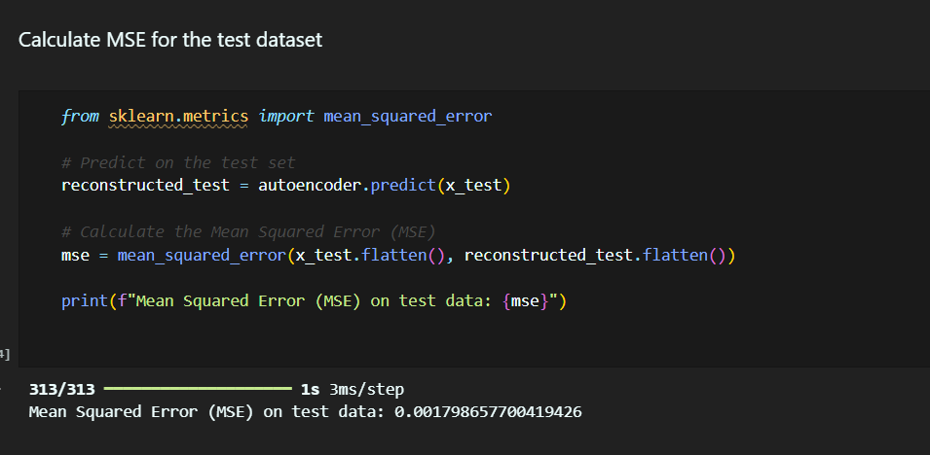

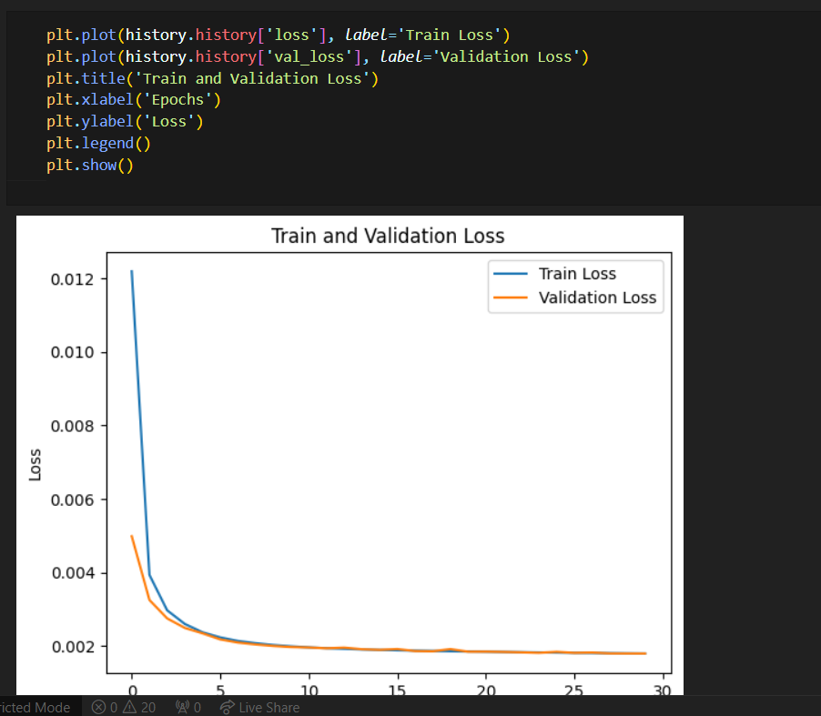

**Explain the Differences Between AE and Variational AE (VAE)**

**Autoencoder (AE)**: AEs learn to compress and reconstruct data by passing it through a bottleneck (latent space), without making assumptions about the distribution of the latent space. It is a deterministic model.

**Variational Autoencoder (VAE)**: Unlike standard AEs, VAEs assume that the latent space follows a specific probability distribution (usually Gaussian). VAEs enforce a structure on the latent space, which allows them to generate new data by sampling from this distribution. This makes VAEs suitable for generative tasks.