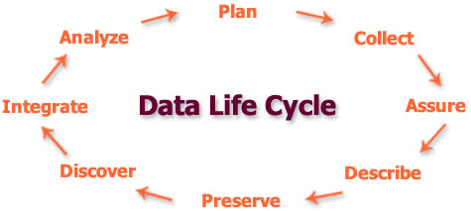



Introduction to Research Data Management and Sharing

In 500 words, describe what impact Research Data Management will have on your current and future research

**Alexandros Ioannidis | Introduction to Research Data Management and Sharing | 24/10/2017**

**Supervisor: Dr. Martin Halvey**

**Dept. Computer and Information Sciences**

**University of Strathclyde**

# -What steps can I take to ensure my research data is secure against accidental damage or data loss?

Some of the actions that can be taken to ensure that research data is secure against any action of theft, accidental damage or data loss, are the following:

* Use either ShareFile, which is an external application, programmed by Citrix, or use Strathcloud the on-site instance of Sharefile to store, organize and share data. Additionally, the network drives of the university, h:drive and the i:drive can be used. The h:drive can be used as a home directory to save own individual files. Whereas, the i:drive can be utilized for sharing folders and giving share privileges to specified teams.
* Using Pure to upload research results and being accumulated to the University’s KnowledgeBase is also a good practice of research data management, which protects data by any unwilling acts.
* Creating a Data management plan, also assists in managing, sharing and protecting research data, because it is ensured that best practice, data handling and organisation and optimal approaches are always followed.
* Additionally, if the research data is stored in a secure storage facility that does not belong to the university or to a partner organisation than the data must be encrypted in order to abide with the encryption policy 2017 of the university.
* Take regular or scheduled backups of the data.

## -How can I ensure the research data I collect or generate will still be accessible and reusable in 10 years’ time?

Using the Pure research data repository is an ideal long-term storage solution for keeping research data accessible and reusable in 10 years’ time. The reason for this, is because the research findings uploaded to Pure are handled by specialized professionals and acquire a persistent digital object identifier (DOI) which is widely used, so that it can be located and accessed more efficiently. Furthermore, the platform allows to manage the visibility by configuring restriction settings in case the data needs to be restricted or in situations where the data need to abide to the Open Access framework[1].

-Which research data would I be willing to make openly and freely available, and how would I do this effectively?

There are numerous research funders that have Open Data Policies for example the Engineering and Physical Sciences Research Council, Marie Curie or the European Research council and many others. When a research is publicly funded by an organization for the public good and interest and has open data policies then the research findings of that study should be made openly available in timely and responsive fashion. Moreover, metadata that are complementary or describe research data should also be made available. In order to make openly and freely available research data it is a good practice to upload the associated files such as data sets, publications, equipment, activities, impact reports and many more in the Pure repository.

-When should I restrict access to the research data I collect or generate, and for what reasons?

One of the ways to restrict access to research data collected or produced is to encrypt the data. Another, solution is to store the research data in storage facilities provided from the university. Some of the reasons why this needs to happen is because there are situations where there is a confidentiality agreement between the university and the funder for example to protect intellectual property, transferring data safely or complying with the data privacy act (DPA) and the agreed wishes of the participant organisations need to be respected and applied.

1. https://en.wikipedia.org/wiki/Open_access