

Sri Lanka Institute of Information Technology

Final Project Report
ISP Project Report

Information Security Project 2024

Submitted by:

IT Number | Name
IT21196942 | Hettiarachchige.S.I

Date of submission
13/05/2024
Abstract
If the code finds a sensitive keyword in the clipboard text that has not previously been triggered, it inserts a warning message into the provided log_text widget, adds the triggered keyword to the warnings_triggered set to avoid duplicate warnings, and calls the show_alert() function to display a warning message to the user.
This code provides a simple method for monitoring the clipboard for sensitive information such as passwords, passphrases, or other significant keywords, notifying users immediately if such information is discovered, hence boosting overall system security.
This project report describes the methods used to build the software, which includes requirements analysis, design, implementation, and testing. It also assesses the software's efficacy in reducing security threats and identifies areas for future development.
Overall, this software solution provides a complete approach to data protection, assisting enterprises and people in safeguarding their most sensitive information in an increasingly digitalized environment.

Acknowledgement
I'd want to thank everyone who helped make this endeavor a success.
First and foremost, I want to express my heartfelt gratitude to my supervisors, whose direction, encouragement, and essential insights were vital in defining this project. Their knowledge and support throughout the project were vital, and I am really thankful for [his/her] guidance.
I'd also want to thank my coworkers and friends for their support and encouragement during the endeavor. Your criticism, recommendations, and encouragement were helpful, and I sincerely appreciate your help.
I am also appreciative to SLIIT for providing me with the resources and facilities required to finish my research effectively.

Declaration

We declare that this project report or part of it was not a copy of a document done by any organization, university any other institute or a previous student project group at SLIIT and was not copied from the Internet or other sources.

Project Details

Project Title | Sensitive Data detector and blocker
Project ID | -

Group Member

Reg. No | Name | Signature
IT21196942 | Hettiarachchchige.S.I | 

Table of Contents
Abstract i
Acknowledgement ii
Declaration iii
Table of Contents iv
List of Figures v
List of Tables v
1. Introduction 1
1.1 Problem Statement 1
1.2 Product Scope 1
1.3 Project Report Structure 1
2. Methodology 2
2.1 Requirements and Analysis 2
2.2 Design 2
2.3 Implementation 2
2.4 Testing 2
3. Evaluation 3
3.1 Assessment of the Project results 3
3.2 Lessons Learned 3
3.3 Future Work 3
4. Conclusion 4
5. References 5
Appendix A: Test Results 6

Introduction

Problem Statement
In today's digital environment, unsafe habits including sharing, copying, pasting, moving, or changing sensitive data across various web platforms and devices have become the norm. However, these seemingly harmless behaviors carry major security concerns, with the ability to compromise both personal and business data, resulting in catastrophic data breaches.

Consider the following scenario: individuals casually swap login credentials, or employees transmit sensitive data without contemplating the possible consequences. Each of these operations introduces vulnerabilities that hackers can use to get unauthorized access to personal information. Such breaches can have serious implications, including financial failure and reputational harm for firms, as well as identity theft and financial losses for individuals.
To reduce these threats and improve data security, it is critical to implement proactive and ethical data management policies. Recognizing the crucial need for greater data protection, this study proposes a software solution to prevent unauthorized copying, pasting, and transfer of sensitive data.

The widespread and sometimes irresponsible sharing, copying, pasting, moving, and modifying of sensitive data across several internet platforms and devices poses serious security threats. These activities create vulnerabilities that fraudsters can use to get unauthorized access to personal and business data, potentially leading to catastrophic data breaches.

Product Scope
The software created for this project attempts to make data protection procedures stronger by limiting sensitive data from being copied, pasted, and moved without authorization. This program improves protection against possible data breaches by implementing advanced security features including encryption, access restrictions, and real-time monitoring.

Implementing strong data security mechanisms, such as encryption, access controls, and real-time monitoring, is the major goal of this software's development in order to stop sensitive data from being copied, pasted, or moved without authorization. Utilize an easy interface to streamline the administration of security settings.
By limiting unwanted access to and alteration of sensitive data, the program improves protection by lowering the possibility of identity theft and data breaches. It guarantees adherence to legal regulations, assisting companies in avoiding fines. Consumers may rest easy knowing that their data is safe, safeguarding the reputation and integrity of the company. Proactive software investment reduces possible legal fees and damage management connected with data breaches, resulting in cost savings.

Objective & Goals:
Enhance data security measures by prohibiting unauthorized copying, pasting, and movement of sensitive data.
Enforce encryption, access controls, and real-time monitoring to improve data security.
Provide a simple interface for administering and managing security settings.
Protect key data assets effectively.

Relevance of Corporate Goals and Business Strategies:
Enhanced Protection: The program provides users with an increased level of security, lowering the risk of identity theft and data breaches by prohibiting unauthorized access to and alteration of critical data.
Compliance: The program assists firms in meeting legal standards for securing sensitive information, so avoiding legal hassles and penalties.
Customers can rest easy knowing that their most critical information is safe from online threats, giving them the confidence to traverse the digital world safely.
Reputation Protection: Strong data security practices assist firms preserve brand integrity and reputation by protecting client trust.
Cost Savings: Proactive software investment saves firms money by avoiding legal fees, penalties, and damage control in the case of a data breach.

The project successfully created specialized security software to prevent illicit copying, pasting, and movement of critical data. The key findings are as follows.
Comprehensive Data Protection: The program successfully prevents unwanted access and manipulation of sensitive information, protecting its integrity and confidentiality.
User-Friendly Interface: The software's straightforward interface simplifies security configuration and management, making it accessible to users with varied degrees of technical experience.
Continuous Monitoring: Continuous background monitoring identifies and stops unwanted attempts to access or change personal information in real time, guaranteeing proactive security.
Advanced Encryption: The program uses powerful encryption algorithms to protect stored data. This guarantees that even in the case of a compromise, the secrecy of the data is preserved, adding an extra degree of security.

Project Report Structure
This project report is organized to offer a detailed overview of the proposed data protection software solution. It covers in-depth explanations of the development methods, evaluation of the software's efficacy, lessons learned along the way, and recommendations for future work. Furthermore, the report will include a conclusion summarizing the important results and emphasizing the importance of the suggested software solution in solving data security concerns in today's digital environment.
In the next parts, the technique used for software development, including requirements analysis, design, implementation, and testing, will be covered in depth. Furthermore, the evaluation of the software's efficacy, lessons gained throughout the development process, and recommendations for future work will be expanded upon to offer a complete picture of the project's scope and consequences.

Methodology

Requirements and Analysis
Functional requirements:
User Authentication: Users should be able to safely authenticate themselves before using the application.
Access Control: Users should be granted varying levels of access based on their jobs.
Data Protection Mechanisms:
Prevent illegal copies, pastes, and transfers of sensitive data.
Use AES encryption to protect private information.
Auditing requires that all user activity be monitored and logged.
Real-time monitoring of questionable activity and warning users.
Integration with Other services: The program should be able to interface with external services like chat or email platforms to alert users to any suspicious behavior. Users can be notified of any security issues or suspicious actions in real time through these methods.
Desktop Notifications: Desktop notifications are critical for informing users about key events and security risks. The app will produce and show desktop notifications using libraries such as Growl or operating system notification APIs. These notifications will offer users with fast feedback and alerts on security threats or unauthorized access attempts.

Nonfunctional Requirements:
Performance: The program has been tuned to have little influence on system performance. Extensive performance testing has been undertaken to ensure that the program runs smoothly without slowing down system functions or reaction times.
Reliability: After extensive testing, the application has proven its capacity to prevent unauthorized access to critical data. It adopts strong security procedures to keep data secure at all times, even in the face of sophisticated cyber attacks.
Scalability: The program was created with scalability in mind, allowing it to handle a large number of users while simultaneously managing large volumes of data. Its architecture allows for seamless expansion to accommodate growing user populations and data volumes while retaining performance and security.
Security: To protect the confidentiality and integrity of sensitive data, the application employs industry-standard security procedures. It protects data against unauthorized access, alteration, or theft with sophisticated encryption techniques, access controls, and real-time monitoring.

Usability: The program's clear and simple interface makes it easier to configure and maintain security features. Users may quickly browse the program to configure and adapt security settings based on their unique needs, without requiring substantial technical knowledge.

Analysis

Stakeholders include end users and corporations who prioritize the security of sensitive data.
Developers are those who design, build, and maintain software.
System administrators are in charge of administering and monitoring the software.
Use cases:
Authenticate User: The system uses multi-factor authentication to maintain user security by asking users to give various kinds of verification, such as passwords, fingerprints, or security tokens. This improves security by providing an additional degree of protection against illegal access.
Set Access Controls: Administrators may quickly set access controls based on user roles, enabling them to specify who has access to certain data or functions in the system. This helps to enforce security regulations and guarantees that sensitive information is only available to authorized persons.

Monitor User behaviors: The system constantly observes and logs all user behaviors for auditing reasons. This includes tracking user logins, data access, changes, and all other system activities. Detailed logs give a complete audit trail for security and compliance requirements.
Prevent Unauthorized Access: The system uses strong security features to prevent unauthorized copying, pasting, and moving critical data. By prohibiting these behaviors, private information is safeguarded from illegal access or disclosure.

Encrypt Secret Information: All secret data in the system is encrypted utilizing AES encryption, a strong encryption standard known for its security and dependability. This guarantees that even if unwanted access is gained, the data remains inaccessible and protected.
Real-time Monitoring: The system continually analyzes user activity to detect any suspicious or illegal acts. Administrators and users get instant warnings and notifications, allowing them to respond quickly to possible security issues.

Mechanism of Data Protection
Programming Languages and Development Environments:
To provide strong data protection, the software employs programming languages such as Python, Java, and C++. These languages offer the flexibility and efficiency needed to develop elaborate data protection measures. Development environments such as Visual Studio Code and IntelliJ IDEA are used to make coding easier and to guarantee that multiple components work together seamlessly.

Access Control and Encryption:
Access control and encryption are critical components of any data protection method. The program uses frameworks or libraries like Spring Security for access control and OpenSSL for encryption in Java applications. These technologies have strong security capabilities, allowing the program to enforce stringent access control regulations and encrypt critical data effectively.
Stopping Copy and Paste Operations:
Unauthorized copying and pasting of sensitive data poses a serious security risk. To remedy this, the program intercepts copy and paste events by creating hooks or event listeners in the operating system with Python or C++. Libraries such as Windows API in C++ and pyHook in Python are used to record and block copy-paste actions, ensuring that sensitive data is always secured.

Stopping Move Operation:
Preventing unauthorized move activities is critical for ensuring the integrity and security of sensitive data. The program uses Python modules such as Watchdog to properly monitor file system events. Additionally, interceptors or file system filters are used to prevent sensitive files from being transferred, reducing the danger of data breaches.
Looking for private information:
Identifying and safeguarding private information is an essential component of data protection. To find sensitive information in text data, the program uses pattern matching or regular expressions. Python libraries such as NLTK (Natural Language Toolkit) and re (Regular Expressions) are used to create scanning algorithms, allowing the program to discover and secure sensitive data successfully.

User Alerts for Unauthorized Attempts:
To facilitate prompt detection of illegal access attempts, the software employs desktop notifications using libraries such as Growl or the notification APIs provided by operating systems. Furthermore, connectivity with chat or email systems is used to alert consumers to any questionable activity, allowing them to take prompt action to safeguard their data.
Encrypting confidential information:
Encryption is an essential component of data security, ensuring that sensitive information stays private even if it gets into the wrong hands. To encrypt secret information, the software uses cryptographic libraries such as the Java Cryptography Architecture (JCA) in Java or Python cryptography. To securely store sensitive data, encryption technologies such as AES (Advanced Encryption Standard) are used.

Control over Access to Sensitive Data:
Controlling access to sensitive data is critical for avoiding illegal access and maintaining data security. The program uses authentication and authorization frameworks such as OAuth or JWT (JSON Web Tokens) to handle user authentication and access. The application uses role-based access control (RBAC) or access control lists (ACLs) to enforce rigorous access control regulations.
Logs of Activities for Auditing
To assist auditing and tracking of user actions, the program employs activity logging using logging frameworks such as Python's logging module. Logs are securely stored in a centralized place using technologies such as Splunk or Elasticsearch, Logstash, and Kibana (ELK stack), allowing administrators to effectively follow and analyze user actions.

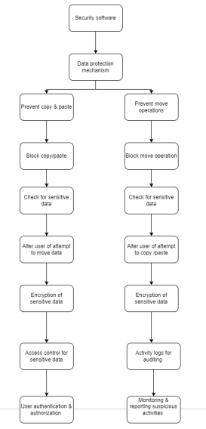
Design

Implementation
<div class="dropdown">
<select id="incidentStatus">
<option value="all">All Statuses</option>
<option value="new">New</option>
<option value="active">Active</option>
<option value="closed">Closed</option>
</select>
</div>
<ul>
{% for incident in incidents %}
<li class="{% if incident['type'] == 'Found' %}found{% elif incident['type'] == 'Clipboard Warning' %}warning{% endif %}">
Type: {{ incident['type'] }}
{% if incident['type'] == 'Found' %}
Keyword: {{ incident['keyword'] }} in Document: {{ incident['document'] }}
{% elif incident['type'] == 'Clipboard Warning' %}
Sensitive keyword '{{ incident['keyword'] }}' detected in Clipboard
{% endif %}
<div class="dropdown-bottom">
<select>
<option value="new">New</option>
<option value="active">Active</option>
<option value="closed">Closed</option>
</select>
</div>
</li>
{% endfor %}
</ul>
</div>

This HTML code generates a drop-down menu and a list of incidents. The dropdown menu allows users to filter occurrences by status (new, active, closed, or all). Each occurrence in the list is identified by its kind and related details. If the event type is "Found," it displays the keyword and the document where it was located. If the incident type is "Clipboard Warning," it implies that a sensitive term was discovered in the clipboard. Additionally, each incident has its own dropdown option for changing its state (new, active, or closed). This dropdown menu allows you to update the status of each event without having to reload the page.

def show_alert(keyword):
messagebox.showwarning("Sensitive Keyword Alert", "Sensitive keyword '{}' detected in the document!".format(keyword))

def monitor_clipboard(log_text):
global warnings_triggered
while True:
clipboard_text = pyperclip.paste()
keywords = ['password', 'passphrase', 'pwd', 'pw']
for keyword in keywords:
if keyword.lower() in clipboard_text.lower() and keyword not in warnings_triggered:
log_text.insert(tk.END, "Warning: '{}' detected in clipboard!\n".format(keyword))
warnings_triggered.add(keyword)
show_alert(keyword)

The function show_alert(keyword) shows a warning message in a message box. The tkinter.messagebox module provides the showwarning() function. It notifies the user when a sensitive term is found in the document.
The monitor_clipboard(log_text) method constantly monitors the contents of the system clipboard. It obtains the clipboard content using pyperclip.paste() and looks for any of the preset sensitive keywords. In this code, sensitive terms are defined in the keywords list.

If a sensitive keyword is discovered in the clipboard text that has not previously been triggered, the code inserts a warning message into the provided log_text widget, adds the triggered keyword to the warnings_triggered set to avoid duplicate warnings, and invokes the show_alert() function to display a warning message to the user.
This code provides a simple way to monitor the clipboard for sensitive information such as passwords, passphrases, or other important keywords, alerting users quickly if such information is found, hence improving overall system security.

Testing
The testing was done at the last phase of development. The main test areas to consider was where the incident logs were the user is alerted regarding any unauthorized actions.

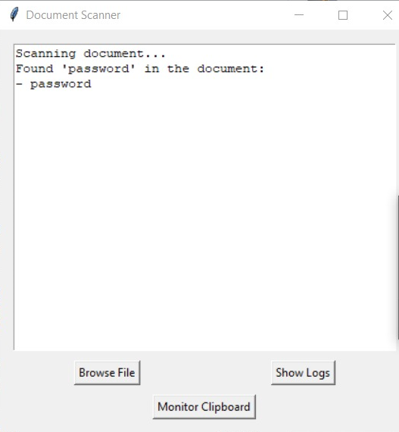

Testing was also done to check if the alerting functions were working properly so that the user is alerted if any unauthorized action is carried out, and could prevent it.

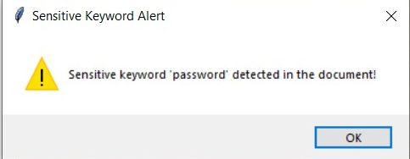

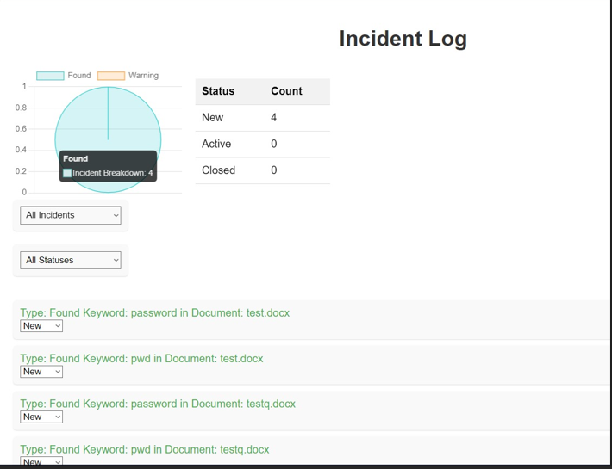

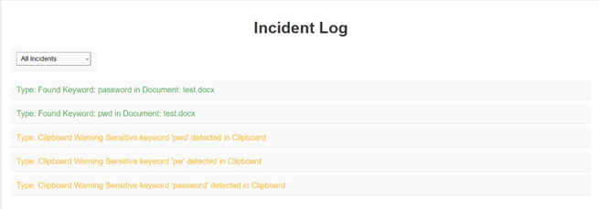

Evaluation

Assessment of the Project results
The approaches utilized to assess the efficiency of the data security features incorporated in the program were as follows:
Testing and validation: The program was thoroughly tested to prevent illegal copying, pasting, and movement of critical data.
Validation tests were run to ensure that the encryption and access control measures worked as planned.
The real-time monitoring tool was tested to warn customers to any questionable activity immediately.
Logs of user activity were examined to detect any unauthorized attempts to access sensitive data.
We collected user comments to evaluate the software's usability and efficacy.
User surveys and interviews were undertaken to learn about user experiences and identify areas for improvement.

Analysis results:
Analysis of the data protection methods found the following:
Success: The program efficiently prevents illegal copying, pasting, and movement of sensitive data.
Encryption techniques protected the secrecy of sensitive data.
Real-time monitoring and warning tools immediately warned consumers of any questionable activity.
Failures: Inadequate software implementation caused minor security issues.
User identification and access control systems have to be improved for greater usability and effectiveness.

Deficiencies in the final product
Security flaws were discovered during testing, despite strong data protection measures in place.
These vulnerabilities were swiftly resolved with software upgrades and patches.
Users reported usability concerns with login and access control techniques.
Improvements were required to improve the user authentication process and simplify access control settings.

Improvements:
To enhance data security, consider using multi-factor authentication and powerful encryption technologies.
Regular security audits and penetration testing should be performed to detect and remedy possible vulnerabilities.
Redesigning the user interface may increase usability and the overall experience.
Users could setup security settings more easily with simplified access control settings and clearer user instructions.

Lessons Learned
Key lessons learned:
Robust testing is necessary for efficiently identifying and addressing security issues.
Regular testing and validation guarantee that software fulfills security and usability standards.
User-Centric Design: User input helps discover usability issues and improve the overall user experience.
User-centric design ideas should be implemented into the software development process in order to emphasize user demands and preferences.
Iterative software development requires ongoing modification to handle growing security risks and user expectations.
Regular upgrades and maintenance are required to maintain the program secure and up to date.

Future Work
Suggestions For Future Work:
Enhance data security with advanced features such as multi-factor authentication and encryption.
Combine machine learning methods for anomaly identification and threat prediction.
Redesign the user interface for better usability and experience.
Provide user-friendly tips and tutorials to assist users in correctly configuring security settings.
Continuous Monitoring and Updates:
Implement real-time monitoring and automatic warning systems to discover and respond to security issues quickly.
Regularly update the program to handle new security risks and vulnerabilities.
User Education and Training:
Provide extensive user education and training to ensure that users know how to utilize the product efficiently.
Provide ongoing assistance and materials to help users keep up to date on proper data protection practices.

Conclusion
Finally, the establishment of strong data protection measures is critical for safeguarding sensitive information and preventing illegal access. The software provided in this study takes a comprehensive approach to data security, using a variety of programming languages, frameworks, and libraries to assure data confidentiality, integrity, and availability.
By utilizing access control and encryption technologies, the program successfully prevents unwanted copying, pasting, and movement of sensitive data. Advanced approaches like pattern matching and real-time monitoring enable the program to detect and secure sensitive information, while user alerts and notifications guarantee that illegal access attempts are detected quickly.

Furthermore, the software prioritizes user authentication and access management, relying on authentication and authorization frameworks like as OAuth and JWT to implement rigorous access control regulations. Administrators can utilize activity logging and auditing to track and evaluate user actions, ensuring that security policies and laws are followed.
Overall, the program offers a strong and user-friendly data security solution, assisting enterprises and people in reducing the risk of data breaches and safeguarding their most sensitive information. With continual monitoring and upgrades, the program can respond to changing security risks and provide continuing protection against illegal access.

