COMPONENT 1 RESEARCH REPORT

Forecast Validation, Deviation Analysis, and Liquidity-Aware Anomaly Detection
  - John Keells Holdings PLC (JKH.N0000) and Browns Investments PLC (BIL.N0000)
AI-Powered Stock Market Insight Generator for the Colombo Stock Exchange
Evidence cutoff: 1 September 2026 | Locked forecast created: 10 May 2026
Research conclusion: the locked three-month upward forecasts were not validated by realized prices. The contribution remains a defensible explainable, liquidity-aware anomaly-analysis framework, not a claim of superior trading prediction.
Prepared as a reproducible BSc-level research record

Executive Summary
This report validates the three-month forecasts locked on 10 May 2026 for JKH and BIL against prices observed after model development, then contrasts those results with a fresh on-demand analysis using data through 1 September 2026. The purpose is not to defend every prediction. It is to establish what the model predicted, what actually occurred, how deviation and anomaly scores are calculated, and where the research novelty remains valid.
Overall assessment: Share with caveats. The validation is reproducible and free from forecast revision, but only two stocks and one three-month regime are available. Both ensemble forecasts underperformed a no-change baseline, and anomaly evaluation relies on proxy labels rather than manually verified CSE anomaly labels.
- JKH: the 30 July forecast was LKR 22.53; the realized close was LKR 19.80, an overestimate of LKR 2.73 (13.78% of the realized price).
- BIL: the 30 July forecast was LKR 6.87; the realized close was LKR 5.20, an overestimate of LKR 1.67 (32.13%).
- Baseline result: the no-change baseline produced lower MAE, RMSE, and MAPE than the ensemble for both stocks.
- Current result: on 1 September, neither JKH nor BIL exceeded its freshly calibrated liquidity-aware anomaly threshold.
- Novel contribution: expected-price modeling is connected to signed deviation, liquidity-aware anomaly scoring, prediction-band checks, separated structural-value interpretation, explanation factors, and explanation-stability evidence.

Plain-English Guide to Component 1
This short guide explains the component in presentation language. It does not replace the detailed validation evidence later in the report.

1. What my component does
Component 1 learns the normal price behaviour of a selected CSE stock from its historical prices, trading volume, and market indicators. It then estimates an expected price and compares that expectation with the price that actually appeared in the market.
- It produces cautious price scenarios for 4 trading days, 1 month, 3 months, and 6 months.
- It measures whether the current price is above or below the expected price and by how much.
- It checks whether the difference is unusual after considering how much trading activity supported the move.
- It shows the anomaly score, the decision threshold, the prediction range, and the main factors behind the result.
- It reports uncertainty and baseline performance so that a forecast is not presented as a guaranteed target.
In one sentence: My component does not only ask, 'Where may the price go?' It also asks, 'Is today's price different from what the stock's recent behaviour would normally suggest, and is that difference strongly supported by market activity?'

2. Novelty and how it was checked
The novelty is the connected workflow, not the invention of forecasting, anomaly detection, trading-volume analysis, or SHAP by themselves. Earlier studies already examined these individual ideas. For example, Fischer and Krauß used LSTM models for financial-market prediction [1]; Chandola, Banerjee, and Kumar described major families of anomaly-detection methods [2]; Karpoff reviewed the relationship between price changes and trading volume [3]; and Lundberg and Lee introduced SHAP for explaining model predictions [4]. More recent emerging-market research has also combined price and volume features with unsupervised anomaly detection [5].

Table A. Plain-language comparison with related research.
Similar research | What it mainly does | How Component 1 is different
Financial LSTM forecasting [1] | Predicts future market movement. | Uses expected price as a reference for deviation and anomaly interpretation, then exposes baseline and interval evidence.
General anomaly detection [2] | Finds observations that do not match normal behaviour. | Turns the expected-versus-actual stock-price gap into a CSE-focused, liquidity-aware and explainable signal.
Price-volume research [3] | Shows that price changes and trading activity are related. | Uses volume directly when judging how strongly market participation supports a price deviation.
SHAP explanations [4] | Explains which inputs influenced a model output. | Adds rolling explanation-stability evidence and presents the factors with the score, threshold, and reliability evidence.
Emerging-market anomaly models [5] | Detects price-volume anomaly groups, commonly using unsupervised models. | Connects forecasting, signed deviation, calibrated thresholds, prediction bands, explanation, and structural-value separation in one traceable workflow.

Novelty was checked in two ways. First, a structured literature comparison examined each study's problem, input data, method, and output. This showed that the building blocks are established, but the contribution lies in how they are joined for CSE decision support. Second, the implemented notebooks and saved artifacts were checked to confirm that the claimed workflow is actually present: immutable forecasts, expected price, signed and absolute deviation, volume-adjusted score, calibrated threshold, prediction-band check, explanation factors, stability evidence, and a fresh run identifier.
Safe novelty claim: Component 1 is a CSE-focused explainable and liquidity-aware market-behaviour framework that connects forecasting, deviation measurement, anomaly detection, explanation, and reliability checks. The literature review supports this as a defensible integration contribution; it does not prove that no similar system exists anywhere in the world.

3. Deviation and anomaly-score calculation
Deviation answers a simple question: how far is the real closing price from the price the model expected? The signed value keeps the direction, while the absolute value keeps only the size of the difference.
Signed deviation = Actual closing price - Expected closing price
Absolute deviation = |Actual closing price - Expected closing price|
Example using the fresh JKH calculation: the actual close was LKR 19.5000 and the expected close was LKR 19.4813.
Signed deviation = 19.5000 - 19.4813 = +0.0187 LKR
Absolute deviation = |+0.0187| = 0.0187 LKR
The positive sign means JKH closed slightly above expectation. The absolute value means the size of the gap was only about two cents.
Volume in millions = Trading volume / 1,000,000
Anomaly score = Absolute deviation / (Volume in millions + epsilon)
JKH traded 7,972,722 shares, which is 7.972722 million shares. Epsilon is a tiny number used only to prevent division by zero.
JKH anomaly score = 0.0187 / (7.972722 + 0.000001) = 0.002345
Decision: 0.002345 < calibrated threshold 0.446011 => no liquidity anomaly
In plain English, the actual price was very close to the expected price and the difference was supported by substantial trading activity. The score was therefore far below the anomaly threshold. For the same price gap, lower volume produces a higher score because the movement has less liquidity support. The system also checks whether the price moves outside its prediction band before making the final anomaly decision.

4. How my component contributes to the overall system
Component 1 supplies the market-behaviour evidence used by the complete application. It turns raw historical prices into a small, understandable evidence package for the integration layer.
- Current position: the latest price and the model's expected price.
- Abnormality evidence: signed deviation, absolute deviation, anomaly score, threshold, prediction-band result, and final anomaly status.
- Future outlook: cautious current-path, favourable, and unfavourable scenarios across the supported horizons.
- Trust evidence: model error, baseline comparison, uncertainty range, run date, and run identifier.
- Explanation evidence: the market variables that most influenced the score and whether those explanations remain stable over time.
The overall system combines this market evidence with the uploaded financial report, relevant news and sentiment, and wider financial-risk context. The final output can therefore explain whether a price weakness looks unusual, whether company performance supports recovery potential, and whether external conditions may be affecting the whole market or the selected stock. Component 1 provides the numerical market foundation; the other evidence provides business and real-world context. The combined result is a plain-language stock outlook, not buying or selling advice.

1. Research Question and Scope
The primary research question is: How accurately did the forecasts created before the validation period represent subsequent JKH and BIL closing prices, and how can expected-versus-observed differences be converted into an interpretable anomaly signal for a relatively low-liquidity emerging market?
The formal forecast validation covers 8 May to 30 July 2026. The current analysis is a separate model run with a 1 September 2026 data cutoff. Current prices are not inserted into the earlier forecast horizon, because doing so would create an invalid date comparison.
Scope boundary: Only JKH and BIL had timestamped, immutable May forecasts. A third-stock result is not invented. This report evaluates price-model and anomaly-analysis evidence; it does not evaluate investment profitability or provide buying or selling advice.

2. Data Lineage and Validation Design
The training snapshots end on 7 May 2026. Forecast files created on 10 May contain 60 business-day predictions ending on 30 July. Later actual-price files were collected independently and matched by exact date. Forecast values were not modified after actual prices became available.
Table 1. Evidence lineage and sample coverage.
Evidence | JKH | BIL | Research control
Training history | 3,308 rows | 3,238 rows | Ends 7 May 2026
Locked forecast | 60 weekdays | 60 weekdays | Created 10 May 2026
Matched CSE sessions | 57 | 57 | Exact-date inner match
Excluded forecast dates | 28 May; 29 Jun; 29 Jul | Same | No price interpolation
Current on-demand history | 3,386 rows | 3,316 rows | Ends 1 Sep 2026

Historical reconciliation confirmed that all 3,308 JKH rows and all 3,238 BIL rows shared between the original and later downloads matched on date, OHLC values, and volume. The 57-session validation windows contained no duplicate dates, missing OHLCV fields, invalid OHLC relationships, or negative volumes.

3. Previous Model Outputs
At the final training date, the one-step expected-price and anomaly calculations classified both stocks as normal. The model then generated an ensemble three-month scenario using a recurrent expected-price path, a no-change/random-walk reference, and moving-average drift, with conformal uncertainty intervals.
Table 2. Locked Component 1 outputs before out-of-sample validation.
Measure | JKH | BIL
Training cutoff | 7 May 2026 | 7 May 2026
One-step expected / actual | 20.5949 / 20.70 | 6.3730 / 6.40
One-step absolute deviation | 0.1051 | 0.0270
Liquidity-aware score / threshold | 0.016764 / 0.961452 | 0.007397 / 0.302219
Initial three-month price | 20.7253 | 6.4067
30 July ensemble forecast | 22.5275 | 6.8708
Forecast direction | +8.83% | +7.36%
95% endpoint range | 15.8806-29.1745 | 2.6831-11.0585

Interpretation: The wide intervals communicated uncertainty, but they did not make the upward point paths accurate. Point accuracy, interval coverage, and anomaly status are separate quantities and must be reported separately.

4. Locked Forecasts Compared with Realized Prices
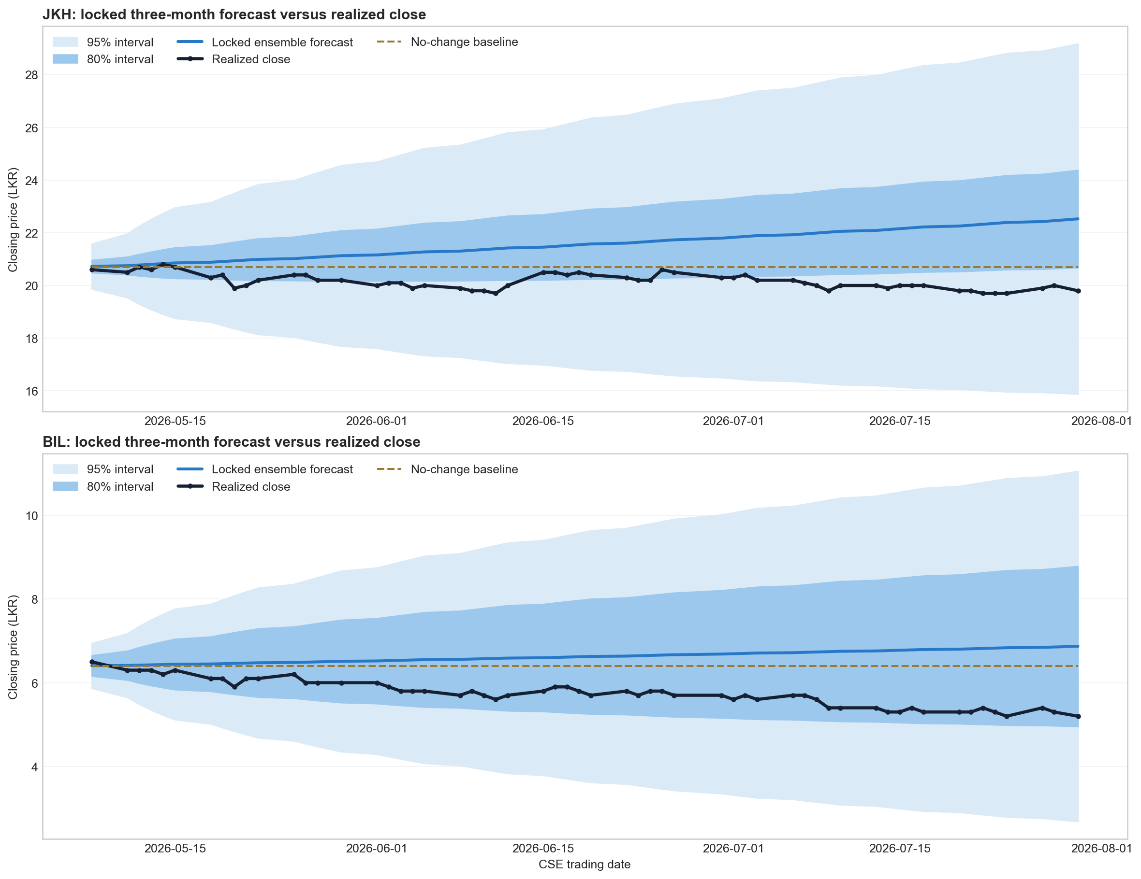
Figure 1. Locked forecasts and realized closing prices over the exact-date validation window. Shaded regions are forecast intervals, not guaranteed price targets.
Table 3. Out-of-sample forecast errors across 57 matched sessions.
Stock / model | MAE (LKR) | RMSE (LKR) | MAPE | Mean bias
JKH ensemble | 1.416 | 1.594 | 7.07% | +1.416
JKH LSTM scenario | 1.109 | 1.260 | 5.54% | +1.107
JKH no-change baseline | 0.547 | 0.617 | 2.74% | +0.544
BIL ensemble | 0.882 | 0.988 | 15.83% | +0.879
BIL LSTM scenario | 0.857 | 0.963 | 15.38% | +0.853
BIL no-change baseline | 0.656 | 0.728 | 11.76% | +0.653

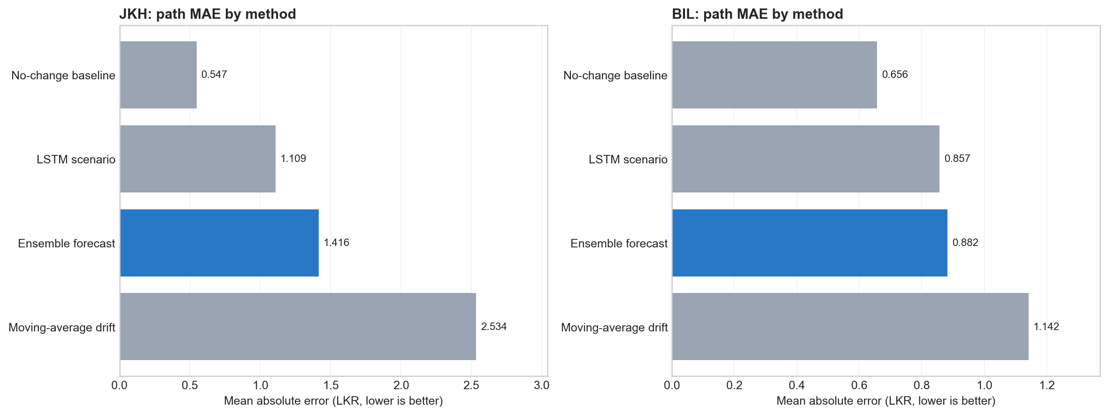
Figure 2. Error comparison across ensemble, LSTM scenario, moving-average drift, and no-change baseline. Lower bars are better.
Table 4. Endpoint comparison at the locked forecast target date.
Stock | 30 Jul forecast | 30 Jul actual | Absolute gap | Gap vs actual | Actual period change
JKH | 22.5275 | 19.80 | 2.7275 | 13.78% | -3.88%
BIL | 6.8708 | 5.20 | 1.6708 | 32.13% | -20.00%

Validated finding: The locked upward scenarios were not supported by the realized paths. Both were positively biased, and the no-change baseline was more accurate. This is a negative forecast result but a positive research practice: the model was tested honestly after the forecast period elapsed.
Interval coverage also requires caution. The JKH 80% interval covered 38.60% of observations, while the 95% interval covered 100% with an average width of LKR 8.91. Both BIL intervals covered all observations, but their average widths were LKR 2.57 and LKR 5.61. High coverage from a very wide interval should not be interpreted as precise forecasting.

5. Deviation and Anomaly-Score Method

5.1 Core calculations
Signed deviation = Actual close - Expected close
Absolute deviation = |Actual close - Expected close|
Volume scaled = Trading volume / 1,000,000
Liquidity-aware anomaly score = Absolute deviation / (Volume scaled + epsilon)
Final anomaly = Liquidity-score flag OR Prediction-band flag
The signed deviation states direction: positive means the observed close is above expectation, while negative means it is below. The absolute deviation states magnitude. Dividing by scaled volume makes an unsupported deviation more prominent when trading participation is weak. Epsilon prevents division by zero.
Important correction: This formulation does not simply reduce all low-volume effects. For the same price gap, lower volume produces a larger score. It therefore highlights deviations that have less liquidity support, while a separate market-confirmed diagnostic can describe large moves accompanied by stronger participation.

5.2 Worked calculations from the original experiment
JKH: |20.7000 - 20.5949| / (6.268465 + 0.000001) = 0.016764 < 0.961452 => no liquidity anomaly
BIL: |6.4000 - 6.3730| / (3.647469 + 0.000001) = 0.007397 < 0.302219 => no liquidity anomaly
Thresholds were selected using chronological training/validation evidence before the test split was evaluated. The final method also checks whether the realized close breaks its prediction band. A structural-value signal is reported separately and is not automatically OR-ed into the anomaly flag. This avoids calling every model-estimated discount an abnormal daily event.

5.3 Post-forecast deviation diagnostic
For validation, the old forecast path is compared with later closes. This diagnostic measures how far reality moved from the locked scenario; it is not the same as the model's contemporaneous one-step anomaly detector.
Table 5. Endpoint post-forecast deviation diagnostics.
Stock | 30 Jul forecast | Actual | Volume | Post-forecast liquidity score | Interpretation
JKH | 22.5275 | 19.80 | 1,819,649 | 1.4989 | Large gap from old scenario
BIL | 6.8708 | 5.20 | 2,908,715 | 0.5744 | Large percentage gap from old scenario

Do not mislabel: These July scores diagnose divergence from the old May scenario. They should not be compared directly with a newly calibrated September threshold or presented as proof that a specific news event caused the divergence.

6. Fresh On-Demand Analysis as of 1 September 2026
Component 1 was rerun from the full MongoDB histories rather than loading the locked May predictions. The latest close, expected close, thresholds, forecast paths, and run identifiers below were generated in fresh_on_demand mode.
Table 6. Fresh current-state expected-price and anomaly evidence.
Measure | JKH | BIL
Current close | 19.50 | 5.70
Same-session expected close | 19.4813 | 5.2263
Signed deviation | +0.0187 | +0.4737
Volume | 7,972,722 | 13,228,274
Liquidity-aware score | 0.002345 | 0.035812
Calibrated threshold | 0.446011 | 0.233377
Current anomaly | No | No
Run identifier | 25f6d486... | 54fcb3ee...

Current JKH: |19.5000 - 19.4813| / 7.972722 = 0.002345 < 0.446011 => normal current movement
Current BIL: |5.7000 - 5.2263| / 13.228274 = 0.035812 < 0.233377 => normal current movement
Meaning: A stock can be normal relative to its newly learned September regime even though the old May forecast was inaccurate. Current anomaly detection and historical forecast validation answer different questions.
Table 7. Fresh central scenario checkpoints; all are available with caution.
Horizon | JKH central path | JKH change | BIL central path | BIL change
4 trading days | 19.4561 | -0.23% | 5.7158 | +0.28%
1 month | 19.2791 | -1.13% | 5.7868 | +1.52%
3 months | 18.9120 | -3.02% | 5.9742 | +4.81%
6 months | 18.4030 | -5.63% | 6.3374 | +11.18%

The fresh backtests still fail the unchanged-price baseline gate. JKH test MAE is LKR 0.3512 versus a naive LKR 0.1916; BIL test MAE is LKR 0.1367 versus a naive LKR 0.1042. Therefore, the scenario checkpoints must remain conditional ranges rather than confident targets, even though the internal reliability composite is numerically high.

7. Component 1 Novelty
Defensible novelty statement: Component 1 is an explainable and liquidity-aware market modeling framework for CSE stocks. It combines time-series expected-price modeling, signed and absolute deviation, volume-adjusted anomaly scoring, calibrated prediction-band checks, separated structural-value interpretation, feature-level explanation, and explanation-stability measurement. Its contribution is the connected interpretation framework, not a claim that its price forecast outperforms every baseline.
- Expected price as a reference, not an oracle. The time-series model provides a contemporaneous expectation against which observed behavior can be measured.
- Liquidity-aware deviation. The same price error is interpreted differently depending on market participation, which is relevant to CSE liquidity conditions.
- Direction and magnitude remain visible. Signed deviation identifies above/below expectation, while absolute deviation supports comparable scoring.
- Two anomaly routes. The final anomaly can arise from a high liquidity-aware score or a prediction-band break, reducing dependence on one threshold.
- Anomaly is separated from value potential. A structural discount may be investor-relevant without being mislabeled as an abnormal current move.
- Explanations are auditable. SHAP explains a surrogate anomaly-score model, and ESI measures whether top explanatory factors recur across rolling windows.
- Forecast reliability is multi-dimensional. Point error, interval coverage, bias, fold stability, and a baseline gate are exposed instead of presenting one accuracy percentage.
- Fresh inference is traceable. Every Analyze request exports the latest selected-stock history, produces a new run ID and cutoff date, and removes temporary files.

7.1 What the novelty does not prove
- It does not prove profitable trading performance.
- It does not prove that the LSTM deviation method is superior to every anomaly baseline; JKH's Z-score baseline achieved the strongest test F1 in the saved comparison.
- It does not provide ground-truth anomaly accuracy because event labels are proxies; JKH had only nine proxy-positive test cases and BIL had two.
- SHAP explains the surrogate anomaly-score model, not the internal recurrent-model gates.
- ESI can be high because trading volume repeatedly dominates, so stability is not the same as balanced explanation quality.
- A forecast interval or reliability score does not guarantee a future price.

8. Explanation and Stability Evidence
Table 8. Saved SHAP-surrogate and Explanation Stability Index evidence.
Stock | Leading explanation factors | Latest ESI | Mean ESI | Required interpretation
JKH | Volume 89.8%; 1D return 3.6%; RSI 2.4% | 1.000 | 0.897 | Highly stable but volume-led
BIL | Volume 97.4%; ATR 1.6%; 1D return 0.4% | 1.000 | 1.000 | Highly stable but strongly volume-led

The explanation layer supports the investor-facing question, 'Why was the score high or low?' It does not claim causal influence on the real market. Repeated appearance of volume across rolling windows makes the explanation stable, but it also requires a dominance warning because the result may reflect the score's liquidity construction.

9. Limitations and Required Improvements
- Only two immutable forecast files were available, covering one market regime.
- The forecasts did not outperform the unchanged-price baseline in the formal three-month validation or the fresh September model checks.
- Anomaly labels are proxy labels rather than manually verified CSE event annotations.
- BIL's anomaly test metrics are unstable because only two positive proxy cases appear in the test split.
- The historical data source includes a TradingView CSELK fallback and should be reconciled with official CSE/MyCSE data when possible.
- Percentage errors are naturally amplified for a low-priced stock such as BIL.
- Corporate actions, dividends, transaction costs, and trading-strategy profitability are outside this evaluation.
- External events can be used as context by the integrated system, but Component 1 deviation alone cannot prove what caused a price gap.

10. Recommended Next Research Iteration
- Add a stronger baseline gate that suppresses central price targets when the advanced model does not beat the unchanged-price benchmark.
- Recalibrate point forecasts and intervals separately by stock and horizon, especially for BIL.
- Use rolling-origin retraining and drift monitoring to test changing market regimes.
- Create a manually reviewed CSE anomaly dataset with event dates, direction, severity, and inter-rater agreement.
- Report anomaly precision, recall, F1, support, and false positives alongside investor explanations.
- Expand only after preserving immutable forecasts and exact creation timestamps for each additional stock.

11. Reproducibility and Demonstration
The following evidence should be shown during a research demonstration:
- Run the JKH or BIL research notebook and show the chronological split, expected price, score, calibrated threshold, baseline comparison, and explanation factors.
- Open the executed forecast-validation notebook and show that predictions were locked before actual prices became available.
- Display Figure 1 and explain why the actual paths invalidate the upward point forecasts.
- Run the application Analyze workflow and point to the fresh run ID, 1 September cutoff, current expected price, deviation, score, and threshold.
- State the limitations before discussing potential: no ground-truth anomaly labels, two-stock scope, and baseline not beaten.
cd research/component1 && PYTHONPATH=src jupyter lab
Open notebooks/component1_forecast_validation.ipynb and select: Restart Kernel and Run All Cells

12. Conclusion
The three-month validation does not support the old upward forecasts for either JKH or BIL. This prevents the project from claiming superior price prediction. However, the experiment strengthens the research by demonstrating immutable forecasting, exact-date validation, baseline comparison, and explicit failure reporting. The most defensible novelty is the integrated expected-price and anomaly-interpretation framework: it measures direction and magnitude of deviation, adjusts the signal for liquidity, uses calibrated thresholds and prediction bands, separates current abnormality from structural value interpretation, and provides traceable explanation and stability evidence.
Final research position: Component 1 should be presented as an explainable decision-support and anomaly-analysis framework with cautious scenario forecasts. It should not be presented as a proven trading predictor or as financial advice.

Sources and Evidence Files
- research/component1/data/training/JKH_history_through_2026-05-07.csv
- research/component1/data/training/BIL_history_through_2026-05-07.csv
- research/component1/data/locked_forecasts/JKH_forecast_created_2026-05-10.csv
- research/component1/data/locked_forecasts/BIL_forecast_created_2026-05-10.csv
- research/component1/data/actuals/*_actual_through_2026-08-28.csv
- research/component1/artifacts/validation/forecast_validation_metrics.csv
- research/component1/artifacts/validation/forecast_endpoint_validation.csv
- research/component1/artifacts/validation/forecast_deviation_summary.csv
- research/component1/artifacts/component1/research_run_summary.csv
- research/component1/notebooks/component1_forecast_validation.ipynb
- Fresh MongoDB-backed on-demand runs generated 1 September 2026 (run IDs recorded in Table 6).

Related Research Used for Novelty Comparison
- [1] Fischer, T., & Krauß, C. (2018). Deep learning with long short-term memory networks for financial market predictions. European Journal of Operational Research, 270(2), 654-669. https://doi.org/10.1016/j.ejor.2017.11.054
- [2] Chandola, V., Banerjee, A., & Kumar, V. (2009). Anomaly detection: A survey. ACM Computing Surveys, 41(3), Article 15. https://doi.org/10.1145/1541880.1541882
- [3] Karpoff, J. M. (1987). The relation between price changes and trading volume: A survey. Journal of Financial and Quantitative Analysis, 22(1), 109-126. https://doi.org/10.2307/2330874
- [4] Lundberg, S. M., & Lee, S.-I. (2017). A unified approach to interpreting model predictions. Advances in Neural Information Processing Systems, 30. https://papers.neurips.cc/paper/7062-a-unified-approach-to-interpreting-model-predictions
- [5] Toufighi, S. P., Khani, A. M., Rezasoltani, A., Ghasemian Sahebi, I., & Vang, J. (2025). Forecasting stock market anomalies in emerging markets: An OPTUNA-optimized isolation forest and K-means approach. Machine Learning with Applications, 22, Article 100770. https://doi.org/10.1016/j.mlwa.2025.100770

