

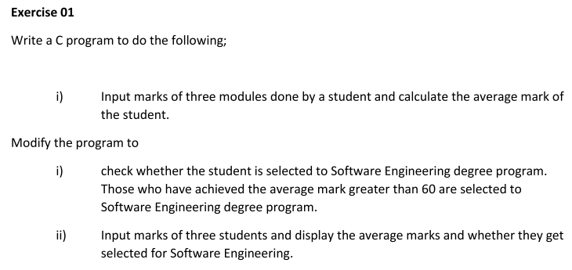

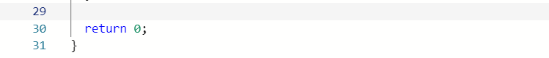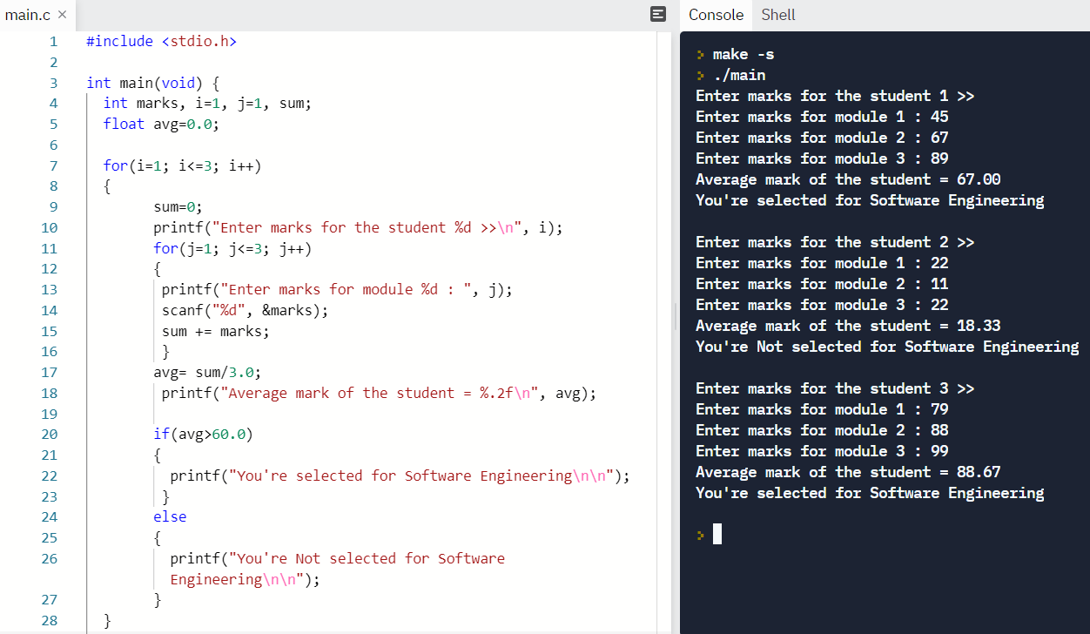

Ex 1 code:

#include <stdio.h>

int main(void) {

int marks, i=1, j=1, sum;

float avg=0.0;

for(i=1; i<=3; i++)

{

sum=0;

printf("Enter marks for the student %d >>\n", i);

for(j=1; j<=3; j++)

{

printf("Enter marks for module %d : ", j);

scanf("%d", &marks);

sum += marks;

}

avg= sum/3.0;

printf("Average mark of the student = %.2f\n", avg);

if(avg>60.0)

{

printf("You're selected for Software Engineering\n\n");

}

else

{

printf("You're Not selected for Software Engineering\n\n");

}

}

return 0;

}

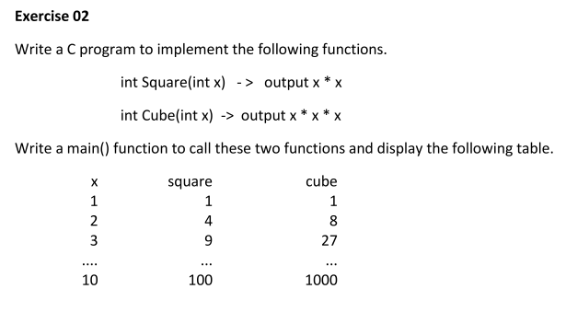

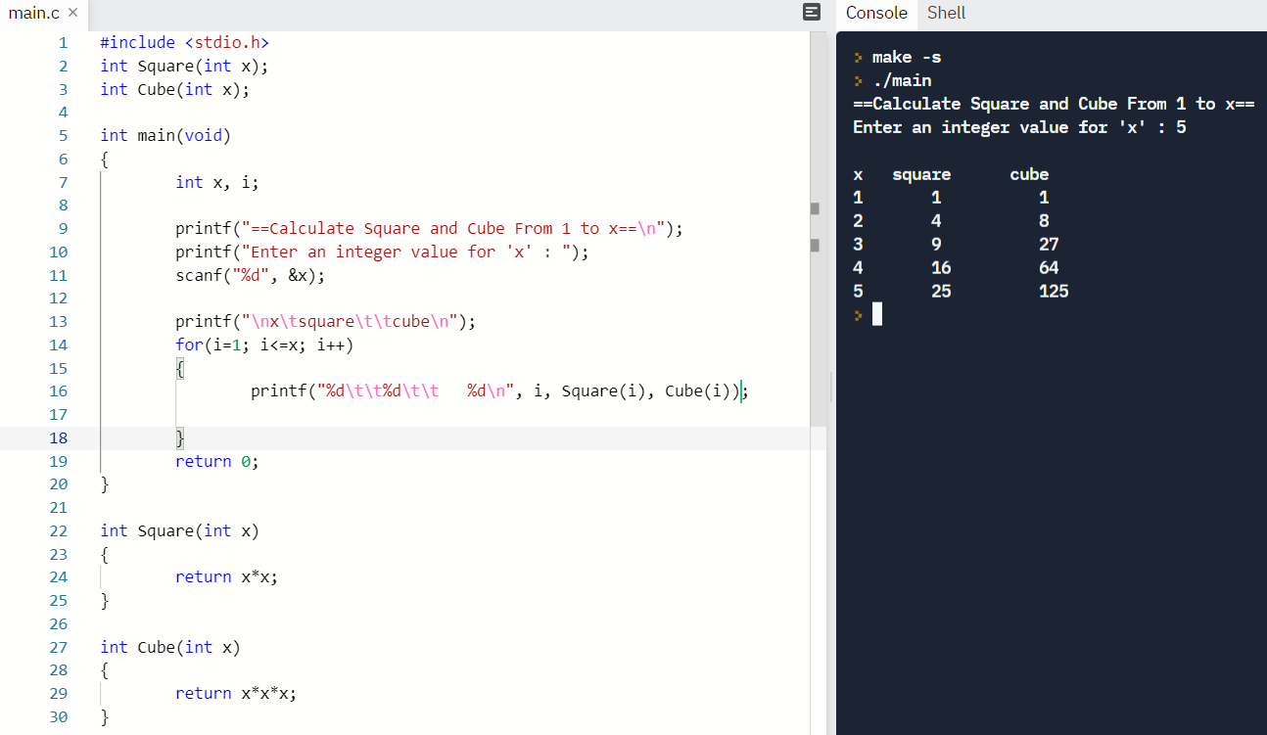

Ex 2 code:

#include <stdio.h>

int Square(int x);

int Cube(int x);

int main(void)

{

int x, i;

printf("==Calculate Square and Cube From 1 to x==\n");

printf("Enter an integer value for 'x' : ");

scanf("%d", &x);

printf("\nx\tsquare\t\tcube\n");

for(i=1; i<=x; i++)

{

printf("%d\t\t%d\t\t %d\n", i, Square(i), Cube(i));

}

return 0;

}

int Square(int x)

{

return x*x;

}

int Cube(int x)

{

return x*x*x;

}

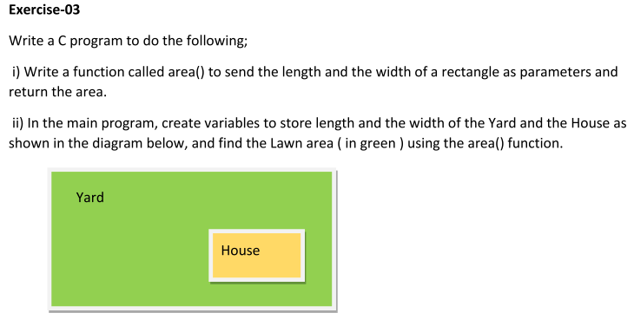

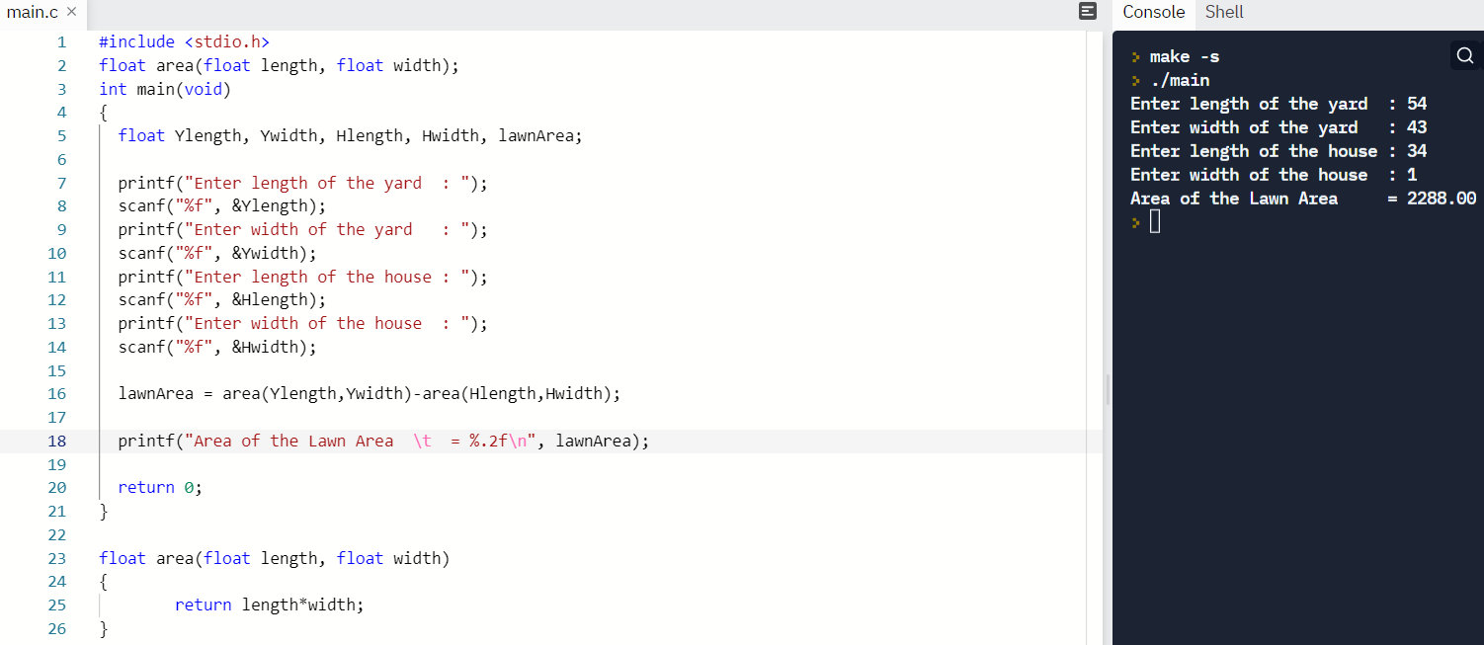

Ex 3 code:

#include <stdio.h>

float area(float length, float width);

int main(void)

{

float Ylength, Ywidth, Hlength, Hwidth, lawnArea;

printf("Enter length of the yard : ");

scanf("%f", &Ylength);

printf("Enter width of the yard : ");

scanf("%f", &Ywidth);

printf("Enter length of the house : ");

scanf("%f", &Hlength);

printf("Enter width of the house : ");

scanf("%f", &Hwidth);

lawnArea = area(Ylength,Ywidth)-area(Hlength,Hwidth);

printf("Area of the Lawn Area \t = %.2f\n", lawnArea);

return 0;

}

float area(float length, float width)

{

return length*width;

}

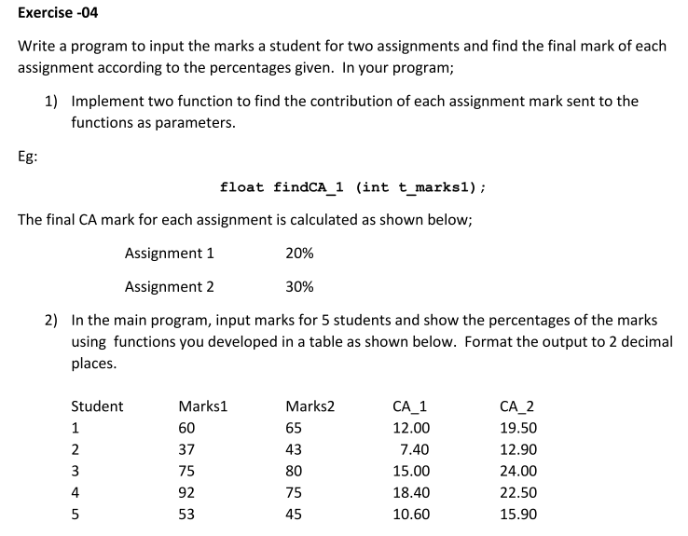

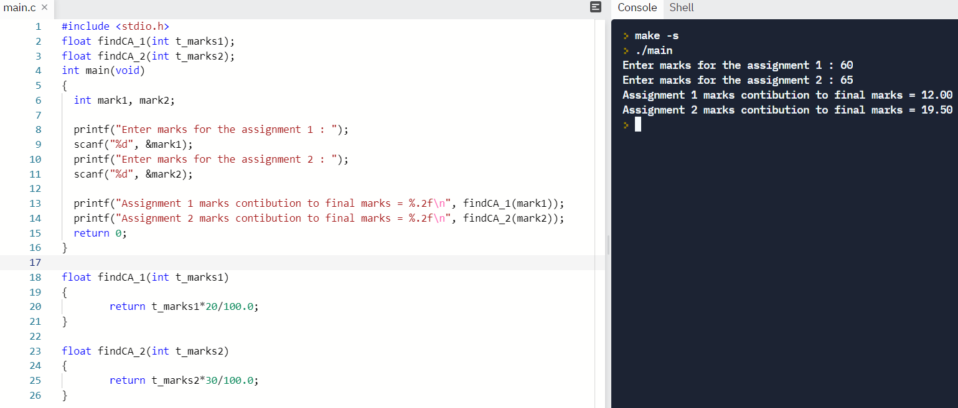

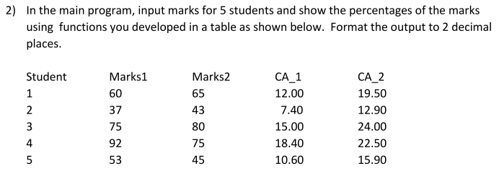

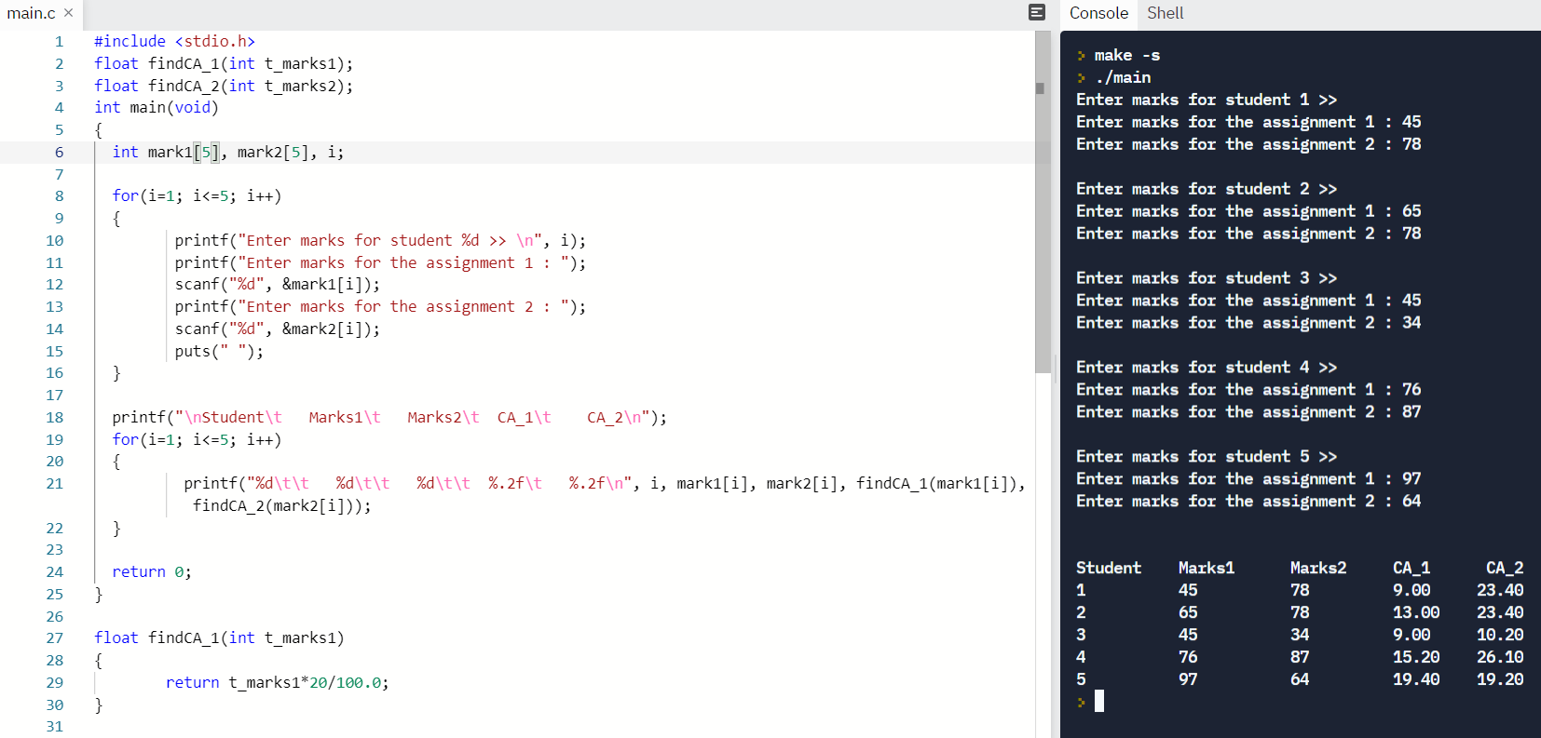

Ex 4 code:

#include <stdio.h>

float findCA_1(int t_marks1);

float findCA_2(int t_marks2);

int main(void)

{

int mark1[5], mark2[5], i;

for(i=1; i<=5; i++)

{

printf("Enter marks for student %d >> \n", i);

printf("Enter marks for the assignment 1 : ");

scanf("%d", &mark1[i]);

printf("Enter marks for the assignment 2 : ");

scanf("%d", &mark2[i]);

puts(" ");

}

printf("\nStudent\t Marks1\t Marks2\t CA_1\t CA_2\n");

for(i=1; i<=5; i++)

{

printf("%d\t\t %d\t\t %d\t\t %.2f\t %.2f\n", i, mark1[i], mark2[i], findCA_1(mark1[i]), findCA_2(mark2[i]));

}

return 0;

}

float findCA_1(int t_marks1)

{

return t_marks1*20/100.0;

}

float findCA_2(int t_marks2)

{

return t_marks2*30/100.0;

}