**Lab sheet 6**

*It23223394*

**Semester 1, 2025**

Exercise 0

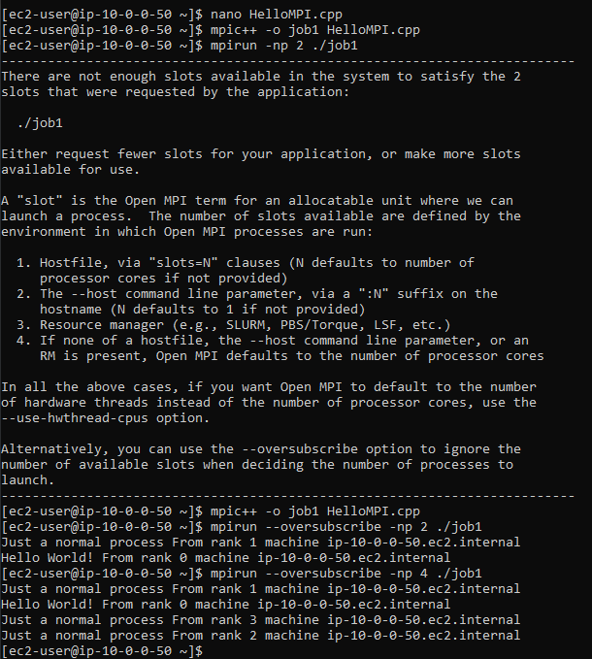

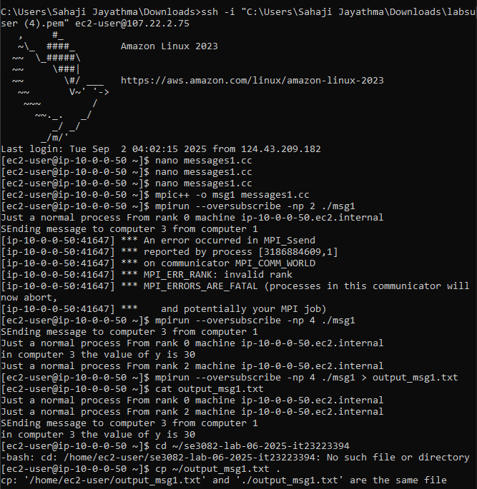

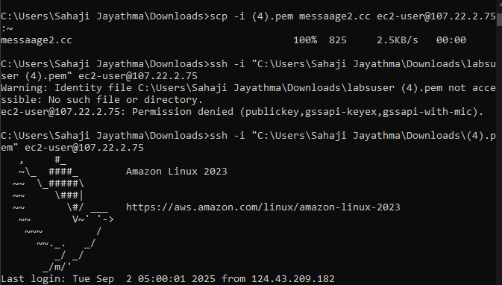

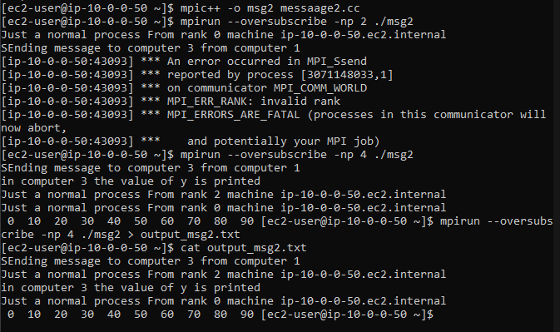

Exercise 02

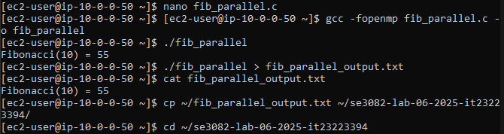

Exercise 03

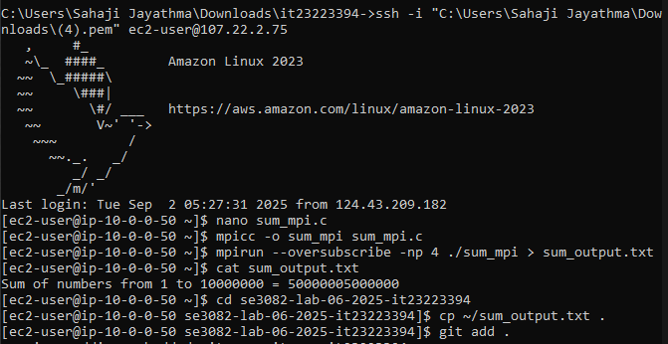

Exercise 04

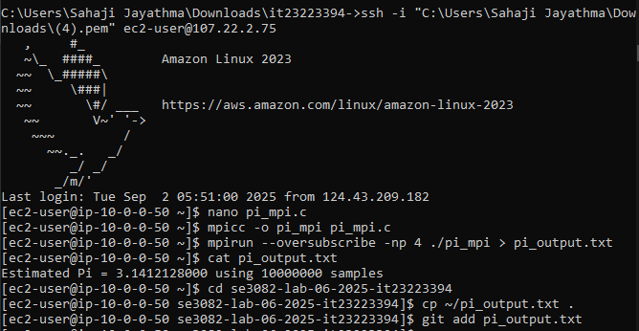

Exercise 05

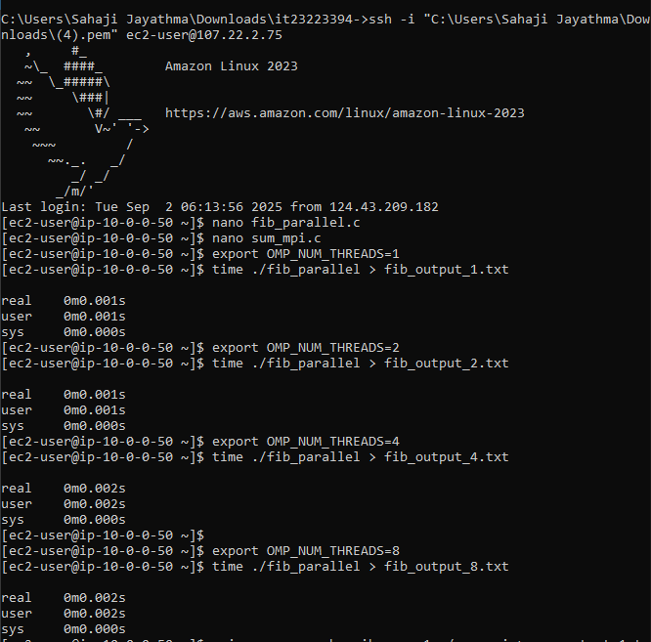

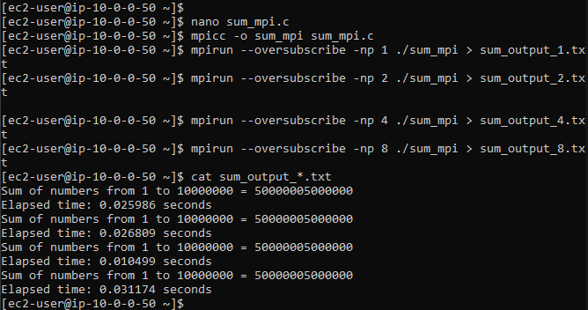

Fibonacci (OpenMP) – Time vs Threads

|  |  |
| --- | --- |
| **Threads** | **Elapsed Time (s)** |
| 1 | 0.001 |
| 2 | 0.001 |
| 4 | 0.002 |
| 8 | 0.002 |

**Speedup Table** (Speedup = Time with 1 thread ÷ Time with N threads)

|  |  |
| --- | --- |
| **Threads** | **Speedup** |
| 1 | 1.0 |
| 2 | 1.0 |
| 4 | 0.5 |
| 8 | 0.5 |

Sum (MPI) – Time vs Processes

|  |  |
| --- | --- |
| **Processes** | **Elapsed Time (s)** |
| 1 | 0.025986 |
| 2 | 0.026809 |
| 4 | 0.010499 |
| 8 | 0.031174 |

**Speedup Table** (Speedup = Time with 1 process ÷ Time with N processes)

|  |  |
| --- | --- |
| **Processes** | **Speedup** |
| 1 | 1.0 |
| 2 | 0.97 |
| 4 | 2.47 |
| 8 | 0.83 |

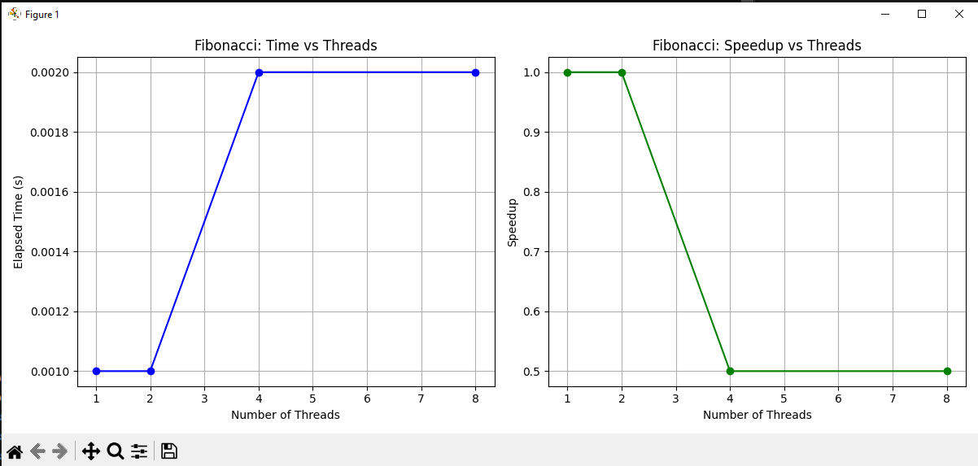

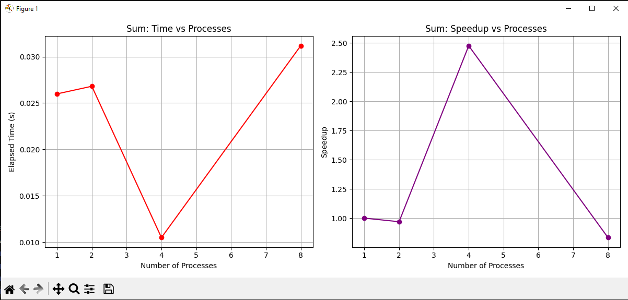

Exercise 06

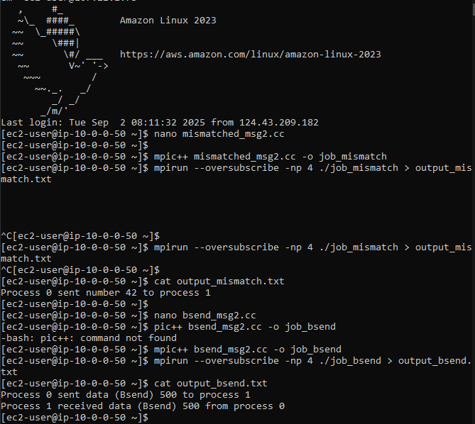

What happens:

* Process 1 tries to send to rank 3.
* Rank 2 is trying to receive from rank 1.
* Result: The program hangs (deadlocks) because no process is actually receiving the message at rank 3. The send cannot complete.

Exercise 07

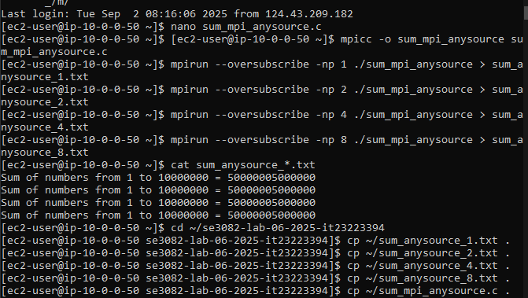

Exercise 08

