JAR OF THOUGHTS
Technical Design Document
A Personal Emotional Keepsake Progressive Web Application
Version 1.0
June 2026
Author: Sahaji Perera

1. Project Overview

1.1 Purpose
Jar of Thoughts is a personal emotional keepsake Progressive Web Application (PWA). It digitally recreates the real-life practice of writing feelings, memories, and reflections on paper chits and storing them in physical jars. The application prioritises emotional connection, privacy, and a warm tactile user experience over productivity or social features.

1.2 Design Philosophy
Principle | Implementation
Privacy first | All data stored client-side in localStorage. No accounts. No server.
Warmth | Illustrated wooden shelf, glass jars, handwritten labels, paper textures
Simplicity | No complex navigation. One shelf. Open a jar. Read or write.
Offline first | Full functionality with no internet after first load
Cross-platform | Single codebase targets web browser, Android PWA, and native APK

1.3 Scope

In Scope
- Thought creation, reading, archiving, and deletion
- Time capsule locking with future unlock dates
- Jar management (add, rename, delete custom jars)
- 5 colour themes each with light and dark variants
- Responsive shelf rack layout system
- Full offline support via service worker
- Android APK packaging via Capacitor
- Data backup and restore (JSON export/import)

Out of Scope
- Social sharing or public profiles
- AI-generated content
- Real-time multi-device cloud sync (planned, not yet implemented)
- Push notifications

2. System Architecture

2.1 Layer Overview
The application follows a client-only architecture with no server component. All persistence is handled by the browser localStorage API. The service worker provides offline capability by caching all static assets on first load.
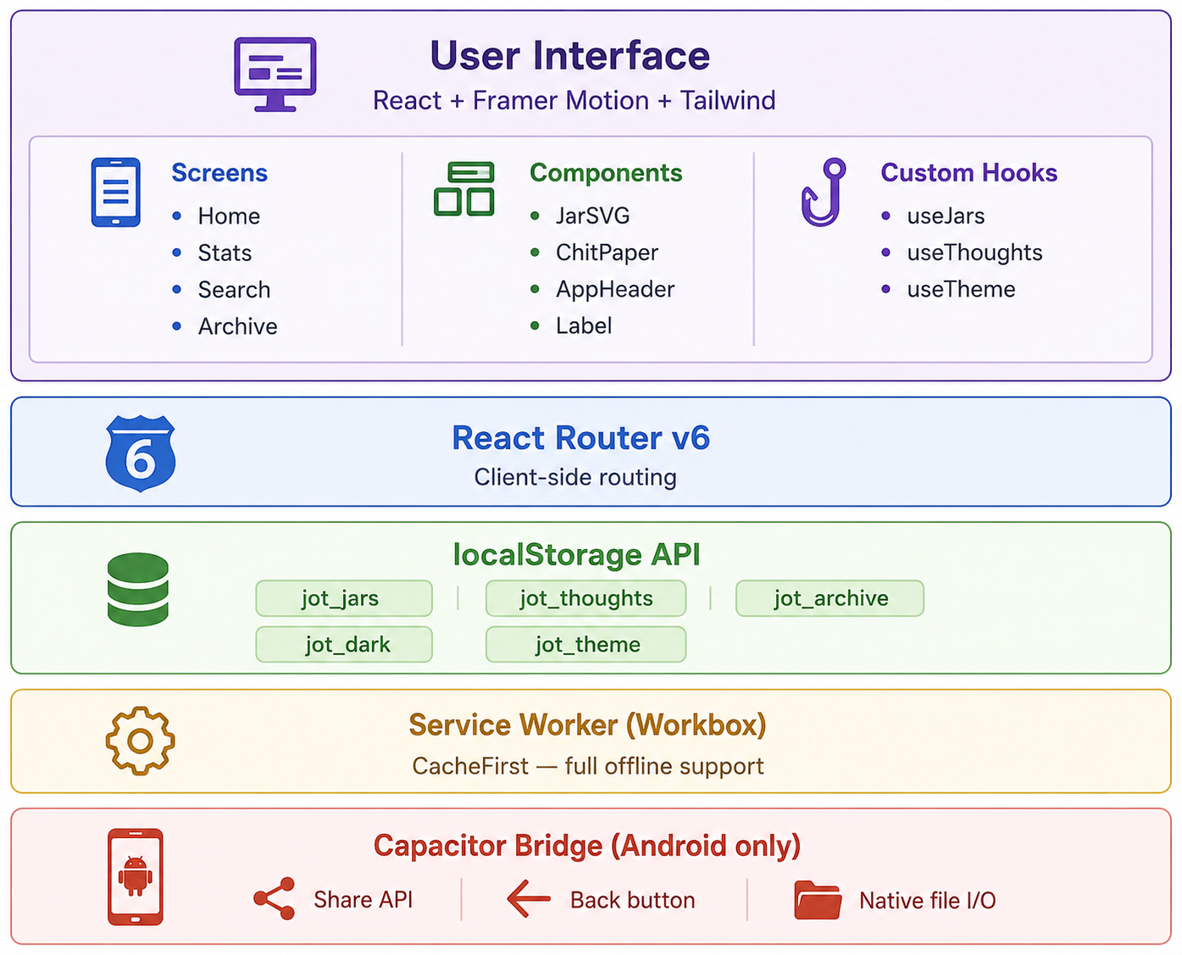

2.2 Key Architecture Decisions
No backend. The application is intentionally serverless. All persistence uses the browser localStorage API. This eliminates authentication complexity, server costs, and privacy concerns. The trade-off is that data is device-local; the Backup & Restore feature mitigates this.
No global state library. React built-in useState combined with custom hooks provides sufficient state management. Each hook wraps localStorage reads/writes and exposes a clean API to screens.
Single-file components. Each screen is self-contained. Shared logic is extracted into hooks and shared UI into components to avoid prop-drilling.

3. Technology Stack
Category | Technology | Version | Purpose
Framework | React | 18.x | UI rendering and component model
Build Tool | Vite | 8.x | Dev server, HMR, production bundling
Styling | Tailwind CSS | v4 | Utility classes; inline styles for dynamic theming
Animations | Framer Motion | 11.x | Drag interactions, spring animations, transitions
Routing | React Router | v6 | Client-side SPA navigation
Date handling | dayjs | 1.x | Relative time, date formatting
Icons | Lucide React | 0.383.x | SVG icon set
PWA | vite-plugin-pwa | latest | Service worker generation, manifest injection
Service Worker | Workbox | bundled | CacheFirst strategy, offline asset caching
Android | Capacitor | 6.x | Native Android bridge, Share API, back button
Fonts | Google Fonts | — | Playfair Display (serif), Inter (sans-serif)

NOTE | 100% free stack. No paid services, no subscriptions, no backend infrastructure costs.

4. Project Structure

jar-of-thoughts/

│

├── android/ # Capacitor Android project

│ └── app/src/main/res/ # App icons, splash screens

│

├── public/

│ ├── manifest.json # PWA manifest

│ ├── icon-192.png # PWA / Android icon

│ └── icon-512.png # PWA / Android icon (large)

│

├── src/

│ ├── hooks/

│ │ ├── useJars.js # Jar CRUD — localStorage

│ │ ├── useThoughts.js # Thought CRUD + archive

│ │ └── useTheme.js # Shared theme colour reader

│ │

│ ├── components/

│ │ ├── JarSVG.jsx # Illustrated glass jar SVG

│ │ ├── ChitPaper.jsx # Draggable paper chit overlay

│ │ ├── AppHeader.jsx # Shared top navigation bar

│ │ └── Label.jsx # Handwritten jar label

│ │

│ ├── screens/

│ │ ├── Home.jsx # Shelf rack system + interactions

│ │ ├── Stats.jsx # Analytics dashboard

│ │ ├── Search.jsx # Full-text thought search

│ │ └── Archive.jsx # Archived thoughts management

│ │

│ ├── App.jsx # Router setup

│ ├── main.jsx # React DOM entry point

│ └── index.css # Tailwind import + global styles

│

├── vite.config.js # Vite + PWA plugin configuration

├── capacitor.config.ts # Capacitor Android configuration

├── package.json

└── README.md

5. Data Architecture

5.1 localStorage Schema
All data is stored as JSON strings in localStorage. Keys are prefixed with jot_ to avoid collisions with other applications.

5.1.1 jot_jars — Jar Array
Field | Type / Description
id | string — crypto.randomUUID()
name | string — Display name e.g. "Love"
emoji | string — Single emoji e.g. "❤️"
color | string — Hex colour e.g. "#f4b8cb"

Default Jars (pre-seeded on first load)
ID | Name | Emoji | Colour
love | Love | ❤️ | #f4b8cb
life | Life | 🌿 | #a8d5a2
sadness | Sadness | 🌧 | #9ec5e8
neutral | Neutral Thoughts | ☁️ | #c8c8c8
dreams | Dreams | ✨ | #c5b8f0
gratitude | Gratitude | 🌻 | #f5cc7a
unsent | Unsent Words | 🔥 | #f0a890

5.1.2 jot_thoughts — Thought Array
Field | Type / Description
id | string — crypto.randomUUID()
text | string — Raw thought text
jarId | string — References Jar.id
createdAt | string — ISO 8601, auto-captured at save time. Never user-entered.
isLocked | boolean — True if time capsule is active
unlockAt | string | null — ISO 8601 unlock date, or null

5.1.3 jot_archive — Archive Array
Same schema as Thought. Thoughts moved here via archiveThought() are removed from jot_thoughts and appended to jot_archive.

5.1.4 Preference Keys
Key | Type | Values | Default
jot_dark | string | "true" / "false" | "false"
jot_theme | string | "amber" / "sage" / "rose" / "slate" / "lavender" | "amber"

5.2 localStorage Write Pattern
Every mutation follows the same read → mutate → write → setState pattern:
function addThought({ text, jarId, isLocked, unlockAt }) {
const thought = {
id: crypto.randomUUID(),
text,
jarId,
createdAt: new Date().toISOString(), // always auto-captured
isLocked,
unlockAt,
}
const updated = [...thoughts, thought]
localStorage.setItem("jot_thoughts", JSON.stringify(updated))
setThoughts(updated)
}

5.3 Time Capsule Logic
- When isLocked === true and unlockAt is set, the chit is visible in the jar as a sealed entry showing only the unlock date
- The chit cannot be opened or read until new Date(unlockAt) <= new Date()
- On every app load, unlockDueThoughts() scans all thoughts and auto-unlocks any whose date has passed
- Locked capsule count is shown in the quick stats row on the home screen

6. Component Specifications

6.1 JarSVG
Path: src/components/JarSVG.jsx
Prop | Type / Default / Description
color | string — required — Hex colour for liquid fill tint
count | number — required — Thought count; drives fill level
isOpen | boolean — false — Animates lid upward when true
width | number — 80 — SVG render width in px
height | number — 110 — SVG render height in px

Fill level formula:
fillLevel = Math.min(0.82, Math.max(0.05, count * 0.11))

SVG layers (bottom to top): drop shadow → jar body base → liquid fill → liquid surface wave → glass overlay → glass outline → neck → lid group (animates on isOpen) → label area.

6.2 ChitPaper
Path: src/components/ChitPaper.jsx
A full-screen overlay containing a draggable paper card. When drag starts, two circular drop zones appear at the bottom corners.
Prop | Type / Description
thought | Thought — The thought object to display
jar | Jar — The jar this thought belongs to
onDrop | function(point: {x,y}) — Called when drag ends
onClose | function — Called when backdrop is tapped
t | ThemeObject — Current theme colour tokens

Drop zone detection:
const W = window.innerWidth, H = window.innerHeight
const inFire = point.x < W * 0.45 && point.y > H * 0.6
const inArchive = point.x > W * 0.55 && point.y > H * 0.6

6.3 useTheme Hook
Path: src/hooks/useTheme.js
Reads jot_theme and jot_dark from localStorage and returns a flat colour token object. Polls every 300ms so theme changes on Home propagate to Stats/Search/Archive without a page reload.
const c = useTheme()
// c.bg, c.surface, c.text, c.muted, c.accent, c.border, c.card, c.lines
7. Screen Specifications

7.1 Home Screen — Route: /
Responsibilities: renders the full shelf rack system, manages all modal state, handles jar tap/double-tap/long-press, manages chit drag-to-delete and drag-to-archive, displays fixed bottom bar.

State | Purpose
openJarId | Which jar panel is open
writeJarId | Which jar write modal is open
viewThought | Which thought chit is showing (draggable)
burning | Fire burn overlay active
archiveOpen | Steel box lid animation
jarsPerRow | Computed from ResizeObserver

7.2 Stats Screen — Route: /stats
- Summary cards: total thoughts, jar count, time capsules, most used jar
- Date range: first thought date to latest thought date
- Donut chart: jar distribution with colour-coded segments and percentages (SVG, no library)
- 6-month bar chart: writing activity per month (CSS bars, theme accent colour)
- At-a-glance grid: active days, average words per thought, journey span, locked capsules
- Export / Import buttons for full data backup and restore

7.3 Search Screen — Route: /search
- Minimum 2 characters to trigger search
- Searches thought text case-insensitively across all jars
- Excludes locked time capsule thoughts from results
- Results grouped by jar with colour dot, emoji, and name
- Each result shows first 2 lines of thought and relative time
- Clear button appears in search input when text is entered
- Tapping a result navigates to the chit view for that thought

7.4 Archive Screen — Route: /archive
- Archived thoughts displayed in reverse chronological order
- Each card shows: jar tag, full thought text, creation date, relative time
- Restore: moves thought back to its original jar
- Delete: permanently removes from archive

8. Theme System

8.1 Overview
Five named themes, each with a light and dark variant — 10 total combinations. Theme and dark mode are stored independently in localStorage and combined at render time.

Theme | Character
Amber | Warm brown — the default; candlelit wooden shelf
Sage | Forest green — calm, nature-inspired
Rose | Dusty rose / mauve — soft, romantic
Slate | Cool blue-grey — clean, minimal
Lavender | Soft purple — dreamy, gentle

8.2 Key Theme Tokens
Token | Usage
pageBg | Full-page background gradient
shelfBg | Wooden shelf plank gradient
shelfBorder | Shelf top border colour
panelBg | Bottom sheet / modal background
panelText | Modal primary text
panelMuted | Modal secondary text
chitBg | Paper chit background
chitLines | Ruled lines on paper texture
writeBtnBg | Primary action button (accent)
labelInk | Handwritten jar label text colour
lowerShelfBg | Bottom shelf gradient (fire + archive)
ambientFire | Radial glow behind fire pit

8.3 Theme Application Pattern
const theme = THEMES[themeName] || THEMES.amber
const t = dark ? theme.dark : theme.light
// All inline styles reference t.tokenName
// e.g. style={{ background: t.panelBg, color: t.panelText }}

9. Shelf Rack Layout System

9.1 Design Requirements
- All jars — default and custom — participate in a single responsive layout
- Jars wrap into horizontal shelf rows based on screen width
- Reflows on: page load, screen resize, new jar added
- No fixed row or column counts — fully dynamic
- At least 2 empty racks always visible
- Fire pit and archive box fixed at bottom, independent of shelf scroll area

9.2 Constants
JAR_W = 72px // jar cell width
JAR_GAP = 8px // gap between jars
JAR_CELL = 80px // total cell width including gap

9.3 jarsPerRow Computation
const w = containerRef.current.clientWidth - 24 // subtract padding
const n = Math.max(2, Math.floor((w + JAR_GAP) / JAR_CELL))
setJarsPerRow(n)

9.4 Responsive Breakpoints (approximate)
Screen Width | Jars Per Row
< 360px (small phone) | 2–3
360–480px (standard phone) | 4
480–768px (large phone) | 5–7
768–1024px (tablet) | 8–10
> 1024px (desktop) | 11+

9.5 Reflow Triggers
- ResizeObserver fires on page load and on every container width change
- useEffect on jars.length calls computeJarsPerRow when a new jar is added
- Framer Motion layout prop handles smooth reflow animation automatically

10. PWA & Offline Support

10.1 Manifest
Location: public/manifest.json
{
"name": "Jar of Thoughts",
"short_name": "JarOfThoughts",
"display": "standalone",
"background_color": "#F9F5EE",
"theme_color": "#B5804A",
"icons": [
{ "src": "icon-192.png", "sizes": "192x192", "type": "image/png" },
{ "src": "icon-512.png", "sizes": "512x512", "type": "image/png" }
]
}

10.2 Service Worker Strategy
Configured via vite-plugin-pwa. Strategy: CacheFirst for all static assets. Google Fonts cached separately under a named cache. Auto-updates service worker on new deployments.

10.3 Android Install Flow
- Deploy to Vercel: npx vercel --prod
- Open URL in Chrome on Android
- Three-dot menu → Add to Home Screen
- App installs with custom icon, runs full-screen, works offline

11. Android (Capacitor)

11.1 Native APIs Used
API | Usage
@capacitor/share | Export: shares JSON backup via native share sheet
Back button override | Navigates to Home instead of exiting the app

11.2 Build Process
npm run build # Vite production build → dist/
npx cap sync android # Copies dist/ into android/ project
# Open android/ in Android Studio
# Build > Generate Signed APK OR Run on device

11.3 Back Button Override

import { App } from '@capacitor/app'

App.addListener('backButton', () => {

if (window.location.pathname !== '/') {

navigate('/')

} else {

App.exitApp()

}

})

11.4 Export on Android
Browser Blob URL download does not work inside Capacitor WebView. Solution uses the native Share API:
import { Share } from '@capacitor/share'
await Share.share({
title: 'Jar of Thoughts Backup',
text: JSON.stringify(backupData),
dialogTitle: 'Save your backup',
})

12. Backup & Restore

12.1 Export
const backup = {
version: 1,
exportedAt: new Date().toISOString(),
jars: JSON.parse(localStorage.getItem('jot_jars') || '[]'),
thoughts: JSON.parse(localStorage.getItem('jot_thoughts') || '[]'),
archive: JSON.parse(localStorage.getItem('jot_archive') || '[]'),
settings: {
theme: localStorage.getItem('jot_theme') || 'amber',
dark: localStorage.getItem('jot_dark') || 'false',
}
}

12.2 Import

const data = JSON.parse(fileContent)

if (data.version !== 1) throw new Error('Incompatible backup version')

localStorage.setItem('jot_jars', JSON.stringify(data.jars))

localStorage.setItem('jot_thoughts', JSON.stringify(data.thoughts))

localStorage.setItem('jot_archive', JSON.stringify(data.archive))

localStorage.setItem('jot_theme', data.settings.theme)

localStorage.setItem('jot_dark', data.settings.dark)

window.location.reload()

13. Animation System
All animations use Framer Motion. No CSS @keyframes. Fire flame animations use Framer Motion animate prop on SVG paths.

Interaction | Type | Config | Notes
Jar cards on mount | Fade + slide up | Stagger 60ms, spring | Entrance animation
Jar lift on open | translateY -8px | Spring stiffness 280 | Plus drop shadow boost
Jar lid animation | translateY + rotate | CSS transition inside SVG | Lid lifts when open
Panel slide up | y: 100% → 0 | Spring stiffness 260 | Bottom sheet
Panel drag close | Drag y, threshold 60px | dragElastic: 0.2 | Swipe to close
Chit paper appear | Scale 0.85 → 1 + fade | Spring stiffness 300 | Paper card
Chit drag | Free drag | dragMomentum: false | Drag to fire/archive
Drop zones appear | Scale + fade in | On drag start | Fire + archive circles
Burn overlay | Opacity pulse + shrink | Duration 1.2s | Full screen fire
Fire flames | ScaleY loop, 3 paths | Infinite stagger | Animated SVG
Steel box lid | RotateX -70deg | Spring on isOpen prop | Archive box opening
Jar reflow | Layout animation | Framer layout prop | On resize / add jar

14. Known Limitations

Issue | Cause | Status
Data is device-local | localStorage by design | Mitigated by Backup & Restore
Rename/delete requires page reload | Hook does not watch external mutations | Acceptable — reload is instant
localStorage size limit | ~5–10MB per browser origin | Unlikely to be hit (text only)
Dark mode label visibility | Light ink colour in dark theme | Fix pending
Time capsule push notifications | No backend / FCM configured | Out of scope for MVP
Blob download in Capacitor | WebView blocks blob URLs | Fixed via Share API

15. Planned Features

15.1 Firestore Cloud Sync (Paused)
STATUS | Firebase project created. Firestore + Auth enabled. Login screen and Firestore hooks written. Not yet integrated into production.

Planned flow:
- Optional sign-in screen (email + password)
- On sign-in: upload local data to Firestore under users/{uid}/jars and users/{uid}/thoughts
- On subsequent loads: merge remote → local
- Real-time Firestore listener for multi-device sync

15.2 Other Planned Items
- Push notifications for time capsule unlocks (requires FCM)
- Jar sorting and reordering by drag
- Thought search within a single jar
- Word count display while writing
- Additional theme options

16. Dependency Reference

Production Dependencies
Package | Purpose
react / react-dom | UI framework
react-router-dom | Client-side routing
framer-motion | Animations and drag interactions
dayjs | Date formatting and relative time
lucide-react | SVG icon set
@capacitor/core | Capacitor core bridge
@capacitor/android | Android platform
@capacitor/app | Back button / app lifecycle
@capacitor/share | Native share sheet for export

Development Dependencies
Package | Purpose
vite | Build tool and dev server
@vitejs/plugin-react | React JSX transform for Vite
tailwindcss | Utility CSS framework (v4)
@tailwindcss/vite | Tailwind v4 Vite integration
vite-plugin-pwa | PWA manifest + service worker generation

