
Mawlana Bhashani Science and Technology University
Santosh, Tangail-1902

Department of Information and Communication Technology
PROJECT REPORT
SHOLO GUTI AND BAGH-CHHAGOL
A Traditional Village Board Game Developed in Java Swing
Course Code: ICT-2200
Course Name: Project-II
Submitted By
Name | : Shayla Akter
ID | : IT24022
Session | : 2023-24
Year / Semester | : 2nd Year, 2nd Semester
Department | : ICT, MBSTU
Submitted To
Supervisor | : Dr. Muhammad Shahin Uddin
Designation | : Professor
Department | : ICT, MBSTU
Date of Submission: ____ / ____ / ________

Certificate

This is to certify that the project report entitled “Sholo Guti And Bagh-Chhagol” has been prepared by Shayla Akter (ID: IT24022, Session: 2023-24), a student of the 2nd Year, 2nd Semester, Department of Information and Communication Technology, Mawlana Bhashani Science and Technology University, Santosh, Tangail-1902, in partial fulfilment of the requirements of the course ICT-2200: Project-II.
The work was carried out under my supervision and, to the best of my knowledge, it is an original work of the student.
______________________________
Dr. Muhammad Shahin Uddin
Professor, Dept. of ICT, MBSTU

______________________________
Shayla Akter
ID: IT24022, Dept. of ICT, MBSTU

Acknowledgement
First of all, I express my sincere gratitude to Almighty Allah for giving me the strength, patience and opportunity to complete this project successfully.
I would like to convey my heartfelt thanks to my respected supervisor, Dr. Muhammad Shahin Uddin, Professor, Department of Information and Communication Technology, Mawlana Bhashani Science and Technology University, for his valuable guidance, constant encouragement and kind suggestions throughout the development of this project.
I am also thankful to all the teachers of the Department of Information and Communication Technology, MBSTU, for the knowledge and support they have given me during my academic journey. I am grateful to my friends and classmates who tested the game and gave useful feedback.
Finally, I am deeply thankful to my family for their love, patience and continuous support, which kept me motivated to finish this work.

Shayla Akter
ID: IT24022

Abstract
Sholo Guti And Bagh-Chhagol is a desktop game that brings two well-loved traditional village board games of Bangladesh and the Indian subcontinent to the computer. The first game, Sholo Guti (16 Guti), is a two-player strategy game in which each player controls 16 pieces and tries to capture all the pieces of the opponent, or block them so that they cannot move. The second game, Bagh-Chhagol (Tiger and Goat), is an asymmetric game in which three tigers hunt sixteen goats while the goats try to trap the tigers.
The project is developed in the Java programming language using the Swing and Java 2D libraries for the graphical interface and the javax.sound.sampled API for sound effects. Every picture in the game, such as the soil-textured board, the betel nut, stick, brickbat and stone pieces, the tiger and the goat, is drawn by program code, so the game needs no external image or sound file.
The game supports two modes: Play with Computer and Two Players on the same computer. The computer opponent has three difficulty levels (Easy, Medium and Hard) and uses a minimax search with alpha-beta pruning. Additional features include a whole-game time limit, a hint system that suggests a good move, pause and resume, multi-jump captures, sound effects, and a built-in How-to-Play guide.
This report describes the objectives, design, rules, implementation, testing and results of the project, and explains the important parts of the source code.
Keywords: Java, Swing, Java 2D, Sholo Guti, Bagh-Chhagol, Minimax, Alpha-Beta Pruning, Board Game, Traditional Game.

Table of Contents
Certificate 2
Acknowledgement 2
Abstract 2
Table of Contents 3
Chapter 1: Introduction 4
Chapter 2: System Requirements and Tools 6
Chapter 3: System Design 7
Chapter 4: Rules and Regulations of the Games 9
Chapter 5: How to Play (Step by Step) 13
Chapter 6: Implementation and Code Explanation 16
Chapter 7: Game Play and Results 26
Chapter 8: Testing 28
Chapter 9: Limitations and Future Work 29
Chapter 10: Conclusion 30

Chapter 1: Introduction

1.1 Background
Sholo Guti and Bagh-Chhagol are traditional games that village children and elders in Bangladesh have played for generations. They are usually drawn on the ground with a stick or on a wooden board, and the pieces are everyday natural objects such as small betel nuts (supari), thin sticks, broken brick pieces or small stones. These games need no costly equipment, but they train the mind to plan ahead, to protect one’s own pieces and to find the weak points of the opponent.
Today, many young people spend their time on mobile and computer games, and these traditional games are slowly being forgotten. A computer version can keep them alive, let people play even when no partner is present, and teach new players the rules in a simple and friendly way.

1.2 About the Two Games
- Sholo Guti (16 Guti): two players, 16 pieces each, played on a 37-point board made of a 5×5 grid with a triangle on the top and another on the bottom. Pieces move one step along a line or capture by jumping over an enemy piece.
- Bagh-Chhagol (Tiger and Goat): one player controls 3 tigers (Bagh), the other controls 16 goats (Chhagol). Goats are first placed on the board one by one and then moved. Tigers capture goats by jumping. The same 37-point board is used.

1.3 Objectives of the Project
- To develop a complete, good-looking and easy-to-use computer version of Sholo Guti and Bagh-Chhagol.
- To implement the exact rules of both games, including jumping, multi-jump, trapping and the winning conditions.
- To build a computer opponent with Easy, Medium and Hard levels.
- To provide extra features: time limit, hint, pause/resume, sound, and a How-to-Play guide.
- To draw the whole game with code only, so that the program is a single self-contained Java file.

1.4 Scope of the Project
The project runs on any computer that has Java installed. It supports one human against the computer, or two humans sharing one computer. Online multiplayer and mobile versions are outside the present scope and are listed as future work.

1.5 Features at a Glance
Table 1: Main features of the game
Feature | Description
Two games in one | 16 Guti and Bagh-Chhagol, selected from the home page.
Two play modes | Play with Computer, or Two Players on the same PC.
Computer levels | Easy (random), Medium (look-ahead 2 moves), Hard (look-ahead 4 moves).
Guti types | Small betel nut, Stick, Brickbats, Small stone (16 Guti only).
Time limit | Optional whole-game timer in hours, minutes and seconds.
Hint | Shows a blue arrow with a suggested good move.
Pause / Resume | Freezes the game and the clock.
Multi-jump | After a capture the same piece may capture again, or the player may press End Turn.
Sound | Move, capture, win, lose and draw sounds generated by code.
How to Play | Built-in rules screen for each game.

Chapter 2: System Requirements and Tools

2.1 Hardware Requirements
Table 2: Hardware requirements
Component | Minimum requirement
Processor | Dual-core 1.5 GHz or better
Memory (RAM) | 2 GB or more
Display | 1024 × 600 resolution or higher
Input devices | Mouse (all moves are made by clicking)
Audio (optional) | Speakers or headphones for sound effects

2.2 Software Requirements
Table 3: Software requirements
Software | Purpose
Java Development Kit (JDK) 8 or later | To compile and run the program
Operating system | Windows, Linux or macOS (any system that supports Java)
Code editor / IDE | Notepad++, VS Code, IntelliJ IDEA, NetBeans or Eclipse

2.3 Java Libraries Used
Table 4: Java packages used in the project
Library / Package | Used for
javax.swing | Window (JFrame), panels, buttons, combo boxes, spinners, dialogs and timers
java.awt and java.awt.event | Layout managers, colours, fonts, mouse events
java.awt.geom (Java 2D) | Drawing shapes: ellipses, curves, rounded rectangles, lines, gradients, rotations
javax.sound.sampled | Generating and playing sound tones without any audio file
java.util | Lists, maps and random numbers for rules, AI and the soil texture

2.4 How to Compile and Run
- Save the source code in a file named Main.java.
- Open a command prompt in that folder and compile with: javac Main.java
- Start the game with: java Main
- The home page of the game appears. Choose the game and options, then click START.

Chapter 3: System Design

3.1 Overall Architecture
The whole program is written in one file, Main.java. The main class Main extends JFrame and contains several small nested classes. Each class has one clear job, so rules, drawing and artificial intelligence are kept separate. The two games share the same board geometry and the same drawing helpers.
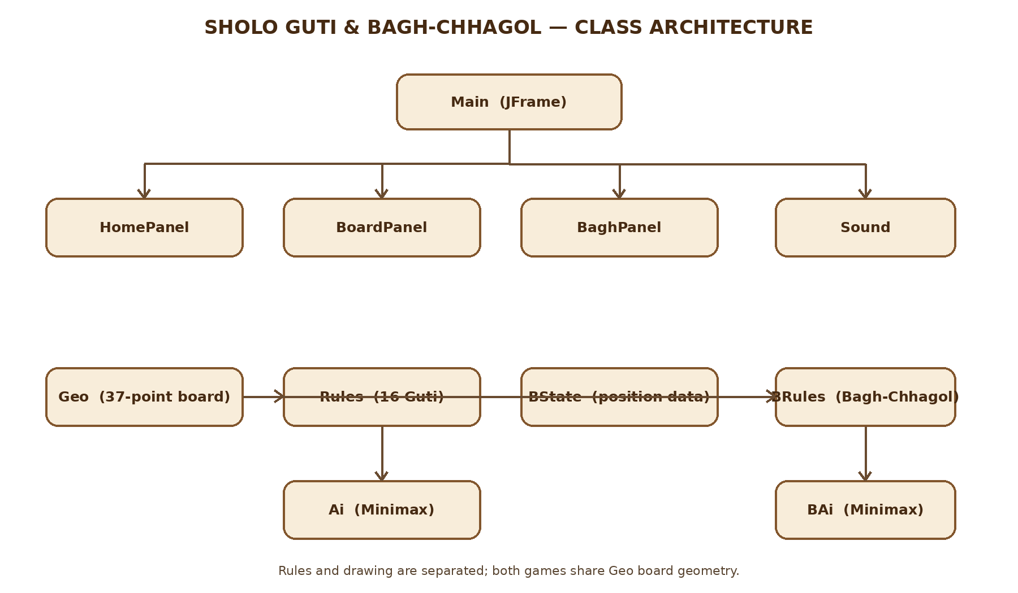
Figure 1: Architecture of the project
Table 5: Classes of the project and their responsibilities
Class | Kind | Responsibility
Main | JFrame (window) | Holds the three screens (Home, 16 Guti, Bagh-Chhagol) in a CardLayout and starts a game.
Sound | Utility | Creates short tones in memory and plays them.
Geo | Board geometry | Builds the 37 points, the lines between them and all possible jumps.
Rules | Game rules (16 Guti) | Initial setup, legal moves, jumps, multi-jump turns and applying a move.
Ai | Computer player (16 Guti) | Random choice or minimax search with alpha-beta pruning.
BState | Data | Position of Bagh-Chhagol: cells, goats placed, goats captured.
BRules | Game rules (Bagh-Chhagol) | Placing, moving, tiger jumps, chains of jumps.
BAi | Computer player (Bagh-Chhagol) | Random choice or minimax search with a tiger-oriented evaluation.
BoardPanel | JPanel | Game screen of 16 Guti: drawing, mouse input, turns, timer, winner.
BaghPanel | JPanel | Game screen of Bagh-Chhagol: drawing, mouse input, turns, timer, winner.
HomePanel | JPanel | Home page where the player chooses game, mode, names, level, time and options.

3.2 Screen Flow
The program has three screens. The player starts on the Home page, chooses the options and presses START. According to the chosen game, the 16 Guti screen or the Bagh-Chhagol screen opens. When a game ends, the player may play again or return to the Home page. The Exit button on a game screen also returns to the Home page.

3.3 The Board Design
Both games use the same board with 37 points. The points are placed on a half-cell coordinate system, so that the two triangles fit exactly above and below the grid.
- A 5 × 5 grid of 25 points (coordinates 0, 2, 4, 6, 8 in both directions). Neighbouring points are joined horizontally and vertically. Diagonal lines are drawn only from alternate points, as in the traditional board.
- A top triangle of 6 points and a bottom triangle of 6 points, joined to the grid at its middle top and middle bottom points.
- Every point has an index from 0 to 36. Points 0–24 are the grid, 25–30 the top triangle and 31–36 the bottom triangle.

3.4 How the Game State Is Stored
Table 6: Data structures used to store the game
Game | Data structure | Meaning
16 Guti | int[] cell (length 37) | 0 = empty, 1 = GREEN (first player), 2 = BROWN (second player).
Bagh-Chhagol | BState.c (length 37) | 0 = empty, 1 = TIGER, 2 = GOAT.
Bagh-Chhagol | BState.placed | How many goats have been placed on the board so far (0 to 16).
Bagh-Chhagol | BState.captured | How many goats the tigers have eaten.
A move (16 Guti) | int[] {to, over} | Destination point and the point jumped over (-1 for a simple step).
A move (Bagh-Chhagol) | int[] {from, to, over} | from = -1 means “place a goat from hand”.

Because the board is just an array of 37 numbers, copying a position is as simple as clone(). This makes the computer’s look-ahead search fast and easy to write.

Chapter 4: Rules and Regulations of the Games
This chapter explains the official rules that are programmed in the game. Images are given beside the rules so that the reader can see each rule on the board.

4.1 Rules of Sholo Guti (16 Guti)

4.1.1 Goal of the Game
A player wins by capturing all the guti of the opponent, or by blocking the opponent so that none of his or her guti can move.

4.1.2 The Board and the Starting Position
- Two players take part. Each player has 16 guti.
- Before the game, each player chooses a guti type: Small betel nut, Stick, Brickbats or Small stone. The two players must choose different types.
- At the start, the first player’s 16 guti stand on the lower part of the board and the second player’s 16 guti stand on the upper part. The middle row of the grid is empty.
- The first player moves first; after that the players move alternately. In one turn a player moves only one guti.
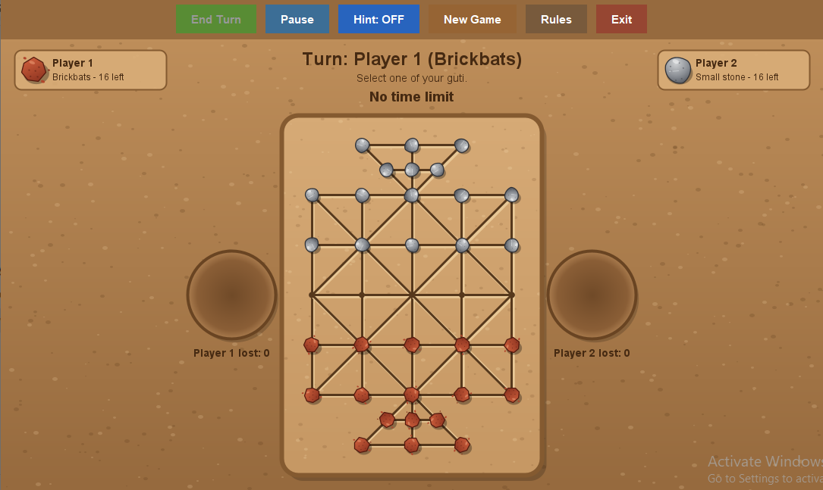
Figure 2: Starting position of 16 Guti (Brickbats against Small stone)

4.1.3 Simple Move
A guti may move one step along a drawn line to an empty neighbouring point. Moves are allowed in all directions along the lines, including the diagonal lines that exist on the board.

4.1.4 Capturing (Jumping)
- If an enemy guti is next to your guti on a line, and the point directly behind it (in the same straight line) is empty, your guti may jump over the enemy guti and land on that empty point.
- The guti that was jumped over is removed from the board and put into the soil circle of its owner.
- Jumping is possible only along the drawn lines, only in a straight line, and only over an enemy guti. A guti cannot jump over its own guti.
- Capturing is not compulsory: a player may make a simple move even if a capture is possible.
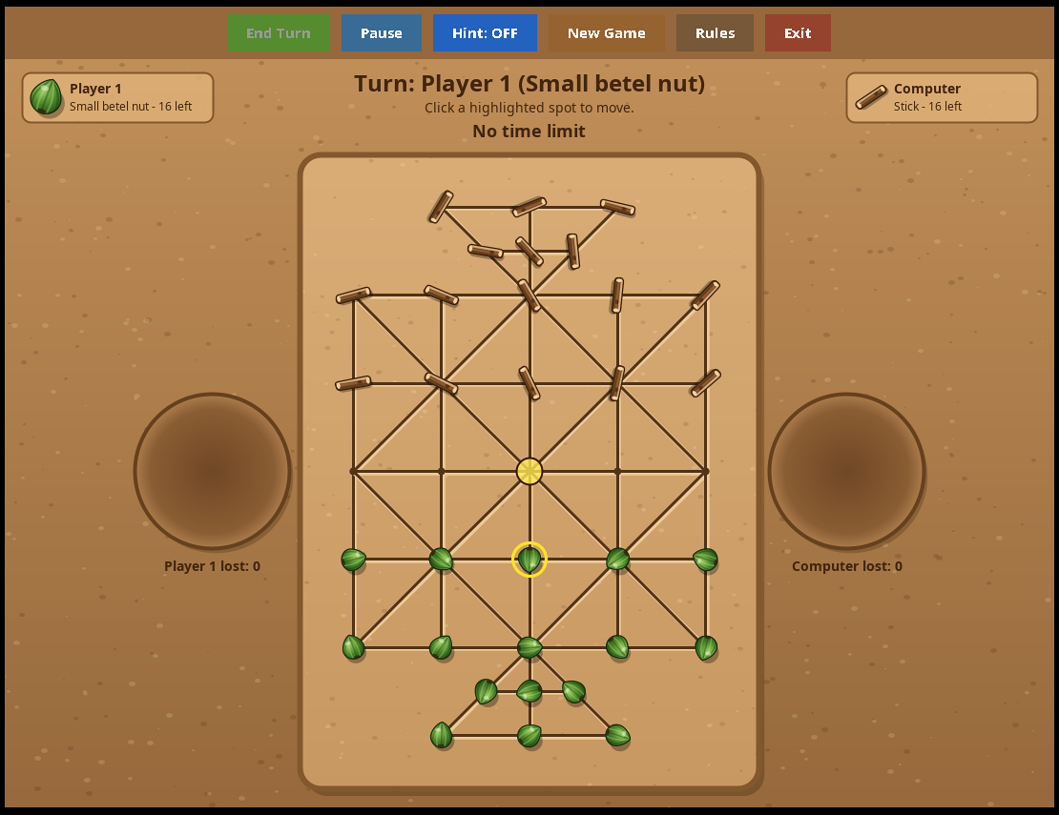 | 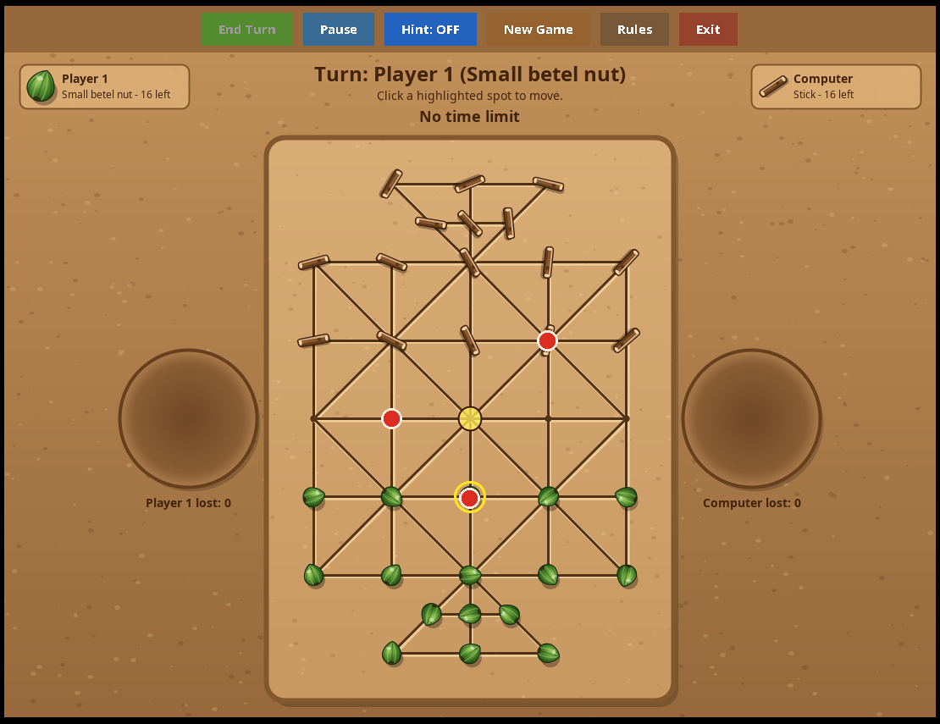
Figure 3: Selecting a guti: yellow dots show its steps | Figure 4: A capture move: red dots show where to jump

4.1.5 Multi-Jump
After a capture, if the same guti can capture another enemy guti, red dots appear again. The player may click a red dot to jump again, or press the End Turn button (or click the same guti) to stop. The turn ends automatically when no further capture is possible.

4.1.6 Winning the Game
Table 7: Winning conditions in 16 Guti
Condition | Result
The opponent has no guti left | The player who captured the last guti wins.
The opponent is stuck (no guti can move) | The blocking player wins.
Time limit finished (if a time limit was set) | The player with more guti on the board wins; equal numbers give a draw.

 | 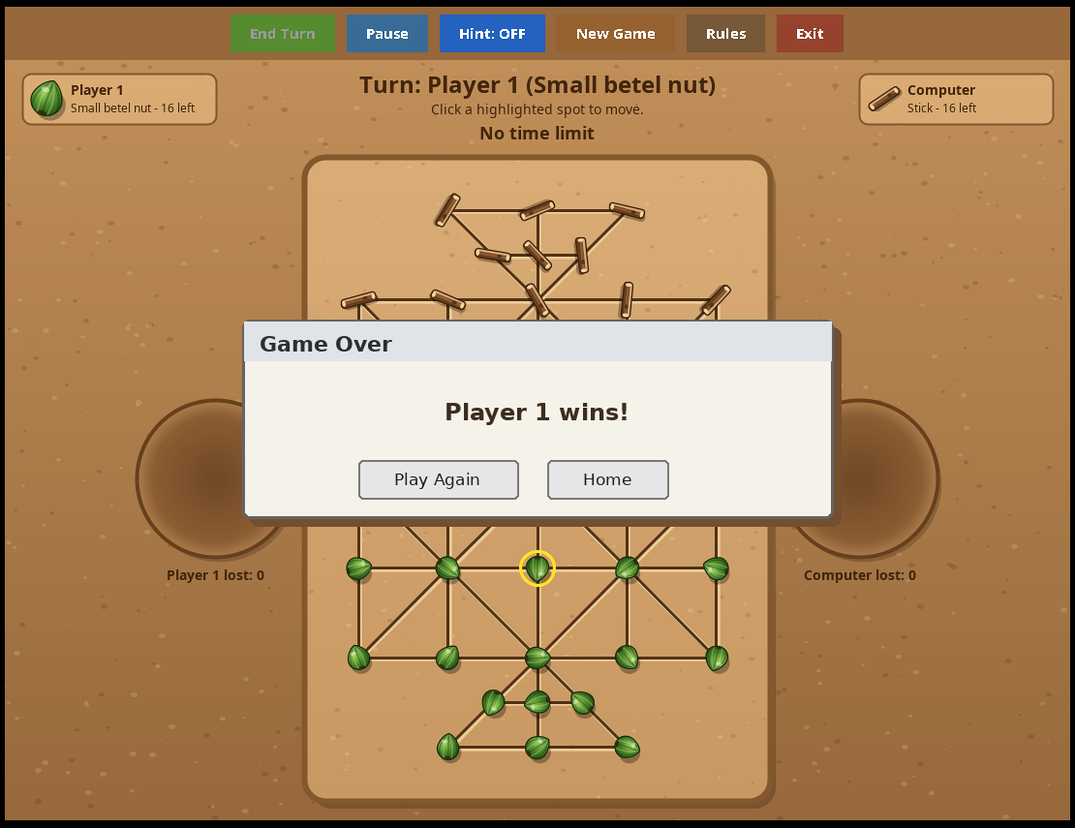
Figure 5: Multi-jump: the same guti captures again | Figure 6: Winner announcement in 16 Guti

4.2 Rules of Bagh-Chhagol (Tiger and Goat)

4.2.1 Players and Goal
- One player is the Bagh (tiger) with 3 tigers. The other player is the Chhagol (goat) with 16 goats.
- The goats win by trapping all three tigers so that none of them can move (no step and no jump).
- The tigers win by eating 8 goats or all 16 goats (this is chosen on the home page), or when the goats are stuck and cannot move.

4.2.2 The Starting Position
- The game uses the same 37-point board. The three tigers start on the middle row of the top triangle.
- All 16 goats start outside the board, in the soil circle on the left, shown as “Goats in hand”.
- The goat player always moves first.
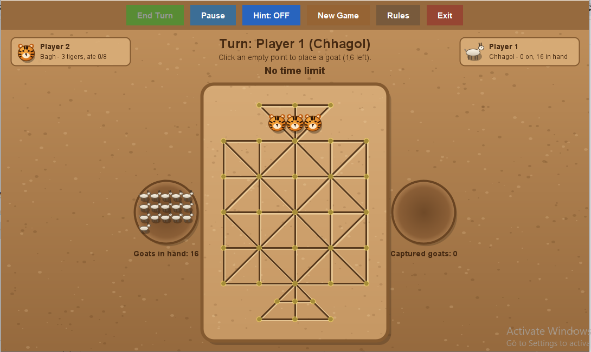
Figure 7: Starting position of Bagh-Chhagol: 3 tigers on the board, 16 goats in hand

4.2.3 Part 1: Placing the Goats
- On his or her turn, the goat player clicks any empty point to put one goat there. Faint yellow dots show the free points.
- Only one goat is placed in each turn, and goats cannot move until all 16 are placed.

4.2.4 Part 2: Moving the Goats
When all 16 goats are on the board, the goat player selects a goat and moves it one step along a line to an empty neighbouring point. Goats never jump and never capture.

4.2.5 The Tiger’s Turn
- A tiger may step to an empty neighbouring point (yellow dots).
- A tiger may eat a goat (red dots): if a goat is next to the tiger on a line and the point right behind the goat is empty, the tiger jumps over it, the goat is removed and the tiger lands on the empty point.
- Multi-jump: after eating, if the same tiger can eat another goat, a red dot appears again. The player may continue or press End Turn.
- Eating is not compulsory. A tiger cannot jump over another tiger, and eaten goats never come back.
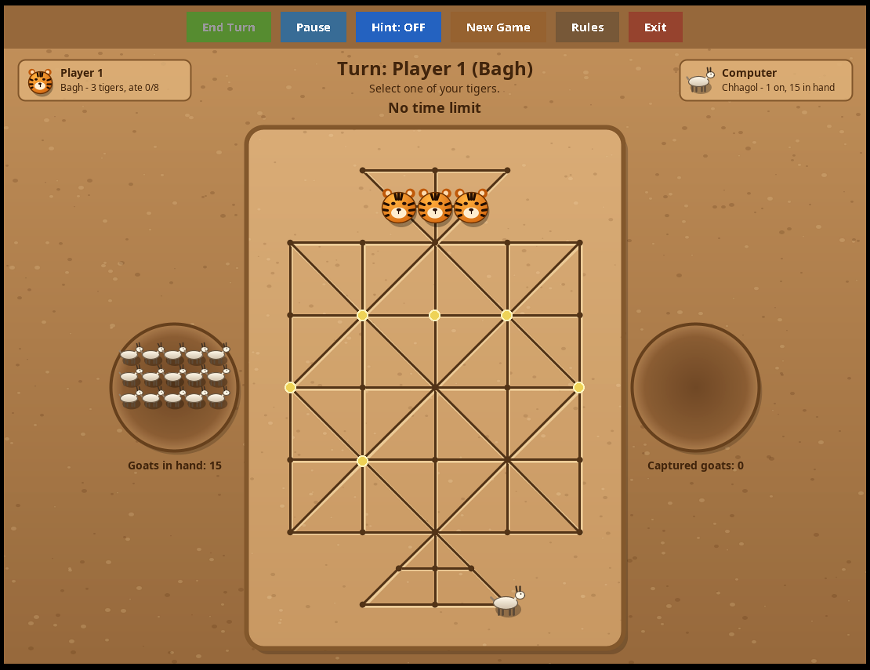 | 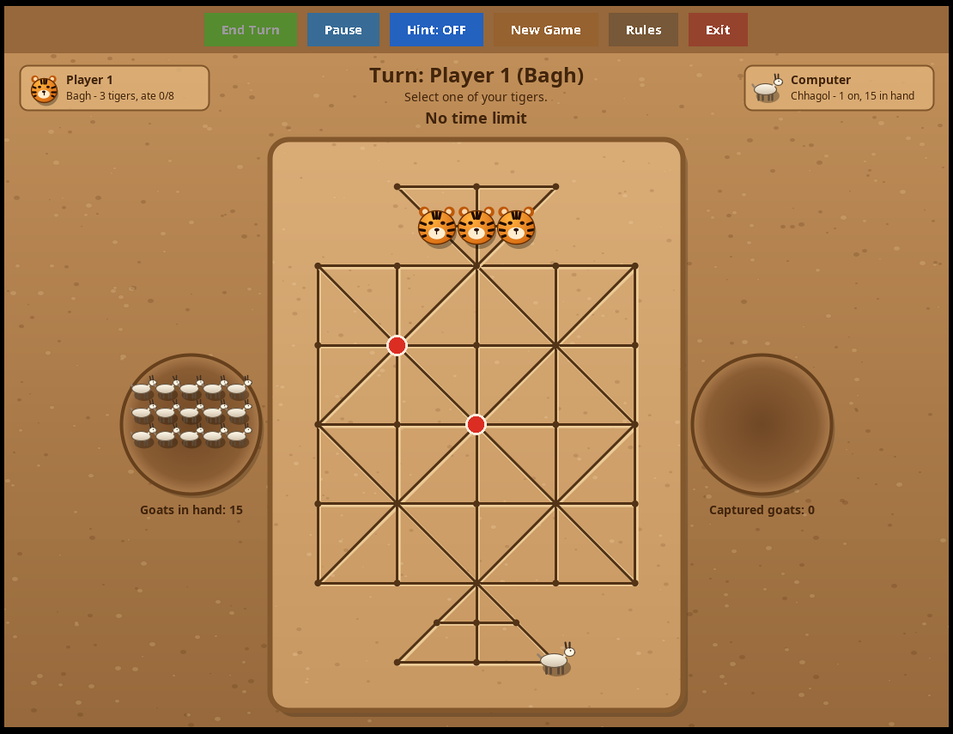
Figure 8: Placing phase: goats are put on the board | Figure 9: A tiger eats a goat by jumping over it

4.2.6 Winning the Game
Table 8: Winning conditions in Bagh-Chhagol
Condition | Winner
Tigers have eaten 8 goats (or 16 goats, if chosen) | Tigers (Bagh)
All three tigers are trapped and cannot move | Goats (Chhagol)
Goats have all been placed and none of them can move | Tigers (Bagh)
Time limit finished | Tigers if 8 or more goats were eaten, otherwise Goats

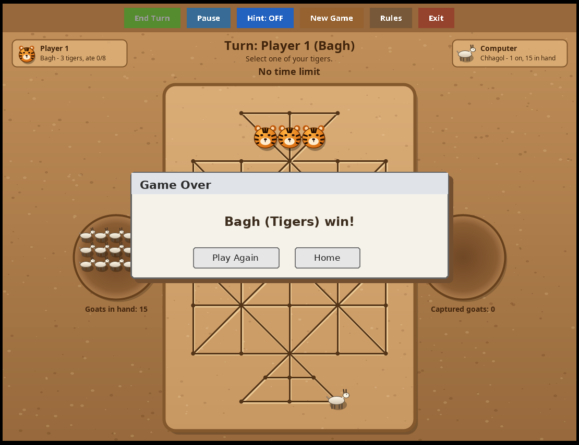
Figure 10: Winner announcement in Bagh-Chhagol | Figure 11: Button bar of the game screen

4.3 General Regulations of the Software
Table 9: General regulations of the software
Regulation | Explanation
Turn order | Players move alternately; the screen shows “Turn: name (guti type)” at the top.
Illegal moves | Clicking a point that is not highlighted does nothing, so illegal moves are impossible.
Computer turn | While the computer is thinking, mouse clicks are ignored.
Time limit | Optional; counted for the whole game. The clock turns red in the last 30 seconds.
Pause | While paused no move can be made and the clock stops.
Guti types | In 16 Guti the two players must select two different guti types.
Exit | Pressing Exit on a game screen asks for confirmation before leaving the game.

4.4 Buttons on the Game Screen
Table 10: Buttons of the game screen
Button | Function
End Turn | Stops a multi-jump and passes the turn to the opponent. Enabled only during a multi-jump.
Pause / Resume | Freezes or continues the game and the clock.
Hint: ON / OFF | Shows or hides a blue arrow that suggests a good move.
New Game | Starts the same game again from the beginning.
Rules | Opens the How-to-Play window.
Exit | Returns to the home page after confirmation.

Chapter 5: How to Play (Step by Step)
This chapter is a user guide. It shows, step by step and with pictures, how a player starts and plays both games.

5.1 Starting the Game and the Home Page
When the program is run, the home page appears on a soil-coloured background. All options are chosen here.
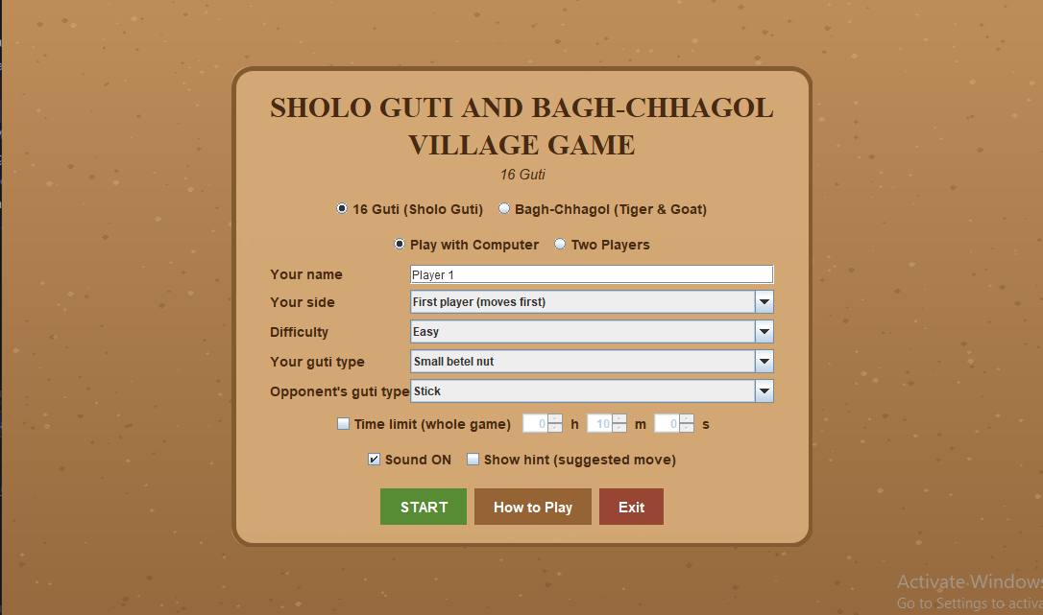
Figure 12: Home page of Sholo Guti And Bagh-Chhagol
Table 11: Options of the home page
Option | What to do
Game selection | Choose 16 Guti (Sholo Guti) or Bagh-Chhagol (Tiger & Goat).
Mode | Choose Play with Computer or Two Players.
Your name / Player 2 name | Type the name(s) of the player(s). Player 2 name is shown only in Two Players mode.
Your side | 16 Guti: first player (moves first) or second player. Bagh-Chhagol: Bagh (Tiger) or Chhagol (Goat).
Difficulty | Easy, Medium or Hard (only against the computer).
Tigers win by | Capture 8 goats or Capture all 16 goats (Bagh-Chhagol only).
Your guti type / Opponent’s guti type | Small betel nut, Stick, Brickbats or Small stone (16 Guti only).
Time limit | Tick the box and set hours, minutes and seconds for the whole game.
Sound ON | Switch the sound effects on or off.
Show hint | Tick to show suggested moves from the start.
START / How to Play / Exit | Start the game, read the rules, or close the program.

5.2 How to Play 16 Guti
- On the home page select 16 Guti (Sholo Guti), select the mode, enter the name, choose the side, difficulty and the guti types, then click START.
- The board opens. The top of the screen shows whose turn it is and a short instruction. The player at the bottom moves first.
- Select a guti: click one of your guti. A yellow ring appears around it and yellow dots show the empty points where it can step.
- Move: click a yellow dot. The guti slides there and the turn passes to the opponent. To change your mind, click another guti of yours.
- Capture: when an enemy guti is next to yours and the point behind it is empty, a red dot appears. Click the red dot to jump. The enemy guti goes into its soil circle.
- Multi-jump: if red dots appear again after a capture, click one to capture again or click End Turn to stop.
- Computer’s turn: the message “Computer is thinking...” appears and the computer moves by itself after a short pause.
- Finish: the game ends when a player has no guti left, cannot move, or when the time is up. A message box announces the winner and offers Play Again or Home.
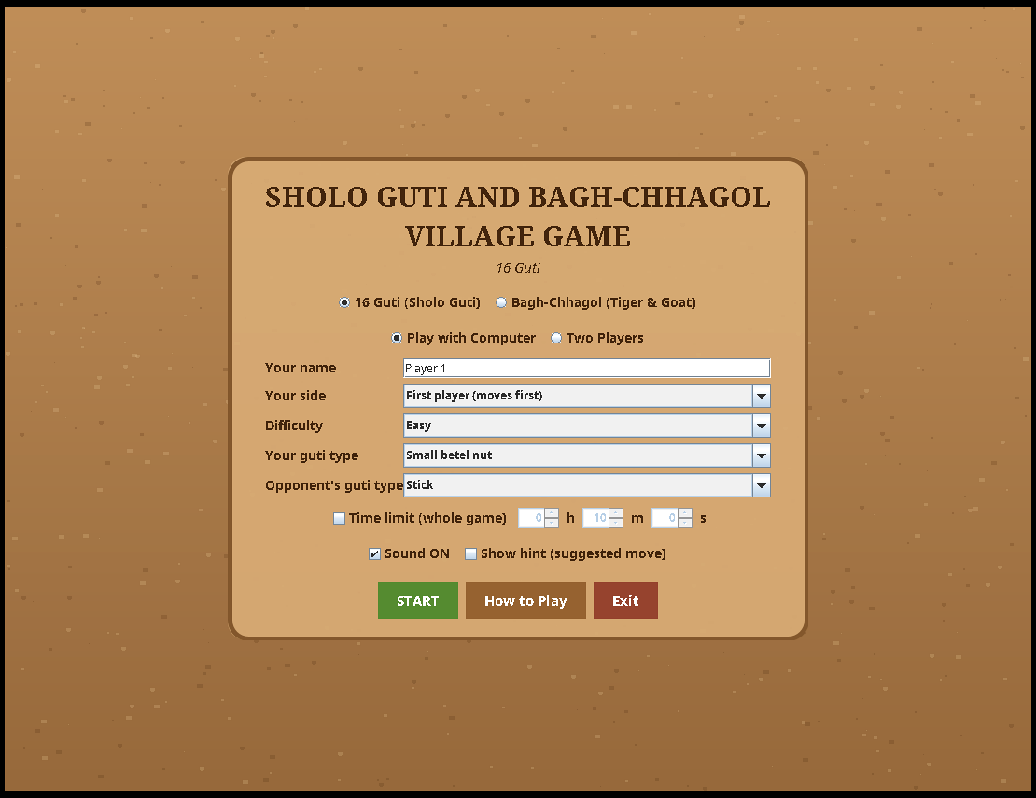
Figure 13: Step 1: choose options and click START | Figure 14: Step 3: select a guti

Figure 15: Step 5: capturing an enemy guti | Figure 16: Step 8: game over

5.3 How to Play Bagh-Chhagol
- On the home page select Bagh-Chhagol (Tiger & Goat). Choose to play as Bagh (Tiger) or Chhagol (Goat), choose how many goats the tigers must eat, and click START.
- The three tigers stand on the top triangle and the 16 goats wait in the left soil circle. The goat player moves first.
- Placing goats: the goat player clicks any empty point to place a goat. This is repeated until all 16 goats are on the board.
- Tiger’s step: the tiger player clicks a tiger, then a yellow dot, to move one step.
- Tiger eats: if a goat has an empty point behind it, a red dot appears. Click it: the tiger jumps and the goat is removed. The “Captured goats” circle on the right grows.
- Moving goats: after all 16 goats are placed, the goat player selects a goat and moves it one step to an empty neighbouring point. The goats try to surround the tigers.
- Finish: the tigers win by eating the chosen number of goats; the goats win by trapping all three tigers.
Figure 17: Step 3: placing the goats | Figure 18: Step 5: the tiger eats a goat

5.4 Two Players on the Same Computer
Select Two Players on the home page and type the names of both players. The two players take turns using the same mouse. There is no computer move and no difficulty option. The turn message at the top shows whose turn it is.

5.5 Using Hint, Pause and Time Limit
- Hint: click Hint: OFF to switch it ON. A blue dashed arrow shows the suggested move; the start point and the end point are circled in blue.
- Pause: click Pause; the screen shows “PAUSED” and the clock stops. Click Resume to continue.
- Time limit: set on the home page. The remaining time is shown below the turn message and becomes red in the last 30 seconds.
 | 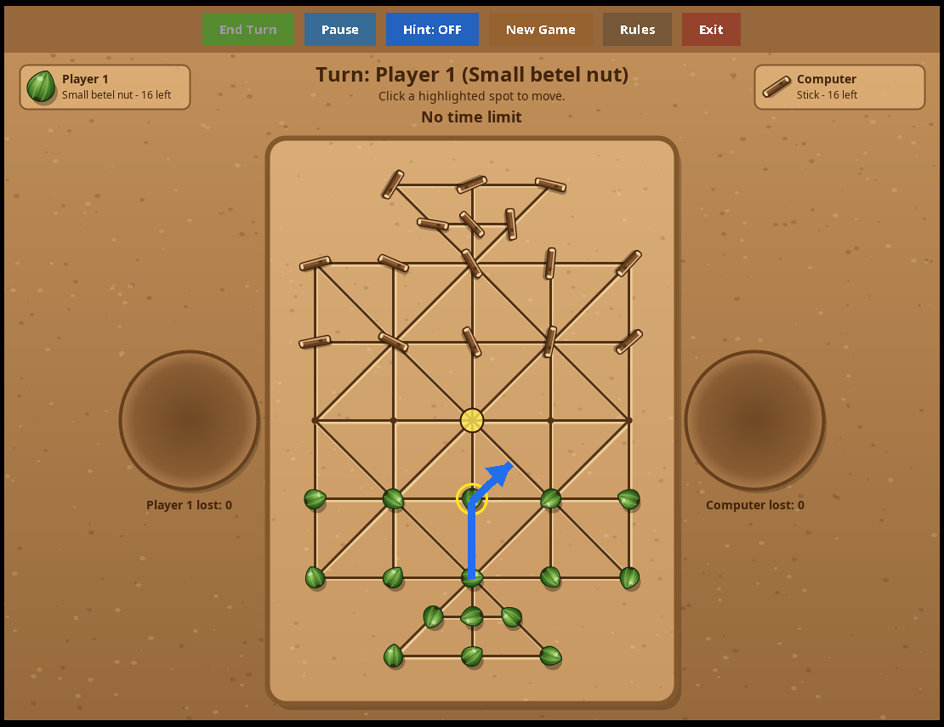
Figure 19: Two Players mode | Figure 20: Hint arrow suggesting a move

5.6 Playing Tips

Tips for Sholo Guti
- Keep your guti together so that the point behind each guti is not empty; this prevents jumps.
- Before moving, check whether the opponent can jump over the new position.
- Try to create a position where you can make a multi-jump.

Tips for Bagh-Chhagol
- Goats should stay close together and fill the points behind each other.
- Goats should first protect the lower part of the board and then slowly push the tigers into a corner.
- Tigers should try to separate the goats and jump over lonely goats.

Chapter 6: Implementation and Code Explanation
This chapter explains the important parts of the source code. For each part, the code is shown first and then it is explained: what it does and how it works. To keep the report readable, simple repeated lines are shortened with “...”; the complete program is in the file Main.java.

6.1 Program Header, Constants and the Main Class
import javax.sound.sampled.*;
import javax.swing.*;
import java.awt.*;
import java.awt.event.*;
import java.awt.geom.*;
import java.util.*;

public class Main extends JFrame {
static final int GREEN = 1, BROWN = 2;
static final int TIGER = 1, GOAT = 2, GOATS_TOTAL = 16;
static final String[] KIND_NAMES =
{"Small betel nut", "Stick", "Brickbats", "Small stone"};
static final int[] kind = {0, 0, 1};

static String pieceName(int color) { return KIND_NAMES[kind[color]]; }

What it does: imports the libraries, declares the main class and defines the constants shared by the whole program.
How it works:
- Main extends JFrame, so the Main object itself is the game window.
- GREEN = 1 and BROWN = 2 are the numbers used for the two players of 16 Guti. TIGER = 1 and GOAT = 2 are the numbers for the two sides of Bagh-Chhagol. Using numbers instead of text makes the board array small and fast.
- KIND_NAMES lists the four guti types. The array kind[ ] remembers which type each player uses: kind[GREEN] is the type of the first player and kind[BROWN] the type of the second player. By default the first player has the betel nut (0) and the second has the stick (1).
- pieceName(color) returns the text name of the guti type of a player, used on the screen.

6.2 Sound Effects (class Sound)
static void play(final double[][] notes) {
if (!on) return;
new Thread(() -> {
float sr = 22050f; // samples per second
ByteArrayOutputStream bo = new ByteArrayOutputStream();
for (double[] n : notes) { // n = {frequency, ms}
int len = (int) (sr * n[1] / 1000.0);
for (int i = 0; i < len; i++) {
double t = i / (double) sr;
double env = Math.min(1.0,
Math.min(i / (sr * 0.01), (len - i) / (sr * 0.05)));
double v = n[0] <= 0 ? 0 : (Math.sin(2*Math.PI*n[0]*t)*0.6
+ Math.sin(4*Math.PI*n[0]*t)*0.2) * env * 0.5;
short sv = (short) (v * 32767);
bo.write(sv & 0xff); bo.write((sv >> 8) & 0xff);
}
}
// ... open a Clip with AudioFormat(sr, 16, 1, true, false) and start it
}).start();
}

What it does: creates a short musical tone from numbers and plays it, so no .wav file is needed.
How it works:
- Every sound is a list of notes. A note is a pair {frequency in Hz, duration in milliseconds}. A frequency of 0 means silence. For example the winning melody is C–E–G–high C (523, 659, 784 and 1047 Hz).
- The sampling rate sr = 22050 means that 22050 numbers describe one second of sound. For each sample the program calculates a sine wave with the note frequency. A second sine wave of double frequency (the harmonic) is added with smaller volume to make the tone richer.
- env is an envelope: the sound fades in during the first 10 ms and fades out during the last 50 ms, which avoids clicking noises.
- Each sample is converted to a 16-bit number (value × 32767) and written as two bytes (low byte first, “little-endian”).
- The bytes are given to a Clip of javax.sound.sampled, which plays them. A new daemon thread is used so that the game does not freeze while the sound is created, and the thread does not stop the program from closing.
- Sound.on is a volatile flag that the “Sound ON” checkbox controls; if it is false, play() returns immediately.
- Short methods such as win(), lose(), draw(), move() and capture() only choose different notes. move() is a tiny 35 ms beep; capture() is a lower two-note sound.

6.3 Board Geometry (class Geo)
List<int[]> p = new ArrayList<>();
for (int y = 0; y <= 8; y += 2)
for (int x = 0; x <= 8; x += 2) p.add(new int[]{x, y}); // 25 grid points
int[][] tri = {{3,-1},{4,-1},{5,-1},{2,-2},{4,-2},{6,-2}, // top triangle
{3, 9},{4, 9},{5, 9},{2,10},{4,10},{6,10}}; // bottom triangle
for (int[] t : tri) p.add(t);
N = p.size(); // N = 37

// lines of the 5 x 5 grid
for (int i = 0; i < 25; i++)
for (int j = i + 1; j < 25; j++) {
int dx = Math.abs(X[i] - X[j]), dy = Math.abs(Y[i] - Y[j]);
if ((dx == 2 && dy == 0) || (dx == 0 && dy == 2)) link(i, j);
else if (dx == 2 && dy == 2 && (X[i]/2 + Y[i]/2) % 2 == 0) link(i, j);
}

What it does: builds the 37 points of the board and decides which points are connected by a line.
How it works:
- The arrays X[ ] and Y[ ] hold the coordinates of each point. Points are placed on a “half-cell” grid, so the grid points use even numbers (0, 2, 4, 6, 8) and the triangle points use odd numbers in between. This is why the two triangles fit exactly.
- The two loops create the 25 grid points. The array tri adds 6 points above (negative y) and 6 points below (y = 9 and 10). The total N = 25 + 12 = 37.
- The matrix E[a][b] is true when points a and b are joined by a line. link(a, b) sets both E[a][b] and E[b][a].
- Two grid points are joined if they are 2 units apart horizontally or vertically (dx = 2, dy = 0 or dx = 0, dy = 2).
- A diagonal line (dx = 2 and dy = 2) is created only if (X/2 + Y/2) is even. This gives the traditional pattern in which diagonals pass only through alternate points.
- The triangle lines are added from a small table te of coordinates, once for the top triangle and once (mirrored, 8 − y) for the bottom triangle.
ADJ[a] = adj.stream().mapToInt(Integer::intValue).toArray(); // neighbours

for (int a = 0; a < N; a++) {
List<int[]> js = new ArrayList<>();
for (int b : ADJ[a])
for (int c : ADJ[b]) {
if (c == a) continue;
int dx1 = X[b] - X[a], dy1 = Y[b] - Y[a];
int dx2 = X[c] - X[b], dy2 = Y[c] - Y[b];
if (dx1 * dy2 - dy1 * dx2 == 0 && dx1 * dx2 + dy1 * dy2 > 0)
js.add(new int[]{b, c}); // jump a -> c over b
}
JUMP[a] = js.toArray(new int[0][]);
}

- ADJ[a] is the list of neighbours of point a. It is made once, so the game never has to search the whole matrix again.
- JUMP[a] is the list of all possible jumps from point a. A jump {b, c} means: from a, jump over the neighbour b and land on c, where c is a neighbour of b.
- The jump must be in a straight line. This is checked with vector mathematics: (dx1, dy1) is the first step and (dx2, dy2) is the second step. The cross product dx1·dy2 − dy1·dx2 = 0 means that the two steps are parallel, and the dot product dx1·dx2 + dy1·dy2 > 0 means that they point in the same direction (not backwards).
- Because the jump table is built from the lines themselves, jumps work correctly on the diagonals and inside the triangles without any special code.

6.4 Rules of 16 Guti (class Rules)
static int[] initial() {
int[] c = new int[Geo.N];
for (int i = 0; i < Geo.N; i++)
c[i] = Geo.Y[i] <= 2 ? BROWN : (Geo.Y[i] >= 6 ? GREEN : 0);
return c;
}

static List<int[]> options(int[] c, int from, boolean jumpsOnly) {
List<int[]> r = new ArrayList<>();
int p = c[from];
if (!jumpsOnly)
for (int b : Geo.ADJ[from]) if (c[b] == 0) r.add(new int[]{b, -1});
for (int[] j : Geo.JUMP[from])
if (c[j[0]] == 3 - p && c[j[1]] == 0) r.add(new int[]{j[1], j[0]});
return r;
}

What it does: creates the starting position and finds all legal next steps of one guti.
How it works:
- initial() fills an array of 37 numbers. Points with y ≤ 2 (the upper part, including the top triangle) get BROWN; points with y ≥ 6 (the lower part and bottom triangle) get GREEN; the middle row stays 0 (empty). Each side gets exactly 16 guti.
- options(c, from, jumpsOnly) returns a list of pairs {to, over}. For a simple step, over = −1.
- A simple step is allowed to every neighbour b with c[b] == 0 (empty).
- A jump is allowed if the middle point holds an enemy (3 − p is the opponent’s number, because 1 and 2 add up to 3) and the landing point is empty. The pair {landing point, jumped point} is returned.
- The parameter jumpsOnly is true during a multi-jump, when only further captures are allowed.
- hasMove checks whether a player has at least one legal move. If not, the player is “stuck” and loses.
- step(c, a, b) performs one step or jump from a to b. If a and b are directly connected (E[a][b]) it is a simple step. Otherwise it is a jump, and overOf finds the point that was jumped over. The guti is copied to b, a becomes empty, and the captured guti is removed (set to 0). The captured point is returned so the screen can count the loss.
static List<int[]> turns(int[] c, int p) {
List<int[]> out = new ArrayList<>();
for (int f = 0; f < Geo.N; f++) {
if (c[f] != p) continue;
for (int b : Geo.ADJ[f]) if (c[b] == 0) out.add(new int[]{f, b});
chain(c, p, f, new int[]{f}, out);
}
return out;
}

private static void chain(int[] c, int p, int pos, int[] path, List<int[]> out) {
boolean any = false;
for (int[] j : Geo.JUMP[pos]) {
if (c[j[0]] == 3 - p && c[j[1]] == 0) {
any = true;
int saved = c[j[0]];
c[pos] = 0; c[j[0]] = 0; c[j[1]] = p; // try the jump
int[] np = Arrays.copyOf(path, path.length + 1);
np[path.length] = j[1];
chain(c, p, j[1], np, out); // look for more jumps
c[j[1]] = 0; c[j[0]] = saved; c[pos] = p; // undo the jump
}
}
if (!any && path.length > 1) out.add(path);
}

- turns(c, p) lists every complete turn of player p as a path of points, such as {12, 13} for a step or {12, 14, 22} for a double jump. It is used by the computer player.
- chain is a recursive (self-calling) method. For each possible jump it temporarily makes the jump on the board, calls itself from the landing point to look for another jump, and then undoes the jump (backtracking). When no further jump exists, the whole path is saved.
- The computer therefore always completes a chain of captures, while a human player may stop with the End Turn button.

6.5 Computer Player of 16 Guti (class Ai)
static int[] choose(int[] c, int p, int level) {
List<int[]> ts = Rules.turns(c, p);
if (ts.isEmpty()) return null;
if (level == 0) return ts.get(RND.nextInt(ts.size())); // Easy
int depth = level == 1 ? 2 : 4; // Medium / Hard
int best = Integer.MIN_VALUE;
int[] bestT = ts.get(0);
for (int[] t : ts) {
int[] n = c.clone();
Rules.applyTurn(n, t);
int score = -search(n, 3 - p, depth - 1, -100000, 100000) * 10
+ RND.nextInt(8);
if (score > best) { best = score; bestT = t; }
}
return bestT;
}

static int search(int[] c, int p, int depth, int alpha, int beta) {
List<int[]> ts = Rules.turns(c, p);
if (ts.isEmpty()) return -10000 - depth; // p is stuck: lost
if (depth == 0) return Rules.count(c, p) * 100 - Rules.count(c, 3 - p) * 100;
int best = Integer.MIN_VALUE;
for (int[] t : ts) {
int[] n = c.clone();
Rules.applyTurn(n, t);
int s = -search(n, 3 - p, depth - 1, -beta, -alpha);
if (s > best) best = s;
if (best > alpha) alpha = best;
if (alpha >= beta) break; // pruning
}
return best;
}

What it does: chooses the move of the computer. The level decides how strong the choice is.
How it works:
- Easy (level 0): one of all legal turns is picked at random.
- Medium and Hard: the computer uses the minimax idea (written in the compact “negamax” form). It imagines a move, then the best answer of the opponent, then its own best reply, and so on up to a depth of 2 moves (Medium) or 4 moves (Hard).
- At the end of the look-ahead, a position is scored by (my guti − opponent guti) × 100. A position where the player has no move gets a very low score (−10000), so being blocked is treated as a loss.
- Because the score of the opponent is the opposite of my score, the code simply uses a minus sign: −search(...).
- Alpha-beta pruning: alpha is the best score already guaranteed for me, beta is the limit the opponent will allow. If alpha ≥ beta the remaining moves of this branch cannot change the result, so they are skipped (break). This makes Hard level fast enough to answer in a fraction of a second.
- A small random number RND.nextInt(8) is added to each score so that the computer does not always repeat the same move when several moves are equally good.

6.6 Bagh-Chhagol State and Rules (classes BState and BRules)
- BState stores a complete Bagh-Chhagol position. The three tigers start at points 25, 26 and 27, which are the middle row of the top triangle.
- copy() makes an independent copy of the position; the computer needs it to test moves without disturbing the real game.
static List<int[]> moves(BState s, int side) {
List<int[]> r = new ArrayList<>();
if (side == GOAT) {
if (s.placed < GOATS_TOTAL) { // placing phase
for (int i = 0; i < Geo.N; i++)
if (s.c[i] == 0) r.add(new int[]{-1, i, -1});
} else { // moving phase
for (int i = 0; i < Geo.N; i++)
if (s.c[i] == GOAT)
for (int b : Geo.ADJ[i])
if (s.c[b] == 0) r.add(new int[]{i, b, -1});
}
} else { // tigers
for (int i = 0; i < Geo.N; i++) {
if (s.c[i] != TIGER) continue;
for (int b : Geo.ADJ[i]) if (s.c[b] == 0) r.add(new int[]{i, b, -1});
for (int[] j : Geo.JUMP[i])
if (s.c[j[0]] == GOAT && s.c[j[1]] == 0)
r.add(new int[]{i, j[1], j[0]});
}
}
return r;
}

What it does: lists every legal move for a side. A move has three numbers: {from, to, over}.
How it works:
- Goat, placing phase (fewer than 16 placed): a goat may be put on any empty point. This is written as from = −1 (the goat comes from the hand).
- Goat, moving phase: after all 16 are placed, each goat may step to an empty neighbour. Goats have no jumps.
- Tiger: each tiger may step to an empty neighbour, or jump over a goat (not over a tiger) to an empty point; the jumped point is stored in “over”.
- apply changes the position. A placed goat increases placed. A moved goat leaves its old point. A tiger move empties its old point, and if “over” is not −1 the goat there is removed and captured is increased by one.
- turns() and chain() (not shown) work like the 16 Guti versions: a tiger turn is either one step or a chain of jumps, and the tiger may stop after any jump.

6.7 Computer Player of Bagh-Chhagol (class BAi)
What it does: gives the computer a way to judge a Bagh-Chhagol position.
How it works:
- The search is the same minimax with alpha-beta pruning as in 16 Guti, with levels Easy (random), Medium (depth 2) and Hard (depth 4).
- The evaluation eval gives a score from the tiger’s point of view: 100 points for every captured goat plus 6 points for every move the tigers can make. Many tiger moves mean the tigers are free; few moves mean they are nearly trapped. The goat side uses the same score with a minus sign.
- If the number of captured goats reaches the winning count (8 or 16), the position is a certain win for the tigers (score 10000 + depth). If a side has no move at all, that side loses.
- On Easy level a tiger that has just eaten always continues eating if it can, so even the weakest computer does not leave a free capture.

6.8 Drawing the Soil, Guti, Tiger and Goat
What it does: paints the soil-coloured background that is used on the home page and on both game screens.
How it works: a vertical GradientPaint fades from light brown to darker brown. Then 700 small light and dark ellipses (semi-transparent) are scattered at random positions to look like grains of soil. The random generator is created with the fixed number 11, so the pattern is the same every time and does not flicker when the window is repainted.
What it does: draws one guti. drawPiece looks at the guti type of the player and calls the matching drawing method.
How it works:
- s is the distance between two board points, so every drawing is scaled with the board size and stays correct when the window is resized. angDeg rotates the guti so that pieces do not all look identical.
- AffineTransform is used to move the origin (0, 0) to the guti’s centre and to rotate the drawing. The old transform is saved at the start and restored at the end, so the next drawing is not affected.
- Path2D with curveTo draws smooth curved outlines (the egg shape of the betel nut, the rounded pebble). The brick uses straight lineTo segments to look like a broken chip.
- RadialGradientPaint and GradientPaint give a 3D shine; a small white translucent ellipse is the highlight; a darker translucent ellipse under the guti is the shadow.
- g.clip(shape) limits drawing to the inside of a shape. It is used for the stripes of the betel nut, the speckles of the stone and the grain of the stick.
- drawKathi draws the stick as a rounded rectangle with a wood-colour gradient, two grain lines, a knot and light end caps.
- drawTiger draws an orange face with a radial gradient, ears, black stripes (clipped to the face), a light muzzle, nose and eyes. drawGoat draws a side view with a white oval body, four legs, a tail, a neck, a head, horns and an ear. No picture file is loaded for any of these.

6.9 The 16 Guti Game Screen (class BoardPanel)
BoardPanel is a JPanel that shows the board, receives mouse clicks and controls the whole game of 16 Guti.

6.9.1 Main variables
- selected is the point of the clicked guti (−1 if none) and targets are the highlighted yellow or red points.
- chaining is true while a player is in the middle of a multi-jump; aiBusy is true while the computer is thinking; paused is true when the game is paused.
- flipped turns the board upside down when the human plays the second side, so the human’s guti are always at the bottom of the screen.
- gen (generation) increases whenever a game is restarted or left. Delayed actions of the computer remember the old number and cancel themselves if it has changed. This prevents a move of the previous game from appearing in a new game.

6.9.2 Mouse input
int nodeAt(int mx, int my) {
layoutVals();
int best = -1;
double bd = 0.5 * s; // must click within half a cell
for (int n = 0; n < Geo.N; n++) {
double d = pt(n).distance(mx, my);
if (d < bd) { bd = d; best = n; }
}
return best;
}

void click(int mx, int my) {
if (over || paused || aiBusy || isComputerTurn()) return;
int n = nodeAt(mx, my);
if (n < 0) return;
if (chaining) {
if (n == selected) { endTurn(); return; }
for (int[] t : targets) if (t[0] == n) { doStep(selected, t); return; }
return;
}
if (cell[n] == turn) { // select own guti
selected = n;
targets = Rules.options(cell, n, false);
repaint();
return;
}
if (selected >= 0) // move to highlighted point
for (int[] t : targets) if (t[0] == n) { doStep(selected, t); return; }
selected = -1;
targets = new ArrayList<>();
repaint();
}

- nodeAt converts the mouse position into a board point. It finds the nearest point and accepts it only if the click is closer than half of a cell. pt(n) gives the screen position of point n.
- click first ignores the click when the game is over, paused or when it is the computer’s turn.
- During a multi-jump only two actions are accepted: clicking a red target (jump again) or clicking the same guti (finish the turn).
- Clicking one’s own guti selects it and calls Rules.options to fill the highlighted targets.
- Clicking a highlighted target moves the selected guti. Clicking anywhere else clears the selection.

6.9.3 Performing a step and ending the turn
void doStep(int from, int[] t) {
if (t[1] >= 0) { lost[cell[t[1]]]++; Sound.capture(); } else Sound.move();
Rules.step(cell, from, t[0]);
selected = t[0];
if (t[1] >= 0) {
targets = Rules.options(cell, selected, true); // more jumps?
if (!targets.isEmpty()) {
chaining = true;
endTurnBtn.setEnabled(true);
repaint();
return; // same player continues
}
}
endTurn();
}

void endTurnCore() {
selected = -1; chaining = false;
targets = new ArrayList<>();
endTurnBtn.setEnabled(false);
int mover = turn;
turn = 3 - turn; // change player
if (Rules.count(cell, turn) == 0)
finish(mover, names[turn] + " has no guti left.");
else if (!Rules.hasMove(cell, turn))
finish(mover, names[turn] + " is stuck and cannot move.");
else if (isComputerTurn()) startAi();
updateHint();
repaint();
}

- doStep plays the sound, updates the “lost” counter of the captured guti, and moves the guti. If it was a capture, it asks Rules.options(…, true) for further jumps. If there are some, the turn does not end: chaining becomes true and the End Turn button is enabled.
- endTurnCore switches the player (3 − turn turns 1 into 2 and 2 into 1) and checks the two winning rules: the new player has no guti, or has guti but no legal move. If the game continues and it is the computer’s turn, startAi() is called.

6.9.4 The timer and the end of the game
- A javax.swing.Timer fires tick() every 1000 ms. tick() reduces the remaining time by one second, but does nothing while the game is paused or over.
- When the time reaches zero, timeUp() counts the guti of both players: the player with more guti wins, equal numbers are a draw.
- finish stores the winner, stops the clock and plays the proper sound (win, lose or draw). Then a dialog with the buttons Play Again and Home is shown. invokeLater makes sure the dialog opens safely on the Swing thread after the screen has been repainted.

6.9.5 The computer’s move
- startAi waits 650 ms (so the human can see what happened), then asks Ai.choose for a path. If the game was restarted meanwhile (g0 != gen) or finished, the move is cancelled. If the game is paused, the waiting timer is restarted.
- animate plays the chosen path one step every 520 ms, with a sound for each step. This shows a multi-jump of the computer clearly, jump by jump, instead of making the guti disappear and appear suddenly. After the last step endTurn() passes the turn to the human.

6.9.6 Drawing the screen (paintComponent)
- layoutVals calculates the size s of one cell from the current window size, so the board always fits the window. The number 14.4 is the board height in cells and 17.8 is the total width, including the two soil circles.
- pt(n) converts a board coordinate to a screen coordinate. When flipped is true, the coordinates are mirrored (8 − x, 8 − y) so that the board turns upside down.
- paintComponent draws everything in layers, from back to front: soil, wooden plate, lines, soil circles, highlight dots, guti, selection ring, hint and the top information area (HUD). Antialiasing is turned on to make the shapes smooth.
- drawPit draws a soil circle and places the captured guti of that player inside it, with the text “name lost: n”. paintHud draws the two player cards, the turn message, the instruction line and the clock.
- The hint is shown by calling Ai.choose(cell, turn, 1) and drawing a dashed blue arrow along the suggested path, with a ring around the starting guti.

6.10 The Bagh-Chhagol Game Screen (class BaghPanel)
BaghPanel works like BoardPanel, with the changes needed for the different rules. Only the important differences are shown.
- turn = GOAT at the start because the goat player moves first.
- In the placing phase a click on an empty point immediately places a goat (move {−1, n, −1}); no selection is needed.
- doStep is almost the same as in 16 Guti, but only a tiger may continue (multi-jump). The check st.captured < winCount stops the turn when the winning number of goats has just been eaten.
- After every turn the program checks the three winning conditions of Bagh-Chhagol: the tigers reached the winning number of captures; all the tigers are trapped (the goats win); the goats are all placed but cannot move (the tigers win).
- timeUp gives the victory to the tigers if they have eaten at least 8 goats, otherwise to the goats.
- drawPit is used here with goat drawings: the left circle shows the goats still in hand (arranged in rows of five) and the right circle shows the captured goats.
- When the goat player has to place a goat, faint yellow dots appear on all empty points to guide the player.

6.11 The Home Page (class HomePanel)
What it does: shows only those options that are needed for the chosen game and mode.
How it works:
- The home page uses a GridBagLayout inside a rounded soil-coloured “plate” whose paintComponent draws a rounded rectangle and a brown border. The page background itself is drawn with paintSoil.
- Radio buttons (ButtonGroup) allow only one game and only one mode to be selected at a time. JComboBox lists sides, difficulty, goat count and guti types; JSpinner sets hours, minutes and seconds.
- The refresh Runnable is called whenever a radio button is clicked. It changes the labels and shows or hides rows: Player 2 name appears only in Two Players mode; Difficulty only against the computer; “Tigers win by” only for Bagh-Chhagol; the guti-type rows only for 16 Guti. The side list changes between “First/Second player” and “Bagh/Chhagol”.
- The time spinners are enabled only when the “Time limit” checkbox is ticked. The Sound checkbox sets Sound.on immediately.
- The three coloured buttons (START, How to Play, Exit) are made by styledButton, which sets font, colour, border and hand cursor. showRules displays the rules text in a scrollable dialog.

6.12 Starting a Game and the Main Method
void startGame(HomePanel h) {
Sound.on = h.cbSound.isSelected();
boolean isBagh = h.rbBagh.isSelected();
int secs = 0;
if (h.cbTime.isSelected()) {
secs = (Integer) h.spH.getValue() * 3600
+ (Integer) h.spM.getValue() * 60 + (Integer) h.spS.getValue();
if (secs <= 0) { JOptionPane.showMessageDialog(this,
"Set a time greater than 0, or turn off the time limit."); return; }
}
int pick = h.side.getSelectedIndex() + 1; // chosen side: 1 or 2
int win = h.wins.getSelectedIndex() == 0 ? 8 : GOATS_TOTAL;
if (!isBagh) {
int mine = h.kindMine.getSelectedIndex(), opp = h.kindOpp.getSelectedIndex();
if (mine == opp) { JOptionPane.showMessageDialog(this,
"Please choose two different guti types for the two players."); return; }
kind[pick] = mine; kind[3 - pick] = opp;
}
if (h.rbCpu.isSelected()) {
... board.start(first, second, pick, h.diff.getSelectedIndex(), secs);
... baghBoard.start(first, second, pick, h.diff.getSelectedIndex(), secs, win);
} else {
... board.start(first, second, 0, 0, secs); // humanSide = 0: two players
}
}

public static void main(String[] args) {
try { UIManager.setLookAndFeel(UIManager.getCrossPlatformLookAndFeelClassName()); }
catch (Exception ignored) { }
SwingUtilities.invokeLater(() -> new Main().setVisible(true));
}

- startGame reads all the options from the home page. The time limit is converted to seconds. A time of zero or two equal guti types are refused with a message.
- pick is the side chosen by the player. The chosen guti type is stored for that side in kind[pick] and the other type for kind[3 − pick].
- In Play-with-Computer mode, humanSide = pick tells the panel which side is human, so all other turns are played by the computer. In Two Players mode humanSide = 0 means that no side is computer-controlled. The names are arranged so that the first-moving side gets the correct name.
- The main window uses a CardLayout that holds three “cards”: home, game (16 Guti) and bagh (Bagh-Chhagol). cards.show(root, "game") switches the visible screen; goHome() returns to the home card.
- main sets the cross-platform (Metal) look and feel so that the colours of the buttons look the same on all systems, then creates the window on the Event Dispatch Thread with SwingUtilities.invokeLater. This is the correct and safe way to start a Swing program.

Chapter 7: Game Play and Results
This chapter shows the program while it is being played, and how a game ends.

7.1 Game Play and Winning Screens of 16 Guti
The 16 Guti screen shows the board on a wooden plate. The soil circle on each side collects the guti that player has lost. The top of the screen shows the two player cards, the turn message, an instruction line and the clock.
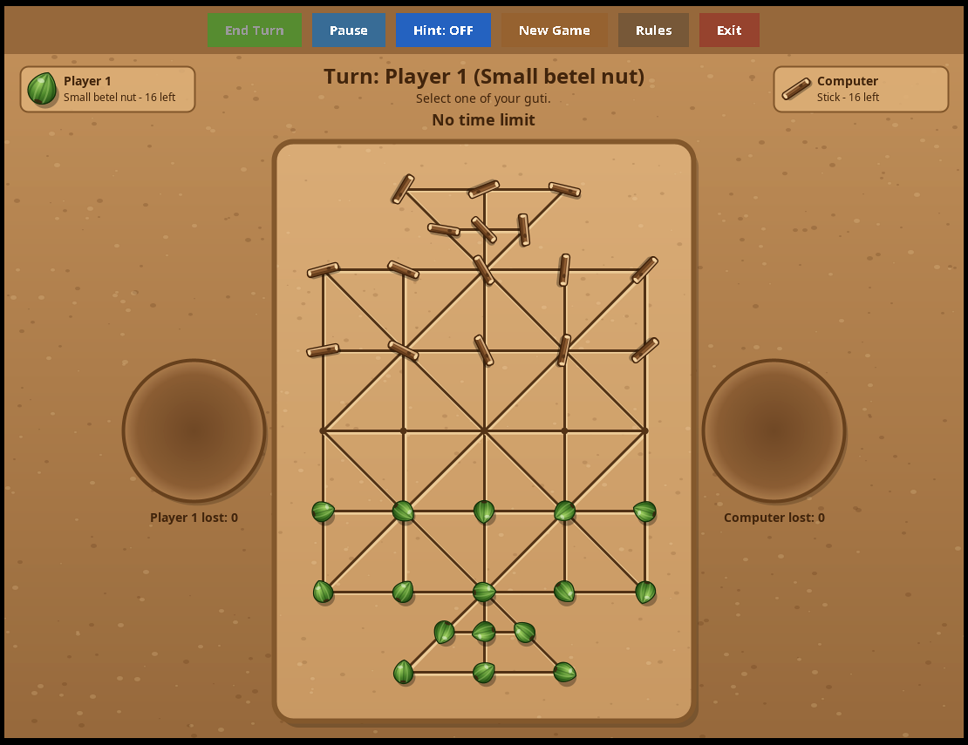
Figure 21: 16 Guti: game in progress | Figure 22: 16 Guti: captured guti in the soil circle

 | 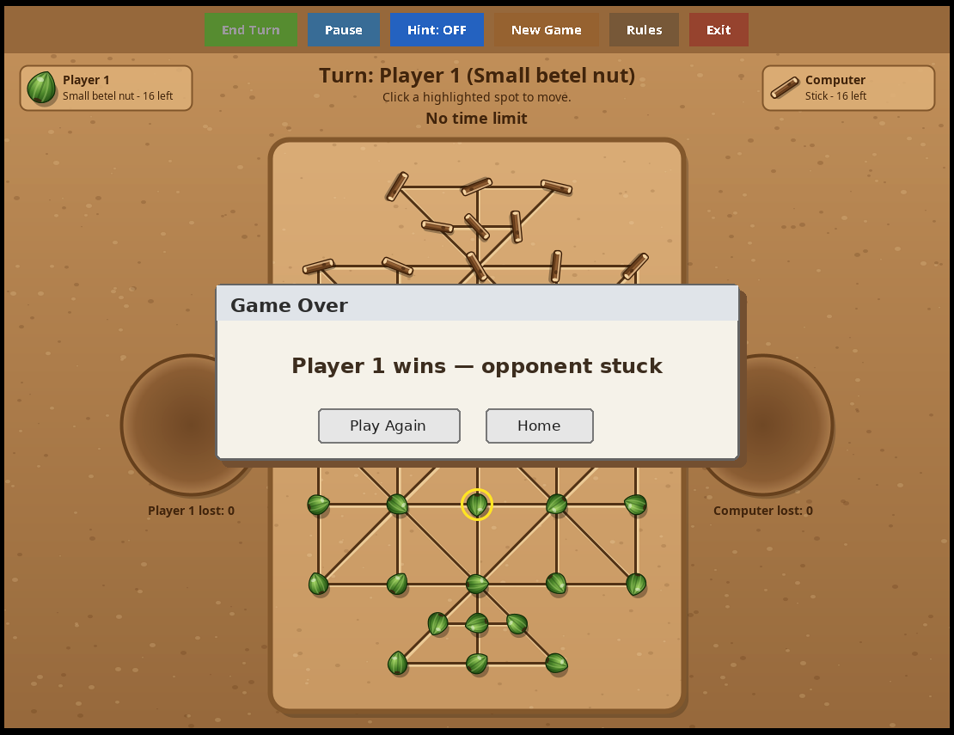
Figure 23: 16 Guti: winner by capturing all guti | Figure 24: 16 Guti: winner by blocking or time up

7.2 Game Play and Winning Screens of Bagh-Chhagol
The left soil circle shows the goats still in hand and the right soil circle shows the captured goats. The tiger card shows how many goats have been eaten out of the winning number (for example “ate 3/8”).
Figure 25: Bagh-Chhagol: placing phase | Figure 26: Bagh-Chhagol: captured goats

 | 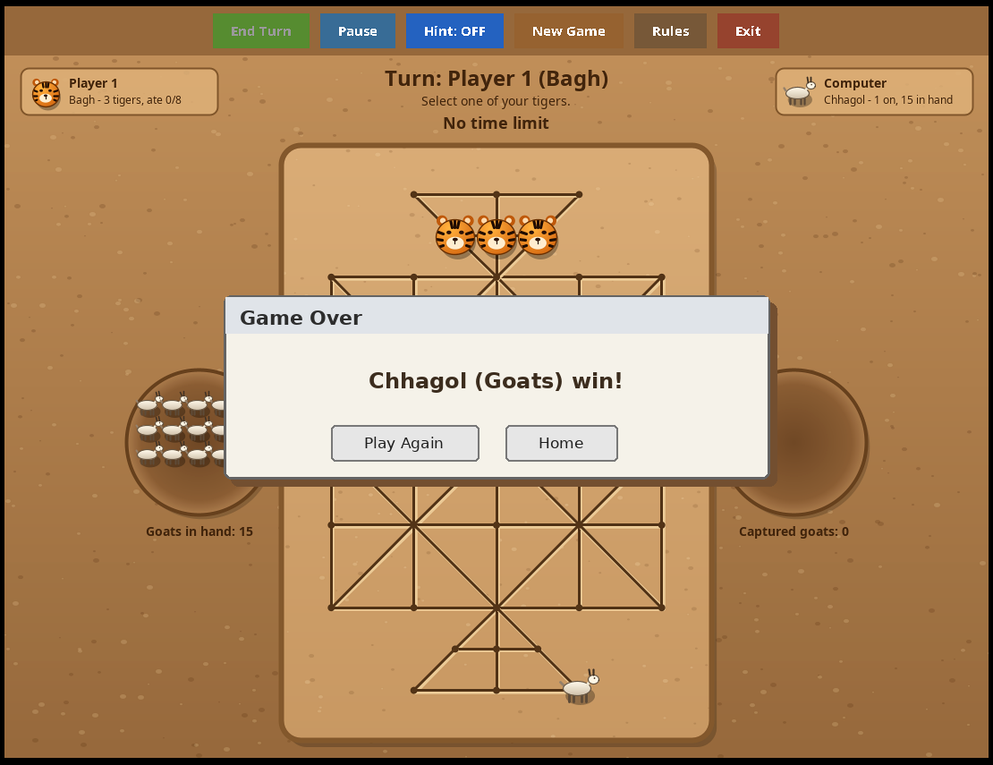
Figure 27: Bagh-Chhagol: tigers win | Figure 28: Bagh-Chhagol: goats win

7.3 Other Screens
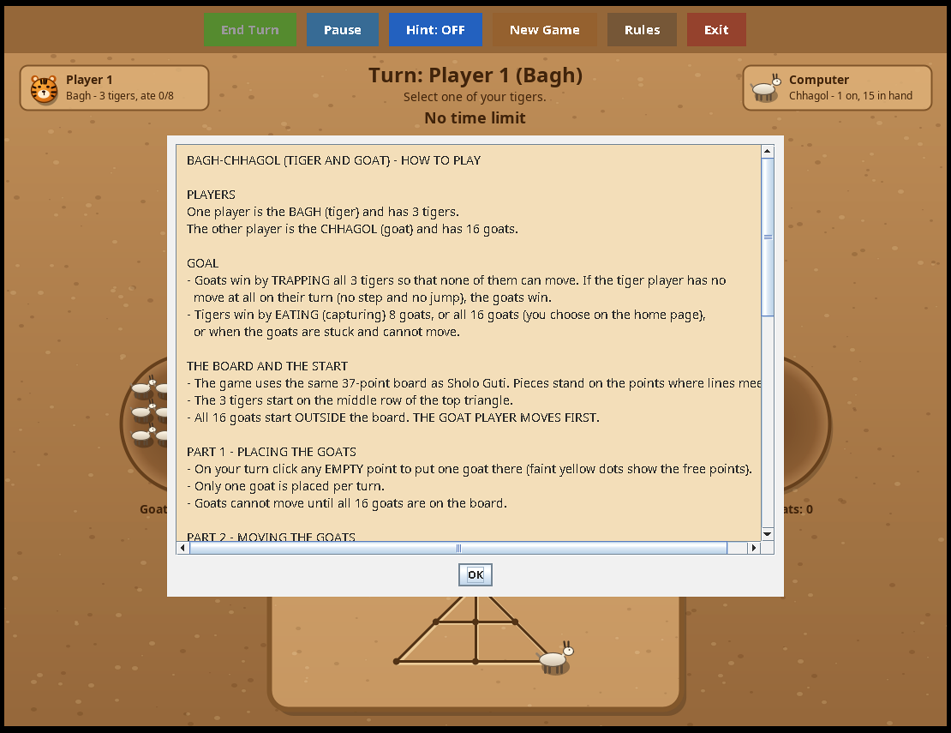 | 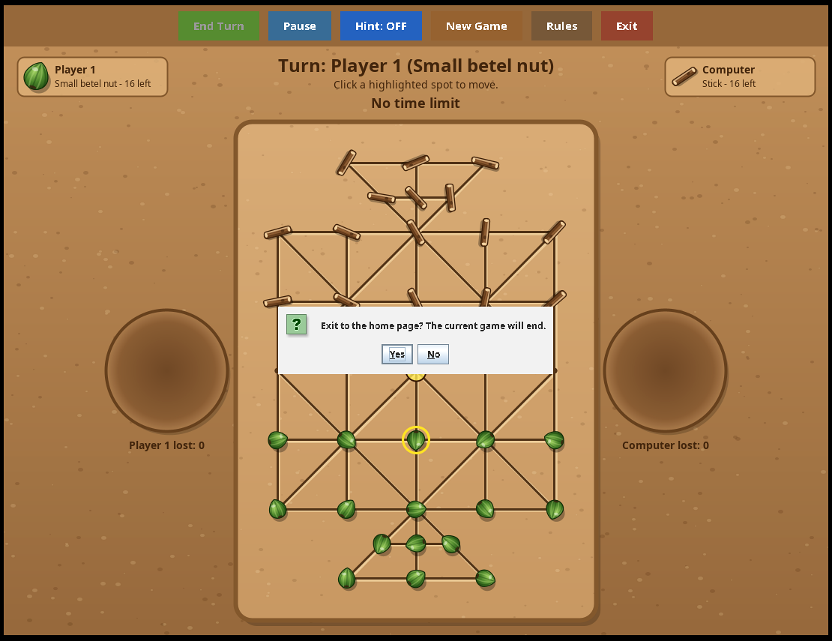
Figure 29: The How-to-Play window | Figure 30: Paused game

7.4 Summary of Results
Table 12: Summary of results
Item | Result
16 Guti rules | Steps, jumps, multi-jump, blocked player and time-up rule work correctly.
Bagh-Chhagol rules | Placing, moving, tiger jumps, multi-jump and all winning conditions work correctly.
Computer opponent | Easy plays randomly; Medium and Hard play stronger and answer within a second.
User interface | Soil-coloured pages, drawn pieces, clear highlights and a turn message at all times.
Extra features | Hint, pause, time limit, sound and rules window work in both games.
Portability | Single Main.java file; runs on any system with Java.

Chapter 8: Testing
The game was tested by playing many complete games in both modes and at all levels. Each rule was tested on purpose with special positions. The main test cases are listed below.
Table 13: Test cases and results
No. | Test case | Expected result | Result
1 | Click an empty point or enemy guti at the start of the turn | Nothing happens | Pass
2 | Select own guti | Yellow ring and yellow dots appear | Pass
3 | Click a yellow dot | Guti moves, turn changes | Pass
4 | Enemy guti next to own guti with an empty point behind it | Red dot appears; jump removes the enemy guti | Pass
5 | Jump along a diagonal line and inside a triangle | Jump works only along drawn lines | Pass
6 | Capture followed by a second possible capture | Red dot appears again; End Turn button enabled | Pass
7 | Press End Turn during multi-jump | Turn passes to the opponent | Pass
8 | Opponent has no guti left (16 Guti) | Winner message appears | Pass
9 | Opponent’s guti are all blocked (16 Guti) | “is stuck” message and win | Pass
10 | Time limit ends with different numbers of guti | Player with more guti wins; equal = draw | Pass
11 | Goat placing: click an occupied point | Nothing happens | Pass
12 | Goat placing: 16 goats placed | Goats-in-hand counter is 0; goats may now move | Pass
13 | Tiger jumps over a goat; over another tiger | Goat is eaten; jump over a tiger is not offered | Pass
14 | Tigers reach 8 (or 16) captured goats | Tigers win | Pass
15 | All three tigers surrounded | Goats win | Pass
16 | Pause during the computer’s turn | Computer waits until Resume | Pass
17 | New Game pressed while the computer is thinking | Old computer move is cancelled; new game starts cleanly | Pass
18 | Same guti type chosen for both players | Warning message; game does not start | Pass
19 | Time limit ticked with 0 h 0 m 0 s | Warning message; game does not start | Pass
20 | Resize the window | Board is scaled and stays centred | Pass

Problems found and solved during testing: an old computer move appearing in a new game (solved with the game-number counter gen); the clock continuing while paused (solved by testing the paused flag in tick()); and the second player’s guti appearing at the top for a human playing the second side (solved by the flipped board).

Chapter 9: Limitations and Future Work

9.1 Limitations
- The game can be played only on one computer; there is no online or network play.
- There is no saving or loading of an unfinished game.
- The Hard level looks only four moves ahead, so a very good human player can still beat it.
- The game is controlled only with the mouse and has no touch or keyboard shortcuts.

9.2 Future Work
- Add online multiplayer so that two players can play from different places.
- Create an Android version so that the game can be played on mobile phones.
- Improve the computer player with deeper search, better position evaluation or machine learning.
- Add save and load, a move history with undo, and a score board.
- Add more traditional games (for example Nine Men’s Morris style or other village games) to the same home page.
- Add background music, more guti designs and a Bangla language option.

Chapter 10: Conclusion
The project Sholo Guti And Bagh-Chhagol successfully turns two traditional village games into a complete desktop game. Both games follow their real rules, including jumping, multi-jump, trapping and several winning conditions. The player can choose to play against a computer of three levels or with a friend on the same computer, can use hints, pause the game, set a time limit and read the rules inside the program.
Technically, the project shows how a full game can be built with only the standard Java library: Swing for the screens, Java 2D for all drawings, Timers for the clock and the animation of the computer’s moves, javax.sound for sound effects generated by mathematics, and minimax search with alpha-beta pruning for the artificial intelligence. Keeping the rules, the computer player and the drawing in separate classes made the program easy to understand, test and extend.
During this project I learned object-oriented design, event-driven programming, recursion and backtracking, game-tree search, and careful testing of rules. I also learned how valuable it is to keep our traditional culture alive through modern technology. I hope this game will be enjoyed by players of all ages and that it can be a base for further improvements in the future.

