- Student Name: Bhanuka Bandara
- Student ID: IT24102291
- GitHub Repository Links: github.com/it24102291/WMT_LabTest_Project
- Screenshot of the locally running existing project Add Item page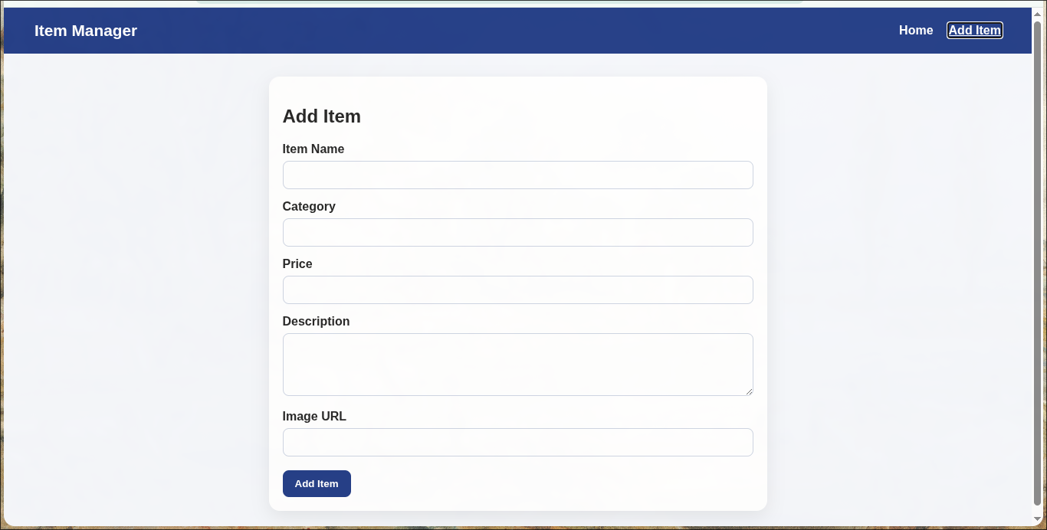
- Screenshot of the locally running existing project Home page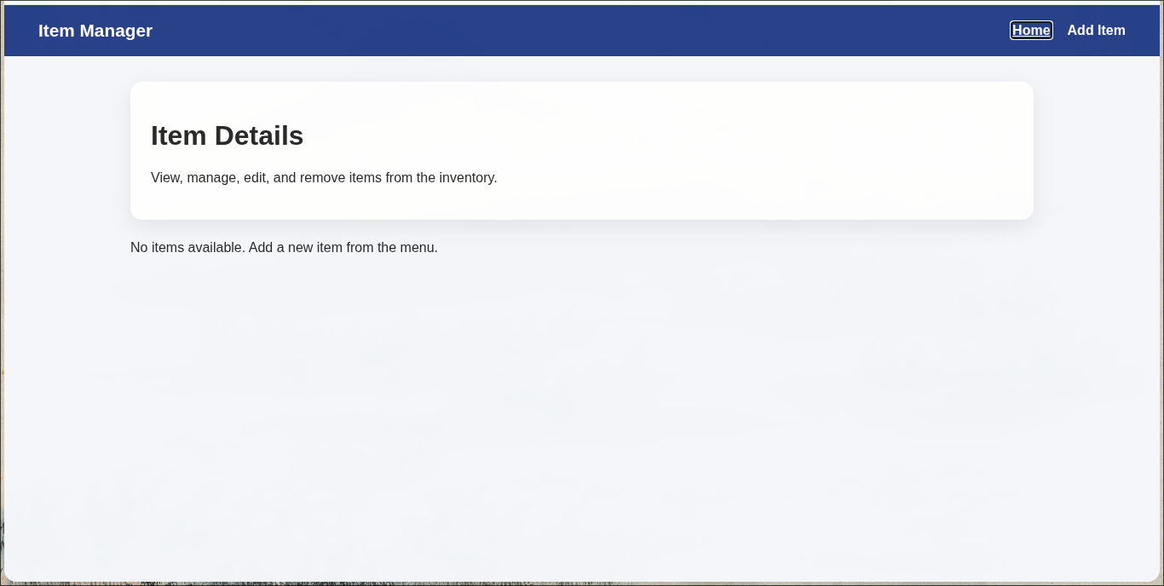
- Screenshot of the locally running updated project Add Item page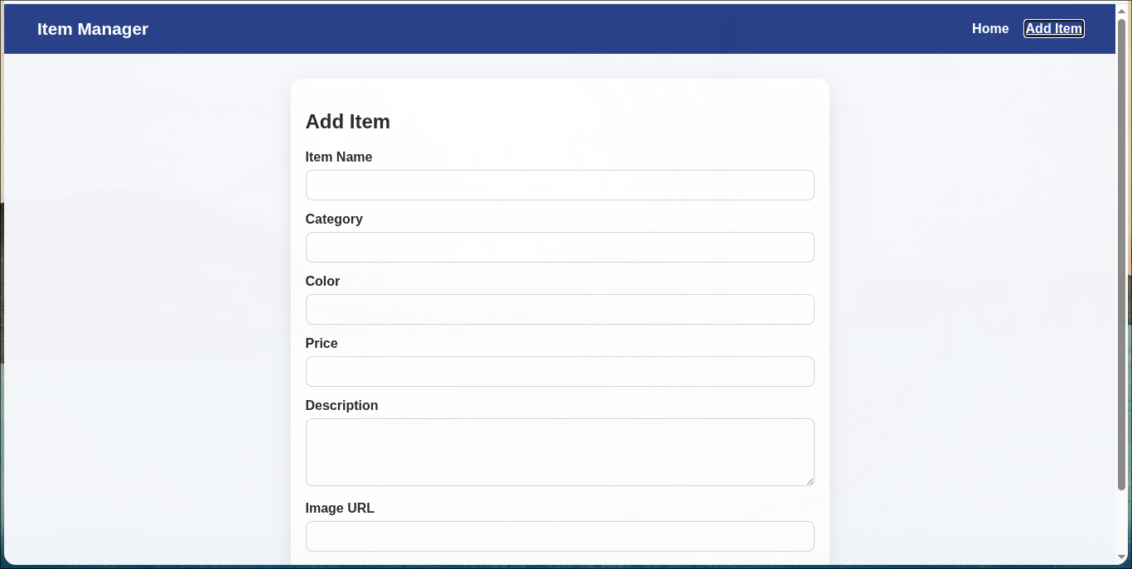
- Screenshot of the locally running updated project Home page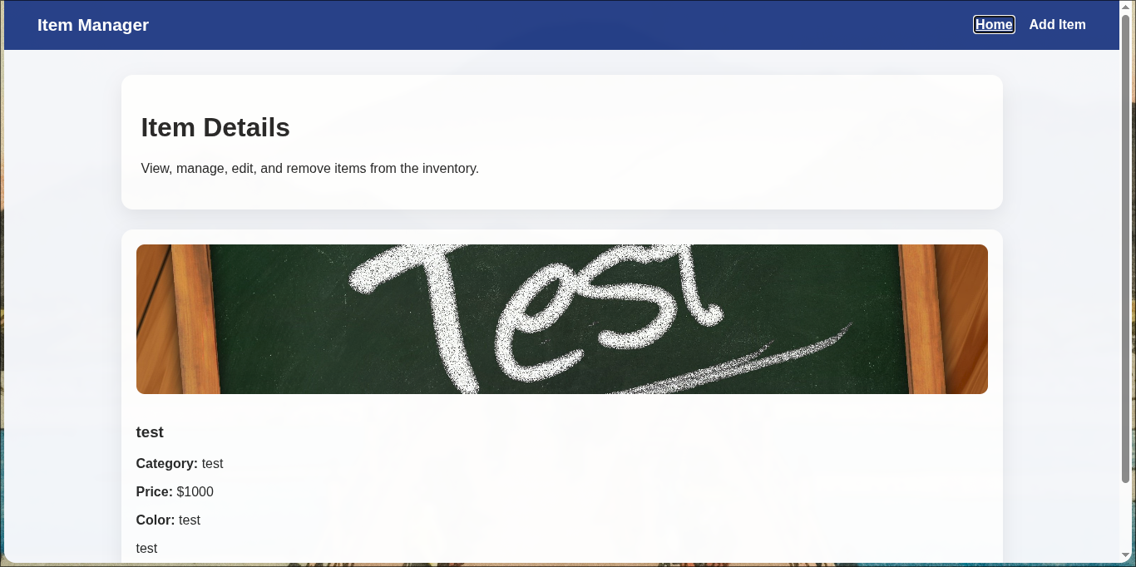
- Frontend Live URL:
  - Main: tmp-wmt.mrbhanuka.dev
  - Backup: endearing-reprieve-production-adb3.up.railway.app
- Backend Live URL
  - Main: tmp-wmt-bknd.mrbhanuka.dev
  - Backup: wmtlabtestproject-production-144c.up.railway.app/
- Brief deployment notes including the platforms used
  - Frontend hosted at cloudflare
  - Backend, MongoDB and backup frontend deployment hosted at railway.app

