Sri Lanka Institute of Information Technology



IT3101 – Data Warehousing and Business Intelligence
Assignment Report

Olist Brazilian E-Commerce
Data Warehouse and Business Intelligence Solution
Data Warehouse Design · ETL Development · OLAP Cube · Power BI Reporting

Group ID: 2026-DS-02
Lab Group: Y3.S1. WD. DS. 0102

Group Members:
Student ID | Name
IT24104110 | Thulmanthi W.A.S.
IT24103860 | Karunathilaka S.H.T.R.
IT24103869 | Thennakoon T.M.S.D.
IT24104178 | Jayasuriya J.A.Y.N.

Introduction

Data warehousing is a core part of modern business intelligence. It lets an organization bring large volumes of historical operational data into one consistent analytical repository that is designed for querying rather than for processing transactions. By integrating data from several sources, cleansing it, and storing it in a dimensional model, a data warehouse helps an organization identify trends, monitor performance, and produce the reports that support strategic and operational decisions.
This project designed and implemented a complete data warehousing and business intelligence solution on the Microsoft BI stack. Microsoft SQL Server was used as the database platform, SQL Server Integration Services (SSIS) and T-SQL for the ETL process, SQL Server Analysis Services (SSAS) as the OLAP engine, and Power BI Desktop for reporting and visualization.
The dataset is the Olist Brazilian E-Commerce Public Dataset, which contains about 100,000 orders placed on the Olist marketplace in Brazil between September 2016 and October 2018. It is distributed as nine related CSV files covering orders, order items, customers, sellers, products, payments, reviews, geolocation and product category translations. Because these files are normalised and linked through business keys, they represent a realistic operational (OLTP) system. The seven transactional tables were imported into a SQL Server database to act as the operational source. The solution also uses two other source types: CSV reference files for geolocation and category translation, and a JSON feed of Brazilian public holidays retrieved from the Nager.Date web API. Profiling the data showed issues such as one customer appearing under many order-level identifiers, orders with no delivery date, products without a category, and a state-only holiday inside the national holiday list. Rules for each were defined and applied during transformation.

The dimensional model contains two fact tables, Fact_Sales (one row per order item) and Fact_OrderFulfilment (one row per order). They share conformed dimensions: Date, Customer, Product, Seller, Location, OrderStatus and PaymentType. Two fact tables were used because delivery, payment and review values belong to the whole order, and storing them on every item row would distort averages. Because the fact tables share dimensions, the model is a fact constellation (galaxy schema). The Location dimension is a role-playing dimension, used once for the customer location and once for the seller location, so that where an order is shipped from can be compared with where it is delivered to.
The warehouse is built in a single SQL Server database organised into four schemas: stg for staging, dw for the warehouse, mart for data marts, and etl for logging. A master SSIS package runs three packages in order: extraction of all sources into staging, loading of the dimensions, and loading of the fact tables. The ETL uses a repeatable full load, in which each run clears and rebuilds the data. The holiday data is retrieved by an SSIS Script Task, with a saved copy of the raw JSON used as a fallback if the API cannot be reached. A validation procedure runs sixteen automated checks after every load, comparing row counts and revenue, freight and payment totals against the source. All checks passed on repeated runs. Two department data marts were then created: a Sales Mart for sales and marketing, and a Delivery and Satisfaction Mart for operations. On top of the warehouse, an SSAS multidimensional cube was built with user hierarchies and two measure groups, and a three-page Power BI report was developed with an Executive Summary, a Trend Analysis and an Interactive Analysis page.

This report documents the full solution. It covers the dataset and data sources, the architecture, the dimensional model, ETL development and validation, the data marts, the OLAP and dashboard layer, and the business insights and recommendations drawn from the results.

Part A – Data Warehouse Design and ETL Development

Task 1 – Dataset Selection

1.1 Selected Dataset

Dataset: Olist Brazilian E-Commerce Public Dataset
Source: Kaggle (Olist Store, Brazil)
The selected dataset contains detailed transactional information about orders placed on the Olist marketplace, a Brazilian e-commerce platform that connects small and medium sellers to the major online marketplaces in Brazil. The data covers roughly 100,000 orders that represents genuine operational data captured by the marketplace order management system.

Item | Description
Business domain | Retail / E-commerce. An online marketplace in Brazil.
System represented | The order management system of Olist. It records customers, orders, items, payments, delivery and reviews. This is an OLTP (online transaction processing) system.
Dataset name | Brazilian E-Commerce Public Dataset by Olist
Dataset source | Published by Olist on Kaggle: https://www.kaggle.com/datasets/olistbr/brazilian-ecommerce
Time period | Orders placed from 4 September 2016 to 17 October 2018
Dataset format | 9 CSV files (comma-separated text files)
Size | About 100,000 orders. About 1.55 million rows across the 9 files.
Currency | Brazilian real (BRL)
Privacy | The data is anonymised. Customer and seller identifiers are encoded, and company names in review text are replaced.
Licence | CC BY-NC-SA 4.0 (non-commercial use, suitable for coursework)

9 CSV files

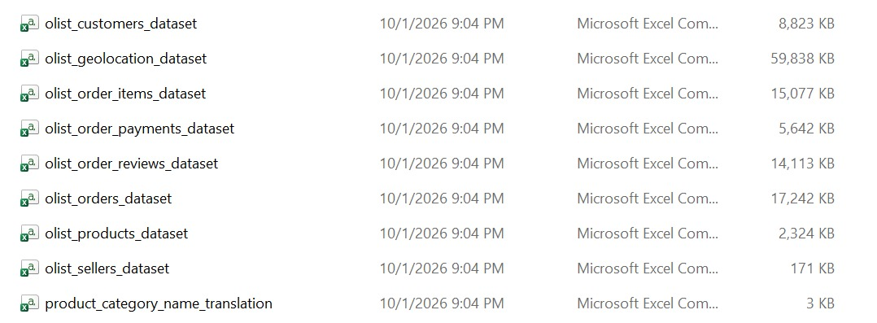

1.2 Dataset Attributes
The following table lists the nine source files and the key attributes that each contributes to the data warehouse.
Source File | Description | Key Attributes
olist_orders_dataset.csv | Order header records, one row per order | order_id, customer_id, order_status, order_purchase_timestamp, order_approved_at, order_delivered_carrier_date, order_delivered_customer_date, order_estimated_delivery_date
olist_order_items_dataset.csv | Order line items, one row per item on an order | order_id, order_item_id, product_id, seller_id, shipping_limit_date, price, freight_value
olist_customers_dataset.csv | Customer master data | customer_id, customer_unique_id, customer_zip_code_prefix, customer_city, customer_state
olist_sellers_dataset.csv | Seller master data | seller_id, seller_zip_code_prefix, seller_city, seller_state
olist_products_dataset.csv | Product master data and physical attributes | product_id, product_category_name, product_name_lenght, product_description_lenght, product_photos_qty, product_weight_g, product_length_cm, product_height_cm, product_width_cm
olist_order_payments_dataset.csv | Payment transactions for each order | order_id, payment_sequential, payment_type, payment_installments, payment_value
olist_order_reviews_dataset.csv | Customer satisfaction reviews | review_id, order_id, review_score, review_comment_title, review_comment_message, review_creation_date, review_answer_timestamp
olist_geolocation_dataset.csv | Brazilian postcode to latitude and longitude reference data | geolocation_zip_code_prefix, geolocation_lat, geolocation_lng, geolocation_city, geolocation_state
product_category_name_translation.csv | Portuguese to English product category lookup | product_category_name, product_category_name_english

1.3 Justification for Selection

The Olist Brazilian E-Commerce dataset was selected because it provides a realistic OLTP source with enough records and attributes for dimensional modelling, and it is publicly available and licensed for academic use. The main reasons are set out below.

1. A genuine OLTP source with sufficient volume
The data comes from the order management system of a real online marketplace and is stored in nine normalised tables linked by business keys such as order_id, product_id and seller_id. It holds 99,441 orders, 112,650 order items, 103,886 payments and 99,224 reviews, enough for meaningful trends yet small enough to reload repeatedly during ETL development. The seven transactional tables were imported into SQL Server as the operational source.

2. Multi-source integration
The solution uses three source types: the SQL Server operational database, CSV reference files for geolocation and category translation, and a JSON feed of Brazilian public holidays from the Nager.Date web API. Combining them requires joining tables, matching zip codes, categories and dates across sources, and resolving attributes to surrogate keys.

3.Attributes that support a fact constellation
The data separates clearly into measures (price, freight value, payment value, instalments, review score and delivery duration) and dimensions (date, customer, product, seller, location, order status and payment type). Sales are recorded per order item, while delivery, payment and review values belong to the whole order. This gives two fact tables at different grains, Fact_Sales and Fact_OrderFulfilment, sharing conformed dimensions.

4. Time and geographic analysis
Order timestamps (purchase, approval, carrier handover, delivery and estimated delivery) support a Year, Quarter, Month and Day hierarchy, delivery delay measures and holiday analysis. Customers and sellers both carry zip code, city and state, so one Location dimension can play two roles, customer location and seller location.

5. Realistic business questions
The dataset answers questions managers would actually ask:
- How do orders and revenue change over time?
- Which categories, sellers and states generate the most revenue?
- How long does delivery take, and how often are orders late?
- Do late deliveries lead to lower review scores?

6. Data quality challenges that justify an ETL process
customer_id changes with every order, so customer_unique_id identifies repeat buyers. Some orders lack delivery dates, some products lack a category, and the holiday feed includes a state-only holiday that must be filtered out.
Limitations
There is no cost or profit data, so profit margin cannot be measured. The data covers about two years, and the first and last months hold very few orders.

Task 2 – Data Source Identification and Preparation

This task identifies the data sources used in the solution, describes their format and attributes, explains how the sources relate to each other, documents the preparation work that was carried out, and explains how the data from the different sources is brought together in one analytical environment.

2.1 Overview of the Data Sources

The solution uses three sources of three different types: a relational database, CSV files and a JSON web API. Using several source types reflects a real organization, where analytical data rarely comes from a single place.

Source | Type of format | Records | Used for
S1: Olist operational database (Olist_OLTP_DB) | Relational database, Microsoft SQL Server | 7 tables, 550,688 rows | Business transactions: customers, orders, order items, payments, reviews, products and sellers
S2: Olist reference files | CSV flat files, UTF-8 | Geolocation 1,000,163 rows. Category translation 71 rows. | Latitude and longitude of locations, and English product category names
S3: Nager.Date public holiday service | JSON, retrieved from a REST API over HTTPS | 42 holidays (Brazil, 2016 to 2018) | Holiday information for the Date dimension

2.2 Source S1: Olist Operational Database

Olist is a Brazilian e-commerce platform that connects small sellers with customers through an online marketplace. Its order management system records each customer order together with the products, sellers, payments, delivery dates and customer reviews. The data was anonymised before publication: customer and seller identifiers are encoded, and company names in review text are replaced. The orders in the dataset were placed between September 2016 and October 2018.

In this project the seven transactional tables are stored in the SQL Server database Olist_OLTP_DB, which acts as the operational source.
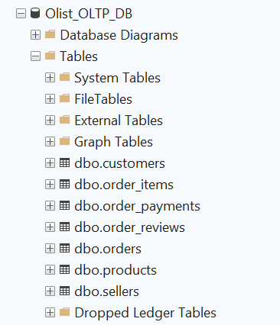

Tables of the Olist_OLTP_DB database

Table | Rows | Primary key | Main attributes
customers | 99,441 | customer_id | customer_id, customer_unique_id, customer_zip_code_prefix, customer_city, customer_state
sellers | 3,095 | seller_id | seller_id, seller_zip_code_prefix, seller_city, seller_state
products | 32,951 | product_id | product_id, product_category_name, product_name_lenght, product_description_lenght, product_photos_qty, product_weight_g, product_length_cm, product_height_cm, product_width_cm
orders | 99,441 | order_id | order_id, customer_id, order_status, order_purchase_timestamp, order_approved_at, order_delivered_carrier_date, order_delivered_customer_date, order_estimated_delivery_date
order_items | 112,650 | order_id and order_item_id | order_id, order_item_id, product_id, seller_id, shipping_limit_date, price, freight_value
order_payments | 103,886 | order_id and payment_sequential | order_id, payment_sequential, payment_type, payment_installments, payment_value
order_reviews | 99,224 | None (review_id repeats) | review_id, order_id, review_score, review_comment_title, review_comment_message, review_creation_date, review_answer_timestamp

The table definitions use data types that suit the data. Identifiers are CHAR(32) because they are fixed 32-character codes. Names use NVARCHAR so that Portuguese accents are stored correctly. Timestamps use DATETIME2(0) and money uses DECIMAL(10,2). Zip code prefixes are stored as text, because many begin with zero.
Points about the data that affect the design:
- One order can contain several items, and can be paid for with several payments.
- customer_id changes with every order. The field customer_unique_id identifies the real person. The customers table has 99,441 rows but only 96,096 distinct people.
- All monetary values are in Brazilian reais (BRL).
- Two source columns are misspelled (product_name_lenght and product_description_lenght). They are kept as they are in the source database and corrected in the warehouse.

2.3 Source S2: Reference Files (CSV)

Two CSV files supply reference data that the transactional tables do not contain. The geolocation file lists latitude and longitude points for Brazilian zip code prefixes. The category translation file gives the English name for each Portuguese product category.

Reference files
File | Rows | Attributes | Purpose
olist_geolocation_dataset.csv | 1,000,163 | geolocation_zip_code_prefix, geolocation_lat, geolocation_lng, geolocation_city, geolocation_state | Coordinates for the Location dimension
product_category_name_translation.csv | 71 | product_category_name, product_category_name_english | English category names for the Product dimension

2.4 Source S3: Public Holiday API (JSON)

Nager.Date is a free public holiday service. It needs no registration or key. One request returns the public holidays of one country and one year as a JSON array. The request used for Brazil has this form, where the year is changed from 2016 to 2018:

https://date.nager.at/api/v3/PublicHolidays/2017/BR

Each holiday in the response is one JSON object. The first record returned for 2016 is shown below.

{"date":"2016-01-01","localName":"Confraternização Universal",
"name":"New Year's Day","countryCode":"BR","fixed":false,
"global":true,"counties":null,"launchYear":null,"types":["Public"]}

Fields of the holiday API response

Field | Data type | Meaning
date | Date | The date of the holiday
localName | Text | The holiday name in Portuguese
name | Text | The holiday name in English
countryCode | Text | Country code, BR for Brazil
fixed | True or false | Whether the holiday falls on the same date every year
global | True or false | True if the holiday applies to the whole country, false if only some states observe it
counties | List | The states where the holiday applies, when it is not nationwide (can be empty)
launchYear | Number | The year the holiday began (can be empty)
types | List | The kind of holiday, for example Public

2.5 Relationships Between the Sources

The tables inside S1 are linked by order, customer, product and seller identifiers. The two outside sources connect to S1 through three shared attributes: the zip code prefix, the product category name and the calendar date

Relationships between tables and sources

From | To | Join attribute | Relationship
orders (S1) | customers (S1) | customer_id | Many to one
order_items (S1) | orders (S1) | order_id | Many to one
order_items (S1) | products (S1) | product_id | Many to one
order_items (S1) | sellers (S1) | seller_id | Many to one
order_payments (S1) | orders (S1) | order_id | Many to one
order_reviews (S1) | orders (S1) | order_id | Many to one, usually one review per order
customers, sellers (S1) | geolocation (S2) | Zip code prefix | Many to one, after geolocation is reduced to one row per prefix
products (S1) | category translation (S2) | product_category_name | Many to one
orders (S1) | holidays (S3) | Purchase date equals holiday date | Many orders to one holiday date, through the Date dimension

2.6 Data Preparation Steps

- Project folders. A project folder was created with sub-folders for the source CSV files, the holiday JSON files, SQL scripts, SSIS projects and report material.
- Download and inspection. The nine CSV files were downloaded from Kaggle and extracted into the source folder. All nine files were present. They were not opened in Excel, because Excel can change dates and codes. A text editor was used instead.
- Creating the operational database. The database Olist_OLTP_DB was created in SQL Server, with one table for each transactional file. Primary keys and foreign keys were defined so that the database behaves like a real OLTP system. The reviews table has no primary key because review_id is not unique.
- Importing the data. The seven CSV files were imported with the T-SQL command BULK INSERT, using the options FORMAT = CSV, a double quote as field quote, FIRSTROW = 2 to skip the header, code page 65001 (UTF-8) so that Portuguese accents load correctly, and KEEPNULLS so that empty values stay empty. Parent tables were loaded before child tables so that the foreign keys were satisfied. This step builds the source system. It is not part of the ETL process.
The reviews file failed on the first attempt with an OLE DB provider error. The cause was the fixed line-ending option. After this option was removed, so that SQL Server detected the line endings itself, all 99,224 rows loaded.
- Checking the load. Row counts were compared with the published counts of the dataset .They match, so no rows were lost.
- Reference files. The geolocation and category translation files were kept as CSV files in the source folder. SSIS reads them as UTF-8 text with the header row skipped.
- Holiday source. The API request was tested in a web browser. The responses for 2016, 2017 and 2018 were saved as raw JSON files in a separate folder and checked in a text editor, which confirmed UTF-8 encoding. The SSIS package later calls the API directly and refreshes these files, and uses the saved files if the service cannot be reached (Task 5).
- Profiling. The data was profiled with SQL queries to find quality problems before any transformation was designed (Section 2.7).
- Staging. A staging area was created in the warehouse database for all three sources. After the first SSIS extraction, the staging tables contained the same number of rows as the sources (Section 2.8).

2.7 Data Profiling and Quality Findings

Data quality findings and planned handling

 | Finding | Quality Dimension | Evidence | Planned handling
1 | Partial months at the start and end of the data | Completeness | Orders per month: 2016-09 = 4, 2016-10 = 324, 2016-12 = 1, no orders in 2016-11, 2018-09 = 16, 2018-10 = 4. | Load all data. Analysis focuses on the full months, January 2017 to August 2018.
2 | Orders that are not real sales | Validity (Business rule) | Statuses: delivered 96,478, shipped 1,107, canceled 625, unavailable 609, invoiced 314, processing 301, created 5, approved 2. | Keep the status. Mark canceled and unavailable orders as not counting as sales.
3 | Missing dates in orders | Completeness | 160 without approval date, 1,783 without carrier date, 2,965 without delivery date. | Keep the rows. Calculate delivery measures only when a delivery date exists.
4 | Delivered orders without a delivery date | Completeness | 8 orders. No order was delivered before it was purchased. | Keep the rows, leave delivery measures empty, and report them in validation.
5 | Several customer identifiers per person | Uniqueness | 99,441 customer rows but 96,096 distinct customer_unique_id values. | One Customer dimension row per customer_unique_id.
6 | Reviews are not one per order | Uniqueness | 99,224 rows, 98,410 distinct review_id values, 98,673 orders with a review. | Keep the latest review of each order. Orders without a review keep an empty score.
7 | Missing product information | Completeness | 610 products without a category, 2 without weight. | Category becomes Unknown. Weight stays empty.
8 | Categories without an English name | Consistency | Two categories are missing from the translation file: pc_gamer and portateis_cozinha_e_preparadores_de_alimentos. | Add an English name for these two categories.
9 | Unclear payment type | Validity | Payment types: credit_card 76,795, boleto 19,784, voucher 5,775, debit_card 1,529, not_defined 3. | Keep not_defined and group it as Not defined.
10 | Prices and freight | Validity | Price 0.85 to 6,735.00. Freight 0.00 to 409.68. No negative values. | No change. Free shipping is valid.
11 | Geolocation points outside Brazil | Accuracy | 1,000,163 rows for 19,015 zip prefixes. 42 points lie outside Brazil. No missing coordinates, and all prefixes have 5 characters. | Remove the 42 points, then average the coordinates for each zip prefix.
12 | Zip prefixes with no geolocation row | Consistency | 157 customer zip prefixes and 7 seller zip prefixes. | Keep these locations with empty coordinates.
13 | State-level holidays in the holiday list | Validity | 3 of the 42 holidays are not nationwide. | Flag only nationwide holidays in the Date dimension.
14 | Text encoding | Consistency | Portuguese accents display correctly in the reviews after import. Holiday names first appeared garbled when loaded with the wrong encoding. | Read all text files as UTF-8.

2.8 Integrating the Sources into One Analytical Environment

The three sources differ in type and format, and in a real company they would belong to different systems. They are combined into one analytical environment in four ways:
- One landing area. The database, CSV and JSON data are first copied into staging tables in the warehouse database, so the same SQL can handle every source.
- Common keys and formats. Zip code prefixes are kept as text of equal length so leading zeros are not lost, product categories are matched with the translation file, and dates are converted to a standard date key.
- Shared dimensions. Location merges customer and seller zip codes with geolocation coordinates, Product adds English category names, and Date is a full calendar enriched with holiday flags from the API.
- Surrogate keys. Each dimension has its own warehouse key, so the model does not depend on source system identifiers.
The result is one consistent warehouse in which sales, delivery, payment, review, location and holiday data can be analysed together.

Task 3: Data Warehouse and Business Intelligence Architecture

3.1 Architecture Diagram

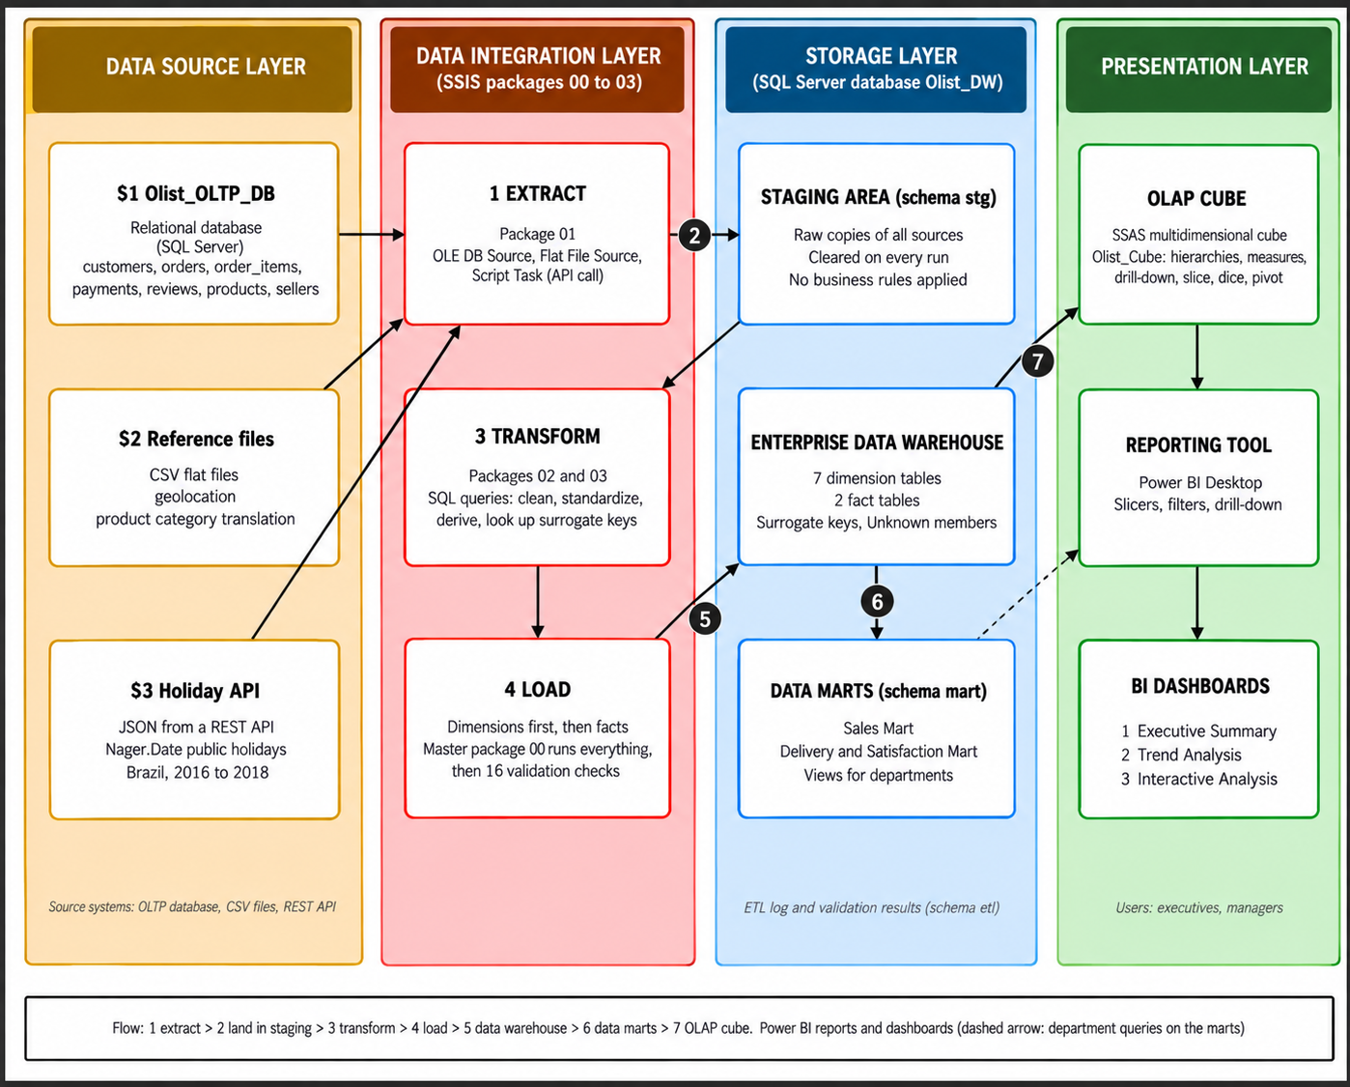

Summary of the Architecture

Layers, components and technologies
Layer | Component | Technology | What was built
Data source | Operational database (S1) | SQL Server database Olist_OLTP_DB | 7 transactional tables with primary and foreign keys
Data source | External files (S2) | CSV files | Geolocation and category translation files
Data source | External web service (S3) | JSON from the Nager.Date REST API | Brazilian public holidays for 2016 to 2018
Data source | Application systems | None | The case has no separate application system
Data integration | Extraction | SSIS: OLE DB Source, Flat File Source, Script Task | Package 01 copies all sources into staging
Data integration | Transformation | T-SQL source queries inside SSIS data flows | Cleaning, standardisation, derived attributes and key lookups
Data integration | Loading | SSIS packages 02, 03 and master package 00 | Dimensions first, then facts, then 16 validation checks
Storage | Staging area | Schema stg in Olist_DW | Raw copies of all sources, cleared on every run
Storage | Enterprise data warehouse | Schema dw in Olist_DW | 7 dimension tables and 2 fact tables
Storage | Data marts | Schema mart in Olist_DW | Sales Mart and Delivery and Satisfaction Mart
Storage | ETL control and log | Schema etl in Olist_DW | Run log, validation results and the validation procedure
Presentation | OLAP | SSAS multidimensional cube Olist_Cube | Hierarchies, measures and OLAP operations
Presentation | Reporting tool | Power BI Desktop | Interactive report with slicers and drill-down
Presentation | BI dashboards | Power BI report pages | Executive Summary, Trend Analysis and Interactive Analysis

3.2 Data Source Layer

The data source layer holds the systems and files that the warehouse is built from. Three sources of three different types are used (see Task 2 for the full description).
- Operational database (S1). The Olist order management data is stored in the SQL Server database Olist_OLTP_DB. It has seven related tables: customers, sellers, products, orders, order items, order payments and order reviews. The data was imported from the dataset files once, and the database has primary and foreign keys so that it behaves like a real transactional system. It holds 550,688 rows in total.
- External files (S2). The geolocation file (1,000,163 rows) and the product category translation file (71 rows) are kept as CSV files in UTF-8 encoding. They supply coordinates and English category names that the database does not contain.
- External web service (S3). The Nager.Date holiday service returns the public holidays of Brazil as JSON. The years 2016, 2017 and 2018 give 42 holidays. The raw responses are saved as JSON files and used as a backup.
- Application systems. No separate application system exists in this case, so none is used.

3.3 Data Integration Layer

SSIS packages
Package | Purpose | Main tasks
01_Staging_Load | Extraction | Clears the staging tables. Copies the 7 database tables with OLE DB data flows. Loads the 2 CSV files with Flat File data flows. A Script Task downloads the holiday JSON from the API. An Execute SQL Task reads the JSON into a staging table.
02_Load_Dimensions | Transformation and loading of dimensions | Clears the warehouse tables. Loads Dim_Date, Dim_OrderStatus, Dim_PaymentType, Dim_Seller, Dim_Customer, Dim_Product and Dim_Location from SQL queries over staging.
03_Load_Facts | Transformation and loading of facts | Clears the fact tables. Loads Fact_Sales and Fact_OrderFulfilment, looking up the dimension keys.
00_Master | Orchestration and validation | Runs packages 01, 02 and 03 in order, then runs the validation procedure.

Extraction. Seven OLE DB data flows read the database tables from Olist_OLTP_DB, and two Flat File data flows read the CSV files as UTF-8 text, skipping the header row. A C# Script Task requests the holiday data for each year and saves the raw JSON. If the service cannot be reached, it logs a warning and uses the saved file, so the package does not fail without an internet connection. All data is written to staging with no business rules.

Transformation. T-SQL queries serve as the sources of the SSIS data flows. They handle missing values, remove duplicates, standardise names and codes, convert data types, aggregate items and payments, and create derived attributes such as delivery days, the late-delivery flag, regions and the holiday flag. Dimension keys are looked up in the same queries, and missing values map to the Unknown member (key -1).

Loading. Dimensions are loaded first so their surrogate keys exist, then the fact tables. Each run clears the warehouse tables first, which makes the process repeatable. The master package then runs a validation procedure with 16 checks and stores the results in the etl schema.

Load strategy. The ETL uses a full load because the dataset is a fixed historical snapshot (September 2016 to October 2018), so no new records arrive between runs. A full load gives the same result every time and avoids loading a period twice or missing one. A system receiving new orders daily would need an incremental load, noted as a possible future improvement.

3.4 Storage Layer

All storage-layer components live in one SQL Server database, Olist_DW. Four schemas separate the layers, so each component is easy to find and check.
- Staging area (schema stg). It has one table for each extracted source (customers, sellers, products, orders, order items, order payments, order reviews, geolocation, category translation and public holidays) plus a table that holds the raw holiday JSON. The tables hold raw copies, have no keys, and are cleared at the start of each run. Review comments are not extracted, because they are not needed for the business questions.
- Enterprise data warehouse (schema dw). It holds the dimensional model: 7 dimension tables (Date, Customer, Product, Seller, Location, OrderStatus and PaymentType) and 2 fact tables (Fact_Sales at order-item level and Fact_OrderFulfilment at order level). Every dimension has a surrogate key and an Unknown member. The design is explained in Task 4.
- Data marts (schema mart). Two department views are built on the warehouse: the Sales Mart for sales and marketing (112,101 rows) and the Delivery and Satisfaction Mart for operations (96,476 rows). They are explained in Task 6.
- ETL control and log (schema etl). The tables run_log and validation_result record each validation run and its 16 checks. The stored procedure usp_run_validation fills them.

3.5 Presentation Layer

- OLAP. An SSAS multidimensional cube named Olist_Cube is built on the warehouse tables. It has the dimensions Date, Customer, Product, Seller, Order Status, Payment Type and Location (used twice, as customer location and seller location), user hierarchies for date, location, product and payment, two measure groups (sales and order fulfilment), and calculated measures such as revenue, average delivery days, late-delivery rate and average review score. In the cube browser the OLAP operations drill-down, roll-up, slice, dice and pivot are demonstrated (Task 7).
- Reporting tool. Power BI Desktop is used to build the report.
- BI dashboards. The report has three pages: an Executive Summary with KPIs and summary cards, a Trend Analysis with time-based and comparison charts, and an Interactive Analysis with slicers and drill-down (Task 7).

3.6 Data Flow Through the Architecture

- Extract. Package 01 reads the database, the two CSV files and the holiday API.
- Stage. The data is copied into the stg schema and is not yet cleaned. Row counts are compared with the sources.
- Transform. SQL queries in packages 02 and 03 clean and reshape the data using the rules found by profiling.
- Load. Dimensions are loaded first and facts second.
- Store. The result is stored in the dw schema, and 16 validation checks confirm that it matches the source.
- Data marts. The mart schema publishes department-specific views of the warehouse.
- Analyse. The SSAS cube and Power BI read the warehouse and present hierarchies, measures, reports and dashboards to users.

3.7 Design Decisions

- A staging area protects the source and allows reruns. The operational database is read once. If a load fails, the process can be restarted from staging without reading the sources again.
- Four schemas in one database. Raw data (stg), clean analytical data (dw), department views (mart) and logs (etl) are kept apart but are easy to set up, back up and reproduce on another computer. A production system would normally use separate servers.
- A dimensional model suits analysis. Facts and dimensions make questions about time, product, location and customer easy to answer. Two fact tables are used because delivery, payment and review values belong to the whole order, and repeating them on every item row would distort averages.
- A full load keeps the ETL simple and repeatable. This fits a fixed snapshot of data.
- Validation gives evidence. Sixteen automated checks compare row counts and totals with the source after every run, and the results are stored.
- The tools meet the assignment. SQL Server, SSIS and T-SQL perform the data work, SSAS provides the OLAP layer, and Power BI provides the dashboards.

Task 4: Dimensional Data Warehouse Design and Implementation

4.1 Design Approach

The Olist data describes two business processes that operate at different levels of detail. Selling products is recorded at the level of an order item, while delivering an order and satisfying the customer are recorded at the level of the whole order. The model therefore uses two fact tables that share the same dimensions, a design known as a fact constellation (or galaxy schema).

The two fact tables
Item | Fact_Sales | Fact_OrderFulfilment
Business process | Selling products through the marketplace | Delivering orders and satisfying customers
Grain | One row per order item (one product in one order) | One row per order
Measures | quantity, price, freight_value, item_total_value | item_count,payment_total,payment_installments, delivery_days,delivery_delay_days, is_late_delivery, review_score
Questions answered | Sales trends, best categories and sellers, regional sales | Delivery time, late deliveries, payment methods, review scores, holiday effects
Expected rows | 112,650 (same as order_items) | 99,441 (same as orders)

Why two fact tables rather than one? Every item in an order shares the same delivery date, payments and review. Storing these order-level values on each item row would count an order with three items three times, which would distort averages and totals. Separate fact tables at their natural grain avoid this problem. Because both use the same conformed dimensions, results from the two can still be compared directly.

4.2 Schema Diagram

Fact constellation schema of the Olist data warehouse
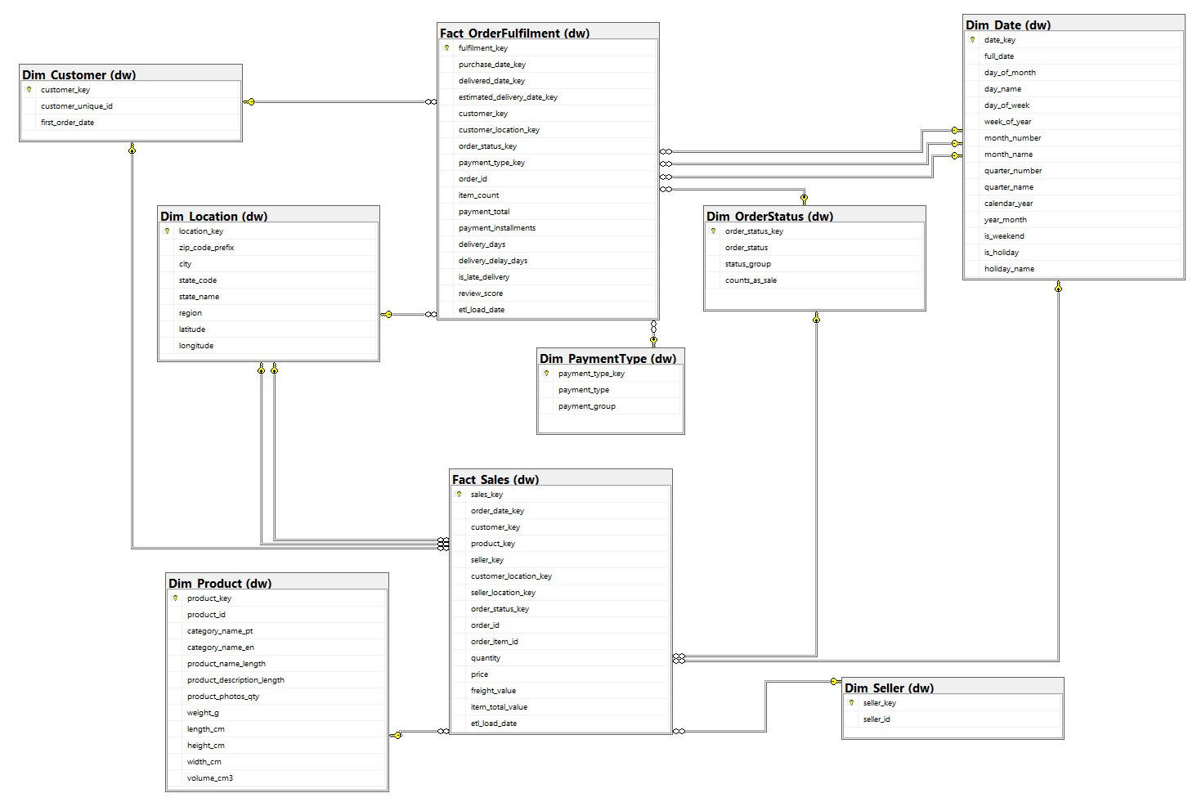

4.3 Fact Tables
Additive measures can be summed across any dimension.
Non-additive measures should be averaged or counted instead, because summing them gives no meaning.

Fact_Sales (grain: one row per order item)

Column | Data type | Role | Description
sales_key | BIGINT identity | Primary key | Surrogate key of the fact row
order_date_key | INT | Foreign key | Date the order was placed (Dim_Date)
customer_key | INT | Foreign key | Customer who bought (Dim_Customer)
product_key | INT | Foreign key | Product sold (Dim_Product)
seller_key | INT | Foreign key | Seller who sold it (Dim_Seller)
customer_location_key | INT | Foreign key | Location of the customer (Dim_Location)
seller_location_key | INT | Foreign key | Location of the seller (Dim_Location)
order_status_key | INT | Foreign key | Status of the order (Dim_OrderStatus)
order_id | CHAR(32) | Degenerate dimension | Order number. It has no table of its own.
order_item_id | INT | Degenerate dimension | Item number inside the order. With order_id it defines the grain (unique constraint).
quantity | INT | Measure, additive | Always 1 per row. Summing gives the number of items sold.
price | DECIMAL(10,2) | Measure, additive | Item price in Brazilian reais
freight_value | DECIMAL(10,2) | Measure, additive | Shipping charge for the item
item_total_value | DECIMAL(10,2) | Measure, additive, derived | price + freight_value
etl_load_date | DATETIME2(0) | Audit | When the ETL inserted the row

Fact_OrderFulfilment (grain: one row per order)

Column | Data type | Role | Description
fulfilment_key | BIGINT identity | Primary key | Surrogate key of the fact row
purchase_date_key | INT | Foreign key | Date the order was placed (Dim_Date, role 1)
delivered_date_key | INT | Foreign key | Date delivered to the customer (Dim_Date, role 2). -1 if not delivered.
estimated_delivery_date_key | INT | Foreign key | Date promised to the customer (Dim_Date, role 3)
customer_key | INT | Foreign key | Customer (Dim_Customer)
customer_location_key | INT | Foreign key | Customer location (Dim_Location)
order_status_key | INT | Foreign key | Order status (Dim_OrderStatus)
payment_type_key | INT | Foreign key | Main payment type, the one with the largest value (Dim_PaymentType)
order_id | CHAR(32) | Degenerate dimension | Order number. Unique, so it defines the grain.
item_count | INT | Measure, additive | Number of items in the order
payment_total | DECIMAL(12,2) | Measure, additive | Sum of all payments for the order
payment_installments | INT | Measure, non-additive | Instalments of the main payment. Empty if there is no payment.
delivery_days | INT | Measure, non-additive | Days from purchase to delivery. Empty if not delivered.
delivery_delay_days | INT | Measure, non-additive | Delivery date minus estimated date. Positive means late, negative means early.
is_late_delivery | BIT | Measure, additive | 1 if late, 0 if on time. Summing gives the number of late orders. Empty if not delivered.
review_score | TINYINT | Measure, non-additive | Score from 1 to 5 of the latest review. Empty if the order has no review.
etl_load_date | DATETIME2(0) | Audit | When the ETL inserted the row

4.4 Dimension Tables

Dim_Date (one row per calendar day, 1 January 2016 to 31 December 2018)
Column | Data type | Description
date_key | INT | Primary key. The date as a number, for example 20171124. The value -1 means Unknown.
full_date | DATE | The calendar date
day_of_month | TINYINT | Day number, 1 to 31
day_name | VARCHAR(10) | Monday to Sunday
day_of_week | TINYINT | 1 (Monday) to 7 (Sunday)
week_of_year | TINYINT | Week number in the year
month_number | TINYINT | 1 to 12
month_name | VARCHAR(10) | January to December
quarter_number | TINYINT | 1 to 4
quarter_name | VARCHAR(10) | Q1 to Q4
calendar_year | SMALLINT | Year, 2016 to 2018
year_month | VARCHAR(10) | Year and month for sorting, for example 2017-11
is_weekend | BIT | 1 for Saturday or Sunday
is_holiday | BIT | 1 for a Brazilian national public holiday (from the holiday API)
holiday_name | NVARCHAR(100) | Name of the holiday. Empty on other days.

Dim_Customer (one row per real customer)
Column | Data type | Description
customer_key | INT identity | Primary key (surrogate)
customer_unique_id | CHAR(32) | Business key. One value per real person, even if the person ordered many times.
first_order_date | DATE | Date of the first order of the customer in the data

Dim_Product (one row per product)
Column | Data type | Description
product_key | INT identity | Primary key (surrogate)
product_id | CHAR(32) | Business key
category_name_pt | NVARCHAR(100) | Category name in Portuguese, as in the source
category_name_en | NVARCHAR(100) | Category name in English. Unknown if the product has no category.
product_name_length | INT | Length of the product name (spelling of the source column corrected)
product_description_length | INT | Length of the product description
product_photos_qty | INT | Number of photos
weight_g, length_cm, height_cm, width_cm | INT | Weight and size of the product
volume_cm3 | INT | Derived: length x height x width

Dim_Seller (one row per seller)
Column | Data type | Description
seller_key | INT identity | Primary key (surrogate)
seller_id | CHAR(32) | Business key

Dim_Location (one row per zip code prefix)
Column | Data type | Description
location_key | INT identity | Primary key (surrogate)
zip_code_prefix | VARCHAR(5) | Business key
city | NVARCHAR(100) | City name, standardised
state_code | CHAR(2) | Two-letter state code, for example SP
state_name | NVARCHAR(50) | Full state name, derived from the code
region | NVARCHAR(20) | Derived: North, Northeast, Central-West, Southeast or South
latitude, longitude | DECIMAL(9,6) | Average of the geolocation points for the zip prefix

Dim_OrderStatus (one row per order status)
Column | Data type | Description
order_status_key | INT identity | Primary key (surrogate)
order_status | VARCHAR(20) | Business key, the status in the source
status_group | VARCHAR(20) | Delivered, In progress or Not fulfilled
counts_as_sale | BIT | 0 for canceled and unavailable orders, 1 for all others

Order status mapping
order_status | status_group | counts_as_sale
delivered | Delivered | 1
shipped, invoiced, processing, approved, created | In progress | 1
canceled, unavailable | Not fulfilled | 0

Dim_PaymentType (one row per payment type)
Column | Data type | Description
payment_type_key | INT identity | Primary key (surrogate)
payment_type | VARCHAR(20) | Business key: credit_card, debit_card, boleto, voucher or not_defined
payment_group | VARCHAR(20) | Card, Bank slip, Voucher or Not defined

Payment type mapping
payment_type | payment_group | Note
credit_card, debit_card | Card | Paid by card
boleto | Bank slip | A Brazilian bank slip payment
voucher | Voucher | Paid with a voucher
not_defined | Not defined | 3 payments with value 0 in the source

4.5 Relationships

Every relationship is many-to-one: many fact rows point to one dimension row. A dimension used more than once by a fact table is called a role-playing dimension.

Foreign key relationships
Fact table | Foreign key column | Dimension | Role
Fact_Sales | order_date_key | Dim_Date | Order date
Fact_Sales | customer_key | Dim_Customer | Buyer
Fact_Sales | product_key | Dim_Product | Product sold
Fact_Sales | seller_key | Dim_Seller | Seller
Fact_Sales | customer_location_key | Dim_Location | Customer location (role 1)
Fact_Sales | seller_location_key | Dim_Location | Seller location (role 2)
Fact_Sales | order_status_key | Dim_OrderStatus | Order status
Fact_OrderFulfilment | purchase_date_key | Dim_Date | Purchase date (role 1)
Fact_OrderFulfilment | delivered_date_key | Dim_Date | Delivery date (role 2)
Fact_OrderFulfilment | estimated_delivery_date_key | Dim_Date | Promised date (role 3)
Fact_OrderFulfilment | customer_key | Dim_Customer | Buyer
Fact_OrderFulfilment | customer_location_key | Dim_Location | Customer location
Fact_OrderFulfilment | order_status_key | Dim_OrderStatus | Order status
Fact_OrderFulfilment | payment_type_key | Dim_PaymentType | Main payment type

4.6 Hierarchies

Hierarchies let users drill down (from a summary to detail) and roll up (back to the summary) in the dashboard.

Dimension | Hierarchy (top to bottom) | Used for
Dim_Date | Year > Quarter > Month > Day | Trend analysis, from yearly totals down to single days
Dim_Location | Region > State > City > Zip prefix | Regional comparison, from a region down to a zip code
Dim_Product | Category > Product | Category performance, then single products
Dim_PaymentType | Payment group > Payment type | Card versus other methods, then credit versus debit
Dim_OrderStatus | Status group > Order status | Delivered versus not fulfilled orders
Dim_Customer, Dim_Seller | None | Olist anonymises them, so they hold only an identifier. They are analysed through location and the measures.

4.7 Modelling Techniques Used

- Surrogate keys. Each dimension has its own warehouse key, so the warehouse does not depend on the source identifiers.
- Unknown members. A row with key -1 in every dimension means no fact row ever needs a missing key.
- Degenerate dimensions. The order number is kept in the fact table because it has no attributes of its own.
- Role-playing dimensions. Dim_Date is used three times in one fact table, and Dim_Location is used for both customers and sellers. In the Power BI model the table is loaded once for each role.
- Conformed dimensions. Both fact tables use the same Dim_Date, Dim_Customer, Dim_Location and Dim_OrderStatus, so their results are comparable.
- Slowly changing dimensions, Type 1. Changed values are overwritten and no history is kept. The source has no change history, and the attributes are mostly stable.

4.8 Source-to-Target Summary

Where each warehouse table gets its data

Warehouse table | Source | Main logic
Dim_Date | Generated calendar and S3 holiday API | One row per day for 2016 to 2018. Holiday flag from the API.
Dim_Customer | customers and orders | One row per customer_unique_id. First order date from orders.
Dim_Product | products and S2 category translation | Add English category, handle missing values, derive volume.
Dim_Seller | sellers | One row per seller_id.
Dim_Location | S2 geolocation, customers and sellers | One row per zip prefix. Average coordinates. Derive state name and region.
Dim_OrderStatus | orders | Distinct statuses with the order status mapping in Section 4.4.
Dim_PaymentType | order_payments | Distinct payment types with the payment type mapping in Section 4.4.
Fact_Sales | order_items and orders | One row per item. Look up all dimension keys. Derive item_total_value.
Fact_OrderFulfilment | orders, order_items, order_payments and order_reviews | One row per order. Aggregate items and payments. Take the latest review. Calculate delivery measures.

4.9 Design Assumptions

- Revenue. Revenue is the item price of orders where counts_as_sale = 1. Canceled and unavailable orders are excluded. Freight is reported separately.

- Currency. All values are in Brazilian reais. No conversion or inflation adjustment is made.

- Customer identity. A customer is identified by customer_unique_id. The customer location comes from each order, so it shows where the customer was at the time of the order.

- History. Dimensions use Type 1 (overwrite). No history of changes is kept.

- Missing values. Missing dimension values use the Unknown row (key -1). Missing measures stay empty, not zero.

- Reviews. Only the latest review of each order is used. Review comment text is not loaded because it is not needed for the business questions.

- Payments. The main payment type is the payment with the largest value in the order. If values are equal, the lowest payment sequence is used. payment_total adds all payments of the order.

- Delivery. Delivery measures exist only for orders with a delivery date. An order is late if it is delivered on a later calendar day than the estimated date. The 8 delivered orders without a delivery date are treated as not delivered.

- Date range. Dim_Date covers 1 January 2016 to 31 December 2018. Every date used in a fact table must exist in it, and this is checked in the ETL validation.

- Products. The misspelled source columns (lenght) are corrected. The category is shown in English. If a category has no translation, the Portuguese name is used. Products with no category are Unknown.

- Locations. There is one row per zip prefix. Coordinates are the average of all geolocation points for that prefix. The region is derived from the state code.

- Holidays. The holiday flag covers national holidays only, because the API does not provide city-level holidays.

- Partial months. The first and last months of the data contain very few orders. They are loaded, but dashboard analysis focuses on January 2017 to August 2018.

Task 5 – ETL Development

5.1 Overview
The ETL process was built with SQL Server Integration Services (SSIS) in one project, Olist_ETL. T-SQL is used inside the packages for source queries, transformations and validation. Four packages run in a fixed order under a master package.
Package | Purpose
01_Staging_Load | Extracts the three sources into the staging area
02_Load_Dimensions | Transforms and loads the 7 dimension tables
03_Load_Facts | Transforms and loads the 2 fact tables
00_Master | Runs 01, 02 and 03 in order, then the validation procedure

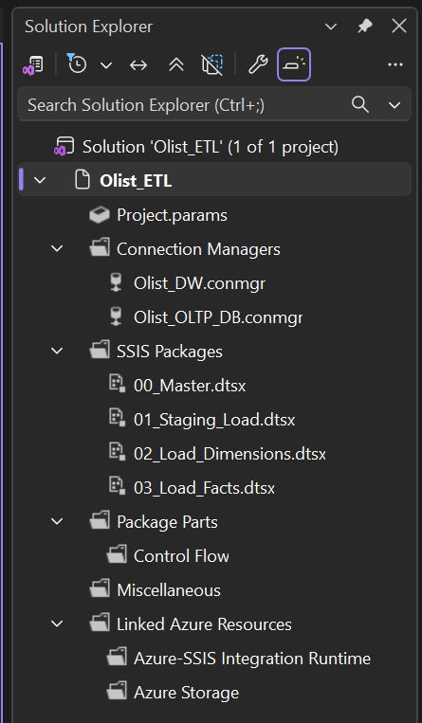
Solution Explorer of the Olist_ETL project

5.2 Extract

5.2.1 Extraction method and source connections

Source | Extraction method | Source connection
S1 Olist database | OLE DB Source to OLE DB Destination (7 data flows) | Project connection Olist_OLTP_DB: Microsoft OLE DB Driver for SQL Server, server localhost, Windows authentication, database Olist_OLTP_DB
S2 CSV files | Flat File Source to OLE DB Destination (2 data flows) | Flat File connections to the source folder: UTF-8 (code page 65001), text qualifier ", header row skipped, columns read as Unicode text
S3 Holiday API | Script Task (C#) plus an Execute SQL Task | HTTPS request to https://date.nager.at/api/v3/PublicHolidays/{year}/BR for 2016, 2017 and 2018

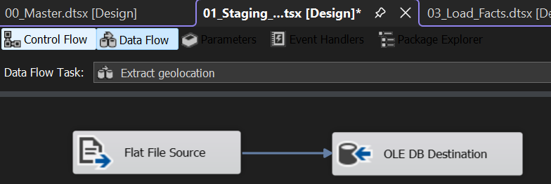
Extract Geolocation from flat files

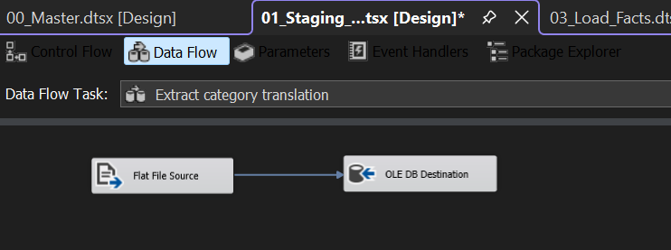
Extract category translation from flat files

5.2.2 Extraction process

Package 01 runs these steps in order:
- An Execute SQL Task, "Truncate staging", empties the ten staging tables so that each run starts clean.
- Seven data flows copy customers, sellers, products, orders, order items, order payments and order reviews from Olist_OLTP_DB to the staging tables. For reviews, a SQL command selects only the columns needed, so the comment text is not extracted.
- Two data flows load the geolocation file (1,000,163 rows) and the category translation file (71 rows).
- A Script Task, "Download holidays (API)", requests the holiday data for each year, saves each response as a raw JSON file, and stores the text in a staging table. If the call fails, it writes a warning and uses the saved file, so the package does not fail because of the internet connection.
- An Execute SQL Task, "Parse holidays", reads the JSON with OPENJSON into stg_public_holidays (42 rows, with the date, names, the nationwide flag and the holiday type).

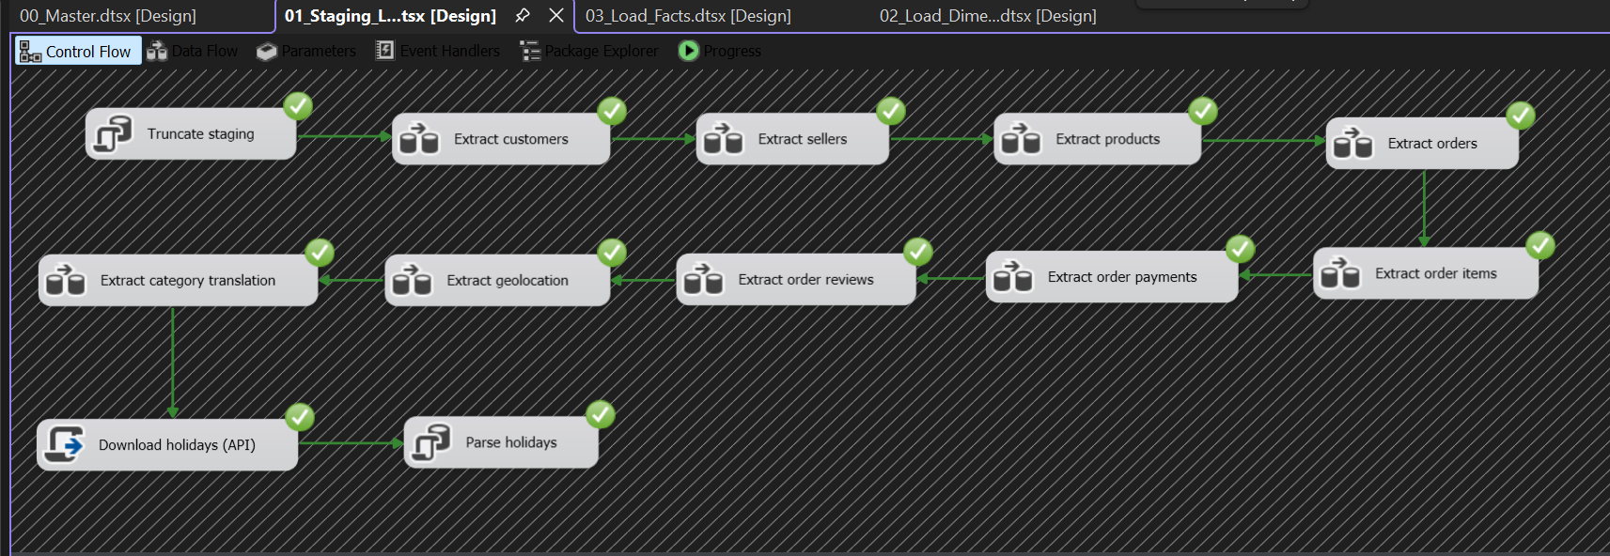Control flow of package 01

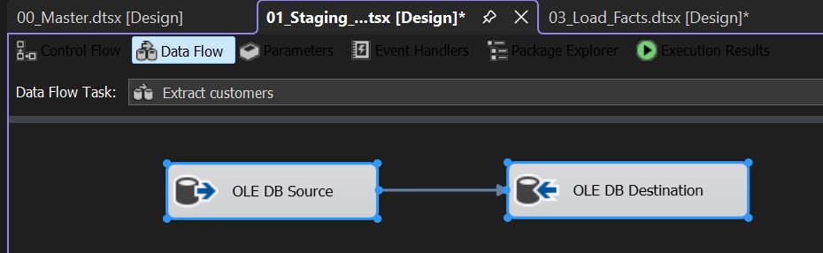
Extract Customers (OLE DB Source to OLE DB Destination)

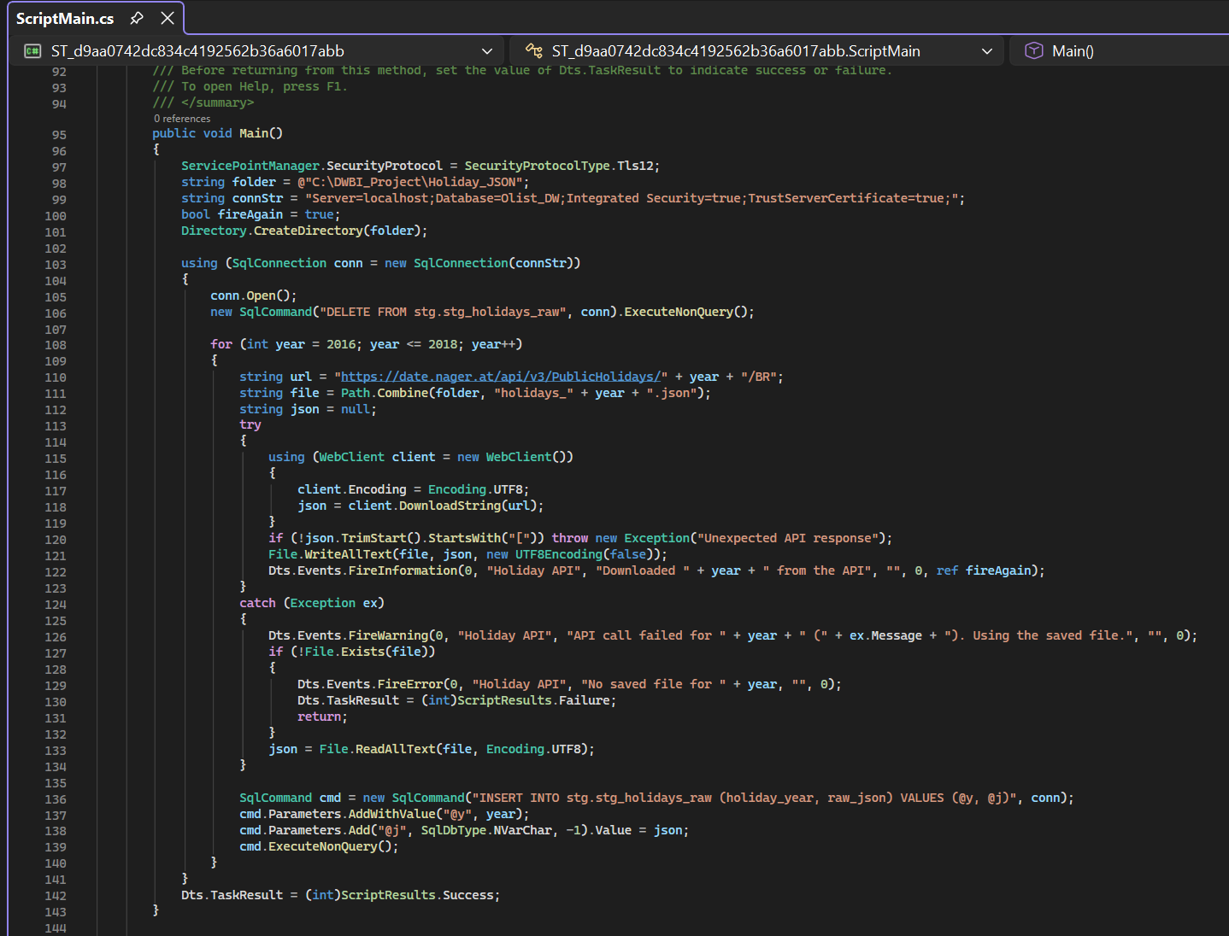
Script task code for download holidays from API
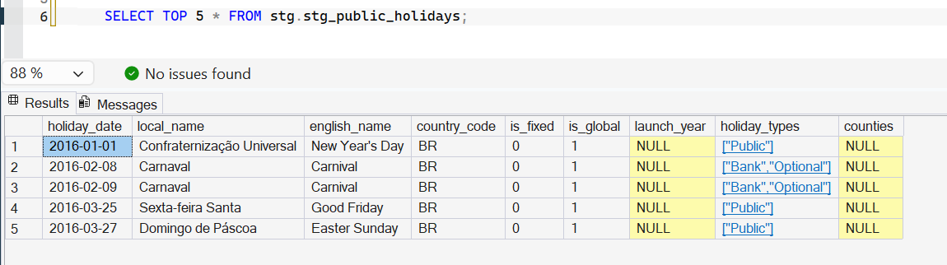
Holidays staging table in SSMS after downloading holidays from the API

5.3 Transform

The transformations were designed from the profiling results (Task 2, Table 2.7). They are written as T-SQL queries that serve as the sources of the data flows in packages 02 and 03.

Transformation type | What was done | Evidence
Missing value handling | Products without a category become Unknown. Orders not delivered keep empty delivery measures and use the Unknown date key (-1). Orders without a review keep an empty score. One order without a payment uses the Unknown payment type. Locations without coordinates keep empty coordinates. | 610 products without category, 2,965 orders without a delivery date, 768 orders without a review
Duplicate removal | One customer row per customer_unique_id. Geolocation points reduced to one row per zip prefix. Only the latest review of each order is kept. One main payment type per order. | 99,441 customer rows became 96,096 customers. 1,000,163 geolocation rows became 15,078 locations.
Data cleansing | 42 geolocation points outside Brazil were removed before averaging. State-level holidays are not flagged. Canceled and unavailable orders are marked as not counting as sales. | 42 points removed. 3 of 42 holidays not nationwide. 625 canceled and 609 unavailable orders.
Standardisation | Misspelled source columns corrected (lenght). English category names used, with the Portuguese name as a fallback. City names trimmed and state codes in upper case. Order statuses and payment types grouped. Zip codes kept as 5-character text. | Dim_Product, Dim_Location, Dim_OrderStatus, Dim_PaymentType
Data type conversion | Text latitude and longitude converted to numbers and then to DECIMAL(9,6). Dates converted to an integer date key (yyyymmdd). Timestamps converted to dates for key matching. JSON text converted to typed columns (date, true or false, number) with OPENJSON. | Dim_Location, Dim_Date, stg_public_holidays
Aggregation | Items counted and payments summed for each order. The earliest order date found for each customer. Coordinates averaged for each zip prefix. | item_count, payment_total, first_order_date, latitude and longitude
Derived attributes | item_total_value, volume_cm3, delivery_days, delivery_delay_days, is_late_delivery, state_name, region, status_group, counts_as_sale, payment_group, holiday flag and name, week, quarter, year_month, is_weekend | Dim_Date, Dim_Location, Dim_Product, both fact tables

5.4 Load

5.4.1 Loading sequence

Step | Package | Task | Target | Rows
1 | 02 | Clear warehouse tables | Facts, then dimensions (the Unknown rows are kept)
2 | 02 | Load Dim_Date | dw.Dim_Date | 1,097
3 | 02 | Load Dim_OrderStatus | dw.Dim_OrderStatus | 9
4 | 02 | Load Dim_PaymentType | dw.Dim_PaymentType | 6
5 | 02 | Load Dim_Seller | dw.Dim_Seller | 3,096
6 | 02 | Load Dim_Customer | dw.Dim_Customer | 96,097
7 | 02 | Load Dim_Product | dw.Dim_Product | 32,952
8 | 02 | Load Dim_Location | dw.Dim_Location | 15,079
9 | 03 | Clear fact tables | Facts, with identity reset
10 | 03 | Load Fact_Sales | dw.Fact_Sales | 112,650
11 | 03 | Load Fact_OrderFulfilment | dw.Fact_OrderFulfilment | 99,441

Dimension rows include the Unknown row. The dimensions are loaded before the facts because each fact row needs the surrogate keys of its dimensions. The facts are cleared before the dimensions because they depend on them through foreign keys. The destinations use fast load, the key columns are left to SQL Server to generate, and the Keep identity option is off.

5.4.2 ETL workflow

The master package 00_Master runs package 01, then 02, then 03, then an Execute SQL Task that calls the validation procedure. If a task fails, the following tasks do not run. Running the master package twice from a clean state produced identical results.

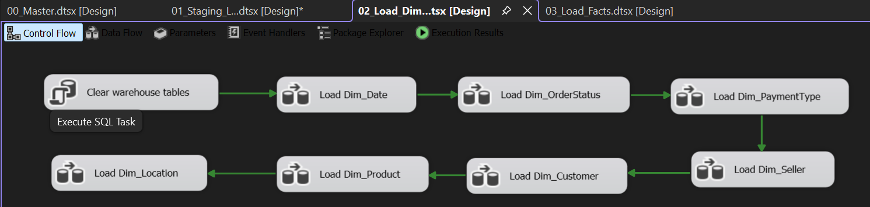

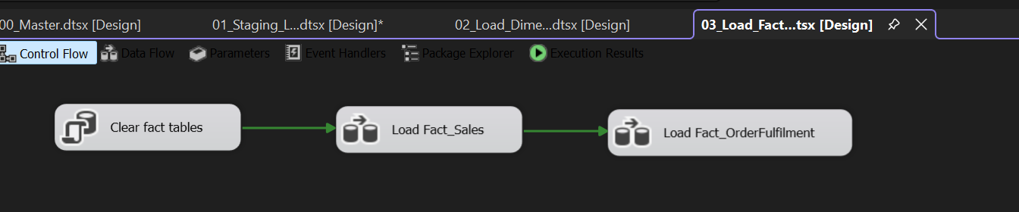

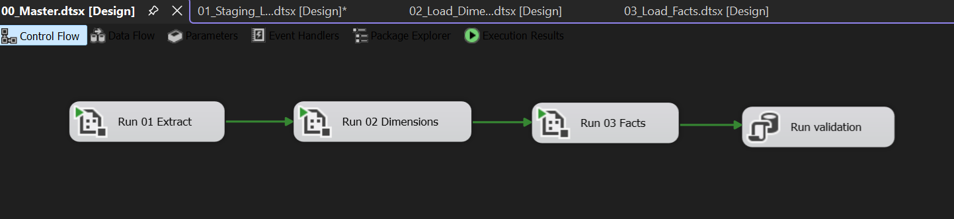

5.5 Validation Results
# | Check | Expected | Actual | Status
1 | Staging orders = source orders | 99,441 | 99,441 | PASS
2 | Staging order items = source order items | 112,650 | 112,650 | PASS
3 | Staging customers = source customers | 99,441 | 99,441 | PASS
4 | Fact_Sales rows = staged order items | 112,650 | 112,650 | PASS
5 | Fact_OrderFulfilment rows = staged orders | 99,441 | 99,441 | PASS
6 | Dim_Customer = distinct customers + Unknown | 96,097 | 96,097 | PASS
7 | Dim_Product = staged products + Unknown | 32,952 | 32,952 | PASS
8 | Total item price = staging | 13,591,643.70 | 13,591,643.70 | PASS
9 | Total freight = staging | 2,251,909.54 | 2,251,909.54 | PASS
10 | Total payments = staging | 16,008,872.12 | 16,008,872.12 | PASS
11 | Fact_Sales rows with an Unknown key | 0 | 0 | PASS
12 | Fact_OrderFulfilment rows with an Unknown key | 0 | 0 | PASS
13 | Review scores outside 1 to 5 | 0 | 0 | PASS
14 | Negative delivery days | 0 | 0 | PASS
15 | Late flag on undelivered orders | 0 | 0 | PASS
16 | Duplicate order items in Fact_Sales | 0 | 0 | PASS

5.6 Problems Found and How They Were Solved

Problem | Cause | Solution
The reviews file failed to import (OLE DB provider error) | A fixed line-ending option did not match the file | Removed the option so SQL Server detected the line endings
72 rows in the translation table, columns named "column 1" and "column 2" | The header row was loaded as data | Rebuilt the load in SSIS with the header row skipped (71 rows)
Accents garbled in the holiday names | The JSON was read with the wrong encoding | Reloaded as UTF-8
Conversion error between Unicode and non-Unicode on customer_city | The source and staging columns had different types | Recreated the staging tables with matching Unicode types
Staging was first loaded with T-SQL | The assignment requires SSIS for the ETL | Rebuilt the extraction as an SSIS package
Validation procedure failed with "Invalid object name" | The source database name in the script was wrong | Corrected the database name in the procedure

Task 6: Data Mart Development

6.1 Overview

Two department-specific data marts were created on top of the enterprise data warehouse. A data mart is a smaller, focused view of the warehouse that gives one department exactly the data it needs, with that department's business rules already applied. Both marts are SQL views in the mart schema of the Olist_DW database. They are built from the warehouse tables, so they always show current warehouse data and need no extra ETL step.

 | Sales Mart | Delivery and Satisfaction Mart
Object name | mart.Sales_Mart | mart.Delivery_Satisfaction_Mart
Grain | One row per order item | One row per order
Built from | Fact_Sales and six dimensions | Fact_OrderFulfilment and five dimensions (Date three times)
Business rule | Only real sales: items of canceled and unavailable orders are removed | Only delivered orders: orders that have a delivery date
Rows | 112,101 | 96,476

6.2 Sales Mart

Purpose. It gives one flat table of real sales. Each row is one sold item, with the date, product category, seller, customer location, status and the money values already attached.
Target users. Sales and marketing managers and analysts.
Business rule applied. Only orders with counts_as_sale = 1 are included. This removes 549 items that belong to canceled and unavailable orders (112,650 items in the warehouse, 112,101 in the mart), so revenue taken from the mart is real revenue.
Columns.
- When: order_date, calendar_year, quarter_name, month_number, month_name, year_month, day_name, is_weekend, is_holiday, holiday_name
- What: product_id, product_category (English name)
- Who sold: seller_id, seller_state, seller_region
- Who bought: customer_unique_id, customer_city, customer_state, customer_region
- Status: order_status
- Measures: quantity, price, freight_value, item_total_value
Analytical benefits.
- Sales questions are answered from one table, with no joins and no knowledge of the warehouse keys.
- Revenue is correct by default, because the sales rule is built in.
- The same table supports questions on categories, sellers, regions, months and holidays, for example which categories earn the most, which regions buy the most, and whether holidays change sales.

6.3 Delivery and Satisfaction Mart

Purpose. It gives one flat table of delivered orders, with the delivery time, whether the order was late, the payment details and the customer's review score.
Target users. Operations and customer service managers.
Business rule applied. Only orders with a delivery date are included (99,441 orders minus 2,965 that were never delivered, which leaves 96,476). Delivery measures are therefore meaningful in every row.
Columns.
- When: purchase_date, purchase_year, purchase_quarter, purchase_month_number, purchase_month, purchase_year_month, delivered_date, estimated_delivery_date
- Where: customer_city, customer_state, customer_region
- Status and payment: order_status, status_group, payment_type, payment_group
- Measures: item_count, payment_total, payment_installments, delivery_days, delivery_delay_days, is_late_delivery, review_score
Analytical benefits.
- Delivery performance and customer satisfaction can be analysed together in one table.
- Averages of delivery time and review score are counted once per order, with no risk of double counting.
- It supports questions on late deliveries by region and month, on payment methods, and on whether late orders receive lower review scores.

6.4 Implementation

The marts were created with the script 06_data_marts.sql. Each mart is a view that joins a fact table to its dimensions with INNER JOINs, selects readable columns, and applies the filter of its department. The script ends with a check that compares the number of rows in each mart with the expected number taken from the warehouse (112,101 and 96,476). Both checks matched.
Design choice. Views were used instead of separate tables. A view always shows the current warehouse data and needs no extra loading step. With about 100,000 rows the speed is not a problem. For a much larger warehouse, the marts could be stored as tables and refreshed by the ETL.
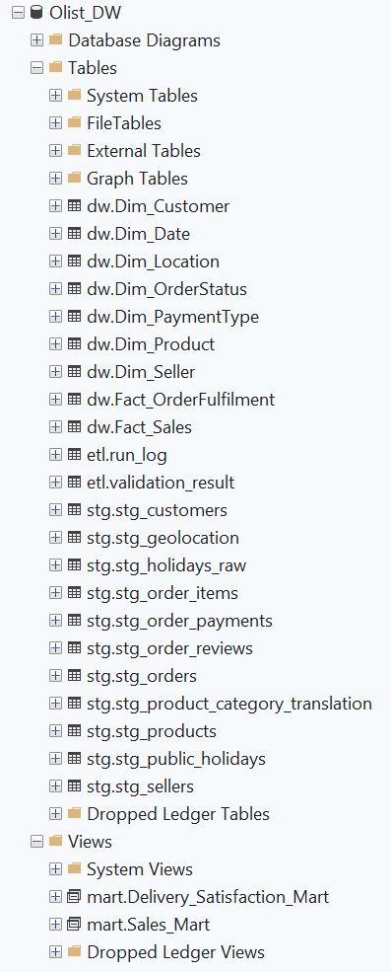

Task 7: OLAP Analysis and Business Intelligence Dashboard Development

7.1 Overview

The analysis layer has two parts. An SSAS multidimensional cube (Olist_Cube) provides the OLAP model, and a three-page Power BI report is connected live to the cube. Both read the data warehouse Olist_DW, so the totals agree.

7.2 OLAP Cube Design

- Data source and view. The cube reads Olist_DW through an OLE DB data source. The data source view contains the nine warehouse tables. Named calculations add readable labels (for example year-quarter and state-city) and helper columns that a cube can add up (for example late order as 0 or 1).
- Dimensions. Date, Customer, Product, Seller, Order Status and Payment Type, plus Location used twice (Customer Location and Seller Location). Date is also used as Delivered Date and Estimated Delivery Date for the order fulfilment facts.
- Hierarchies. Calendar (Year, Quarter, Month, Date), Geography (Region, State, City, Zip prefix), Product (Category, Product), Payment (Group, Type) and Status (Group, Status).
- Measure groups. Fact Sales (price, freight, quantity) and Fact Order Fulfilment (item count, payment total, delivery days, review score, delivered orders, review count, late orders).
- Calculated members.

Measure | Definition
Revenue | Price minus the price of the Not fulfilled status group
Freight, Items Sold, Sales Orders | The same rule applied to freight, quantity and orders with items
Avg Delivery Days | Delivery days divided by delivered orders
Avg Review Score | Review score divided by review count
Late Delivery % | Late orders divided by delivered orders

- Rule for combining measures. Sales measures work only with Date, Customer, Product, Seller, Customer Location, Seller Location and Order Status. Order measures work only with Date, Customer, Customer Location, Order Status and Payment Type. A measure used with an unrelated dimension repeats the same total on every row, so the dashboard avoids these combinations.

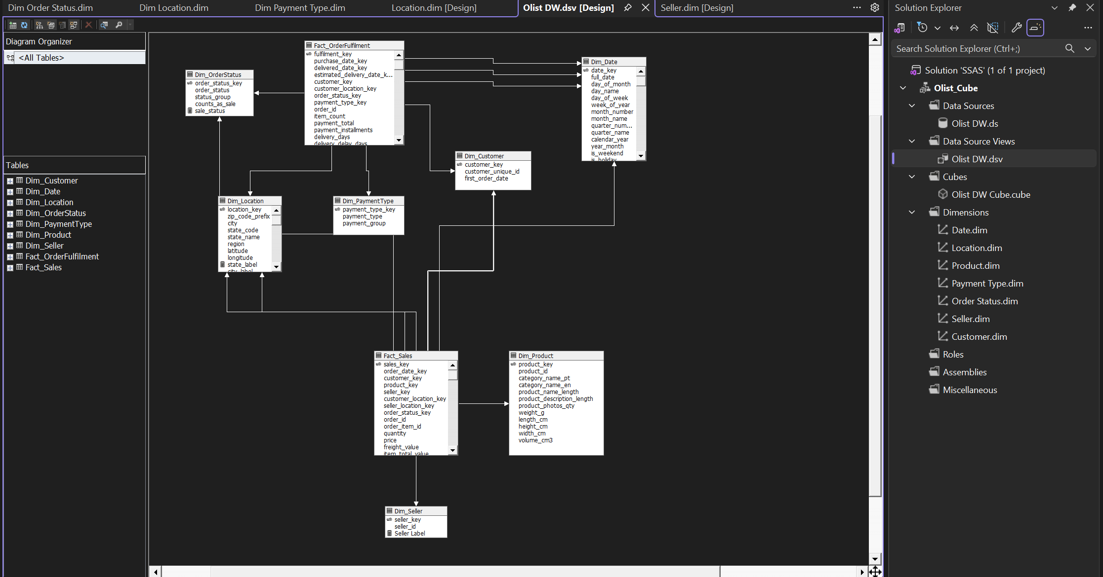
[Data Source View diagram]

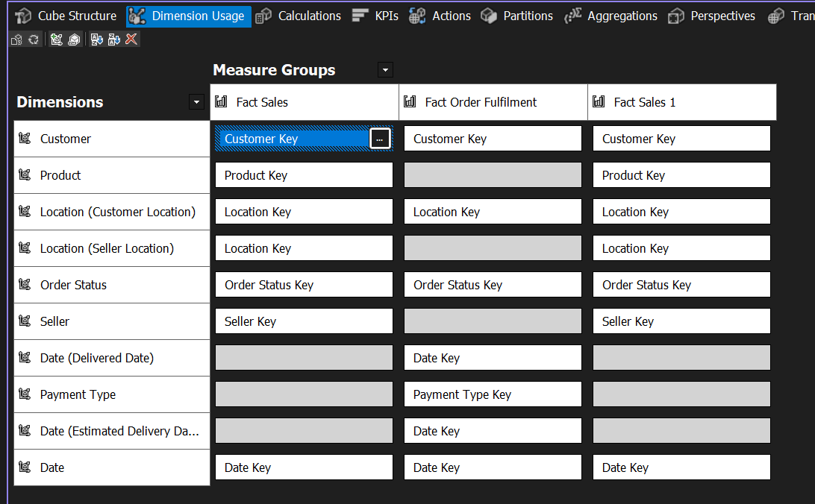
[Dimension Usage tab]

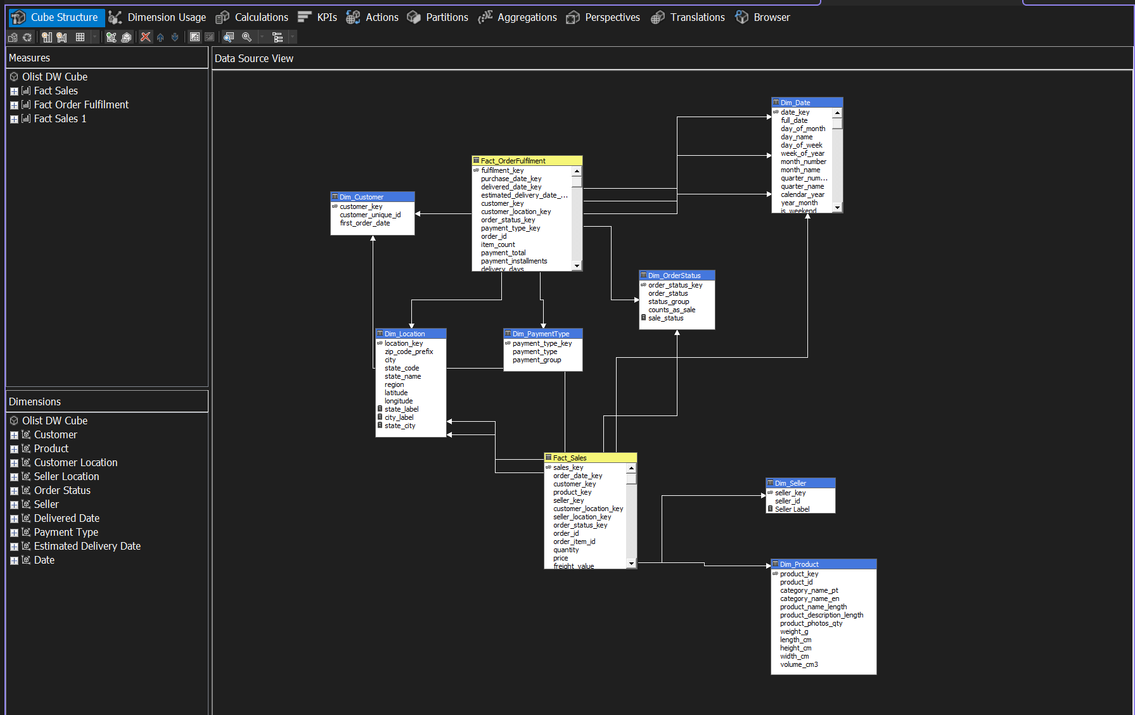
[Cube Structure tab]

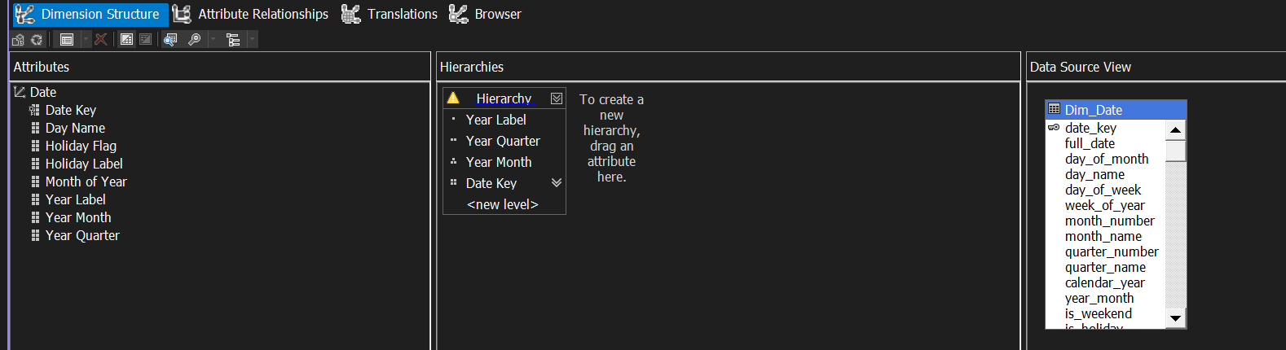
[Date dimension with the Calendar hierarchy]

7.3 Cube Verification

Measure | Cube result | Check
Price (no filter) | 13,591,643.70 | Equals the staging total
Quantity | 112,650 | Equals the order items
Fact Order Fulfilment Count | 99,441 | Equals the orders
Delivered Orders | 96,476 | Orders with a delivery date
Avg Delivery Days | 12.50 | 1,205,693 days over 96,476 orders
Avg Review Score | 4.09 | 403,204 over 98,673 reviews
Revenue (sales rule) | 13,494,400.74 | Equals Power BI
Items Sold | 112,101 | Equals Power BI
Sales Orders | 98,199 | Equals Power BI
Freight | 2,241,126.29 | Equals the warehouse

[cube browser with the totals]

7.4 Power BI Report Design

The report connects live to Olist_Cube, so every measure comes from the cube and matches its numbers. All pages share one theme, a left sidebar with page navigation and slicers, and a title area. The sidebar slicers are Year, State City and Product Category. The month filter excludes the five nearly empty months (September, October and December 2016, and September and October 2018), so every page covers January 2017 to August 2018. Seller names are anonymised in the data, so sellers appear as numbers assigned by the warehouse.

Page 1: Executive Summary

Visual | Fields | Purpose
7 KPI cards | Revenue, Sales Orders, Items Sold, Avg Delivery Days, Avg Review Score, Late Delivery %, Freight | Overall performance at a glance
Revenue by category | Product category, Revenue (top 10) | Where revenue comes from
Revenue by seller | Seller, Revenue (top 10) | Seller concentration
Sales orders by state | Customer state (drills down to payment group), Sales Orders | Where orders come from and how they are paid
Sales orders by quarter | Year > Quarter > Month, Sales Orders | Order volume over time

Page 2: Trend Analysis

Visual | Fields | Purpose
Orders and items sold | Year > Quarter > Month, Sales Orders, Items Sold | Growth and seasonality
2017 versus 2018 | Quarter or month of year, year as legend, Revenue | A comparison chart
Delivery trend | Year Month, Avg Delivery Days, Late Delivery % | Delivery speed over time
Satisfaction trend | Year Month, Avg Review Score | Customer satisfaction over time

Page 3: Interactive Analysis

Visual | Fields | Purpose
Revenue by seller region | Seller region, Revenue | Where sales are shipped from
Avg order value by region | Customer region, Avg Order Value | Spending per order
Review score by city | Customer state and city, Avg Review Score | Spread of satisfaction across cities
Drill-down matrix | Location hierarchy (State > City > Zip prefix), Revenue, Sales Orders, Avg Delivery Days, Late Delivery %, Avg Review Score | Drill-down and roll-up

Filters, slicers, drill-down and roll-up. The three slicers filter the pages. Year and State City filter every visual. The Category slicer filters only the revenue visuals, because the order measures have no product link. The location matrix and the date charts support drill-down, and the up arrow rolls back up.

7.5 Problems Solved in This Task

Problem | Cause | Solution
Login failed when processing the cube | The SSAS service account had no rights on Olist_DW | Gave the account read access to the database
Averages were thousands of days | Count measures were created as distinct counts | Replaced them with count of non-empty values
Revenue showed #Error | A formula used a different dimension name from the cube | Renamed the dimension to match
Extra measure groups appeared | Leftover measures from the first attempt | Deleted the empty groups
Seller IDs unreadable in charts | Source identifiers are anonymised hash codes | Used numbered labels, with the key reset in the ETL

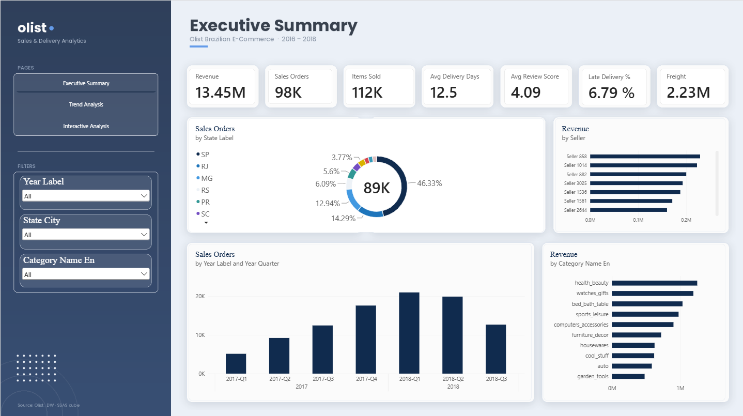

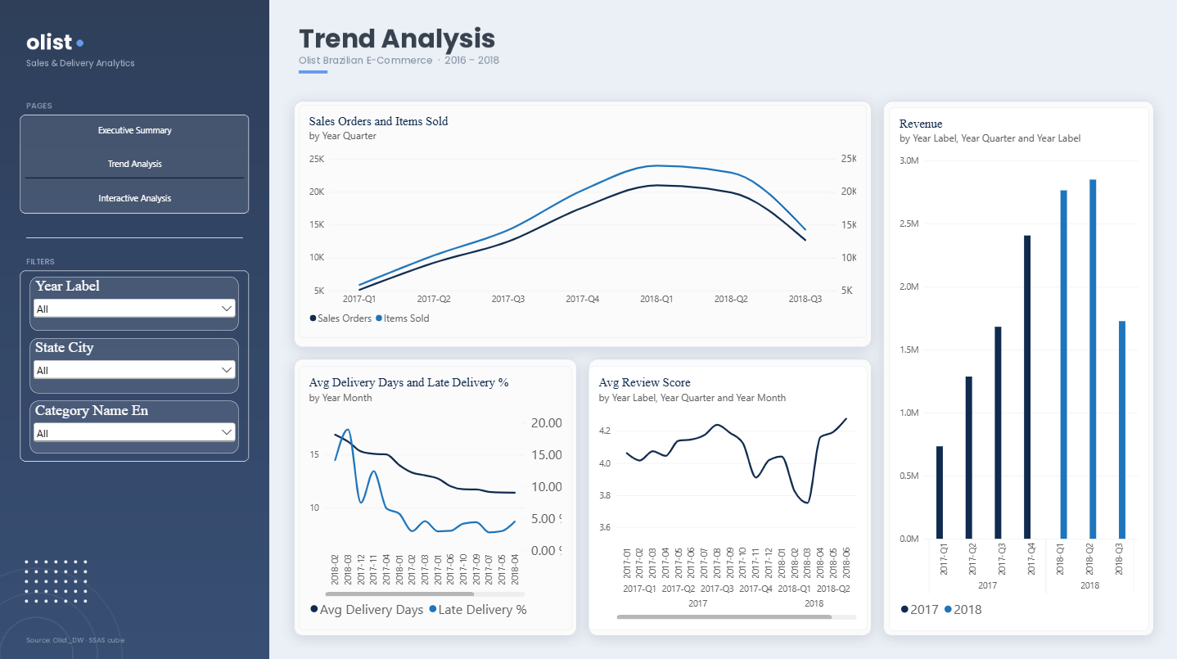

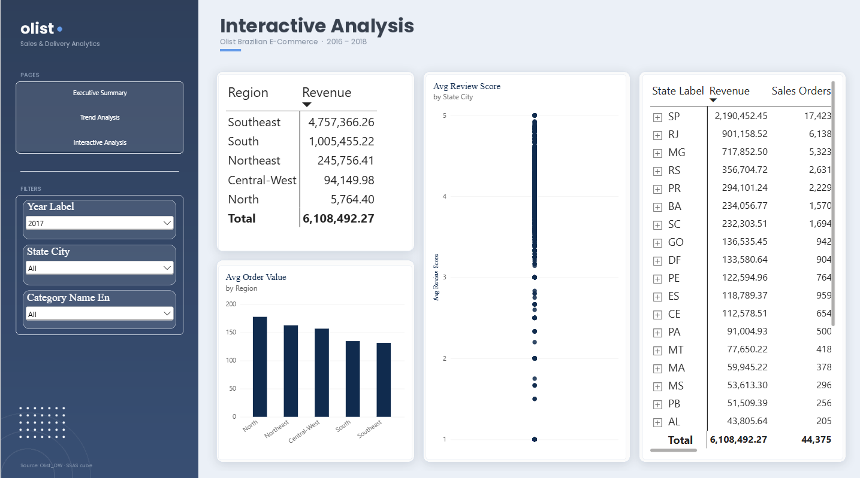

Task 8: Business Insights and Recommendations

8.1 Insights

Insight 1: Demand grew about fourfold within a year.

Evidence:
Orders rose from about 5,100 in 2017-Q1 to about 20,900 in 2018-Q1. Quarterly revenue rose from about 0.73M to 2.76M, 3.8 times as much. Full-year 2017 revenue was 6.11M from 44,375 orders. In only eight months of 2018, revenue reached 7.34M from 53,531 orders.
Decision it supports:
The marketplace is scaling quickly, so logistics, support and seller capacity must grow with it.
Recommendation:
Plan carrier and staffing capacity against the 2018 run rate, not against 2017.

Insight 2: Growth levelled off in 2018, and November 2017 was the biggest spike.
Evidence:

Quarterly revenue grew about 15% from 2017-Q4 (about 2.40M) to 2018-Q1 (about 2.76M), then only about 3% to 2018-Q2 (about 2.84M). Orders slipped slightly, from about 20,900 to 19,900. The 2018-Q3 drop is a partial quarter, because it holds only July and August. In the Task 2 profiling, monthly orders stayed between about 6,200 and 7,300 throughout 2018. November 2017 had 7,544 orders, 63% above October (4631), and higher than any month in 2018.

Decision it supports:
Further growth will need new demand, not just more of the same, and peak seasons need early preparation.
Recommendation:
Prepare stock, promotions and delivery capacity before November, and look for new customer segments to restart growth.

Insight 3: Demand is concentrated in three states.
Evidence:
In 2017, São Paulo alone produced 2.19M of 6.11M revenue (35.9%) and 17,423 of 44,375 orders (39.3%). With Rio de Janeiro (14.8%) and Minas Gerais (11.8%), the three states produced 62.4% of revenue. The top five states (adding Rio Grande do Sul and Paraná) produced 73%.
Decision it supports:
Marketing and delivery partnerships are concentrated in a few places.
Recommendation:
Protect delivery quality in these three states, and run a targeted campaign in mid sized states such as BA, SC and GO.

Insight 4: Sellers are even more concentrated than customers.
Evidence:
In 2017, sellers in the Southeast generated 77.9% of revenue (4.76M), while customers in the Southeast (SP, RJ, MG and ES) accounted for 64.3% (3.93M). About 0.83M, or 13.6% of revenue, was therefore shipped from Southeast sellers to customers elsewhere. The North's sellers generated only 0.1%.
Decision it supports: Seller recruitment and shipping distance.
Recommendation: Recruit sellers in the South, Northeast and Central West, so products ship from closer to the buyers.

Insight 5: Customers in remote regions spend more per order.
Evidence:
In 2017, the average order value was about 178 in the North, 162 in the Northeast, 156 in the Central West, 134 in the South and 130 in the Southeast.
Decision it supports: Pricing, shipping and promotion by region.
Recommendation: Test free shipping thresholds and bundles in the Southeast and South, where orders are smaller. Check whether remote customers order less often but buy more each time.

Insight 6: Delivery slowdowns coincide with lower customer satisfaction.
Evidence:
The overall average delivery time is 12.5 days and 6.79% of deliveries are late. The months with the longest delivery times were February 2018 (about 17 days), March 2018, December 2017 and November 2017 (about 15 to 16 days). The average review score fell to about 3.9 in November 2017 and to about 3.75 in March 2018, against 4.09 overall, then recovered to about 4.3 by June 2018. These dips follow the two busiest periods.

Decision it supports:
Operations capacity during peak periods.
Recommendation:
Add carrier capacity before peak periods, set realistic delivery promises when volume is high, and warn customers when an order is running late.

Insight 7: Revenue depends on a few categories, but not on a few sellers.
Evidence:
The top five categories (health_beauty, watches_gifts, bed_bath_table, sports_leisure and computers_accessories) bring in roughly 5.3M, about 40% of revenue. The top ten bring in about 8.3M, about 62%. The largest seller earns about 0.23M, around 2% of revenue, and the seven largest sellers visible together bring in about 10%. The marketplace has 3,095 sellers.
Decision it supports:
Stock, marketing and supplier risk.
Recommendation:
Protect supply in the leading categories and test growth in the next ranked ones. The marketplace does not rely on any one seller, which lowers supplier risk.

Insight 8: Customers rarely come back.
Evidence:
The Task 2 profiling shows 99,441 orders placed by 96,096 different customers, about 1.03 orders per customer.
Decision it supports:
Whether to invest in new or returning customers.
Recommendation:
Start a repeat purchase programme with an offer after the first delivery, and measure the repeat rate each quarter.

8.2 How the Insights Support Decisions

Area | Insights | Decision supported
Sales and marketing | 1, 2, 3, 5, 8 | Where and when to spend, and how to keep customers
Operations and logistics | 1, 2, 6 | Carrier capacity, peak preparation, delivery promises
Seller and category management | 4, 7 | Seller recruitment and stock priorities
Regional strategy | 3, 4, 5 | Where to grow and what to fix first

8.3 Limitations

- The data covers about two years, and the first and last months hold very few orders, so the analysis uses January 2017 to August 2018. The 2018-Q3 figures are a partial quarter.
- There is no cost or profit data, so margins cannot be measured.
- Customers and sellers are anonymised and shown as numbers assigned by the warehouse.
- Review comments were not loaded, so the reasons behind low scores cannot be analysed.
- The links between delivery time and satisfaction are associations in time, not proof of cause.
Seasonal conclusions rest on a single November.

Acknowledgement of AI Usage
Generative AI (Claude, by Anthropic) was used as a supporting tool in this assignment, following the CLEAR framework. It was used to explain concepts, suggest the structure of SQL scripts and ETL procedures, help debug errors (for example in SSIS, SSAS deployment and cube processing), give guidance on building the Power BI dashboard, and proofread parts of the report.
All AI output was reviewed, tested and adapted by the group. Every script was run on our own SQL Server, the ETL was checked with automated validation, and all figures in this report come from our own queries, cube and dashboard. Suggestions that were wrong or did not fit our setup were rejected or corrected. The design decisions, implementation and insights reflect the group's own understanding, and the group takes full responsibility for the submission.

