
Emotion Classification from Movie Review Data
Artificial Intelligence and Machine Learning Group Report
IT2011 Artificial Intelligence and Machine Learning 2026 Year 2 Semester 1
Group Assignment Final Evaluation and Viva
Group ID 2026 Y2 S1 MET 24
Student ID | Student Name
IT25102549 | Athapaththu A. M. P. P.
IT25102550 | Nishara W. A. S.
IT25102631 | Fernando B. K. H.
IT25102877 | Abdullah H. F.
IT25103066 | Sameeha M. S. F.
IT25103132 | Silva A. M. K. N.
BSc Honours in Information Technology
Faculty of Computing
Sri Lanka Institute of Information Technology

Report Scope and Current Conclusion
This report documents an end-to-end multiclass emotion-classification project using an assigned movie-review dataset. The group cleaned duplicated and conflicting text, removed the unsupported surprise class, created a movie-grouped evaluation protocol, and implemented reusable preprocessing and evaluation components. Among the currently validated primary models, Random Forest has the highest held-out macro-F1 at 0.1942, while Multinomial Naive Bayes records 0.1870. The difference is small, and the final conclusion must be recalculated after all six members submit valid standardized results.

Group Members and Responsibilities
Member | IT number | Preprocessing | Primary model | Result status
Athapaththu A. M. P. P. | IT25102549 | Text cleaning | Multinomial Naive Bayes | Validated
Nishara W.A.S. | IT25102550 | Stopword filtering | Logistic Regression | Pending
Fernando B. K. H. | IT25102631 | Genre encoding | Linear SVC | Pending
Abdullah H.F. | IT25102877 | Outlier handling and scaling | Random Forest | Validated
Sameeha M.S.F. | IT25103066 | Class imbalance | HistGradientBoosting | Requires protocol correction
Silva A.M.K.N. | IT25103132 | TF-IDF and SVD | MLP | Pending rerun

Completion Required Before Submission
- Add validated Logistic Regression, Linear SVC, HistGradientBoosting and MLP result pairs using the shared split and evaluation schema.
- Rerun the role-aware comparison notebook and replace the provisional three-model tables and figure in this draft.
- Confirm each member's reflection and AI-tool declaration, then export the final report as a PDF titled 2026-Y2-S1-MET-24.

1 Introduction and Problem Statement
Movie reviews contain opinions, descriptions and emotional language that can support content analysis, recommendation research and audience-response studies. This project investigates whether supervised machine-learning models can predict one of seven emotion categories from cleaned review text and associated movie metadata. The retained labels are anger, anticipation, disgust, fear, joy, optimism and sadness.
The task is difficult for two reasons. First, the class distribution is imbalanced: sadness accounts for 40.70 percent of the cleaned observations, whereas disgust accounts for 3.32 percent. Second, the target label belongs to the movie, not to each individual review. Reviews from the same film must therefore remain in the same data partition; otherwise, movie-specific names, genres and repeated language could leak between training and evaluation data.
The project objective is to build a reproducible pipeline that cleans the assigned data, fits stateful feature transformations only on training observations, evaluates models with movie-grouped cross-validation, and compares one primary model from each group member using macro-F1 as the main selection metric.

2 Dataset Description
The assigned raw dataset contains 46,173 movie-review records and eight original attributes. After normalized-text deduplication, removal of conflicting labels and exclusion of the sparse surprise category, the canonical dataset contains 16,107 unique reviews from 1,309 movies. The feature set combines review text, movie genres, review length and numerical rating information.
Field | Type | Role in the project
Reviews and cleaned_review | Text | Source text for cleaning and TF-IDF
tokens_filtered | Text | Filtered text representation
movie_name | Categorical | Grouping key for leakage control
genres and genre indicators | Categorical | Multi-label movie metadata
Ratings | Numeric | Scaled metadata feature
word_count | Numeric | Capped and robust-scaled length feature
emotion | Target | Seven-class classification label

The canonical split contains 12,886 reviews from 1,048 training movies and 3,221 reviews from 261 held-out movies. All model tuning uses five grouped and stratified folds constructed from the training set.
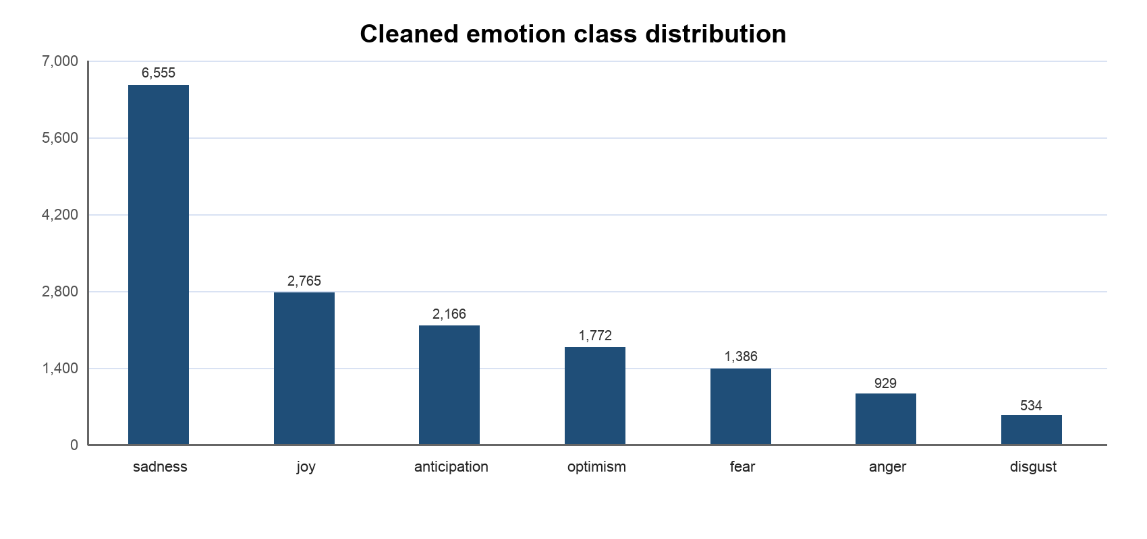
Figure 1 Distribution of the seven cleaned emotion classes

3 Preprocessing and Exploratory Data Analysis
The group implemented preprocessing as reusable transformers and integrated them into a shared pipeline. Stateless cleaning creates the canonical dataset, while stateful transformations are fitted separately within each training fold. This design prevents information from validation or test observations from influencing learned vocabularies, scaling parameters or dimensionality-reduction components.
Member contribution | Method | Purpose
Text cleaning | HTML, URL, contraction, punctuation and duplicate handling | Reduce noise and contradictory review text
Stopword filtering | Domain-aware token filtering | Remove low-information terms while retaining emotional language
Genre encoding | Multi-label binary encoding | Represent multiple genres per movie
Outlier handling | Tukey IQR capping and RobustScaler | Limit extreme review-length influence
Class imbalance | Training-only balanced loss weights | Increase minority-class contribution to model fitting
Feature extraction | TF-IDF and TruncatedSVD | Create sparse or reduced text representations

Cleaning reduced the raw data by removing repeated and conflicting text. The surprise label was excluded because only 19 reviews remained after cleaning and all came from one movie, which could not support grouped cross-validation. EDA also showed strong target imbalance and long-tailed review lengths. These findings motivated macro-F1 evaluation, balanced class weights and robust handling of word-count outliers.
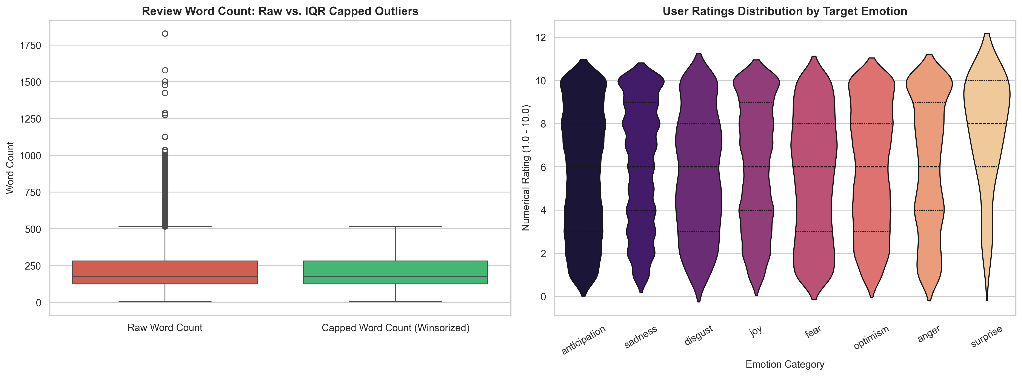
Figure 2 Raw numerical EDA before final class filtering with IQR capping shown at left

4 Model Design and Implementation
The shared model protocol fixes the cleaned dataset, movie-grouped train and test split, five grouped cross-validation folds, metric definitions and baseline calculations. Each model owner trains and tunes only on the training set, then evaluates the selected estimator once on the protected test set. Standard result JSON and prediction CSV files allow the comparison notebook to verify split fingerprints and prediction alignment before including a model.

Validated Model Implementations
Model | Role | Search | Configurations | Selected settings
Multinomial Naive Bayes | Primary | GridSearchCV | 14 | alpha 2.0; fit_prior False
Random Forest | Primary | RandomizedSearchCV | 15 | depth 16; sqrt features; balanced subsample
Decision Tree | Additional baseline | GridSearchCV | 30 | depth 20; leaf size 5; balanced

Multinomial Naive Bayes suits non-negative frequency-like TF-IDF features and provides a fast probabilistic baseline. Random Forest captures nonlinear interactions between text and metadata while reducing the variance of individual trees through averaging. The Decision Tree provides an interpretable additional baseline but is more sensitive to sample and library variation.

Preprocessing Variety Study
Member 4 evaluated five preprocessing alternatives with the same grouped folds and fixed best classifier settings: the full pipeline, text only, metadata only, reduced unigram text with metadata, and TF-IDF followed by 100-component SVD with metadata. For Random Forest, reduced text plus metadata and text-only processing were statistically tied with the full pipeline under the larger-standard-deviation rule. For the single Decision Tree, every alternative was clearly worse than the full pipeline.

Pending Primary Models
Logistic Regression, Linear SVC and MLP do not yet have validated standardized result pairs. HistGradientBoosting has an executed notebook and provisional artifacts, but its JSON does not match the shared schema and its prediction identifiers do not align with the canonical test file. These models are excluded from the numerical comparison in this draft.

5 Evaluation and Comparison
Macro-F1 is the primary metric because it gives equal importance to each emotion class. Accuracy alone is misleading: a predictor that always selects sadness achieves 0.4070 accuracy but only 0.0827 macro-F1. Weighted-F1 is reported as a secondary measure, and the confusion matrix supports class-specific error analysis.
Model | Role | CV macro-F1 | Test accuracy | Test macro-F1 | Test weighted-F1
Multinomial Naive Bayes | Primary | 0.1788 ± 0.0239 | 0.2952 | 0.1870 | 0.2817
Random Forest | Primary | 0.1708 ± 0.0138 | 0.2729 | 0.1942 | 0.2707
Decision Tree | Baseline | 0.1767 ± 0.0211 | 0.2866 | 0.1914 | 0.2788

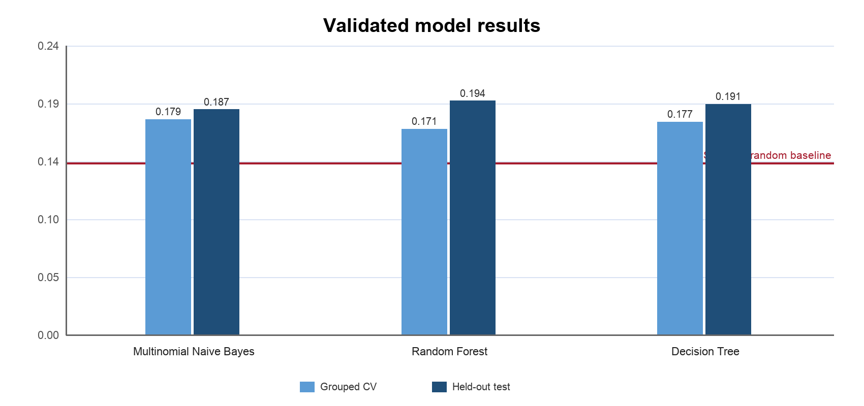
Figure 3 Provisional comparison using only validated result artifacts
Random Forest records the highest held-out macro-F1 among the two currently validated primary models. Naive Bayes records the highest test accuracy of the validated learned models, but its lower macro-F1 indicates weaker balance across minority classes. Decision Tree slightly exceeds Random Forest in mean CV macro-F1, whereas Random Forest performs slightly better on the held-out test set. The difference between these tree models is smaller than the larger CV standard deviation and is not considered clear evidence of superiority.
The current results do not support a final six-model winner. The comparison notebook must be rerun after all primary models pass schema, split-fingerprint and prediction-alignment checks. The final report should then replace this table and figure with the complete role-aware comparison and paired-bootstrap tie analysis.

6 Ethical Considerations and Bias Mitigation
The dataset contains strong class imbalance and uses movie-level emotion labels for individual review records. A prediction should therefore be interpreted as an estimate of the assigned movie category, not as a reliable assessment of a reviewer's psychological state. Deploying the model for individual profiling, moderation penalties or mental-health inference would exceed the evidence supported by the data.
Risk | Potential effect | Mitigation used or recommended
Class imbalance | Majority classes dominate accuracy | Use macro-F1, class weights and per-class analysis
Movie-level labels | Review language may not express the assigned label | State the supervision limitation and avoid person-level interpretation
Movie identity leakage | Names and repeated context inflate evaluation | Use movie-disjoint split and grouped CV
Text and genre bias | Performance may vary across genres and writing styles | Audit per-class and genre-level errors before deployment
Data provenance | Unknown consent or representativeness limits reuse | Restrict use to coursework and document the assigned source
Automation misuse | Predictions may be treated as objective emotion labels | Require human review and communicate uncertainty

The group reduced technical bias by removing duplicate and contradictory text, excluding an unsupported class, keeping movies disjoint across partitions, reporting class-balanced metrics and retaining transparent baseline comparisons. These controls do not remove dataset bias; they make the remaining limitations easier to measure and explain.

7 AI Tool Usage Declaration and Transparency
Generative AI tools supported repository review, debugging, protocol design and preparation of this editable report draft. The group remains responsible for every submitted claim, result and code path. AI-assisted changes were checked against notebook outputs, result files, automated tests and the official assignment documents.
Tool | Supported work | Extent | Verification and ownership
OpenAI Codex and ChatGPT | Code review, debugging, protocol checks, report drafting and explanation editing | Extensive for integration and documentation | Reviewed repository diffs; reran notebooks and tests; compared saved metrics and fingerprints
Other member-selected AI tools | Pending confirmation from each member | To be declared | Each member must identify the tool, use and checks before final submission

No model result is treated as valid solely because an AI tool generated or reviewed it. The shared validator, fixed split fingerprints, prediction alignment checks and reproducibility tests determine whether an artifact can enter the group comparison.

8 Reflections and Lessons Learned
The project showed that evaluation design can matter more than a small difference in model score. Row-level splitting initially appeared convenient, but it allowed the same movie context to enter training and testing. Moving to grouped splitting produced a more defensible estimate of generalization to unseen movies.
The team also learned that preprocessing experiments must be performed inside cross-validation. Fitting TF-IDF, scaling or SVD before a split leaks information, while comparing preprocessing choices on the held-out test set weakens the independence of the final evaluation. Shared helper functions and standardized result files reduced these risks and made member outputs easier to audit.
The current integration work also exposed a collaboration lesson: a notebook can execute without being comparable. Consistent filenames, result schemas, identifiers, split fingerprints and role definitions are necessary for a six-member evaluation. Before final submission, each member should verify both model performance and protocol compatibility.

Member Reflections to Confirm
- Member 1 should confirm the lessons learned from text cleaning and Naive Bayes feature assumptions.
- Members 2, 3, 5 and 6 should add a short reflection after their final model artifacts pass validation.
- Member 4 should confirm the observed trade-off between tree interpretability, variance and macro-F1.

9 References
[1] Sri Lanka Institute of Information Technology, IT2011 Group Assignment Specification, Year 2 Semester 1, 2026.
[2] Sri Lanka Institute of Information Technology, IT2011 Progress Review I Data Preprocessing and EDA, 2026.
[3] Sri Lanka Institute of Information Technology, IT2011 Final Evaluation Implementation, 2026.
[4] Sri Lanka Institute of Information Technology, IT2011 Final Evaluation Documentation, 2026.
[5] F. Pedregosa et al., Scikit-learn Machine Learning in Python, Journal of Machine Learning Research, vol. 12, pp. 2825–2830, 2011.
[6] L. Breiman, Random Forests, Machine Learning, vol. 45, pp. 5–32, 2001.
[7] C. D. Manning, P. Raghavan and H. Schütze, Introduction to Information Retrieval, Cambridge University Press, 2008.
[8] Assigned Movies Reviews modified dataset supplied for the IT2011 group assignment, 2026.

Draft Finalization Checklist
- Replace provisional comparison content after six valid primary models are delivered.
- Collect and approve each member's reflection and AI-tool disclosure.
- Update model notebook names and result statuses in the repository and report.
- Review citations, figure numbering and page count before PDF export.
- Export the submission PDF with the title 2026-Y2-S1-MET-24.

