

**Rajshahi University of Engineering & Technology**

**Course No:** CSE 4108

**Course Title:** Sessional based on CSE 4107

**Report No: 04**

**Report Title: Final System Analysis Report of Tech Rajshahi**

**Submitted By:**

**Group no: 6**

**Group members:**

|  |  |
| --- | --- |
| **Name** | **Roll** |
| Akanto Roy (Team Leader) | 1803068 |
| Md. Al Amin Tokder Shoukhin | 1803078 |
| Shusreeta Sarkar | 1803080 |
| Ummay Ruma | 1803084 |

**Submitted To:**

Mahit Kumar Paul

Assistant Professor

Department of Computer Science & Engineering

Rajshahi University of Engineering & Technology

**Table of Contents**

**Overview** . . . . . . . . . . . . . . . . . . . . . . . . . . . . . . . . . . . . . . . . . . . . . . . . . . . . . . . . . . . . . . 01

**Acknowledgements** . . . . . . . . . . . . . . . . . . . . . . . . . . . . . . . . . . . . . . . . . . . . . . . . . . . . 02

1. **System Concepts and the Information Systems Environment** . . . . .  **03**
   1. Introduction . . . . . . . . . . . . . . . . . . . . . . . . . . . . . . . . . . . . . . . . . . . . . . . . . . . . . 03
      1. Details of the company . . . . . . . . . . . . . . . . . . . . . . . . . . . . . . . . . . . . 04
      2. Mission . . . . . . . . . . . . . . . . . . . . . . . . . . . . . . . . . . . . . . . . . . . . . . . . . . . 04
      3. Vision . . . . . . . . . . . . . . . . . . . . . . . . . . . . . . . . . . . . . . . . . . . . . . . . . . . . . 04
   2. Organization Hierarchy. . . . . . . . . . . . . . . . . . . . . . . . . . . . . . . . . . . . . . . . . . . 05
   3. Elements of the System . . . . . . . . . . . . . . . . . . . . . . . . . . . . . . . . . . . . . . . . . . 05
      1. Outputs and inputs . . . . . . . . . . . . . . . . . . . . . . . . . . . . . . . . . . . . . . . . .05
      2. Processors . . . . . . . . . . . . . . . . . . . . . . . . . . . . . . . . . . . . . . . . . . . . . . . . . 06
      3. Control . . . . . . . . . . . . . . . . . . . . . . . . . . . . . . . . . . . . . . . . . . . . . . . . . . . . 06
      4. Feedback . . . . . . . . . . . . . . . . . . . . . . . . . . . . . . . . . . . . . . . . . . . . . . . . . . 06
      5. Environment . . . . . . . . . . . . . . . . . . . . . . . . . . . . . . . . . . . . . . . . . . . . . . . 06
      6. Boundaries and Interface . . . . . . . . . . . . . . . . . . . . . . . . . . . . . . . . . . . 06
   4. Problem with Present System . . . . . . . . . . . . . . . . . . . . . . . . . . . . . . . . . . . . . 07
      1. Rural Client’s Problem . . . . . . . . . . . . . . . . . . . . . . . . . . . . . . . . . . . . . . 07
      2. Admin Panel Problem . . . . . . . . . . . . . . . . . . . . . . . . . . . . . . . . . . . . . . .07
      3. Working Space Problem . . . . . . . . . . . . . . . . . . . . . . . . . . . . . . . . . . . . 07
      4. Company’s Ambassador Problem . . . . . . . . . . . . . . . . . . . . . . . . . . . 07
   5. Conclusion . . . . . . . . . . . . . . . . . . . . . . . . . . . . . . . . . . . . . . . . . . . . . . . . . . . . . . . 08
2. **The System Development Life Cycle**
   1. Introduction . . . . . . . . . . . . . . . . . . . . . . . . . . . . . . . . . . . . . . . . . . . . . . . . . . . . . 08
      1. Recognition of Need - What Is the Problem? . . . . . . . . . . . . . . . 08
      2. Feasibility Study & Analysis . . . . . . . . . . . . . . . . . . . . . . . . . . . . . . . . 08
      3. Implementation . . . . . . . . . . . . . . . . . . . . . . . . . . . . . . . . . . . . . . . . . . . 09
      4. Post-Implementation and Maintenance . . . . . . . . . . . . . . . . . . . . 09
   2. Prototyping . . . . . . . . . . . . . . . . . . . . . . . . . . . . . . . . . . . . . . . . . . . . . . . . . . . . . . 09
   3. Conclusion. . . . . . . . . . . . . . . . . . . . . . . . . . . . . . . . . . . . . . . . . . . . . . . . . . . . . . . 10
3. **Existing System Analysis**
   1. Introduction. . . . . . . . . . . . . . . . . . . . . . . . . . . . . . . . . . . . . . . . . . . . . . . . . . . . . 11
      1. Interview . . . . . . . . . . . . . . . . . . . . . . . . . . . . . . . . . . . . . . . . . . . . . . . . . 11
   2. Tools of Structured Analysis . . . . . . . . . . . . . . . . . . . . . . . . . . . . . . . . . . . . . 13
      1. Data Flow Diagram (DFD)- For the Existing System . . . . . . . . 13
      2. Decision Tree of Existing System . . . . . . . . . . . . . . . . . . . . . . . . . . 15
      3. Structured English of Existing System . . . . . . . . . . . . . . . . . . . . . 17
   3. Form Design . . . . . . . . . . . . . . . . . . . . . . . . . . . . . . . . . . . . . . . . . . . . . . . . . . . . 18
   4. Conclusion . . . . . . . . . . . . . . . . . . . . . . . . . . . . . . . . . . . . . . . . . . . . . . . . . . . . . . 25
4. **Cost Benefit Analysis**
   1. Introduction . . . . . . . . . . . . . . . . . . . . . . . . . . . . . . . . . . . . . . . . . . . . . . . . . . . . . 26
   2. Steps of Cost Benefit Analysis . . . . . . . . . . . . . . . . . . . . . . . . . . . . . . . . . . . . .26
      1. Identification of Cost and Benefits . . . . . . . . . . . . . . . . . . . . . . . . . . 26
      2. Categories of Cost Benefit Analysis . . . . . . . . . . . . . . . . . . . . . . . . . 27
      3. Selecting a Method of Evaluation . . . . . . . . . . . . . . . . . . . . . . . . . . . 28
      4. Interpretation of Results . . . . . . . . . . . . . . . . . . . . . . . . . . . . . . . . . . . .29
   3. Conclusion. . . . . . . . . . . . . . . . . . . . . . . . . . . . . . . . . . . . . . . . . . . . . . . . . . . . . . . 30
5. **Comparison of Existing and Proposed Candidate System**
   1. Proposed Candidate System . . . . . . . . . . . . . . . . . . . . . . . . . . . . . . . . . . . . . . 31
      1. Managing Level Hierarchy . . . . . . . . . . . . . . . . . . . . . . . . . . . . . . . . . . 31
      2. Payment System of the Project and Courses . . . . . . . . . . . . . . . . . 32
      3. Website . . . . . . . . . . . . . . . . . . . . . . . . . . . . . . . . . . . . . . . . . . . . . . . . . . . . 32
   2. Proposed Data Flow Diagram. . . . . . . . . . . . . . . . . . . . . . . . . . . . . . . . . . . . . 32
   3. Proposed Cost Benefit Analysis . . . . . . . . . . . . . . . . . . . . . . . . . . . . . . . . . . . . 34
      1. Personnel Cost . . . . . . . . . . . . . . . . . . . . . . . . . . . . . . . . . . . . . . . . . . . . . .34
      2. Source of Income . . . . . . . . . . . . . . . . . . . . . . . . . . . . . . . . . . . . . . . . . . . 34
      3. Selecting Method of Evaluation . . . . . . . . . . . . . . . . . . . . . . . . . . . . . 35
   4. Conclusion. . . . . . . . . . . . . . . . . . . . . . . . . . . . . . . . . . . . . . . . . . . . . . . . . . . . . . . . 37
6. **Summary of the System**
   1. Tech Rajshahi . . . . . . . . . . . . . . . . . . . . . . . . . . . . . . . . . . . . . . . . . . . . . . . . . . . . .38
   2. Some problems of the System . . . . . . . . . . . . . . . . . . . . . . . . . . . . . . . . . . . . . 38
   3. Proposed System and Solution. . . . . . . . . . . . . . . . . . . . . . . . . . . . . . . . . . . . .38

**References** . . . . . . . . . . . . . . . . . . . . . . . . . . . . . . . . . . . . . . . . . . . . . . . . . . . . . . . . . . . . . . 39

**Overview**

Throughout this study, an overview of "Tech Rajshahi," a well-established software development company situated in Rajshahi, is delved into. It is known for delivering innovative solutions to diverse clients for over a decade. The company's employee hierarchy is organized with a CEO at the top, guiding the company's vision and strategy. Reporting to the CEO is the BDM, responsible for overseeing the company's technical aspects and implementation of cutting-edge technologies. Several core problems within Tech Rajshahi are identified and described, with specific challenges and limitations being analysed. Furthermore, system enhancements are proposed to improve the efficiency and effectiveness of the organization. The feasibility study evaluates these proposed system enhancements from three perspectives: economic feasibility, technical feasibility, and behavioural feasibility. Overall, the feasibility study provides a comprehensive analysis of the existing problems within Tech Rajshahi and proposes system enhancements that can address these issues and improve the organization's efficiency and effectiveness. Additionally, the four components of DFDs (Data Flow Diagrams) are explained, including external entities, processes, data stores, and data flows. An existing DFD of Tech Rajshahi is presented, and an analysis is conducted to determine the potential benefits of technology-based steps in the company. Furthermore, a proposed data flow diagram for Tech Rajshahi is presented, incorporating the use of a database to store information about potential industrial areas. This proposed DFD aims to improve the efficiency of the system and simplify the process of gathering information about potential areas. Furthermore, an efficient approach to cost-benefit analysis is explained, enabling informed decision-making and maximizing returns on investments of Tech Rajshahi. The financial implications of various projects, initiatives, and strategies are examined, providing a comprehensive assessment of their viability and potential benefits. The net impact of a project or initiative is determined by carefully comparing the costs and benefits. Moreover, alternative scenarios are considered, sensitivity analyses are performed, and risk assessment is incorporated to mitigate potential uncertainties and optimize outcomes. Additionally, a proposed candidate system is identified and described, which is combined with effective management hierarchy, a well-structured payment system, and an appealing website for Tech Rajshahi. This transformative system aims to optimize and revolutionize the recruitment process, saving valuable time and resources, improving hiring efficiency, and attracting high-quality candidates to meet their organizational needs. The management hierarchy of the company is also outlined, with three levels: top-level managers, middle-level managers, and first-level managers. Each level has distinct roles in driving the company's success and achieving its goals. A clear picture of how the proposed system and related strategies aim to enhance the company's recruitment process, employee management, and overall success in the competitive IT industry is presented. Lastly, the challenges faced by Tech Rajshahi within its existing system are described, ranging from employee payment rules and resource allocation to the absence of user guidelines in forms and the lack of campus ambassadors for university outreach. Additionally, the improvement of employee benefits, such as bonuses, medical insurance, and personal transport facilities, to boost employee motivation and satisfaction is emphasized. In response to these challenges, a proposed system is introduced as a potential solution. Due to limited access to their database, specific details about their issues cannot be verified. The embracing of the proposed system's improvements can enhance Tech Rajshahi's competitiveness, drive innovation, and create a more dynamic and rewarding environment for both its employees and clients.

**Acknowledgements**

We would like to express our heartfelt gratitude to Md. Shahinur Rahman, the Business Development Manager of "Tech Rajshahi," for generously offering his valuable time and providing us with insightful information about the company. His willingness to share knowledge and experiences has been instrumental in enriching our understanding of the software development industry.

Additionally, we extend our sincere thanks to our esteemed course supervisor sir, Mr. Mahit Kumar Paul, Assistant Professor of Rajshahi University of Engineering & Technology (RUET), for his exemplary leadership and initiative in organizing the survey of various companies. This endeavour has provided us with a tremendous learning experience, allowing us to gain practical insights into real-world business practices. We also acknowledge and appreciate the essential guidelines he provided throughout the course. His expertise and mentorship have been invaluable in shaping our understanding and approach to the subject matter.

**Chapter 1**

**System Concepts and the**



**Information Systems**

**Environment**

# 1.1 Introduction

**Tech Rajshahi** is an IT based company which is located at Rajshahi. It was established formally at 2018. It provides not only software development and e-commerce services but also some IT course. As a part of system, analysis we find the quality of software, services are provided by it. Also, any system fault will be detected and a candidate system will be suggested on the basis of feasibility study, cost/benefit analysis etc.

This company facilitates with different types technological solutions. Service that is provided by Tech Rajshahi is given below:

1. Software development
2. Web design & development
3. E-commerce
4. Graphic designing

It also provides some of the elementary IT basis courses such as:

1. Graphic design
2. Web design
3. Web development
4. Mobile apps development
5. IT consulting & support
6. IT training

## 1.1.1 Details of the Company

## Tech Rajshahi is a leading IT company in Rajshahi, Bangladesh. It was founded in 2018 by a group of experienced IT professionals with a vision to provide quality IT services to the people of Rajshahi and the surrounding areas. Also, it organises various events, workshops, seminars and meet ups to cover a wide range of topics such as software developing, graphic design, web-developing and innovation.

Its new office is situated at the 4th floor of Sheikh Kamal IT training & Incubation Centre, Bangabandhu Sheikh Mujib Hi-tech Park, Rajshahi. Also, it has no branch in either Rajshahi or other districts.

Tech Rajshahi has about 142 employees. The company has a good reputation for customer satisfaction. On Google Reviews, Tech Rajshahi has a 4.5-star rating out of 100 reviews. Customers have praised the company's customer service, quality of work, and competitive prices.

Here are some of the company's achievements:

* Developing the first private archive of an art collection to make available online for public view.
* Working with the “Durjoy Bangladesh” Foundation to develop a number of innovative projects.
* Helping numerous entities with their IT needs.
* Having a strong focus on innovation and is always looking for new ways to use technology to solve problems.
* Being committed to providing its clients with the highest quality of service.
* Awarded the “Most trusted IT company” in 2021, Rajshahi.

## Mission

* To ensure best quality software & service to clients
* To make a good place in the market
* To provide individuals with knowledge and skills to excel in the field of technology

## Vision

* To establish Rajshahi as a prominent technology hub
* Contributing to the socio-economic development of the region

# 1.2 Organization Hierarchy

**Teams**

Figure 1.1: Organizational structure of Tech Rajshahi [Ref]

# 1.3 Elements of the System

Company consists of following elements.

## 1.3.1 Outputs and Inputs

Student or any person who want to work with developing, web-developing & different organizations are considered the input of the company. On the other hand, website, android apps, good freelancers, risk free e-commerce with clients are considered as their output.

**Ref**: Shahriar Ratul

Acc. Co-Ordinator

Tech Rajshahi

## 1.3.2 Processors

Processors are that element that transform the input into an output. As a result, trainer who train students in different IT courses as well as developers & acc. Co-ordinators are the core processors of the system.

## 1.3.3 Control

Control is that element that guide the system. As a result, admin, marketing officers, human resource officers are considered as the control element. The control flow of tech Rajshahi is following:

* CEO (Chief Executive Officer)
  + - * Business Dev. Manager
    - Business Acc. Manager
      * Acc. Supervisor 1

Acc. Co-ordinators

* + - * Acc. Supervisor 2

Acc. Co-ordinators

## 1.3.4 Feedback

Tech Rajshahi believe that feedback is the key to provide good service. For this they consider the customer interest to work with them. They take feedback from client and check if their product fulfils the client criteria.

## 1.3.5 Environment

Company creates a friendly working environment in which everyone helps each other.

## 1.3.6 Boundaries and Interface

Tech Rajshahi tries to avoid to work with client who cannot define the problem clearly. They don’t work with IOT or hardware-based products.

# 1.4 Problem with Present System

## 1.4.1 Rural Client’s Problem

* Client has no idea about budget
* Client doesn’t clearly define their requirement
* Client has little concept about technology

**1.4.2 Admin Panel Problem**

CEO is the only one who runs the company

## 1.4.3 Working Space Problem

Though it has good reputation but their working area is too small. Though the employees don’t complain but when the number of employees will increase, it may turn into a huge problem.

## 1.4.4 Company’s Ambassador Problem

Though it’s a reputed company but this company hasn’t still recruited company ambassadors to represent their companies in different places. As a result, they may lose the chance recruiting talented workers.

**1.5 Conclusion**

Despite of problems Tech Rajshahi is a splendid software and E-commerce company where everyone gets equal attention from their supervisors and learn anything from them. Also every position of the hierarchy, employees are suitably paid. There is less work tension and the higher ups are very considerate. Thus, this company is very suitable for our future analyses.

**Chapter 2**

**The System Development**

**Life Cycle**

# 2.1 Introduction

System analysis and design are keyed to the system life cycle. Tech Rajshahi also follows every stage of development. Starting with analysis and ending with post maintenance, every stage is equally important for this company. Every stage of this cycle is maintained and reported to the chief of the project after finishing a stage.

**2.1.1 Recognition of Need – [What is the problem?]**

* Determination of client requirement is one of the major issues. If requirement is not clearly identified a good project can’t be developed.
* Sometimes collection of information for a project becomes difficult as client have low knowledge about technical term as well as data is not organized.
* At present company works in a small working area. But if they want to increase their business, they should expand their working area to recruit more capable candidates. Otherwise, other companies will take the opportunity and expand their office and working environment.
* Sometimes work become slow because of the lack of skilled employees also senior employees and supervisors stays busy in teaching the newbie employees in their observation period.
* Company’s present web site is still not enriched with information.
* Company’s present Business Dev. Manager is the only person who govern the system. Though CEO is above everyone but he is only present when dealing with client. He doesn’t involve himself with the development side.

## 2.1.2 Feasibility Study & Analysis

Feasibility study evaluate present system, present data, cost of the present system. For this, data should be collected, analysis data and redefine a present system.

## 2.1.3 Implementation

At this stage company provide some training to their developers, trainers. They create an environment so that each one can develop their skill from others.

Human resource officers monitor the work of developer. He works as a medium between client and developers. Client doesn’t communicate with developers directly.

## 2.1.4 Post-Implementation and Maintenance

Company always tries to complete the project. If they find that developing project is not profitable then they terminate during the early stage.

A post implementation service is provided by company. First six months after hand over the project company provide service freely. After that for each day they took 2 thousand per day.

# 2.2 Prototyping

Company should follow prototype model to fulfil the client requirement with a small amount of time and small budget. Suggested prototype is shown at figure 2.1.

|  |
| --- |
| Feedback from customer |

Figure 2.1: Prototype model for Tech Rajshahi

**2.3 Conclusion**

In conclusion, the feasibility study conducted for Tech Rajshahi identified several core problems in the existing system to address these issues and enhance efficiency and effectiveness, a set of proposed system enhancements should be introduced.

For example, Tech Rajshahi needs a proper workspace, a proper communicator who can understand clients very well and a campus ambassador who will work to spread company's name to every student. Weak monitoring and evaluation, limited entrepreneurship and innovation may hinder the growth and sustainability of Tech Rajshahi. Despite these challenges, Tech Rajshahi continues to operate within its available means and strives to find alternative ways to improve its services and support its clients.

**Chapter 3**

**Existing System Analysis**

# 3.1 Introduction to Information Gathering

Information gathering is a crucial step in the functioning of any system. It involves the collection, organization, and analysis of data to obtain valuable insights and make informed decisions. Overall, information gathering in a system is a comprehensive process that involves identifying relevant data sources, collecting and organizing data, validating its accuracy, analysing the data to extract insights, and presenting the information in a usable format. To get this information several methods can be used. Such as,

* Review Literature, procedures and forms
* On site observations
* Interviews
* Questionnaires

In this case interview is the most effective way to get information. Because sample data is less and interview has flexibility in questions.

## 3.1.1 Interview

### Interview with Business Dev. Manager

**Name:** Md. Shahinur Rahman

**Question1.**What is the history or background of your company?

*Answer:* I worked in so many companies but Tech Rajshahi was little different from others. The environment as well as CEO’s behaviour is so amazing. Even the subordinates are sincere to work. This tech office was founded in 2018 but before that we used to work at CEO’s house. Back then there were only five of us including CEO and me. So, we actually came a long way to establish this company.

**Question2.**What is company’s mission?

*Answer:* Our mission is ensuring software quality as well as providing best training.

**Question3.**What is company’s vision?

*Answer:* Our vision is to establish Tech Rajshahi as a prominent technology hub in whole Rajshahi.

**Question4.**What is the structure of your company?

*Answer:* The structure is very simple. CEO is directly above me and I am the main system manager here. I do the recruitments with the Business Acc. Manager and others do the development works.

**Question5.**How do you motivate your employee?

*Answer:* We arrange an annual tour, singing party to motivate employee. We also provide some award in different occasion like as employee of the year, retirement day of any employee or company’s big successes. There is also a recreation centre next to this office.

**Question6.**Do you provide extra bonus, and money for healthcare?

*Answer:* No. Only Eid & Puja bonus is given but our employees are satisfied with their salary.

**Question7.**What happens when an employee turnover occurs?

*Answer:* Actually, this case is rare. Alhamdulillah, we didn’t have to face this problem before.

### Interview with Acc. Co Ordinator

**Name:** Md. Ratul Shahriar

**Question1.**Do you face any problem from client?

*Answer:* Yes.

**Question2.** What are the types of technical that problems?

*Answer:*  Sometimes client can’t clarify the problem requirement. Client has little idea about technology. They have no idea about budget.

**Question3.** How do you handle problem of the clients??

*Answer*: At that moment we suggest some requirement to the client and we also provide some demo version of project.

**Question4.**How do you ensure your profit?

*Answer:* We fix the cost two or three times of client’s expectation as there is some possibility of messing some money. After negotiation we fix the cost. If it was a mega project, we fix the cost.

# 3.2 Tools of Structured Analysis

Analysis was performed by using following tools.

1. Data Flow Diagram (DFD)
2. Decision Tree
3. Structured English
4. Decision Table

## 3.2.1 Data flow diagram (DFD)- For the Existing System

Tech Rajshahi has two major department. They are:

1. Software Development & E-commerce.
2. IT training (BFDS*).

### DFD for Software Development

Data flow diagram of e-commerce department is shown in figure

3.1.

### DFD for IT Training

Data flow diagram of IT training sector is shown in figure 3.2.

|  |
| --- |
| *BFDS=Bangladesh Freelancer Development Society |



3

1

Show Demo

Create Demo

Previously created website/stores

Customer Feedback

Modified Requirement

Requirement

Project backlog

2

Customer

4

7

Monitor

6

Implementation

Discussion about problem

5

Product Shipping

Take data

Feature Analysis

Data Warehouse

Handover to client

Figure 3.1: DFD for E-commerce sector (Existing System)

1

payment details

register

Discount Policy

1.Refer 2 students (10%)

2.One-time Payment (10%)

3.Meritorious, orphan & autistic people (special)

Student

changed payment

payment

2

take course

take course

Video Editing

take course

take course

take course

Amazon (FBA, private label)

take course

Social Media Marketing

UI/UX Design

training

training

training

training

Graphic Design

Web Design

training

training

3

complete course

Experienced individual

Figure 3.2: DFD for IT training sector (BFDS Institute)

*BFDS=Bangladesh Freelancer Development Society

## 3.2.2 Decision Tree of Existing System

As mentioned in previous section that Tech Rajshahi has two major department. They are:

1. Software development & E-commerce.
2. IT training (BFDS).

### Decision Tree for Project Development Sector

For developing a project cost is estimated on the basis of time value and the type of project. Decision tree for software development is demonstrated at figure 3.3.

Total Payment

Payment Phase

Project Type

Customer

20%

50% advance payment

Design

20%

Implementation

15-22 Lakh

Mega Project

70%

Testing, Quality Assurance

10%

Project

20%

Testing, Quality Assurance

Implementation

Design

30%

Mini Project

20%

5-8 Lakh

10%

yearly charge

Maintenance

Figure 3.3: Decision tree for project development (Existing System)

**Decision Tree for IT Training Sector**

Decision tree for provided IT course is demonstrated at figure 3.4.

Course Name

Course Fee (Tk)

Course Duration

Name of Institution

30,000

3 months

Amazon (FBA, private Label)

15,000

3 months

Web Design

Graphic Design

12,000

3 months

BFDS Institute IT Courses

12,000

3 months

Video Editing

4 months

UI/UX Design

12,000

8,000

1.5 months

Social Media Marketing

Figure 3.4: Decision tree for IT training (BFDS Institute)

## 3.2.3 Structured English of Existing System

### Structured English for Project Development

IF client makes 50% payment and IF it is a mega project

THEN: Cost is 15-22 Lakh taka in total

ELSE IF client makes 50% payment and IF it is a mini project

THEN: Cost is 5-8 Lakh taka in total

ELSE client makes yearly charge

SO: Cost is according to the project

IF client pays for specific phase and−IF It is Design phase

THEN: Cost =Total Cost – (Implementation Cost + Quality Assurance Cost)

ELSE IF client pays for Implementation phase

THEN: Cost =Total Cost – (Design Cost + Quality Assurance Cost)

ELSE client pays for Quality Assurance phase

SO: Cost =Total Cost – (Implementation Cost + Design Cost)

### Structured English for IT training

In IT training student should pay if take any course, which was shown in Structured English below:

IF student take course and−IF name of the class is Amazon (FBA, private Label)

THEN: Course fee is 30,000 taka

ELSE IF name of the class is Web Design

THEN: Course fee is 15,000 taka

ELSE IF name of the class is Graphic Design

THEN: Course fee is 12,000 taka

ELSE IF name of the class is Video Editing

THEN: Course fee is 12,000 taka

ELSE IF name of the class is UI/UX Design

THEN: Course fee is 12,000 taka

ELSE name of the class Social Media Marketing

SO: Course fee is 8000 taka

# 3.3 Form Design

Tech Rajshahi prefers final overview of their employee recruitment in a form. They actually do have an online form that helps employees or candidates to fill up their information. The online format of the form is shown below:

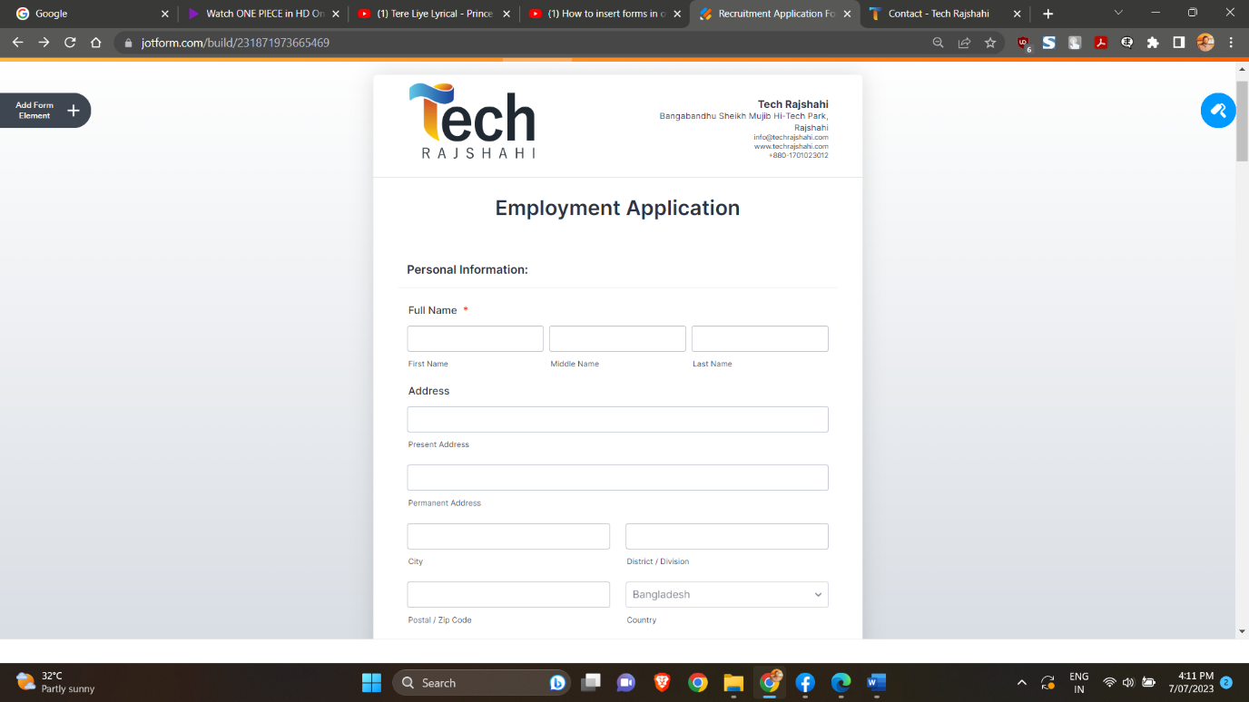

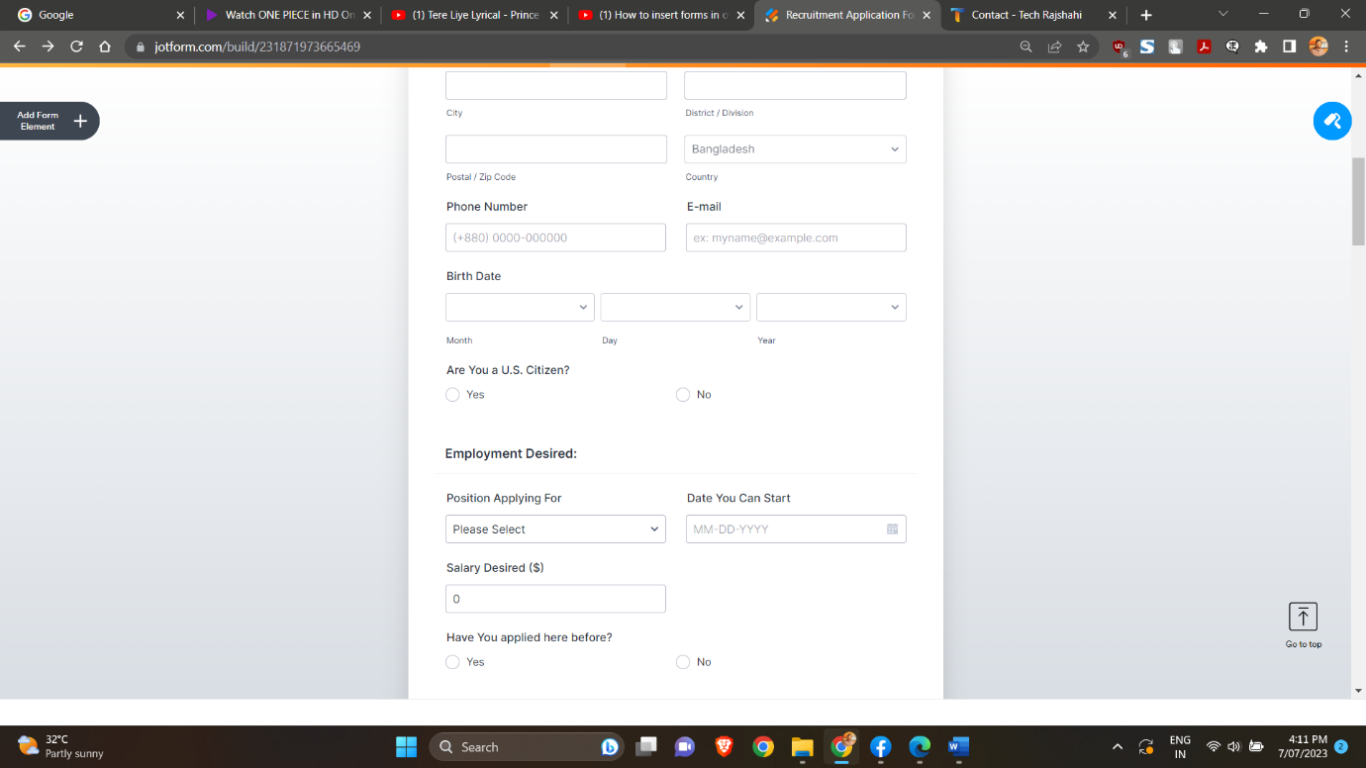

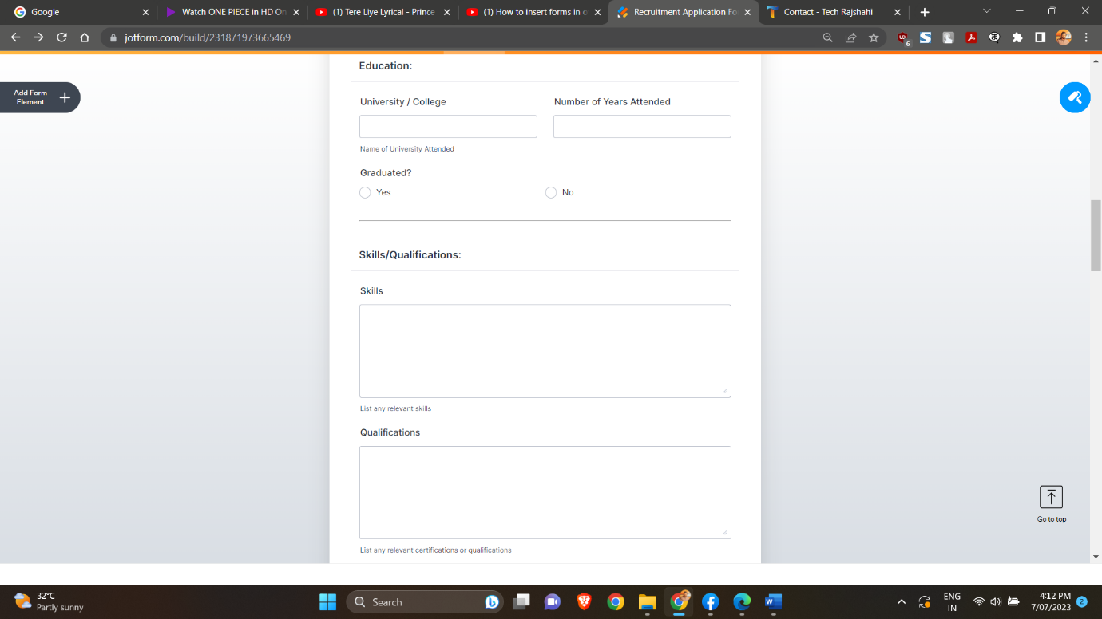

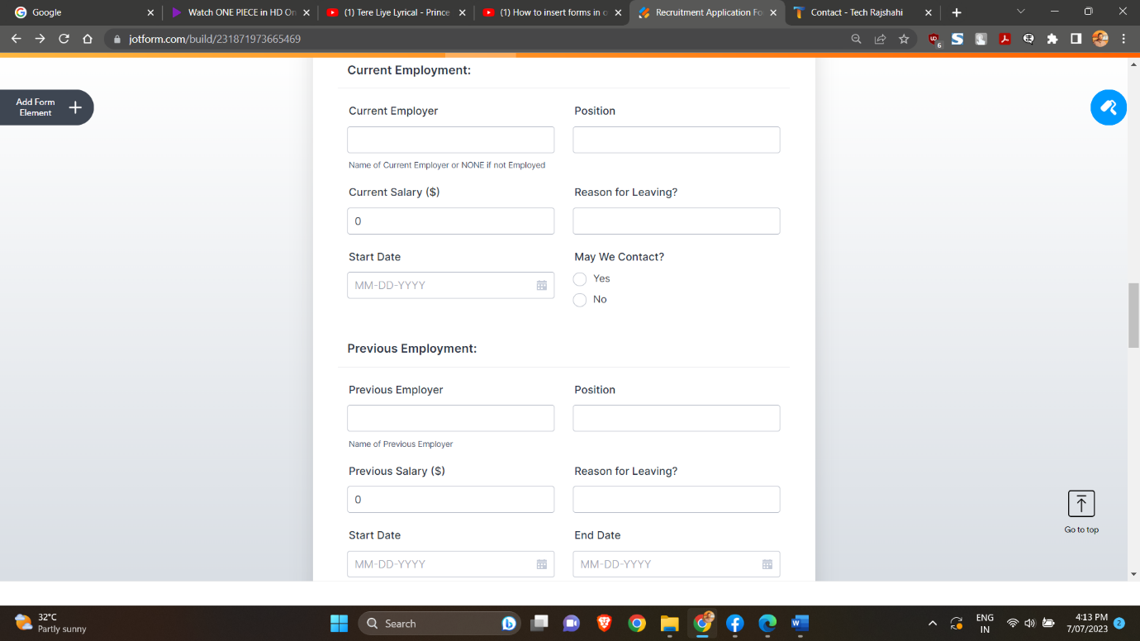

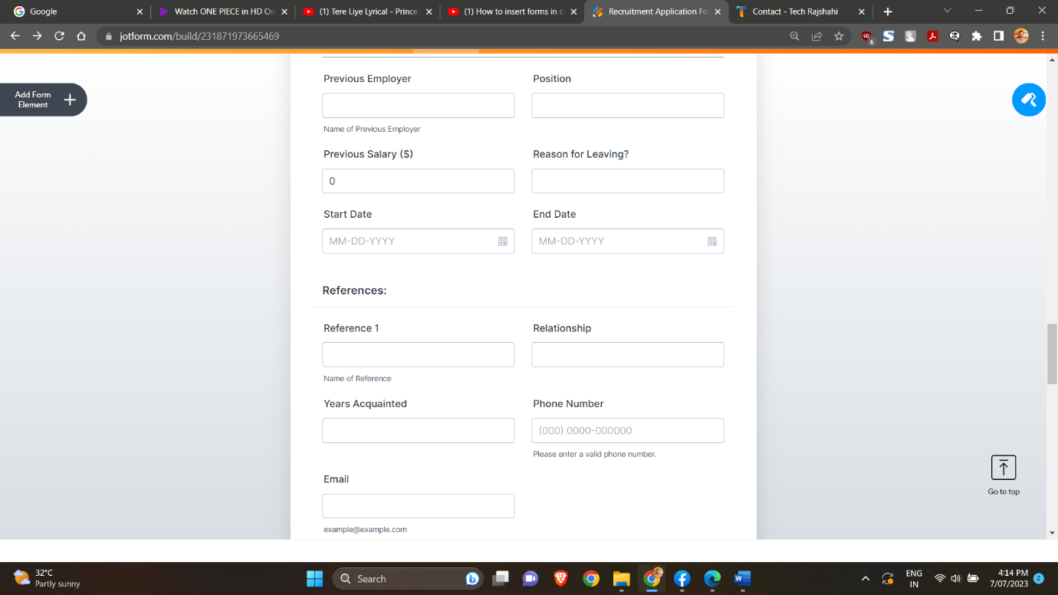

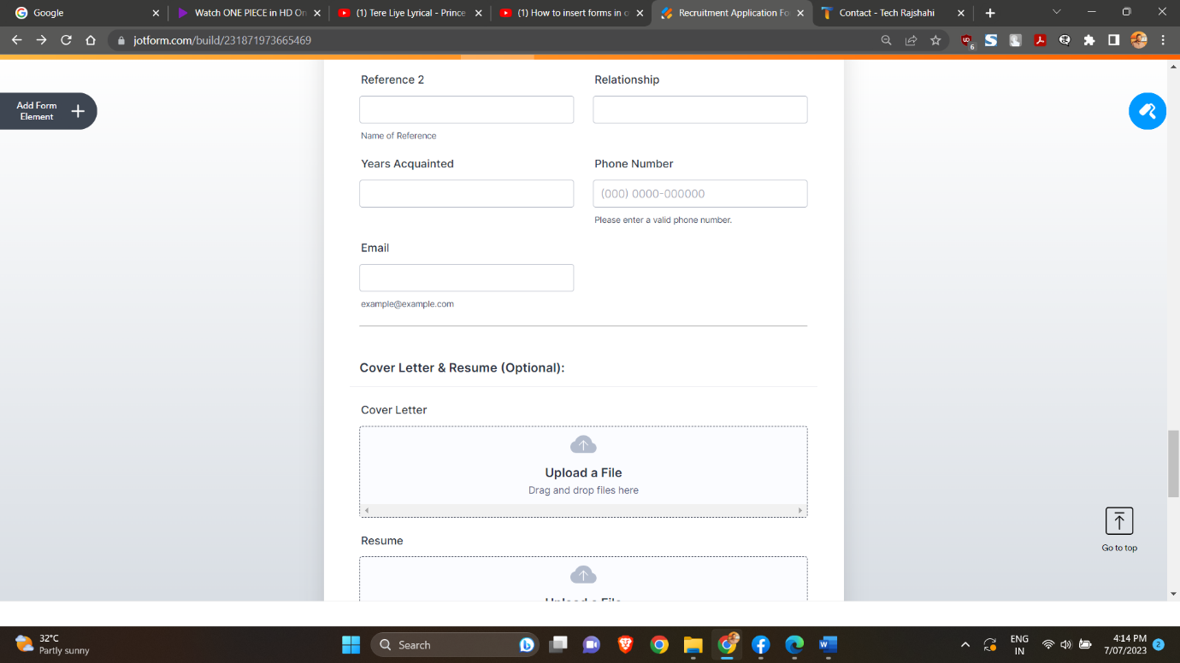

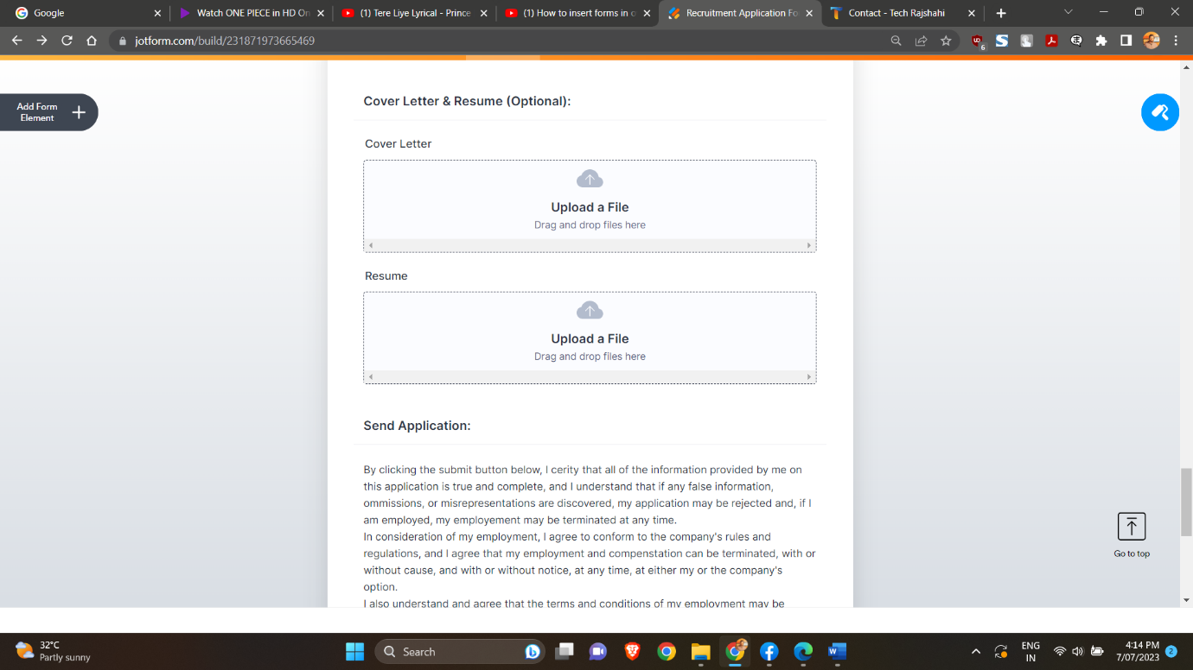

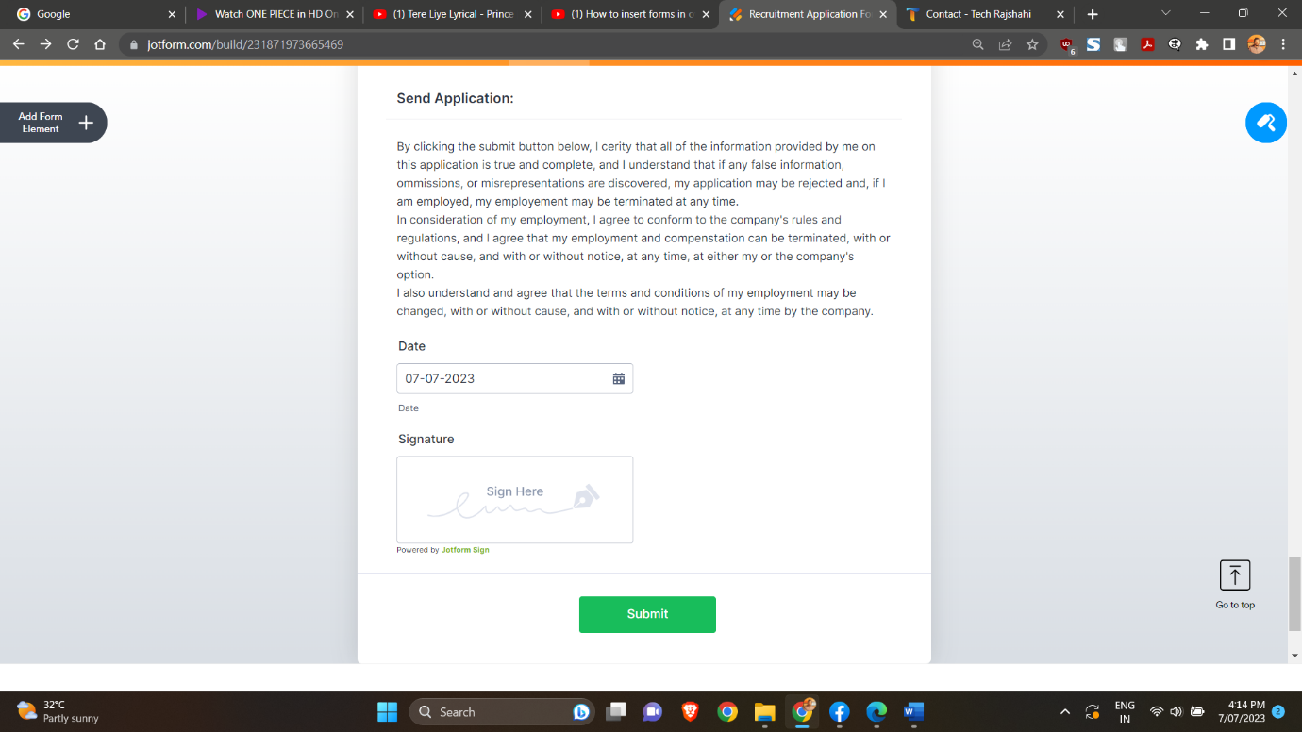

# 3.4 Conclusion

Tech Rajshahi's data flow practices showcase their ability to handle and manage information seamlessly. Furthermore, the company's work flow is equally impressive, reflecting their dedication to streamlined operations and optimal resource allocation. Tech Rajshahi's ability to design and implement efficient work processes ensures that tasks are executed seamlessly, deadlines are met, and projects are delivered with high quality.Tech Rajshahi's commitment to impressive data flow and work flow demonstrates their dedication to excellence and their ability to leverage technology and processes effectively. With their strong foundation, Tech Rajshahi is poised for continued success in the software industry, delivering innovative solutions that meet the evolving needs of their clients.

**Chapter 4**

**Cost Benefit Analysis**

# 4.1 Introduction to Cost Benefit Analysis

Cost-benefit analysis is a systematic process used to evaluate the potential costs and benefits associated with a project, decision, or investment. Cost-benefit analysis provides a structured framework for decision-making, allowing for a comprehensive assessment of the potential impacts of a particular course of action. The main purpose of cost-benefit analysis is to determine whether the benefits of a particular course of action outweigh its costs, thereby providing a basis for decision-making and resource allocation. This chapter discusses approaches to developing design recommendations for the end user. Each approach has costs and benefits that are compared with those of other approaches before a final recommendation is made. The outcome of the analysis will determine whether the project is financially feasible or if the company should pursue another project.

**4.2 Steps of Cost Benefit Analysis**

Following steps are used to determine the cost benefit analysis of Tech Rajshahi.

• Identifying cost and benefits

• Categorizing various cost benefits

• Selecting a method of evaluation

• Interpreting the results of analysis

• Take action

**4.2.1 Identification of Cost and Benefits**

Tech Rajshahi has different cost and benefits. Types of cost that it has is given below:

1. Hardware cost

2. Personnel cost

3. Facility cost

4. Operating cost

5.Supply cost

## 4.2.2 Categories of Cost Benefit Analysis

**Hardware costs:**

Hardware cost includes different type of cost like server, workstation, laptop, storages backup system cost etc. Additional hardware components that Tech Rajshahi require including printers, scanners, monitors and other peripheral devices.

|  |  |
| --- | --- |
| Categories | Amount (TK) |
| Laptop | 12,00,000 |
| Storage | 8,00,000 |
| Printer | 50,000 |
| Total | 20,50,000 |

Table 4.1: Table of hardware cost (Existing system)

**Personnel Costs:**

Personnel cost includes salaries and wages, overtime and bonuses, benefits and allowances etc.

|  |  |
| --- | --- |
| Categories | Amount (TK) |
| Salary | 20,00,000 |
| Wages | 50,000 |
| Total | 20,50,000 |

Table 4.2: Table of personnel cost (Existing system)

**Facility costs:**

Facility costs refer to the expenses associated with acquiring, operating, and maintaining physical facilities for business operations. In this company facility cost includes renting the apartment, electricity wiring, broadband connection, furniture and so on.

|  |  |
| --- | --- |
| Categories | Amount (TK) |
| Apartment cost | 30,00,000 |
| Furniture | 5,00,000 |
| Broadband-connection | 3,000 |
| Electricity | 30,000 |
| Others | 5,000 |
| Total | 35,38,000 |

Table 4.3: Table of facility cost (Existing system)

**Operating costs**:

Operating costs refer to the expenses incurred by a business or organization on a regular basis to maintain its operations and sustain its day-to-day activities.

To show hospitality, customers are served with snacks. Even when we visited their company for system analysis, we were also served with delicious snacks. Employees are also provided with lunch.

**4.2.3 Selecting a Method of Evaluation**

For cost benefit analysis Break-even analysis is selected.

|  |  |
| --- | --- |
| Categories | Amount (TK) |
| Snack and lunch | 10,000 |
| Travel cost | 30,000 |
| Total | 40,000 |

Table 4.4: Table of operating cost (Existing system)

**Source of income:**

Tech Rajshahi earns money form following sources:

1. Software development
2. Web design & development
3. Amazon & E-commerce Market
4. IT course
   * Graphic design
   * Web design course
   * UI/ UX design
   * Social Media Marketing
   * Amazon FBA private label
   * Video Editing

Now calculation of one month’s income from IT course is given table 4.5:

Company can also earn money from software development project, though it depends on several factors. Factors are like:

* Size & scope of the projects
* Manpower per project

|  |  |  |  |
| --- | --- | --- | --- |
| Course name | Average no of students | course fee | Amount (TK) |
| Graphic design | 5 | 12,000 | 60,000 |
| Web design | 6 | 15,000 | 90,000 |
| Video Editing | 3 | 12,000 | 36,000 |
| Amazon FBA Label | 5 | 30,000 | 1,50,000 |
| Social Media Marketing | 6 | 8,000 | 48,000 |
| UI/UX Design | 5 | 12,000 | 60,000 |
| — | Total = 30 | Total | 4,44,000 |

Table 4.5: Table of per month income from IT course (Existing system)

* Available number of developers
* Coordination among the software team

However on in average they earn able to complete 3 simple projects and 2 big projects in two month. per month income from software developing is demonstrated at table 4.6.

|  |  |  |  |
| --- | --- | --- | --- |
| Project category | Amount(TK) | Quantity | Subtotal(Tk) |
| mini project | 8,00,000 | 2 | 16,00,000 |
| Mega project | 20,00,000 | 4 | 80,00,000 |
| — | — | Total | 96,00,000 |

Table 4.6: Table of per month income from software developing (Existing)

From table 4.5 and table 4.6 total income per month is (4,44,000+96,00,000) =1,00,44,000 taka

From table 4.4 variable cost per month is 40,000 taka. So contribution margin per month is =(1,00,44,000-40,000) taka or 1,00,04,000 taka. This amount of money help to reduce the fixed money.

**4.2.4 Interpretation of Results**

From previous section it is known that company has monthly income about 1,00,44,000 taka and variable cost about 40,000 Tk. As a result, we find a contribution margin of about 1,00,04,000 Tk.

Company has a fixed cost of employee salary. This contribution margin helps to reduce fixed cost.

**4.3 Conclusion**

Tech Rajshahi's dedication to sustainability has not only improved its brand image but also generated cost savings over time. By adopting eco-friendly practices and renewable energy sources, the company has reduced its environmental impact and operational expenses. This commitment to corporate social responsibility aligns with the growing market demand for environmentally conscious businesses. The company's strategic investments, commitment to innovation, and responsible business practices position it as a leader in the tech sector. With a positive trajectory, Tech Rajshahi is poised to achieve sustainable growth and deliver value to its stakeholders.

**Chapter 5**

**Comparison of Existing &**

**Proposed Candidate System**

**5.1 Introduction to Proposed Candidate System**

A proposed candidate system in a software company is a software solution that can be used to manage the recruitment process. The specific features and functionality of the system would vary depending on the needs of the software company. However, the system should be designed to help the company save time and money on recruitment, improve the efficiency of the hiring process, and increase the number of qualified candidates. It can be used to:

* Post jobs on job boards and social media
* Receive and screen applications
* Schedule interviews
* Track the progress of candidates through the hiring process
* Generate reports on the hiring process

**5.1.1 Managing Level Hierarchy**

They should arrange their management hierarchy as follow:

**Top level managers**

Top-level managers, or top managers, are also called senior management or executives. These individuals are at the top one or two levels in an organization, and hold titles such as: Chief Executive Officer (CEO), Business development manager (BDM), Business Account Manager (BAM), also Chairperson of the Board, President, Vice president, corporate head of different teams.

**Middle level managers**

Middle-level managers, or middle managers, are those in the levels below top managers. Middle managers’ job titles include: Account Supervisor, Account Co-ordinator, Junior Developer, and Office manager. Middle-level managers are responsible for carrying out the goals set by top management. They do so by setting goals for their departments and other business units. Middle managers can motivate and assist first-line managers to achieve business objectives. Middle managers may also communicate upward, by offering suggestions and feedback to top managers. Because middle managers are more involved in the day-to-day workings of a company, they may provide valuable information to top managers to help improve the organization’s bottom line.

**First level managers**

First-level managers are also called first-line managers or supervisors. These managers have job titles such as: Security manager, Shift supervisor, Department manager, Foreperson, Crew leader, Store manager. First-line managers are responsible for the daily management of line workers—the employees who actually produce the product or offer the service. There are first-line managers in every work unit in the organization. Although first-level managers typically do not set goals for the organization, they have a very strong influence on the company. These are the managers that most employees interact with on a daily basis, and if the managers perform poorly, employees may also perform poorly, may lack motivation, or may leave the company.

**5.1.2 Payment System of the Project and Courses**

In the payment system there is bonus for employee. They pay bonus on religious festivals. They should give some bonus as a reward. The payment system follows the ranking system. The highest paid rank is the business development manager. In Tech-Rajshahi CEO is the owner of the company so he decides how the salary the would be for his employees. If they want to recruit more employees, their personnel cost will be increased. The income form BFDS is now closed due to some internal limitations but was a good source of income in the first month.

**5.1.3 Website**

For an IT company, websites literally bear identity of their company. To have a strong base of the company, A dynamic website should be developed. This website should contain all the information of current staff, the hierarchy of the company, mission and vision of the company, online course registration system and description on the previous built projects. Tech Rajshahi has a very unique and eye-catching website with so many animations and transitions.

**5.2 Proposed DFD (Data Flow Diagram)**

As we proposed three label management so that chief executive officer (CEO) can delegate his work with different label of manager. A data flow diagram (DFD) for this scenario is shown in figure 5.1

CEO

Command to apply

General Manager

Decision

Co-ordination

command

Chief Finance Officer

meeting

Chief Information Officer

Decision

Co-ordination

Command to apply

Decision

Chief Operational Officer

Co-ordination

Plant Manager

meeting

monitor

monitor

Trainer

Developer

teaching

Student

developing

Product for Customer

Fig 5.1: Data Flow Diagram of Tech-Rajshahi (Proposed)

**5.3 Proposed Cost Benefit Analysis**

The main problem of their cost benefit system was that they do not provide any incentives or bonus to the employees during holy occasions like Eid. So personnel cost of this company would be increased if they provide bonus to their employees. Bonus can be provided for worthy performances too. As cost of the company is increasing then they must look for ways to increase their profits. A new cost benefit system has been proposed here where company can provide incentives to employees as well as they can have same amount of profit.

**5.3.1 Fixed & Variable Cost Analysis**

In the existing system, Tech-Rajshahi pays only for their company monthly salary. But they also provide bonus for Eid or puja. The costs are calculated per month below. **NB:** Fixed cost remains same in every month.

|  |  |  |  |
| --- | --- | --- | --- |
| Fixed Costs (FC) | Amount (Tk) | Variable Costs (VC) | Amount (Tk) |
| Third Party Software Cost | 5,00,000 | Cloud Computing | 1,00,000 |
| Salaries & Wages | 20,50,000 | Bandwidth | 10,000 |
| Office-space | 50,000 | Storage | 20,000 |
| Food & Annual Trip | 40,000 | Customer Support | 70,000 |
| Marketing & Sales | 5,00,000 | Electricity Bill | 30,000 |
|  | Total=31,40,000 |  | Total=2,30,000 |

Table 5.1: Table of per month fixed and variable costs of Tech-Rajshahi (existing)

**5.3.2 Source of Income**

Tech Rajshahi earns money form flowing sources which was mentioned in cost benefit analysis chapter.

* + 1. Software development
    2. Web design & development
    3. Amazon & web-based E-commerce

So, in our existing income from system, we have to increase the course fees slightly to meet the increasing personnel cost. But the intern course system is closed for reason only income source for Tech Rajshahi is making projects.

|  |  |  |  |
| --- | --- | --- | --- |
| Project category | Amount (TK) | Quantity | Subtotal (Tk) |
| Mini project | 8,00,000 | 2 | 16,00,000 |
| Mega project | 20,00,000 | 4 | 80,00,000 |
| — | — | Total=6 | Total=96,00,000 |

Table 5.2: Table of project income in 2 months of Tech Rajshahi (Existing system)

On average they handle 6 projects in two months. But all project charges are not identical. For mini projects, they should charge three times than making cost of that project. So the per project sales will be 16,00,000 Tk.

**5.3.3 Selecting Method of Evaluation**

For analysing proposed cost and benefit system, break even analysis method has been selected. From the above discussion we can see that their total cost, **TC= Fixed Cost + Variable Cost**. Also, sales will be, **Sales=average sales per month* unit of projects.** Taking necessary values from Table 5.1 & 5.2. Including everything into a table will give a result like following:

|  |  |  |  |  |
| --- | --- | --- | --- | --- |
| Unit of Projects | Fixed Cost (per month) | Variable Cost (per month) | Total Cost (Tk) /month | Sales (Tk)/month |
| 1 | 3140000 | 230000 | 3370000 | 1600000 |
| 2 | 3140000 | 460000 | 3600000 | 3200000 |
| 3 | 3140000 | 690000 | 3830000 | 4800000 |
| 4 | 3140000 | 920000 | 4060000 | 6400000 |
| 5 | 3140000 | 1150000 | 4290000 | 8000000 |
| 6 | 3140000 | 1380000 | 4520000 | 9600000 |
| 7 | 3140000 | 1610000 | 4750000 | 11200000 |
| 8 | 3140000 | 1840000 | 4980000 | 12800000 |
| 9 | 3140000 | 2070000 | 5210000 | 14400000 |
| 10 | 3140000 | 2300000 | 5440000 | 16000000 |

Table 5.3: Table of per month cost and income of Tech Rajshahi (Existing system)

Doing only one project a month, they will have total net revenue of (1600000-3370000) or -1770000 taka. In the same way two projects a month net revenue is (3200000-3600000) or -400000 taka. In the third month net revenue is 970000 taka. Thus **(sales-total cost)** increases by increasing number of projects in a month. We know, break even point,

**BEP=Fixed Cost/ (Sales per unit-Variable cost per unit)** =3140000/ (1600000-230000) = 2.2919 ~ 3 unit of projects. BEP is shown as a point in the graph where Total cost and sales intersect each other. Graph is following:

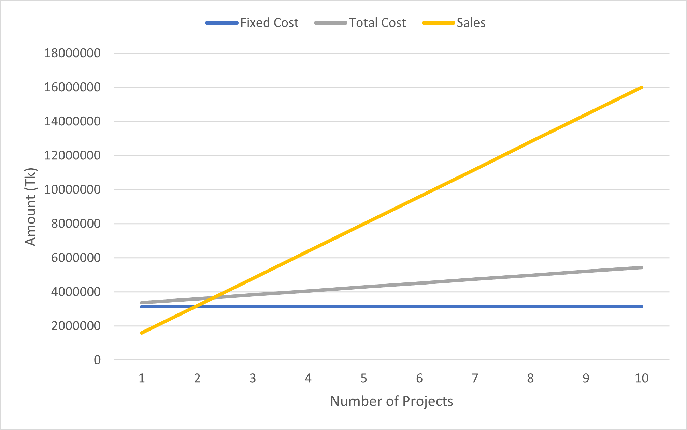

BEP

Fig 5.2: Break even point analysis of Tech Rajshahi

The thing is, for simplicity, we have calculated this BEP without adding BDFS income. So according to the result, Tech Rajshahi must do at least 3 projects in a month to remain in profit state. Tech Rajshahi does 6 projects in two months so they are in profit state.

**5.4 Conclusion**

This chapter concludes that developing a proposed candidate system is a crucial part of studying a system and coming up with effective solutions. In conclusion, the proposed candidate system, combined with effective management hierarchy, a well-structured payment system, and an appealing website, positions the IT company for sustainable success and growth in the highly competitive industry. By implementing a comprehensive software solution, the company aims to save valuable time and resources, improve hiring efficiency, and attract high-quality candidates to meet their organizational needs. With the system's key features such as job posting on job boards and social media, streamlined application screening, efficient interview scheduling, candidate progress tracking, and insightful hiring process reports, the company will have a competitive edge in the talent acquisition process. Additionally, the proposed system emphasizes the importance of managing the company's level hierarchy effectively. With top-level managers responsible for strategic decisions and overall direction, middle-level managers executing the goals set by top management, and first-level managers overseeing daily operations and workforce management. A well-structured hierarchy will lead to improved communication, coordination, and overall productivity. With this enhanced proposed system, Tech Rajshahi can solve their several core problems and improve the organization’s efficiency and effectiveness.

**Chapter 6**

**Summary of the System**

**6.1 Tech Rajshahi**

Tech Rajshahi is a software firm. It started their activity at 2006.Though firstly they worked only IT course but after some days they earned a good experience and established a developing organization. Now it is one of the leading software companies in Rajshahi.

**6.2 Some Problems of the System**

Day by day Tech Rajshahi earn a good name in IT firm. But their system has some problem.

* Their employee payment rules should be modified which increase employee work flow. As a result, they can develop good product.
* They have to pay some amount of money for some political purposes.
* The form they provide has some problem like absence of user guideline, Income and cost data was not user readable.
* They don’t have any campus ambassadors in renowned universities. As a result, they are losing chances of advertising their company to other students.
* They don’t pay bonuses to hard workers or medical insurances and personal transports to their employees which might demotivate the employees to work in Tech Rajshahi.

**6.3 Proposed System & Solution**

In our proposed system we provide a candidate system which good a better solution of their existing system’s problem. We can’t access their database. So, we can’t verify their problem in database. Furthermore, they don’t need any proposed cost benefit analysis because they are already in profit state. If Tech Rajshahi also keeps an eye on the above-mentioned problems and tries to improve them, there will be more and more opportunities and success for Tech Rajshahi.

**References**

**Elias M. Awad**. “System Analysis and Design” 2nd edition.

Official Website of Tech Rajshahi: [techrajshahi.com](https://techrajshahi.com/)

[https://www.office.com/](https://www.office.com/%20)

[www.google.com](http://www.google.com)

<https://chat.openai.com/>