Behavioral Health Among Indiana Medicaid Beneficiaries, 2021
Executive Summary — Prepared for Centene by the National Minority Quality Forum (NMQF): Center for Clinical and Social Research (CCSR) and Center for Health Information Systems and Services (HISS)
October 1, 2026

Purpose and scope
This summary identifies where diagnosed behavioral health conditions are concentrated among Indiana's 2,068,191 Medicaid beneficiaries, and which groups are diagnosed least often relative to their peers. It supports MHS Indiana's procurement and growth planning as a proof of concept for a repeatable state-level landscape analysis.
NMQF analyzed 2021 T-MSIS Analytic Files (TAF) claims for six behavioral health condition groups: schizophrenia and other psychotic disorders, bipolar and related disorders, depressive disorders, anxiety disorders, trauma, stress and adjustment-related disorders, and personality disorders. Prevalence is reported at the ZIP code, county, and Indiana Medicaid managed care region levels, stratified by race/ethnicity and age. Full data tables are in the accompanying Excel workbook; ZIP-level heat maps for each condition are provided as separate high-resolution files.

Key findings at a glance
Depressive and anxiety disorders are the dominant diagnosed conditions, each affecting roughly 1 in 20 beneficiaries. Condition groups overlap (a beneficiary can appear in more than one), so the counts below are not additive.
Condition group | Beneficiaries diagnosed | Statewide prevalence
Depressive disorders | 111,569 | 5.39%
Anxiety disorders | 100,651 | 4.87%
Trauma, stress & adjustment-related disorders | 52,166 | 2.52%
Bipolar & related disorders | 43,551 | 2.11%
Schizophrenia & other psychotic disorders | 26,823 | 1.30%
Personality disorders | 6,116 | 0.30%

Three patterns stand out and are developed below:
- Diagnosed prevalence is highest in rural and small city counties of the East Central, Northeast, and Southwest regions, and lowest in Marion (Indianapolis) and Lake (Gary) counties, which together hold 30% of all beneficiaries.
- Black and Hispanic beneficiaries are diagnosed with mood, anxiety, and trauma disorders at a fraction of the White rate in nearly every county, while schizophrenia shows no such gap. This pattern is consistent with under-detection rather than lower underlying need.
- Working age adults carry the highest burden for anxiety, bipolar, trauma-related, and personality disorders, while depression (8.0%) and schizophrenia (2.6%) peak among beneficiaries 65 and older.

Geographic hotspots
Diagnosed prevalence is highest in the East Central, Northeast, and Southwest regions and lowest in the Northwest, Central, and North Central regions, with a spread of nearly 2:1 between the top and bottom regions for depression (7.3% East Central vs. 4.2% Northwest) and anxiety (6.3% Southwest vs. 3.7% Northwest).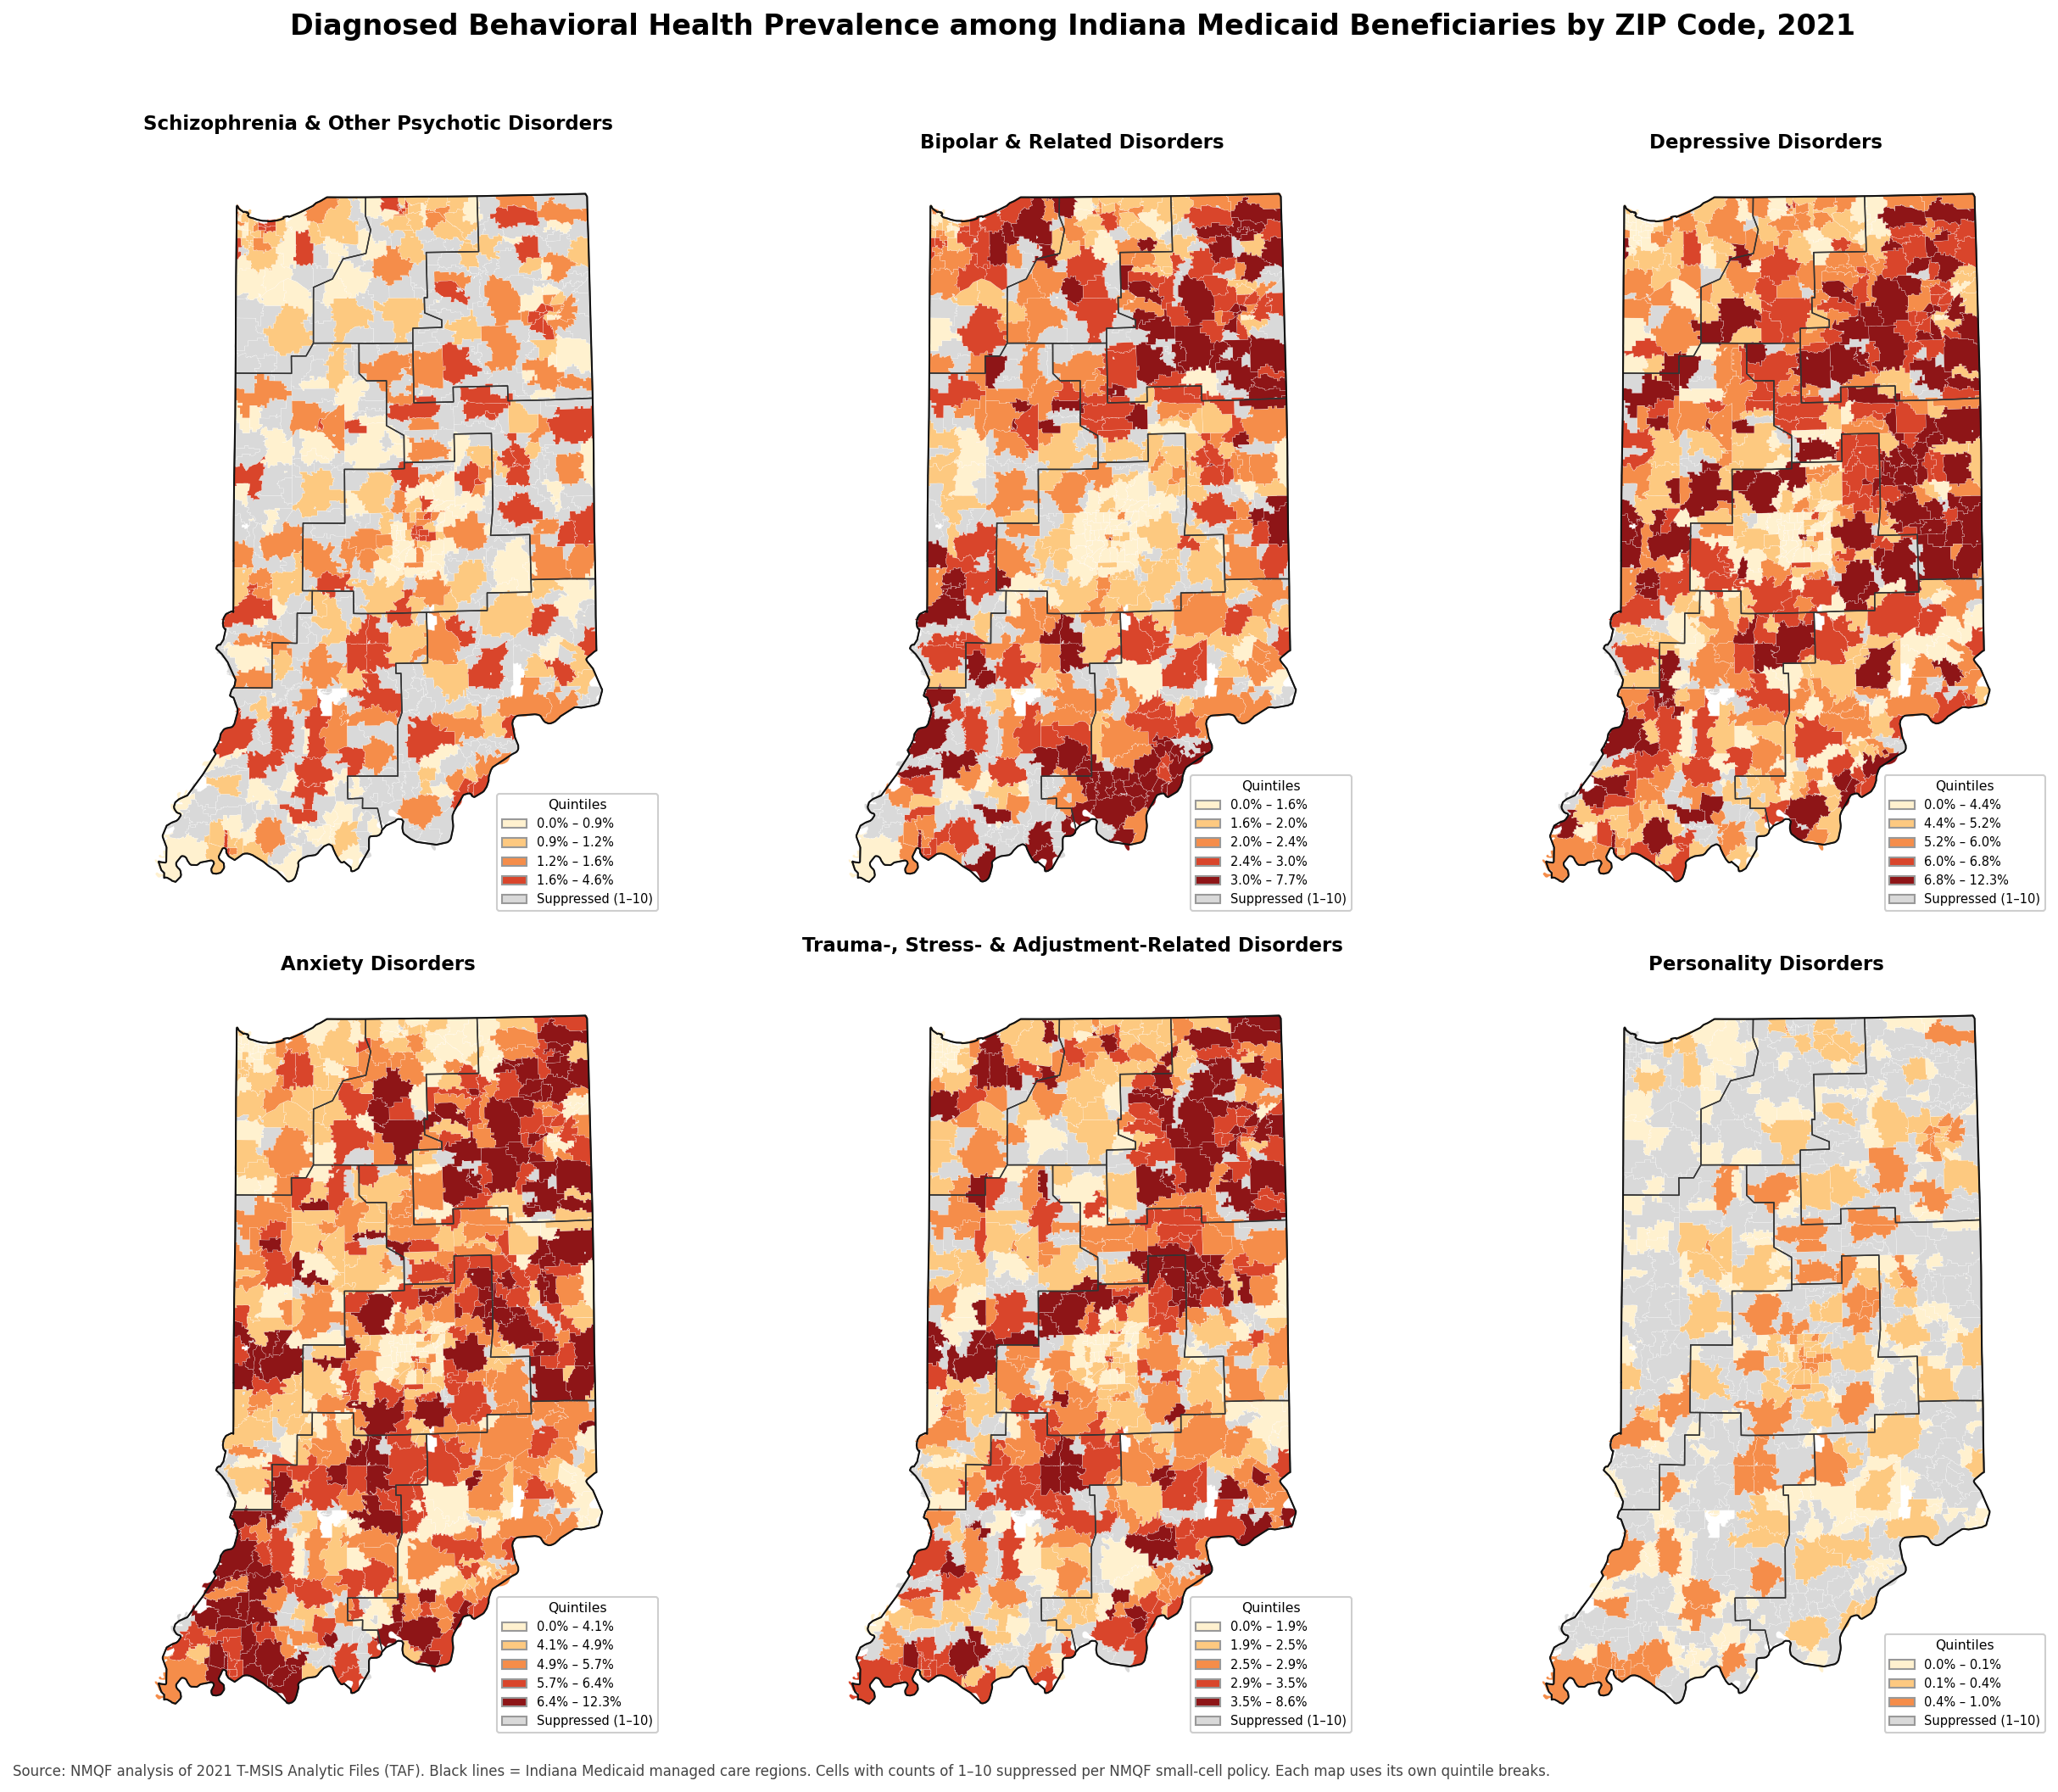
Figure 1. ZIP code heat maps for the six condition groups. Black lines are Indiana Medicaid managed care regions. Grey ZIP codes are suppressed (counts of 1–10). Individual full-size maps are provided as separate files.
Highest-prevalence counties cluster along the Ohio border and in the small cities of eastern and southwestern Indiana. Wayne (Richmond), Fayette (Connersville), Huntington, Wabash, and Knox (Vincennes) counties exceed 8% for depression, and Adams, Huntington, Wabash, Fayette, and Knox exceed 7% for anxiety; Knox, Monroe (Bloomington), Wayne, and Vigo (Terre Haute) lead for schizophrenia at about 2%; Floyd, Vigo, and Clark lead for bipolar disorder at 3.4–3.9%.
Highest-prevalence ZIP codes (1,000+ beneficiaries) include 47305 and 47304 (Muncie), 47374 and 47330 (Richmond/Centerville), 46992 (Wabash), 47804 (Terre Haute), 47331 (Connersville), 46750 (Huntington), and 47591 (Vincennes), all at 8.4–10.5% for depression. For anxiety, 46733 (Decatur), 46750 (Huntington), 46992 (Wabash), 47601 (Boonville), and 46706 (Auburn) range from 7.9% to 8.9%.
Highest-volume ZIP codes are a different list. ZIP 47374 (Richmond, 19,673 beneficiaries) leads the state in diagnosed volume for depression, anxiety, and schizophrenia and is also a top three rate ZIP for depression (1,829 diagnoses, 9.3%). The other volume leaders split into two groups: Indianapolis ZIPs 46227, 46203, 46219, 46201, and 46241, each with 850–1,300 depression or anxiety diagnoses at below average rates (4.2–5.4%), and 47150 (New Albany), 47302 (Muncie), 47130 (Jeffersonville), and 46901 (Kokomo), where both volume (790–1,170) and rate (5.5–7.6%) are high.
Large metro counties. Marion and Lake counties hold 29.6% of Indiana's Medicaid beneficiaries but only 21.4% of diagnosed depression. Their diagnosed rates (depression 4.0% and 3.7%; anxiety 3.7% and 3.2%) are the lowest in the state and well below the rural counties above. Because these two counties hold the state's two largest Black populations (38–39% of their beneficiaries) and Marion its largest Hispanic population, and because the racial gaps below hold within every county, the low metro rates most likely reflect a detection gap rather than lower need.

Racial, ethnic, and age disparities
Black beneficiaries are diagnosed with depression at half the White rate (3.1% vs. 6.3%) and Hispanic beneficiaries at less than a quarter (1.5%); the same gap appears for anxiety (2.4% and 1.4% vs. 5.9%), bipolar disorder (1.0% and 0.3% vs. 2.4%), and trauma-related disorders (1.6% and 0.7% vs. 2.9%). Schizophrenia is the exception: Black and White rates are identical statewide (1.2%), and in Wayne and Madison counties the Black rate is 1.6–1.7 times the White rate.
The gap is not a product of where people live. In every one of the 21 counties with 2,000 or more Black beneficiaries, the Black depression rate is 39–86% of the White rate in the same county (Marion 48%, Lake 45%, Allen 50%, St. Joseph 46%); for anxiety it is 32–64%. Hispanic rates are lower still, at 15–48% of the White rate where reportable. This within-county consistency, together with parity for schizophrenia, is consistent with the national literature, which finds Black patients under diagnosed with depression and bipolar disorder and over diagnosed with psychotic disorders relative to White patients (Schwartz & Blankenship, 2014).
By age, adults 19–64 have the highest diagnosed rates for anxiety (6.7%), bipolar (3.1%), and trauma-related disorders (2.8%). Depression (8.0%) and schizophrenia (2.6%) peak at 65+ and trauma, stress and adjustment-related disorders are the one group where children 0–18 (2.5%) approach the adult rate.
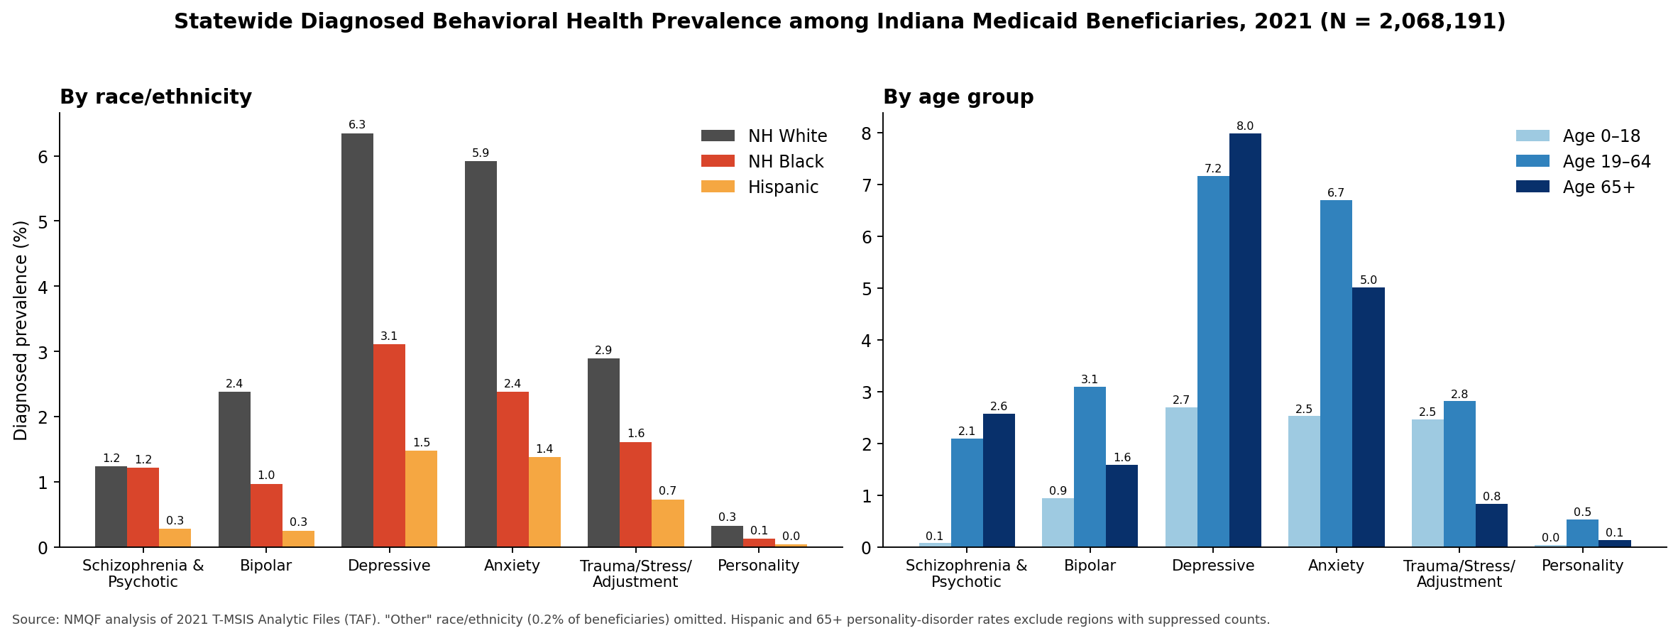
Figure 2. Statewide diagnosed prevalence by race/ethnicity (left) and age group (right).

Strategic implications
- Treat Marion and Lake as under detection markets, not low need markets. Bringing their diagnosed rates up to the statewide average would identify roughly 9,100 additional members with depression and 8,100 with anxiety. Screening outreach, integrated primary-care behavioral health, and community-based providers in Indianapolis ZIPs 46201, 46203, 46219, 46227, and 46241 and Lake County ZIPs 46410 (Merrillville), 46342 (Hobart), 46307 (Crown Point), and 46312 (East Chicago) offer the largest absolute opportunity.
- Set race and language specific screening and engagement targets. A Black member is half as likely as a White member in the same county to carry a mood or anxiety diagnosis, and a Hispanic member one-fifth to one-third as likely. Culturally and linguistically matched screening, Spanish-language access, and provider level feedback on diagnostic patterns are the levers; the schizophrenia finding warrants clinical review of psychotic-disorder diagnostic patterns among Black members.
- Match network capacity to the rural eastern and southwestern hotspots. Wayne, Fayette, Huntington, Wabash, Adams, Knox, and Monroe counties show 7–9% depression and 6.5–8% anxiety prevalence. These are small, high rate markets where the question is treatment capacity and access (telehealth, mobile crisis, SMI case management), not detection.
- Use Richmond (ZIP 47374) as a pilot site. It is the state's highest volume ZIP for depression, anxiety, and schizophrenia, a top three rate ZIP for depression, and sits in the highest prevalence region.
- Prioritize older adults for depression and working age adults for everything else. The 65+ depression rate (8.0%) exceeds every other age condition combination; dual-eligible care coordination is the natural vehicle.

Extending this analysis to other markets
The Indiana work establishes a repeatable template, with the six condition groups, three-level geography, race/ethnicity and age stratification, and small-cell rules now fixed, that NMQF can apply to Idaho, Pennsylvania, and other Centene markets from its in-house TAF data on the same timeline. Components deferred from the original Indiana request can be added to any state as scope allows:
- Substance use and opioid use disorder, including co-occurring SMI and SUD
- Maternal and child health: low birth weight, preterm delivery, and behavioral health among pregnant and postpartum members
- Utilization for priority populations (emergency department visits, inpatient admissions, readmissions) to quantify the cost and quality case
- Multiyear trends (2019–2021) and urban/rural comparisons
- Side-by-side benchmarking across states using identical definitions

Methods and data notes
Beneficiaries were identified from 2021 TAF inpatient and other-services claims and linked to the 2021 demographic and eligibility file. A beneficiary was counted in a condition group with at least one inpatient claim or two other-services claims carrying a qualifying ICD-10 code; the 291 codes and their six-group assignment are in the accompanying diagnosis-grouping file. Race/ethnicity is categorized as non-Hispanic White, non-Hispanic Black, Hispanic, and Other; age as 0–18, 19–64, and 65+. Counties roll up to the eight Indiana Medicaid managed care regions per the IHCP region map.
All prevalence figures are diagnosed prevalence in claims, not population prevalence: a low rate can reflect lower need, lower screening, or lower access. Cells with counts of 1–10 are suppressed (shown as −1 in the workbook) and appear grey on the heat maps; no additional population floor is applied, so rates in ZIP codes with small populations may be less stable. ZIP codes are mapped to 2010 ZCTA boundaries, which cover 99.6% of beneficiaries; the remainder are PO-box ZIPs with no land area. Data reflect 2021, the most recent year available in NMQF's in-house TAF holdings.
Accompanying files
- BH_DIAG_MEDICAID_INDIANA2021_wLabel.xlsx -- full data tables (ZIP, county, region × race/ethnicity × age) for all six condition groups
- ZIP_heatmap_1…6_*.png -- one ZIP code heat map per condition (high resolution)
- ZIP_heatmaps_all_six_conditions.png and County_heatmaps_all_six_conditions.png -- six-panel overviews
- County_disparity_Black_White_ratio.png -- Black-to-White prevalence ratio by county
- Method.docx, behavioral_health_diagnosis_grouping.xlsx, Indiana_fipscounty_region2021.xlsx — methodology, code list, and county-region crosswalk
- Disclosure: AI tools were used to assist in writing and formatting this report. All data analysis, condition definitions, and cell suppression were performed by NMQF analysts; AI was not used in the analysis.

