**מפרט תיכון תוכנה – SDS**

**1. דף ראשי**

This document purpose is to design the implementation of "BudgetBuddy" in terms of architecture and data storage.

**Capabilities & Risks :**

|  |  |  |  |
| --- | --- | --- | --- |
| **Risks** | **Description** | **Capabilities** |  |
| * Team not familiar with python . |  | General | 0. |
| * No team experience in google API. * No team experience in DataStore .   Solution: learn and test the google API & DataStore. | In order to use BudgetBuddy service ,user will need to register service by service registration or by google account. | Register | 1.  1. |
| * Hacking to Budgeteer account.   Solution: create authentication by google authentication or by service authentication. | In order to get access to Budgeteer account, user need to login to BudgetBuddy. | Login | 1. 2   2. |
| * No team experience in DataStore ,creating budget will cause save data in DataStore.   Solution: learn and test DataStore. | In order to manage expenses for a specific occasion, Budgeteer need to create a Budget. | Create Budget | 3. |
| * No team experience in DataStore ,view budget cause query on data in DataStore. * No team experience in creating statistics analyze.   Solution: learn and test DataStore and create methods that analyze our data and give statistic results . | In order to get information regarding a budget budgeteer member of. | View a Budget | 4. |
| * No team experience in DataStore , Edit Entries cause add data or change exist data in DataStore.   Solution: learn and test DataStore. | In order to edit entries in the budget.  Permissions: budgeteer Manager Or Partner | Edit Entries | 5. |
| * No team experience in DataStore , Edit proprieties cause add data or change exist data in DataStore.   Solution: learn and test DataStore. | In order to set up the budget properties  Permissions: budgeteer Manager Or Partner | Edit proprieties | 6. |
| * No team experience in DataStore ,Add\Remove Budgeteers cause add\delete data in DataStore.   Solution: learn and test DataStore. | In Order share the access of the budget.  Permissions: budgeteer Manager | Add\Remove Budgeteers | 7. |
| * No predictable risks | In case budgeteer want to finish the session. | Logout | 8. |
| * No predictable risks | In case budgeteer forget his password and want to restore the password to get access to service . | Forget Password | 9. |
| * No predictable risks   . | In case budgeteer wants to share budget with non member of service | Invite a friend | 10. |
| * No predictable risks | In order to get information about company and help use the service. | Site navigation | 11. |

**2. תרשים (ארכיטקטורת) הפצה – Deployment Diagrams**

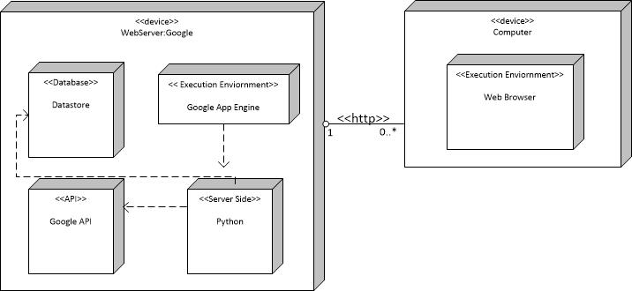

**3. זיהוי מחלקות ותרשימי מבנה סטטי – CRC Cards & Class/Object**

**Budgeteer**

Responsibilities

CreateBudget()

UpdateAccount()

Collaborators

Budget

BudgetViewer

BudgetPartner

BudgetManager

**BudgetManager**

Responsibilities

ViewBudget()

DeleteBudget()

EditBudgetNotification()

EditBudgterEntries()

InviteBudgeteerToShareBudget()

Collaborators

Budgeteer

BudgetPartner

**BudgetViewer**

Responsibilities

ViewBudget()

Collaborators

Budgeteer

**BudgetPartner**

Responsibilities

EditBudgetEntries()

EditBudgetNotification()

ViewBudget()

**SharedBudget**

Responsibilities

SetProperties()

AddEntry()

Collaborators

Budget

**PrivateBudget**

Responsibilities

RemoveBudget()

AddBudgeteer()

SetProperties()

AddEntry()

Collaborators

Budget

SharedBudget

**Budget**

Responsibilities

GetTable()

getMyPermissionLevel()

Collaborators

Budgeteer

PrivateBudget

SharedBudget

DataTable

**DataTable**

Responsibilities

AddEntry()

Collaborators

Budget

Entry

**Entry**

Responsibilities

GetDescription()

GetAmout()

GetTag()

GetAddedBy()

GetCreatedIn()

Collaborators

DataTable

**GoogleAPI**

Responsibilities

CheckUserLoginInfo()

RetrieveUserInfo()

Collaborators

**DataStoreBL**

Responsibilities

AddUser()

AddBudgetToBudgeteer()

UpdateUserInfo()

UpdateUserBudgterEntries()

SetUserNotification()

Collaborators

DataStoreDAL

**DataStoreDAL**

Responsibilities

InsertUser()

InsertBudgetToUser()

DeleteBudgetFromUser()

UpdateUserPermissionOnBudget()

Collaborators

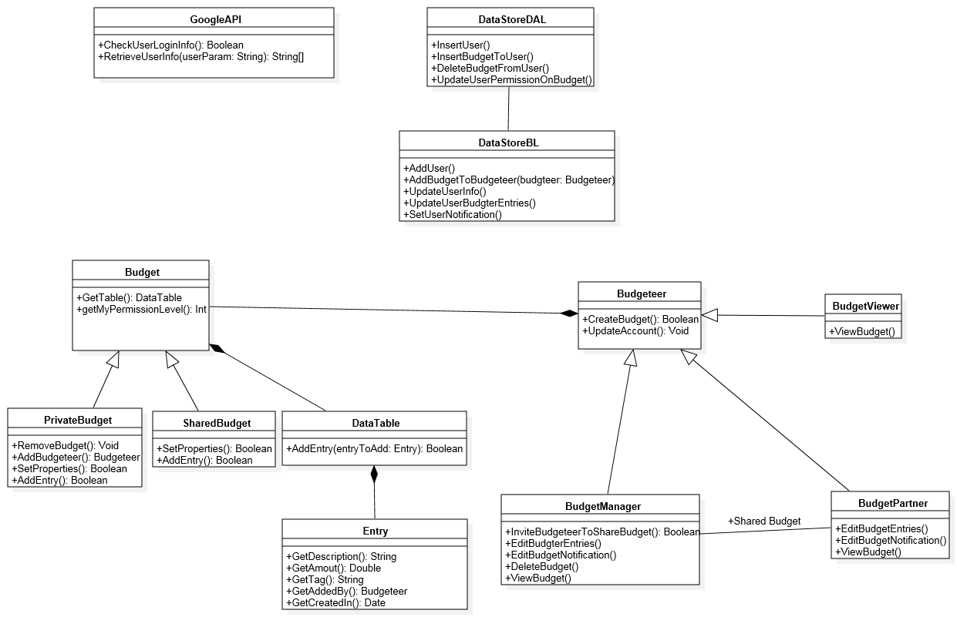

**4. תרשימי רצף התנהגותי – Sequence Diagrams ו\או מצב State**

*תרחישים אפשריים לאחרי יצירת התקציב*

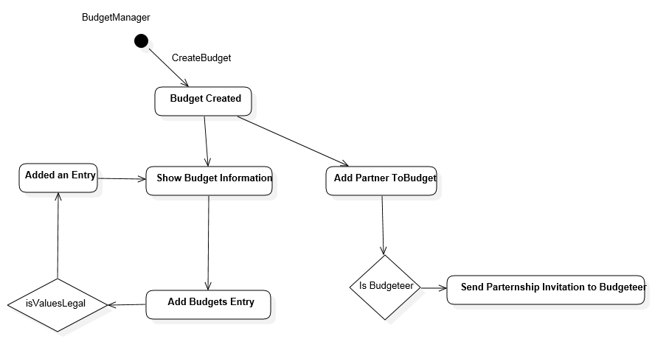

*תרחיש ההרשמה בעזרת השירות\התחברות עם חשבון גוגל*

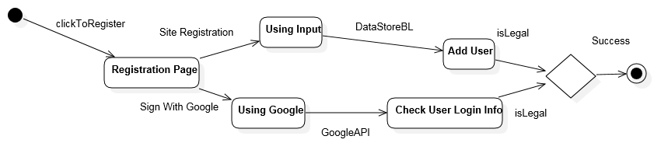

**5. שמירת נתונים \ אחסון – Persistence**

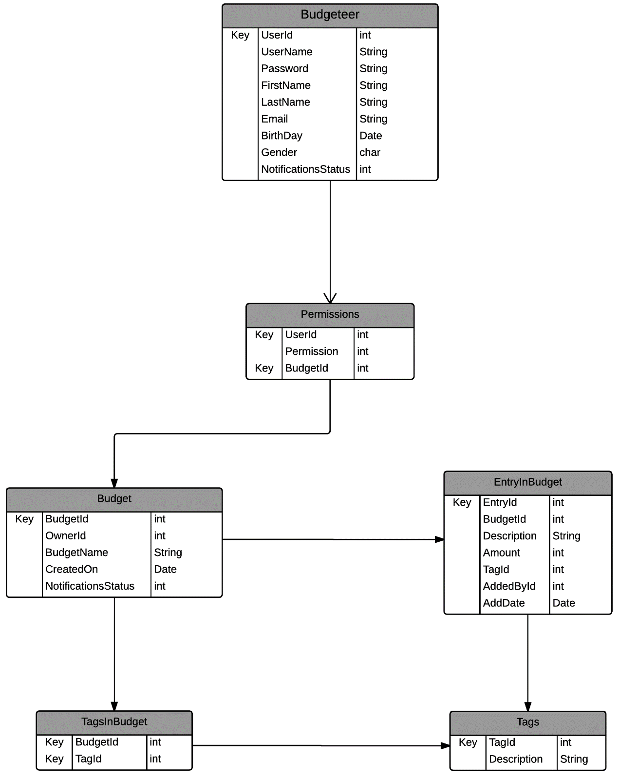

**6. דרישות לא-פונקציונליות**

לא קיימות דרישות לא-פונקציונליות בשלב זה.

**7. ניהול סיכונים**

|  |  |  |  |  |
| --- | --- | --- | --- | --- |
| If the risk is realized | What steps will performed lowering risk | Probability that the risk will occur | The severity of the impact on the project | Risks |
| Find the offending users and remove all their entries from the database. | A captcha on the registration page and an additional captcha that will appear on the entry submission form after a user have submitted several entries in an improbable timeframe. | The probability for this risk to occur is a function of the exposure the service gets. | Spam bots that submit garbage values to the database (Google's Datastore) and corrupt the authenticity of the data (Global statistics won't be as accurate). | Spam Bots |
| Once a DoS attack has been identified, the CDN will be turned on to help mitigate the attack. | Using CDN services such as Cloudflare to help mitigate the attacks. | As mentioned above, the probability is a function of the exposure and success level of the service. | Overload the website with requests that cause the website to work slowly or not at all. | Denial of Service |
| Reset the user's password, send it to his mail, and block attacker. | After 2 failed login attempts a captcha will be added to the login page. | Depends on the will of the person to get the information. | Hack a Budgeteer account by brute forcing the password and tamper with the data. | Brute Force Attacks |
|  |  |  |  |  |

**8. תיעוד המוצר – דף וויקי**

<https://github.com/itai-m/BudgetBuddy/wiki/User-Manual>